**Quiz 9**

1. **Briefly explain about the symbol table?**

* It’s a compile-time data structure used to map names into declarations
* It’s an environment that stores information about identifiers
* A data structure that captures scope information
* Each entry in symbol table contains
* The name of an identifier
* Its kind (variable/method/field…)
* Type
* Additional properties, e.g, final, public
* There is only one symbol table for each scope
* It’s the primary data structure inside a compiler. (Symbol table is created for every program during the compilation process.)
* Store information about the symbols in the input program including:
* Type (or class)
* Size (if not implied by type)
* Scope
* Scope represented explicitly or implicitly (based on table structure)
* Classes can also be represented by structure – one difference = information about classes must persist after have left scope
* Symbol table is used in all phases of the compiler.

1. **Explain about the symbol table operations?**

Symbol table operations are following:

* Insert(x) – A new symbol is defined
* Delete(x) – The lifetime of a symbol ends
* Lookup(x) – A symbol is used
* EnterScope(s) – A new scope is entered
* ExitScope(s) – A scope is left

1. **Write about the symbol table implementation?**

* Variety of choices, including arrays, lists, trees, heaps, hash tables, …
* Different structures may be used for local tables versus tables representing scope.
* Each table in the hierarchy could be implemented using **java.util.HashMap**
* Scopes implemented using symbol tables
* Data-structure for “look-up”
* key – identifier
* value – type of identifier, other semantic properties

1. **Give an example of symbol table for the code A?**

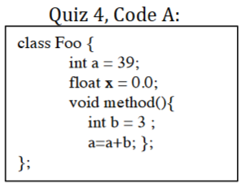

|  |  |  |  |
| --- | --- | --- | --- |
| **Symbol** | **Kind** | **Type** | **Properties** |
| a | var | Int | … |
| x | var | Float | … |
| method | method | ->Void | … |
| b | var | Int | … |

1. **Explain about the symbol table Naïve solution?**

* Building visitor
* Propagates (at least) a reference to the symbol table of the current scope
* In some cases have to use type information (inherits)
* Checking visitor
* On visit to node – perform check using symbol tables
* Resolve identifiers
* try to find symbol in table hierarchy
* In some cases have to use global type table and type information
* You may postpone these checks

1. **Give an example of symbol table implementation for the code B?**

(foo)

|  |  |  |  |
| --- | --- | --- | --- |
| Symbol | Kind | Type | Properties |
| x | var | Int | … |

(ABC)

|  |  |  |  |
| --- | --- | --- | --- |
| Symbol | Kind | Type | Properties |
| value | var | Int | … |
| foo | method | → Int | … |
| setValue | method | → Int | … |

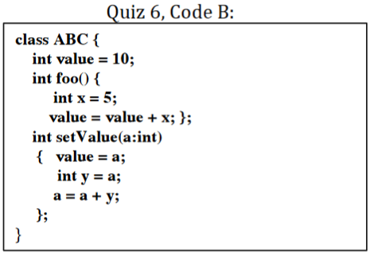

(setValue-block)

|  |  |  |  |
| --- | --- | --- | --- |
| Symbol | Kind | Type | Properties |
| a | var | Int | … |

(setValue)

|  |  |  |  |
| --- | --- | --- | --- |
| Symbol | Kind | Type | Properties |
| y | var | Int | … |

1. **For code B in quiz number 6, show the connection between the parse tree and the constructed symbol table?**

