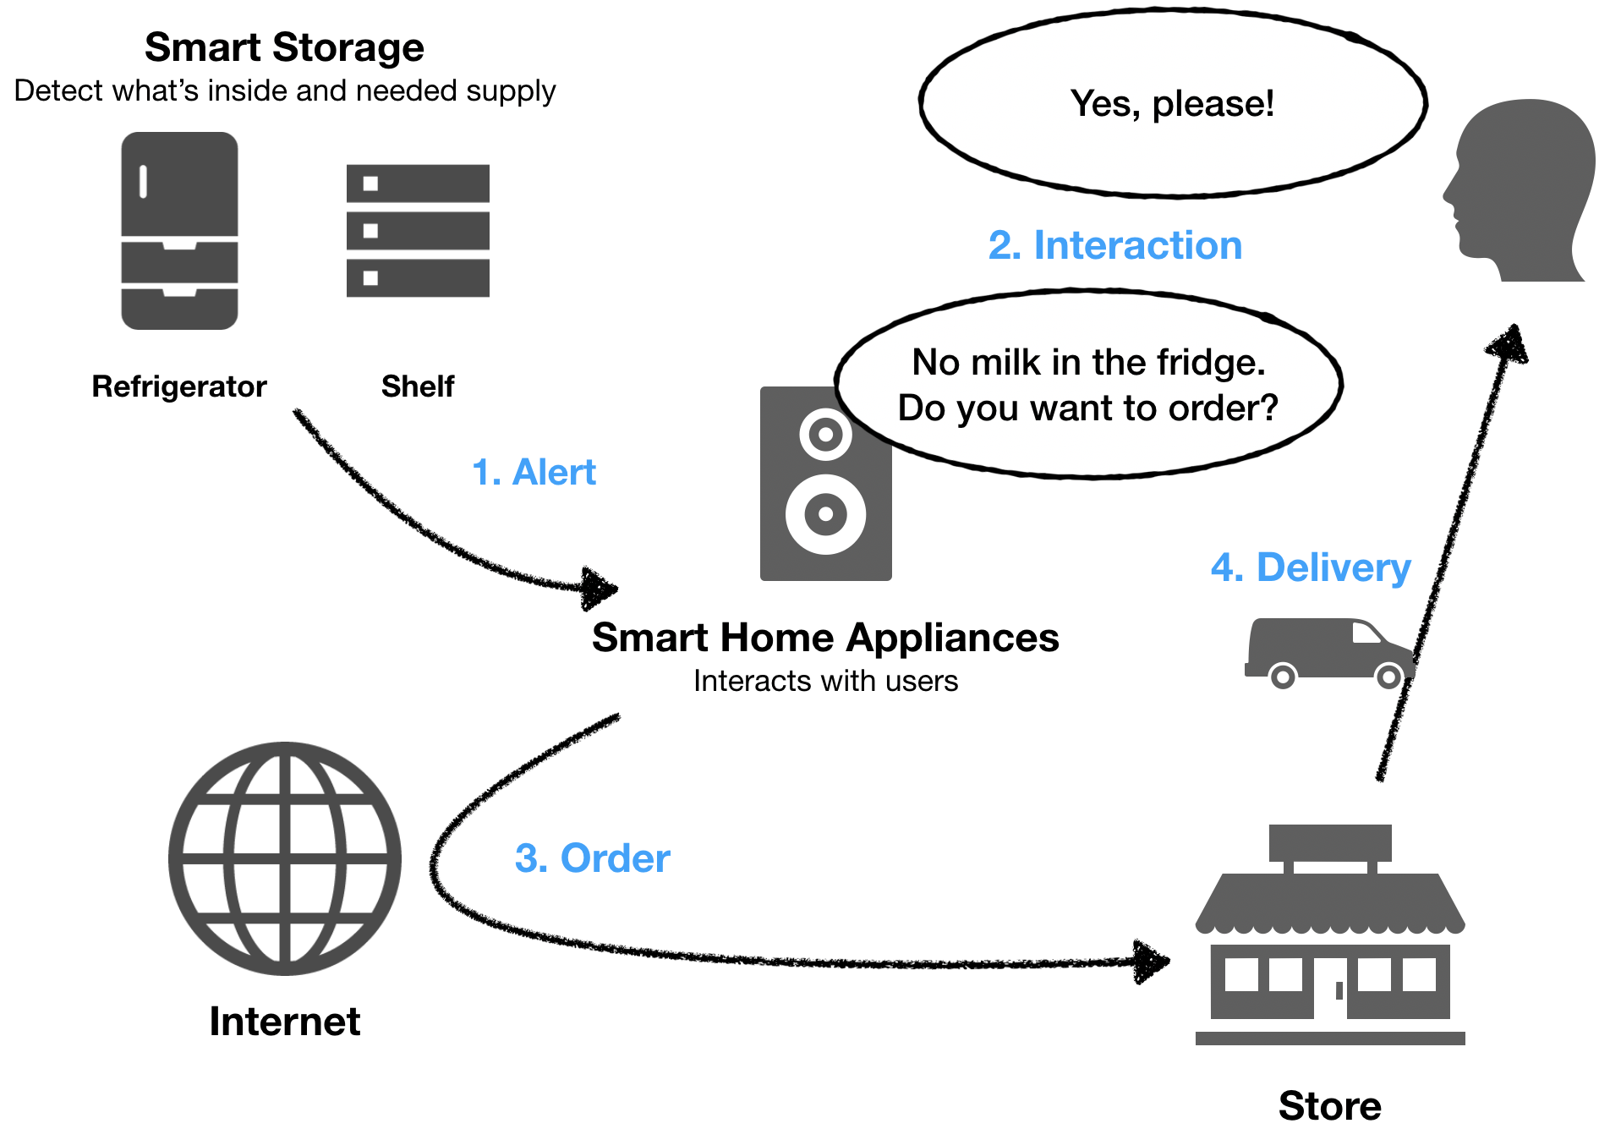
Abstract
Figure 1. Overall System
Smart Supply System for Handicapped People Living in Rural Area: Approach from Smart Appliances
Yuta Nemoto m5231153
The problem of “Food Desert” is one of the social problems recently. But especially in Japan, still, there are many handicapped people who cannot access the foods easily although it has been a while since the problem has presented. One reason is that such people are generally unfamiliar with digital systems which makes the reasonable supply system and supposed to be the solution to this problem. In this paper, we present an idea of the supply system based on a smart home mechanism which can be accepted by such people who has difficulty to interact with digital devices. The presented smart home system is implemented by smart storage which detects the demanded item automatically, and smart home assistant devices which interact with the user with natural conversation. The image processing technology is one of the key points and focused on, in the discussion for the practical implementation.
- Introduction
Nowadays, the decline of the infrastructure caused by the decreasing number of the working population is getting to be one of the urgent social problems in Japan. Especially the percentage of the elderly people is getting higher in the rural area of this country [1] and drop of living infrastructure in the provincial area has been appeared as an issue already. One serious example is the decreasing number of food stores. Today, the situation that elderly habitants living in the rural area have a certain difficulty to purchase foods because of the distance to stores is very common and this kind of problem is called “Food Desert” [2].
According to a document [3], support for the local shopping street, promotion of the mobile sales or delivery service, familiarization of online shopping, or the improvement of the public transportation are pointed out as the countermeasures for the issue. However, obviously, most of the elderly people living in the rural area are unfamiliar with a digital device to use such convenient services. Apparently, the use of mobile sales or online shopping is quite hard for such handicapped people. The idea for a reasonable supply system for such people living in the inconvenient area is strongly demanded.
On the other hand, nowadays the technologies of IoT and applications of the smart home is evolving year by year. A sort of smart home applications are getting to be familiar in the market and the efficiency of the use of such smart home tools for elderly people is also evaluated positively [4].
In this paper, we present an effective smart supply system utilizing the IoT technology to help handicapped people living in the rural area and mainly focus on the smart home system to understand the practical knowledge in detail.
- Proposed System
  - Overall Idea
In short, our proposal is the food supply system utilizing IoT smart storage. Figure 1 shows a simple description of this overall idea. The main process of the proposed system is the following:
- Smart storage such as smart refrigerator detects what is inside and what is needed to be supplied, then send an alert to some smart home appliances/assistants such as Google Home to notify the user.
- Smart home appliances/assistants have a voice interaction with the user to confirm the purchasing process.
- Smart home appliances/assistants make an order automatically and send it to the store through the Internet.
- The store sends the groceries based on the order comes from smart home appliances/assistants and the items are delivered to the user by delivery service.
The key point of this system is the interaction method and automation. Users do not need to interact with machines through complicated UI. In other words, everything that the user should do is just to respond to the smart home assistant’s question. Smart storage automatically detects the demand of the user and suggests what is needed. And the other point is that all of the processes are automated. As it is mentioned in the above part, the decreasing number of the working population is exactly one of the factors of this problem. The sustainable system without wasteful costs is the prerequisite for this proposal.
  - What is needed?
Today, the technology about voice recognition is dramatically developed. Smart assistant devices such as Google Home, Amazon Echo, etc. with the high-level performance of voice interaction, is provided in reasonable price [5]. In fact, for the items listed above, item 2 and 3 is already realized by products on the market. For example, Google Home is providing a function that makes an order to the store based on the conversation with the user. Amazon Echo is also providing a way to order the product by its voice interaction. These products are providing comprehensive support for the rich amount of commands with several languages in high-quality performance.
Next, item 4, the delivery service is also can be achieved easily with the existing services. In Japan, there are many trustable posting services which can provide the package for fresh or frozen foods. For example, Japan Post is providing a package which is delivered under the controlled temperature [8]. The proposed system can use such existing services effectively.
The part we need to focus on is item 1 in the above list, the part related to the alert from the smart storage. This part is containing the technical issue and the most important point in the system. In the following part of this paper, we’ll mainly discuss how to implement the function in this key part: detect what is inside of the storage and make an alert.
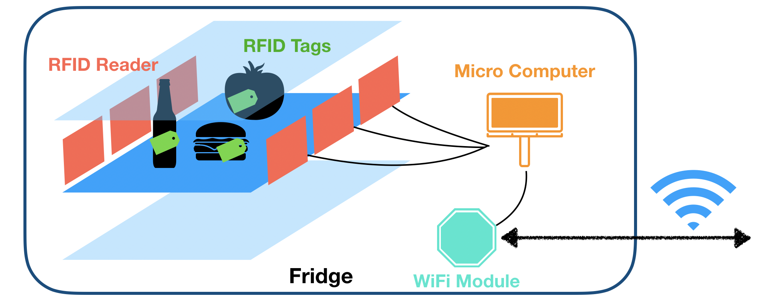
  - Requirements for the smart storage
Figure 2. Mechanism with RIFD System
As the definition of smart storage, it needs to satisfy the following requirements:
- Detect the item inside of the storage.
- Store the information about what is inside.
- Send an alert to the smart assistant device when there are some items needed to be supplied.
We present the practical system architecture in the next section based on the requirements above.
- System Architecture and Design
To achieve the requirements defined in the last section we propose the system architecture of the smart storage in the following 3 layers: sensing, network, and application.
  - Sensing Layer
Sensing layer is responsible for the physical sensing process, in other words, all of the processes to detect the contents inside, in this system. To put it plainly, the tasks assigned to this layer are the following: detection of the object, and inspection of what is the object.
To detect the items inside, there are 2 ways to achieve the goal. One is the way using RFID technology, and another one is the way using camera and image processing technology.
    - Method with RFID Sensor
The idea of the first method shown in Figure 2 is the following: suppose every item inside have its own RFID tag and its readers attached inside of the storage detects what kind of RFID tags there. The strength of this way is the extensibility of use. If the RFID tags attached to the items have the expression for its classification (e.g. vegetable, meat, snack, etc.) or expiration date, the product can provide more applied usages. For example, the recommendation of recipe or alert of damaging items. However, this method is including several difficulties to be utilized. First of all, this method stands on the prerequisite of RFID tags attached to every item inside of the storage. Although the RFID tag is inexpensive in case of the passive tag [9], there is no standard that proposes the attachment of RFID tag to the grocery products for now. Secondly, the practical economical problem is the price of RFID readers. The price of the tag is cheap though, still, the price of the readers tends to be expensive. The expensive cost of the frequently-used component may affect the meaning of the product itself. Thirdly, the problem of RFID collision is one of the technical issues. Because the passive tags have limited computational capacity, no ability to sense the channel, detect collisions, and interact with each other [9]. We need to think a special method to realize the way to avoid collision [10].
    - Method with Image Processing
The idea of the second method shown in Figure 3 is the following: detect what is added to/removed from the storage by using the camera attached in front of the storage. Nowadays the technology of image processing has been improved dramatically and the effective mechanism can be used in the system at reasonable costs. It doesn’t need special tags and no requirements for the items inside. The difficulty of this method is the image processing technology itself and its performance. First, to detect the item, we need a tool to identify what is the object in the image. Generally, this kind of process: detect what is the object in the image, is the topic of deep learning technology. If we prepare the detection system by ourselves, it needs a huge amount of datasets about the images of groceries. And also, even if we use any third-party recognition system, although the precision of the image processing is getting better day by day, we cannot expect 100% of the score every time. It means that it is difficult to expect some applied functionalities we did it in the RFID way.
    - RFID Sensor vs. Image Processing
In this project, we prioritize the reality of the product. By the discussion above, the RFID method has a high level of applicability, but the possibility of the realization is negative because of its prerequisite of RFID tags. On the other hand, the method using image processing can be introduced in today’s real life, although its applicability is low compared to another. We continue discussing the implementation using the second method: the method with camera and image processing, below.
    - Workflow with the Image Processing
Figure 4 shows the flowchart of the sensing layer workflow utilizing image processing method. The main process of this layer is the following: activate the camera in front of the storage when the door is opened, and send the taken picture to the image inspection process. The image inspection process identifies what is the object and what is the action (adding or removing). The result of the inspection is saved to the database called “action record” which is consisting of “object identification” and “action to the object”. Then the record is used in the application layer to generate the suggestion to the user.
  - Network Layer
The network layer is responsible for the connection between an object and the other object in the system. For the system we propose in this paper, the main part of this layer is the connection between the smart storage and the smart assistant device.
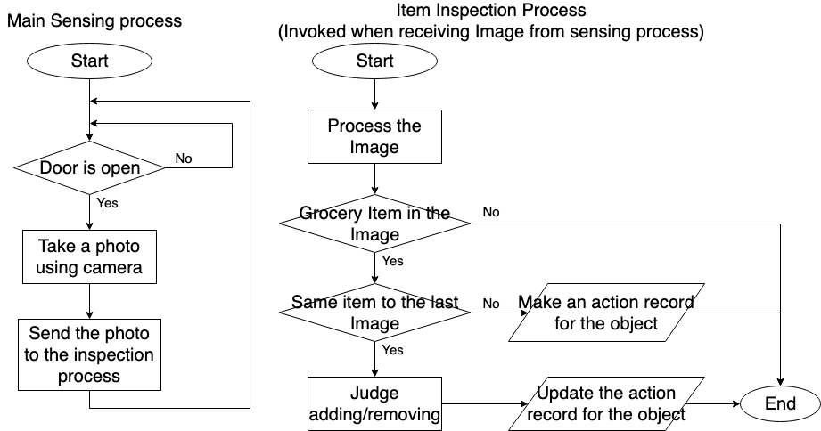
Because most of the smart home controllers require the smart home products to be connected to the same local area network, this smart storage is also needed to be connected. Connection using Wi-Fi is a widely used way [11] [12]. To implement the connection with the smart home control device, we attach a module which is responsible for the communication to the Wi-Fi router. A study [12] shows a similar work using Arduino, WiFly module which gives the solution to the Wi-Fi connection, and this method is enough adaptable for our project also.
Figure 4. Flowchart for the sensing layer workflow
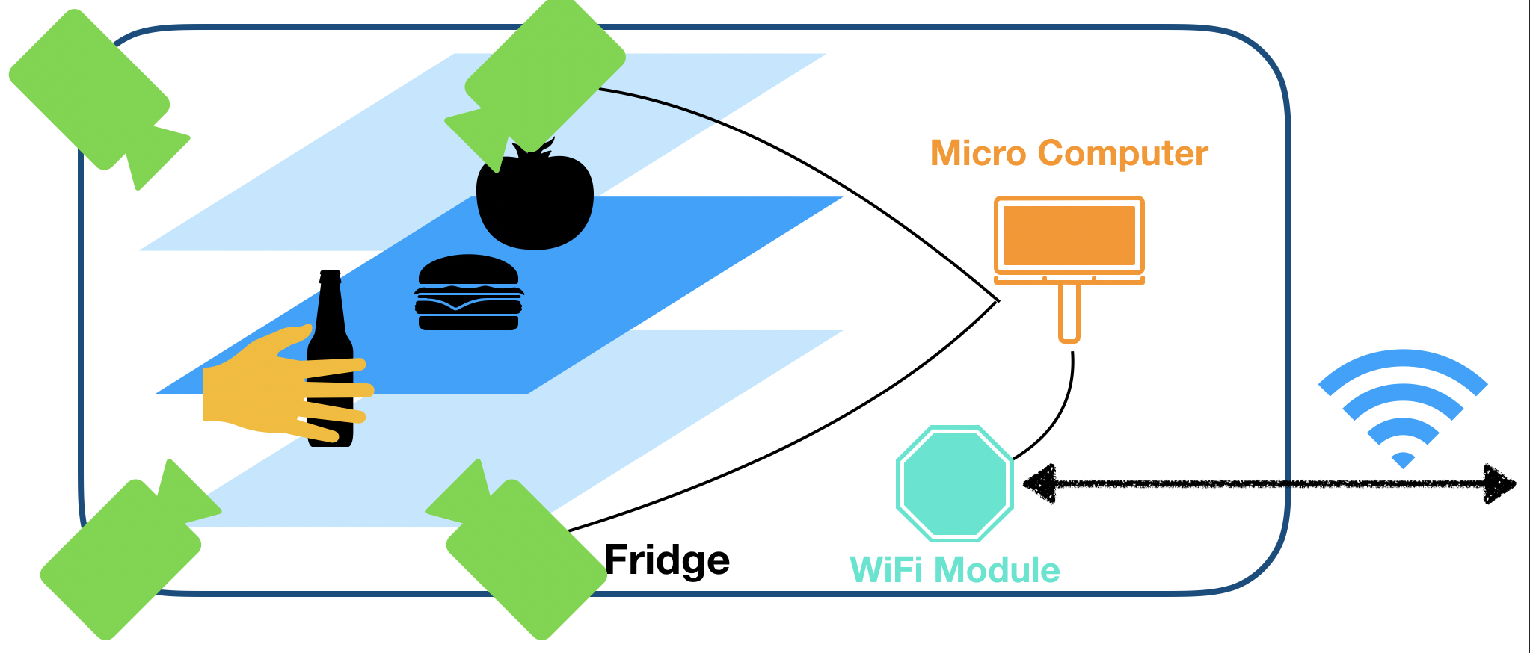
  - Application Layer
Figure 3. Mechanism with Image Processing
Application layer is the functionally major part of our project. The main task assigned to this layer is to make a suggestion based on the stored data.
The suggestion can work helpfully to the user in the way: confirmation of items to be ordered, suggestion of recipe for cooking, alert of damaging items, and so on.
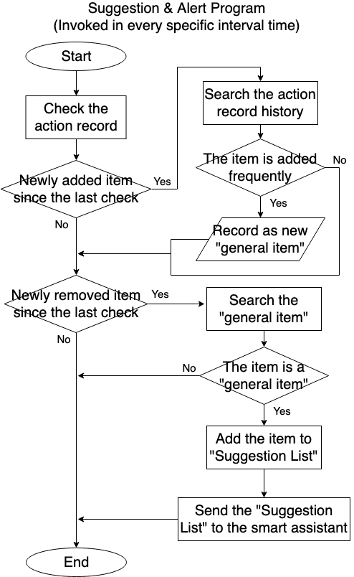
Figure 5 presents an example of workflow for suggesting the items to be ordered. To make a suggestion list, the program is invoked in every specific interval time, for example, 6 hours or 12 hours. The program read the “action record” saved by the sensing layer process, and detect what is needed to be supplied. If there is any item newly added to the storage, the program judges whether the added item is “general item” for the user or not. Although the judging criteria depends on the item, for example, in case of milk, if there was a supply within a week to 10 days, it is enough to be identified as frequently needed item. After processing the newly added items, work on the newly removed items next. If the item in the “general item” list, it means the item is frequently needed one, so put the item in the “suggestion list” to be submitted to the smart assistant and asked to the user whether he/she wants to purchase or not. For example, if milk is one of the removed item and in the “general item” list, put it in the “suggestion list” because it can be thought as needed item but not in the storage. After processing all the removed items, send the suggestion list through the network layer mechanism and end the process.
Figure 5. Flowchart for the application layer workflow
- Related Works
In this section, we give some similar works contributing to the development of IoT smart home knowledge.
First, a publication [13] is one of the papers worth to be compared to this study. This publication is presenting a way to develop a smart refrigerator to make a shopping list automatically. In contrast to the study presented by us, this research is utilizing the development with RFID method which is discussed above and published a practical implementation report in its content. Although the approach is basically under the prerequisite of RFID tags attached to the items, this publication reports the mechanism and realistic product process in detail.
Secondly, an article [14] widely introduces life design with smart home products. Although it does not focus on the technical aspect, the idea of the smart refrigerator is introduced as an idea which can provide applicable approaches for practice: it acts as an integrated kitchen product. This way of thinking is practical (most of the commercial smart refrigerators are produced in the context of this kind of purpose as we mention below) and including of such variety of convenient functions is one of the needs from the consumers for the product.
To take a look around the actual market situation, an online article [14] gives an overview of the current trend of the smart refrigerator products. The point acquired from this article is the achievement which has been done in the current commercial products. As a notice about the technological point, many products are presenting its technology to keep the items inside fresh. Although it is the normal way when they want to approach the consumers in the current market situation, such basic functions of the refrigerator itself have the top priority to be presented in the real market. As an awareness, all of the product presented here has a kind of coffee/water server. Although this function is not essential for refrigerator, all the items implement the extra operation. It means the diversity of the needs for the smart home appliances in the market. To see the product from the perspective of business, the device only for the purpose of the supply system is insufficient to commit the real life of the consumers. Our approach also should take into account that it needs to be combined with other essential/non-essential technologies or functionalities to be accepted in the pragmatic situation.
- Experiment: Image Inspection

  - Experiment Approach
Supermarket
  - Experiment Approach II
Supermarket
  - Experiment Approach III
Supermarket
- Conclusion
In this study, we have presented a system which enables to provide a reasonable, effective, and usable supply system especially for users who have difficulty to utilize the digital devices. In the discussion part, we mainly focus on the mechanism to detect the demand of the user automatically to make an order by using intuitive voice interaction. To dig in the practical detail, we have presented the architecture and design in the 3 layers: sensing layer, network layer, and application layer, which are needed to be considered when implementing the product in reality.
Image processing is one of the key technology in our project. Although the research in this field is dramatically improving the beneficial knowledge today, still we have difficulty to inspect the specific kinds of items in a practical situation, because it needs a huge size of resource to learn widely ranged products.
However, the inspection program can work exactly in the limited number of labels. This idea is enough possible to be an achievable product.
Reference
- Statistics Bureau of Japan, “Population Estimates 2017”. [Online] https://www.stat.go.jp.
- Tetsuro Yakushiji, Katsuya Takahashi, “Estimation of Population Classified by Distance to the Nearest Fresh Food Store- Using Grid-Square Statistics of Population Census and Census of Commerce –“, Theory and Applications of GIS, 2012, Vol. 20, No. 1, pp.31-37
- Nobuyuki Iwama, “フードデザート問題の現状と対策案”, [Online] https://www.maff.go.jp/
- Demiris, G., Oliver, D.P., Dickey, G., Skubic, M., & Rantz, M. (2008). Findings from a participatory evaluation of a smart home application for older adults. Technology and health care : official journal of the European Society for Engineering and Medicine, 16 2, 111-8
- WIRED, “The 8 Best Smart Speakers With Alexa and Google Assistant”, [Online] https://www.wired.com/story/best-smart-speakers/
- Google Nest Help, “Explore what you can do with Google Home”, [Online] https://support.google.com/googlenest/answer/7130274?hl=en
- Amazon.com, “Learn What Alexa Can Do”, [Online] https://www.amazon.com/b?ie=UTF8&node=17934671011
- Japan Post, “Refrigerated Yu-Pack”, [Online] https://www.post.japanpost.jp/service/you_pack/chilled/index_en.html
- D. K. Klair, et al., “A Survey and Tutorial of RFID Anti-Collision Protocols” in IEEE Communications Surveys & Tutorials, vol. 12, no. 3, pp. 400-421, Third Quarter 2010.
doi: 10.1109/SURV.2010.031810.00037
- Nowshad Amin, Puah Weng Lin, “Anti-collision Protocol Development for Passive RFID Tags”, the 7th WSEAS International Conference on Applied Informatics and Communications, Athens, Greece, August 24-26, 2007. pp. 393 – 397.
- M. Kusriyanto and B. D. Putra, “Smart home using local area network (LAN) based Arduino mega 2560,” 2016 2nd International Conference on Wireless and Telematics (ICWT), Yogyakarta, 2016, pp. 127-131.
doi: 10.1109/ICWT.2016.7870866
- Ahmed ElShafee, Karim Alaa Hamed, “Design and Implementation of a WiFi Based Home Automation System”, World Academy of Science, Engineering and Technology 68, 2012, pp. 2177-2183.
- A. Floarea and V. Sgârciu, "Smart refrigerator: A next generation refrigerator connected to the IoT," 2016 8th International Conference on Electronics, Computers and Artificial Intelligence (ECAI), Ploiesti, 2016, pp. 1-6.
doi: 10.1109/ECAI.2016.7861170
- Lifewire, “The 7 Best Smart Fridges of 2019”, [Online] https://www.lifewire.com/best-smart-fridges-4159454

