Dataset report of a burrow data file

Suzanne Fox

February 2017

## Run the Burrow function to analyse the source data

## [1] "BURROW ... Run started : Sun Feb 12 2017, 12:13:04"  
## [1] "BURROW ... Analysing dataset"  
## [1] "... write_Datasetinfo ... Writing dataset details"  
## [1] "... write_Datasetinfo ... Finished."  
## [1] "BURROW ... Calculating correlations"  
## [1] "... calculate_Correlations ... number of variables 4"  
## [1] "... calculate_Correlations ... numeric cols are Sepal.Length"  
## [2] "... calculate_Correlations ... numeric cols are Sepal.Width"   
## [3] "... calculate_Correlations ... numeric cols are Petal.Length"  
## [4] "... calculate_Correlations ... numeric cols are Petal.Width"   
## [1] "... calculate_Correlations ... Finished"  
## [1] "BURROW ... Analysing field : Sepal.Length"  
## [1] "BURROW ... Adding Correlation : Sepal.Length"  
## [1] "BURROW ... Best Guess is : DECIMALS"  
## [1] "BURROW ... Analysing field : Sepal.Width"  
## [1] "BURROW ... Adding Correlation : Sepal.Width"  
## [1] "BURROW ... Best Guess is : DECIMALS"  
## [1] "BURROW ... Analysing field : Petal.Length"  
## [1] "BURROW ... Adding Correlation : Petal.Length"  
## [1] "BURROW ... Best Guess is : DECIMALS"  
## [1] "BURROW ... Analysing field : Petal.Width"  
## [1] "BURROW ... Adding Correlation : Petal.Width"  
## [1] "BURROW ... Best Guess is : DECIMALS"  
## [1] "BURROW ... Analysing field : Species"  
## [1] "BURROW ... Best Guess is : CATEGORICAL"  
## [1] "BURROW ... Finished. Processing time : 0.35"

## Dataset details

Source data name - Data.source  
Source data description - Iris dataset  
Burrow data created - Sun Feb 12 2017, 12:13:04  
Dataset dimensions - 5 columns (variables) and 150 rows (cases)

## Best Guess at datatype for each variable

Variable Datatype  
 Sepal.Length DECIMALS  
 Sepal.Width DECIMALS  
 Petal.Length DECIMALS  
 Petal.Width DECIMALS  
 Species CATEGORICAL

## Variable analysis - level of missing values

There were no missing values for any variable

## Variable analysis - level of unique values

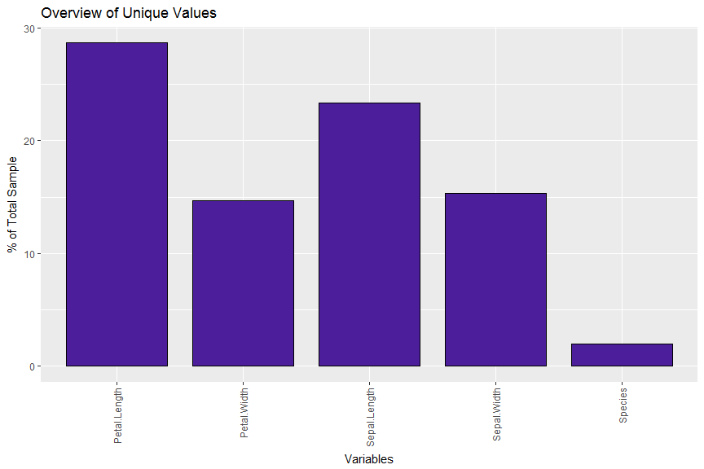

## Variable analysis - correlations

[1] "Correlations for numeric Variables"

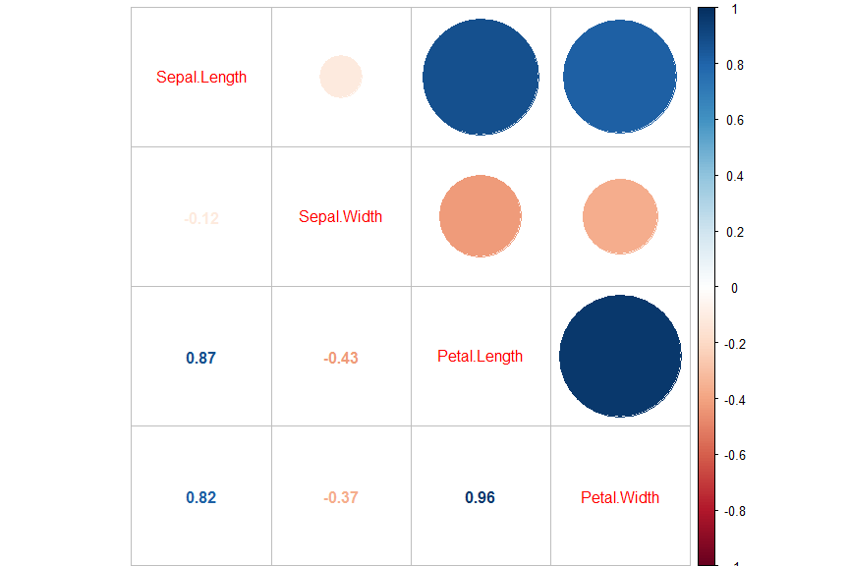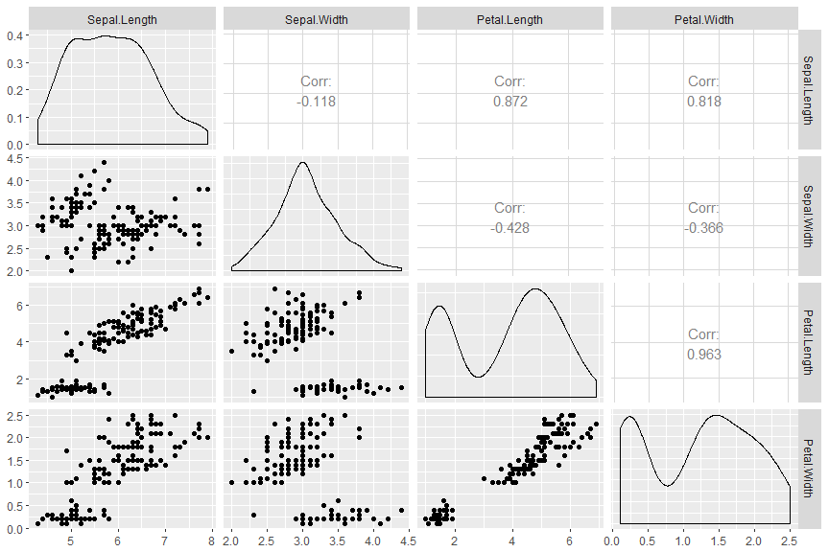

## Variable analysis - distributions and outliers for numeric variables

[1] "Charting - Sepal.Length datatype is DECIMALS"

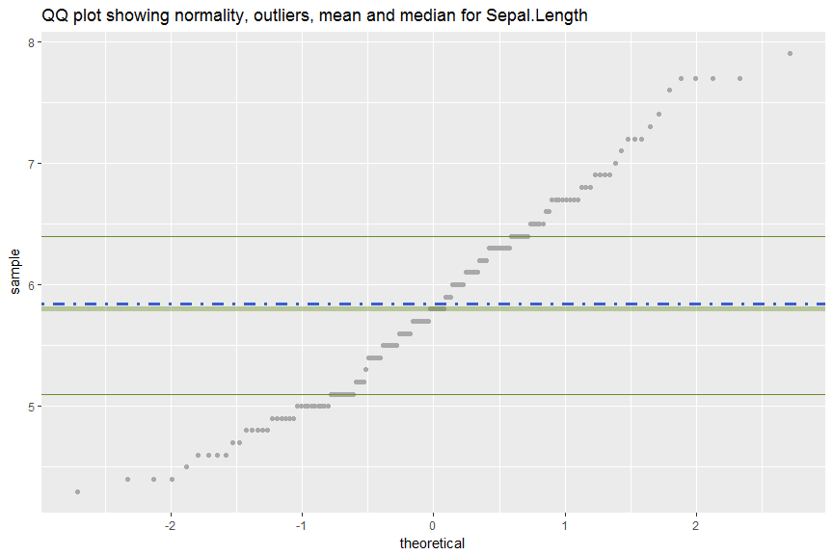

[1] "Charting - Sepal.Width datatype is DECIMALS"

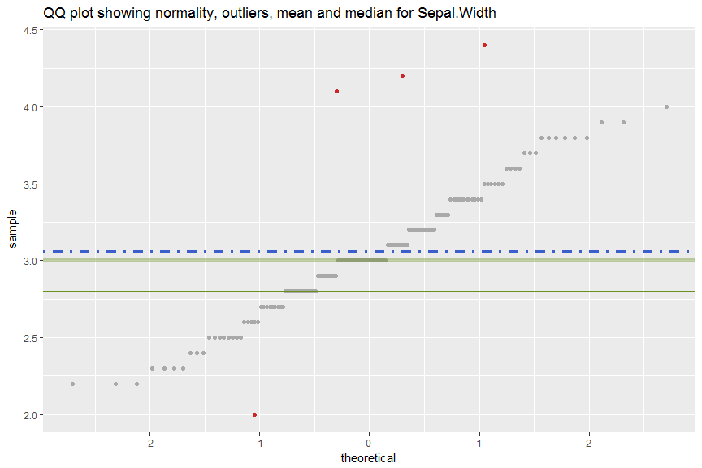

[1] "Charting - Petal.Length datatype is DECIMALS"

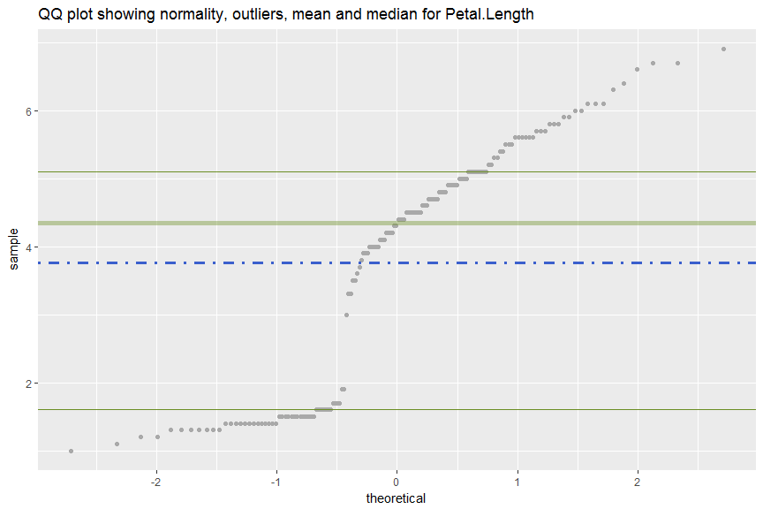

[1] "Charting - Petal.Width datatype is DECIMALS"

