I built an MFA factor that listens for the scam
Voice verification on Azure Communication Services and Microsoft Entra ID — and the thirteen things that went wrong on the way
Suzaril Shah · Microsoft Certified Trainer · Built for the Microsoft Garage Hackathon

This is a long post, and most of it is about failure. If you only want the architecture, Figure 1 is two pages down and you can stop there. If you want the part that was actually useful to me — the thirteen ways this thing broke, several of which were platform behaviour I would not have guessed in a year — start at "The hiccups".
Contents

Why I built this
In September 2023, someone phoned the MGM Resorts IT help desk, said they were an employee, and asked for a password reset. They got one. The group behind it — Scattered Spider — did the same thing to Caesars, and later to Marks & Spencer. No malware, no zero-day. A phone call and a convincing story.
What has always bothered me about that class of attack is that multi-factor authentication does not help, and it is not supposed to. MFA answers one question very well: is the person approving this the person who owns the account? It has nothing at all to say about a second question, which in these attacks is the only one that matters — does that person actually want this to happen, or is somebody on the phone telling them to press approve?
A number-matching prompt proves possession of a device. It cannot prove free will. A victim being walked through a sign-in by a confident stranger produces exactly the same telemetry as a user signing in normally, because they are doing exactly the same thing. That gap is the entire premise of what I built.
The idea in one sentence
Place the step-up challenge as a real voice call, and while the user answers it, listen to the call for evidence that somebody is coaching them through it.
The name is EntraGuard. It is a hackathon project, it runs on real Azure, and everything I describe below happened.

What it actually is
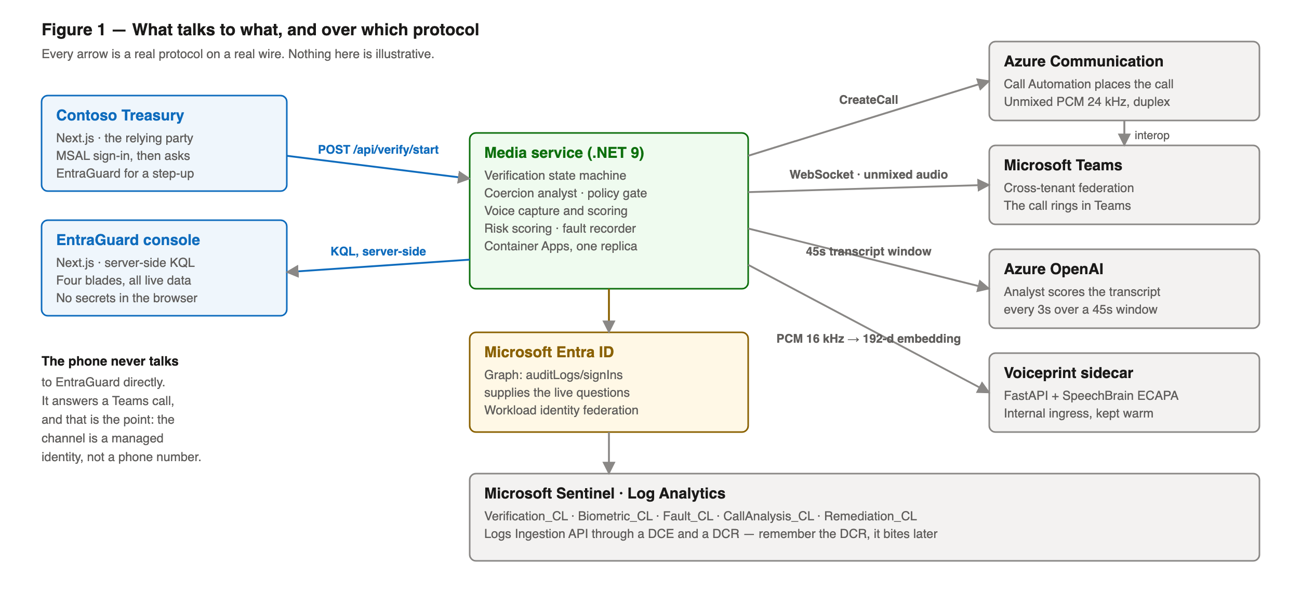
Figure 1 — Component and protocol view. Every arrow is a real wire protocol, not a conceptual link.
A relying party — in the demo, a fake payments app called Contoso Treasury — asks EntraGuard for a step-up. EntraGuard places an outbound call through Azure Communication Services Call Automation, which rings the user in Microsoft Teams through cross-tenant federation. The user sees a two-digit number in their browser and keys it on their phone.
While that is happening, the call audio is streaming both ways over a WebSocket as unmixed PCM. Unmixed matters: it means each participant arrives on their own channel, so I can tell the difference between the person I called and anybody else who happens to be talking. A transcript is built from that, and every three seconds an Azure OpenAI model scores the last 45 seconds for signs of coercion — someone reading digits aloud to the user, an authority claim, manufactured urgency.
Then there are the questions. Instead of stored security questions, EntraGuard asks about the user’s own recent sign-in activity, pulled live from Microsoft Graph: which town were you in the last time you signed in, what device did you use. Nothing is stored, nothing can be researched in advance, and the answers expire on their own. NIST SP 800-63 rejects stored security questions as an authenticator, and it is right to.
Voice biometrics came last, and I will come back to why I now think it is the weakest part of the system rather than the headline.
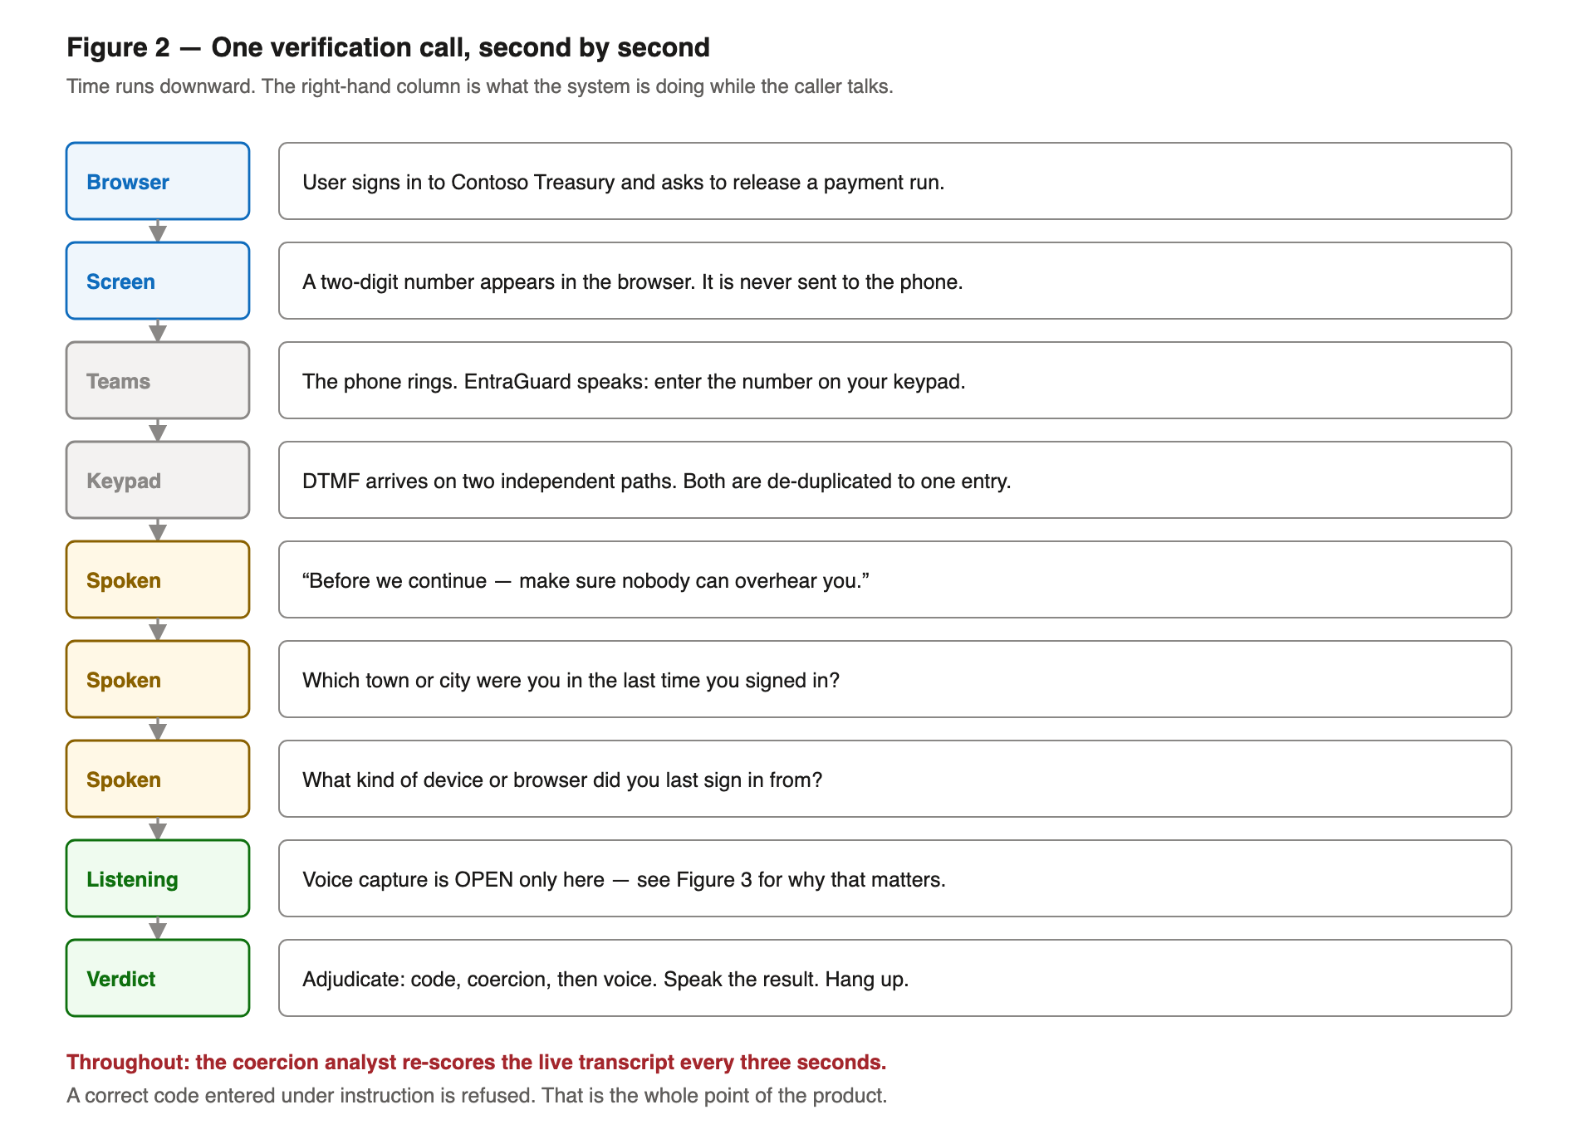
Figure 2 — The sequence of a single verification call. The coercion analyst runs continuously underneath all of it.
The design decision I am most confident about
Voice never denies access on its own. A poor match asks for a stronger factor; it does not refuse you. A speaker model running over a phone codec is not accurate enough to lock somebody out of their own money, and pretending otherwise is how you ship a product that fails honest users.

The hiccups
I kept a list. Some of these are my own carelessness, some are platform behaviour that is documented but easy to miss, and two of them I would call genuinely surprising. In rough order of how much time they cost me.

1. Teams federation wants a GUID, not the thing that looks like an ID
Calling a Teams user from ACS needs the Teams tenant to allow-list your Communication Services resource. The cmdlet is Set-CsTeamsAcsFederationConfiguration, and it takes the resource’s immutable resource ID — a bare GUID. I spent a while feeding it the full ARM resource path, which is the thing that looks like an identifier and is right there in the portal. It is rejected outright.
403#10124 the ACS resource is not allow-listed in the Teams tenant
403#10391 the user is not Enterprise Voice enabled
487#10004 it rang, nobody answered
412#10119 personal Microsoft account — no Teams identity to call
The second one deserves its own sentence, because it cost me an afternoon: a Teams Phone licence is not the same thing as being Enterprise Voice enabled. You can have the licence and still get a 403.

2. Two AI agents, talking to each other, on my authentication call
I wired the Azure OpenAI Realtime API in to make the call conversational. The result was two voices having a polite exchange while the actual human waited. The cause is a single default: with server-side voice activity detection, create_response defaults to true, so the model answers anything it hears — including its own previous utterance echoing back off the caller’s speakerphone.
Setting it to false and driving every utterance explicitly fixed it. But the underlying lesson took longer to land, and it is the next entry.

3. The system confidently answered its own question
Log line, from a real call: heard "OK, which town, city or?" — judged against the expected answer "Petaling Jaya". Twice, eight seconds apart, burning both of the user’s attempts before they had finished listening to the question.
On a phone call, the prompt you play comes back to you. Teams echoes it, or the handset speaker feeds its own microphone, and speech recognition attributes it to the person you called — because it arrived on their channel. If you start listening for an answer the moment you request playback, the first thing you "hear" is yourself.
The fix is to wait for the PlayCompleted callback and then a further 900 milliseconds for the echo to drain, and to discard any reply that is mostly words from the question just asked. Both parts are needed. I will return to that second part, because it later ate a real answer from a real user.

4. amr: three rounds with a claim that will not do what you want
Registering a voiceprint should require MFA — otherwise a stolen password lets somebody bind their own voice to your account, and unlike a password you cannot change your voice afterwards. The obvious way to check is the amr claim, which lists the authentication methods used. Three attempts, three different walls:
- Round one: I added amr as an optional claim on the access token. Entra accepts this, stores it, shows it in the manifest — and ignores it. amr is not deliverable in an access token. The check looked configured and could never have passed.
- Round two: I moved it to the ID token, which does carry amr, and validated that token server-side. Correct — but I was also still sending a claims challenge asking for amr.
- Round three: that challenge broke sign-in entirely.
AADSTS901001: The 'amr' values request parameter value 'Empty' is invalid.
amr is not a requestable claim. The claims parameter exists for acrs — Conditional Access authentication context — and asking it for amr produces a request Entra cannot parse. It refuses the sign-in before it starts. The fix was to delete the challenge entirely: amr arrives because it is an optional claim on the ID token, and prompt=login is what makes it describe the sign-in that just happened.
What I would tell my past self
A claim being accepted by the registration UI is not evidence it will ever be issued. I burned three of my tester’s sign-in attempts on a check that was unsatisfiable by construction, and I could not test it myself because I cannot mint a real Entra token.

5. The data collection rule that quietly ate my telemetry
This is my favourite one, in the way that only a bug you have finished fixing can be a favourite. I had a voice score being computed on every call, written to a Log Analytics custom table, and displayed on a dashboard tile that read zero. Forever.
The table had the columns. The service was sending them. Ingestion returned success. But the data collection rule’s streamDeclarations block did not list them — and the Logs Ingestion API silently drops any column a stream does not declare. No error, no warning, no partial-success response. Just an empty column.
The whole point of that column was to accumulate real scores so I could replace my synthetic thresholds with measured ones. That dataset never existed. The comment above the DCR in my own Bicep file said "streamDeclarations must mirror the table schemas exactly". It had drifted anyway.

6. Four different ways a deployment can lie to you
I claimed something was fixed and deployed, three separate times, and was wrong each time. Not because the code was wrong — because the code was not running.
What happened | Why nothing looked wrong
A comment inside a backslash-continued az command silently ended it | Every earlier stage printed success; set -e aborted the rest
A compile error broke the image build | Health checks stayed green — the old container was perfectly healthy
An invalid --no-cache flag meant no image was ever pushed | Revisions failed to pull and traffic fell back to the previous one
A draining revision answered probes after the new tag went live | The tag matched. The code answering did not.
The habit I ended up with: never trust an image tag, never trust a green health check, and never trust a serving revision. Call the endpoint whose behaviour changed and assert the new value, two or three times a few seconds apart. I eventually built this into the product as /api/build, which reports what is compiled in rather than what was requested.

7. A genuine speaker scored 0.07 against their own voiceprint
My calibration run put genuine speakers between 0.65 and 0.88, and impostors below 0.30. My tester — the enrolled user, on their own phone, saying their own words — scored 0.0004, then 0.071. And because I had enforcement switched on at their request, it refused them access to their own account.
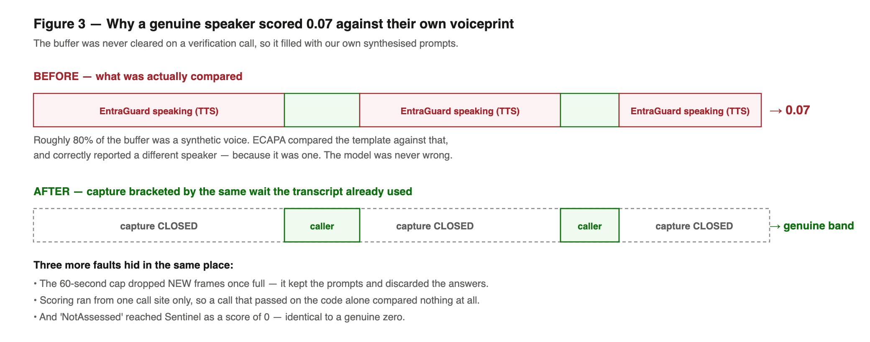
Figure 3 — The buffer was never cleared on a verification call, so most of what got compared was our own text-to-speech.
The audio buffer filled from the moment the media socket opened. On a verification call that is a minute of prompts, questions and retries — all of which echo back on the caller’s channel, which is mapped to the caller, because it is theirs. So the comparison was mostly the enrolled template against synthesised speech. The model was not wrong. It correctly reported a different speaker, because a different speaker is what it was given.
The enrolment path had solved this months earlier — it clears the buffer before each recording window, with a comment explaining exactly this failure. The verification path never got the same treatment. Two more faults were hiding underneath: the 60-second cap dropped new frames once full, so it kept the prompts and discarded the answers; and scoring only ran from one call site, so a verification that passed on the code alone compared nothing at all.

8. The echo guard started eating real answers
Remember the echo defence from hiccup three — discard any reply that is mostly words from the question. Here is the question, and here is a completely honest answer to it:
Q: "Which town, city, or country were you in the last time you signed in?"
A: "I signed in from Kuala Lumpur last time"

words in the answer: signed, from, kuala, lumpur, last, time (6)
words also in the question: signed, last, time (3)
3 of 6 = 50% -> discarded as an echo
People answer in the question’s own words. That is how conversation works. The user was told nothing had been heard, spent both attempts that way, and was refused — having answered correctly, twice. The rule now requires the reply to contain at least two words the question does not have, because an echo cannot introduce content the question never contained.

9. The risk score that was always zero
The coercion analyst was running the whole time and scoring correctly. Its output was copied onto the verification record in exactly one place: during keypad entry, a few seconds into the call, before the caller had said a word. The later re-checks — after the spoken questions, which is precisely where coaching would be audible — computed a score and recorded nothing.
So the product’s headline claim was unevidenced in its own audit trail. Every row said risk zero.

10. Four smaller ones, quickly
- Every single sign-in was filtered out of the telemetry questions, because the filter excluded apps beginning "EntraGuard" — and in a tenant used to demo EntraGuard, that is all of them. 25 returned, 25 discarded, zero questions built, silent fallback to a stored question. The user reasonably concluded I had deleted the feature.
- One of my three questions asked for a different city than the previous answer. Entra records the city an IP resolves to, and one desk resolves to several neighbouring cities across a week, so "a different city" is usually the same place under another name. Unanswerable, so it was asked again, verbatim.
- The infrastructure script defaults all three container apps to the Azure hello-world image. Running it out of habit would have wiped a working deployment.
- The verification list endpoint returned the live two-digit match code, unauthenticated, for every in-flight attempt — with the target’s UPN. A code comment three lines away asserted that the code is never transmitted to the device.

What I got wrong about the design
Voice biometrics is the part of this project everybody asks about, and after building it I think it is the weakest component in the system.
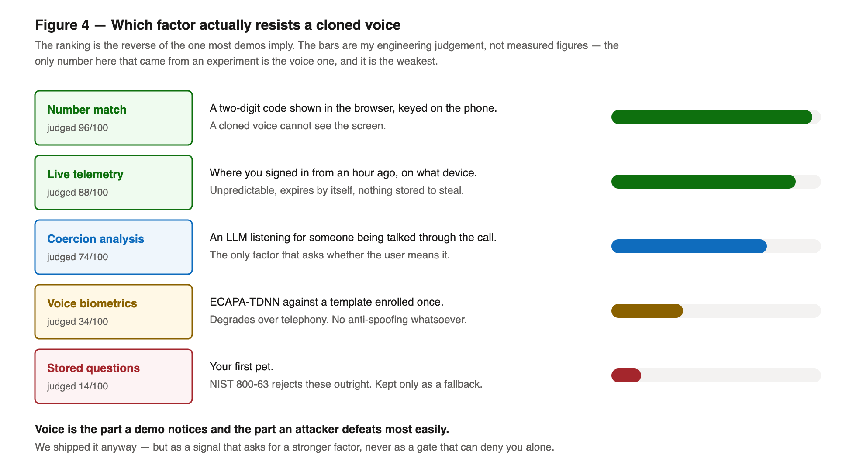
Figure 4 — Ranked by how well each factor resists a cloned voice. The ordering surprised me.
The number match is the strong one, and it is strong for an unglamorous reason: a cloned voice cannot see the screen. The telemetry questions are strong because the answers come from activity minutes old and cannot be researched. The voiceprint is the part that degrades over a phone codec, has no anti-spoofing whatsoever, and would be defeated by a good clone.
SpeechBrain’s ECAPA-TDNN is a speaker verification model. It is not a liveness detector and does not claim to be. A recording of the enrolled speaker scores as the enrolled speaker, because it is one. Whatever replay resistance the system has comes from the questions being unpredictable, not from anything in the audio.
Which leads somewhere slightly uncomfortable for a hackathon pitch. Banks have had voice biometrics for a decade and several are quietly retiring it because of cloning. The genuinely novel thing here is not that EntraGuard recognises your voice. It is that it listens to whether somebody is talking you into it.

The pattern behind almost all of it
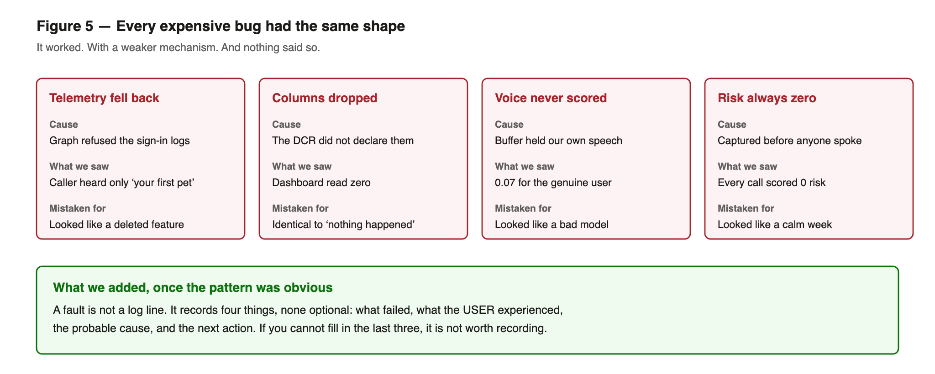
Figure 5 — Four unrelated bugs, one shape: it worked, with a weaker mechanism, and nothing said so.
Look back at the list and most of the expensive ones are the same bug wearing different clothes. The system did its job using a weaker mechanism than intended, and there was no signal anywhere that it had done so. The call still completed. The user still got an answer. Nothing in the response distinguished the strong path from the weak one.
A missing telemetry column and a quiet week look identical on a dashboard. A verification that never compared a voice and one that compared a voice and scored zero were the same row. Falling back from live telemetry to a stored security question — a materially weaker authentication — was one Information-level log line on one replica.
So I added a type. A fault carries four things and none of them is optional: what failed, what the user experienced, the probable cause, and the next action. If I cannot fill in the last three, the condition is probably not worth recording. The most important severity is not "broken" — it is "degraded", which means it worked and you should know how.
FAULT telemetry.signins_unavailable [Telemetry/Degraded]
failed : Entra sign-in logs could not be read; no live questions were built.
impact : The caller was asked only their stored security question - a secret
an attacker can research - instead of facts from their own activity.
likely : Tenant has not consented to AuditLog.Read.All, or has no Entra ID P1.
do : GET /api/verify/telemetry-probe/{tenantId}/{objectId}
Alongside that, a small circuit breaker around the one dependency that genuinely falls over — the model sidecar — which sheds calls after repeated failure and reopens on the next success. The shedding is the self-healing part, not the retry. Retrying survives a dropped packet; shedding stops a dead dependency turning every subsequent call into a timeout, with nobody paged and nothing restarted.
The self-test that immediately earned its keep
There is one check nothing else can make: does the reporting path itself work? Everything reports failures through the fault recorder, so if the recorder is broken the system goes quiet in exactly the way it would if all were well. I added an endpoint that raises a deliberate test fault and tells you where to look for it. The first time I ran it, it caught a real gap between the in-memory buffer and Sentinel.

Where this sits against the standards
Worth writing down, because "you are doing biometrics" invites a specific set of questions and it is better to have answers than opinions.
Standard | What it requires | Where EntraGuard stands
NIST SP 800-63B-4 (final, July 2025) | Biometrics must be paired with a possession factor; PAD mandatory at AAL3; FMR 1 in 1000; alternatives for users who cannot enrol | Possession pairing and alternatives: met. Presentation attack detection: not implemented. FMR on real telephony: unmeasured.
ISO/IEC 30107-3:2023 | The testing and reporting standard for presentation attack detection | Not certified, and I use its vocabulary rather than inventing my own. Stated plainly rather than glossed.
GDPR Article 9 | A voiceprint used to identify is special-category data; explicit, versioned, revocable consent | Versioned consent recorded, immediate user-initiated deletion, raw audio never stored — only a 192-dimension template.
EU AI Act (biometric provisions from 2 August 2026) | Distinguishes 1-to-many identification (high risk) from 1-to-1 verification | One-to-one verification against the already-identified account, so outside the high-risk category — but still fully subject to Article 9.
The honest summary is that two of those rows contain a "not". I would rather write that down than have someone find it.

What I would do differently, and what is next
If I started again tomorrow, the first thing I would build is not the call. It would be the fault type and the build-provenance endpoint. Nearly every day I lost was spent establishing facts a well-instrumented system would have handed me in a single request: is my code running, did that mechanism actually fire, and if it fell back, to what.
The second thing is a discipline rather than a component. Ship every new decision in observe mode first — computing, recording, and changing nothing — until real data justifies the thresholds. I did that for the risk score and it was clearly right. I did not do it for voice enforcement, and it locked my own tester out of his account using numbers measured on synthesised speech.
Still on the list:
- Challenge-response liveness — a phrase generated during the call, which no pre-recorded clone can have prepared. This is more valuable than any detector, and I had it backwards: randomised phrases are currently used at enrolment, the flow where replay matters least.
- A presentation attack detection model as a second head on the existing sidecar, reported as a separate signal. With the caveat that ASVspoof-trained detectors degrade badly over telephony codecs — it is a layer, not a solution.
- Thresholds derived from real calls rather than synthesised voices. Until then voice stays in observe mode, where it records and refuses nobody.
If you take one thing from this
Build the thing that tells you when your system quietly did something weaker than you intended. Not the thing that tells you when it crashed — crashes announce themselves. The expensive failures are the ones where everything looks fine, because from the outside, everything does.
Happy to answer questions in the comments, particularly on the ACS and Teams federation parts — that is where the documentation is thinnest and where I would have most liked to find a post like this one.
Built on Azure Communication Services, Microsoft Entra ID, Azure OpenAI, Azure Container Apps, Microsoft Sentinel and SpeechBrain (Apache 2.0). Names and figures in this post are from the running system.

