Input 1:

1 book at 12.49

1 music CD at 14.99

1 chocolate bar at 0.85

Output 1:

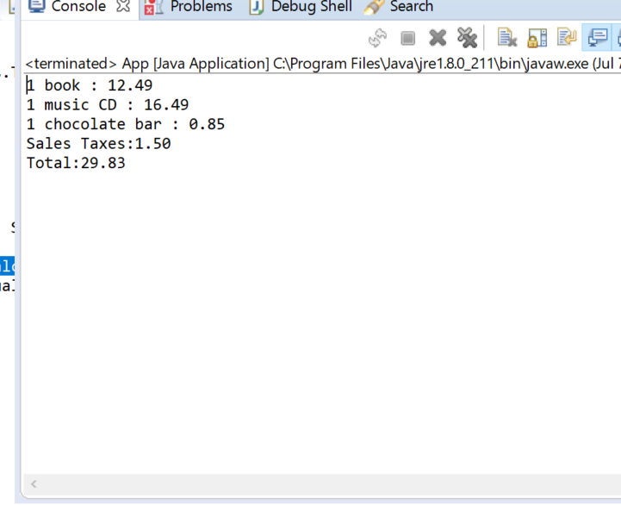

Input 2:

1 imported box of chocolates at 10.00

1 imported bottle of perfume at 47.50

Output 2:

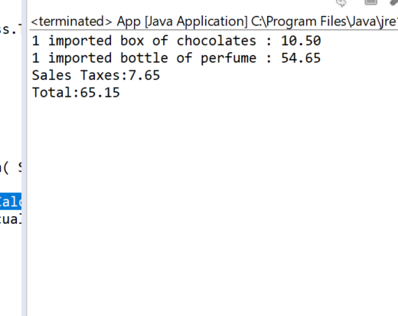

Input 3:

1 imported bottle of perfume at 27.99

1 bottle of perfume at 18.99

1 packet of headache pills at 9.75

1 box of imported chocolates at 11.25

Output 3:

