1. **Exercise 2.1**: value of 0.1 in the IEEE Standard 754 single precision format
   1. Default round mode: 00111101110011001100110011001101
   2. Round down mode: 00111101110011001100110011001100
   3. Round up mode: 00111101110011001100110011001101
2. **Exercise 2.3**:
3. **Exercise 2.9**:
4. **Exercise 2.12**:

> x <- 20

> ex <- 1

> ifac <- 1

> xi <- 1

> error <- c()

> for (i in 1:100) {

+ xi <- x * xi

+ ifac <- i * ifac

+ ex <- ex + xi / ifac

+ error <- c(error, abs(exp(x) - ex))

+ }

> plot(c(1:100), error, main='x = 20', xlab='number of iterats', ylab='relative error')

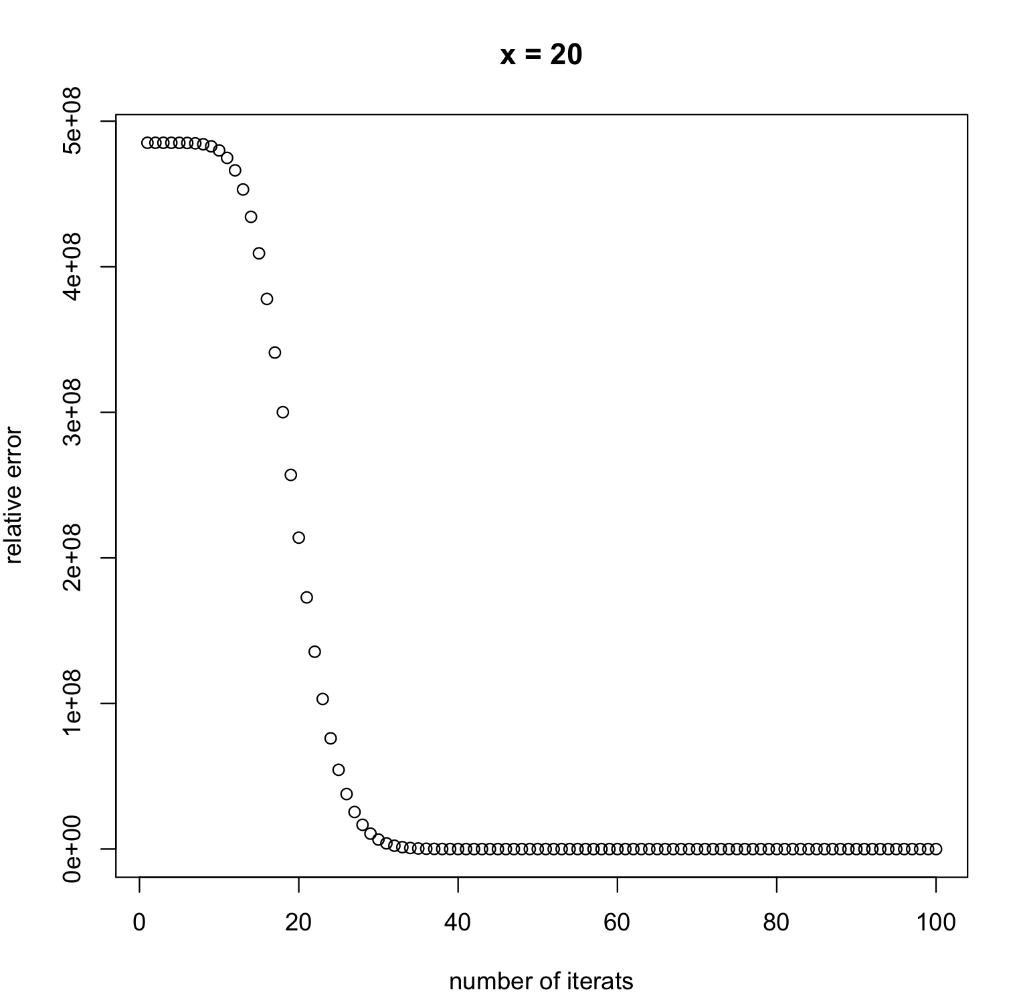

> x <- 20

> ex <- 1

> ifac <- 1

> xi <- 1

> error <- c()

> for (i in 1:100) {

+ xi <- x * xi

+ ifac <- i * ifac

+ ex <- ex + xi / ifac

+ error <- c(error, abs(exp(x) - ex))

+ }

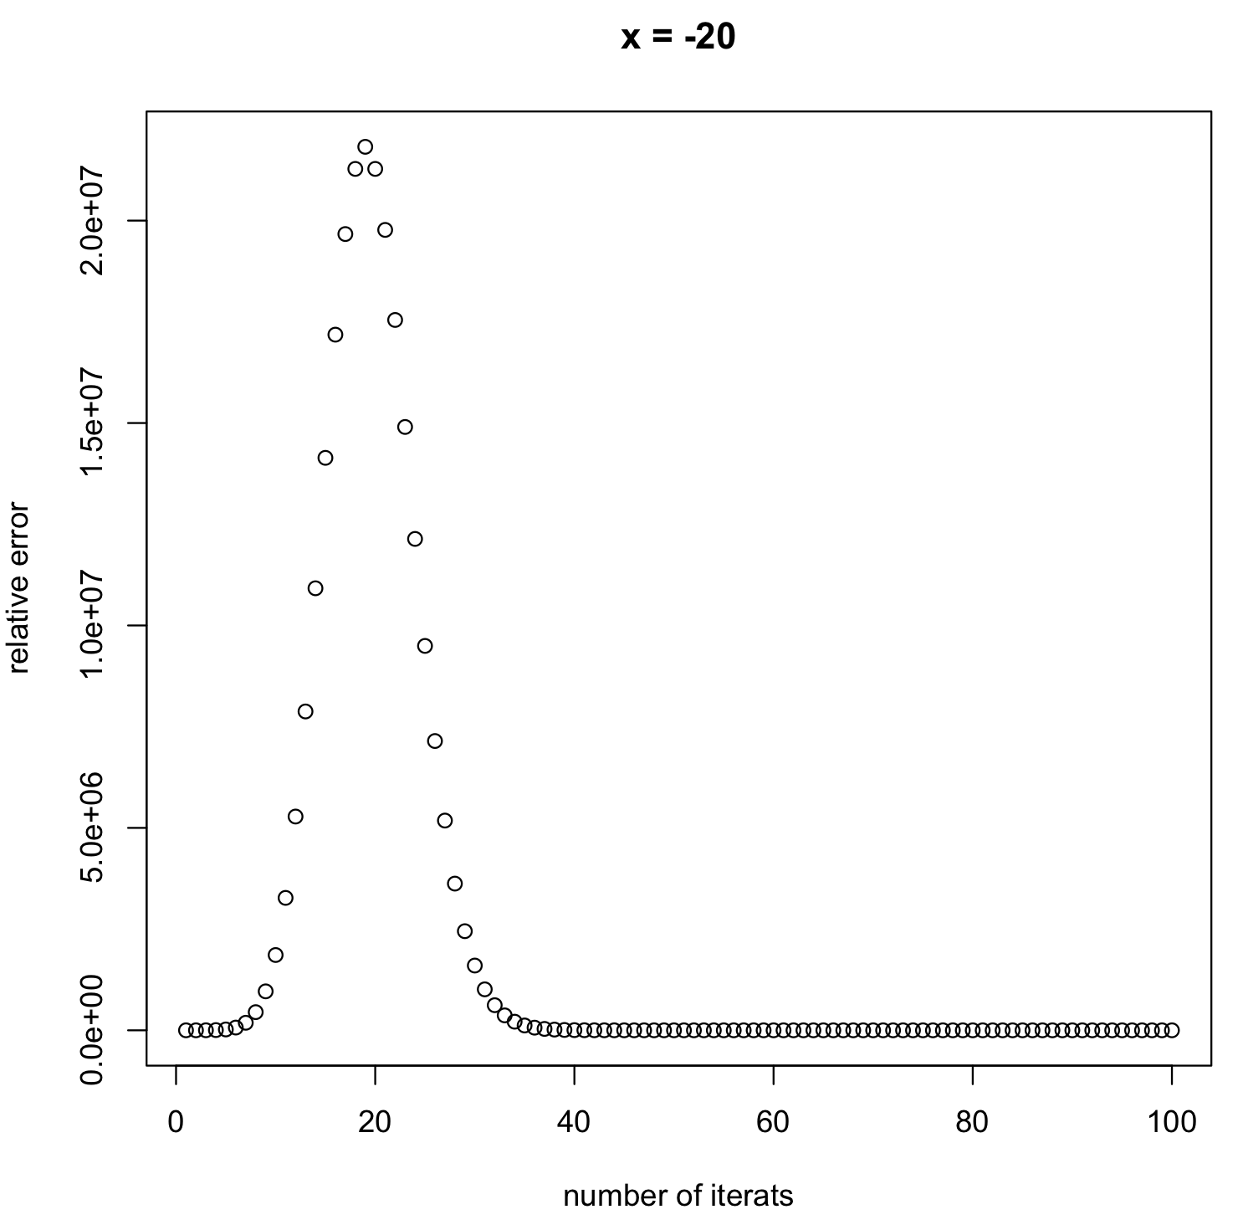> plot(c(1:100), error, main='x = 20', xlab='number of iterats', ylab='relative error')