Result notes

Yuta Suzuki

4/23/2021

## Article information

Pupil response asymmetries of the periphery visual field in the glare illusion

Novera Istiqomah, Yuta Suzuki, Yuya Kinzuka, Minami Tetsuto, Shigeki Nakauchi

*Corresponding author: Yuta Suzuki

## Early and late compornents

To assess temporal component of papillary response, the early component corresponded to peak pupil constriction after stimulus onset and the late comportment which was defined by are under the curve (AUC) were calculated (see Method). In early component (Fig 3B), pupil constriction to the glare illusion was larger than control pattern as the previous analysis ($F$ (1, 16) = 7.709, p = 0.013, $η_{p}^{2}$ = 0.325). The UVF produces larger pupil dilation than the other visual field regardless of the stimulus pattern ($F$ (2.46, 39.367) = 5.233, p = 0.006, $η_{p}^{2}$ = 0.246) in line with the previous studies **(Hong et al., 2001; Sabeti et al., 2011; Tan et al., 2001; Wilhelm et al., 2000)**. There was no significant interaction between visual field and stimulus pattern ($F$ (2.793, 44.683) = 0.306, p = 0.807, $η_{p}^{2}$ = 0.019).

In late component, there was a significant interaction between visual field and stimulus pattern ($F$ (2.99, 47.835) = 2.955, p = 0.042, $η_{p}^{2}$ = 0.156). Crucial, the significant differences of pupil response between glare and control stimuli was seen only in the UVF (F(1,16) = 5.652,p = 0.03, $η_{p}^{2}$ = 0.261).

$$AUC=\sum_{i=0.787}^{4}{x_{i}}−x_{0.787}$$

## Figure 3

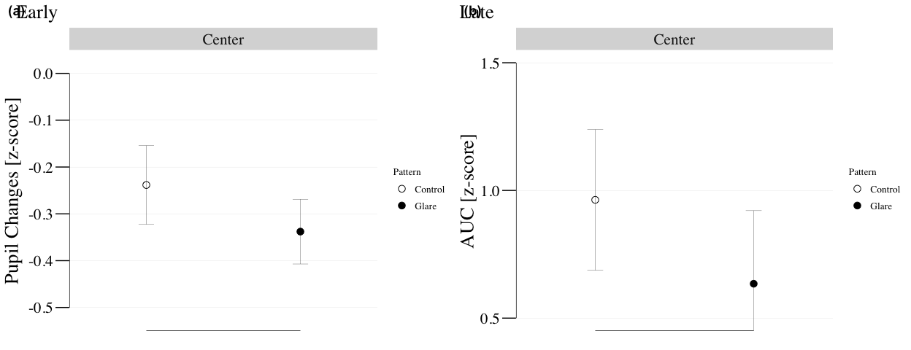

## quartz_off_screen   
## 2

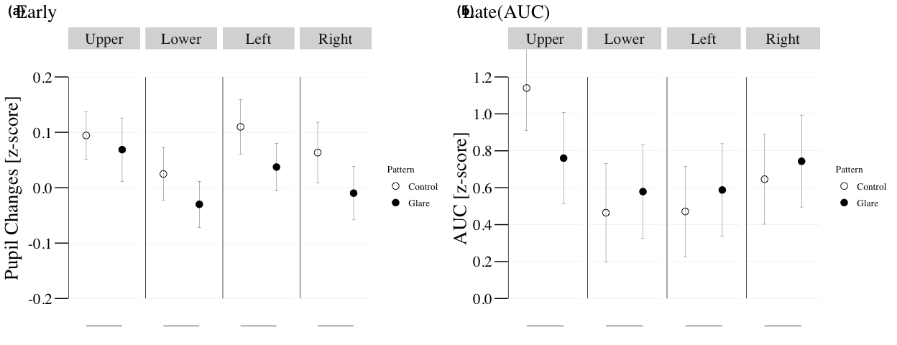

## quartz_off_screen   
## 2