Untitled

Udumaga Onyeukwu

2024-08-06

$$EnviromentBuild$$

*Packages Load*

# load packages  
  
library(readr) # load csv files  
library(readxl) # load excel files  
library(dplyr) # data manipulation  
library(lubridate) # date & time manipulation  
library(ggplot2) # data visualization  
library(tidyr) # collection of statistical packages, packages loaded individually  
library(corrplot) # to visualize correlations  
library(leaps) # for subset selection  
library(caret) # test for correlation  
library(car) # for VIF  
library(scales) # for visualizing plots in %  
library(forcats) # ordering data frames  
library(codebookr) # adding appendix to r code  
library(gtsummary) # creating tables  
library(cardx) # to include statistic results  
library(moments) # to calculate skewness and kurtosis  
library(VIM) # to run K- Nearest Neighbour  
library(pROC) # to analyse and display reciever operating characteristics(ROC) curvees  
library(randomForest) # to impletement Random Forest algorithm  
library(glmnet)  
library(tidymodels)  
library(recipes)  
library(lmtest)  
library(xgboost)  
library(openxlsx)

*Data load*

# load data  
sdoh_data <- read_csv("data/sdoh_data.csv")

## Warning: One or more parsing issues, call `problems()` on your data frame for details,  
## e.g.:  
## dat <- vroom(...)  
## problems(dat)

## Rows: 3229 Columns: 682  
## ── Column specification ────────────────────────────────────────────────────────  
## Delimiter: ","  
## chr (15): COUNTYFIPS, STATEFIPS, STATE, COUNTY, REGION, CAF_ADJ_COUNTY_1, C...  
## dbl (664): YEAR, TERRITORY, ACS_TOT_POP_WT, ACS_TOT_POP_US_ABOVE1, ACS_TOT_P...  
## lgl (3): CAF_ADJ_COUNTY_12, CAF_ADJ_COUNTY_13, CAF_ADJ_COUNTY_14  
##   
## ℹ Use `spec()` to retrieve the full column specification for this data.  
## ℹ Specify the column types or set `show_col_types = FALSE` to quiet this message.

dim(sdoh_data)

## [1] 3229 682

# remove unwanted features, create calculated feature, convert fips_code to data type matching chr_data  
sdoh_data <- sdoh_data %>%   
 select("COUNTYFIPS",   
 "STATE",   
 "COUNTY",   
 "REGION",   
 "ACS_TOT_POP_WT",   
 "ACS_AVG_HH_SIZE",   
 "ACS_PCT_MALE",   
 "ACS_PCT_AIAN",   
 "ACS_PCT_ASIAN",   
 "ACS_PCT_BLACK",   
 "ACS_PCT_HISPANIC",   
 "ACS_PCT_OTHER_RACE",   
 "ACS_PCT_WHITE",   
 "ACS_PCT_CHILD_1FAM",   
 "ACS_PCT_CHILDREN_GRANDPARENT",   
 "ACS_PCT_GRANDP_RESPS_NO_P",   
 "ACS_PCT_GRANDP_RESPS_P",  
 "ACS_PCT_HH_OTHER_COMP",   
 "ACS_PCT_HH_INTERNET",  
 "ACS_PCT_EMPLOYED",  
 "ACS_PCT_HH_INC_99999",  
 "ACS_PCT_MEDICARE_ONLY",  
 "AHRF_CLIN_NURSE_SPEC_RATE",   
 "AHRF_DENTISTS_RATE",  
 "AHRF_PHYSICIAN_ASSIST_RATE",  
 "AMFAR_MHFAC_RATE",  
 "CEN_POPDENSITY_COUNTY",  
 "NEPHTN_HEATIND_90",  
 "SAIPE_MEDIAN_HH_INCOME",  
 "POS_MEDIAN_DIST_ED",  
 "POS_MEDIAN_DIST_PED_ICU",  
 "POS_MEDIAN_DIST_CLINIC",   
 "POS_MEDIAN_DIST_ALC",   
 ) %>%   
 mutate(percent_grandparents_as_guardians = ACS_PCT_CHILDREN_GRANDPARENT * ((ACS_PCT_GRANDP_RESPS_P + ACS_PCT_GRANDP_RESPS_NO_P)/100)) %>%   
 select(-ACS_PCT_GRANDP_RESPS_P, -ACS_PCT_GRANDP_RESPS_NO_P, -ACS_PCT_CHILDREN_GRANDPARENT) %>%   
 rename("fips_code" = "COUNTYFIPS",  
 "state" = "STATE",  
 "county" = "COUNTY",  
 "region" = "REGION",  
 "weighted_population" = "ACS_TOT_POP_WT",  
 "average_hh_size" = "ACS_AVG_HH_SIZE",  
 "pct_male" = "ACS_PCT_MALE",  
 "pct_native_american" = "ACS_PCT_AIAN",  
 "pct_asian" = "ACS_PCT_ASIAN",  
 "pct_black" = "ACS_PCT_BLACK",  
 "pct_hispanic" = "ACS_PCT_HISPANIC",  
 "pct_other_race" = "ACS_PCT_OTHER_RACE",  
 "pct_white" = "ACS_PCT_WHITE",  
 "pct_single_parent" = "ACS_PCT_CHILD_1FAM",  
 "pct_hh_other_computer" = "ACS_PCT_HH_OTHER_COMP",  
 "pct_hh_internet" = "ACS_PCT_HH_INTERNET",  
 "pct_employed" = "ACS_PCT_EMPLOYED",  
 "pct_hh_inc_99999" = "ACS_PCT_HH_INC_99999", # renamed by mg  
 "pct_w_medicare" = "ACS_PCT_MEDICARE_ONLY",  
 "clinical_nurse_pt" = "AHRF_CLIN_NURSE_SPEC_RATE",  
 "dentist_pt" = "AHRF_DENTISTS_RATE",  
 "pa_pt" = "AHRF_PHYSICIAN_ASSIST_RATE",  
 "mental_health_faciliy_pt" = "AMFAR_MHFAC_RATE",  
 "population_density" = "CEN_POPDENSITY_COUNTY",  
 "days_over_90_f" = "NEPHTN_HEATIND_90",  
 "median_hh_income" = "SAIPE_MEDIAN_HH_INCOME",  
 "median_er_dist" = "POS_MEDIAN_DIST_ED",  
 "median_pediatric_icu_dist" = "POS_MEDIAN_DIST_PED_ICU",  
 "median_health_clinic_dist" = "POS_MEDIAN_DIST_CLINIC",  
 "median_drug_alcohol_care_dist" = "POS_MEDIAN_DIST_ALC"  
   
 ) %>%   
 mutate(fips_code = as.numeric(fips_code))  
  
chr_data <- read_csv("data/chr_data.csv", skip = 1)

## Rows: 3194 Columns: 720  
## ── Column specification ────────────────────────────────────────────────────────  
## Delimiter: ","  
## chr (2): state, county  
## dbl (572): statecode, countycode, fipscode, year, county_ranked, v001_rawval...  
## lgl (146): v002_numerator, v002_denominator, v036_numerator, v036_denominato...  
##   
## ℹ Use `spec()` to retrieve the full column specification for this data.  
## ℹ Specify the column types or set `show_col_types = FALSE` to quiet this message.

dim(chr_data)

## [1] 3194 720

# remove unwanted features  
# convert principal care providers from per 100,000 people to per 1,000 people to match other data  
  
chr_data <- chr_data %>%  
 select("fipscode",  
 "v002_rawvalue",  
 "v009_rawvalue",  
 "v011_rawvalue",  
 "v070_rawvalue",   
 "v049_rawvalue",  
 "v085_rawvalue",  
 "v168_rawvalue",   
 "v069_rawvalue",  
 "v044_rawvalue",   
 "v140_rawvalue",  
 "v125_rawvalue",  
 "v124_rawvalue",  
 "v136_other_data_1",  
 "v136_other_data_2",  
 "v137_rawvalue",  
 "v147_rawvalue",  
 "v139_rawvalue",  
 "v177_rawvalue",  
 "v153_rawvalue",  
 "v053_rawvalue",   
 "v058_rawvalue",   
 "v004_rawvalue",  
 ) %>%   
 mutate(pcp_pt = v004_rawvalue/100) %>%   
 select(-v004_rawvalue) %>%   
 rename("fips_code" = "fipscode",  
 "pct_poor_to_fair_health" = "v002_rawvalue",  
 "pct_adult_smokers" = "v009_rawvalue",  
 "pct_obese_adults" = "v011_rawvalue",  
 "pct_no_exercise" = "v070_rawvalue",  
 "pct_binge_drinkers" = "v049_rawvalue",  
 "pct_under_65_no_health_insurance" = "v085_rawvalue",  
 "pct_highschool_diploma" = "v168_rawvalue",  
 "pct_some_college" = "v069_rawvalue",  
 "inequality_ratio" = "v044_rawvalue",  
 "social_clubs_per_10k" = "v140_rawvalue",  
 "air_polution_metric" = "v125_rawvalue",  
 "water_quality" = "v124_rawvalue", # renamed by mg  
 "pct_high_housing_costs" = "v136_other_data_1",  
 "pct_overcrowded_hh" = "v136_other_data_2",  
 "pct_food_insecurities" = "v139_rawvalue",  
 "pct_voters" = "v177_rawvalue",  
 "pct_home_owner" = "v153_rawvalue",  
 "pct_65_plus" = "v053_rawvalue",  
 "pct_rural_population" = "v058_rawvalue",  
 "life_expectancy_years" = "v147_rawvalue",  
 "pct_30_min_plus_commute" = "v137_rawvalue")  
  
# full data sets are extremely large, initial dimension reduction was performed previously

*Combine datasets*

# Create and clean the qol_data dataset  
qol_data <- sdoh_data %>%  
 inner_join(chr_data, by = "fips_code") %>%  
 #mutate(response = ifelse(pct_poor_to_fair_health >= 0.154, "worse", "better")) %>%  
 #mutate(response = as.factor(response)) %>%  
 #select(-pct_poor_to_fair_health) %>% # keep until analysis has been performed  
 mutate_at(vars(state, county, region), as.factor) # convert characters to factors

$$Pre−processingandFeatureEnginering$$

eliminate variables with no predictive value: fipscode, county and state, pct_poor_to_fair_health:

qol_data <- qol_data %>% select(-c(fips_code,county,state))

calcSplitRatio <- function(p = NA, df) {  
 ## @p = the number of parameters. by default, if none are provided, the number of columns (predictors) in the dataset are used  
 ## @df = the dataframe that will be used for the analysis  
   
 ## If the number of parameters isn't supplied, set it to the number of features minus 1 for the target  
 if(is.na(p)) {  
 p <- ncol(df) -1 ## COMMENT HERE  
 }  
   
 ## Calculate the ideal number of testing set  
 test_N <- (1/sqrt(p))*nrow(df)  
 ## Turn that into a testing proportion  
 test_prop <- round((1/sqrt(p))*nrow(df)/nrow(df), 2)  
 ## And find the training proportion  
 train_prop <- 1-test_prop  
   
 ## Tell us the results!  
 print(paste0("The ideal split ratio is ", train_prop, ":", test_prop, " training:testing"))  
   
 ## Return the size of the training set  
 return(train_prop)  
}  
  
calcSplitRatio(df = qol_data)

## [1] "The ideal split ratio is 0.86:0.14 training:testing"

## [1] 0.86

Split data intraining and testing sets, delete non useful features, input missing values

# Find columns with missing data  
#sum(colSums(is.na(qol_data)))  
  
# delete column with large number of missing values 'pcp_pt'  
  
qol_data <- qol_data[, !names(qol_data) %in% "pcp_pt"]  
  
set.seed(112)  
# Splitting the data into train and test sets  
  
  
data_split <- initial_split(qol_data, strata = "pct_poor_to_fair_health", prop = 0.86)  
  
qol_train <- training(data_split)  
qol_test <- testing(data_split)  
  
  
# Selecting only numeric columns for imputation  
numeric_cols <- sapply(qol_train, is.numeric)  
qol_train_numeric <- qol_train[, numeric_cols]  
qol_test_numeric <- qol_test[, numeric_cols]  
  
# Imputing missing values using mice  
library(mice)  
  
# Imputing missing values in the training set  
qol_train_imputed <- mice(qol_train_numeric, m = 1, method = "cart", # Using CART for imputation  
 maxit = 5) # Maximum iterations for imputation

##   
## iter imp variable  
## 1 1 weighted_population average_hh_size pct_male pct_native_american pct_asian pct_black pct_hispanic pct_other_race pct_white pct_single_parent pct_hh_other_computer pct_hh_internet pct_employed pct_hh_inc_99999 pct_w_medicare population_density days_over_90_f median_hh_income median_er_dist median_pediatric_icu_dist median_health_clinic_dist median_drug_alcohol_care_dist percent_grandparents_as_guardians pct_poor_to_fair_health pct_adult_smokers pct_obese_adults pct_no_exercise pct_binge_drinkers pct_under_65_no_health_insurance inequality_ratio air_polution_metric water_quality life_expectancy_years pct_voters pct_rural_population  
## 2 1 weighted_population average_hh_size pct_male pct_native_american pct_asian pct_black pct_hispanic pct_other_race pct_white pct_single_parent pct_hh_other_computer pct_hh_internet pct_employed pct_hh_inc_99999 pct_w_medicare population_density days_over_90_f median_hh_income median_er_dist median_pediatric_icu_dist median_health_clinic_dist median_drug_alcohol_care_dist percent_grandparents_as_guardians pct_poor_to_fair_health pct_adult_smokers pct_obese_adults pct_no_exercise pct_binge_drinkers pct_under_65_no_health_insurance inequality_ratio air_polution_metric water_quality life_expectancy_years pct_voters pct_rural_population  
## 3 1 weighted_population average_hh_size pct_male pct_native_american pct_asian pct_black pct_hispanic pct_other_race pct_white pct_single_parent pct_hh_other_computer pct_hh_internet pct_employed pct_hh_inc_99999 pct_w_medicare population_density days_over_90_f median_hh_income median_er_dist median_pediatric_icu_dist median_health_clinic_dist median_drug_alcohol_care_dist percent_grandparents_as_guardians pct_poor_to_fair_health pct_adult_smokers pct_obese_adults pct_no_exercise pct_binge_drinkers pct_under_65_no_health_insurance inequality_ratio air_polution_metric water_quality life_expectancy_years pct_voters pct_rural_population  
## 4 1 weighted_population average_hh_size pct_male pct_native_american pct_asian pct_black pct_hispanic pct_other_race pct_white pct_single_parent pct_hh_other_computer pct_hh_internet pct_employed pct_hh_inc_99999 pct_w_medicare population_density days_over_90_f median_hh_income median_er_dist median_pediatric_icu_dist median_health_clinic_dist median_drug_alcohol_care_dist percent_grandparents_as_guardians pct_poor_to_fair_health pct_adult_smokers pct_obese_adults pct_no_exercise pct_binge_drinkers pct_under_65_no_health_insurance inequality_ratio air_polution_metric water_quality life_expectancy_years pct_voters pct_rural_population  
## 5 1 weighted_population average_hh_size pct_male pct_native_american pct_asian pct_black pct_hispanic pct_other_race pct_white pct_single_parent pct_hh_other_computer pct_hh_internet pct_employed pct_hh_inc_99999 pct_w_medicare population_density days_over_90_f median_hh_income median_er_dist median_pediatric_icu_dist median_health_clinic_dist median_drug_alcohol_care_dist percent_grandparents_as_guardians pct_poor_to_fair_health pct_adult_smokers pct_obese_adults pct_no_exercise pct_binge_drinkers pct_under_65_no_health_insurance inequality_ratio air_polution_metric water_quality life_expectancy_years pct_voters pct_rural_population

# Imputing missing values in the test set using the trained model  
qol_test_imputed <- mice(qol_test_numeric, m = 1, method = "cart",  
 maxit = 5,  
 use.all = FALSE) # Using only the training data for imputation

##   
## iter imp variable  
## 1 1 days_over_90_f percent_grandparents_as_guardians inequality_ratio air_polution_metric water_quality life_expectancy_years pct_voters  
## 2 1 days_over_90_f percent_grandparents_as_guardians inequality_ratio air_polution_metric water_quality life_expectancy_years pct_voters  
## 3 1 days_over_90_f percent_grandparents_as_guardians inequality_ratio air_polution_metric water_quality life_expectancy_years pct_voters  
## 4 1 days_over_90_f percent_grandparents_as_guardians inequality_ratio air_polution_metric water_quality life_expectancy_years pct_voters  
## 5 1 days_over_90_f percent_grandparents_as_guardians inequality_ratio air_polution_metric water_quality life_expectancy_years pct_voters

# Combining the imputed numeric columns back with the original data  
qol_train <- cbind(qol_train[, !numeric_cols], complete(qol_train_imputed))  
qol_test <- cbind(qol_test[, !numeric_cols], complete(qol_test_imputed))

one hot encode character Variables,center and scale all predictors except one hot encoded variables.

set.seed(12)  
# Create a recipe  
response_recipe <- recipe(pct_poor_to_fair_health ~ ., data = qol_train) %>%  
   
 step_dummy(region, one_hot = TRUE) %>% # One-hot encode the 'region' feature to include all 4 regions  
 step_center(all_predictors(), -starts_with("region_")) %>% # Center all predictors except the one-hot encoded 'region' columns  
 step_scale(all_predictors(), -starts_with("region_")) %>% # Scale all predictors except the one-hot encoded 'region' columns  
 prep(training = qol_train, retain = TRUE)  
  
# Apply the recipe to the training and testing datasets  
qol_train <- bake(response_recipe, new_data = qol_train)  
qol_test <- bake(response_recipe, new_data = qol_test)

Build and compare OLs, RF and lasso models

# Fit the OLS model  
ols_model <- lm(pct_poor_to_fair_health ~ ., data = qol_train)  
  
# Print OLS coefficients  
print(summary(ols_model)$coefficients)

## Estimate Std. Error t value  
## (Intercept) 0.1667531239 0.0007402773 225.2576492  
## weighted_population -0.0001832448 0.0002244152 -0.8165437  
## average_hh_size 0.0012214552 0.0003438822 3.5519581  
## pct_male 0.0008986935 0.0002289776 3.9248099  
## pct_native_american 0.0004253901 0.0007519222 0.5657368  
## pct_asian 0.0005004165 0.0004255643 1.1758893  
## pct_black 0.0036175517 0.0011814665 3.0619166  
## pct_hispanic 0.0063347871 0.0004276278 14.8137867  
## pct_other_race -0.0001299606 0.0003844120 -0.3380763  
## pct_white 0.0009844123 0.0013762409 0.7152907  
## pct_single_parent 0.0005423958 0.0002991155 1.8133327  
## pct_hh_other_computer -0.0002905630 0.0001873700 -1.5507444  
## pct_hh_internet -0.0008739334 0.0003257878 -2.6825236  
## pct_employed -0.0006194164 0.0002626579 -2.3582630  
## pct_hh_inc_99999 -0.0014631466 0.0002577000 -5.6777122  
## pct_w_medicare -0.0002824302 0.0002682869 -1.0527170  
## clinical_nurse_pt -0.0000357989 0.0001902213 -0.1881961  
## dentist_pt 0.0001455579 0.0002461408 0.5913601  
## pa_pt -0.0002644818 0.0002080331 -1.2713444  
## mental_health_faciliy_pt 0.0002876091 0.0001962302 1.4656717  
## population_density -0.0005634245 0.0002130007 -2.6451769  
## days_over_90_f -0.0010073222 0.0003387878 -2.9733130  
## median_hh_income -0.0005651299 0.0004226812 -1.3370122  
## median_er_dist -0.0008034986 0.0002696165 -2.9801533  
## median_pediatric_icu_dist 0.0000323153 0.0002417681 0.1336624  
## median_health_clinic_dist -0.0010167693 0.0002165432 -4.6954574  
## median_drug_alcohol_care_dist 0.0010989580 0.0002692086 4.0821797  
## percent_grandparents_as_guardians 0.0002012997 0.0002549438 0.7895848  
## pct_adult_smokers 0.0090831870 0.0006014870 15.1012199  
## pct_obese_adults 0.0043190441 0.0004044524 10.6787446  
## pct_no_exercise 0.0175265377 0.0005828287 30.0715090  
## pct_binge_drinkers -0.0015395616 0.0002782273 -5.5334676  
## pct_under_65_no_health_insurance -0.0012962860 0.0003050287 -4.2497178  
## pct_highschool_diploma -0.0038438246 0.0003963252 -9.6986638  
## pct_some_college 0.0006251624 0.0003690030 1.6941934  
## inequality_ratio 0.0005590815 0.0002688658 2.0794072  
## social_clubs_per_10k -0.0004348399 0.0002231403 -1.9487283  
## air_polution_metric 0.0014700099 0.0002650512 5.5461352  
## water_quality 0.0003260659 0.0001906233 1.7105245  
## pct_high_housing_costs 0.0006638655 0.0002805090 2.3666457  
## pct_overcrowded_hh 0.0013419150 0.0003074762 4.3642892  
## pct_30_min_plus_commute -0.0003714686 0.0002852210 -1.3023887  
## life_expectancy_years 0.0003029483 0.0003266542 0.9274279  
## pct_food_insecurities 0.0076641066 0.0003829749 20.0120347  
## pct_voters 0.0015272981 0.0003322259 4.5971669  
## pct_home_owner 0.0006649507 0.0003183508 2.0887356  
## pct_65_plus 0.0004789357 0.0003718530 1.2879703  
## pct_rural_population 0.0001099482 0.0003438049 0.3197981  
## region_Midwest -0.0140374670 0.0009233961 -15.2019987  
## region_Northeast -0.0132849220 0.0010057865 -13.2084907  
## region_South -0.0020169893 0.0009273715 -2.1749528  
## Pr(>|t|)  
## (Intercept) 0.000000e+00  
## weighted_population 4.142627e-01  
## average_hh_size 3.890459e-04  
## pct_male 8.900852e-05  
## pct_native_american 5.716206e-01  
## pct_asian 2.397448e-01  
## pct_black 2.221335e-03  
## pct_hispanic 9.228516e-48  
## pct_other_race 7.353325e-01  
## pct_white 4.744925e-01  
## pct_single_parent 6.989365e-02  
## pct_hh_other_computer 1.210824e-01  
## pct_hh_internet 7.352290e-03  
## pct_employed 1.843296e-02  
## pct_hh_inc_99999 1.513570e-08  
## pct_w_medicare 2.925667e-01  
## clinical_nurse_pt 8.507373e-01  
## dentist_pt 5.543296e-01  
## pa_pt 2.037178e-01  
## mental_health_faciliy_pt 1.428564e-01  
## population_density 8.213056e-03  
## days_over_90_f 2.972607e-03  
## median_hh_income 1.813334e-01  
## median_er_dist 2.907243e-03  
## median_pediatric_icu_dist 8.936797e-01  
## median_health_clinic_dist 2.795647e-06  
## median_drug_alcohol_care_dist 4.593590e-05  
## percent_grandparents_as_guardians 4.298410e-01  
## pct_adult_smokers 1.720990e-49  
## pct_obese_adults 4.309915e-26  
## pct_no_exercise 3.530838e-171  
## pct_binge_drinkers 3.447243e-08  
## pct_under_65_no_health_insurance 2.214370e-05  
## pct_highschool_diploma 7.027500e-22  
## pct_some_college 9.034609e-02  
## inequality_ratio 3.767591e-02  
## social_clubs_per_10k 5.143332e-02  
## air_polution_metric 3.209358e-08  
## water_quality 8.728601e-02  
## pct_high_housing_costs 1.802165e-02  
## pct_overcrowded_hh 1.324223e-05  
## pct_30_min_plus_commute 1.928968e-01  
## life_expectancy_years 3.537889e-01  
## pct_food_insecurities 4.413767e-83  
## pct_voters 4.483610e-06  
## pct_home_owner 3.682677e-02  
## pct_65_plus 1.978688e-01  
## pct_rural_population 7.491466e-01  
## region_Midwest 4.196444e-50  
## region_Northeast 1.268686e-38  
## region_South 2.972184e-02

# Predict on the test set  
predictions_ols <- predict(ols_model, new_data = qol_test)  
  
# Evaluate the OLS model  
mse_ols <- mean((qol_test$pct_poor_to_fair_health - predictions_ols)^2)

## Warning in qol_test$pct_poor_to_fair_health - predictions_ols: longer object  
## length is not a multiple of shorter object length

rmse_ols <- sqrt(mse_ols)  
r2_ols <- summary(ols_model)$r.squared  
print(paste("MSE (OLS):", mse_ols))

## [1] "MSE (OLS): 0.0039069415003134"

print(paste("RMSE (OLS):", rmse_ols))

## [1] "RMSE (OLS): 0.0625055317577044"

print(paste("R-squared (OLS):", r2_ols))

## [1] "R-squared (OLS): 0.957627822349486"

# --- Feature Importance Visualization (OLS) ---  
  
# Calculate feature importance for OLS  
feature_importance_ols <- abs(summary(ols_model)$coefficients[, "Estimate"])  
importance_df_ols <- data.frame(Feature = names(feature_importance_ols), Importance = feature_importance_ols)  
importance_df_ols <- importance_df_ols[order(-importance_df_ols$Importance), ]  
  
# Select top 20 features  
top_20_features_ols <- head(importance_df_ols, 20)  
  
# Plot top 20 feature importance for OLS  
ggplot(top_20_features_ols, aes(x = reorder(Feature, Importance), y = Importance)) +  
 geom_bar(stat = "identity", fill = "steelblue") +  
 coord_flip() +  
 labs(title = "Top 20 Feature Importance (OLS)", x = "Feature", y = "Importance") +  
 theme_minimal()

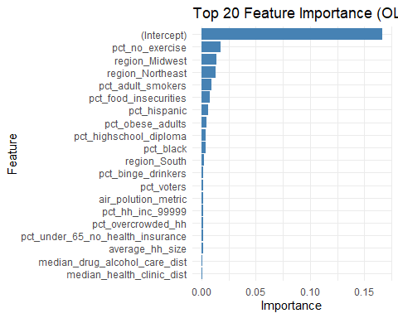

# --- Assumptions Diagnostics for OLS Model ---  
  
# Residuals plot  
ggplot(data.frame(residuals = residuals(ols_model), fitted = fitted(ols_model)), aes(x = fitted, y = residuals)) +  
 geom_point() +  
 geom_smooth(method = "lm", se = FALSE, color = "red") +  
 labs(title = "Residuals vs Fitted", x = "Fitted values", y = "Residuals") +  
 theme_minimal()

## `geom_smooth()` using formula = 'y ~ x'

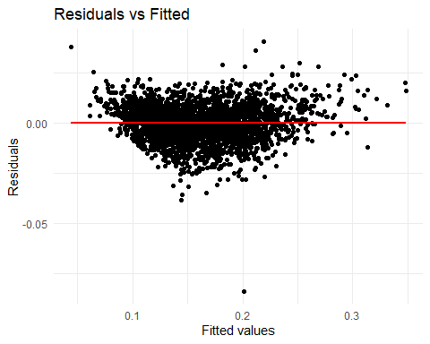

# Q-Q plot  
ggplot(data.frame(sample = residuals(ols_model)), aes(sample = sample)) +  
 stat_qq() +  
 stat_qq_line() +  
 labs(title = "Q-Q Plot", x = "Theoretical Quantiles", y = "Sample Quantiles") +  
 theme_minimal()

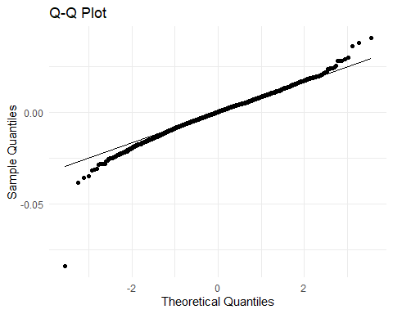

# Durbin-Watson test  
#dwtest(ols_model)  
  
# Perform the Breusch-Godfrey test for autocorrelation  
bg_test <- bgtest(ols_model, order = 1) # You can change the order as needed  
  
# Print the test results  
print(bg_test)

##   
## Breusch-Godfrey test for serial correlation of order up to 1  
##   
## data: ols_model  
## LM test = 738.41, df = 1, p-value < 2.2e-16

Random forest model

# Load necessary library  
library(randomForest)  
  
# Train a random forest model  
rf_model <- randomForest(pct_poor_to_fair_health ~ ., data = qol_train, ntree = 1000, na.action = na.omit)  
  
# Predict on the test set  
predictions_rf <- predict(rf_model, qol_test)  
  
# Evaluate the Random Forest model  
mse_rf <- mean((qol_test$pct_poor_to_fair_health - predictions_rf)^2)  
rmse_rf <- sqrt(mse_rf)  
r2_rf <- 1 - (sum((qol_test$pct_poor_to_fair_health - predictions_rf)^2) / sum((qol_test$pct_poor_to_fair_health - mean(qol_test$pct_poor_to_fair_health))^2))  
print(paste("MSE (RF):", mse_rf))

## [1] "MSE (RF): 6.5813230305314e-05"

print(paste("RMSE (RF):", rmse_rf))

## [1] "RMSE (RF): 0.00811253538083588"

print(paste("R-squared (RF):", r2_rf))

## [1] "R-squared (RF): 0.966253647924883"

# --- Feature Importance Visualization (RF) ---  
  
# Calculate feature importance for RF  
feature_importance_rf <- importance(rf_model)  
importance_df_rf <- data.frame(Feature = rownames(feature_importance_rf), Importance = abs(feature_importance_rf[, 1]))  
importance_df_rf <- importance_df_rf[order(-importance_df_rf$Importance), ]  
  
# Select top 20 features  
top_20_features_rf <- head(importance_df_rf, 20)  
  
# Plot top 20 feature importance for RF  
ggplot(top_20_features_rf, aes(x = reorder(Feature, Importance), y = Importance)) +  
 geom_bar(stat = "identity", fill = "steelblue") +  
 coord_flip() +  
 labs(title = "Top 20 Feature Importance (RF)", x = "Feature", y = "Importance") +  
 theme_minimal()

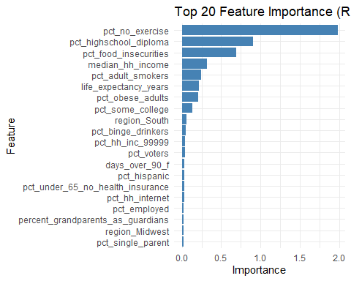

# Create design matrices (excluding response variable)  
x_train <- model.matrix(pct_poor_to_fair_health ~ ., data = qol_train)[, -1]  
x_test <- model.matrix(pct_poor_to_fair_health ~ ., data = qol_test)[, -1]  
  
# Fit the Lasso model  
lasso_model <- glmnet(x_train, qol_train$pct_poor_to_fair_health, alpha = 1)  
  
# Find optimal lambda using cross-validation  
cv_lasso <- cv.glmnet(x_train, qol_train$pct_poor_to_fair_health, alpha = 1)  
  
# Predict on the test set using the optimal lambda  
predictions_lasso <- predict(lasso_model, newx = x_test, s = cv_lasso$lambda.min)  
  
# Evaluate the Lasso model  
mse_lasso <- mean((qol_test$pct_poor_to_fair_health - predictions_lasso)^2)  
rmse_lasso <- sqrt(mse_lasso)  
r2_lasso <- 1 - (sum((qol_test$pct_poor_to_fair_health - predictions_lasso)^2) / sum((qol_test$pct_poor_to_fair_health - mean(qol_test$pct_poor_to_fair_health))^2))  
print(paste("MSE (Lasso):", mse_lasso))

## [1] "MSE (Lasso): 7.98139624859371e-05"

print(paste("RMSE (Lasso):", rmse_lasso))

## [1] "RMSE (Lasso): 0.00893386604365306"

print(paste("R-squared (Lasso):", r2_lasso))

## [1] "R-squared (Lasso): 0.959074640979245"

# --- Feature Importance Visualization (Lasso) ---  
  
# Extract coefficients as a dense vector  
coef_lasso <- coef(lasso_model, s = cv_lasso$lambda.min)  
  
# Extract non-zero coefficients  
non_zero_coefs <- coef_lasso[which(coef_lasso != 0)]  
  
# Get the names of the non-zero coefficients  
feature_names <- rownames(coef_lasso)[which(coef_lasso != 0)]  
  
# Create the data frame  
importance_df_lasso <- data.frame(Feature = feature_names, Importance = abs(non_zero_coefs))  
  
# Select top 20 features  
top_20_features_lasso <- head(importance_df_lasso[order(-importance_df_lasso$Importance), ], 20)  
  
# Plot top 20 feature importance  
ggplot(top_20_features_lasso, aes(x = reorder(Feature, Importance), y = Importance)) +  
 geom_bar(stat = "identity", fill = "steelblue") +  
 coord_flip() +  
 labs(title = "Top 20 Feature Importance (Lasso)", x = "Feature", y = "Importance") +  
 theme_minimal()

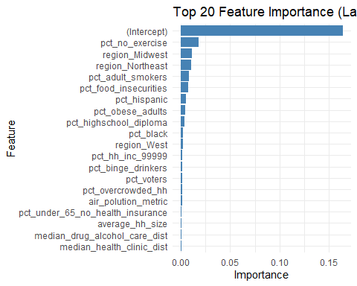

# Prepare data for xgboost  
dtrain <- xgb.DMatrix(data = as.matrix(qol_train[, -which(names(qol_train) == "pct_poor_to_fair_health")]), label = qol_train$pct_poor_to_fair_health)  
dtest <- xgb.DMatrix(data = as.matrix(qol_test[, -which(names(qol_test) == "pct_poor_to_fair_health")]), label = qol_test$pct_poor_to_fair_health)  
  
# Set parameters for xgboost  
params <- list(  
 objective = "reg:squarederror",  
 eta = 0.1,  
 max_depth = 6,  
 subsample = 0.8,  
 colsample_bytree = 0.8  
)  
  
# Train the GBM model  
gbm_model <- xgb.train(params, dtrain, nrounds = 100)  
  
# Predict on the test set  
predictions_gbm <- predict(gbm_model, dtest)  
  
# Evaluate the GBM model  
mse_gbm <- mean((qol_test$pct_poor_to_fair_health - predictions_gbm)^2)  
rmse_gbm <- sqrt(mse_gbm)  
r2_gbm <- 1 - (sum((qol_test$pct_poor_to_fair_health - predictions_gbm)^2) / sum((qol_test$pct_poor_to_fair_health - mean(qol_test$pct_poor_to_fair_health))^2))  
print(paste("MSE (GBM):", mse_gbm))

## [1] "MSE (GBM): 5.05616020737363e-05"

print(paste("RMSE (GBM):", rmse_gbm))

## [1] "RMSE (GBM): 0.00711066818757115"

print(paste("R-squared (GBM):", r2_gbm))

## [1] "R-squared (GBM): 0.974074063571311"

Compare the 4 models based on the evaluation metrics (MSE, RMSE, and R-squared),

Lower MSE and RMSE indicate better model performance. Higher R-squared indicates better model performance. After running the code, you can visually compare the performance of the three models. The model with the lowest MSE and RMSE and the highest R-squared would be the recommended choice.

# Create a data frame to store the results  
results <- data.frame(  
 Model = c("OLS", "Random Forest", "Lasso", "GBM"),  
 MSE = c(mse_ols, mse_rf, mse_lasso,mse_gbm),  
 RMSE = c(rmse_ols, rmse_rf, rmse_lasso,rmse_gbm),  
 R_squared = c(r2_ols, r2_rf, r2_lasso,r2_gbm)  
)  
  
# Print the results  
print(results)

## Model MSE RMSE R_squared  
## 1 OLS 3.906942e-03 0.062505532 0.9576278  
## 2 Random Forest 6.581323e-05 0.008112535 0.9662536  
## 3 Lasso 7.981396e-05 0.008933866 0.9590746  
## 4 GBM 5.056160e-05 0.007110668 0.9740741

# Plot the results  
library(ggplot2)  
  
# MSE Comparison  
ggplot(results, aes(x = Model, y = MSE, fill = Model)) +  
 geom_bar(stat = "identity") +  
 labs(title = "MSE Comparison", x = "Model", y = "Mean Squared Error") +  
 theme_minimal()

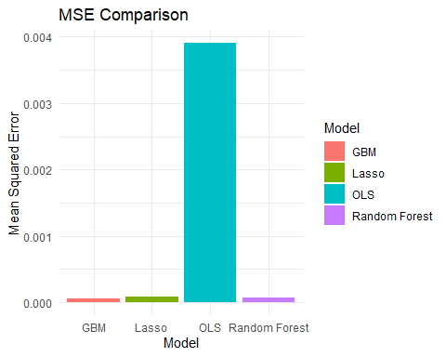

# RMSE Comparison  
ggplot(results, aes(x = Model, y = RMSE, fill = Model)) +  
 geom_bar(stat = "identity") +  
 labs(title = "RMSE Comparison", x = "Model", y = "Root Mean Squared Error") +  
 theme_minimal()

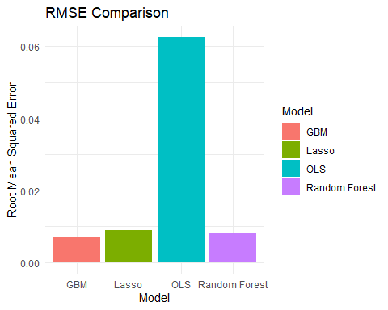

# R-squared Comparison  
ggplot(results, aes(x = Model, y = R_squared, fill = Model)) +  
 geom_bar(stat = "identity") +  
 labs(title = "R-squared Comparison", x = "Model", y = "R-squared") +  
 theme_minimal()

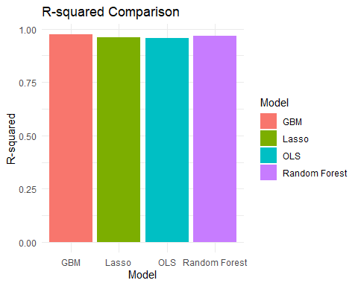

# Create a data frame with the results  
results <- data.frame(  
 Model = c("OLS", "Random Forest", "Lasso", "GBM"),  
 MSE = c(3.906942e-03, 6.581323e-05, 7.981396e-05, 5.056160e-05),  
 RMSE = c(0.062505532, 0.008112535, 0.008933866, 0.007110668),  
 R_squared = c(0.9576278, 0.9662536, 0.9590746, 0.9740741)  
)  
  
# Write the data frame to an Excel file  
#write.xlsx(results, "model_comparison.xlsx")

Analysis 1. Mean Squared Error (MSE): a. GBM has the lowest MSE (5.056160e-05), indicating the best performance in terms of prediction accuracy. b. Forest follows with an MSE of 6.581323e-05. c, Lasso has an MSE of 7.981396e-05. d, OLS has the highest MSE (3.906942e-03), indicating the least accurate predictions among the models.

1. Root Mean Squared Error (RMSE): a, GBM again has the lowest RMSE (0.007110668), reinforcing its superior performance. b, Random Forest has an RMSE of 0.008112535.
2. Lasso has an RMSE of 0.008933866. d, OLS has the highest RMSE (0.062505532).
3. R-squared:
4. GBM has the highest R-squared (0.9740741), indicating the best fit to the data.
5. Random Forest follows with an R-squared of 0.9662536.
6. Lasso has an R-squared of 0.9590746.
7. OLS has the lowest R-squared (0.9576278).

Recommendation Based on the evaluation metrics, the GBM (Gradient Boosting Machine) model performs the best, with the lowest MSE and RMSE and the highest R-squared. Therefore, I recommend using the GBM model for our analysis.

# Combine training and testing data for cross-validation  
data <- rbind(qol_train, qol_test)  
  
# Define cross-validation method  
train_control <- trainControl(method = "cv", number = 10) # 10-fold cross-validation  
  
# OLS Model  
ols_model <- train(pct_poor_to_fair_health ~ ., data = data, method = "lm", trControl = train_control)  
# Predicted values and residuals for OLS model  
ols_predicted <- predict(ols_model, data)  
ols_residuals <- data$pct_poor_to_fair_health - ols_predicted  
  
# Random Forest Model  
rf_model <- train(pct_poor_to_fair_health ~ ., data = data, method = "rf", trControl = train_control, ntree = 1000)  
# Predicted values and residuals for Random Forest model  
rf_predicted <- predict(rf_model, data)  
rf_residuals <- data$pct_poor_to_fair_health - rf_predicted  
  
# Lasso Model  
lasso_model <- train(pct_poor_to_fair_health ~ ., data = data, method = "glmnet", trControl = train_control, tuneGrid = expand.grid(alpha = 1, lambda = seq(0.001, 0.1, by = 0.001)))

## Warning in nominalTrainWorkflow(x = x, y = y, wts = weights, info = trainInfo,  
## : There were missing values in resampled performance measures.

# Predicted values and residuals for Lasso model  
lasso_predicted <- predict(lasso_model, data)  
lasso_residuals <- data$pct_poor_to_fair_health - lasso_predicted  
  
# GBM Model  
gbm_model <- train(pct_poor_to_fair_health ~ ., data = data, method = "xgbTree", trControl = train_control, tuneGrid = expand.grid(nrounds = 100, max_depth = 6, eta = 0.1, gamma = 0, colsample_bytree = 0.8, min_child_weight = 1, subsample = 0.8))  
# Predicted values and residuals for GBM model  
gbm_predicted <- predict(gbm_model, data)  
gbm_residuals <- data$pct_poor_to_fair_health - gbm_predicted  
  
# Create ggplot objects for each model  
p1 <- ggplot(data, aes(x = ols_predicted, y = pct_poor_to_fair_health)) +  
 geom_point() +  
 geom_abline(slope = 1, intercept = 0, color = "red") +  
 labs(title = "OLS: Predicted vs Actual Values", x = "Predicted", y = "Actual")  
  
p2 <- ggplot(data, aes(x = ols_predicted, y = ols_residuals)) +  
 geom_point() +  
 geom_hline(yintercept = 0, color = "red") +  
 labs(title = "OLS: Residuals vs Predicted Values", x = "Predicted", y = "Residuals")  
  
p3 <- ggplot(data, aes(x = rf_predicted, y = pct_poor_to_fair_health)) +  
 geom_point() +  
 geom_abline(slope = 1, intercept = 0, color = "red") +  
 labs(title = "Random Forest: Predicted vs Actual Values", x = "Predicted", y = "Actual")  
  
p4 <- ggplot(data, aes(x = rf_predicted, y = rf_residuals)) +  
 geom_point() +  
 geom_hline(yintercept = 0, color = "red") +  
 labs(title = "Random Forest: Residuals vs Predicted Values", x = "Predicted", y = "Residuals")  
  
p5 <- ggplot(data, aes(x = lasso_predicted, y = pct_poor_to_fair_health)) +  
 geom_point() +  
 geom_abline(slope = 1, intercept = 0, color = "red") +  
 labs(title = "Lasso: Predicted vs Actual Values", x = "Predicted", y = "Actual")  
  
p6 <- ggplot(data, aes(x = lasso_predicted, y = lasso_residuals)) +  
 geom_point() +  
 geom_hline(yintercept = 0, color = "red") +  
 labs(title = "Lasso: Residuals vs Predicted Values", x = "Predicted", y = "Residuals")  
  
p7 <- ggplot(data, aes(x = gbm_predicted, y = pct_poor_to_fair_health)) +  
 geom_point() +  
 geom_abline(slope = 1, intercept = 0, color = "red") +  
 labs(title = "GBM: Predicted vs Actual Values", x = "Predicted", y = "Actual")  
  
p8 <- ggplot(data, aes(x = gbm_predicted, y = gbm_residuals)) +  
 geom_point() +  
 geom_hline(yintercept = 0, color = "red") +  
 labs(title = "GBM: Residuals vs Predicted Values", x = "Predicted", y = "Residuals")  
  
# Combine plots into one  
library(gridExtra)

##   
## Attaching package: 'gridExtra'

## The following object is masked from 'package:randomForest':  
##   
## combine

## The following object is masked from 'package:dplyr':  
##   
## combine

grid.arrange(p1, p2, p3, p4, p5, p6, p7, p8, ncol = 2)

