Capstone Project Pre-Processing and Feature Engineering

Steve Uzupis

2024-07-07

$$EnviromentBuild$$

*Packages Load*

# load packages  
  
library(readr) # load csv files  
library(readxl) # load excel files  
library(dplyr) # data manipulation

##   
## Attaching package: 'dplyr'

## The following objects are masked from 'package:stats':  
##   
## filter, lag

## The following objects are masked from 'package:base':  
##   
## intersect, setdiff, setequal, union

library(lubridate) # date & time manipulation

##   
## Attaching package: 'lubridate'

## The following objects are masked from 'package:base':  
##   
## date, intersect, setdiff, union

library(ggplot2) # data visualization  
library(tidyr) # collection of statistical packages, packages loaded individually  
library(corrplot) # to visualize correlations

## corrplot 0.92 loaded

library(leaps) # for subset selection  
library(caret) # test for correlation

## Loading required package: lattice

library(car) # for VIF

## Loading required package: carData

##   
## Attaching package: 'car'

## The following object is masked from 'package:dplyr':  
##   
## recode

library(scales) # for visualizing plots in %

##   
## Attaching package: 'scales'

## The following object is masked from 'package:readr':  
##   
## col_factor

library(forcats) # ordering data frames  
library(codebookr) # adding appendix to r code  
library(gtsummary) # creating tables  
library(cardx) # to include statistic results  
library(moments) # to calculate skewness and kurtosis  
library(VIM) # to run K- Nearest Neighbour

## Loading required package: colorspace

## Loading required package: grid

## VIM is ready to use.

## Suggestions and bug-reports can be submitted at: https://github.com/statistikat/VIM/issues

##   
## Attaching package: 'VIM'

## The following object is masked from 'package:datasets':  
##   
## sleep

library(pROC) # to analyse and display reciever operating characteristics(ROC) curvees

## Type 'citation("pROC")' for a citation.

##   
## Attaching package: 'pROC'

## The following object is masked from 'package:colorspace':  
##   
## coords

## The following objects are masked from 'package:stats':  
##   
## cov, smooth, var

library(randomForest) # to impletement Random Forest algorithm

## randomForest 4.7-1.1

## Type rfNews() to see new features/changes/bug fixes.

##   
## Attaching package: 'randomForest'

## The following object is masked from 'package:ggplot2':  
##   
## margin

## The following object is masked from 'package:dplyr':  
##   
## combine

library(glmnet)

## Loading required package: Matrix

##   
## Attaching package: 'Matrix'

## The following objects are masked from 'package:tidyr':  
##   
## expand, pack, unpack

## Loaded glmnet 4.1-8

library(tidymodels)

## ── Attaching packages ────────────────────────────────────── tidymodels 1.2.0 ──

## ✔ broom 1.0.6 ✔ rsample 1.2.1  
## ✔ dials 1.3.0 ✔ tibble 3.2.1  
## ✔ infer 1.0.7 ✔ tune 1.2.1  
## ✔ modeldata 1.4.0 ✔ workflows 1.1.4  
## ✔ parsnip 1.2.1 ✔ workflowsets 1.1.0  
## ✔ purrr 1.0.2 ✔ yardstick 1.3.1  
## ✔ recipes 1.1.0

## ── Conflicts ───────────────────────────────────────── tidymodels_conflicts() ──  
## ✖ randomForest::combine() masks dplyr::combine()  
## ✖ purrr::discard() masks scales::discard()  
## ✖ Matrix::expand() masks tidyr::expand()  
## ✖ dplyr::filter() masks stats::filter()  
## ✖ dplyr::lag() masks stats::lag()  
## ✖ purrr::lift() masks caret::lift()  
## ✖ randomForest::margin() masks ggplot2::margin()  
## ✖ Matrix::pack() masks tidyr::pack()  
## ✖ yardstick::precision() masks caret::precision()  
## ✖ recipes::prepare() masks VIM::prepare()  
## ✖ yardstick::recall() masks caret::recall()  
## ✖ car::recode() masks dplyr::recode()  
## ✖ yardstick::sensitivity() masks caret::sensitivity()  
## ✖ purrr::some() masks car::some()  
## ✖ yardstick::spec() masks readr::spec()  
## ✖ yardstick::specificity() masks caret::specificity()  
## ✖ recipes::step() masks stats::step()  
## ✖ Matrix::unpack() masks tidyr::unpack()  
## ✖ recipes::update() masks Matrix::update(), stats::update()  
## • Search for functions across packages at https://www.tidymodels.org/find/

library(recipes)

*Data load*

# load data  
sdoh_data <- read_csv("data/sdoh_data.csv")

## Warning: One or more parsing issues, call `problems()` on your data frame for details,  
## e.g.:  
## dat <- vroom(...)  
## problems(dat)

## Rows: 3229 Columns: 682  
## ── Column specification ────────────────────────────────────────────────────────  
## Delimiter: ","  
## chr (15): COUNTYFIPS, STATEFIPS, STATE, COUNTY, REGION, CAF_ADJ_COUNTY_1, C...  
## dbl (664): YEAR, TERRITORY, ACS_TOT_POP_WT, ACS_TOT_POP_US_ABOVE1, ACS_TOT_P...  
## lgl (3): CAF_ADJ_COUNTY_12, CAF_ADJ_COUNTY_13, CAF_ADJ_COUNTY_14  
##   
## ℹ Use `spec()` to retrieve the full column specification for this data.  
## ℹ Specify the column types or set `show_col_types = FALSE` to quiet this message.

dim(sdoh_data)

## [1] 3229 682

# remove unwanted features, create calculated feature, convert fips_code to data type matching chr_data  
sdoh_data <- sdoh_data %>%   
 select("COUNTYFIPS",   
 "STATE",   
 "COUNTY",   
 "REGION",   
 "ACS_TOT_POP_WT",   
 "ACS_AVG_HH_SIZE",   
 "ACS_PCT_MALE",   
 "ACS_PCT_AIAN",   
 "ACS_PCT_ASIAN",   
 "ACS_PCT_BLACK",   
 "ACS_PCT_HISPANIC",   
 "ACS_PCT_OTHER_RACE",   
 "ACS_PCT_WHITE",   
 "ACS_PCT_CHILD_1FAM",   
 "ACS_PCT_CHILDREN_GRANDPARENT",   
 "ACS_PCT_GRANDP_RESPS_NO_P",   
 "ACS_PCT_GRANDP_RESPS_P",  
 "ACS_PCT_HH_OTHER_COMP",   
 "ACS_PCT_HH_INTERNET",  
 "ACS_PCT_EMPLOYED",  
 "ACS_PCT_HH_INC_99999",  
 "ACS_PCT_MEDICARE_ONLY",  
 "AHRF_CLIN_NURSE_SPEC_RATE",   
 "AHRF_DENTISTS_RATE",  
 "AHRF_PHYSICIAN_ASSIST_RATE",  
 "AMFAR_MHFAC_RATE",  
 "CEN_POPDENSITY_COUNTY",  
 "NEPHTN_HEATIND_90",  
 "SAIPE_MEDIAN_HH_INCOME",  
 "POS_MEDIAN_DIST_ED",  
 "POS_MEDIAN_DIST_PED_ICU",  
 "POS_MEDIAN_DIST_CLINIC",   
 "POS_MEDIAN_DIST_ALC",   
 ) %>%   
 mutate(percent_grandparents_as_guardians = ACS_PCT_CHILDREN_GRANDPARENT * ((ACS_PCT_GRANDP_RESPS_P + ACS_PCT_GRANDP_RESPS_NO_P)/100)) %>%   
 select(-ACS_PCT_GRANDP_RESPS_P, -ACS_PCT_GRANDP_RESPS_NO_P, -ACS_PCT_CHILDREN_GRANDPARENT) %>%   
 rename("fips_code" = "COUNTYFIPS",  
 "state" = "STATE",  
 "county" = "COUNTY",  
 "region" = "REGION",  
 "weighted_population" = "ACS_TOT_POP_WT",  
 "average_hh_size" = "ACS_AVG_HH_SIZE",  
 "pct_male" = "ACS_PCT_MALE",  
 "pct_native_american" = "ACS_PCT_AIAN",  
 "pct_asian" = "ACS_PCT_ASIAN",  
 "pct_black" = "ACS_PCT_BLACK",  
 "pct_hispanic" = "ACS_PCT_HISPANIC",  
 "pct_other_race" = "ACS_PCT_OTHER_RACE",  
 "pct_white" = "ACS_PCT_WHITE",  
 "pct_single_parent" = "ACS_PCT_CHILD_1FAM",  
 "pct_hh_other_computer" = "ACS_PCT_HH_OTHER_COMP",  
 "pct_hh_internet" = "ACS_PCT_HH_INTERNET",  
 "pct_employed" = "ACS_PCT_EMPLOYED",  
 "pct_hh_inc_99999" = "ACS_PCT_HH_INC_99999", # renamed by mg  
 "pct_w_medicare" = "ACS_PCT_MEDICARE_ONLY",  
 "clinical_nurse_pt" = "AHRF_CLIN_NURSE_SPEC_RATE",  
 "dentist_pt" = "AHRF_DENTISTS_RATE",  
 "pa_pt" = "AHRF_PHYSICIAN_ASSIST_RATE",  
 "mental_health_faciliy_pt" = "AMFAR_MHFAC_RATE",  
 "population_density" = "CEN_POPDENSITY_COUNTY",  
 "days_over_90_f" = "NEPHTN_HEATIND_90",  
 "median_hh_income" = "SAIPE_MEDIAN_HH_INCOME",  
 "median_er_dist" = "POS_MEDIAN_DIST_ED",  
 "median_pediatric_icu_dist" = "POS_MEDIAN_DIST_PED_ICU",  
 "median_health_clinic_dist" = "POS_MEDIAN_DIST_CLINIC",  
 "median_drug_alcohol_care_dist" = "POS_MEDIAN_DIST_ALC"  
   
 ) %>%   
 mutate(fips_code = as.numeric(fips_code))  
  
chr_data <- read_csv("data/chr_data.csv", skip = 1)

## Rows: 3194 Columns: 720  
## ── Column specification ────────────────────────────────────────────────────────  
## Delimiter: ","  
## chr (2): state, county  
## dbl (572): statecode, countycode, fipscode, year, county_ranked, v001_rawval...  
## lgl (146): v002_numerator, v002_denominator, v036_numerator, v036_denominato...  
##   
## ℹ Use `spec()` to retrieve the full column specification for this data.  
## ℹ Specify the column types or set `show_col_types = FALSE` to quiet this message.

dim(chr_data)

## [1] 3194 720

# remove unwanted features  
# convert principal care providers from per 100,000 people to per 1,000 people to match other data  
  
chr_data <- chr_data %>%  
 select("fipscode",  
 "v002_rawvalue",  
 "v009_rawvalue",  
 "v011_rawvalue",  
 "v070_rawvalue",   
 "v049_rawvalue",  
 "v085_rawvalue",  
 "v168_rawvalue",   
 "v069_rawvalue",  
 "v044_rawvalue",   
 "v140_rawvalue",  
 "v125_rawvalue",  
 "v124_rawvalue",  
 "v136_other_data_1",  
 "v136_other_data_2",  
 "v137_rawvalue",  
 "v147_rawvalue",  
 "v139_rawvalue",  
 "v177_rawvalue",  
 "v153_rawvalue",  
 "v053_rawvalue",   
 "v058_rawvalue",   
 "v004_rawvalue",  
 ) %>%   
 mutate(pcp_pt = v004_rawvalue/100) %>%   
 select(-v004_rawvalue) %>%   
 rename("fips_code" = "fipscode",  
 "pct_poor_to_fair_health" = "v002_rawvalue",  
 "pct_adult_smokers" = "v009_rawvalue",  
 "pct_obese_adults" = "v011_rawvalue",  
 "pct_no_exercise" = "v070_rawvalue",  
 "pct_binge_drinkers" = "v049_rawvalue",  
 "pct_under_65_no_health_insurance" = "v085_rawvalue",  
 "pct_highschool_diploma" = "v168_rawvalue",  
 "pct_some_college" = "v069_rawvalue",  
 "inequality_ratio" = "v044_rawvalue",  
 "social_clubs_per_10k" = "v140_rawvalue",  
 "air_polution_metric" = "v125_rawvalue",  
 "water_quality" = "v124_rawvalue", # renamed by mg  
 "pct_high_housing_costs" = "v136_other_data_1",  
 "pct_overcrowded_hh" = "v136_other_data_2",  
 "pct_food_insecurities" = "v139_rawvalue",  
 "pct_voters" = "v177_rawvalue",  
 "pct_home_owner" = "v153_rawvalue",  
 "pct_65_plus" = "v053_rawvalue",  
 "pct_rural_population" = "v058_rawvalue",  
 "life_expectancy_years" = "v147_rawvalue",  
 "pct_30_min_plus_commute" = "v137_rawvalue")  
  
# full data sets are extremely large, initial dimension reduction was performed previously

*Combine datasets*

# Create and clean the qol_data dataset  
qol_data <- sdoh_data %>%  
 inner_join(chr_data, by = "fips_code") %>%  
 mutate(response = ifelse(pct_poor_to_fair_health >= 0.154, "worse", "better")) %>%  
 mutate(response = as.factor(response)) %>%  
 #select(-pct_poor_to_fair_health) %>% # keep until analysis has been performed  
 mutate_at(vars(state, county, region), as.factor) # convert characters to factors

$$Pre−processingandFeatureEnginering$$

eliminate variables with no predictive value: fipscode, county and state, pct_poor_to_fair_health:

qol_data <- qol_data %>% select(-c(fips_code,county,state,pct_poor_to_fair_health))

calcSplitRatio <- function(p = NA, df) {  
 ## @p = the number of parameters. by default, if none are provided, the number of columns (predictors) in the dataset are used  
 ## @df = the dataframe that will be used for the analysis  
   
 ## If the number of parameters isn't supplied, set it to the number of features minus 1 for the target  
 if(is.na(p)) {  
 p <- ncol(df) -1 ## COMMENT HERE  
 }  
   
 ## Calculate the ideal number of testing set  
 test_N <- (1/sqrt(p))*nrow(df)  
 ## Turn that into a testing proportion  
 test_prop <- round((1/sqrt(p))*nrow(df)/nrow(df), 2)  
 ## And find the training proportion  
 train_prop <- 1-test_prop  
   
 ## Tell us the results!  
 print(paste0("The ideal split ratio is ", train_prop, ":", test_prop, " training:testing"))  
   
 ## Return the size of the training set  
 return(train_prop)  
}  
  
calcSplitRatio(df = qol_data)

## [1] "The ideal split ratio is 0.86:0.14 training:testing"

## [1] 0.86

# Find columns with missing data  
colSums(is.na(qol_data))

## region weighted_population   
## 0 1   
## average_hh_size pct_male   
## 1 1   
## pct_native_american pct_asian   
## 1 1   
## pct_black pct_hispanic   
## 1 1   
## pct_other_race pct_white   
## 1 1   
## pct_single_parent pct_hh_other_computer   
## 2 1   
## pct_hh_internet pct_employed   
## 1 1   
## pct_hh_inc_99999 pct_w_medicare   
## 1 1   
## clinical_nurse_pt dentist_pt   
## 0 0   
## pa_pt mental_health_faciliy_pt   
## 0 0   
## population_density days_over_90_f   
## 1 34   
## median_hh_income median_er_dist   
## 2 1   
## median_pediatric_icu_dist median_health_clinic_dist   
## 13 1   
## median_drug_alcohol_care_dist percent_grandparents_as_guardians   
## 1 40   
## pct_adult_smokers pct_obese_adults   
## 2 2   
## pct_no_exercise pct_binge_drinkers   
## 2 2   
## pct_under_65_no_health_insurance pct_highschool_diploma   
## 1 0   
## pct_some_college inequality_ratio   
## 0 7   
## social_clubs_per_10k air_polution_metric   
## 0 27   
## water_quality pct_high_housing_costs   
## 43 0   
## pct_overcrowded_hh pct_30_min_plus_commute   
## 0 0   
## life_expectancy_years pct_food_insecurities   
## 70 0   
## pct_voters pct_home_owner   
## 30 0   
## pct_65_plus pct_rural_population   
## 0 7   
## pcp_pt response   
## 147 2

# Delete rows with missing values in the "response" column  
qol_data <- qol_data[!is.na(qol_data$response), ]  
# delete column with large number of missing values 'pcp_pt'  
  
qol_data <- qol_data[, !names(qol_data) %in% "pcp_pt"]  
  
set.seed(112)  
# Splitting the data into train and test sets  
#qol_train <- qol_data[sample(nrow(qol_data), 0.86*nrow(qol_data)), ]  
#qol_test <- qol_data[!(rownames(qol_data) %in% rownames(qol_train)), ]  
  
data_split <- initial_split(qol_data, strata = "response", prop = 0.86)  
  
qol_train <- training(data_split)  
qol_test <- testing(data_split)  
  
  
# Selecting only numeric columns for imputation  
numeric_cols <- sapply(qol_train, is.numeric)  
qol_train_numeric <- qol_train[, numeric_cols]  
qol_test_numeric <- qol_test[, numeric_cols]  
  
# Imputing missing values using mice  
library(mice)

##   
## Attaching package: 'mice'

## The following object is masked from 'package:stats':  
##   
## filter

## The following objects are masked from 'package:base':  
##   
## cbind, rbind

# Imputing missing values in the training set  
qol_train_imputed <- mice(qol_train_numeric, m = 1, method = "cart", # Using CART for imputation  
 maxit = 5) # Maximum iterations for imputation

##   
## iter imp variable  
## 1 1 pct_single_parent days_over_90_f median_hh_income median_pediatric_icu_dist percent_grandparents_as_guardians pct_under_65_no_health_insurance inequality_ratio air_polution_metric water_quality life_expectancy_years pct_voters pct_rural_population  
## 2 1 pct_single_parent days_over_90_f median_hh_income median_pediatric_icu_dist percent_grandparents_as_guardians pct_under_65_no_health_insurance inequality_ratio air_polution_metric water_quality life_expectancy_years pct_voters pct_rural_population  
## 3 1 pct_single_parent days_over_90_f median_hh_income median_pediatric_icu_dist percent_grandparents_as_guardians pct_under_65_no_health_insurance inequality_ratio air_polution_metric water_quality life_expectancy_years pct_voters pct_rural_population  
## 4 1 pct_single_parent days_over_90_f median_hh_income median_pediatric_icu_dist percent_grandparents_as_guardians pct_under_65_no_health_insurance inequality_ratio air_polution_metric water_quality life_expectancy_years pct_voters pct_rural_population  
## 5 1 pct_single_parent days_over_90_f median_hh_income median_pediatric_icu_dist percent_grandparents_as_guardians pct_under_65_no_health_insurance inequality_ratio air_polution_metric water_quality life_expectancy_years pct_voters pct_rural_population

# Imputing missing values in the test set using the trained model  
qol_test_imputed <- mice(qol_test_numeric, m = 1, method = "cart",  
 maxit = 5,  
 use.all = FALSE) # Using only the training data for imputation

##   
## iter imp variable  
## 1 1 days_over_90_f median_pediatric_icu_dist percent_grandparents_as_guardians air_polution_metric water_quality life_expectancy_years pct_voters  
## 2 1 days_over_90_f median_pediatric_icu_dist percent_grandparents_as_guardians air_polution_metric water_quality life_expectancy_years pct_voters  
## 3 1 days_over_90_f median_pediatric_icu_dist percent_grandparents_as_guardians air_polution_metric water_quality life_expectancy_years pct_voters  
## 4 1 days_over_90_f median_pediatric_icu_dist percent_grandparents_as_guardians air_polution_metric water_quality life_expectancy_years pct_voters  
## 5 1 days_over_90_f median_pediatric_icu_dist percent_grandparents_as_guardians air_polution_metric water_quality life_expectancy_years pct_voters

# Combining the imputed numeric columns back with the original data  
qol_train <- cbind(qol_train[, !numeric_cols], complete(qol_train_imputed))  
qol_test <- cbind(qol_test[, !numeric_cols], complete(qol_test_imputed))  
  
sum(colSums(is.na(qol_test)))

## [1] 0

Encode character Variables

# use count of areas (state and region) for features that are characters  
# Create dummy variables for 'region' in training data  
#set.seed(1)  
#dummies_train <- dummyVars(~ region, data = qol_train, fullRank = FALSE)  
#qol_train_encoded <- predict(dummies_train, newdata = qol_train)  
#qol_train <- cbind(qol_train, qol_train_encoded) %>%  
 #select(-region) # Remove the original 'region' column  
  
#set.seed(1)  
# Create dummy variables for 'region' in test data  
#dummies_test <- dummyVars(~ region, data = qol_test, fullRank = FALSE)  
#qol_test_encoded <- predict(dummies_test, newdata = qol_test)  
#qol_test <- cbind(qol_test, qol_test_encoded) %>%  
 #select(-region) # Remove the original 'region' column  
  
#Encode response variable as 1(worse) and 0(better)   
  
#encode response variable in training set  
#qol_train <- qol_train %>%  
 #mutate(response = ifelse(response == "better", 0, 1))  
#table(qol_train$response)  
# Convert response variable to factor   
#qol_train$response <- as.factor(qol_train$response)  
  
  
  
#encode response variable in testing set  
#qol_test <- qol_test %>%  
 #mutate(response = ifelse(response == "better", 0, 1))  
#table(qol_test$response)  
# Convert response variable to factor   
#qol_test$response <- as.factor(qol_test$response)

library(recipes)  
set.seed(12)  
# Create a recipe  
response_recipe <- recipe(response ~ ., data = qol_train) %>%  
 step_mutate(response = ifelse(response == "better", 0, 1)) %>% # Encode 'response' as 1 and 0  
 step_dummy(region, one_hot = TRUE) %>% # One-hot encode the 'region' feature to include all 4 regions  
 step_center(all_predictors()) %>%  
 step_scale(all_predictors()) %>%  
 #step_rm(region) %>% # Remove the original 'region' column  
 #step_rm(response) %>% # Remove the original 'response' column  
 prep(training = qol_train, retain = TRUE)  
  
# Apply the recipe to the training and testing datasets  
qol_train <- bake(response_recipe, new_data = qol_train)  
qol_test <- bake(response_recipe, new_data = qol_test)  
  
#show distribution of response variable in   
# For qol_train dataset  
table(qol_train$response)

##   
## 0 1   
## 1359 1340

# For qol_test dataset  
table(qol_test$response)

##   
## 0 1   
## 222 219

# use to identify which transformation to use  
  
# use square root + 3 (from q-q values) to get shapiro wilk p-value of around 0.5, if less than 0.05, it is not normally distributed  
  
# Q-Q plotsare useful if greater than 5000 observations

# run a pca (DO this with 0, 1) or lda (prefered) on numeric data

Build a simple OLS and RF model

# Convert response variable to numeric  
qol_train$response <- as.numeric(as.character(qol_train$response))  
  
# --- OLS Model ---  
  
# Fit the OLS model  
ols_model <- lm(response ~ ., data = qol_train)  
  
# Print OLS coefficients  
print(summary(ols_model)$coefficients)

## Estimate Std. Error t value  
## (Intercept) 0.4964801778 0.005418819 91.62146448  
## weighted_population 0.0089464501 0.006896139 1.29731298  
## average_hh_size 0.0243631205 0.010227761 2.38205811  
## pct_male -0.0242662250 0.006949771 -3.49165837  
## pct_native_american -0.0069018112 0.023034388 -0.29963077  
## pct_asian -0.0007704927 0.013060153 -0.05899569  
## pct_black 0.0284404930 0.037411872 0.76019968  
## pct_hispanic 0.0505781587 0.012953036 3.90473379  
## pct_other_race 0.0324762294 0.011900663 2.72894276  
## pct_white 0.0226478722 0.043306762 0.52296388  
## pct_single_parent 0.0006293589 0.009261174 0.06795670  
## pct_hh_other_computer -0.0036238794 0.005752333 -0.62998426  
## pct_hh_internet 0.0095325097 0.010034122 0.95000934  
## pct_employed 0.0179736014 0.008112687 2.21549297  
## pct_hh_inc_99999 -0.0148898972 0.007944334 -1.87427892  
## pct_w_medicare 0.0120993829 0.008081453 1.49717921  
## clinical_nurse_pt 0.0040767992 0.005806001 0.70216994  
## dentist_pt 0.0212414670 0.007312702 2.90473567  
## pa_pt -0.0188355185 0.006407077 -2.93979877  
## mental_health_faciliy_pt -0.0159326464 0.005906869 -2.69730807  
## population_density -0.0041293235 0.006720298 -0.61445541  
## days_over_90_f 0.0424241761 0.010400891 4.07889841  
## median_hh_income 0.0036107492 0.012713846 0.28400134  
## median_er_dist -0.0043476135 0.008230263 -0.52824718  
## median_pediatric_icu_dist -0.0142014779 0.007534933 -1.88475183  
## median_health_clinic_dist -0.0029548842 0.006621209 -0.44627560  
## median_drug_alcohol_care_dist 0.0236493492 0.008162836 2.89719760  
## percent_grandparents_as_guardians 0.0064473228 0.007798499 0.82673892  
## pct_adult_smokers 0.1568963800 0.018366141 8.54269699  
## pct_obese_adults 0.0281949877 0.012275571 2.29683721  
## pct_no_exercise 0.0267856549 0.018211314 1.47082492  
## pct_binge_drinkers -0.0260296319 0.008517594 -3.05598403  
## pct_under_65_no_health_insurance 0.0187185427 0.009198963 2.03485361  
## pct_highschool_diploma 0.0002995497 0.012368565 0.02421863  
## pct_some_college -0.0390191691 0.011350992 -3.43751193  
## inequality_ratio 0.0048139008 0.008236069 0.58449012  
## social_clubs_per_10k -0.0014126193 0.006872383 -0.20555013  
## air_polution_metric 0.0094938544 0.008076558 1.17548276  
## water_quality -0.0133358226 0.005799055 -2.29965462  
## pct_high_housing_costs 0.0098093416 0.008459723 1.15953463  
## pct_overcrowded_hh -0.0101635778 0.009523151 -1.06724950  
## pct_30_min_plus_commute 0.0112510997 0.008747745 1.28617139  
## life_expectancy_years -0.0210434480 0.009738927 -2.16075640  
## pct_food_insecurities 0.0457803478 0.011567561 3.95764930  
## pct_voters -0.0616108220 0.010125395 -6.08478210  
## pct_home_owner -0.0122532750 0.009881835 -1.23997971  
## pct_65_plus -0.0042739239 0.011498179 -0.37170442  
## pct_rural_population 0.0185240861 0.010412873 1.77896011  
## region_Midwest -0.0930435854 0.013534358 -6.87462136  
## region_Northeast -0.0566797247 0.007783826 -7.28173056  
## region_South -0.0214077652 0.014327242 -1.49420000  
## Pr(>|t|)  
## (Intercept) 0.000000e+00  
## weighted_population 1.946365e-01  
## average_hh_size 1.728640e-02  
## pct_male 4.878868e-04  
## pct_native_american 7.644823e-01  
## pct_asian 9.529600e-01  
## pct_black 4.472029e-01  
## pct_hispanic 9.668553e-05  
## pct_other_race 6.395768e-03  
## pct_white 6.010431e-01  
## pct_single_parent 9.458252e-01  
## pct_hh_other_computer 5.287592e-01  
## pct_hh_internet 3.421942e-01  
## pct_employed 2.681102e-02  
## pct_hh_inc_99999 6.100201e-02  
## pct_w_medicare 1.344658e-01  
## clinical_nurse_pt 4.826349e-01  
## dentist_pt 3.706089e-03  
## pa_pt 3.312683e-03  
## mental_health_faciliy_pt 7.034562e-03  
## population_density 5.389672e-01  
## days_over_90_f 4.658538e-05  
## median_hh_income 7.764316e-01  
## median_er_dist 5.973721e-01  
## median_pediatric_icu_dist 5.957278e-02  
## median_health_clinic_dist 6.554347e-01  
## median_drug_alcohol_care_dist 3.796028e-03  
## percent_grandparents_as_guardians 4.084595e-01  
## pct_adult_smokers 2.177647e-17  
## pct_obese_adults 2.170576e-02  
## pct_no_exercise 1.414573e-01  
## pct_binge_drinkers 2.265610e-03  
## pct_under_65_no_health_insurance 4.196503e-02  
## pct_highschool_diploma 9.806800e-01  
## pct_some_college 5.961451e-04  
## inequality_ratio 5.589404e-01  
## social_clubs_per_10k 8.371581e-01  
## air_polution_metric 2.399073e-01  
## water_quality 2.154525e-02  
## pct_high_housing_costs 2.463429e-01  
## pct_overcrowded_hh 2.859565e-01  
## pct_30_min_plus_commute 1.984957e-01  
## life_expectancy_years 3.080357e-02  
## pct_food_insecurities 7.768148e-05  
## pct_voters 1.335223e-09  
## pct_home_owner 2.150928e-01  
## pct_65_plus 7.101427e-01  
## pct_rural_population 7.536099e-02  
## region_Midwest 7.722988e-12  
## region_Northeast 4.324858e-13  
## region_South 1.352425e-01

# Predict on the test set  
predictions_ols <- predict(ols_model, newdata = qol_test)  
  
# Evaluate the OLS model  
confusion_matrix_ols <- table(qol_test$response, predictions_ols > 0.5)  
accuracy_ols <- sum(diag(confusion_matrix_ols)) / sum(confusion_matrix_ols)  
print(paste("Accuracy (OLS):", accuracy_ols))

## [1] "Accuracy (OLS): 0.920634920634921"

# Calculate feature importance for OLS  
feature_importance_ols <- abs(summary(ols_model)$coefficients[, "Estimate"])  
importance_df_ols <- data.frame(Feature = names(feature_importance_ols), Importance = feature_importance_ols)  
importance_df_ols <- importance_df_ols[order(-importance_df_ols$Importance), ]  
  
# --- Random Forest Model ---  
  
# Train a random forest model  
rf_model <- randomForest(as.factor(response) ~ ., data = qol_train, ntree = 1000, na.action = na.omit)  
  
# Predict on the test set  
predictions_rf <- predict(rf_model, qol_test, type = "prob")[, 2]  
  
# Evaluate the Random Forest model  
confusion_matrix_rf <- table(qol_test$response, predictions_rf > 0.5)  
accuracy_rf <- sum(diag(confusion_matrix_rf)) / sum(confusion_matrix_rf)  
print(paste("Accuracy (RF):", accuracy_rf))

## [1] "Accuracy (RF): 0.936507936507937"

# --- ROC Curve (Both Models) ---  
  
# Function to plot ROC curves  
plot_roc <- function(predictions, model_name) {  
 roc_obj <- roc(qol_test$response, predictions)  
 auc_value <- auc(roc_obj)  
   
 roc_df <- data.frame(  
 tpr = roc_obj$sensitivities,  
 fpr = 1 - roc_obj$specificities  
 )  
   
 ggplot(roc_df, aes(x = fpr, y = tpr)) +  
 geom_line() +  
 geom_abline(linetype = "dashed") +  
 xlab("False Positive Rate") +  
 ylab("True Positive Rate") +  
 ggtitle(paste("ROC Curve (", model_name, ", AUC =", round(auc_value, 4), ")"))  
}  
  
# Plot ROC curves for both models  
plot_roc(predictions_ols, "OLS")

## Setting levels: control = 0, case = 1

## Setting direction: controls < cases

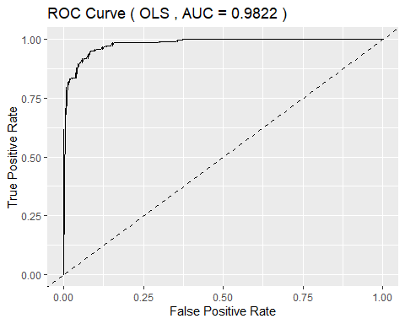

plot_roc(predictions_rf, "Random Forest")

## Setting levels: control = 0, case = 1  
## Setting direction: controls < cases

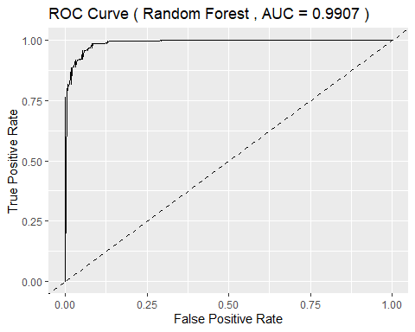

# --- Feature Importance Visualization (OLS) ---  
  
# Select top 20 features  
top_20_features_ols <- head(importance_df_ols, 20)  
  
# Plot top 20 feature importance for OLS  
ggplot(top_20_features_ols, aes(x = reorder(Feature, Importance), y = Importance)) +  
 geom_bar(stat = "identity", fill = "steelblue") +  
 coord_flip() +  
 labs(title = "Top 20 Feature Importance (OLS)", x = "Feature", y = "Importance") +  
 theme_minimal()

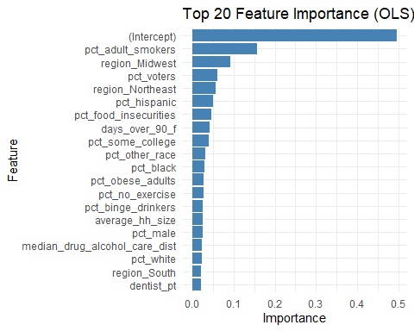

# --- Feature Importance Visualization (RF) ---  
  
# Calculate feature importance for RF  
feature_importance_rf <- importance(rf_model)  
importance_df_rf <- data.frame(Feature = rownames(feature_importance_rf), Importance = feature_importance_rf[, 1])  
importance_df_rf <- importance_df_rf[order(-importance_df_rf$Importance), ]  
  
# Select top 20 features  
top_20_features_rf <- head(importance_df_rf, 20)  
  
# Plot top 20 feature importance for RF  
ggplot(top_20_features_rf, aes(x = reorder(Feature, Importance), y = Importance)) +  
 geom_bar(stat = "identity", fill = "steelblue") +  
 coord_flip() +  
 labs(title = "Top 20 Feature Importance (RF)", x = "Feature", y = "Importance") +  
 theme_minimal()

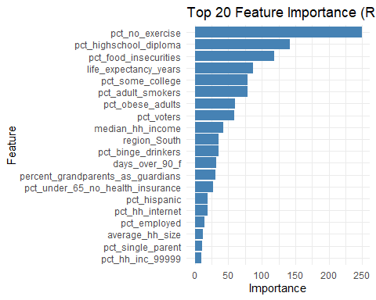

Assumptions OLS Model Linearity: Assumes a linear relationship between the predictors and the response variable. Independence: Assumes that the observations are independent. Homoscedasticity: Assumes constant variance of the errors. Normality: Assumes that the errors are normally distributed. To check these assumptions, use the following diagnostics:

Residuals Plot: To check for homoscedasticity and linearity. Q-Q Plot: To check for normality of residuals. Durbin-Watson Test: To check for independence of residuals.

# Residuals plot  
plot(ols_model, which = 1)

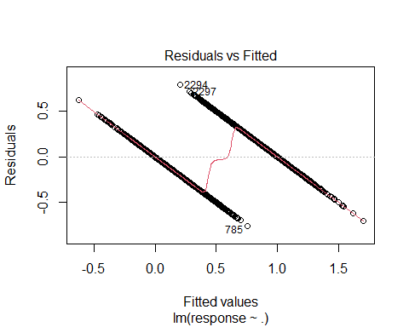

# Q-Q plot  
plot(ols_model, which = 2)

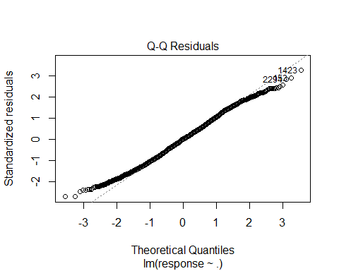

# Durbin-Watson test  
library(lmtest)

## Loading required package: zoo

##   
## Attaching package: 'zoo'

## The following objects are masked from 'package:base':  
##   
## as.Date, as.Date.numeric

dwtest(ols_model)

##   
## Durbin-Watson test  
##   
## data: ols_model  
## DW = 0.89266, p-value = 0.3085  
## alternative hypothesis: true autocorrelation is greater than 0

build Lasso Model

# Convert response variable to factor  
qol_train$response <- as.factor(qol_train$response)  
qol_test$response <- as.factor(qol_test$response)  
  
# Create design matrices (excluding response variable)  
x_train <- model.matrix(~ ., data = qol_train[,-which(names(qol_train) == "response")])  
x_test <- model.matrix(~ ., data = qol_test[,-which(names(qol_test) == "response")])  
  
# Fit the Lasso model  
lasso_model <- glmnet(x_train, qol_train$response, family = "binomial", alpha = 1)   
  
# Find optimal lambda using cross-validation  
cv_lasso <- cv.glmnet(x_train, qol_train$response, family = "binomial", alpha = 1)  
  
# Predict on the test set using the optimal lambda  
predictions_lasso <- predict(lasso_model, newx = x_test, s = cv_lasso$lambda.min, type = "response")  
  
# Convert probabilities to class predictions (0 or 1)  
predicted_classes_lasso <- ifelse(predictions_lasso > 0.5, 1, 0)  
  
# Calculate accuracy  
accuracy_lasso <- mean(qol_test$response == predicted_classes_lasso)  
cat("Accuracy (Lasso):", accuracy_lasso, "\n")

## Accuracy (Lasso): 0.9319728

# Plot ROC curve  
roc_lasso <- roc(qol_test$response, predictions_lasso)

## Setting levels: control = 0, case = 1

## Warning in roc.default(qol_test$response, predictions_lasso): Deprecated use a  
## matrix as predictor. Unexpected results may be produced, please pass a numeric  
## vector.

## Setting direction: controls < cases

auc_lasso <- auc(roc_lasso)  
cat("AUC (Lasso):", auc_lasso, "\n")

## AUC (Lasso): 0.9896129

ggplot(data.frame(fpr = 1 - roc_lasso$specificities, tpr = roc_lasso$sensitivities),   
 aes(x = fpr, y = tpr)) +  
 geom_line() +  
 geom_abline(linetype = "dashed") +  
 ggtitle(paste("ROC Curve (Lasso, AUC =", round(auc_lasso, 2), ")")) +  
 xlab("False Positive Rate") +  
 ylab("True Positive Rate")

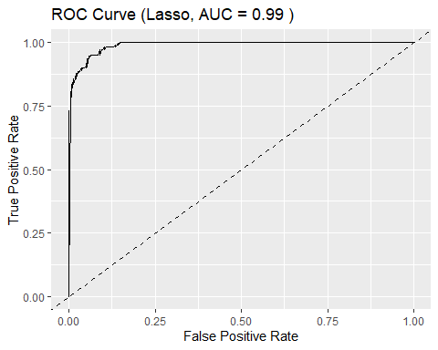

# Feature importance  
  
# Extract coefficients as a dense vector  
coef_lasso <- coef(lasso_model, s = cv_lasso$lambda.min)  
  
# Extract non-zero coefficients  
non_zero_coefs <- coef_lasso[which(coef_lasso != 0)]  
  
# Get the names of the non-zero coefficients  
feature_names <- rownames(coef_lasso)[which(coef_lasso != 0)]  
  
# Create the data frame  
importance_df_lasso <- data.frame(Feature = feature_names, Importance = abs(non_zero_coefs))  
  
  
importance_df_lasso <- importance_df_lasso[order(-importance_df_lasso$Importance), ]  
top_20_features_lasso <- head(importance_df_lasso, 20)  
  
# Plot top 20 feature importance  
ggplot(top_20_features_lasso, aes(x = reorder(Feature, Importance), y = Importance)) +  
 geom_bar(stat = "identity", fill = "steelblue") +  
 coord_flip() +  
 labs(title = "Top 20 Feature Importance (Lasso)", x = "Feature", y = "Importance") +  
 theme_minimal()

