Team Beta Capstone Project

Mirande Gemme, Udumaga Onyeukwu, Steve Uzupis

2024-08-25

$$EnviromentBuild$$

*Package Installation*

# install packages not on machine and needed for project  
installed_packages <- installed.packages()  
  
list_of_packages <- c(  
 "readr",  
 "readxl",  
 "dplyr",  
 "lubridate",  
 "ggplot2",  
 "tidyr",  
 "corrplot",  
 "leaps",  
 "caret",  
 "car",  
 "scales",  
 "forcats",  
 "codebookr",  
 "gtsummary",  
 "tigris",  
 "cardx",  
 "moments",  
 "VIM",  
 "pROC",  
 "randomForest",  
 "glmnet",  
 "tidymodels",  
 "recipes",  
 "lmtest",  
 "xgboost",  
 "openxlsx",  
 "class",  
 "e1071",  
 "vip",  
 "pdp",  
 "gbm",  
 "gtsummary",  
 "gt"  
 )  
  
new_packages <- list_of_packages[!(  
 list_of_packages %in% installed.packages()[,"Package"]  
 )]  
  
if(length(new_packages)) install.packages(new_packages)

rm(  
 installed_packages,  
 list_of_packages,  
 new_packages  
)

*Packages Load*

# load packages  
  
library(readr) # load csv files  
library(readxl) # load excel files  
library(dplyr) # data manipulation  
#library(lubridate) # date & time manipulation  
library(ggplot2) # data visualization  
library(tidyr) # collection of statistical packages  
#library(corrplot) # to visualize correlations  
#library(leaps) # for subset selection  
library(caret) # test for correlation  
#library(car) # for VIF  
#library(scales) # for visualizing plots in %  
#library(forcats) # ordering data frames  
library(codebookr) # adding appendix to r code  
library(gtsummary) # creating tables  
#library(tigris) # access to US geographic data  
#library(cardx) # to include statistic results  
#library(moments) # to calculate skewness and kurtosis  
#library(VIM) # to run K- Nearest Neighbor  
#library(pROC) # to analyse and display receiver operating characteristics(ROC) curves  
#library(randomForest) # to impalement Random Forest algorithm  
#library(glmnet) # for Regularized regression models.  
library(tidymodels) # for Machine learning workflows.  
#library(recipes) # for data preprocessing  
#library(lmtest) # to implement Hypothesis testing for linear models.  
#library(xgboost) # to build Gradient boosted models  
#library(openxlsx) # for Excel file manipulation   
#library(class) # for K-nearest neighbors classification  
library(e1071) # Support Vector Machines and other machine learning algorithms.  
#library(vip) # Variable importance plots for machine learning models.  
library(pdp) # partial dependence plots   
library(gbm) # evaluate GBM for feature   
library(gtsummary)  
#library(gt)

*Data load*

# load data  
  
all_sdoh_data <- read_csv("data/sdoh_data.csv")  
dim(all_sdoh_data)

## [1] 3229 682

#cdc_data <- read_csv("data/cdc_data.csv") found better response data set  
  
all_chr_data <- read_csv("data/chr_data.csv",  
 skip = 1)  
dim(all_chr_data)

## [1] 3194 720

$$DataCleaning$$

*Initial data cleaning*

# remove unused features - not using  
  
#cdc_data <- cdc_data %>%   
# filter(Response == '65+') %>%   
# select('LocationAbbr', 'LocationDesc', 'Data_Value', 'Number', 'WeightedNumber', 'StratificationCategory1', 'Stratification1', 'LocationID')

# remove unwanted features, create calculated feature  
  
sdoh_data <- all_sdoh_data %>%   
 select(#"YEAR",  
 "COUNTYFIPS", #"STATEFIPS",  
 "STATE", "COUNTY", "REGION", #"TERRITORY",  
 "ACS_TOT_POP_WT", #"ACS_TOT_POP_US_ABOVE1", "ACS_TOT_POP_ABOVE5", "ACS_TOT_POP_ABOVE15", "ACS_TOT_POP_ABOVE16", "ACS_TOT_POP_16_19", "ACS_TOT_POP_ABOVE25", "ACS_TOT_CIVIL_POP_ABOVE18", "ACS_TOT_CIVIL_VET_POP_ABOVE25", "ACS_TOT_OWN_CHILD_BELOW17", "ACS_TOT_WORKER_NWFH", "ACS_TOT_WORKER_HH", "ACS_TOT_CIVILIAN_LABOR", "ACS_TOT_CIVIL_EMPLOY_POP", "ACS_TOT_POP_POV", "ACS_TOT_CIVIL_NONINST_POP_POV", "ACS_TOT_CIVIL_POP_POV", "ACS_TOT_GRANDCHILDREN_GP", "ACS_TOT_HU", "ACS_TOT_HH",  
 "ACS_AVG_HH_SIZE",# "ACS_TOT_CIVIL_NONINST_POP", "ACS_TOT_CIVIL_VET_POP", "ACS_PCT_CHILD_DISAB", "ACS_PCT_DISABLE", "ACS_PCT_NONVET_DISABLE_18_64", "ACS_PCT_VET_DISABLE_18_64",   
 "ACS_PCT_MALE", "ACS_PCT_FEMALE", #"ACS_PCT_CTZ_US_BORN", "ACS_PCT_CTZ_NONUS_BORN", "ACS_PCT_FOREIGN_BORN",  
 "ACS_PCT_NON_CITIZEN", "ACS_PCT_CTZ_NATURALIZED", "ACS_PCT_CTZ_ABOVE18", #"ACS_PCT_NONCTN_1990", "ACS_PCT_NONCTN_1999", "ACS_PCT_NONCTN_2000", "ACS_PCT_NONCTN_2010", "ACS_PCT_API_LANG",   
 "ACS_PCT_ENGL_NOT_ALL", #"ACS_PCT_ENGL_NOT_WELL", "ACS_PCT_ENGL_VERY_WELL", "ACS_PCT_ENGL_WELL", "ACS_PCT_ENGLISH", "ACS_PCT_HH_LIMIT_ENGLISH", "ACS_PCT_OTH_EURP", "ACS_PCT_OTH_LANG", "ACS_PCT_SPANISH", "ACS_PCT_VET", "ACS_PCT_GULFWAR_1990_2001", "ACS_PCT_GULFWAR_2001", "ACS_PCT_GULFWAR_VIETNAM", "ACS_PCT_VIETNAM", "ACS_MEDIAN_AGE", "ACS_MEDIAN_AGE_MALE", "ACS_MEDIAN_AGE_FEMALE", "ACS_PCT_AGE_0_4", "ACS_PCT_AGE_5_9", "ACS_PCT_AGE_10_14", "ACS_PCT_AGE_15_17", "ACS_PCT_AGE_0_17", "ACS_PCT_AGE_18_29", "ACS_PCT_AGE_18_44", "ACS_PCT_AGE_30_44", "ACS_PCT_AGE_45_64", "ACS_PCT_AGE_50_64", "ACS_PCT_AGE_ABOVE65", "ACS_PCT_AGE_ABOVE80",   
 "ACS_PCT_AIAN", #"ACS_PCT_AIAN_FEMALE", "ACS_PCT_AIAN_NONHISP",   
 "ACS_PCT_ASIAN", #"ACS_PCT_ASIAN_FEMALE", "ACS_PCT_ASIAN_MALE", "ACS_PCT_ASIAN_NONHISP",   
 "ACS_PCT_BLACK", #"ACS_PCT_BLACK_FEMALE", "ACS_PCT_BLACK_MALE", "ACS_PCT_BLACK_NONHISP", #"ACS_PCT_HISP_FEMALE", "ACS_PCT_HISP_MALE",  
 "ACS_PCT_HISPANIC", #"ACS_PCT_MULT_RACE", "ACS_PCT_MULT_RACE_FEMALE", "ACS_PCT_MULT_RACE_MALE", "ACS_PCT_MULT_RACE_NONHISP", "ACS_PCT_NHPI", "ACS_PCT_NHPI_FEMALE", "ACS_PCT_NHPI_MALE", "ACS_PCT_NHPI_NONHISP", "ACS_PCT_OTHER_FEMALE", "ACS_PCT_OTHER_MALE", "ACS_PCT_OTHER_NONHISP",   
 "ACS_PCT_OTHER_RACE", "ACS_PCT_WHITE", #"ACS_PCT_WHITE_FEMALE", "ACS_PCT_WHITE_MALE", "ACS_PCT_WHITE_NONHISP", "ACS_PCT_HOUSEHOLDER_WHITE", "ACS_PCT_HOUSEHOLDER_BLACK", "ACS_PCT_HOUSEHOLDER_AIAN", "ACS_PCT_HOUSEHOLDER_ASIAN", "ACS_PCT_HOUSEHOLDER_NHPI", "ACS_PCT_HOUSEHOLDER_OTHER", "ACS_PCT_HOUSEHOLDER_MULT", "ACS_PCT_AIAN_COMB", "ACS_PCT_ASIAN_COMB", "ACS_PCT_BLACK_COMB", "ACS_PCT_NHPI_COMB", "ACS_PCT_WHITE_COMB",   
 "ACS_PCT_CHILD_1FAM", "ACS_PCT_CHILDREN_GRANDPARENT", "ACS_PCT_GRANDP_RESPS_NO_P", "ACS_PCT_GRANDP_RESPS_P", #"ACS_PCT_GRANDP_NO_RESPS", "ACS_PCT_HH_KID_1PRNT",   
 "ACS_PCT_HH_NO_COMP_DEV", "ACS_PCT_HH_SMARTPHONE", #"ACS_PCT_HH_SMARTPHONE_ONLY",   
 "ACS_PCT_HH_TABLET", #"ACS_PCT_HH_TABLET_ONLY",   
 "ACS_PCT_HH_PC", #"ACS_PCT_HH_PC_ONLY",   
 "ACS_PCT_HH_OTHER_COMP", #"ACS_PCT_HH_OTHER_COMP_ONLY",   
 "ACS_PCT_HH_INTERNET", #"ACS_PCT_HH_INTERNET_NO_SUBS", "ACS_PCT_HH_BROADBAND", "ACS_PCT_HH_BROADBAND_ONLY",   
 "ACS_PCT_HH_BROADBAND_ANY", "ACS_PCT_HH_CELLULAR", #"ACS_PCT_HH_CELLULAR_ONLY",   
 "ACS_PCT_HH_NO_INTERNET", "ACS_PCT_HH_SAT_INTERNET", "ACS_PCT_HH_DIAL_INTERNET_ONLY", #"ACS_PCT_DIVORCED_F", "ACS_PCT_DIVORCED_M", "ACS_PCT_MARRIED_SP_AB_F", "ACS_PCT_MARRIED_SP_AB_M", "ACS_PCT_MARRIED_SP_PR_F", "ACS_PCT_MARRIED_SP_PR_M", "ACS_PCT_NVR_MARRIED_F", "ACS_PCT_NVR_MARRIED_M", "ACS_PCT_WIDOWED_F", "ACS_PCT_WIDOWED_M", "ACS_PCT_POP_SAME_SEX_UNMRD_P", "ACS_PCT_POP_SAME_SEX_SPOUSE",   
 "ACS_PCT_ADMIN", "ACS_PCT_ART", "ACS_PCT_CONSTRUCT", "ACS_PCT_EDUC", "ACS_PCT_FINANCE", "ACS_PCT_GOVT", "ACS_PCT_INFORM", "ACS_PCT_MANUFACT", "ACS_PCT_NATURE", "ACS_PCT_OTHER", "ACS_PCT_PROFESS", "ACS_PCT_PVT_NONPROFIT", #"ACS_PCT_PVT_PROFIT",   
 "ACS_PCT_RETAIL", "ACS_PCT_TRANSPORT", "ACS_PCT_WHOLESALE", #"ACS_PCT_WORK_RES_F", "ACS_PCT_WORK_RES_M",   
 "ACS_PCT_EMPLOYED", "ACS_PCT_UNEMPLOY", #"ACS_PCT_NOT_LABOR", "ACS_PCT_VET_UNEMPL_18_64", "ACS_PCT_VET_LABOR_FORCE_18_64", "ACS_PCT_ARMED_FORCES",   
 "ACS_GINI_INDEX", #"ACS_MDN_GRNDPRNT_NO_PRNT_INC", "ACS_MDN_GRNDPRNT_INC", "ACS_MEDIAN_HH_INC_AIAN", "ACS_MEDIAN_HH_INC_ASIAN" , "ACS_MEDIAN_HH_INC_BLACK", "ACS_MEDIAN_HH_INC_HISP", "ACS_MEDIAN_HH_INC_MULTI", "ACS_MEDIAN_HH_INC_NHPI", "ACS_MEDIAN_HH_INC_OTHER", "ACS_MEDIAN_HH_INC_WHITE", "ACS_MEDIAN_HH_INC", "ACS_MEDIAN_INC_F", "ACS_MEDIAN_INC_M", "ACS_MEDIAN_NONVET_INC", "ACS_MEDIAN_VET_INC", "ACS_PCT_INC50_ABOVE65", "ACS_PCT_INC50_BELOW17", "ACS_PCT_HEALTH_INC_BELOW137", "ACS_PCT_HEALTH_INC_138_199", "ACS_PCT_HEALTH_INC_200_399", "ACS_PCT_HEALTH_INC_ABOVE400",   
 "ACS_PCT_HH_INC_10000", "ACS_PCT_HH_INC_100000", "ACS_PCT_HH_INC_14999", "ACS_PCT_HH_INC_24999", "ACS_PCT_HH_INC_49999", "ACS_PCT_HH_INC_99999", #"ACS_PCT_INC50", "ACS_PCT_NONVET_POV_18_64", "ACS_PCT_VET_POV_18_64", "ACS_PCT_PERSON_INC_100_124", "ACS_PCT_PERSON_INC_125_199", "ACS_PCT_PERSON_INC_ABOVE200", "ACS_PCT_PERSON_INC_BELOW99",   
 "ACS_PER_CAPITA_INC", #"ACS_PCT_POV_AIAN", "ACS_PCT_POV_ASIAN", "ACS_PCT_POV_BLACK", "ACS_PCT_POV_HISPANIC", "ACS_PCT_POV_MULTI", "ACS_PCT_POV_NHPI", "ACS_PCT_POV_OTHER", "ACS_PCT_POV_WHITE", "ACS_PCT_HH_1FAM_FOOD_STMP", "ACS_PCT_HH_FOOD_STMP", "ACS_PCT_HH_PUB_ASSIST", "ACS_PCT_HH_FOOD_STMP_BLW_POV", "ACS_PCT_HH_NO_FD_STMP_BLW_POV", "ACS_PCT_COLLEGE_ASSOCIATE_DGR", "ACS_PCT_BACHELOR_DGR", "ACS_PCT_NO_WORK_NO_SCHL_16_19", "ACS_PCT_GRADUATE_DGR", "ACS_PCT_HS_GRADUATE", "ACS_PCT_LT_HS", "ACS_PCT_POSTHS_ED", "ACS_PCT_VET_BACHELOR", "ACS_PCT_VET_COLLEGE", "ACS_PCT_VET_HS",   
 "ACS_MEDIAN_HOME_VALUE", "ACS_MEDIAN_RENT", #"ACS_PCT_1UP_RENT_1ROOM", "ACS_PCT_1UP_OWNER_1ROOM", "ACS_PCT_1UP_PERS_1ROOM", "ACS_PCT_HH_1PERS", "ACS_PCT_10UNITS", "ACS_PCT_GRP_QRT", "ACS_PCT_HU_MOBILE_HOME", "ACS_PCT_OWNER_HU", "ACS_PCT_OWNER_HU_CHILD", "ACS_PCT_RENTER_HU", "ACS_PCT_RENTER_HU_ABOVE65", "ACS_PCT_RENTER_HU_CHILD", "ACS_PCT_RENTER_HU_COST_30PCT", "ACS_PCT_RENTER_HU_COST_50PCT",   
 "ACS_PCT_VACANT_HU", #"ACS_PCT_HU_NO_FUEL", "ACS_PCT_HU_UTILITY_GAS", "ACS_PCT_HU_BOT_TANK_LP_GAS", "ACS_PCT_HU_OIL", "ACS_PCT_HU_WOOD", "ACS_PCT_HU_COAL", "ACS_PCT_HU_OTHER", "ACS_PCT_HU_ELEC", "ACS_PCT_HU_SOLAR", "ACS_MDN_OWNER_COST_MORTGAGE", "ACS_MDN_OWNER_COST_NO_MORTG", #"ACS_PCT_OWNER_HU_COST_30PCT", "ACS_PCT_OWNER_HU_COST_50PCT", "ACS_MEDIAN_YEAR_BUILT", "ACS_PCT_HU_BUILT_1979", "ACS_PCT_HU_KITCHEN", "ACS_PCT_HU_PLUMBING", "ACS_PCT_IN_STATE_MOVE", "ACS_PCT_IN_COUNTY_MOVE", "ACS_PCT_DIF_STATE", "ACS_PCT_HH_ABOVE65", "ACS_PCT_HH_ALONE_ABOVE65",   
 "ACS_PCT_COMMT_15MIN", "ACS_PCT_COMMT_29MIN", "ACS_PCT_COMMT_59MIN", "ACS_PCT_COMMT_60MINUP", #"ACS_PCT_HU_NO_VEH", "ACS_PCT_WORK_NO_CAR", "ACS_PCT_DRIVE_2WORK",   
 "ACS_PCT_PUBL_TRANSIT", #"ACS_PCT_PUB_COMMT_15MIN", "ACS_PCT_PUB_COMMT_29MIN", "ACS_PCT_PUB_COMMT_59MIN", "ACS_PCT_PUB_COMMT_60MINUP","ACS_PCT_TAXICAB_2WORK", "ACS_PCT_WALK_2WORK",   
 "ACS_PCT_MEDICAID_ANY", #"ACS_PCT_MEDICAID_ANY_BELOW64",  
 "ACS_PCT_MEDICARE_ONLY", #"ACS_PCT_OTHER_INS", "ACS_PCT_PVT_EMPL_DRCT", "ACS_PCT_PVT_EMPL_DRCT_BELOW64", "ACS_PCT_PRIVATE_ANY", "ACS_PCT_PRIVATE_ANY_BELOW64", "ACS_PCT_PRIVATE_EMPL", "ACS_PCT_PRIVATE_EMPL_BELOW64", "ACS_PCT_PRIVATE_MDCR", "ACS_PCT_PRIVATE_MDCR_35_64", "ACS_PCT_PRIVATE_OTHER", "ACS_PCT_PRIVATE_OTHER_BELOW64", "ACS_PCT_PRIVATE_SELF", "ACS_PCT_PRIVATE_SELF_BELOW64", "ACS_PCT_PUBLIC_ONLY", "ACS_PCT_PUBLIC_OTHER", "ACS_PCT_PUBLIC_OTHER_BELOW64", "ACS_PCT_SELF_MDCR_ABOVE35", "ACS_PCT_TRICARE_VA", "ACS_PCT_TRICARE_VA_BELOW64", "ACS_PCT_UNINSURED", "ACS_PCT_UNINSURED_BELOW64", "AHRF_USDA_RUCC_2013", "AHRF_VET", "AHRF_VET_MALE", "AHRF_VET_FEMALE", "AHRF_UNEMPLOYED_RATE", "AHRF_DAYS_AIR_QLT", "AHRF_PCT_GOOD_AQ", "AHRF_TXC_SITE_NO_DATA", "AHRF_TXC_SITE_CNTRL", "AHRF_TXC_SITE_NO_CNTRL", "AHRF_HPSA_DENTIST", "AHRF_HPSA_MENTAL", "AHRF_HPSA_PRIM", "AHRF_MARKET_ENROL", "AHRF_MARKET_ENROL_NEW", "AHRF_MARKET_ENROL_ACTIVE", "AHRF_MARKET_ENROL_AUTO", "AHRF_MARKET_ENROL_150", "AHRF_MARKET_ENROL_200", "AHRF_MARKET_ENROL_250", "AHRF_MARKET_ENROL_300", "AHRF_MARKET_ENROL_400", "AHRF_MARKET_ENROL_OTHER", "AHRF_MARKET_ENROL_NO_ASST", "AHRF_PRESC_ENROLLMENT", "AHRF_PCT_PRESC_PEN", "AHRF_TOT_ADV_NURSES",   
 "AHRF_ADV_NURSES_RATE", #"AHRF_TOT_CLIN_NURSE_SPEC",   
 "AHRF_CLIN_NURSE_SPEC_RATE", #"AHRF_TOT_DENTISTS",   
 "AHRF_DENTISTS_RATE", #"AHRF_TOT_NURSE_ANESTH",   
 "AHRF_NURSE_ANESTH_RATE", #"AHRF_TOT_NURSE_MIDWIVES",   
 "AHRF_NURSE_MIDWIVES_RATE", #"AHRF_TOT_NURSE_PRACT",   
 "AHRF_NURSE_PRACT_RATE", #"AHRF_TOT_PHYSICIAN_ASSIST",   
 "AHRF_PHYSICIAN_ASSIST_RATE", #"AMFAR_SSP",   
 "AMFAR_SSP_RATE", #"AMFAR_TOT_MEDSAFAC",  
 "AMFAR_MEDSAFAC_RATE", #"AMFAR_TOT_AMATFAC", "AMFAR_AMATFAC_RATE", "AMFAR_TOT_HCVTFAC", "AMFAR_HCVTFAC_RATE", "AMFAR_TOT_HIVHCVTFAC", "AMFAR_HIVHCVTFAC_RATE", "AMFAR_TOT_HIVTFAC", "AMFAR_HIVTFAC_RATE", "AMFAR_TOT_MEDAMATFAC", "AMFAR_MEDAMATFAC_RATE", "AMFAR_TOT_MEDHCVTFAC", "AMFAR_MEDHCVTFAC_RATE", "AMFAR_TOT_MEDHIVHCVTFAC", "AMFAR_MEDHIVHCVTFAC_RATE", "AMFAR_TOT_MEDHIVTFAC", "AMFAR_MEDHIVTFAC_RATE", "AMFAR_TOT_MEDMHFAC", "AMFAR_MEDMHFAC_RATE", "AMFAR_TOT_MHFAC",   
 "AMFAR_MHFAC_RATE", #"CAF_ADJ_COUNTY_1", "CAF_ADJ_COUNTY_2", "CAF_ADJ_COUNTY_3", "CAF_ADJ_COUNTY_4", "CAF_ADJ_COUNTY_5", "CAF_ADJ_COUNTY_6", "CAF_ADJ_COUNTY_7", "CAF_ADJ_COUNTY_8", "CAF_ADJ_COUNTY_9", "CAF_ADJ_COUNTY_10", "CAF_ADJ_COUNTY_11", "CAF_ADJ_COUNTY_12", "CAF_ADJ_COUNTY_13", "CAF_ADJ_COUNTY_14","CDCW_TOT_POPULATION", "CDCW_INJURY_DTH_RATE", "CDCW_TRANSPORT_DTH_RATE", "CDCW_SELFHARM_DTH_RATE", "CDCW_ASSAULT_DTH_RATE", "CDCW_MATERNAL_DTH_RATE", "CDCW_OPIOID_DTH_RATE", "CDCW_DRUG_DTH_RATE",   
 "CEN_AREALAND_SQM_COUNTY", "CEN_POPDENSITY_COUNTY", #"CHR_TOT_MENTAL_PROV", "CHR_MENTAL_PROV_RATE", "CHR_TOT_POPULATION", "MP_MEDICARE_ELIGIBLES", "MP_MEDICARE_ADVTG_ENROLLED", "MP_PCT_ADVTG_PEN", "NCHS_URCS_2006", "NCHS_URCS_2013", "NEPHTN_ARSENIC_MEAN_CSW", "NEPHTN_ARSENIC_MEAN_POP", "NEPHTN_PCT_ARSENIC_MCL_NOTDETECT", "NEPHTN_PCT_ARSENIC_MCL_LESS10", "NEPHTN_PCT_ARSENIC_MCL_GREATER10",   
 "NEPHTN_HEATIND_90", #"NEPHTN_HEATIND_95", "NEPHTN_HEATIND_100", "NEPHTN_HEATIND_105", "NEPHTN_MAXDROUGHT", "NEPHTN_NUMDROUGHT", "NEPHTN_TEMPERATURE_90", "NEPHTN_TEMPERATURE_95", "NEPHTN_TEMPERATURE_100", "NEPHTN_TEMPERATURE_105", "NHC_AVG_LIC_STAFF", "NHC_AVG_REP_NURSE_STAFF", "NHC_AVG_ADJ_NURSE_STAFF", "NHC_TOT_FACS", "NHC_FACS_RATE",   
 "EPAA_2NDMAX_CO_1HR", #"EPAA_2NDMAX_CO_8HR",   
 "EPAA_98PR_NO2_1HR", #"EPAA_MEAN_NO2_1HR", "EPAA_2NDMAX_O3_1HR", "EPAA_4THMAX_O3_8HR",   
 "EPAA_MAX_PB_3MON", #"EPAA_2NDMAX_PM10_24HR", "EPAA_MEAN_WTD_PM10", "EPAA_MEAN_WTD_PM25",   
 "EPAA_98PR_PM25_DAILY", "EPAA_99PR_SO2_1HR", #"EPAA_2NDMAX_SO2_24HR", "EPAA_MEAN_SO2_1HR", "NOAAC_AVG_TEMP_APR", "NOAAC_AVG_TEMP_AUG", "NOAAC_AVG_TEMP_DEC", "NOAAC_AVG_TEMP_FEB", "NOAAC_AVG_TEMP_JAN", "NOAAC_AVG_TEMP_JUL", "NOAAC_AVG_TEMP_JUN", "NOAAC_AVG_TEMP_MAR", "NOAAC_AVG_TEMP_MAY", "NOAAC_AVG_TEMP_NOV", "NOAAC_AVG_TEMP_OCT", "NOAAC_AVG_TEMP_SEP", "NOAAC_MAX_TEMP_APR", "NOAAC_MAX_TEMP_AUG", "NOAAC_MAX_TEMP_DEC", "NOAAC_MAX_TEMP_FEB", "NOAAC_MAX_TEMP_JAN", "NOAAC_MAX_TEMP_JUL", "NOAAC_MAX_TEMP_JUN", "NOAAC_MAX_TEMP_MAR", "NOAAC_MAX_TEMP_MAY", "NOAAC_MAX_TEMP_NOV", "NOAAC_MAX_TEMP_OCT", "NOAAC_MAX_TEMP_SEP", "NOAAC_MIN_TEMP_APR", "NOAAC_MIN_TEMP_AUG", "NOAAC_MIN_TEMP_DEC", "NOAAC_MIN_TEMP_FEB", "NOAAC_MIN_TEMP_JAN", "NOAAC_MIN_TEMP_JUL", "NOAAC_MIN_TEMP_JUN", "NOAAC_MIN_TEMP_MAR", "NOAAC_MIN_TEMP_MAY", "NOAAC_MIN_TEMP_NOV", "NOAAC_MIN_TEMP_OCT", "NOAAC_MIN_TEMP_SEP", "NOAAC_PRECIPITATION_APR", "NOAAC_PRECIPITATION_AUG", "NOAAC_PRECIPITATION_DEC", "NOAAC_PRECIPITATION_FEB", "NOAAC_PRECIPITATION_JAN", "NOAAC_PRECIPITATION_JUL", "NOAAC_PRECIPITATION_JUN", "NOAAC_PRECIPITATION_MAR", "NOAAC_PRECIPITATION_MAY", "NOAAC_PRECIPITATION_NOV", "NOAAC_PRECIPITATION_OCT", "NOAAC_PRECIPITATION_SEP", "NOAAS_PROPERTY_DAMAGE", "NOAAS_TOT_DEATHS_DIRECT", "NOAAS_TOT_DEATHS_INDIRECT", "NOAAS_TOT_INJURIES_DIRECT", "NOAAS_TOT_INJURIES_INDIRECT", "NOAAS_TOT_STORMEVENT", "NOAAS_TOT_TORNADO", "NOAAS_TOT_WIND", "NOAAS_TOT_HAIL", "NOAAS_TOT_HURRICANE_STORM", "NOAAS_TOT_FLOOD", "NOAAS_TOT_WILDFIRE", "NOAAS_TOT_HEAT_EVENTS", "NOAAS_TOT_DROUGHT",   
 "SAIPE_MEDIAN_HH_INCOME", "SAIPE_PCT_POV", #"SAIPE_PCT_POV_0_17", "SAIPE_PCT_POV_5_17", "SAIPE_TOT_POV", "SAIPE_TOT_POV_0_17", "SAIPE_TOT_POV_5_17", "WUSTL_AVG_PM25", "HHC_PCT_HHA_NURSING", "HHC_PCT_HHA_PHYS_THERAPY", "HHC_PCT_HHA_OCC_THERAPY", "HHC_PCT_HHA_SPEECH", "HHC_PCT_HHA_MEDICAL", "HHC_PCT_HHA_AIDE", "HIFLD_MEDIAN_DIST_UC", "HIFLD_MEAN_DIST_UC", "HIFLD_MIN_DIST_UC", "HIFLD_MAX_DIST_UC", "HIFLD_UC", "HIFLD_UC_RATE", "IHS_HEALTH_FACILITY", "IHS_HEALTH_FACILITY_RATE", "LTC_AVG_PCT_PRESSURE_ULCER", "LTC_PCT_RESD_BLACK", "LTC_PCT_RESD_HISPANIC", "LTC_PCT_RESD_WHITE", "LTC_AVG_AGE", "LTC_PCT_MULTI_FAC", "LTC_PCT_FOR_PROFIT", "LTC_AVG_ACUITY_INDEX", "LTC_TOT_BEDS", "LTC_TOT_BEDS_RATE",  
 "LTC_AVG_OBS_REHOSP_RATE", "LTC_AVG_OBS_SUCCESSFUL_DISC_RATE", #"LTC_AVG_PCT_MEDICAID", "LTC_AVG_PCT_MEDICARE", "LTC_OCCUPANCY_RATE", "MGV_PCT_MEDICAID", "MGV_TOT_BEN_PART_A_B", "MGV_TOT_BEN_FFS", "MGV_PCT_BEN_FFS_WHITE", "MGV_PCT_BEN_FFS_BLACK", "MGV_PCT_BEN_FFS_HISPANIC", "MGV_PER_CAPITA_ACTUAL_IP",   
 "MGV_PER_CAPITA_STD_IP", #"MGV_PER_CAPITA_ACTUAL_OP",   
 "MGV_PER_CAPITA_STD_OP", #"MGV_PER_CAPITA_ACTUAL_EM",   
 "MGV_PER_CAPITA_STD_EM", #"MGV_PER_CAPITA_ACTUAL_PA",   
 "MGV_PER_CAPITA_STD_PA", #"MGV_PER_CAPITA_ACTUAL_HC",   
 "MGV_PER_CAPITA_STD_HC", #"MMD_OVERALL_PQI_M_RATE", "MMD_OVERALL_PQI_F_RATE", "MMD_OVERALL_PQI_WHITE_RATE", "MMD_OVERALL_PQI_BLACK_RATE", "MMD_OVERALL_PQI_OTHER_RATE", "MMD_OVERALL_PQI_ASIAN_RATE", "MMD_OVERALL_PQI_HISP_RATE", "MMD_OVERALL_PQI_AIAN_RATE", "MMD_ACUTE_PQI_M_RATE", "MMD_ACUTE_PQI_F_RATE", "MMD_ACUTE_PQI_WHITE_RATE", "MMD_ACUTE_PQI_BLACK_RATE", "MMD_ACUTE_PQI_OTHER_RATE", "MMD_ACUTE_PQI_ASIAN_RATE", "MMD_ACUTE_PQI_HISP_RATE", "MMD_ACUTE_PQI_AIAN_RATE", "MMD_CHRONIC_PQI_M_RATE", "MMD_CHRONIC_PQI_F_RATE", "MMD_CHRONIC_PQI_WHITE_RATE", "MMD_CHRONIC_PQI_BLACK_RATE", "MMD_CHRONIC_PQI_OTHER_RATE", "MMD_CHRONIC_PQI_ASIAN_RATE", "MMD_CHRONIC_PQI_HISP_RATE", "MMD_CHRONIC_PQI_AIAN_RATE", "MMD_ED_VISITS_M_RATE", "MMD_ED_VISITS_F_RATE", "MMD_ED_VISITS_WHITE_RATE", "MMD_ED_VISITS_BLACK_RATE", "MMD_ED_VISITS_OTHER_RATE", "MMD_ED_VISITS_ASIAN_RATE", "MMD_ED_VISITS_HISP_RATE", "MMD_ED_VISITS_AIAN_RATE", "MMD_ED_VISITS_MED_RATE", "MMD_ED_VISITS_DUAL_RATE", "MMD_READM_M_RATE", "MMD_READM_F_RATE", "MMD_READM_WHITE_RATE", "MMD_READM_BLACK_RATE", "MMD_READM_OTHER_RATE", "MMD_READM_ASIAN_RATE", "MMD_READM_HISP_RATE", "MMD_READM_AIAN_RATE", "MMD_ANXIETY_DISD", "MMD_BIPOLAR_DISD", "MMD_DEPR_DISD", "MMD_PERSONALITY_DISD", "MMD_OUD_IND", "PC_PCT_MEDICARE_APPRVD_FULL_AMT", "PC_PCT_MCARE_MAY_ACPT_APPRVD_AMT",   
 "POS_MEDIAN_DIST_ED", #"POS_MEAN_DIST_ED", "POS_MIN_DIST_ED", "POS_MAX_DIST_ED",   
 "POS_MEDIAN_DIST_MEDSURG_ICU", #"POS_MEAN_DIST_MEDSURG_ICU", "POS_MIN_DIST_MEDSURG_ICU", "POS_MAX_DIST_MEDSURG_ICU",   
 "POS_MEDIAN_DIST_TRAUMA", #"POS_MEAN_DIST_TRAUMA", "POS_MIN_DIST_TRAUMA", "POS_MAX_DIST_TRAUMA",   
 "POS_MEDIAN_DIST_PED_ICU", #"POS_MEAN_DIST_PED_ICU", "POS_MIN_DIST_PED_ICU", "POS_MAX_DIST_PED_ICU",   
 "POS_MEDIAN_DIST_OBSTETRICS", #"POS_MEAN_DIST_OBSTETRICS", "POS_MIN_DIST_OBSTETRICS", "POS_MAX_DIST_OBSTETRICS",   
 "POS_MEDIAN_DIST_CLINIC", #"POS_MEAN_DIST_CLINIC", "POS_MIN_DIST_CLINIC", "POS_MAX_DIST_CLINIC",   
 "POS_MEDIAN_DIST_ALC", #"POS_MEAN_DIST_ALC", "POS_MIN_DIST_ALC", "POS_MAX_DIST_ALC", "POS_TOT_FQHC", "POS_FQHC_RATE", "POS_TOT_CMHC", "POS_CMHC_RATE", "POS_TOT_RHC", "POS_RHC_RATE", "POS_TOT_HHA", "POS_HHA_RATE", "POS_TOT_HOSPICE", "POS_HOSPICE_RATE", "POS_TOT_ASC", "POS_ASC_RATE", "POS_TOT_NF", "POS_NF_RATE", "POS_TOT_NF_BEDS", "POS_NF_BEDS_RATE", "POS_TOT_SNF", "POS_SNF_RATE", "POS_TOT_SNF_BEDS", "POS_SNF_BEDS_RATE", "POS_TOT_HOSP_OBSTETRIC", "POS_HOSP_OBSTETRIC_RATE", "POS_TOT_HOSP_PED_ICU", "POS_HOSP_PED_ICU_RATE", "POS_TOT_HOSP_BURN", "POS_HOSP_BURN_RATE", "POS_TOT_HOSP_MEDSURG_ICU", "POS_HOSP_MEDSURG_ICU_RATE", "POS_TOT_HOSP_REHAB", "POS_HOSP_REHAB_RATE", "POS_TOT_HOSP_ALC", "POS_HOSP_ALC_RATE", "POS_TOT_HOSP_PSYCH", "POS_HOSP_PSYCH_RATE", "POS_TOT_HOSP_AMBULANCE", "POS_HOSP_AMBULANCE_RATE", "POS_TOT_HOSP_CHEMO", "POS_HOSP_CHEMO_RATE", "POS_TOT_HOSP_ED", "POS_HOSP_ED_RATE", "POS_PCT_HOSP_FOR_PROFIT", "POS_PCT_HOSP_NON_PROFIT", "POS_PCT_HOSP_GOV", "CEN_AIAN_NH_IND"  
 ) %>%   
 mutate(percent_grandparents_as_guardians = ACS_PCT_CHILDREN_GRANDPARENT * ((ACS_PCT_GRANDP_RESPS_P + ACS_PCT_GRANDP_RESPS_NO_P)/100)) %>%   
 select(-ACS_PCT_GRANDP_RESPS_P, -ACS_PCT_GRANDP_RESPS_NO_P, -ACS_PCT_CHILDREN_GRANDPARENT)

sdoh_data <- sdoh_data %>%   
 rename(  
 "fips_code" = "COUNTYFIPS",  
 "state" = "STATE",  
 "county" = "COUNTY",  
 "region" = "REGION",  
 "weighted_population" = "ACS_TOT_POP_WT",  
 "average_hh_size" = "ACS_AVG_HH_SIZE",  
 "pct_male" = "ACS_PCT_MALE",  
 "pct_female" = "ACS_PCT_FEMALE",  
 "pct_not_citizens" = "ACS_PCT_NON_CITIZEN",  
 "pct_naturalized_citizens" = "ACS_PCT_CTZ_NATURALIZED",  
 "pct_adult_citizens" = "ACS_PCT_CTZ_ABOVE18",  
 "pct_no_english_spoken" = "ACS_PCT_ENGL_NOT_ALL",  
 "pct_native_american" = "ACS_PCT_AIAN",  
 "pct_asian" = "ACS_PCT_ASIAN",  
 "pct_black" = "ACS_PCT_BLACK",  
 "pct_hispanic" = "ACS_PCT_HISPANIC",  
 "pct_other_race" = "ACS_PCT_OTHER_RACE",  
 "pct_white" = "ACS_PCT_WHITE",  
 "pct_single_parent" = "ACS_PCT_CHILD_1FAM",  
 "pct_hh_no_computing_device" = "ACS_PCT_HH_NO_COMP_DEV",  
 "pct_hh_smartphone" = "ACS_PCT_HH_SMARTPHONE",  
 "pct_hh_tablet" = "ACS_PCT_HH_TABLET",  
 "pct_hh_computer" = "ACS_PCT_HH_PC",  
 "pct_hh_other_computer" = "ACS_PCT_HH_OTHER_COMP",  
 "pct_hh_internet" = "ACS_PCT_HH_INTERNET",  
 "pct_hh_broadband" = "ACS_PCT_HH_BROADBAND_ANY",  
 "pct_hh_cell_data" = "ACS_PCT_HH_CELLULAR",  
 "pct_hh_no_internet" = "ACS_PCT_HH_NO_INTERNET",  
 "pct_hh_satellite" = "ACS_PCT_HH_SAT_INTERNET",  
 "pct_hh_dial_up" = "ACS_PCT_HH_DIAL_INTERNET_ONLY",  
 "pct_employed_admin" = "ACS_PCT_ADMIN",  
 "pct_employed_arts" = "ACS_PCT_ART",   
 "pct_employed_construction" = "ACS_PCT_CONSTRUCT",  
 "pct_employed_education" = "ACS_PCT_EDUC",  
 "pct_employed_finance" = "ACS_PCT_FINANCE",  
 "pct_employed_government" = "ACS_PCT_GOVT",  
 "pct_employed_information" = "ACS_PCT_INFORM",  
 "pct_employed_manufacturing" = "ACS_PCT_MANUFACT",  
 "pct_employed_nature" = "ACS_PCT_NATURE",  
 "pct_employed_other" = "ACS_PCT_OTHER",  
 "pct_employed_professional" = "ACS_PCT_PROFESS",  
 "pct_employed_nonprofit" = "ACS_PCT_PVT_NONPROFIT",  
 "pct_employed_retail" = "ACS_PCT_RETAIL",  
 "pct_employed_transportation" = "ACS_PCT_TRANSPORT",  
 "pct_employed_wholesale" = "ACS_PCT_WHOLESALE",  
 "pct_employed" = "ACS_PCT_EMPLOYED",  
 "pct_unemployed" = "ACS_PCT_UNEMPLOY",  
 "gini_index" = "ACS_GINI_INDEX",  
 "pct_hh_inc_10,000" = "ACS_PCT_HH_INC_10000",  
 "pct_hh_inc_100,000" = "ACS_PCT_HH_INC_100000",  
 "pct_hh_inc_14,999" = "ACS_PCT_HH_INC_14999",  
 "pct_hh_inc_24,999" = "ACS_PCT_HH_INC_24999",  
 "pct_hh_inc_49,999" = "ACS_PCT_HH_INC_49999",  
 "pct_hh_inc_99999" = "ACS_PCT_HH_INC_99999",  
 "per_capita_income" = "ACS_PER_CAPITA_INC",  
 "median_home_value" = "ACS_MEDIAN_HOME_VALUE",  
 "median_rent" = "ACS_MEDIAN_RENT",  
 "pct_houses_vacant" = "ACS_PCT_VACANT_HU",  
 "pct_15_min_commute" = "ACS_PCT_COMMT_15MIN",  
 "pct_29_min_commute" = "ACS_PCT_COMMT_29MIN",  
 "pct_59_min_commute" = "ACS_PCT_COMMT_59MIN",  
 "pct_60_min_plus_commute" = "ACS_PCT_COMMT_60MINUP",  
 "pct_public_transportatin" = "ACS_PCT_PUBL_TRANSIT",  
 "pct_w_medicaid" = "ACS_PCT_MEDICAID_ANY",  
 "pct_w_medicare" = "ACS_PCT_MEDICARE_ONLY",  
 "adv_practice_nurse_pt" = "AHRF_ADV_NURSES_RATE",  
 "clinical_nurse_pt" = "AHRF_CLIN_NURSE_SPEC_RATE",  
 "dentist_pt" = "AHRF_DENTISTS_RATE",  
 "anesthetist_nurse_pt" = "AHRF_NURSE_ANESTH_RATE",  
 "midwife_pt" = "AHRF_NURSE_MIDWIVES_RATE",  
 "nurse_practitioner_pt" = "AHRF_NURSE_PRACT_RATE",  
 "pa_pt" = "AHRF_PHYSICIAN_ASSIST_RATE",  
 "syringe_exchange_pt" = "AMFAR_SSP_RATE",  
 "substance_abuse_facility_pt" = "AMFAR_MEDSAFAC_RATE",  
 "mental_health_faciliy_pt" = "AMFAR_MHFAC_RATE",  
 "land_area_sqm" = "CEN_AREALAND_SQM_COUNTY",  
 "population_density" = "CEN_POPDENSITY_COUNTY",  
 "days_over_90_f" = "NEPHTN_HEATIND_90",  
 "co_measure" = "EPAA_2NDMAX_CO_1HR",  
 "no2_measure" = "EPAA_98PR_NO2_1HR",  
 "pb_measure" = "EPAA_MAX_PB_3MON",  
 "pm_2.5_measure" = "EPAA_98PR_PM25_DAILY",  
 "so2_measure" = "EPAA_99PR_SO2_1HR",  
 "median_hh_income" = "SAIPE_MEDIAN_HH_INCOME",  
 "pct_people_in_poverty" = "SAIPE_PCT_POV",  
 "rehospitalization_rate" = "LTC_AVG_OBS_REHOSP_RATE",  
 "successful_discharge_rate" = "LTC_AVG_OBS_SUCCESSFUL_DISC_RATE",  
 "medicare_inpatient_payment" = "MGV_PER_CAPITA_STD_IP" ,  
 "medicare_outpatient_payment" = "MGV_PER_CAPITA_STD_OP",  
 "medicare_e&m_payment" = "MGV_PER_CAPITA_STD_EM",  
 "medicare_acute_care_payment" = "MGV_PER_CAPITA_STD_PA",  
 "medicare_fqrc_rhc_payment" = "MGV_PER_CAPITA_STD_HC",  
 "median_er_dist" = "POS_MEDIAN_DIST_ED",  
 "median_surgery_dist" = "POS_MEDIAN_DIST_MEDSURG_ICU",  
 "median_trauma_center_dist" = "POS_MEDIAN_DIST_TRAUMA",  
 "median_pediatric_icu_dist" = "POS_MEDIAN_DIST_PED_ICU",  
 "median_obstetrics_dist" = "POS_MEDIAN_DIST_OBSTETRICS",  
 "median_health_clinic_dist" = "POS_MEDIAN_DIST_CLINIC",  
 "median_drug_alcohol_care_dist" = "POS_MEDIAN_DIST_ALC"   
 )

# remove unwanted features  
# convert principal care providers from per 100,000 people to per 1,000 people to match other data  
  
chr_data <- all_chr_data %>%  
 select(  
 #"statecode","countycode",  
 "fipscode", #"state","county", "year", "county_ranked", "v001_rawvalue", "v001_numerator", "v001_denominator", "v001_cilow", "v001_cihigh", "v001_flag", "v001_race_aian", "v001_race_aian_cilow", "v001_race_aian_cihigh", "v001_race_aian_flag", "v001_race_asian", "v001_race_asian_cilow", "v001_race_black", "v001_race_black_cilow", "v001_race_hispanic", "v001_race_hispanic_cilow", "v001_race_hispanic_cihigh", "v001_race_hispanic_flag", "v001_race_white", "v001_race_white_cilow", "v001_race_white_cihigh", "v001_race_white_flag",   
 "v002_rawvalue", #"v002_numerator", "v002_denominator", "v002_cilow", "v002_cihigh", "v036_rawvalue", "v036_numerator", "v036_denominator", "v036_cilow", "v036_cihigh",  
 "v042_rawvalue", #"v042_numerator", "v042_denominator", "v042_cilow", "v042_cihigh",  
 "v037_rawvalue", #"v037_numerator", "v037_denominator", "v037_cilow", "v037_cihigh", "v037_flag", "v037_race_aian", "v037_race_aian_cilow", "v037_race_aian_cihigh", "v037_race_asian", "v037_race_asian_cilow", "v037_race_asian_cihigh", "v037_race_black", "v037_race_black_cilow", "v037_race_black_cihigh", "v037_race_hispanic", "v037_race_hispanic_cilow", "v037_race_hispanic_cihigh", "v037_race_white", "v037_race_white_cilow", "v037_race_white_cihigh",  
 "v009_rawvalue", #"v009_numerator", "v009_denominator", "v009_cilow", "v009_cihigh",  
 "v011_rawvalue", #"v011_numerator", "v011_denominator", "v011_cilow", "v011_cihigh",   
 "v133_rawvalue", #"v133_numerator", "v133_denominator", "v133_cilow", "v133_cihigh",   
 "v070_rawvalue", #"v070_numerator", "v070_denominator", "v070_cilow", "v070_cihigh",   
 "v132_rawvalue", #"v132_numerator", "v132_denominator", "v132_cilow", "v132_cihigh",   
 "v049_rawvalue", #"v049_numerator", "v049_denominator", "v049_cilow", "v049_cihigh", "v134_rawvalue", "v134_numerator", "v134_denominator", "v134_cilow", "v134_cihigh", "v045_rawvalue", "v045_numerator", "v045_denominator", "v045_cilow", "v045_cihigh",   
 "v014_rawvalue", #"v014_numerator", "v014_denominator", "v014_cilow", "v014_cihigh", "v014_race_aian", "v014_race_aian_cihigh", "v014_race_asian", "v014_race_asian_cilow", "v014_race_asian_cihigh", "v014_race_black", "v014_race_black_cilow", "v014_race_black_cihigh", "v014_race_hispanic", "v014_race_hispanic_cilow", "v014_race_hispanic_cihigh", "v014_race_white", "v014_race_white_cilow", "v014_race_white_cihigh",  
 "v085_rawvalue", #"v085_numerator", "v085_denominator", "v085_cilow", "v085_cihigh",   
 "v004_rawvalue", #"v004_numerator", "v004_denominator", "v004_cilow", "v004_cihigh","v004_other_data_1", "v088_rawvalue", "v088_numerator", "v088_denominator", "v088_cilow", "v088_cihigh", "v088_other_data_1",  
 "v062_rawvalue", #"v062_numerator", "v062_denominator", "v062_cilow", "v062_cihigh", "v062_other_data_1",   
 "v005_rawvalue", #"v005_numerator", "v005_denominator", "v005_cilow", "v005_cihigh", "v005_race_aian", "v005_race_asian", "v005_race_black", "v005_race_hispanic", "v005_race_white",   
 "v050_rawvalue", #"v050_numerator", "v050_denominator", "v050_cilow", "v050_cihigh", "v050_race_aian", "v050_race_asian", "v050_race_black", "v050_race_hispanic", "v050_race_white",   
 "v155_rawvalue", #"v155_numerator", "v155_denominator", "v155_cilow", "v155_cihigh", "v155_race_aian", "v155_race_asian", "v155_race_black", "v155_race_hispanic", "v155_race_white",   
 "v168_rawvalue", #"v168_numerator", "v168_denominator", "v168_cilow", "v168_cihigh",   
 "v069_rawvalue", #"v069_numerator", "v069_denominator", "v069_cilow", "v069_cihigh",   
 "v023_rawvalue", #"v023_numerator", "v023_denominator", "v023_cilow", "v023_cihigh",  
 "v024_rawvalue", #"v024_numerator", "v024_denominator", "v024_cilow", "v024_cihigh", "v024_race_aian", "v024_race_aian_cilow", "v024_race_aian_cihigh", "v024_race_asian", "v024_race_asian_cilow", "v024_race_asian_cihigh", "v024_race_black", "v024_race_black_cilow", "v024_race_black_cihigh", "v024_race_hispanic", "v024_race_hispanic_cilow", "v024_race_hispanic_cihigh", "v024_race_white", "v024_race_white_cilow", "v024_race_white_cihigh",   
 "v044_rawvalue", #"v044_numerator", "v044_denominator", "v044_cilow", "v044_cihigh", "v082_rawvalue", "v082_numerator", "v082_denominator", "v082_cilow", "v082_cihigh",   
 "v140_rawvalue", #"v140_numerator", "v140_denominator", "v140_cilow", "v140_cihigh",   
 "v135_rawvalue", #"v135_numerator", "v135_denominator", "v135_cilow", "v135_cihigh", "v135_race_aian", "v135_race_aian_cilow", "v135_race_aian_cihigh", "v135_race_asian", "v135_race_asian_cilow", "v135_race_asian_cihigh", "v135_race_black", "v135_race_black_cilow", "v135_race_black_cihigh", "v135_race_hispanic" , "v135_race_hispanic_cilow", "v135_race_hispanic_cihigh", "v135_race_white", "v135_race_white_cilow", "v135_race_white_cihigh",   
 "v125_rawvalue", #"v125_numerator", "v125_denominator", "v125_cilow", "v125_cihigh",   
 "v124_rawvalue", #"v124_numerator", "v124_denominator", "v124_cilow", "v124_cihigh", "v136_rawvalue", "v136_numerator", "v136_denominator", "v136_cilow", "v136_cihigh",   
 "v136_other_data_1", #"v136_other_data_1_cilow", "v136_other_data_1_cihigh",  
 "v136_other_data_2", #"v136_other_data_2_cilow", "v136_other_data_2_cihigh",   
 "v136_other_data_3", #"v136_other_data_3_cilow", "v136_other_data_3_cihigh", "v067_rawvalue", "v067_numerator", "v067_denominator", "v067_cilow", "v067_cihigh", "v067_race_aian", "v067_race_aian_cilow", "v067_race_aian_cihigh", "v067_race_asian", "v067_race_asian_cilow", "v067_race_asian_cihigh", "v067_race_black", "v067_race_black_cilow", "v067_race_black_cihigh", "v067_race_hispanic", "v067_race_hispanic_cilow", "v067_race_hispanic_cihigh", "v067_race_white", "v067_race_white_cilow", "v067_race_white_cihigh",   
 "v137_rawvalue", #"v137_numerator", "v137_denominator", "v137_cilow", "v137_cihigh",   
 "v147_rawvalue", #"v147_numerator", "v147_denominator", "v147_cilow", "v147_cihigh", "v147_race_aian", "v147_race_aian_cilow", "v147_race_aian_cihigh", "v147_race_asian", "v147_race_asian_cilow", "v147_race_asian_cihigh", "v147_race_black", "v147_race_black_cilow", "v147_race_black_cihigh", "v147_race_hispanic", "v147_race_hispanic_cilow", "v147_race_hispanic_cihigh", "v147_race_white", "v147_race_white_cilow", "v147_race_white_cihigh",   
 "v127_rawvalue", #"v127_numerator", "v127_denominator", "v127_cilow", "v127_cihigh", "v127_race_aian", "v127_race_aian_cilow", "v127_race_aian_cihigh", "v127_race_asian", "v127_race_asian_cilow", "v127_race_asian_cihigh", "v127_race_black", "v127_race_black_cilow", "v127_race_black_cihigh", "v127_race_hispanic", "v127_race_hispanic_cilow", "v127_race_hispanic_cihigh", "v127_race_white", "v127_race_white_cilow", "v127_race_white_cihigh",   
 "v128_rawvalue", #"v128_numerator", "v128_denominator", "v128_cilow", "v128_cihigh", "v128_race_aian", "v128_race_aian_cilow", "v128_race_aian_cihigh", "v128_race_asian", "v128_race_asian_cilow", "v128_race_asian_cihigh", "v128_race_black", "v128_race_black_cilow", "v128_race_black_cihigh", "v128_race_hispanic", "v128_race_hispanic_cilow", "v128_race_hispanic_cihigh", "v128_race_white", "v128_race_white_cilow", "v128_race_white_cihigh",   
 "v129_rawvalue", #"v129_numerator", "v129_denominator", "v129_cilow", "v129_cihigh", "v129_race_aian", "v129_race_aian_cilow", "v129_race_aian_cihigh", "v129_race_asian", "v129_race_asian_cilow","v129_race_asian_cihigh", "v129_race_black", "v129_race_black_cilow", "v129_race_black_cihigh", "v129_race_hispanic", "v129_race_hispanic_cilow", "v129_race_hispanic_cihigh", "v129_race_white", "v129_race_white_cilow", "v129_race_white_cihigh",   
 "v144_rawvalue", #"v144_numerator", "v144_denominator", "v144_cilow", "v144_cihigh", "v145_rawvalue", "v145_numerator", "v145_denominator", "v145_cilow", "v145_cihigh", "v060_rawvalue", "v060_numerator", "v060_denominator", "v060_cilow", "v060_cihigh",   
 "v061_rawvalue", #"v061_numerator", "v061_denominator", "v061_cilow", "v061_cihigh",   
 "v139_rawvalue", #"v139_numerator", "v139_denominator", "v139_cilow", "v139_cihigh", "v083_rawvalue", "v083_numerator", "v083_denominator", "v083_cilow", "v083_cihigh",   
 "v138_rawvalue", #"v138_numerator", "v138_denominator", "v138_cilow", "v138_cihigh", "v138_race_aian", "v138_race_aian_cilow", "v138_race_aian_cihigh", "v138_race_asian", "v138_race_asian_cilow", "v138_race_asian_cihigh", "v138_race_black", "v138_race_black_cilow", "v138_race_black_cihigh", "v138_race_hispanic", "v138_race_hispanic_cilow", "v138_race_hispanic_cihigh", "v138_race_white", "v138_race_white_cilow", "v138_race_white_cihigh",   
 "v143_rawvalue", #"v143_numerator", "v143_denominator", "v143_cilow", "v143_cihigh", "v003_rawvalue", "v003_numerator", "v003_denominator", "v003_cilow", "v003_cihigh", "v122_rawvalue", "v122_numerator", "v122_denominator", "v122_cilow", "v122_cihigh", "v131_rawvalue", "v131_numerator, "v131_denominator", "v131_cilow", "v131_cihigh", "v131_other_data_1",   
 "v021_rawvalue", #"v021_numerator", "v021_denominator", "v021_cilow", "v021_cihigh",   
 "v149_rawvalue", #"v149_numerator", "v149_denominator", "v149_cilow", "v149_cihigh",   
 "v159_rawvalue", #"v159_numerator", "v159_denominator", "v159_cilow", "v159_cihigh", "v159_race_aian", "v159_race_asian", "v159_race_black", "v159_race_hispanic", "v159_race_white",   
 "v160_rawvalue", #"v160_numerator", "v160_denominator", "v160_cilow", "v160_cihigh", "v160_race_aian", "v160_race_asian", "v160_race_black", "v160_race_hispanic", "v160_race_white",   
 "v167_rawvalue", #"v167_numerator", "v167_denominator", "v167_cilow", "v167_cihigh",   
 "v169_rawvalue", #"v169_numerator", "v169_denominator", "v169_cilow", "v169_cihigh",   
 "v151_rawvalue", #"v151_numerator", "v151_denominator", "v151_cilow", "v151_cihigh",   
 "v063_rawvalue", #"v063_numerator", "v063_denominator", "v063_cilow", "v063_cihigh", "v063_race_aian", "v063_race_aian_cilow", "v063_race_aian_cihigh", "v063_race_asian", "v063_race_asian_cilow", "v063_race_asian_cihigh", "v063_race_black", "v063_race_black_cilow", "v063_race_black_cihigh", "v063_race_hispanic", "v063_race_hispanic_cilow", "v063_race_hispanic_cihigh", "v063_race_white", "v063_race_white_cilow", "v063_race_white_cihigh",   
 "v170_rawvalue", #"v170_numerator", "v170_denominator", "v170_cilow", "v170_cihigh",   
 "v065_rawvalue", #"v065_numerator", "v065_denominator", "v065_cilow", "v065_cihigh",   
 "v141_rawvalue", #"v141_numerator", "v141_denominator", "v141_cilow", "v141_cihigh",   
 "v171_rawvalue", #"v171_numerator", "v171_denominator", "v171_cilow", "v171_cihigh", "v172_rawvalue", "v172_numerator", "v172_denominator", "v172_cilow", "v172_cihigh",   
 "v015_rawvalue", #"v015_numerator", "v015_denominator", "v015_cilow", "v015_cihigh", "v015_race_aian", "v015_race_aian_cilow", "v015_race_aian_cihigh", "v015_race_asian", "v015_race_asian_cilow", "v015_race_asian_cihigh", "v015_race_black", "v015_race_black_cilow", "v015_race_black_cihigh", "v015_race_hispanic", "v015_race_hispanic_cilow", "v015_race_hispanic_cihigh", "v015_race_white", "v015_race_white_cilow", "v015_race_white_cihigh",   
 "v161_rawvalue", #"v161_numerator", "v161_denominator", "v161_cilow", "v161_cihigh", "v161_other_data_1", "v161_race_aian", "v161_race_aian_cilow", "v161_race_aian_cihigh", "v161_race_asian", "v161_race_asian_cilow", "v161_race_asian_cihigh", "v161_race_black", "v161_race_black_cilow", "v161_race_black_cihigh", "v161_race_hispanic", "v161_race_hispanic_cilow", "v161_race_hispanic_cihigh", "v161_race_white", "v161_race_white_cilow", "v161_race_white_cihigh",   
 "v148_rawvalue", #"v148_numerator", "v148_denominator", "v148_cilow", "v148_cihigh", "v148_race_aian", "v148_race_aian_cilow", "v148_race_aian_cihigh", "v148_race_asian", "v148_race_asian_cilow", "v148_race_asian_cihigh", "v148_race_black", "v148_race_black_cilow", "v148_race_black_cihigh", "v148_race_hispanic", "v148_race_hispanic_cilow", "v148_race_hispanic_cihigh", "v148_race_white", "v148_race_white_cilow", "v148_race_white_cihigh", "v039_rawvalue", "v039_numerator", "v039_denominator", "v039_cilow", "v039_cihigh", "v039_race_aian", "v039_race_aian_cilow", "v039_race_aian_cihigh", "v039_race_asian", "v039_race_asian_cilow", "v039_race_asian_cihigh", "v039_race_black", "v039_race_black_cilow", "v039_race_black_cihigh", "v039_race_hispanic", "v039_race_hispanic_cilow", "v039_race_hispanic_cihigh", "v039_race_white", "v039_race_white_cilow", "v039_race_white_cihigh",   
 "v158_rawvalue", #"v158_numerator", "v158_denominator", "v158_cilow", "v158_cihigh", "v158_other_data_1", "v158_other_data_2",   
 "v177_rawvalue", #"v177_numerator", "v177_denominator", "v177_cilow", "v177_cihigh", "v178_rawvalue", "v178_numerator", "v178_denominator", "v178_cilow", "v178_cihigh",   
 "v156_rawvalue", #"v156_numerator", "v156_denominator", "v156_cilow", "v156_cihigh", "v153_rawvalue",   
 "v153_numerator", #"v153_denominator", "v153_cilow", "v153_cihigh", "v154_rawvalue", "v154_numerator", "v154_denominator", "v154_cilow", "v154_cihigh", "v166_rawvalue", "v166_numerator", "v166_denominator", "v166_cilow", "v166_cihigh", "v051_rawvalue", "v051_numerator", "v051_denominator", "v051_cilow", "v051_cihigh",   
 "v052_rawvalue", #"v052_numerator", "v052_denominator", "v052_cilow", "v052_cihigh",   
 "v053_rawvalue", #"v053_numerator", "v053_denominator", "v053_cilow", "v053_cihigh", "v054_rawvalue", "v054_numerator", "v054_denominator", "v054_cilow", "v054_cihigh", "v055_rawvalue", "v055_numerator", "v055_denominator", "v055_cilow", "v055_cihigh", "v081_rawvalue", "v081_numerator", "v081_denominator", "v081_cilow", "v081_cihigh", "v080_rawvalue", "v080_numerator" , "v080_denominator", "v080_cilow", "v080_cihigh", "v056_rawvalue", "v056_numerator", "v056_denominator", "v056_cilow", "v056_cihigh", "v126_rawvalue", "v126_numerator", "v126_denominator", "v126_cilow", "v126_cihigh", "v059_rawvalue", "v059_numerator", "v059_denominator", "v059_cilow", "v059_cihigh", "v057_rawvalue", "v057_numerator", "v057_denominator", "v057_cilow", "v057_cihigh",   
 "v058_rawvalue", #"v058_numerator", "v058_denominator", "v058_cilow", "v058_cihigh"  
 ) %>%   
 mutate(pcp_pt = v004_rawvalue/100) %>%   
 select(-v004_rawvalue)

chr_data <- chr_data %>%  
 rename(  
 "fips_code" = "fipscode",  
 "pct_poor_to_fair_health" = "v002_rawvalue",  
 "pct_adult_smokers" = "v009_rawvalue",  
 "pct_obese_adults" = "v011_rawvalue",  
 "pct_no_exercise" = "v070_rawvalue",  
 "pct_binge_drinkers" = "v049_rawvalue",  
 "pct_under_65_no_health_insurance" = "v085_rawvalue",  
 "pct_highschool_diploma" = "v168_rawvalue",  
 "pct_some_college" = "v069_rawvalue",  
 "pct_adult_poverty" = "v024_rawvalue",  
 "inequality_ratio" = "v044_rawvalue",  
 "social_clubs_per_10k" = "v140_rawvalue",  
 "air_polution_metric" = "v125_rawvalue",  
 "water_quality" = "v124_rawvalue",  
 "pct_high_housing_costs" = "v136_other_data_1",  
 "pct_overcrowded_hh" = "v136_other_data_2",  
 "pct_no_kitchen_or_plumbing" = "v136_other_data_3",  
 "pct_food_insecurities" = "v139_rawvalue",  
 "pct_insufficient_sleep" = "v143_rawvalue",  
 "school_funding_gap" = "v169_rawvalue",  
 "pct_income_to_childcare" = "v171_rawvalue",  
 "pct_voters" = "v177_rawvalue",  
 "pct_home_owner" = "v153_numerator",  
 "pct_0_17_age" = "v052_rawvalue",  
 "pct_65_plus" = "v053_rawvalue",  
 "pct_rural_population" = "v058_rawvalue",  
 "poor_mental_health" = "v042_rawvalue",  
 "pct_low_birthweight" = "v037_rawvalue",  
 "food_enviroment" = "v133_rawvalue",  
 "pct_access_to_exercise" = "v132_rawvalue",  
 "teen_births_prk_1k" = "v014_rawvalue",  
 "mental_health_providers_per_100k" = "v062_rawvalue",  
 "hospital_stay_per_100k" = "v005_rawvalue",  
 "pct_elderly_mmmograms" = "v050_rawvalue",  
 "pct_flu_vaccines_billed" = "v155_rawvalue",  
 "pct_unemployed" = "v023_rawvalue",  
 "injury_death_rate_per_100k" = "v135_rawvalue",  
 "life_expectancy_years" = "v147_rawvalue",  
 "premature_deaths_per_100k" = "v127_rawvalue",  
 "underage_deaths_per_100k" = "v128_rawvalue",  
 "infant_deaths_per_1k_births" = "v129_rawvalue",  
 "pct_poor_health" = "v144_rawvalue",  
 "pct_hiv" = "v061_rawvalue",  
 "drug_overdose_per_100k" = "v138_rawvalue",  
 "pct_insufficieficient_sleep" = "v143_rawvalue",  
 "pct_on_time_hs_graduation" = "v021_rawvalue",  
 "pct_disconnected_youth" = "v149_rawvalue",  
 "children_reading_score" = "v159_rawvalue",  
 "children_math_score" = "v160_rawvalue",  
 "school_segregation" = "v167_rawvalue",  
 "women_to_man_pay_ratio" = "v151_rawvalue",  
 "median_hh_income" = "v063_rawvalue",  
 "hourly_living_wage" = "v170_rawvalue",  
 "children_eligible_for_lunch" = "v065_rawvalue",  
 "black_white_segregation" = "v141_rawvalue",  
 "homicides_per_100k" = "v015_rawvalue",  
 "suicides_per_100k" = "v161_rawvalue",  
 "firearm_fatalities_per_100k" = "v148_rawvalue",  
 "juvenile_arrests_per_1k" = "v158_rawvalue",  
 "traffic_per_meter" = "v156_rawvalue",  
 "pct_30_min_plus_commute" = "v137_rawvalue"  
 )

# convert fips code to numeric to match sdoh value  
sdoh_data <- sdoh_data %>%   
 mutate(fips_code = as.numeric(fips_code))  
# check for errors  
print(sum(is.na(sdoh_data$fips_code)))

## [1] 0

*Combined data*

# join sdoh and chr datasets   
qol_data <- sdoh_data %>%  
 inner_join(chr_data, "fips_code") %>%   
 mutate(response = ifelse(  
 pct_poor_to_fair_health >= 0.12,  
 "worse",  
 "better")  
 ) %>%  
 mutate(response = as.factor(response)) %>%  
 #select(-pct_poor_to_fair_health) %>% # keep until analysis has been performed   
 mutate_at(vars(state, county, region), as.factor) # convert characters to factors

# clean enviroment, remove large data frames: mg  
rm(  
 all_chr_data,  
 all_sdoh_data  
 )

$$Codebook$$

sdoh_data_2 <- sdoh_data %>%  
 select(  
 "fips_code",  
 "weighted_population",  
 "average_hh_size",  
 "pct_male",  
 "pct_native_american",  
 "pct_asian",  
 "pct_black",  
 "pct_hispanic",  
 "pct_other_race",  
 "pct_white",  
 "pct_single_parent",  
 "pct_hh_other_computer",  
 "pct_hh_internet",  
 "pct_employed",  
 "pct_hh_inc_99999",  
 "pct_w_medicare",  
 "clinical_nurse_pt",  
 "dentist_pt",  
 "pa_pt",  
 "mental_health_faciliy_pt",  
 "population_density",  
 "days_over_90_f",  
 "median_er_dist",  
 "median_trauma_center_dist",  
 "median_pediatric_icu_dist",  
 "median_health_clinic_dist",  
 "median_drug_alcohol_care_dist",  
 "percent_grandparents_as_guardians"  
 )

chr_2 <- chr_data %>%  
 select(  
 "fips_code",  
 "median_hh_income",  
 "pct_poor_to_fair_health",  
 "pct_adult_smokers",  
 "pct_binge_drinkers",  
 "pct_under_65_no_health_insurance",  
 "pct_highschool_diploma",  
 "inequality_ratio",  
 "social_clubs_per_10k",  
 "air_polution_metric",  
 "water_quality",  
 "pct_high_housing_costs",  
 "pct_overcrowded_hh",  
 "pct_30_min_plus_commute",  
 "school_funding_gap",  
 "pct_voters",  
 "pct_home_owner",  
 "pct_65_plus",  
 "pct_rural_population",  
 "pct_obese_adults",  
 "pct_food_insecurities"  
 )

beta_data <- merge(  
 sdoh_data_2,  
 chr_2,  
 by = "fips_code")  
  
beta_data <- na.omit(beta_data)  
  
beta_data <- beta_data %>%  
 mutate(response = ifelse(pct_poor_to_fair_health >= 0.154, "worse", "better")) %>%  
 mutate(response = as.factor(response))

rm(chr_2)  
rm(sdoh_data_2)

beta_codebook <- beta_data %>%  
 cb_add_col_attributes(  
 fips_code,  
 description = "State-county FIPS Code (5-digit)",  
 source = "Both SDOH and CHR") %>%  
 cb_add_col_attributes(  
 weighted_population,  
 description = "Total weighted population",  
 source = "SDOH") %>%  
 cb_add_col_attributes(  
 average_hh_size,  
 description = "Average household size",  
 source = "SDOH") %>%  
 cb_add_col_attributes(  
 pct_male,  
 description = "Percentage of population that is male",  
 source = "SDOH") %>%  
 cb_add_col_attributes(  
 pct_native_american,  
 description = "Percentage of population reporting American Indian and Alaska Native race alone",  
 source = "SDOH") %>%  
 cb_add_col_attributes(  
 pct_asian,  
 description = "Percentage of population reporting Asian race alone",  
 source = "SDOH") %>%  
 cb_add_col_attributes(  
 pct_black,  
 description = "Percentage of population reporting Black or African American ethnicity alone",  
 source = "SDOH") %>%  
 cb_add_col_attributes(  
 pct_hispanic,  
 description = "Percentage of population reporting Hispanic ethnicity",  
 source = "SDOH") %>%  
 cb_add_col_attributes(  
 pct_other_race,  
 description = "Percentage of population reporting some other ethnicity alone",  
 source = "SDOH") %>%  
 cb_add_col_attributes(  
 pct_white,  
 description = "Percentage of population reporting White race alone",  
 source = "SDOH") %>%  
 cb_add_col_attributes(  
 pct_single_parent,  
 description = "Percentage of families with children that are single-parent families",  
 source = "SDOH") %>%  
 cb_add_col_attributes(  
 pct_hh_other_computer,  
 description = "Percentage of households with other type of computer",  
 source = "SDOH") %>%  
 cb_add_col_attributes(  
 pct_hh_internet,  
 description = "Percentage of households with internet access",  
 source = "SDOH") %>%  
 cb_add_col_attributes(  
 pct_employed,  
 description = "Percentage of civilian labor force that is employed (ages 16 and over)",  
 source = "SDOH") %>%  
 cb_add_col_attributes(  
 pct_hh_inc_99999,  
 description = "Percentage of population with household income between $50,000 and $99,999",  
 source = "SDOH") %>%  
 cb_add_col_attributes(  
 pct_w_medicare,  
 description = "Percentage of population with Medicare",  
 source = "SDOH") %>%  
 cb_add_col_attributes(  
 clinical_nurse_pt,  
 description = "Total number of clinical nurse specialists with NPI per 1,000 population",  
 source = "SDOH") %>%  
 cb_add_col_attributes(  
 dentist_pt,  
 description = "Total number of dentists with NPI per 1,000 population",  
 source = "SDOH") %>%  
 cb_add_col_attributes(  
 pa_pt,  
 description = "Total number of physician assistants with NPI per 1,000 population",  
 source = "SDOH") %>%  
 cb_add_col_attributes(  
 mental_health_faciliy_pt,  
 description = "Total number of facilities that provide mental health services per 1,000 population",  
 source = "SDOH") %>%  
 cb_add_col_attributes(  
 population_density,  
 description = "Population density (County)",  
 source = "SDOH") %>%  
 cb_add_col_attributes(  
 days_over_90_f,  
 description = "Number of days over 90 degrees Fahrenheit",  
 source = "SDOH") %>%  
 cb_add_col_attributes(  
 median_hh_income,  
 description = "Estimated median household income",  
 source = "CHR") %>%  
 cb_add_col_attributes(  
 median_er_dist,  
 description = "Median distance in miles to the nearest emergency department, calculated using population weighted tract centroids in the county",  
 source = "SDOH") %>%  
 cb_add_col_attributes(  
 median_trauma_center_dist,  
 description = "Median distance in miles to the nearest designated trauma center, calculated using population weighted tract centroids in the county",  
 source = "SDOH") %>%  
 cb_add_col_attributes(  
 median_pediatric_icu_dist,  
 description = "Median distance in miles to the nearest pediatric ICU, calculated using population weighted tract centroids in the county",  
 source = "SDOH") %>%  
 cb_add_col_attributes(  
 median_health_clinic_dist,  
 description = "Median distance in miles to the nearest health clinic (FQHC, RHC), calculated using population weighted tract centroids in the county",  
 source = "SDOH") %>%  
 cb_add_col_attributes(  
 median_drug_alcohol_care_dist,  
 description = "Median distance in miles to the nearest hospital with alcohol and drug abuse inpatient care, calculated using population weighted tract centroids in the county",  
 source = "SDOH") %>%  
 cb_add_col_attributes(  
 percent_grandparents_as_guardians,  
 description = "Percentage of children living with grandparent householder whose grandparent is responsible for them: parent may or may not be present",  
 source = "SDOH") %>%  
 cb_add_col_attributes(  
 pct_poor_to_fair_health,  
 description = "Percentage of adults reporting fair or poor health",  
 source = "CHR") %>%  
 cb_add_col_attributes(  
 pct_adult_smokers,  
 description = "Percentage of adults who are current smokers",  
 source = "CHR") %>%  
 cb_add_col_attributes(  
 pct_binge_drinkers,  
 description = "Percentage of adults reporting binge or heavy drinking",  
 source = "CHR") %>%  
 cb_add_col_attributes(  
 pct_under_65_no_health_insurance,  
 description = "Percentage of population with no health insurance",  
 source = "CHR") %>%  
 cb_add_col_attributes(  
 pct_highschool_diploma,  
 description = "Percentage of adults ages 25 and over with a high school diploma or equivalent",  
 source = "CHR") %>%  
 cb_add_col_attributes(  
 inequality_ratio,  
 description = "Ratio of household income at the 80th percentile to income at the 20th percentile",  
 source = "CHR") %>%  
 cb_add_col_attributes(  
 social_clubs_per_10k,  
 description = "Number of membership associations per 10,000 population",  
 source = "CHR") %>%  
 cb_add_col_attributes(  
 air_polution_metric,  
 description = "Average daily density of fine particulate matter in micrograms per cubic meter",  
 source = "CHR") %>%  
 cb_add_col_attributes(  
 water_quality,  
 description = "Indicator of the presence of health-related drinking water violations. 0=No, 1=Yes",  
 source = "CHR") %>%  
 cb_add_col_attributes(  
 pct_high_housing_costs,  
 description = "Percentage of households with severe cost burden – monthly housing costs (including utilities) exceed 50% of monthly income",  
 source = "CHR") %>%  
 cb_add_col_attributes(  
 pct_overcrowded_hh,  
 description = "Percentage of households with overcrowding – more than 1 person per room",  
 source = "CHR") %>%  
 cb_add_col_attributes(  
 pct_30_min_plus_commute,  
 description = "Percentage of workers who commute in their car alone, the percentage that commute more than 30 minutes",  
 source = "CHR") %>%  
 cb_add_col_attributes(  
 school_funding_gap,  
 description = "The average gap in dollars between actual and required spending per pupil among public school districts. Required spending is an estimate of dollars needed to achieve U.S. average test scores in each district",  
 source = "CHR") %>%  
 cb_add_col_attributes(  
 pct_voters,  
 description = "Percentage for voter turnout",  
 source = "CHR") %>%  
 cb_add_col_attributes(  
 pct_home_owner,  
 description = "Percentage of owner-occupied housing units",  
 source = "CHR") %>%  
 cb_add_col_attributes(  
 pct_65_plus,  
 description = "Percentage of 65 and Older raw value",  
 source = "CHR") %>%  
 cb_add_col_attributes(  
 pct_rural_population,  
 description = "Percentage Rural raw value",  
 source = "CHR") %>%  
 cb_add_col_attributes(  
 pct_obese_adults,  
 description = "Percentage of the adult population that is obese (ages 20 and over)",  
 source = "CHR") %>%  
 cb_add_col_attributes(  
 pct_food_insecurities,  
 description = "Percentage of population who lack  
adequate access to food",  
source = "CHR") %>%  
 cb_add_col_attributes(  
 response,  
 description = "Response variable, percentage of adults reporting fair or poor health",  
 source = "Calculated as Better or Worse")

## The following attribute(s) are being added to a variable in the data frame for the first time: description, source. If you believe this/these attribute(s) were previously added, then check for a typo in the attribute name. If you are adding this/these attribute(s) for the first time, you can probably safely ignore this message.

print(x = codebook(beta_codebook,   
 title = "Social Determinants of Health Impact on Quality of Life in US Counties Codebook",  
 subtitle = "By: Steven Uzupis, Udumaga Onyeukwu, and Miranda Gemme",  
 description = "Team Beta capstone project for Merrimack College, Masters in Data Science Program, focusing on using Social Determinants of Health to predict quality of life in US Counties.  
  
Research Question: How do social determinants of life affect the quality of life in different localities?  
  
Hypothesis: Social determinants of health, such as economic stability, social connectedness, access to healthcare, and neighborhood environment, significantly predict self-reported health status in US counties.  
  
Prediction: US counties with higher economic security, stronger social support infrastructure, better access to healthcare services, and safer, more accessible neighborhoods will report better overall health status than counties lacking these social determinants.  
  
The predictor variables are obtained from the Social Determinants of Health (SDOH) Database provided by the Agency for Healthcare Research and Quality (AHRQ). The response variable represents 'the percentage of adults reporting fair or poor health.'  
  
To test the research question or hypothesis, the statistical software R is being used."  
), target = "beta_codebook_v2.docx")

rm(beta_codebook)  
rm(beta_data)

*NA evaluation*

# Sum of NAs in each column  
na_counts <- colSums(is.na(qol_data))  
  
# Combine column names and NA counts into a dataframe  
na_counts_df <- data.frame(  
 variable_name = names(na_counts),  
 na_count = na_counts  
 )  
  
# Sort the dataframe by NA_Count in descending order  
na_counts_df <- na_counts_df[order(-na_counts_df$na_count), ]  
  
# View the sorted dataframe  
print(na_counts_df)

## variable_name na_count  
## hourly_living_wage hourly_living_wage 3142  
## pb_measure pb_measure 3106  
## co_measure co_measure 2988  
## no2_measure no2_measure 2915  
## so2_measure so2_measure 2860  
## pm_2.5_measure pm_2.5_measure 2616  
## pct_disconnected_youth pct_disconnected_youth 1938  
## infant_deaths_per_1k_births infant_deaths_per_1k_births 1925  
## homicides_per_100k homicides_per_100k 1816  
## drug_overdose_per_100k drug_overdose_per_100k 1345  
## underage_deaths_per_100k underage_deaths_per_100k 1258  
## juvenile_arrests_per_1k juvenile_arrests_per_1k 1178  
## black_white_segregation black_white_segregation 1059  
## firearm_fatalities_per_100k firearm_fatalities_per_100k 871  
## pct_on_time_hs_graduation pct_on_time_hs_graduation 830  
## suicides_per_100k suicides_per_100k 709  
## children_eligible_for_lunch children_eligible_for_lunch 577  
## pct_hiv pct_hiv 459  
## children_math_score children_math_score 448  
## children_reading_score children_reading_score 361  
## successful_discharge_rate successful_discharge_rate 345  
## rehospitalization_rate rehospitalization_rate 323  
## school_segregation school_segregation 232  
## mental_health_providers_per_100k mental_health_providers_per_100k 201  
## teen_births_prk_1k teen_births_prk_1k 189  
## traffic_per_meter traffic_per_meter 153  
## pcp_pt pcp_pt 147  
## pct_low_birthweight pct_low_birthweight 106  
## injury_death_rate_per_100k injury_death_rate_per_100k 105  
## hospital_stay_per_100k hospital_stay_per_100k 71  
## life_expectancy_years life_expectancy_years 70  
## pct_access_to_exercise pct_access_to_exercise 62  
## premature_deaths_per_100k premature_deaths_per_100k 60  
## school_funding_gap school_funding_gap 59  
## water_quality water_quality 43  
## percent_grandparents_as_guardians percent_grandparents_as_guardians 40  
## days_over_90_f days_over_90_f 34  
## food_enviroment food_enviroment 33  
## pct_voters pct_voters 30  
## air_polution_metric air_polution_metric 27  
## medicare_fqrc_rhc_payment medicare_fqrc_rhc_payment 25  
## pct_elderly_mmmograms pct_elderly_mmmograms 21  
## pct_flu_vaccines_billed pct_flu_vaccines_billed 18  
## median_pediatric_icu_dist median_pediatric_icu_dist 13  
## median_rent median_rent 11  
## medicare_inpatient_payment medicare_inpatient_payment 8  
## medicare_acute_care_payment medicare_acute_care_payment 7  
## inequality_ratio inequality_ratio 7  
## women_to_man_pay_ratio women_to_man_pay_ratio 7  
## pct_rural_population pct_rural_population 7  
## median_home_value median_home_value 6  
## medicare_outpatient_payment medicare_outpatient_payment 3  
## medicare_e&m_payment medicare_e&m_payment 3  
## pct_single_parent pct_single_parent 2  
## median_hh_income.x median_hh_income.x 2  
## pct_people_in_poverty pct_people_in_poverty 2  
## median_surgery_dist median_surgery_dist 2  
## median_trauma_center_dist median_trauma_center_dist 2  
## pct_poor_to_fair_health pct_poor_to_fair_health 2  
## poor_mental_health poor_mental_health 2  
## pct_adult_smokers pct_adult_smokers 2  
## pct_obese_adults pct_obese_adults 2  
## pct_no_exercise pct_no_exercise 2  
## pct_binge_drinkers pct_binge_drinkers 2  
## pct_poor_health pct_poor_health 2  
## pct_insufficieficient_sleep pct_insufficieficient_sleep 2  
## median_hh_income.y median_hh_income.y 2  
## pct_income_to_childcare pct_income_to_childcare 2  
## response response 2  
## weighted_population weighted_population 1  
## average_hh_size average_hh_size 1  
## pct_male pct_male 1  
## pct_female pct_female 1  
## pct_not_citizens pct_not_citizens 1  
## pct_naturalized_citizens pct_naturalized_citizens 1  
## pct_adult_citizens pct_adult_citizens 1  
## pct_no_english_spoken pct_no_english_spoken 1  
## pct_native_american pct_native_american 1  
## pct_asian pct_asian 1  
## pct_black pct_black 1  
## pct_hispanic pct_hispanic 1  
## pct_other_race pct_other_race 1  
## pct_white pct_white 1  
## pct_hh_no_computing_device pct_hh_no_computing_device 1  
## pct_hh_smartphone pct_hh_smartphone 1  
## pct_hh_tablet pct_hh_tablet 1  
## pct_hh_computer pct_hh_computer 1  
## pct_hh_other_computer pct_hh_other_computer 1  
## pct_hh_internet pct_hh_internet 1  
## pct_hh_broadband pct_hh_broadband 1  
## pct_hh_cell_data pct_hh_cell_data 1  
## pct_hh_no_internet pct_hh_no_internet 1  
## pct_hh_satellite pct_hh_satellite 1  
## pct_hh_dial_up pct_hh_dial_up 1  
## pct_employed_admin pct_employed_admin 1  
## pct_employed_arts pct_employed_arts 1  
## pct_employed_construction pct_employed_construction 1  
## pct_employed_education pct_employed_education 1  
## pct_employed_finance pct_employed_finance 1  
## pct_employed_government pct_employed_government 1  
## pct_employed_information pct_employed_information 1  
## pct_employed_manufacturing pct_employed_manufacturing 1  
## pct_employed_nature pct_employed_nature 1  
## pct_employed_other pct_employed_other 1  
## pct_employed_professional pct_employed_professional 1  
## pct_employed_nonprofit pct_employed_nonprofit 1  
## pct_employed_retail pct_employed_retail 1  
## pct_employed_transportation pct_employed_transportation 1  
## pct_employed_wholesale pct_employed_wholesale 1  
## pct_employed pct_employed 1  
## pct_unemployed.x pct_unemployed.x 1  
## gini_index gini_index 1  
## pct_hh_inc_10,000 pct_hh_inc_10,000 1  
## pct_hh_inc_100,000 pct_hh_inc_100,000 1  
## pct_hh_inc_14,999 pct_hh_inc_14,999 1  
## pct_hh_inc_24,999 pct_hh_inc_24,999 1  
## pct_hh_inc_49,999 pct_hh_inc_49,999 1  
## pct_hh_inc_99999 pct_hh_inc_99999 1  
## per_capita_income per_capita_income 1  
## pct_houses_vacant pct_houses_vacant 1  
## pct_15_min_commute pct_15_min_commute 1  
## pct_29_min_commute pct_29_min_commute 1  
## pct_59_min_commute pct_59_min_commute 1  
## pct_60_min_plus_commute pct_60_min_plus_commute 1  
## pct_public_transportatin pct_public_transportatin 1  
## pct_w_medicaid pct_w_medicaid 1  
## pct_w_medicare pct_w_medicare 1  
## land_area_sqm land_area_sqm 1  
## population_density population_density 1  
## median_er_dist median_er_dist 1  
## median_obstetrics_dist median_obstetrics_dist 1  
## median_health_clinic_dist median_health_clinic_dist 1  
## median_drug_alcohol_care_dist median_drug_alcohol_care_dist 1  
## pct_under_65_no_health_insurance pct_under_65_no_health_insurance 1  
## pct_unemployed.y pct_unemployed.y 1  
## pct_adult_poverty pct_adult_poverty 1  
## fips_code fips_code 0  
## state state 0  
## county county 0  
## region region 0  
## adv_practice_nurse_pt adv_practice_nurse_pt 0  
## clinical_nurse_pt clinical_nurse_pt 0  
## dentist_pt dentist_pt 0  
## anesthetist_nurse_pt anesthetist_nurse_pt 0  
## midwife_pt midwife_pt 0  
## nurse_practitioner_pt nurse_practitioner_pt 0  
## pa_pt pa_pt 0  
## syringe_exchange_pt syringe_exchange_pt 0  
## substance_abuse_facility_pt substance_abuse_facility_pt 0  
## mental_health_faciliy_pt mental_health_faciliy_pt 0  
## pct_highschool_diploma pct_highschool_diploma 0  
## pct_some_college pct_some_college 0  
## social_clubs_per_10k social_clubs_per_10k 0  
## pct_high_housing_costs pct_high_housing_costs 0  
## pct_overcrowded_hh pct_overcrowded_hh 0  
## pct_no_kitchen_or_plumbing pct_no_kitchen_or_plumbing 0  
## pct_30_min_plus_commute pct_30_min_plus_commute 0  
## pct_food_insecurities pct_food_insecurities 0  
## pct_home_owner pct_home_owner 0  
## pct_0_17_age pct_0_17_age 0  
## pct_65_plus pct_65_plus 0

# Due to large amount of NA values in these observations, the following will beremoved as no clear value can be used to replace the NA's and there are reasonable alternatives to that predictor:  
# hourly_living_wage, pb_measure, co_measure, no2_measure, so2_measure, pm_2.5_measure, pct_disconnected_youth, infant_deaths_per_1k_births, homicides_per_100k, drug_overdose_per_100k, underage_deaths_per_100k, juvenile_arrests_per_1k, black_white_segregation, firearm_fatalities_per_100k, pct_on_time_hs_graduation, suicides_per_100k, children_eligible_for_lunch, pct_hiv, children_math_score, children_reading_score, successful_discharge_rate, rehospitalization_rate, school_segregation_0:1__low:high, mental_health_providers_per_100k, teen_births_prk_1k, traffic_per_meter, pcp_pt, pct_low_birthweight, injury_death_rate_per_100k, hospital_stay_per_100k, premature_deaths_per_100k  
  
# This still leaves a large number of predictors which can be further winnowed down due to duplication or near duplication between data-sets:  
#pct_unemployed.y, median_hh_income.y, pct_15_min_commute, pct_29_min_commute, pct_59_min_commute, pct_60_min_plus_commute, pct_access_to_exercise, poor_mental_health, life_expectancy_years, food_enviroment_1:10_bad:good, pct_poor_health  
  
# Others will be removed due to the data being obscure for our purposes:  
# medicare_inpatient_payment, medicare_outpatient_payment, medicare_e&m_payment, medicare_acute_care_payment, medicare_fqrc/rhc_payment, pct_elderly_mmmograms, pct_flu_vaccines_billed, pct_insufficieficient_sleep, women_to_man_pay_ratio

qol_data <- qol_data %>%   
 select(  
 -hourly_living_wage,   
 -pb_measure,   
 -co_measure,   
 -no2_measure,   
 -so2_measure,   
 -pm_2.5_measure,   
 -pct_disconnected_youth,   
 -infant_deaths_per_1k_births,   
 -homicides_per_100k,   
 -drug_overdose_per_100k,   
 -underage_deaths_per_100k,   
 -juvenile_arrests_per_1k,   
 -black_white_segregation,   
 -firearm_fatalities_per_100k,   
 -pct_on_time_hs_graduation,   
 -suicides_per_100k,   
 -children_eligible_for_lunch,   
 -pct_hiv,   
 -children_math_score,   
 -children_reading_score,   
 -successful_discharge_rate,   
 -rehospitalization_rate,   
 -school_segregation,   
 -mental_health_providers_per_100k,   
 -teen_births_prk_1k,   
 -traffic_per_meter,   
 -pcp_pt,   
 -pct_low_birthweight,   
 -injury_death_rate_per_100k,   
 -hospital_stay_per_100k,   
 -premature_deaths_per_100k,  
 -pct_unemployed.y,   
 -median_hh_income.y,   
 -pct_15_min_commute,   
 -pct_29_min_commute,   
 -pct_59_min_commute,   
 -pct_60_min_plus_commute,   
 -pct_access_to_exercise,   
 -pct_poor_health,   
 # -life_expectancy_years, # keep for initial analysis   
 -food_enviroment,   
 -poor_mental_health,  
 -medicare_inpatient_payment,   
 -medicare_outpatient_payment,   
 -matches("medicare_e&m_payment"),   
 -medicare_acute_care_payment,   
 -medicare_fqrc_rhc_payment,   
 -pct_elderly_mmmograms,   
 -pct_flu_vaccines_billed,   
 -pct_insufficieficient_sleep,   
 -women_to_man_pay_ratio   
 ) %>%   
 na.omit()  
  
# ideal number of observation, roughly square root of # of observations  
sqrt(nrow(qol_data))

## [1] 54.35991

# clean workspace  
#rm(na_counts_df, na_counts)

*Correlation evaluation*

# find predictors with high correlation to shrink the model  
  
# subset qol_data to include only numeric variables  
# identify values with variance inflation factors  
qol_numeric <- qol_data %>%  
 mutate(response = if_else(  
 response == "worse",  
 0,  
 1))%>%   
 select(  
 -state,  
 -county,  
 -region  
 )  
  
# Calculate the correlation matrix  
cor_matrix <- cor(qol_numeric)  
  
# Find the indices of correlations greater than 0.7  
high_cor_indices <- which(abs(cor_matrix) > 0.7, arr.ind = TRUE)  
  
# Extract the pairs of variables with correlation greater than 0.7  
high_cor_pairs <- data.frame(  
 var1 = rownames(cor_matrix)[high_cor_indices[, 1]],  
 var2 = colnames(cor_matrix)[high_cor_indices[, 2]],  
 correlation = cor_matrix[high_cor_indices]  
)  
  
# Filter out duplicates and self-correlations  
high_cor_pairs <- high_cor_pairs[high_cor_pairs$var1 != high_cor_pairs$var2, ]  
high_cor_pairs <- high_cor_pairs[!duplicated(t(apply(high_cor_pairs, 1, sort))), ]  
  
print(high_cor_pairs)

## var1 var2 correlation  
## 3 pct_home_owner weighted_population 0.9768797  
## 6 pct_female pct_male -1.0000000  
## 10 pct_naturalized_citizens pct_not_citizens 0.7460535  
## 11 pct_adult_citizens pct_not_citizens -0.7604839  
## 12 pct_no_english_spoken pct_not_citizens 0.8039729  
## 13 pct_hispanic pct_not_citizens 0.7112025  
## 16 pct_asian pct_naturalized_citizens 0.7205063  
## 19 pct_0_17_age pct_adult_citizens -0.7853593  
## 22 pct_hispanic pct_no_english_spoken 0.7028031  
## 27 pct_white pct_black -0.8307521  
## 36 pct_hh_smartphone pct_hh_no_computing_device -0.8745077  
## 37 pct_hh_tablet pct_hh_no_computing_device -0.8329862  
## 38 pct_hh_computer pct_hh_no_computing_device -0.8579791  
## 39 pct_hh_internet pct_hh_no_computing_device -0.8829880  
## 40 pct_hh_broadband pct_hh_no_computing_device -0.8841641  
## 41 pct_hh_cell_data pct_hh_no_computing_device -0.7829934  
## 42 pct_hh_no_internet pct_hh_no_computing_device 0.9160206  
## 45 pct_hh_tablet pct_hh_smartphone 0.7294597  
## 46 pct_hh_internet pct_hh_smartphone 0.7386430  
## 47 pct_hh_broadband pct_hh_smartphone 0.7491716  
## 48 pct_hh_cell_data pct_hh_smartphone 0.7969493  
## 49 pct_hh_no_internet pct_hh_smartphone -0.7612280  
## 53 pct_hh_computer pct_hh_tablet 0.8641927  
## 54 pct_hh_internet pct_hh_tablet 0.8455591  
## 55 pct_hh_broadband pct_hh_tablet 0.8460944  
## 56 pct_hh_cell_data pct_hh_tablet 0.7637942  
## 57 pct_hh_no_internet pct_hh_tablet -0.8623915  
## 58 pct_hh_inc_100,000 pct_hh_tablet 0.7582842  
## 59 median_hh_income.x pct_hh_tablet 0.7668542  
## 60 pct_adult_poverty pct_hh_tablet -0.7047426  
## 64 pct_hh_internet pct_hh_computer 0.8636050  
## 65 pct_hh_broadband pct_hh_computer 0.8596444  
## 66 pct_hh_cell_data pct_hh_computer 0.7091640  
## 67 pct_hh_no_internet pct_hh_computer -0.8930643  
## 68 pct_hh_inc_100,000 pct_hh_computer 0.7442133  
## 69 per_capita_income pct_hh_computer 0.7480006  
## 70 median_hh_income.x pct_hh_computer 0.7642493  
## 71 pct_people_in_poverty pct_hh_computer -0.7301866  
## 72 pct_poor_to_fair_health pct_hh_computer -0.7925179  
## 73 pct_adult_smokers pct_hh_computer -0.7288549  
## 74 pct_no_exercise pct_hh_computer -0.8008113  
## 75 pct_some_college pct_hh_computer 0.7203738  
## 76 pct_adult_poverty pct_hh_computer -0.7708390  
## 83 pct_hh_broadband pct_hh_internet 0.9982100  
## 84 pct_hh_cell_data pct_hh_internet 0.8652018  
## 85 pct_hh_no_internet pct_hh_internet -0.9720126  
## 86 median_hh_income.x pct_hh_internet 0.7107642  
## 87 pct_adult_poverty pct_hh_internet -0.7112662  
## 94 pct_hh_cell_data pct_hh_broadband 0.8720069  
## 95 pct_hh_no_internet pct_hh_broadband -0.9704187  
## 96 median_hh_income.x pct_hh_broadband 0.7111758  
## 97 pct_adult_poverty pct_hh_broadband -0.7042475  
## 105 pct_hh_no_internet pct_hh_cell_data -0.8380513  
## 114 median_hh_income.x pct_hh_no_internet -0.7109353  
## 115 pct_adult_poverty pct_hh_no_internet 0.7216922  
## 119 pct_employed_government pct_employed_admin 0.7410970  
## 131 median_rent pct_employed_professional 0.7117222  
## 137 pct_unemployed.x pct_employed -1.0000000  
## 142 pct_people_in_poverty pct_hh_inc_10,000 0.8218685  
## 143 pct_poor_to_fair_health pct_hh_inc_10,000 0.7349967  
## 144 pct_adult_poverty pct_hh_inc_10,000 0.7782551  
## 145 inequality_ratio pct_hh_inc_10,000 0.7372305  
## 146 pct_food_insecurities pct_hh_inc_10,000 0.7375304  
## 150 pct_hh_inc_24,999 pct_hh_inc_100,000 -0.7620918  
## 151 pct_hh_inc_49,999 pct_hh_inc_100,000 -0.7922814  
## 152 per_capita_income pct_hh_inc_100,000 0.8745999  
## 153 median_home_value pct_hh_inc_100,000 0.7586850  
## 154 median_rent pct_hh_inc_100,000 0.7942470  
## 155 median_hh_income.x pct_hh_inc_100,000 0.9315370  
## 156 pct_adult_smokers pct_hh_inc_100,000 -0.7364367  
## 158 median_hh_income.x pct_hh_inc_14,999 -0.7039120  
## 159 pct_people_in_poverty pct_hh_inc_14,999 0.7025136  
## 160 pct_adult_poverty pct_hh_inc_14,999 0.7047035  
## 163 median_hh_income.x pct_hh_inc_24,999 -0.7697360  
## 164 pct_adult_poverty pct_hh_inc_24,999 0.7091168  
## 167 median_hh_income.x pct_hh_inc_49,999 -0.7282559  
## 172 median_home_value per_capita_income 0.7445663  
## 173 median_rent per_capita_income 0.7042592  
## 174 median_hh_income.x per_capita_income 0.8430250  
## 175 pct_people_in_poverty per_capita_income -0.7147403  
## 176 pct_poor_to_fair_health per_capita_income -0.7507918  
## 177 pct_adult_smokers per_capita_income -0.7274287  
## 178 pct_no_exercise per_capita_income -0.7372847  
## 179 pct_some_college per_capita_income 0.7004612  
## 183 median_rent median_home_value 0.8494514  
## 184 median_hh_income.x median_home_value 0.7430840  
## 190 median_hh_income.x median_rent 0.7676485  
## 193 population_density pct_public_transportatin 0.7390805  
## 195 pct_people_in_poverty pct_w_medicaid 0.7501432  
## 196 pct_poor_to_fair_health pct_w_medicaid 0.7126802  
## 197 pct_adult_poverty pct_w_medicaid 0.7579946  
## 198 pct_food_insecurities pct_w_medicaid 0.7029890  
## 201 anesthetist_nurse_pt adv_practice_nurse_pt 0.7561631  
## 202 nurse_practitioner_pt adv_practice_nurse_pt 0.9596472  
## 231 pct_people_in_poverty median_hh_income.x -0.7771547  
## 232 pct_adult_smokers median_hh_income.x -0.7401780  
## 233 pct_adult_poverty median_hh_income.x -0.7728660  
## 241 pct_poor_to_fair_health pct_people_in_poverty 0.8297380  
## 242 pct_no_exercise pct_people_in_poverty 0.7650908  
## 243 pct_adult_poverty pct_people_in_poverty 0.9133787  
## 244 pct_food_insecurities pct_people_in_poverty 0.7973447  
## 259 pct_adult_smokers pct_poor_to_fair_health 0.7272550  
## 260 pct_obese_adults pct_poor_to_fair_health 0.7220514  
## 261 pct_no_exercise pct_poor_to_fair_health 0.9262070  
## 262 pct_highschool_diploma pct_poor_to_fair_health -0.8215580  
## 263 pct_some_college pct_poor_to_fair_health -0.7396619  
## 264 pct_adult_poverty pct_poor_to_fair_health 0.8413465  
## 265 life_expectancy_years pct_poor_to_fair_health -0.7028386  
## 266 pct_food_insecurities pct_poor_to_fair_health 0.8186087  
## 273 pct_obese_adults pct_adult_smokers 0.7038164  
## 274 pct_no_exercise pct_adult_smokers 0.7749808  
## 275 life_expectancy_years pct_adult_smokers -0.7111940  
## 279 pct_no_exercise pct_obese_adults 0.7870511  
## 287 pct_highschool_diploma pct_no_exercise -0.7694530  
## 288 pct_some_college pct_no_exercise -0.7258065  
## 289 pct_adult_poverty pct_no_exercise 0.7775970  
## 290 life_expectancy_years pct_no_exercise -0.7102781  
## 291 pct_food_insecurities pct_no_exercise 0.7098093  
## 297 pct_some_college pct_highschool_diploma 0.7441917  
## 318 pct_food_insecurities pct_adult_poverty 0.8111507

# clean workspace  
#rm(  
# qol_numeric,  
# cor_matrix,  
# high_cor_indices  
# )  
  
# Remove predictors with large correlation value (|0.7|) or greater with multi-colinearity and low relevance.

qol_data <- qol_data %>%  
 select(  
 -adv_practice_nurse_pt,  
 -pct_0_17_age,  
 -pct_adult_poverty,  
 -pct_female,  
 -pct_hh_broadband,  
 -pct_hh_cell_data,  
 -matches("pct_hh_inc_10,000"),  
 -matches("pct_hh_inc_100,000"),  
 -matches("pct_hh_inc_14,999"),  
 -matches("pct_hh_inc_24,999"),  
 -matches("pct_hh_inc_49,999"),  
 -pct_hh_no_computing_device,  
 -pct_hh_no_internet,  
 -pct_hh_smartphone,  
 -pct_hh_tablet,  
 -pct_no_exercise,  
 -pct_not_citizens,  
 -pct_people_in_poverty,  
 -pct_unemployed.x,  
 -per_capita_income,  
 #-weighted_population, # keep for EDA  
 -pct_food_insecurities,  
 -pct_hh_computer,  
 -pct_naturalized_citizens,  
 -median_rent,  
 -median_home_value,  
 -pct_w_medicaid  
 )

#rm(high_cor_pairs)

*Near Zero Variance evaluation*

qol_numeric <- qol_data %>%  
 select(  
 -fips_code,  
 -state,  
 -county,  
 -region  
 )  
  
# identify predictors with NZV (near-zero variance, high collinearity)  
nzv <- nearZeroVar(qol_numeric, saveMetrics = TRUE)  
  
print(nzv[which(nzv$nzv == TRUE), ])

## freqRatio percentUnique zeroVar nzv  
## syringe_exchange_pt 447.3333 5.922166 FALSE TRUE

#rm(qol_numeric)

qol_data <- qol_data %>%  
 select(-syringe_exchange_pt  
 )

#rm(nzv)

*Varience Inflation Factor evaluation*

# create linear model for vif analysis, no scaling, no centering, numeric values only  
qol_numeric <- qol_data %>%   
 select(where(is.numeric))  
  
qol_lm <- lm(  
 pct_poor_to_fair_health ~ .,  
 qol_numeric  
)  
  
vif_values <- car::vif(qol_lm)  
  
vif_values

## fips_code weighted_population   
## 1.413956e+00 2.937561e+01   
## average_hh_size pct_male   
## 4.230557e+00 1.991965e+00   
## pct_adult_citizens pct_no_english_spoken   
## 8.682471e+00 3.175002e+00   
## pct_native_american pct_asian   
## 1.961932e+01 4.857908e+00   
## pct_black pct_hispanic   
## 7.672287e+01 6.551841e+00   
## pct_other_race pct_white   
## 7.261959e+00 9.855127e+01   
## pct_single_parent pct_hh_other_computer   
## 3.020044e+00 1.116598e+00   
## pct_hh_internet pct_hh_satellite   
## 3.677090e+00 1.468289e+00   
## pct_hh_dial_up pct_employed_admin   
## 1.198700e+00 7.924150e+04   
## pct_employed_arts pct_employed_construction   
## 1.051799e+05 5.553576e+04   
## pct_employed_education pct_employed_finance   
## 1.922058e+05 3.553441e+04   
## pct_employed_government pct_employed_information   
## 6.164183e+00 5.418630e+03   
## pct_employed_manufacturing pct_employed_nature   
## 4.514068e+05 3.566457e+05   
## pct_employed_other pct_employed_professional   
## 1.632713e+04 9.980477e+04   
## pct_employed_nonprofit pct_employed_retail   
## 2.476122e+00 5.164249e+04   
## pct_employed_transportation pct_employed_wholesale   
## 3.983079e+04 1.384352e+04   
## pct_employed gini_index   
## 2.089750e+00 2.709078e+00   
## pct_hh_inc_99999 pct_houses_vacant   
## 2.507535e+00 2.812388e+00   
## pct_public_transportatin pct_w_medicare   
## 3.354212e+00 2.341255e+00   
## clinical_nurse_pt dentist_pt   
## 1.222284e+00 1.939791e+00   
## anesthetist_nurse_pt midwife_pt   
## 2.434778e+00 1.318057e+00   
## nurse_practitioner_pt pa_pt   
## 2.101674e+00 2.278364e+00   
## substance_abuse_facility_pt mental_health_faciliy_pt   
## 1.543153e+00 1.469924e+00   
## land_area_sqm population_density   
## 1.697197e+00 2.546185e+00   
## days_over_90_f median_hh_income.x   
## 3.746303e+00 6.747624e+00   
## median_er_dist median_surgery_dist   
## 2.101413e+00 2.254958e+00   
## median_trauma_center_dist median_pediatric_icu_dist   
## 1.464692e+00 1.768941e+00   
## median_obstetrics_dist median_health_clinic_dist   
## 2.405678e+00 1.220238e+00   
## median_drug_alcohol_care_dist percent_grandparents_as_guardians   
## 1.906096e+00 2.127187e+00   
## pct_adult_smokers pct_obese_adults   
## 8.804114e+00 4.239526e+00   
## pct_binge_drinkers pct_under_65_no_health_insurance   
## 2.435285e+00 3.928932e+00   
## pct_highschool_diploma pct_some_college   
## 6.303198e+00 4.701598e+00   
## inequality_ratio social_clubs_per_10k   
## 2.866709e+00 1.787229e+00   
## air_polution_metric water_quality   
## 2.429196e+00 1.146228e+00   
## pct_high_housing_costs pct_overcrowded_hh   
## 2.667037e+00 2.818148e+00   
## pct_no_kitchen_or_plumbing pct_30_min_plus_commute   
## 1.221599e+00 3.063413e+00   
## life_expectancy_years school_funding_gap   
## 3.759726e+00 3.321014e+00   
## pct_income_to_childcare pct_voters   
## 1.862612e+00 4.166233e+00   
## pct_home_owner pct_65_plus   
## 3.221387e+01 5.977418e+00   
## pct_rural_population   
## 4.758681e+00

# Create a data frame with GVIF and Df  
vif_df <- data.frame(  
 Feature = names(vif_values),  
 GVIF = vif_values,  
 Df = rep(1, length(vif_values)) # Df is typically 1 for univariate cases  
)  
  
# Calculate GVIF^(1/(2*Df)) and add it to the data frame  
vif_df$Adjusted_VIF <- vif_df$GVIF^(1/(2 * vif_df$Df))  
  
# Sort the data frame by Adjusted VIF in ascending order  
vif_df <- vif_df[order(vif_df$Adjusted_VIF, decreasing = TRUE), ]  
  
# Set a threshold for high VIF  
high_vif_threshold <- 5  
  
# Filter for features with high VIF values  
high_vif_features <- vif_df[vif_df[, "Adjusted_VIF"] > high_vif_threshold, ]  
  
# Print the table  
# Add a column indicating if the Adjusted VIF is above the threshold  
vif_df <- high_vif_features %>%  
 mutate(High_VIF = if_else(Adjusted_VIF > high_vif_threshold, "Yes", "No"))  
  
# Print the table  
vif_df

## Feature GVIF Df  
## pct_employed_manufacturing pct_employed_manufacturing 451406.79575 1  
## pct_employed_nature pct_employed_nature 356645.69262 1  
## pct_employed_education pct_employed_education 192205.84298 1  
## pct_employed_arts pct_employed_arts 105179.87896 1  
## pct_employed_professional pct_employed_professional 99804.77089 1  
## pct_employed_admin pct_employed_admin 79241.49518 1  
## pct_employed_construction pct_employed_construction 55535.75977 1  
## pct_employed_retail pct_employed_retail 51642.48523 1  
## pct_employed_transportation pct_employed_transportation 39830.79133 1  
## pct_employed_finance pct_employed_finance 35534.41159 1  
## pct_employed_other pct_employed_other 16327.12931 1  
## pct_employed_wholesale pct_employed_wholesale 13843.51829 1  
## pct_employed_information pct_employed_information 5418.62987 1  
## pct_white pct_white 98.55127 1  
## pct_black pct_black 76.72287 1  
## pct_home_owner pct_home_owner 32.21387 1  
## weighted_population weighted_population 29.37561 1  
## Adjusted_VIF High_VIF  
## pct_employed_manufacturing 671.868139 Yes  
## pct_employed_nature 597.198202 Yes  
## pct_employed_education 438.412868 Yes  
## pct_employed_arts 324.314475 Yes  
## pct_employed_professional 315.918931 Yes  
## pct_employed_admin 281.498659 Yes  
## pct_employed_construction 235.660263 Yes  
## pct_employed_retail 227.249830 Yes  
## pct_employed_transportation 199.576530 Yes  
## pct_employed_finance 188.505734 Yes  
## pct_employed_other 127.777656 Yes  
## pct_employed_wholesale 117.658482 Yes  
## pct_employed_information 73.611343 Yes  
## pct_white 9.927299 Yes  
## pct_black 8.759159 Yes  
## pct_home_owner 5.675727 Yes  
## weighted_population 5.419927 Yes

qol_data <- qol_data %>%   
 select(  
 -pct_adult_citizens,  
 -pct_employed_admin,  
 -pct_employed_arts,  
 -pct_employed_construction,  
 -pct_employed_education,  
 -pct_employed_finance,  
 -pct_employed_government,  
 -pct_employed_information,  
 -pct_employed_manufacturing,  
 -pct_employed_nature,  
 -pct_employed_other,  
 -pct_employed_professional,  
 -pct_employed_retail,  
 -pct_employed_transportation,  
 -pct_employed_wholesale,  
 -pct_65_plus  
 )

#rm(  
# vif_values,  
# high_vif,  
# high_vif_threshold,  
# high_vif_features,  
# vif_df  
#)

*Final feature cleaning and testing*

qol_data <- qol_data %>%   
 select(  
 -pct_no_english_spoken,  
 -pct_hh_satellite,  
 -pct_hh_dial_up,  
 -gini_index,  
 -pct_houses_vacant,  
 -pct_public_transportatin,  
 -anesthetist_nurse_pt,  
 -midwife_pt,  
 -nurse_practitioner_pt,  
 -substance_abuse_facility_pt,  
 -land_area_sqm,  
 -median_surgery_dist,  
 -median_obstetrics_dist,  
 -pct_obese_adults,  
 -pct_some_college,  
 -pct_no_kitchen_or_plumbing,  
 -pct_income_to_childcare,  
 )

# recreate numerc vector with updated features  
qol_numeric <- qol_data %>%   
 select(  
 -fips_code,  
 -state,  
 -county,  
 -region  
 )  
  
# identify best model for response with regsubset  
qol_regfit_full <- leaps::regsubsets(  
 response ~ . - weighted_population,  
 qol_numeric,  
 really.big = TRUE,  
 nvmax = 45  
 )  
  
reg_fit_summary <- summary(qol_regfit_full)

# identifying ideal number of variables  
which.min(reg_fit_summary$rss)

## [1] 45

which.max(reg_fit_summary$adjr2)

## [1] 29

which.min(reg_fit_summary$cp)

## [1] 26

which.min(reg_fit_summary$bic)

## [1] 14

plot(qol_regfit_full)

# extract the metrics  
rss <- reg_fit_summary$rss  
adjr2 <- reg_fit_summary$adjr2  
cp <- reg_fit_summary$cp  
bic <- reg_fit_summary$bic  
  
# ideal value labaled  
min_rss <- which.min(rss)  
max_adjr2 <- which.max(adjr2)  
min_cp <- which.min(cp)  
min_bic <- which.min(bic)

par(mfrow = c(2, 2))  
  
# plot RSS  
plot(  
 rss,  
 type = "b",  
 pch = 19,  
 col = "blue",  
 ylab = "RSS",  
 xlab = "Number of Variables",  
 main = "RSS vs Number of Variables"  
 )  
points(  
 min_rss, rss[min_rss],  
 col = "red",  
 pch = 19,  
 cex = 2  
 )  
  
# plot R^2  
plot(  
 adjr2,  
 type = "b",  
 pch = 19,  
 col = "blue",  
 ylab = "Adjusted R²",  
 xlab = "Number of Variables",  
 main = "Adjusted R² vs Number of Variables"  
 )  
points(  
 max_adjr2,  
 adjr2[max_adjr2],  
 col = "red",  
 pch = 19,  
 cex = 2  
 )  
  
# plot Cp  
plot(  
 cp,  
 type = "b",  
 pch = 19,  
 col = "blue",  
 ylab = "Cp",  
 xlab = "Number of Variables",  
 main = "Cp vs Number of Variables"  
 )  
points(min_cp,  
 cp[min_cp],  
 col = "red",  
 pch = 19,  
 cex = 2  
 )  
  
# plot BIC  
plot(  
 bic,  
 type = "b",  
 pch = 19,  
 col = "blue",  
 ylab = "BIC",  
 xlab = "Number of Variables",  
 main = "BIC vs Number of Variables"  
 )  
points(  
 min_bic,  
 bic[min_bic],  
 col = "red",  
 pch = 19,  
 cex = 2  
 )

# clean enviroment  
#rm(  
# qol_numeric,  
# qol_regfit_full,  
# reg_fit_summary,  
# adjr2,  
# bic,  
# cp,  
# max_adjr2,  
# min_bic,  
# min_cp,  
# min_rss,  
# rss  
#)

$$ExploratoryDataAnalysis$$

*Overall Summary*

glimpse(qol_data)

## Rows: 2,955  
## Columns: 51

## Warning in grepl(",", levels(x), fixed = TRUE): input string 2 is invalid UTF-8

## $ fips_code <dbl> 1001, 1003, 1005, 1007, 1009, 1011, …  
## $ state <fct> Alabama, Alabama, Alabama, Alabama, …  
## $ county <fct> Autauga County, Baldwin County, Barb…  
## $ region <fct> South, South, South, South, South, S…  
## $ weighted_population <dbl> 55639, 218289, 25026, 22374, 57755, …  
## $ average_hh_size <dbl> 2.55, 2.56, 2.37, 2.85, 2.70, 2.84, …  
## $ pct_male <dbl> 48.62, 48.51, 52.57, 53.73, 49.65, 5…  
## $ pct_native_american <dbl> 0.28, 0.69, 0.35, 0.05, 0.10, 0.00, …  
## $ pct_asian <dbl> 1.17, 0.93, 0.49, 0.25, 0.41, 1.35, …  
## $ pct_black <dbl> 19.53, 8.77, 47.67, 22.55, 1.40, 68.…  
## $ pct_hispanic <dbl> 2.88, 4.56, 4.44, 2.68, 9.28, 8.10, …  
## $ pct_other_race <dbl> 0.67, 1.56, 3.10, 0.04, 1.80, 3.13, …  
## $ pct_white <dbl> 75.76, 85.44, 46.30, 76.60, 93.97, 2…  
## $ pct_single_parent <dbl> 27.41, 18.10, 52.76, 32.19, 25.75, 5…  
## $ pct_hh_other_computer <dbl> 1.05, 1.75, 2.15, 0.23, 2.16, 1.84, …  
## $ pct_hh_internet <dbl> 82.80, 85.52, 65.00, 76.17, 80.03, 6…  
## $ pct_employed_nonprofit <dbl> 7.72, 5.68, 4.20, 3.48, 5.30, 6.76, …  
## $ pct_employed <dbl> 97.09, 96.08, 93.06, 92.56, 94.80, 9…  
## $ pct_hh_inc_99999 <dbl> 30.40, 30.52, 23.63, 34.92, 28.64, 2…  
## $ pct_w_medicare <dbl> 6.87, 7.27, 7.51, 7.74, 8.81, 5.87, …  
## $ clinical_nurse_pt <dbl> 0.02, 0.02, 0.00, 0.00, 0.00, 0.00, …  
## $ dentist_pt <dbl> 0.34, 0.49, 0.37, 0.27, 0.19, 0.20, …  
## $ pa_pt <dbl> 0.04, 0.17, 0.04, 0.23, 0.00, 0.10, …  
## $ mental_health_faciliy_pt <dbl> 0.0178, 0.0174, 0.0813, 0.0000, 0.01…  
## $ population_density <dbl> 93.60, 137.30, 28.28, 35.94, 89.56, …  
## $ days_over_90_f <dbl> 104, 97, 104, 97, 80, 103, 103, 84, …  
## $ median_hh_income.x <dbl> 67565, 71135, 38866, 50907, 55203, 3…  
## $ median_er_dist <dbl> 2.25, 6.01, 5.58, 8.44, 10.56, 4.89,…  
## $ median_trauma_center_dist <dbl> 12.07, 25.37, 41.37, 26.40, 26.16, 3…  
## $ median_pediatric_icu_dist <dbl> 55.65, 22.62, 63.76, 21.97, 52.24, 5…  
## $ median_health_clinic_dist <dbl> 9.20, 8.57, 1.17, 3.85, 3.91, 1.63, …  
## $ median_drug_alcohol_care_dist <dbl> 12.24, 13.21, 35.73, 26.48, 25.22, 4…  
## $ percent_grandparents_as_guardians <dbl> 4.901316, 5.961440, 11.165644, 12.54…  
## $ pct_poor_to_fair_health <dbl> 0.169, 0.149, 0.275, 0.216, 0.184, 0…  
## $ pct_adult_smokers <dbl> 0.183, 0.169, 0.259, 0.228, 0.218, 0…  
## $ pct_binge_drinkers <dbl> 0.1665626, 0.1896517, 0.1342877, 0.1…  
## $ pct_under_65_no_health_insurance <dbl> 0.1055942, 0.1087488, 0.1436828, 0.1…  
## $ pct_highschool_diploma <dbl> 0.8958449, 0.9101416, 0.7567102, 0.8…  
## $ inequality_ratio <dbl> 4.794400, 4.300710, 5.180597, 5.0349…  
## $ social_clubs_per_10k <dbl> 12.645828, 9.594962, 9.353776, 9.035…  
## $ air_polution_metric <dbl> 10.0, 7.6, 9.4, 9.8, 9.6, 9.3, 9.1, …  
## $ water_quality <dbl> 0, 1, 1, 0, 0, 0, 0, 0, 0, 0, 0, 0, …  
## $ pct_high_housing_costs <dbl> 0.12635805, 0.10561056, 0.13464346, …  
## $ pct_overcrowded_hh <dbl> 0.011217574, 0.012912393, 0.03852327…  
## $ pct_30_min_plus_commute <dbl> 0.416, 0.376, 0.365, 0.551, 0.595, 0…  
## $ life_expectancy_years <dbl> 76.58565, 77.72473, 72.86721, 73.609…  
## $ school_funding_gap <dbl> -2077.14200, 343.03810, -13560.45000…  
## $ pct_voters <dbl> 0.6618208, 0.6529095, 0.5402157, 0.5…  
## $ pct_home_owner <dbl> 16227, 67242, 5654, 5580, 16865, 222…  
## $ pct_rural_population <dbl> 0.4200216, 0.4227910, 0.6778963, 0.6…  
## $ response <fct> worse, worse, worse, worse, worse, w…

qol_names <- names(qol_data)

ggplot(qol_data, aes(x = pct_poor_to_fair_health)) +  
 geom_histogram(binwidth = 0.005) +  
 ggtitle("Histogram of pct_poor_to_fair_health") +  
 xlab("pct_poor_to_fair_health") +  
 ylab("Frequency") +  
 theme_minimal()

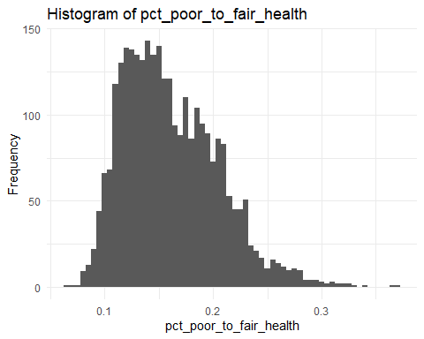

skew_value <- skewness(  
 qol_data$pct_poor_to_fair_health,  
 na.rm = TRUE  
 )  
  
print(skew_value)

## [1] 0.731473

# data is right skewed

# Create histogram plot of population density  
ggplot(data = qol_data, aes(x = population_density)) +  
 geom_histogram(binwidth = 50, fill = "skyblue", color = "black") +  
 labs(title = "Histogram of Population Density",  
 x = "Population Density",  
 y = "Frequency") +  
 theme_minimal()

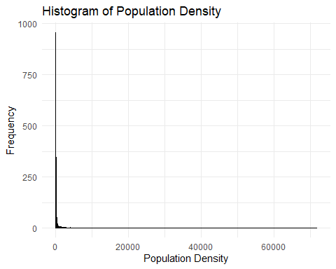

summary(qol_data$population_density)

## Min. 1st Qu. Median Mean 3rd Qu. Max.   
## 0.44 18.76 45.70 213.44 115.72 71895.54

skew_value <- skewness(  
 qol_data$population_density,  
 na.rm = TRUE  
 )  
  
print(skew_value)

## [1] 39.54178

response_data <- qol_data %>%   
 select(  
 pct_poor_to_fair_health,  
 weighted_population  
 ) %>%   
 mutate(  
 weighted_response = pct_poor_to_fair_health * weighted_population  
 )  
  
ggplot(response_data, aes(x = weighted_response)) +  
 geom_histogram(binwidth = 10000) +  
 ggtitle("Histogram of Weighted Response") +  
 xlab("Weighted Response") +  
 ylab("Frequency") +  
 theme_minimal()

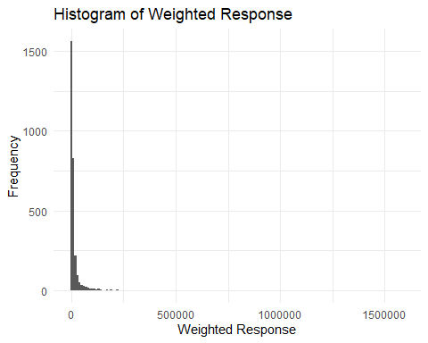

skew_value <- skewness(  
 response_data$weighted_response,  
 na.rm = TRUE  
 )  
  
print(skew_value)

## [1] 15.47122

# data is still right skewed, failed to correct for skewness

#rm(  
# skew_value,  
# response_data  
#)

median_value <- median(qol_data$pct_poor_to_fair_health, na.rm = TRUE)  
  
median_value

## [1] 0.154

ggplot(qol_data,  
 aes(x = "",  
 y = pct_poor_to_fair_health)) +  
 geom_boxplot() +  
 geom_segment(  
 aes(x = 0.625,  
 xend = 1.375,  
 y = 0.12,  
 yend = 0.12  
 ),  
 color = "red",  
 size = 1  
 ) +  
 annotate(  
 "text",  
 x = 1,  
 y = 0.12,  
 label = "CHR US Value = 0.12",  
 color = "red",  
 vjust = -1  
 ) +  
 annotate(  
 "text",  
 x = 1,  
 y = median_value,  
 label = paste(  
 "Median =",  
 round(median_value, 2)  
 ),  
 color = "black",  
 vjust = -1,  
 hjust = -0.1  
 ) +  
 labs(  
 y = "Percentage of Poor to Fair Health",  
 x = "") +  
 theme_minimal()

## Warning: Using `size` aesthetic for lines was deprecated in ggplot2 3.4.0.  
## ℹ Please use `linewidth` instead.  
## This warning is displayed once every 8 hours.  
## Call `lifecycle::last_lifecycle_warnings()` to see where this warning was  
## generated.

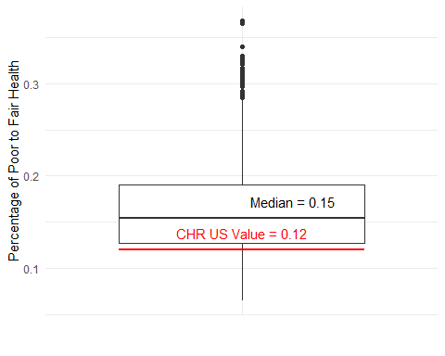

# use new median value as it is representative of data in model and not the total us value

qol_data <- qol_data %>%   
 mutate(response = ifelse(  
 pct_poor_to_fair_health >= median_value,  
 "worse",  
 "better")  
 )

*Create groups of interest*

# qol dataset grouped by median values  
qol_state_median <- qol_data %>%  
 group_by(state) %>%  
 summarize(across(where(is.numeric), median, na.rm = TRUE))

## Warning: There was 1 warning in `summarize()`.  
## ℹ In argument: `across(where(is.numeric), median, na.rm = TRUE)`.  
## ℹ In group 1: `state = Alabama`.  
## Caused by warning:  
## ! The `...` argument of `across()` is deprecated as of dplyr 1.1.0.  
## Supply arguments directly to `.fns` through an anonymous function instead.  
##   
## # Previously  
## across(a:b, mean, na.rm = TRUE)  
##   
## # Now  
## across(a:b, \(x) mean(x, na.rm = TRUE))

# qol dataset grouped by mean values  
qol_state_mean <- qol_data %>%  
 group_by(state) %>%  
 summarize(across(where(is.numeric), mean, na.rm = TRUE))

# check for NA  
sum(is.na(qol_data$weighted_population))

## [1] 0

# list of race variables  
race_vars <- c(  
 "pct_native_american",  
 "pct_asian",  
 "pct_black",  
 "pct_hispanic",  
 "pct_other_race",  
 "pct_white"  
 )  
  
# create longer table with race as a column  
qol_data_long <- qol_data %>%  
 pivot_longer(  
 cols = all_of(race_vars),  
 names_to = "race",  
 values_to = "percentage"  
 ) %>%  
 mutate(race = case_when(  
 race == "pct_native_american" ~ "native_american",  
 race == "pct_asian" ~ "asian",  
 race == "pct_black" ~ "black",  
 race == "pct_hispanic" ~ "hispanic",  
 race == "pct_other_race" ~ "other",  
 race == "pct_white" ~ "white",  
 TRUE ~ race  
 )) %>%   
 select(  
 race,  
 region,  
 percentage,  
 pct_poor_to_fair_health,  
 life_expectancy_years,  
 pct_voters,  
 weighted_population  
 )  
  
# new data frames by filtering for individual races  
qol_data_na <- qol_data_long %>%  
 filter(race == "native_american")  
  
qol_data_asian <- qol_data_long %>%  
 filter(race == "asian")  
  
qol_data_black <- qol_data_long %>%  
 filter(race == "black")  
  
qol_data_hispanic <- qol_data_long %>%  
 filter(race == "hispanic")  
  
qol_data_white <- qol_data_long %>%  
 filter(race == "white")  
  
qol_data_other <- qol_data_long %>%  
 filter(race == "other")

*Explore individual features*

# Reorder states by median pct_poor_to_fair_health  
qol_state_median <- qol_state_median %>%  
 mutate(state = forcats::fct_reorder(  
 state,  
 pct_poor_to_fair_health,  
 .desc = TRUE))  
  
# Create the bar plot with vertically rotated labels and percent y-axis  
ggplot(data = qol_state_median,  
 aes(x = state, y = pct_poor_to_fair_health)) +  
 geom_bar(stat = "identity") +  
 scale_y_continuous(labels = percent_format(scale = 100)) +  
 labs(  
 title = "States by Percent Poor to Fair Health From Worst to Best",  
 x = "State",   
 y = "Percent Reporting Poor to Fair Health"  
 ) +  
 theme_minimal() +  
 theme(axis.text.x = element_text(angle = 60, hjust = 1))

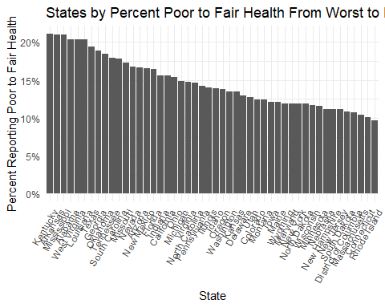

# Reorder states by median pct_poor_to_fair_health  
qol_state_median <- qol_state_median %>%  
 mutate(state = forcats::fct_reorder(  
 state,  
 life_expectancy_years,  
 .desc = FALSE))  
  
# Create the bar plot with vertically rotated labels and percent y-axis  
ggplot(data = qol_state_median,  
 aes(x = state, y = life_expectancy_years)) +  
 geom_bar(stat = "identity") +  
 labs(title = "States by Life Expectany From Worst to Best",  
 x = "State",   
 y = "Life Expectancy in Years") +  
 theme_minimal() +  
 theme(axis.text.x = element_text(angle = 60, hjust = 1))

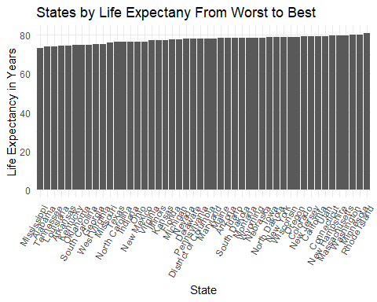

#rm(  
# qol_state_median,  
# qol_state_mean  
# )

# Remove rows with missing values in pct_poor_to_fair_health  
#qol_data_clean <- qol_data %>%  
# filter(!is.na(pct_poor_to_fair_health))  
  
# Arrange qol_data by pct_poor_to_fair_health  
qol_data_sorted <- qol_data %>%  
 arrange(pct_poor_to_fair_health)  
  
# Select top 10 and bottom 10 counties  
top_bottom_counties <- qol_data_sorted %>%  
 dplyr::slice(c(1:10, (n() - 9):n())) # Select first 10 and last 10 rows

# Plotting the bar chart with formatted labels  
ggplot(top_bottom_counties, aes(x = reorder(paste(county, state, sep = ", "), pct_poor_to_fair_health), y = pct_poor_to_fair_health)) +  
 geom_bar(stat = "identity") +  
 scale_y_continuous(labels = scales::percent_format(scale = 100)) +  
 labs(title = "Top and Bottom Counties by Percent Poor to Fair Health",  
 x = "County, State",  
 y = "Percent Reporting Poor to Fair Health") +  
 theme_minimal() +  
 theme(axis.text.x = element_text(angle = 60, hjust = 1))

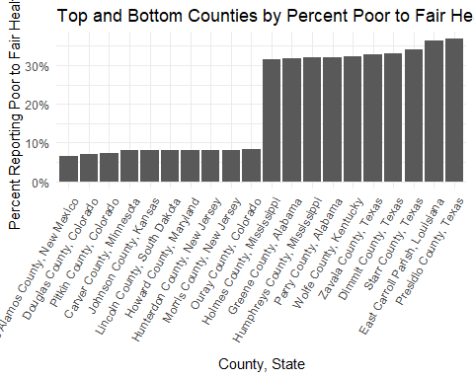

# Create the scatter plot with x-axis limit, percentage formatting, and state labels  
ggplot(data = qol_data,  
 aes(x = pct_voters, y = pct_poor_to_fair_health)) +  
 geom_point() +  
 #geom_text(aes(label = state), hjust = 1.2, vjust = 0.5, size = 2) + # Add state labels  
 scale_y_continuous(labels = percent_format(scale = 100)) +  
 scale_x_continuous(labels = percent_format(scale = 100), limits = c(0.5, 0.81)) +  
 labs(title = "Percent Poor to Fair Health From Worst to Best Vs Voters",  
 x = "Percent Voters",   
 y = "Percent Reporting Poor to Fair Health")

## Warning: Removed 300 rows containing missing values (`geom_point()`).

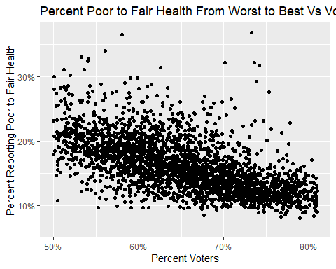

# Create the scatter plot with x-axis limit, percentage formatting, and state labels  
ggplot(data = qol_data,  
 aes(x = school_funding_gap, y = pct_poor_to_fair_health)) +  
 geom_point() +  
 # geom_text(aes(label = state), hjust = 1.2, vjust = 0.5, size = 2) + # Add state labels  
 scale_y_continuous(labels = percent_format(scale = 100)) +  
 scale_x_continuous(limits = c(-6000, 13000)) +  
 labs(title = "Percent Poor to Fair Health From Worst to Best Vs Voters",  
 x = "School Funding Gap",   
 y = "Percent Reporting Poor to Fair Health")

## Warning: Removed 273 rows containing missing values (`geom_point()`).

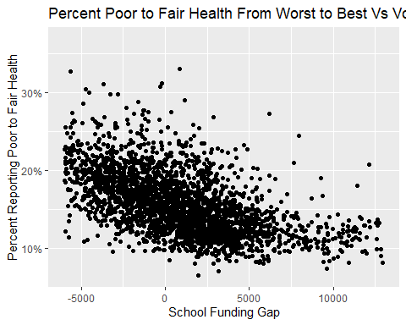

# Create the scatter plot with x-axis limit, percentage formatting, and state labels  
ggplot(data = qol_data,  
 aes(x = pct_poor_to_fair_health, y = life_expectancy_years)) +  
 geom_point() +  
 # scale_y_continuous() +  
 # scale_x_continuous(labels = percent_format(scale = 100), limits = c(0.42,0.80)) +  
 labs(title = "Life Expectancy in Years vs Percent Reporting Poor to Fair Health",  
 x = "Percent Poor to Fair Health",   
 y = "Life Expetancy, Years")

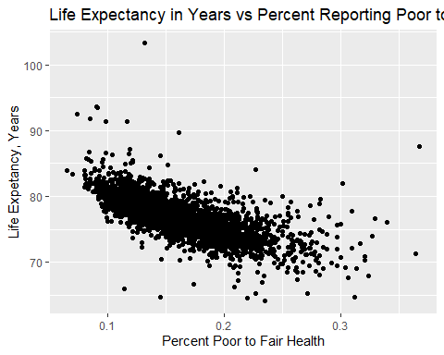

*Exploring community features*

# Comparing important features from the "community aspect domain" of SDOH with the response variable "Percentage of adults reporting poor to fair health per county  
  
# Create a list of features  
features <- c("pct_single_parent", "percent_grandparents_as_guardians",   
 "pct_adult_smokers", "pct_binge_drinkers",   
 "social_clubs_per_10k", "pct_overcrowded_hh", "average_hh_size" )  
  
# Create a plot for each feature  
for (feature in features) {  
 print(  
 ggplot(qol_data, aes_string(x = feature, y = "pct_poor_to_fair_health")) +  
 geom_point(color = "steelblue") +  
 geom_smooth(method = "lm", se = FALSE, color = "red") +  
 labs(title = paste("Scatter Plot of", feature, "Vs 'Poor_To_Fair_Health' Reported Per County"),  
 subtitle = "data from www.ahrq.gov and www.countyhealthrankings.org ",  
 x = feature,  
 y = "Percentage of Poor to Fair Health")  
 )  
}

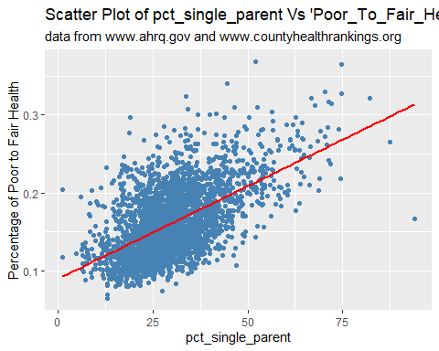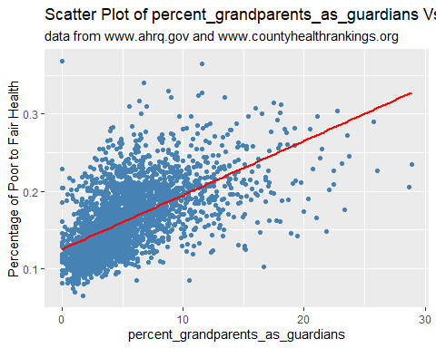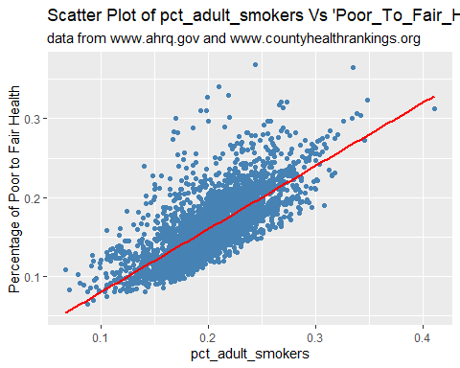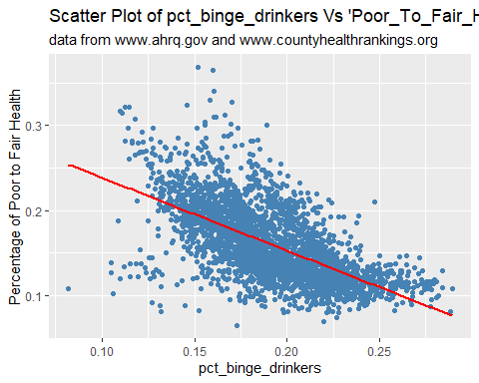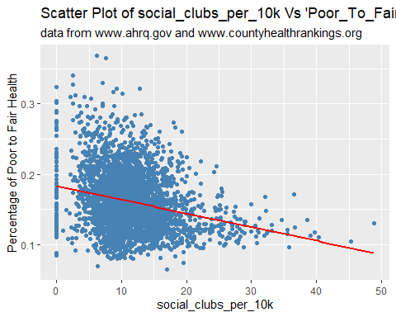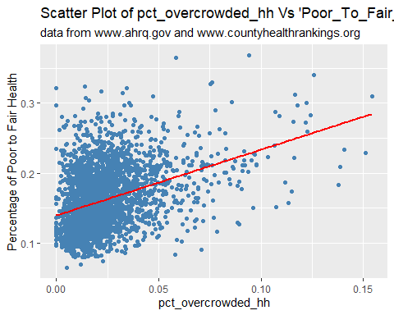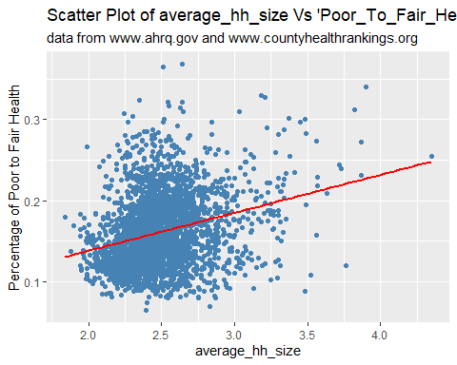

#Exploring the relationship between median household income and health status in US counties along geographical lines by creating heat maps. UO  
  
# Load US counties shapefile  
counties <- tigris::counties(cb = TRUE)

## Retrieving data for the year 2022

## | | | 0% | | | 1% | |= | 1% | |== | 2% | |== | 3% | |=== | 4% | |=== | 5% | |==== | 5% | |==== | 6% | |===== | 6% | |===== | 7% | |===== | 8% | |====== | 8% | |====== | 9% | |======= | 10% | |======== | 11% | |========= | 12% | |========= | 13% | |========== | 14% | |========== | 15% | |=========== | 16% | |============ | 17% | |============ | 18% | |============= | 18% | |============= | 19% | |============== | 20% | |============== | 21% | |=============== | 21% | |=============== | 22% | |================ | 23% | |================= | 24% | |================= | 25% | |================== | 25% | |================== | 26% | |=================== | 27% | |=================== | 28% | |==================== | 28% | |==================== | 29% | |===================== | 29% | |===================== | 30% | |====================== | 31% | |====================== | 32% | |======================= | 32% | |======================= | 33% | |======================== | 34% | |======================== | 35% | |========================= | 35% | |========================= | 36% | |========================== | 37% | |=========================== | 39% | |============================ | 39% | |============================ | 40% | |============================ | 41% | |============================= | 41% | |============================= | 42% | |============================== | 43% | |============================== | 44% | |=============================== | 44% | |================================ | 45% | |================================ | 46% | |================================= | 48% | |================================== | 48% | |================================== | 49% | |=================================== | 49% | |=================================== | 50% | |==================================== | 51% | |==================================== | 52% | |===================================== | 53% | |====================================== | 54% | |========================================= | 58% | |========================================= | 59% | |========================================== | 60% | |=========================================== | 61% | |=========================================== | 62% | |============================================ | 63% | |============================================ | 64% | |============================================= | 64% | |============================================== | 66% | |=============================================== | 67% | |=============================================== | 68% | |================================================ | 68% | |================================================ | 69% | |================================================= | 70% | |================================================== | 71% | |================================================== | 72% | |=================================================== | 72% | |=================================================== | 73% | |==================================================== | 74% | |==================================================== | 75% | |===================================================== | 75% | |===================================================== | 76% | |====================================================== | 77% | |====================================================== | 78% | |======================================================= | 78% | |======================================================= | 79% | |======================================================== | 80% | |========================================================= | 81% | |========================================================== | 82% | |========================================================== | 83% | |=========================================================== | 85% | |============================================================ | 85% | |============================================================ | 86% | |============================================================= | 87% | |============================================================= | 88% | |============================================================== | 88% | |============================================================== | 89% | |================================================================ | 91% | |================================================================ | 92% | |================================================================= | 92% | |================================================================== | 94% | |=================================================================== | 96% | |==================================================================== | 96% | |==================================================================== | 97% | |==================================================================== | 98% | |===================================================================== | 98% | |======================================================================| 100%

# add 0's to fips code  
qol_data$fips_code <- sprintf("%05d", qol_data$fips_code)  
  
  
# Ensure fips_code is a character  
qol_data$fips_code <- as.character(qol_data$fips_code)  
  
# Merge shapefile with qol_data  
counties <- counties %>%  
 left_join(qol_data, by = c("GEOID" = "fips_code"))  
  
# Set plot size  
#options(repr.plot.width = 10, repr.plot.height = 8)  
  
# Create map for Percentage of Poor to Fair Health  
ggplot(data = counties) +  
 geom_sf(aes(fill = pct_poor_to_fair_health), color = NA) +  
 scale_fill_viridis_c(option = "plasma") +  
 labs(title = "Percentage of Poor to Fair Health by County",  
 fill = "Pct Poor to Fair Health") +  
 coord_sf(xlim = c(-125, -66), ylim = c(24, 50), expand = FALSE) +  
 theme_minimal()

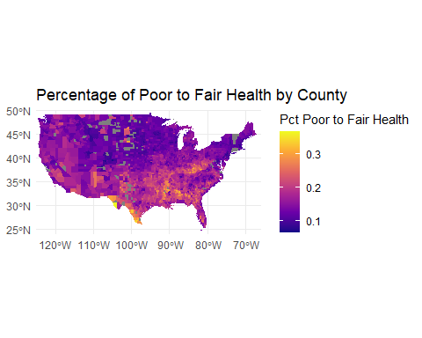

# Create map for Median Household income  
ggplot(data = counties) +  
 geom_sf(aes(fill = median_hh_income.x), color = NA) +  
 scale_fill_viridis_c(option = "plasma") +  
 labs(title = "Median Household Income by County",  
 fill = "Median Household Income") +  
 coord_sf(xlim = c(-125, -66), ylim = c(24, 50), expand = FALSE) +  
 theme_minimal()

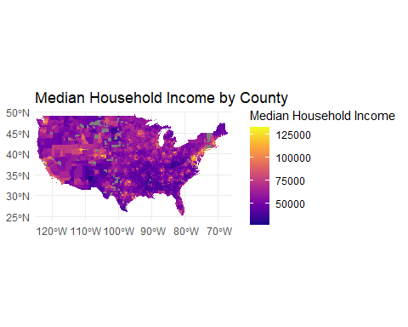

# Create faceted plot  
ggplot(qol_data_long, aes(x = percentage, y = pct_poor_to_fair_health)) +  
 geom_point(color = "steelblue") +  
 geom_smooth(method = "lm", se = FALSE, color = "red") +  
 facet_wrap(~race, scales = "free_x") +  
 labs(title = "Quality of Life by race in US Counties",  
 x = "Percentage of Race",  
 y = "Percentage of Poor to Fair Health")

## `geom_smooth()` using formula = 'y ~ x'

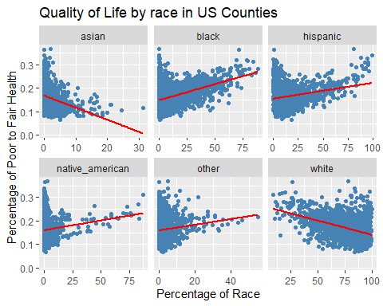

*Exploring education, economic, and local environment features*

data_mg <- qol_data %>%  
 select(  
 "pct_hh_inc_99999",  
 "pct_employed",  
 "inequality_ratio",  
 "pct_high_housing_costs",   
 "pct_30_min_plus_commute",  
 "pct_hh_other_computer",  
 "pct_hh_internet",  
 "median_hh_income.x",  
 "pct_highschool_diploma",  
 "school_funding_gap",  
 "population_density",  
 "days_over_90_f",  
 "air_polution_metric",  
 "water_quality",  
 "pct_poor_to_fair_health"  
 )  
  
sum(is.na(data_mg))

## [1] 0

summary(data_mg)

## pct_hh_inc_99999 pct_employed inequality_ratio pct_high_housing_costs  
## Min. :13.50 Min. : 69.61 Min. : 2.773 Min. :0.02103   
## 1st Qu.:28.61 1st Qu.: 93.67 1st Qu.: 4.002 1st Qu.:0.07982   
## Median :31.49 Median : 95.10 Median : 4.409 Median :0.09764   
## Mean :31.13 Mean : 94.79 Mean : 4.537 Mean :0.10150   
## 3rd Qu.:33.94 3rd Qu.: 96.32 3rd Qu.: 4.937 3rd Qu.:0.11909   
## Max. :47.18 Max. :100.00 Max. :11.128 Max. :0.24733   
## pct_30_min_plus_commute pct_hh_other_computer pct_hh_internet  
## Min. :0.0000 Min. : 0.000 Min. :41.38   
## 1st Qu.:0.2360 1st Qu.: 1.295 1st Qu.:74.60   
## Median :0.3250 Median : 1.830 Median :80.13   
## Mean :0.3311 Mean : 2.110 Mean :78.98   
## 3rd Qu.:0.4185 3rd Qu.: 2.470 3rd Qu.:84.43   
## Max. :0.7840 Max. :17.850 Max. :96.81   
## median_hh_income.x pct_highschool_diploma school_funding_gap  
## Min. : 25997 Min. :0.4967 Min. :-18852.8   
## 1st Qu.: 47731 1st Qu.:0.8462 1st Qu.: -2420.8   
## Median : 55010 Median :0.8914 Median : 441.6   
## Mean : 57130 Mean :0.8785 Mean : 247.0   
## 3rd Qu.: 63763 3rd Qu.:0.9215 3rd Qu.: 2866.0   
## Max. :132509 Max. :0.9862 Max. : 27719.2   
## population_density days_over_90_f air_polution_metric water_quality   
## Min. : 0.44 Min. : 0.00 Min. : 0.900 Min. :0.0000   
## 1st Qu.: 18.75 1st Qu.: 25.00 1st Qu.: 6.600 1st Qu.:0.0000   
## Median : 45.70 Median : 55.00 Median : 7.800 Median :0.0000   
## Mean : 213.44 Mean : 55.98 Mean : 7.615 Mean :0.3425   
## 3rd Qu.: 115.72 3rd Qu.: 87.00 3rd Qu.: 8.900 3rd Qu.:1.0000   
## Max. :71895.54 Max. :144.00 Max. :15.600 Max. :1.0000   
## pct_poor_to_fair_health  
## Min. :0.0650   
## 1st Qu.:0.1270   
## Median :0.1540   
## Mean :0.1613   
## 3rd Qu.:0.1900   
## Max. :0.3680

variables <- c(  
 "pct_hh_inc_99999",  
 "pct_employed",  
 "inequality_ratio",  
 "pct_high_housing_costs",  
 "pct_30_min_plus_commute",  
 "pct_hh_other_computer",  
 "pct_hh_internet",  
 "median_hh_income.x",  
 "pct_highschool_diploma",  
 "school_funding_gap",  
 "population_density",  
 "days_over_90_f",  
 "air_polution_metric",  
 "water_quality",  
 "pct_poor_to_fair_health"  
)  
  
mg_sum_stats <- function(data, vars) {  
 summary_stats <- data %>%  
 select(all_of(vars)) %>%  
 summarise(across(everything(), list(  
 mean = ~mean(. , na.rm = TRUE),  
 median = ~median(. , na.rm = TRUE),  
 sd = ~sd(. , na.rm = TRUE),  
 min = ~min(. , na.rm = TRUE),  
 max = ~max(. , na.rm = TRUE)  
 )))  
 return(summary_stats)  
}  
  
summary_stats <- mg_sum_stats(data_mg, variables)  
  
summary_matrix <- matrix(ncol = length(variables), nrow = 5)  
colnames(summary_matrix) <- variables  
rownames(summary_matrix) <- c("Mean", "Median", "sd", "Min", "Max")  
  
for (i in 1:length(variables)) {  
 summary_matrix[1, i] <- summary_stats[[paste0(variables[i], "_mean")]]  
 summary_matrix[2, i] <- summary_stats[[paste0(variables[i], "_median")]]  
 summary_matrix[3, i] <- summary_stats[[paste0(variables[i], "_sd")]]  
 summary_matrix[4, i] <- summary_stats[[paste0(variables[i], "_min")]]  
 summary_matrix[5, i] <- summary_stats[[paste0(variables[i], "_max")]]  
}  
  
mg_summary_matrix <- round(summary_matrix, 3)  
print(mg_summary_matrix)

## pct_hh_inc_99999 pct_employed inequality_ratio pct_high_housing_costs  
## Mean 31.129 94.787 4.537 0.101  
## Median 31.490 95.100 4.409 0.098  
## sd 4.245 2.453 0.787 0.032  
## Min 13.500 69.610 2.773 0.021  
## Max 47.180 100.000 11.128 0.247  
## pct_30_min_plus_commute pct_hh_other_computer pct_hh_internet  
## Mean 0.331 2.11 78.976  
## Median 0.325 1.83 80.130  
## sd 0.125 1.57 8.033  
## Min 0.000 0.00 41.380  
## Max 0.784 17.85 96.810  
## median_hh_income.x pct_highschool_diploma school_funding_gap  
## Mean 57130.43 0.878 247.028  
## Median 55010.00 0.891 441.583  
## sd 13978.53 0.058 4726.185  
## Min 25997.00 0.497 -18852.820  
## Max 132509.00 0.986 27719.240  
## population_density days_over_90_f air_polution_metric water_quality  
## Mean 213.439 55.982 7.615 0.342  
## Median 45.700 55.000 7.800 0.000  
## sd 1480.657 38.088 1.672 0.475  
## Min 0.440 0.000 0.900 0.000  
## Max 71895.540 144.000 15.600 1.000  
## pct_poor_to_fair_health  
## Mean 0.161  
## Median 0.154  
## sd 0.044  
## Min 0.065  
## Max 0.368

data_mg_part1 <- data_mg %>%  
 select("pct_hh_inc_99999", "pct_employed", "inequality_ratio", "pct_high_housing_costs", "pct_30_min_plus_commute", "pct_hh_other_computer", "pct_hh_internet", "pct_poor_to_fair_health")  
  
data_mg_part2 <- data_mg %>%  
 select("median_hh_income.x", "pct_highschool_diploma", "school_funding_gap", "population_density", "days_over_90_f", "air_polution_metric", "water_quality", "pct_poor_to_fair_health")  
  
pairs(data_mg_part1, main = "Pairwise Scatterplots of Variables (Part 1)")

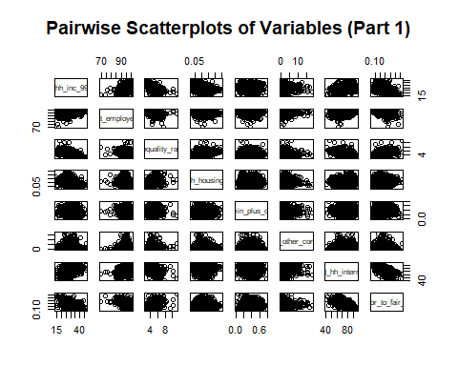

pairs(data_mg_part2, main = "Pairwise Scatterplots of Variables (Part 2)")

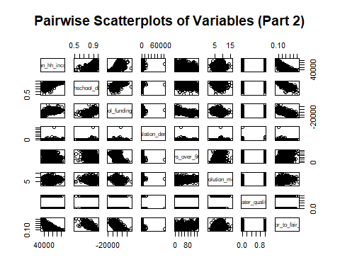

ggplot(data_mg, aes(x = pct_poor_to_fair_health, y = median_hh_income.x)) +  
 geom_point() +  
 geom_smooth(method = "lm", col = "red") +  
 labs(title = "Scatterplot of Percentage of Poor to Fair Health vs. Median Household Income",  
 x = "Percentage of Poor to Fair Health (Higher number is worse)",  
 y = "Median Household Income") +  
 theme_minimal()

## `geom_smooth()` using formula = 'y ~ x'

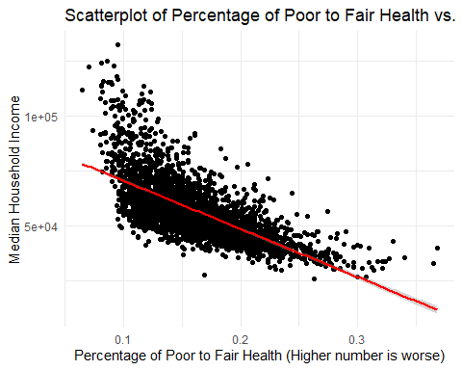

ggplot(data_mg, aes(x = school_funding_gap, y = pct_poor_to_fair_health)) +  
 geom_point() +  
 geom_smooth(method = "lm", col = "red") +  
 labs(title = "Scatterplot of Percentage of Poor to Fair Health vs. School Funding Gap",  
 x = "School Funding Gap",  
 y = "Percentage of Poor to Fair Health") +  
 theme_minimal()

## `geom_smooth()` using formula = 'y ~ x'

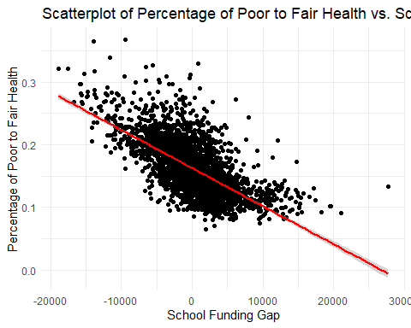

*Table creation for EDA*

# list of races  
df_race_list <- c("asian", "black", "hispanic", "native_american", "other", "white")  
  
# list of features to evaluate  
feature_list <- c("pct_poor_to_fair_health", "life_expectancy_years", "pct_voters")  
  
# function  
race_stats_calc <- function(data, race_list, feature_list) {  
 # create list to fill  
 results <- list()  
 # iterate over race list  
 for (race in race_list) {  
 filtered_data <- data %>%  
 filter(race == !!race)  
   
 stats <- filtered_data %>%  
 summarise(across(all_of(feature_list), list(  
 Mean = ~mean(.),  
 Median = ~median(.),  
 SD = ~sd(.),  
 Kurtosis = ~kurtosis(.),  
 Skewness = ~skewness(.)  
 ), .names = "{fn}_{col}"))  
   
 results[[race]] <- stats  
 }  
   
 combined_results <- bind_rows(results, .id = "race")  
   
 return(combined_results)  
}

statistic_table <- race_stats_calc(data = qol_data_long,  
 race = df_race_list,  
 feature = feature_list)  
  
statistic_table

## # A tibble: 6 × 16  
## race Mean_pct_poor_to_fai…¹ Median_pct_poor_to_f…² SD_pct_poor_to_fair_…³  
## <chr> <dbl> <dbl> <dbl>  
## 1 asian 0.161 0.154 0.0440  
## 2 black 0.161 0.154 0.0440  
## 3 hispanic 0.161 0.154 0.0440  
## 4 native_a… 0.161 0.154 0.0440  
## 5 other 0.161 0.154 0.0440  
## 6 white 0.161 0.154 0.0440  
## # ℹ abbreviated names: ¹​Mean_pct_poor_to_fair_health,  
## # ²​Median_pct_poor_to_fair_health, ³​SD_pct_poor_to_fair_health  
## # ℹ 12 more variables: Kurtosis_pct_poor_to_fair_health <dbl>,  
## # Skewness_pct_poor_to_fair_health <dbl>, Mean_life_expectancy_years <dbl>,  
## # Median_life_expectancy_years <dbl>, SD_life_expectancy_years <dbl>,  
## # Kurtosis_life_expectancy_years <dbl>, Skewness_life_expectancy_years <dbl>,  
## # Mean_pct_voters <dbl>, Median_pct_voters <dbl>, SD_pct_voters <dbl>, …

# Create the summary table  
summary_table <- tbl_summary(  
 data = qol_data_long,  
 include = c(pct_poor_to_fair_health, life_expectancy_years, pct_voters),  
 by = race,  
 statistic = list(  
 all_continuous() ~ "{median} ({sd})",  
 all_dichotomous() ~ "{p}%"  
 ),  
 missing = "no"  
)  
  
# Print the summary table  
summary_table

| **Characteristic** | **asian** N = 2,955*1* | **black** N = 2,955*1* | **hispanic** N = 2,955*1* | **native_american** N = 2,955*1* | **other** N = 2,955*1* | **white** N = 2,955*1* |
| --- | --- | --- | --- | --- | --- | --- |
| pct_poor_to_fair_health | 0.15 (0.04) | 0.15 (0.04) | 0.15 (0.04) | 0.15 (0.04) | 0.15 (0.04) | 0.15 (0.04) |
| life_expectancy_years | 76.89 (3.08) | 76.89 (3.08) | 76.89 (3.08) | 76.89 (3.08) | 76.89 (3.08) | 76.89 (3.08) |
| pct_voters | 0.66 (0.10) | 0.66 (0.10) | 0.66 (0.10) | 0.66 (0.10) | 0.66 (0.10) | 0.66 (0.10) |
| *1*Median (SD) | | | | | | |

# explore individual race variables  
summary_table_black <- tbl_summary(  
 data = qol_data_black,  
 include = c(pct_poor_to_fair_health, life_expectancy_years, pct_voters),  
 by = race,  
 statistic = list(  
 all_continuous() ~ "{mean} ({sd})",  
 all_dichotomous() ~ "{p}%"  
 ),  
 missing = "no"  
)  
  
# Print the summary table  
summary_table_black

| **Characteristic** | **black** N = 2,955*1* |
| --- | --- |
| pct_poor_to_fair_health | 0.16 (0.04) |
| life_expectancy_years | 76.84 (3.08) |
| pct_voters | 0.65 (0.10) |
| *1*Mean (SD) | |

summary_table_white <- tbl_summary(  
 data = qol_data_white,  
 include = c(pct_poor_to_fair_health, life_expectancy_years, pct_voters),  
 by = race,  
 statistic = list(  
 all_continuous() ~ "{mean} ({sd})",  
 all_dichotomous() ~ "{p}%"  
 ),  
 missing = "no"  
)  
  
# Print the summary table  
summary_table_white

| **Characteristic** | **white** N = 2,955*1* |
| --- | --- |
| pct_poor_to_fair_health | 0.16 (0.04) |
| life_expectancy_years | 76.84 (3.08) |
| pct_voters | 0.65 (0.10) |
| *1*Mean (SD) | |

# all values same for all races, although percentagers of each race different in county, all feature values reported as the same

qol_data_long$population_of_race <- qol_data_long$percentage/100  
qol_data_long$pct_poor_to_fair_health <- qol_data_long$pct_poor_to_fair_health * qol_data_long$percentage  
qol_data_long$life_expectancy_years <- qol_data_long$life_expectancy_years * qol_data_long$percentage  
qol_data_long$pct_voters <-qol_data_long$pct_voters * qol_data_long$percentage  
  
statistic_table <- race_stats_calc(data = qol_data_long,  
 race = df_race_list,  
 feature = feature_list)  
  
statistic_table

## # A tibble: 6 × 16  
## race Mean_pct_poor_to_fai…¹ Median_pct_poor_to_f…² SD_pct_poor_to_fair_…³  
## <chr> <dbl> <dbl> <dbl>  
## 1 asian 0.182 0.0994 0.274  
## 2 black 1.75 0.369 3.29   
## 3 hispanic 1.68 0.645 3.14   
## 4 native_a… 0.296 0.0498 1.40   
## 5 other 0.374 0.156 0.742  
## 6 white 13.0 12.5 3.64   
## # ℹ abbreviated names: ¹​Mean_pct_poor_to_fair_health,  
## # ²​Median_pct_poor_to_fair_health, ³​SD_pct_poor_to_fair_health  
## # ℹ 12 more variables: Kurtosis_pct_poor_to_fair_health <dbl>,  
## # Skewness_pct_poor_to_fair_health <dbl>, Mean_life_expectancy_years <dbl>,  
## # Median_life_expectancy_years <dbl>, SD_life_expectancy_years <dbl>,  
## # Kurtosis_life_expectancy_years <dbl>, Skewness_life_expectancy_years <dbl>,  
## # Mean_pct_voters <dbl>, Median_pct_voters <dbl>, SD_pct_voters <dbl>, …

# Create the summary table  
summary_table <- tbl_summary(  
 data = qol_data_long,  
 include = c(pct_poor_to_fair_health, life_expectancy_years, pct_voters),  
 by = race,  
 statistic = list(  
 all_continuous() ~ "{median} ({sd})",  
 all_dichotomous() ~ "{p}%"  
 ),  
 missing = "no"  
)  
  
# Print the summary table  
summary_table

| **Characteristic** | **asian** N = 2,955*1* | **black** N = 2,955*1* | **hispanic** N = 2,955*1* | **native_american** N = 2,955*1* | **other** N = 2,955*1* | **white** N = 2,955*1* |
| --- | --- | --- | --- | --- | --- | --- |
| pct_poor_to_fair_health | 0.1 (0.3) | 0.4 (3.3) | 0.6 (3.1) | 0.0 (1.4) | 0.2 (0.7) | 12.5 (3.6) |
| life_expectancy_years | 49 (174) | 184 (1,055) | 334 (1,081) | 25 (443) | 80 (295) | 6,801 (1,301) |
| pct_voters | 0 (2) | 2 (9) | 3 (8) | 0 (3) | 1 (2) | 56 (14) |
| *1*Median (SD) | | | | | | |

# explore individual race variables  
summary_table_white <- tbl_summary(  
 data = qol_data_white,  
 include = c(pct_poor_to_fair_health, life_expectancy_years, pct_voters),  
 by = race,  
 statistic = list(  
 all_continuous() ~ "{mean} ({sd})",  
 all_dichotomous() ~ "{p}%"  
 ),  
 missing = "no"  
)  
  
# Print the summary table  
summary_table_white

| **Characteristic** | **white** N = 2,955*1* |
| --- | --- |
| pct_poor_to_fair_health | 0.16 (0.04) |
| life_expectancy_years | 76.84 (3.08) |
| pct_voters | 0.65 (0.10) |
| *1*Mean (SD) | |

summary_table_black <- tbl_summary(  
 data = qol_data_black,  
 include = c(pct_poor_to_fair_health, life_expectancy_years, pct_voters),  
 by = race,  
 statistic = list(  
 all_continuous() ~ "{mean} ({sd})",  
 all_dichotomous() ~ "{p}%"  
 ),  
 missing = "no"  
)  
  
# Print the summary table  
summary_table_black

| **Characteristic** | **black** N = 2,955*1* |
| --- | --- |
| pct_poor_to_fair_health | 0.16 (0.04) |
| life_expectancy_years | 76.84 (3.08) |
| pct_voters | 0.65 (0.10) |
| *1*Mean (SD) | |

# does not give mean percent of value for race but contribution of each mean race value to total population value  
# unable to extract these values by race, data gives percentage weigthed by county so all races will appear to have same values in each county, but will contribute to total differently. use um plots for best analysis by race

table_1 <- tbl_summary(  
 qol_data,   
 include = c(  
 pct_hh_inc_99999,  
 pct_employed,  
 inequality_ratio,  
 pct_high_housing_costs,  
 pct_30_min_plus_commute,  
 pct_hh_other_computer,  
 pct_hh_internet,  
 median_hh_income.x,  
 pct_highschool_diploma,  
 school_funding_gap,  
 population_density,  
 days_over_90_f,  
 air_polution_metric,  
 water_quality,  
 pct_poor_to_fair_health  
 )  
 )  
  
table_1

| **Characteristic** | **N = 2,955***1* |
| --- | --- |
| pct_hh_inc_99999 | 31.5 (28.6, 33.9) |
| pct_employed | 95.10 (93.67, 96.32) |
| inequality_ratio | 4.41 (4.00, 4.94) |
| pct_high_housing_costs | 0.10 (0.08, 0.12) |
| pct_30_min_plus_commute | 0.33 (0.24, 0.42) |
| pct_hh_other_computer | 1.83 (1.29, 2.47) |
| pct_hh_internet | 80 (75, 84) |
| median_hh_income.x | 55,010 (47,722, 63,785) |
| pct_highschool_diploma | 0.89 (0.85, 0.92) |
| school_funding_gap | 442 (-2,426, 2,870) |
| population_density | 46 (19, 116) |
| days_over_90_f | 55 (25, 87) |
| air_polution_metric | 7.80 (6.60, 8.90) |
| water_quality | 1,012 (34%) |
| pct_poor_to_fair_health | 0.15 (0.13, 0.19) |
| *1*Median (Q1, Q3); n (%) | |

# summary by region  
summary_table_region <- tbl_summary(  
 data = qol_data,  
 include = c(pct_poor_to_fair_health, life_expectancy_years, pct_voters),  
 by = region,  
 statistic = list(  
 all_continuous() ~ "{mean} ({sd}, {kurtosis}, {skewness})",  
 all_dichotomous() ~ "{p}%"  
 ),  
 missing = "no"  
)  
  
# Print the summary table  
summary_table_region

| **Characteristic** | **Midwest** N = 1,018*1* | **Northeast** N = 199*1* | **South** N = 1,354*1* | **West** N = 384*1* |
| --- | --- | --- | --- | --- |
| pct_poor_to_fair_health | 0.14 (0.03, 1.89, 0.95) | 0.12 (0.02, -0.36, 0.15) | 0.19 (0.04, 0.68, 0.41) | 0.14 (0.03, 0.61, 0.60) |
| life_expectancy_years | 77.67 (2.60, 4.64, -0.55) | 78.75 (1.76, 0.00, 0.19) | 75.37 (2.67, 0.77, 0.30) | 78.88 (3.59, 7.85, 1.08) |
| pct_voters | 0.68 (0.08, 0.65, -0.23) | 0.68 (0.08, 0.63, 0.25) | 0.61 (0.09, 0.24, 0.09) | 0.71 (0.10, -0.01, -0.25) |
| *1*Mean (SD, kurtosis, skewness) | | | | |

#rm(  
# counties,  
# data_mg,  
# data_mg_part1,  
# data_mg_part2,  
# mg_summary_matrix,  
# qol_data_asian,  
# qol_data_black,  
# qol_data_hispanic,  
# qol_data_long,  
# qol_data_na,  
# qol_data_other,  
# qol_data_sorted,  
# qol_data_white,  
# statistic_table,  
# summary_table,  
# summary_table_black,  
# summary_table_white,  
# table_1,  
# summary_table_region,  
# summary_matrix,  
# summary_stats,  
# top_bottom_counties,  
# df_race_list,  
# feature,  
# features,  
# feature_list,  
# i,  
# qol_names,  
# race_vars,  
# variables,  
# mg_sum_stats,  
# race_stats_calc  
#)

$$InitialModelBuilds$$

*Data Prep for Model builds*

# Remove features with no analytical value namely Fipscode and county, state and pct_poor_to_fair_health  
qol_data <- qol_data %>%  
 select(  
 -c(fips_code,  
 county,  
 state,  
 pct_poor_to_fair_health)  
 )

calcSplitRatio <- function(p = NA, df) {  
 ## @p = the number of parameters. by default, if none are provided, the number of columns (predictors) in the dataset are used  
 ## @df = the dataframe that will be used for the analysis  
   
 ## If the number of parameters isn't supplied, set it to the number of features minus 1 for the target  
 if(is.na(p)) {  
 p <- ncol(df) -1 ## COMMENT HERE  
 }  
   
 ## Calculate the ideal number of testing set  
 test_N <- (1/sqrt(p))*nrow(df)  
 ## Turn that into a testing proportion  
 test_prop <- round((1/sqrt(p))*nrow(df)/nrow(df), 2)  
 ## And find the training proportion  
 train_prop <- 1-test_prop  
   
 ## Tell us the results!  
 print(paste0("The ideal split ratio is ", train_prop, ":", test_prop, " training:testing"))  
   
 ## Return the size of the training set  
 return(train_prop)  
}  
  
calcSplitRatio(df = qol_data)

## [1] "The ideal split ratio is 0.85:0.15 training:testing"

## [1] 0.85

# Split the data into training and testing sets  
set.seed(123)  
split <- sample(2, nrow(qol_data), replace = TRUE, prob = c(0.86, 0.14))  
qol_train <- qol_data[split == 1, ]  
qol_test <- qol_data[split == 2, ]  
  
# Check the distribution of the response variable in the training and testing sets  
table(qol_train$response)

##   
## better worse   
## 1267 1293

table(qol_test$response)

##   
## better worse   
## 190 205

# Create dummy variables for 'region' in training data  
dummies_train <- dummyVars(~ region, data = qol_train, fullRank = FALSE)  
qol_train_encoded <- predict(dummies_train, newdata = qol_train)  
qol_train <- cbind(qol_train, qol_train_encoded) %>%  
 select(-region) # Remove the original 'region' column  
  
# Create dummy variables for 'region' in test data  
dummies_test <- dummyVars(~ region, data = qol_test, fullRank = FALSE)  
qol_test_encoded <- predict(dummies_test, newdata = qol_test)  
qol_test <- cbind(qol_test, qol_test_encoded) %>%  
 select(-region) # Remove the original 'region' column  
  
# View the transformed training data  
print("Transformed Training Data:")

## [1] "Transformed Training Data:"

print(head(qol_train))

## weighted_population average_hh_size pct_male pct_native_american pct_asian  
## 1 55639 2.55 48.62 0.28 1.17  
## 2 218289 2.56 48.51 0.69 0.93  
## 3 25026 2.37 52.57 0.35 0.49  
## 4 10173 2.84 54.83 0.00 1.35  
## 5 19726 2.92 45.88 0.33 1.32  
## 6 33427 2.42 47.65 0.24 1.10  
## pct_black pct_hispanic pct_other_race pct_white pct_single_parent  
## 1 19.53 2.88 0.67 75.76 27.41  
## 2 8.77 4.56 1.56 85.44 18.10  
## 3 47.67 4.44 3.10 46.30 52.76  
## 4 68.61 8.10 3.13 26.18 50.41  
## 5 44.59 1.47 0.50 51.62 39.55  
## 6 40.00 2.52 0.79 56.89 44.71  
## pct_hh_other_computer pct_hh_internet pct_employed_nonprofit pct_employed  
## 1 1.05 82.80 7.72 97.09  
## 2 1.75 85.52 5.68 96.08  
## 3 2.15 65.00 4.20 93.06  
## 4 1.84 62.79 6.76 96.65  
## 5 5.07 74.31 6.77 93.53  
## 6 1.63 74.84 4.38 96.41  
## pct_hh_inc_99999 pct_w_medicare clinical_nurse_pt dentist_pt pa_pt  
## 1 30.40 6.87 0.02 0.34 0.04  
## 2 30.52 7.27 0.02 0.49 0.17  
## 3 23.63 7.51 0.00 0.37 0.04  
## 4 24.91 5.87 0.00 0.20 0.10  
## 5 25.09 7.49 0.00 0.36 0.00  
## 6 31.75 7.36 0.00 0.21 0.00  
## mental_health_faciliy_pt population_density days_over_90_f median_hh_income.x  
## 1 0.0178 93.60 104 67565  
## 2 0.0174 137.30 97 71135  
## 3 0.0813 28.28 104 38866  
## 4 0.1002 16.33 103 33124  
## 5 0.1538 25.39 103 42268  
## 6 0.0000 56.03 87 39318  
## median_er_dist median_trauma_center_dist median_pediatric_icu_dist  
## 1 2.25 12.07 55.65  
## 2 6.01 25.37 22.62  
## 3 5.58 41.37 63.76  
## 4 4.89 39.11 56.79  
## 5 3.51 39.77 94.42  
## 6 4.67 29.43 4.67  
## median_health_clinic_dist median_drug_alcohol_care_dist  
## 1 9.20 12.24  
## 2 8.57 13.21  
## 3 1.17 35.73  
## 4 1.63 4.89  
## 5 2.83 43.08  
## 6 4.42 23.21  
## percent_grandparents_as_guardians pct_adult_smokers pct_binge_drinkers  
## 1 4.901316 0.183 0.1665626  
## 2 5.961440 0.169 0.1896517  
## 3 11.165644 0.259 0.1342877  
## 4 15.405228 0.255 0.1277270  
## 5 9.496840 0.223 0.1374772  
## 6 14.975107 0.217 0.1507498  
## pct_under_65_no_health_insurance pct_highschool_diploma inequality_ratio  
## 1 0.1055942 0.8958449 4.794400  
## 2 0.1087488 0.9101416 4.300710  
## 3 0.1436828 0.7567102 5.180597  
## 4 0.1236755 0.7760651 6.274395  
## 5 0.1348505 0.8556485 5.335266  
## 6 0.1321949 0.8278154 4.212493  
## social_clubs_per_10k air_polution_metric water_quality pct_high_housing_costs  
## 1 12.645828 10.0 0 0.12635805  
## 2 9.594962 7.6 1 0.10561056  
## 3 9.353776 9.4 1 0.13464346  
## 4 7.016840 9.3 0 0.12785388  
## 5 9.228876 9.1 0 0.09451411  
## 6 18.865054 9.8 0 0.10871873  
## pct_overcrowded_hh pct_30_min_plus_commute life_expectancy_years  
## 1 0.01121757 0.416 76.58565  
## 2 0.01291239 0.376 77.72473  
## 3 0.03852328 0.365 72.86721  
## 4 0.00000000 0.494 73.81468  
## 5 0.01537279 0.347 73.47328  
## 6 0.05278810 0.281 73.76110  
## school_funding_gap pct_voters pct_home_owner pct_rural_population response  
## 1 -2077.1420 0.6618208 16227 0.4200216 worse  
## 2 343.0381 0.6529095 67242 0.4227910 better  
## 3 -13560.4500 0.5402157 5654 0.6778963 worse  
## 4 -15766.8500 0.5906530 2220 0.5137438 worse  
## 5 -9255.5640 0.6291777 4728 0.7123216 worse  
## 6 -11972.6670 0.5852575 9089 0.4914803 worse  
## region.Midwest region.Northeast region.South region.West  
## 1 0 0 1 0  
## 2 0 0 1 0  
## 3 0 0 1 0  
## 4 0 0 1 0  
## 5 0 0 1 0  
## 6 0 0 1 0

# View the transformed test data  
print("Transformed Test Data:")

## [1] "Transformed Test Data:"

print(head(qol_test))

## weighted_population average_hh_size pct_male pct_native_american pct_asian  
## 1 22374 2.85 53.73 0.05 0.25  
## 2 57755 2.70 49.65 0.10 0.41  
## 3 114324 2.50 48.04 0.31 0.81  
## 4 44147 2.55 48.75 1.14 0.44  
## 5 52238 2.59 49.42 1.00 1.61  
## 6 37096 2.43 48.61 0.21 0.66  
## pct_black pct_hispanic pct_other_race pct_white pct_single_parent  
## 1 22.55 2.68 0.04 76.60 32.19  
## 2 1.40 9.28 1.80 93.97 25.75  
## 3 21.16 3.85 1.64 73.30 34.42  
## 4 9.67 7.75 3.56 82.13 34.19  
## 5 17.05 7.68 1.29 74.69 32.20  
## 6 12.69 1.77 0.36 84.27 29.04  
## pct_hh_other_computer pct_hh_internet pct_employed_nonprofit pct_employed  
## 1 0.23 76.17 3.48 92.56  
## 2 2.16 80.03 5.30 94.80  
## 3 2.43 79.97 6.03 92.71  
## 4 1.40 74.92 6.60 93.90  
## 5 2.24 83.18 4.92 94.50  
## 6 11.13 75.93 7.04 92.30  
## pct_hh_inc_99999 pct_w_medicare clinical_nurse_pt dentist_pt pa_pt  
## 1 34.92 7.74 0.00 0.27 0.23  
## 2 28.64 8.81 0.00 0.19 0.00  
## 3 31.39 5.18 0.01 0.68 0.10  
## 4 34.07 5.28 0.00 0.29 0.02  
## 5 31.50 4.30 0.00 0.34 0.04  
## 6 28.68 7.69 0.00 0.38 0.08  
## mental_health_faciliy_pt population_density days_over_90_f median_hh_income.x  
## 1 0.0000 35.94 97 50907  
## 2 0.0173 89.56 80 55203  
## 3 0.0353 188.69 84 50259  
## 4 0.0225 63.72 94 52693  
## 5 0.0188 76.94 105 54203  
## 6 0.0812 36.00 107 43544  
## median_er_dist median_trauma_center_dist median_pediatric_icu_dist  
## 1 8.44 26.40 21.97  
## 2 10.56 26.16 52.24  
## 3 3.51 24.79 45.01  
## 4 7.27 31.37 28.36  
## 5 2.74 23.44 44.21  
## 6 1.86 12.59 61.42  
## median_health_clinic_dist median_drug_alcohol_care_dist  
## 1 3.85 26.48  
## 2 3.91 25.22  
## 3 4.08 15.30  
## 4 3.51 30.65  
## 5 4.12 29.84  
## 6 1.86 54.17  
## percent_grandparents_as_guardians pct_adult_smokers pct_binge_drinkers  
## 1 12.543648 0.228 0.1591628  
## 2 6.226566 0.218 0.1631069  
## 3 5.798538 0.210 0.1618824  
## 4 4.091697 0.221 0.1637214  
## 5 4.730133 0.196 0.1525075  
## 6 8.664498 0.214 0.1538523  
## pct_under_65_no_health_insurance pct_highschool_diploma inequality_ratio  
## 1 0.1300788 0.8053808 5.034985  
## 2 0.1325467 0.8364808 4.803718  
## 3 0.1292500 0.8521486 4.819868  
## 4 0.1526298 0.8176132 4.131532  
## 5 0.1369450 0.8635622 4.790742  
## 6 0.1209324 0.8518224 5.483394  
## social_clubs_per_10k air_polution_metric water_quality pct_high_housing_costs  
## 1 9.035056 9.8 0 0.07985348  
## 2 6.738195 9.6 0 0.07380601  
## 3 13.395729 9.7 0 0.09838489  
## 4 14.865869 9.9 0 0.11185830  
## 5 12.586887 9.1 0 0.07904374  
## 6 11.643650 9.1 0 0.09875173  
## pct_overcrowded_hh pct_30_min_plus_commute life_expectancy_years  
## 1 0.01161103 0.551 73.60936  
## 2 0.01798993 0.595 74.17146  
## 3 0.01681426 0.300 72.82501  
## 4 0.02983752 0.508 74.39108  
## 5 0.01756587 0.308 75.26854  
## 6 0.02121212 0.279 72.91764  
## school_funding_gap pct_voters pct_home_owner pct_rural_population response  
## 1 -2659.8410 0.5456355 5580 0.6835261 worse  
## 2 -889.3883 0.6418799 16865 0.8995150 worse  
## 3 -4113.4269 0.5785633 31441 0.3369683 worse  
## 4 -1903.9890 0.5950693 12221 0.8674472 worse  
## 5 -2322.7189 0.5721074 14153 0.4719508 worse  
## 6 -4510.3738 0.6034274 10681 0.6965179 worse  
## region.Midwest region.Northeast region.South region.West  
## 1 0 0 1 0  
## 2 0 0 1 0  
## 3 0 0 1 0  
## 4 0 0 1 0  
## 5 0 0 1 0  
## 6 0 0 1 0

# Encode response variable as 1 and 0. (1 if worse than national median and 0 if better than national median) and convert to factor  
  
#encode response variable in training set  
qol_train <- qol_train %>%  
 mutate(response = ifelse(response == "better", 0, 1))  
table(qol_data$response)

##   
## better worse   
## 1457 1498

# Convert response variable to factor   
qol_train$response <- as.factor(qol_train$response)  
  
#encode response variable in testing set  
qol_test <- qol_test %>%  
 mutate(response = ifelse(response == "better", 0, 1))  
table(qol_test$response)

##   
## 0 1   
## 190 205

# Convert response variable to factor   
qol_test$response <- as.factor(qol_test$response)

#Handling missing values; identifying and imputing missing characters  
  
# Count missing values in the train set  
total_missing <- sum(is.na(qol_train))  
print(paste("Total missing values in dataframe:", total_missing))

## [1] "Total missing values in dataframe: 0"

# Count missing values in the test set  
total_missing <- sum(is.na(qol_train))  
print(paste("Total missing values in dataframe:", total_missing))

## [1] "Total missing values in dataframe: 0"

#To determine if there are unwanted characters and whitespace and make corrections:  
#We print a sample of the data for visual inspection.  
#We use regular expressions to detect unwanted characters in text columns.  
#We check for leading, trailing, or excessive whitespace in text columns.  
  
# Visual inspection  
#print(head(qol_train))  
  
# Detect unwanted characters using regular expressions  
unwanted_chars <- function(x) {  
 if (is.character(x)) {  
 return(grepl("[^[:alnum:][:space:]]", x))  
 } else {  
 return(FALSE)  
 }  
}  
  
# Apply the function to each column qol_train  
unwanted_chars_results <- sapply(qol_train, function(col) sum(unwanted_chars(col)))  
print("Number of unwanted characters in each column:")

## [1] "Number of unwanted characters in each column:"

#print(unwanted_chars_results)  
  
# Apply the function to each column qol_test  
unwanted_chars_results <- sapply(qol_train, function(col) sum(unwanted_chars(col)))  
print("Number of unwanted characters in each column:")

## [1] "Number of unwanted characters in each column:"

#print(unwanted_chars_results)  
  
  
  
# Detect leading, trailing, or excessive whitespace  
whitespace_check <- function(x) {  
 if (is.character(x)) {  
 return(grepl("^\\s+|\\s+$|\\s{2,}", x))  
 } else {  
 return(FALSE)  
 }  
}  
  
# Apply the function to each column of training and test sets  
whitespace_results <- sapply(qol_train, function(col) sum(whitespace_check(col)))  
print("Number of whitespace issues in each column:")

## [1] "Number of whitespace issues in each column:"

#print(whitespace_results)  
  
  
whitespace_results <- sapply(qol_test, function(col) sum(whitespace_check(col)))  
print("Number of whitespace issues in each column:")

## [1] "Number of whitespace issues in each column:"

#print(whitespace_results)

*OlS Model*

# Convert response variable to numeric  
qol_train$response <- as.numeric(as.character(qol_train$response))  
# Fit the OLS model  
ols_model <- lm(response ~ ., data = qol_train)  
# Predict on the test set  
predictions <- predict(ols_model, newdata = qol_test)  
  
# Convert predictions to binary outcomes  
predicted_classes <- ifelse(predictions > 0.5, 1, 0)  
  
# Evaluate the model  
confusion_matrix <- table(qol_test$response, predicted_classes)  
accuracy_ols <- sum(diag(confusion_matrix)) / sum(confusion_matrix)  
# Extract coefficients  
coefficients <- summary(ols_model)$coefficients  
  
# Calculate importance (absolute value of coefficients)  
feature_importance <- abs(coefficients[, "Estimate"])  
  
# Create a data frame for better visualization  
importance_df <- data.frame(Feature = rownames(coefficients), Importance = feature_importance)  
  
# Sort by importance  
importance_df <- importance_df[order(-importance_df$Importance), ]  
  
print(importance_df)

## Feature  
## pct_adult_smokers pct_adult_smokers  
## pct_voters pct_voters  
## (Intercept) (Intercept)  
## pct_binge_drinkers pct_binge_drinkers  
## pct_under_65_no_health_insurance pct_under_65_no_health_insurance  
## pct_high_housing_costs pct_high_housing_costs  
## pct_overcrowded_hh pct_overcrowded_hh  
## mental_health_faciliy_pt mental_health_faciliy_pt  
## region.Northeast region.Northeast  
## region.Midwest region.Midwest  
## clinical_nurse_pt clinical_nurse_pt  
## average_hh_size average_hh_size  
## dentist_pt dentist_pt  
## pct_30_min_plus_commute pct_30_min_plus_commute  
## pa_pt pa_pt  
## water_quality water_quality  
## region.South region.South  
## air_polution_metric air_polution_metric  
## life_expectancy_years life_expectancy_years  
## pct_rural_population pct_rural_population  
## pct_other_race pct_other_race  
## pct_male pct_male  
## pct_highschool_diploma pct_highschool_diploma  
## inequality_ratio inequality_ratio  
## pct_hispanic pct_hispanic  
## percent_grandparents_as_guardians percent_grandparents_as_guardians  
## pct_black pct_black  
## median_health_clinic_dist median_health_clinic_dist  
## pct_w_medicare pct_w_medicare  
## pct_hh_inc_99999 pct_hh_inc_99999  
## pct_white pct_white  
## median_trauma_center_dist median_trauma_center_dist  
## pct_hh_other_computer pct_hh_other_computer  
## pct_native_american pct_native_american  
## median_drug_alcohol_care_dist median_drug_alcohol_care_dist  
## pct_employed pct_employed  
## pct_asian pct_asian  
## days_over_90_f days_over_90_f  
## social_clubs_per_10k social_clubs_per_10k  
## median_er_dist median_er_dist  
## pct_hh_internet pct_hh_internet  
## pct_employed_nonprofit pct_employed_nonprofit  
## pct_single_parent pct_single_parent  
## median_pediatric_icu_dist median_pediatric_icu_dist  
## school_funding_gap school_funding_gap  
## population_density population_density  
## pct_home_owner pct_home_owner  
## median_hh_income.x median_hh_income.x  
## weighted_population weighted_population  
## Importance  
## pct_adult_smokers 4.828369e+00  
## pct_voters 8.247546e-01  
## (Intercept) 7.903573e-01  
## pct_binge_drinkers 7.839616e-01  
## pct_under_65_no_health_insurance 4.602606e-01  
## pct_high_housing_costs 3.170296e-01  
## pct_overcrowded_hh 3.000245e-01  
## mental_health_faciliy_pt 2.026490e-01  
## region.Northeast 1.932589e-01  
## region.Midwest 1.756903e-01  
## clinical_nurse_pt 1.054102e-01  
## average_hh_size 1.051512e-01  
## dentist_pt 8.346996e-02  
## pct_30_min_plus_commute 8.052080e-02  
## pa_pt 4.887201e-02  
## water_quality 2.211443e-02  
## region.South 2.189672e-02  
## air_polution_metric 1.592127e-02  
## life_expectancy_years 1.422724e-02  
## pct_rural_population 1.076160e-02  
## pct_other_race 8.430577e-03  
## pct_male 8.109387e-03  
## pct_highschool_diploma 7.186500e-03  
## inequality_ratio 6.277583e-03  
## pct_hispanic 4.537704e-03  
## percent_grandparents_as_guardians 3.596366e-03  
## pct_black 3.250043e-03  
## median_health_clinic_dist 2.991093e-03  
## pct_w_medicare 2.917590e-03  
## pct_hh_inc_99999 2.472234e-03  
## pct_white 2.407196e-03  
## median_trauma_center_dist 1.965789e-03  
## pct_hh_other_computer 1.500778e-03  
## pct_native_american 1.436703e-03  
## median_drug_alcohol_care_dist 1.374840e-03  
## pct_employed 1.263213e-03  
## pct_asian 1.222137e-03  
## days_over_90_f 9.324034e-04  
## social_clubs_per_10k 8.707673e-04  
## median_er_dist 7.218458e-04  
## pct_hh_internet 3.840578e-04  
## pct_employed_nonprofit 2.926322e-04  
## pct_single_parent 6.075693e-05  
## median_pediatric_icu_dist 5.675872e-05  
## school_funding_gap 3.458337e-06  
## population_density 1.357713e-06  
## pct_home_owner 7.047753e-07  
## median_hh_income.x 5.233738e-07  
## weighted_population 1.620800e-07

# Select the top 20 important features  
top_20_features_ols <- importance_df %>%  
 arrange(desc(Importance)) %>%  
 head(20)  
  
# Create the bar plot for the top 20 features  
ggplot(top_20_features_ols, aes(x = reorder(Feature, Importance), y = Importance)) +  
 geom_bar(stat = "identity", fill = "steelblue") +  
 coord_flip() + # Flip coordinates for better readability  
 labs(title = "Top 20 Feature Importance using ols", x = "Feature", y = "Importance") +  
 theme_minimal()

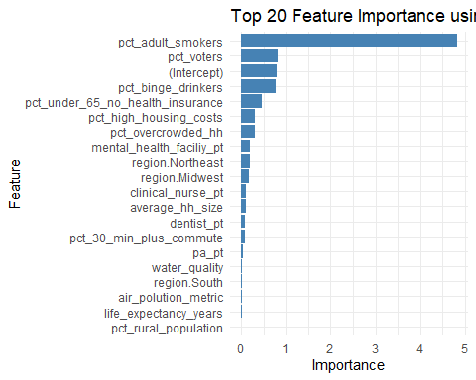

# Calculate ROC curve  
roc_ols <- pROC::roc(qol_test$response, predictions)

## Setting levels: control = 0, case = 1

## Setting direction: controls < cases

# Create a data frame for ggplot  
roc_data <- data.frame(  
 specificity = rev(roc_ols$specificities),  
 sensitivity = rev(roc_ols$sensitivities)  
)  
  
# Plot ROC curve using ggplot2  
ggplot(roc_data, aes(x = 1-specificity, y = sensitivity)) +  
 geom_line(color = "blue") +  
 geom_abline(linetype = "dashed", color = "red") +  
 labs(title = paste("ROC Curve (AUC =", round(pROC::auc(roc_ols), 2), ")"),  
 x = "1 - Specificity",  
 y = "Sensitivity") +  
 theme_minimal() +  
 coord_fixed(ratio = 1)

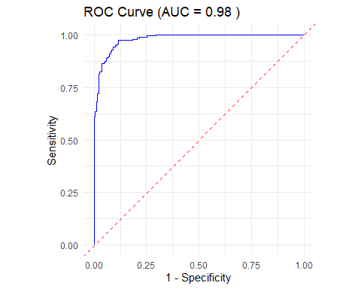

*Random Forest*

names(qol_train)

## [1] "weighted_population" "average_hh_size"   
## [3] "pct_male" "pct_native_american"   
## [5] "pct_asian" "pct_black"   
## [7] "pct_hispanic" "pct_other_race"   
## [9] "pct_white" "pct_single_parent"   
## [11] "pct_hh_other_computer" "pct_hh_internet"   
## [13] "pct_employed_nonprofit" "pct_employed"   
## [15] "pct_hh_inc_99999" "pct_w_medicare"   
## [17] "clinical_nurse_pt" "dentist_pt"   
## [19] "pa_pt" "mental_health_faciliy_pt"   
## [21] "population_density" "days_over_90_f"   
## [23] "median_hh_income.x" "median_er_dist"   
## [25] "median_trauma_center_dist" "median_pediatric_icu_dist"   
## [27] "median_health_clinic_dist" "median_drug_alcohol_care_dist"   
## [29] "percent_grandparents_as_guardians" "pct_adult_smokers"   
## [31] "pct_binge_drinkers" "pct_under_65_no_health_insurance"   
## [33] "pct_highschool_diploma" "inequality_ratio"   
## [35] "social_clubs_per_10k" "air_polution_metric"   
## [37] "water_quality" "pct_high_housing_costs"   
## [39] "pct_overcrowded_hh" "pct_30_min_plus_commute"   
## [41] "life_expectancy_years" "school_funding_gap"   
## [43] "pct_voters" "pct_home_owner"   
## [45] "pct_rural_population" "response"   
## [47] "region.Midwest" "region.Northeast"   
## [49] "region.South" "region.West"

# Train a random forest model for classification  
model_rf <- randomForest::randomForest(as.factor(response) ~ ., data = qol_train, ntree = 500)  
  
# Predict the response variable for the testing set  
predictions2 <- predict(model_rf, qol_test, type = "response")  
  
# Calculate the accuracy of the random forest model  
accuracy <- mean(qol_test$response == predictions2)  
print(accuracy)

## [1] 0.9189873

# Calculate the ROC AUC score  
roc_obj <- pROC::roc(qol_test$response, as.numeric(predictions2))

## Setting levels: control = 0, case = 1

## Setting direction: controls < cases

auc_rf <- pROC::auc(roc_obj)  
print(auc_rf)

## Area under the curve: 0.9187

# Plot the ROC curve using ggplot2  
roc_df <- data.frame(  
 tpr = roc_obj$sensitivities,  
 fpr = 1 - roc_obj$specificities  
)  
  
ggplot(roc_df, aes(x = fpr, y = tpr)) +  
 geom_line() +  
 geom_abline(linetype = "dashed") +  
 xlab("False Positive Rate") +  
 ylab("True Positive Rate") +  
 ggtitle(paste("ROC Curve (AUC =", round(auc_rf, 2), ")"))

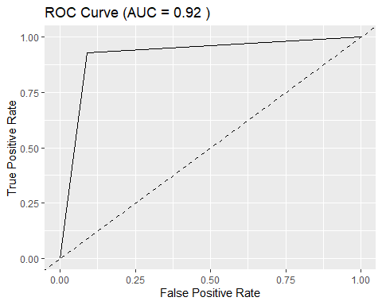

# Calculate feature importance  
importance_rf <- randomForest::importance(model_rf)  
importance_df <- data.frame(Feature = rownames(importance_rf), Importance = importance_rf[, 1])  
  
# Select top 20 important features  
top_20_importance <- importance_df[order(-importance_df$Importance), ][1:20, ]  
  
# Plot top 20 feature importance using ggplot2  
ggplot(top_20_importance, aes(x = reorder(Feature, Importance), y = Importance)) +  
 geom_bar(stat = "identity") +  
   
 coord_flip() +  
 xlab("Feature") +  
 ylab("Importance") +  
 ggtitle("Top 20 Feature Importance from Random Forest Model")

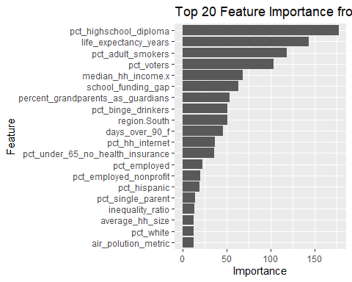

*PCA*

qol_train_standardized <- qol_train %>%  
 select(-response) %>%  
 scale() # standardize the data (exclude the response variable)  
  
pca_model <- prcomp(  
 qol_train_standardized,  
 center = TRUE,  
 scale. = TRUE) # apply PCA  
  
summary(pca_model) # print summary of PCA model

## Importance of components:  
## PC1 PC2 PC3 PC4 PC5 PC6 PC7  
## Standard deviation 3.0738 2.4277 1.88430 1.64694 1.46286 1.29916 1.23369  
## Proportion of Variance 0.1928 0.1203 0.07246 0.05536 0.04367 0.03445 0.03106  
## Cumulative Proportion 0.1928 0.3131 0.38556 0.44091 0.48459 0.51903 0.55009  
## PC8 PC9 PC10 PC11 PC12 PC13 PC14  
## Standard deviation 1.18920 1.13229 1.06695 1.02135 0.99346 0.97896 0.96790  
## Proportion of Variance 0.02886 0.02617 0.02323 0.02129 0.02014 0.01956 0.01912  
## Cumulative Proportion 0.57895 0.60512 0.62835 0.64964 0.66978 0.68934 0.70846  
## PC15 PC16 PC17 PC18 PC19 PC20 PC21  
## Standard deviation 0.95441 0.93561 0.91171 0.90620 0.85330 0.84947 0.79781  
## Proportion of Variance 0.01859 0.01786 0.01696 0.01676 0.01486 0.01473 0.01299  
## Cumulative Proportion 0.72705 0.74492 0.76188 0.77864 0.79350 0.80822 0.82121  
## PC22 PC23 PC24 PC25 PC26 PC27 PC28  
## Standard deviation 0.77590 0.75804 0.7441 0.73246 0.71214 0.69716 0.68708  
## Proportion of Variance 0.01229 0.01173 0.0113 0.01095 0.01035 0.00992 0.00963  
## Cumulative Proportion 0.83350 0.84523 0.8565 0.86748 0.87783 0.88774 0.89738  
## PC29 PC30 PC31 PC32 PC33 PC34 PC35  
## Standard deviation 0.6677 0.65763 0.65260 0.62780 0.6104 0.59681 0.56805  
## Proportion of Variance 0.0091 0.00883 0.00869 0.00804 0.0076 0.00727 0.00659  
## Cumulative Proportion 0.9065 0.91530 0.92399 0.93204 0.9396 0.94691 0.95349  
## PC36 PC37 PC38 PC39 PC40 PC41 PC42  
## Standard deviation 0.54476 0.53473 0.51540 0.50718 0.47576 0.45814 0.42964  
## Proportion of Variance 0.00606 0.00584 0.00542 0.00525 0.00462 0.00428 0.00377  
## Cumulative Proportion 0.95955 0.96539 0.97081 0.97606 0.98068 0.98496 0.98873  
## PC43 PC44 PC45 PC46 PC47 PC48  
## Standard deviation 0.41021 0.39122 0.35776 0.28203 0.13587 0.07104  
## Proportion of Variance 0.00343 0.00312 0.00261 0.00162 0.00038 0.00010  
## Cumulative Proportion 0.99216 0.99528 0.99790 0.99952 0.99990 1.00000  
## PC49  
## Standard deviation 1.521e-15  
## Proportion of Variance 0.000e+00  
## Cumulative Proportion 1.000e+00

plot(pca_model, type = "l") # plot explained variance

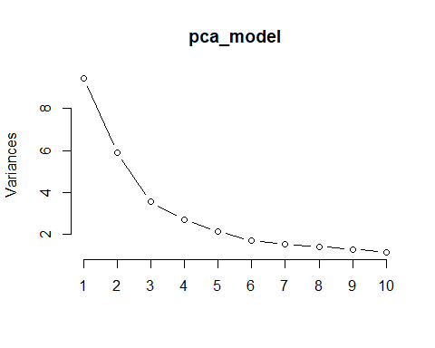

pca_components <- predict(pca_model, qol_train_standardized) # extract the principal components  
  
head(pca_components)

## PC1 PC2 PC3 PC4 PC5 PC6  
## 1 -0.6127441 -0.9361597 1.3031995 1.7763247 0.288469981 -0.9666984  
## 2 0.5807855 -1.1181728 0.3408208 1.9352077 -0.487141027 -0.4551443  
## 3 -7.1467713 -0.4795094 0.6581118 -0.9474059 0.003362109 -1.4972232  
## 4 -7.4119548 -1.1695122 1.8557677 -0.2122726 -0.522624808 -1.4578988  
## 5 -4.8750373 -0.2791846 0.8859073 -0.2640337 -0.509742062 -1.9973717  
## 6 -4.5049055 -0.4989681 1.4467336 0.9313069 1.105113000 -0.9705355  
## PC7 PC8 PC9 PC10 PC11 PC12  
## 1 0.53701912 -0.8816795 0.68944699 -0.059828171 -0.53980355 -0.5759332  
## 2 -0.01007776 -0.9898687 0.10904640 1.077253528 -0.25855318 0.9614640  
## 3 0.17781358 0.3710773 0.07664114 -1.477254937 1.14789471 1.4237628  
## 4 1.21345581 0.2218297 0.50435337 -3.334930626 -0.08728498 0.4034684  
## 5 1.70780036 -0.1748125 0.12255645 0.126536289 -0.42217926 -0.4004569  
## 6 1.57067275 0.4392751 0.23098429 -0.001550246 0.42583037 -0.3558475  
## PC13 PC14 PC15 PC16 PC17 PC18  
## 1 -0.4724690 -0.4802183 -0.9591240 0.6665025 1.01012416 0.1069751  
## 2 -0.6538932 -0.4004458 -0.9221007 0.1991984 0.24266555 0.7797966  
## 3 -0.3099003 -0.0746471 0.2337516 -0.7371858 -0.17164559 0.6194155  
## 4 -0.1877531 -0.7816651 0.6714243 -0.6278555 0.33998562 -0.3538821  
## 5 -0.2354246 1.5582305 0.9067967 -0.8887286 2.05559574 1.3223058  
## 6 -0.6891490 0.8209054 0.2287970 -0.5225074 -0.02587832 -0.9518404  
## PC19 PC20 PC21 PC22 PC23 PC24  
## 1 -0.14797562 -0.5880193 -0.06184543 0.17718739 0.0517747 0.9394226  
## 2 0.14377536 -0.6046132 -0.42721970 -0.09545512 0.5483337 -0.5185464  
## 3 -0.06567448 -0.3454150 0.69206841 -0.27283053 0.2642255 0.6424421  
## 4 -0.86413155 -0.0227908 1.58137196 0.76055409 1.1854040 0.5878847  
## 5 -0.64342697 0.4466650 0.55158604 -0.50086839 -0.3121362 1.9032502  
## 6 0.81541025 -0.8067816 -0.13255422 0.62625918 0.8145652 0.2035835  
## PC25 PC26 PC27 PC28 PC29 PC30 PC31  
## 1 0.24201366 0.2251178 0.5672451 0.1900485 1.1604255 -0.2338644 -0.3552296  
## 2 -0.02834286 -0.2681109 -0.2488004 0.2904646 0.2245030 0.2638751 0.2570353  
## 3 0.45479351 -0.1674047 0.3634690 0.3220357 0.2804890 -0.3541319 0.5994937  
## 4 0.52805139 -1.6586806 0.4394417 1.3127146 1.8098382 -0.3075267 0.5018353  
## 5 0.60317187 -0.7251845 0.7473448 0.2744898 0.4777129 0.6191258 0.1462448  
## 6 -1.19665983 0.2040953 -0.2002272 -0.8517779 0.5873163 -2.1744199 0.3579190  
## PC32 PC33 PC34 PC35 PC36 PC37  
## 1 0.3804850 -0.31967824 0.5519703 -0.01550138 -0.238328628 -0.17132098  
## 2 0.1452856 -0.15100328 -0.3676045 -0.12185567 -0.009529687 -0.38238027  
## 3 -0.7470514 0.38625358 0.5259742 0.01033937 0.751602162 -0.37445727  
## 4 -1.0462428 -0.70628369 -0.3845502 0.28310568 -0.045315955 0.08384884  
## 5 -0.2727371 -0.06422084 -0.8034518 -0.07403673 -0.277491067 -0.35619534  
## 6 -1.3148505 0.23769967 -0.1113828 0.16093579 0.433304265 -0.39327316  
## PC38 PC39 PC40 PC41 PC42 PC43  
## 1 -0.27169033 0.11079301 0.15765945 0.1651158 0.3142116 -0.283652967  
## 2 0.06639147 0.56527128 0.53532927 0.1635970 0.1050017 -0.303198744  
## 3 0.45579101 0.09655068 0.26483966 0.2905933 0.4715022 -0.006811686  
## 4 -1.25431583 -0.73820526 0.04760868 0.2601355 1.3353003 0.310455606  
## 5 -0.52865594 -0.18927769 0.71738584 -0.8451750 0.4062473 -0.070985592  
## 6 0.94273395 0.38217557 0.89028082 0.3844681 0.8621787 -0.104104675  
## PC44 PC45 PC46 PC47 PC48 PC49  
## 1 0.414200587 0.1726176 -0.06081322 0.06246710 0.020140664 -1.609823e-15  
## 2 0.198865965 0.3169539 -0.21709086 -0.12874657 0.031378129 5.551115e-17  
## 3 0.331106290 0.3700642 -0.13055504 -0.02803791 0.019602823 -3.719247e-15  
## 4 -0.001246531 -0.8470838 0.20530970 0.07836619 0.030262054 -4.163336e-15  
## 5 -0.451398036 -0.4900740 0.14337599 0.01096690 0.004142922 -2.053913e-15  
## 6 -0.295310709 -0.1740252 -0.27604566 -0.06742737 0.045074205 -3.719247e-15

qol_train$response <- as.factor(qol_train$response) # ensure the response variable is a factor  
  
train_control <- trainControl(method = "cv", number = 5) # define control for cross-validation  
  
  
set.seed(123)  
ols_cv <- train(response ~ ., data = qol_train, method = "glm", family = binomial, trControl = train_control) # train an OLS model: cross-validation used for classification

## Warning: glm.fit: fitted probabilities numerically 0 or 1 occurred

## Warning in predict.lm(object, newdata, se.fit, scale = 1, type = if (type == :  
## prediction from rank-deficient fit; attr(*, "non-estim") has doubtful cases

## Warning: glm.fit: fitted probabilities numerically 0 or 1 occurred

## Warning in predict.lm(object, newdata, se.fit, scale = 1, type = if (type == :  
## prediction from rank-deficient fit; attr(*, "non-estim") has doubtful cases

## Warning: glm.fit: fitted probabilities numerically 0 or 1 occurred

## Warning in predict.lm(object, newdata, se.fit, scale = 1, type = if (type == :  
## prediction from rank-deficient fit; attr(*, "non-estim") has doubtful cases  
  
## Warning in predict.lm(object, newdata, se.fit, scale = 1, type = if (type == :  
## prediction from rank-deficient fit; attr(*, "non-estim") has doubtful cases

## Warning: glm.fit: fitted probabilities numerically 0 or 1 occurred

## Warning in predict.lm(object, newdata, se.fit, scale = 1, type = if (type == :  
## prediction from rank-deficient fit; attr(*, "non-estim") has doubtful cases

## Warning: glm.fit: fitted probabilities numerically 0 or 1 occurred

print(ols_cv)

## Generalized Linear Model   
##   
## 2560 samples  
## 49 predictor  
## 2 classes: '0', '1'   
##   
## No pre-processing  
## Resampling: Cross-Validated (5 fold)   
## Summary of sample sizes: 2049, 2048, 2048, 2048, 2047   
## Resampling results:  
##   
## Accuracy Kappa   
## 0.9402297 0.8804562

print(ols_cv$results) # OLS cross-validation results

## parameter Accuracy Kappa AccuracySD KappaSD  
## 1 none 0.9402297 0.8804562 0.0118743 0.02374931

print(paste("Best OLS model accuracy:", max(ols_cv$results$Accuracy)))

## [1] "Best OLS model accuracy: 0.940229710918754"

set.seed(123)  
rf_cv <- train(response ~ ., data = qol_train, method = "rf", trControl = train_control, ntree = 500) # train random forest model using cross-validation for classification  
  
print(rf_cv)

## Random Forest   
##   
## 2560 samples  
## 49 predictor  
## 2 classes: '0', '1'   
##   
## No pre-processing  
## Resampling: Cross-Validated (5 fold)   
## Summary of sample sizes: 2049, 2048, 2048, 2048, 2047   
## Resampling results across tuning parameters:  
##   
## mtry Accuracy Kappa   
## 2 0.9359275 0.8718624  
## 25 0.9324134 0.8648050  
## 49 0.9257735 0.8515097  
##   
## Accuracy was used to select the optimal model using the largest value.  
## The final value used for the model was mtry = 2.

print(rf_cv$results)

## mtry Accuracy Kappa AccuracySD KappaSD  
## 1 2 0.9359275 0.8718624 0.01054265 0.02110702  
## 2 25 0.9324134 0.8648050 0.01245597 0.02492389  
## 3 49 0.9257735 0.8515097 0.01169499 0.02339492

print(paste("best rf model accuracy = ", max(rf_cv$results$Accuracy)))

## [1] "best rf model accuracy = 0.935927481911113"

# print random Forest cross-validation results

# Calculate cumulative explained variance  
explained_variance <- summary(pca_model)$importance[2, ]  
cumulative_explained_variance <- cumsum(explained_variance)  
  
# Plot cumulative explained variance  
plot(  
 cumulative_explained_variance,  
 type = "b",  
 xlab = "Number of Principal Components",  
 ylab = "Cumulative Explained Variance"  
 )  
abline(  
 h = 0.9,  
 col = "red",  
 lty = 2) # line for 95% explained variance

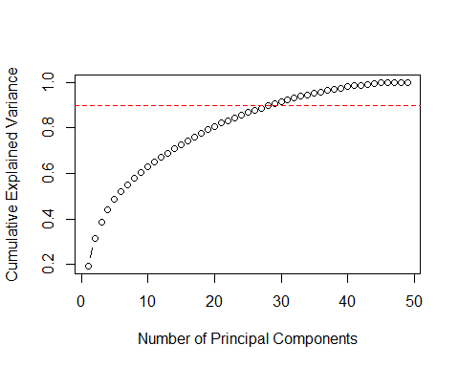

# Find the number of components needed to explain 95% of the variance  
num_components_90 <- which(cumulative_explained_variance >= 0.9)[1]  
num_components_90

## PC29   
## 29

num_components_95 <- which(cumulative_explained_variance >= 0.95)[1]  
num_components_95

## PC35   
## 35

results_psych <- psych::fa.parallel(  
 qol_train_standardized,  
 fa = "pc",  
 n.iter = 5000,  
 quant = 0.95)

## In smc, smcs < 0 were set to .0  
## In smc, smcs < 0 were set to .0  
## In smc, smcs < 0 were set to .0

## Warning in cor.smooth(r): Matrix was not positive definite, smoothing was done

## In factor.scores, the correlation matrix is singular, the pseudo inverse is used

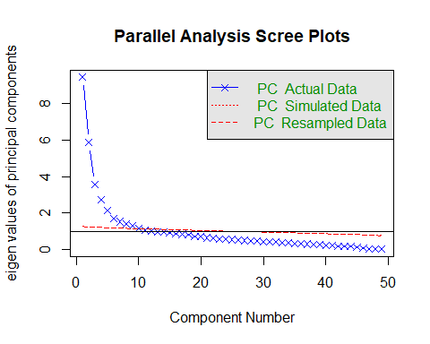

## Parallel analysis suggests that the number of factors = NA and the number of components = 9

results_psych$pc.values

## [1] 9.448158e+00 5.893636e+00 3.550599e+00 2.712404e+00 2.139955e+00  
## [6] 1.687826e+00 1.521996e+00 1.414208e+00 1.282091e+00 1.138388e+00  
## [11] 1.043147e+00 9.869625e-01 9.583672e-01 9.368396e-01 9.108978e-01  
## [16] 8.753683e-01 8.312208e-01 8.211898e-01 7.281155e-01 7.215916e-01  
## [21] 6.365071e-01 6.020176e-01 5.746213e-01 5.536883e-01 5.364955e-01  
## [26] 5.071371e-01 4.860293e-01 4.720759e-01 4.457856e-01 4.324792e-01  
## [31] 4.258807e-01 3.941344e-01 3.725534e-01 3.561831e-01 3.226841e-01  
## [36] 2.967647e-01 2.859380e-01 2.656386e-01 2.572278e-01 2.263480e-01  
## [41] 2.098890e-01 1.845947e-01 1.682697e-01 1.530549e-01 1.279926e-01  
## [46] 7.954012e-02 1.846141e-02 5.047163e-03 -9.092872e-17

results_psych$pc.sim

## [1] 1.2725715 1.2481236 1.2293236 1.2131355 1.1984121 1.1847580 1.1720796  
## [8] 1.1598719 1.1483247 1.1369568 1.1262069 1.1156199 1.1052274 1.0951341  
## [15] 1.0853450 1.0756404 1.0661706 1.0568986 1.0475790 1.0384396 1.0294900  
## [22] 1.0204846 1.0117088 1.0028018 0.9941526 0.9853351 0.9767283 0.9681147  
## [29] 0.9594666 0.9509057 0.9422066 0.9335329 0.9249724 0.9163467 0.9077816  
## [36] 0.8988845 0.8900990 0.8811287 0.8721191 0.8629643 0.8536481 0.8440989  
## [43] 0.8343249 0.8240444 0.8133928 0.8021128 0.7896886 0.7757268 0.7579196

# PCA give low value to features with high collinearity  
  
# 35 features predict 95% of response variability  
# 29 features predict 90% of response variability  
# sqrt(obresvations) = 51, rounded   
  
# Parallel analysis suggests that the number of factors = NA and the number of components = 9

# extract the features (rotation matrix)  
features <- pca_model$rotation  
  
# subset the loadings for the first 35 principal components  
top_features <- features[, 1:35]  
  
# find the most important variables for each principal component  
important_vars <- apply(  
 top_features,  
 2,  
 function(x) names(x[order(abs(x), decreasing = TRUE)])  
 )  
  
# convert to a data frame  
important_vars_df <- as.data.frame(important_vars)  
  
# most important variables  
important_vars_list <- unique(unlist(important_vars_df))  
  
important_vars_list

## [1] "pct_highschool_diploma" "life_expectancy_years"   
## [3] "school_funding_gap" "pct_hh_internet"   
## [5] "region.South" "median_hh_income.x"   
## [7] "percent_grandparents_as_guardians" "pct_adult_smokers"   
## [9] "pct_binge_drinkers" "pct_voters"   
## [11] "pct_single_parent" "days_over_90_f"   
## [13] "pct_black" "pct_white"   
## [15] "pct_employed" "inequality_ratio"   
## [17] "pct_under_65_no_health_insurance" "pct_hh_inc_99999"   
## [19] "pct_employed_nonprofit" "region.Midwest"   
## [21] "dentist_pt" "air_polution_metric"   
## [23] "pct_w_medicare" "pct_overcrowded_hh"   
## [25] "pa_pt" "region.Northeast"   
## [27] "average_hh_size" "pct_asian"   
## [29] "social_clubs_per_10k" "pct_30_min_plus_commute"   
## [31] "pct_rural_population" "median_health_clinic_dist"   
## [33] "region.West" "median_trauma_center_dist"   
## [35] "pct_native_american" "pct_home_owner"   
## [37] "pct_hispanic" "median_drug_alcohol_care_dist"   
## [39] "pct_high_housing_costs" "weighted_population"   
## [41] "clinical_nurse_pt" "median_pediatric_icu_dist"   
## [43] "median_er_dist" "pct_other_race"   
## [45] "pct_hh_other_computer" "population_density"   
## [47] "water_quality" "mental_health_faciliy_pt"   
## [49] "pct_male"

*Clean Environment*

#rm(  
# chr_data,  
# sdoh_data,  
# coefficients,  
# dummies_test,  
# dummies_train,  
# importance_df,  
# importance_rf,  
# model_rf,  
# ols_cv,  
# ols_model,  
# pca_components,  
# pca_model,  
# qol_data,  
# qol_test,  
# qol_test_encoded,  
# qol_train,  
# qol_train_encoded,  
# qol_train_standardized,  
# rf_cv,  
# roc_data,  
# roc_df,  
# roc_obj,  
# roc_ols,  
# top_20_features_ols,  
# top_20_importance,  
# train_control,  
# accuracy,  
# accuracy_ols,  
# auc_rf,  
# confusion_matrix,  
# feature_importance,  
# predicted_classes,  
# predictions,  
# predictions2,  
# split,  
# total_missing,  
# unwanted_chars_results,  
# whitespace_results,  
# unwanted_chars,  
# whitespace_check,  
# features,  
# important_vars,  
# important_vars_df,  
# results_psych,  
# top_features,  
# cumulative_explained_variance,  
# explained_variance,  
# important_vars_list,  
# median_value,  
# num_components_90,  
# num_components_95,  
# calcSplitRatio,  
# qol_lm  
#)

**Upon evaluation of models, it was decided that the model overfit the data, Key features were picked and evaluation was to be done as continuous response with a large feature subset to understand domain causation**

$$ModelEvaluationandEvaluation$$

*Cleaned data reload*

# load data  
sdoh_data <- read_csv("data/sdoh_data.csv")  
dim(sdoh_data)

## [1] 3229 682

# remove unwanted features, create calculated feature, convert fips_code to data type matching chr_data  
sdoh_data <- sdoh_data %>%   
 select("COUNTYFIPS",   
 "STATE",   
 "COUNTY",   
 "REGION",   
 "ACS_TOT_POP_WT",   
 "ACS_AVG_HH_SIZE",   
 "ACS_PCT_MALE",   
 "ACS_PCT_AIAN",   
 "ACS_PCT_ASIAN",   
 "ACS_PCT_BLACK",   
 "ACS_PCT_HISPANIC",   
 "ACS_PCT_OTHER_RACE",   
 "ACS_PCT_WHITE",   
 "ACS_PCT_CHILD_1FAM",   
 "ACS_PCT_CHILDREN_GRANDPARENT",   
 "ACS_PCT_GRANDP_RESPS_NO_P",   
 "ACS_PCT_GRANDP_RESPS_P",  
 "ACS_PCT_HH_OTHER_COMP",   
 "ACS_PCT_HH_INTERNET",  
 "ACS_PCT_EMPLOYED",  
 "ACS_PCT_HH_INC_99999",  
 "ACS_PCT_MEDICARE_ONLY",  
 "AHRF_CLIN_NURSE_SPEC_RATE",   
 "AHRF_DENTISTS_RATE",  
 "AHRF_PHYSICIAN_ASSIST_RATE",  
 "AMFAR_MHFAC_RATE",  
 "CEN_POPDENSITY_COUNTY",  
 "NEPHTN_HEATIND_90",  
 "SAIPE_MEDIAN_HH_INCOME",  
 "POS_MEDIAN_DIST_ED",  
 "POS_MEDIAN_DIST_PED_ICU",  
 "POS_MEDIAN_DIST_CLINIC",   
 "POS_MEDIAN_DIST_ALC",  
 "ACS_TOT_WORKER_HH", #mg  
 "ACS_PCT_VET", #mg  
 "ACS_PCT_UNINSURED", #mg  
 "ACS_PCT_HH_PUB_ASSIST" #mg  
  
 ) %>%   
 mutate(percent_grandparents_as_guardians = ACS_PCT_CHILDREN_GRANDPARENT * ((ACS_PCT_GRANDP_RESPS_P + ACS_PCT_GRANDP_RESPS_NO_P)/100)) %>%   
 select(-ACS_PCT_GRANDP_RESPS_P, -ACS_PCT_GRANDP_RESPS_NO_P, -ACS_PCT_CHILDREN_GRANDPARENT) %>%   
 rename("fips_code" = "COUNTYFIPS",  
 "state" = "STATE",  
 "county" = "COUNTY",  
 "region" = "REGION",  
 "weighted_population" = "ACS_TOT_POP_WT",  
 "average_hh_size" = "ACS_AVG_HH_SIZE",  
 "pct_male" = "ACS_PCT_MALE",  
 "pct_native_american" = "ACS_PCT_AIAN",  
 "pct_asian" = "ACS_PCT_ASIAN",  
 "pct_black" = "ACS_PCT_BLACK",  
 "pct_hispanic" = "ACS_PCT_HISPANIC",  
 "pct_other_race" = "ACS_PCT_OTHER_RACE",  
 "pct_white" = "ACS_PCT_WHITE",  
 "pct_single_parent" = "ACS_PCT_CHILD_1FAM",  
 "pct_hh_other_computer" = "ACS_PCT_HH_OTHER_COMP",  
 "pct_hh_internet" = "ACS_PCT_HH_INTERNET",  
 "pct_employed" = "ACS_PCT_EMPLOYED",  
 "pct_hh_inc_99999" = "ACS_PCT_HH_INC_99999", # renamed by mg  
 "pct_w_medicare" = "ACS_PCT_MEDICARE_ONLY",  
 "clinical_nurse_pt" = "AHRF_CLIN_NURSE_SPEC_RATE",  
 "dentist_pt" = "AHRF_DENTISTS_RATE",  
 "pa_pt" = "AHRF_PHYSICIAN_ASSIST_RATE",  
 "mental_health_faciliy_pt" = "AMFAR_MHFAC_RATE",  
 "population_density" = "CEN_POPDENSITY_COUNTY",  
 "days_over_90_f" = "NEPHTN_HEATIND_90",  
 "median_hh_income" = "SAIPE_MEDIAN_HH_INCOME",  
 "median_er_dist" = "POS_MEDIAN_DIST_ED",  
 "median_pediatric_icu_dist" = "POS_MEDIAN_DIST_PED_ICU",  
 "median_health_clinic_dist" = "POS_MEDIAN_DIST_CLINIC",  
 "median_drug_alcohol_care_dist" = "POS_MEDIAN_DIST_ALC",  
 "hh_tot_workers" = "ACS_TOT_WORKER_HH", # mg  
 "pct_vet" = "ACS_PCT_VET", # mg  
 "pct_uninsured" ="ACS_PCT_UNINSURED", # mg   
 "pct_assistance" = "ACS_PCT_HH_PUB_ASSIST" # mg  
  
   
 ) %>%   
 mutate(fips_code = as.numeric(fips_code))  
  
chr_data <- read_csv("data/chr_data.csv", skip = 1)  
dim(chr_data)

## [1] 3194 720

# remove unwanted features  
# convert principal care providers from per 100,000 people to per 1,000 people to match other data  
  
chr_data <- chr_data %>%  
 select("fipscode",  
 "v002_rawvalue",  
 "v009_rawvalue",  
 "v011_rawvalue",  
 "v070_rawvalue",   
 "v049_rawvalue",  
 "v085_rawvalue",  
 "v168_rawvalue",   
 "v069_rawvalue",  
 "v044_rawvalue",   
 "v140_rawvalue",  
 "v125_rawvalue",  
 "v124_rawvalue",  
 "v136_other_data_1",  
 "v136_other_data_2",  
 "v137_rawvalue",  
 "v147_rawvalue",  
 "v139_rawvalue",  
 "v177_rawvalue",  
 "v153_rawvalue",  
 "v053_rawvalue",   
 "v058_rawvalue",   
 "v004_rawvalue",  
 ) %>%   
 mutate(pcp_pt = v004_rawvalue/100) %>%   
 select(-v004_rawvalue) %>%   
 rename("fips_code" = "fipscode",  
 "pct_poor_to_fair_health" = "v002_rawvalue",  
 "pct_adult_smokers" = "v009_rawvalue",  
 "pct_obese_adults" = "v011_rawvalue",  
 "pct_no_exercise" = "v070_rawvalue",  
 "pct_binge_drinkers" = "v049_rawvalue",  
 "pct_under_65_no_health_insurance" = "v085_rawvalue",  
 "pct_highschool_diploma" = "v168_rawvalue",  
 "pct_some_college" = "v069_rawvalue",  
 "inequality_ratio" = "v044_rawvalue",  
 "social_clubs_per_10k" = "v140_rawvalue",  
 "air_polution_metric" = "v125_rawvalue",  
 "water_quality" = "v124_rawvalue", # renamed by mg  
 "pct_high_housing_costs" = "v136_other_data_1",  
 "pct_overcrowded_hh" = "v136_other_data_2",  
 "pct_food_insecurities" = "v139_rawvalue",  
 "pct_voters" = "v177_rawvalue",  
 "pct_home_owner" = "v153_rawvalue",  
 "pct_65_plus" = "v053_rawvalue",  
 "pct_rural_population" = "v058_rawvalue",  
 "life_expectancy_years" = "v147_rawvalue",  
 "pct_30_min_plus_commute" = "v137_rawvalue")  
  
# full data sets are extremely large, initial dimension reduction was performed previously

*Combine datasets*

# Create and clean the qol_data dataset  
qol_data <- sdoh_data %>%  
 inner_join(chr_data, by = "fips_code") %>%  
 #mutate(response = ifelse(pct_poor_to_fair_health >= 0.154, "worse", "better")) %>%  
 #mutate(response = as.factor(response)) %>%  
 #select(-pct_poor_to_fair_health) %>% # keep until analysis has been performed  
 mutate_at(vars(state, county, region), as.factor) # convert characters to factors

# create linear model for vif analysis, no scaling, no centering, numeric values only  
qol_numeric <- qol_data %>%   
 select(where(is.numeric))  
  
qol_lm <- lm(  
 pct_poor_to_fair_health ~ .,  
 qol_numeric  
)  
  
vif_values <- car::vif(qol_lm)  
  
vif_values

## fips_code weighted_population   
## 1.367787 389.483096   
## average_hh_size pct_male   
## 3.915448 1.715235   
## pct_native_american pct_asian   
## 18.999046 5.119266   
## pct_black pct_hispanic   
## 83.581892 6.343153   
## pct_other_race pct_white   
## 7.407086 106.195952   
## pct_single_parent pct_hh_other_computer   
## 3.111589 1.099768   
## pct_hh_internet pct_employed   
## 3.598688 2.311021   
## pct_hh_inc_99999 pct_w_medicare   
## 2.356736 2.287768   
## clinical_nurse_pt dentist_pt   
## 1.158814 1.877711   
## pa_pt mental_health_faciliy_pt   
## 1.659227 1.161591   
## population_density days_over_90_f   
## 1.395979 3.383845   
## median_hh_income median_er_dist   
## 6.491325 1.592515   
## median_pediatric_icu_dist median_health_clinic_dist   
## 1.657468 1.178996   
## median_drug_alcohol_care_dist hh_tot_workers   
## 1.676041 392.722923   
## pct_vet pct_uninsured   
## 1.837037 5.588217   
## pct_assistance percent_grandparents_as_guardians   
## 4.748838 2.057071   
## pct_adult_smokers pct_obese_adults   
## 11.134324 4.289091   
## pct_no_exercise pct_binge_drinkers   
## 11.633357 2.309359   
## pct_under_65_no_health_insurance pct_highschool_diploma   
## 6.929268 6.145603   
## pct_some_college inequality_ratio   
## 4.550463 2.530376   
## social_clubs_per_10k air_polution_metric   
## 1.733348 2.093544   
## water_quality pct_high_housing_costs   
## 1.110293 2.719547   
## pct_overcrowded_hh pct_30_min_plus_commute   
## 2.673865 2.776362   
## life_expectancy_years pct_food_insecurities   
## 3.721053 5.222556   
## pct_voters pct_home_owner   
## 3.818977 4.109748   
## pct_65_plus pct_rural_population   
## 5.627477 3.798256   
## pcp_pt   
## 2.285573

# Create a data frame with GVIF and Df  
vif_df <- data.frame(  
 Feature = names(vif_values),  
 GVIF = vif_values,  
 Df = rep(1, length(vif_values)) # Df is typically 1 for univariate cases  
)  
  
# Calculate GVIF^(1/(2*Df)) and add it to the data frame  
vif_df$Adjusted_VIF <- vif_df$GVIF^(1/(2 * vif_df$Df))  
  
# Sort the data frame by Adjusted VIF in ascending order  
vif_df <- vif_df[order(vif_df$Adjusted_VIF, decreasing = TRUE), ]  
  
# Set a threshold for high VIF  
high_vif_threshold <- 5  
  
# Filter for features with high VIF values  
high_vif_features <- vif_df[vif_df[, "Adjusted_VIF"] > high_vif_threshold, ]  
  
# Print the table  
# Add a column indicating if the Adjusted VIF is above the threshold  
vif_df <- high_vif_features %>%  
 mutate(High_VIF = if_else(Adjusted_VIF > high_vif_threshold, "Yes", "No"))  
  
# Print the table  
vif_df

## Feature GVIF Df Adjusted_VIF High_VIF  
## hh_tot_workers hh_tot_workers 392.72292 1 19.817238 Yes  
## weighted_population weighted_population 389.48310 1 19.735326 Yes  
## pct_white pct_white 106.19595 1 10.305142 Yes  
## pct_black pct_black 83.58189 1 9.142313 Yes

$$Pre−processingandFeatureEnginering$$

*VIF Analysis*

# create linear model for vif analysis, no scaling, no centering, numeric values only  
qol_numeric <- qol_data %>%   
 select(where(is.numeric))  
  
qol_lm <- lm(  
 pct_poor_to_fair_health ~ .,  
 qol_numeric  
)  
  
vif_values <- car::vif(qol_lm)  
  
vif_values

## fips_code weighted_population   
## 1.367787 389.483096   
## average_hh_size pct_male   
## 3.915448 1.715235   
## pct_native_american pct_asian   
## 18.999046 5.119266   
## pct_black pct_hispanic   
## 83.581892 6.343153   
## pct_other_race pct_white   
## 7.407086 106.195952   
## pct_single_parent pct_hh_other_computer   
## 3.111589 1.099768   
## pct_hh_internet pct_employed   
## 3.598688 2.311021   
## pct_hh_inc_99999 pct_w_medicare   
## 2.356736 2.287768   
## clinical_nurse_pt dentist_pt   
## 1.158814 1.877711   
## pa_pt mental_health_faciliy_pt   
## 1.659227 1.161591   
## population_density days_over_90_f   
## 1.395979 3.383845   
## median_hh_income median_er_dist   
## 6.491325 1.592515   
## median_pediatric_icu_dist median_health_clinic_dist   
## 1.657468 1.178996   
## median_drug_alcohol_care_dist hh_tot_workers   
## 1.676041 392.722923   
## pct_vet pct_uninsured   
## 1.837037 5.588217   
## pct_assistance percent_grandparents_as_guardians   
## 4.748838 2.057071   
## pct_adult_smokers pct_obese_adults   
## 11.134324 4.289091   
## pct_no_exercise pct_binge_drinkers   
## 11.633357 2.309359   
## pct_under_65_no_health_insurance pct_highschool_diploma   
## 6.929268 6.145603   
## pct_some_college inequality_ratio   
## 4.550463 2.530376   
## social_clubs_per_10k air_polution_metric   
## 1.733348 2.093544   
## water_quality pct_high_housing_costs   
## 1.110293 2.719547   
## pct_overcrowded_hh pct_30_min_plus_commute   
## 2.673865 2.776362   
## life_expectancy_years pct_food_insecurities   
## 3.721053 5.222556   
## pct_voters pct_home_owner   
## 3.818977 4.109748   
## pct_65_plus pct_rural_population   
## 5.627477 3.798256   
## pcp_pt   
## 2.285573

# Create a data frame with GVIF and Df  
vif_df <- data.frame(  
 Feature = names(vif_values),  
 GVIF = vif_values,  
 Df = rep(1, length(vif_values)) # Df is typically 1 for univariate cases  
)  
  
# Calculate GVIF^(1/(2*Df)) and add it to the data frame  
vif_df$Adjusted_VIF <- vif_df$GVIF^(1/(2 * vif_df$Df))  
  
# Sort the data frame by Adjusted VIF in ascending order  
vif_df <- vif_df[order(vif_df$Adjusted_VIF, decreasing = TRUE), ]  
  
# Set a threshold for high VIF  
high_vif_threshold <- 5  
  
# Filter for features with high VIF values  
high_vif_features <- vif_df[vif_df[, "Adjusted_VIF"] > high_vif_threshold, ]  
  
# Print the table  
# Add a column indicating if the Adjusted VIF is above the threshold  
vif_df <- vif_df %>%  
 mutate(High_VIF = if_else(Adjusted_VIF > high_vif_threshold, "Yes", "No"))  
  
# Print the table  
vif_df

## Feature GVIF  
## hh_tot_workers hh_tot_workers 392.722923  
## weighted_population weighted_population 389.483096  
## pct_white pct_white 106.195952  
## pct_black pct_black 83.581892  
## pct_native_american pct_native_american 18.999046  
## pct_no_exercise pct_no_exercise 11.633357  
## pct_adult_smokers pct_adult_smokers 11.134324  
## pct_other_race pct_other_race 7.407086  
## pct_under_65_no_health_insurance pct_under_65_no_health_insurance 6.929268  
## median_hh_income median_hh_income 6.491325  
## pct_hispanic pct_hispanic 6.343153  
## pct_highschool_diploma pct_highschool_diploma 6.145603  
## pct_65_plus pct_65_plus 5.627477  
## pct_uninsured pct_uninsured 5.588217  
## pct_food_insecurities pct_food_insecurities 5.222556  
## pct_asian pct_asian 5.119266  
## pct_assistance pct_assistance 4.748838  
## pct_some_college pct_some_college 4.550463  
## pct_obese_adults pct_obese_adults 4.289091  
## pct_home_owner pct_home_owner 4.109748  
## average_hh_size average_hh_size 3.915448  
## pct_voters pct_voters 3.818977  
## pct_rural_population pct_rural_population 3.798256  
## life_expectancy_years life_expectancy_years 3.721053  
## pct_hh_internet pct_hh_internet 3.598688  
## days_over_90_f days_over_90_f 3.383845  
## pct_single_parent pct_single_parent 3.111589  
## pct_30_min_plus_commute pct_30_min_plus_commute 2.776362  
## pct_high_housing_costs pct_high_housing_costs 2.719547  
## pct_overcrowded_hh pct_overcrowded_hh 2.673865  
## inequality_ratio inequality_ratio 2.530376  
## pct_hh_inc_99999 pct_hh_inc_99999 2.356736  
## pct_employed pct_employed 2.311021  
## pct_binge_drinkers pct_binge_drinkers 2.309359  
## pct_w_medicare pct_w_medicare 2.287768  
## pcp_pt pcp_pt 2.285573  
## air_polution_metric air_polution_metric 2.093544  
## percent_grandparents_as_guardians percent_grandparents_as_guardians 2.057071  
## dentist_pt dentist_pt 1.877711  
## pct_vet pct_vet 1.837037  
## social_clubs_per_10k social_clubs_per_10k 1.733348  
## pct_male pct_male 1.715235  
## median_drug_alcohol_care_dist median_drug_alcohol_care_dist 1.676041  
## pa_pt pa_pt 1.659227  
## median_pediatric_icu_dist median_pediatric_icu_dist 1.657468  
## median_er_dist median_er_dist 1.592515  
## population_density population_density 1.395979  
## fips_code fips_code 1.367787  
## median_health_clinic_dist median_health_clinic_dist 1.178996  
## mental_health_faciliy_pt mental_health_faciliy_pt 1.161591  
## clinical_nurse_pt clinical_nurse_pt 1.158814  
## water_quality water_quality 1.110293  
## pct_hh_other_computer pct_hh_other_computer 1.099768  
## Df Adjusted_VIF High_VIF  
## hh_tot_workers 1 19.817238 Yes  
## weighted_population 1 19.735326 Yes  
## pct_white 1 10.305142 Yes  
## pct_black 1 9.142313 Yes  
## pct_native_american 1 4.358790 No  
## pct_no_exercise 1 3.410771 No  
## pct_adult_smokers 1 3.336814 No  
## pct_other_race 1 2.721596 No  
## pct_under_65_no_health_insurance 1 2.632350 No  
## median_hh_income 1 2.547808 No  
## pct_hispanic 1 2.518562 No  
## pct_highschool_diploma 1 2.479033 No  
## pct_65_plus 1 2.372230 No  
## pct_uninsured 1 2.363941 No  
## pct_food_insecurities 1 2.285291 No  
## pct_asian 1 2.262579 No  
## pct_assistance 1 2.179183 No  
## pct_some_college 1 2.133181 No  
## pct_obese_adults 1 2.071012 No  
## pct_home_owner 1 2.027251 No  
## average_hh_size 1 1.978749 No  
## pct_voters 1 1.954220 No  
## pct_rural_population 1 1.948912 No  
## life_expectancy_years 1 1.929003 No  
## pct_hh_internet 1 1.897021 No  
## days_over_90_f 1 1.839523 No  
## pct_single_parent 1 1.763970 No  
## pct_30_min_plus_commute 1 1.666242 No  
## pct_high_housing_costs 1 1.649105 No  
## pct_overcrowded_hh 1 1.635196 No  
## inequality_ratio 1 1.590716 No  
## pct_hh_inc_99999 1 1.535166 No  
## pct_employed 1 1.520204 No  
## pct_binge_drinkers 1 1.519658 No  
## pct_w_medicare 1 1.512537 No  
## pcp_pt 1 1.511811 No  
## air_polution_metric 1 1.446909 No  
## percent_grandparents_as_guardians 1 1.434249 No  
## dentist_pt 1 1.370296 No  
## pct_vet 1 1.355373 No  
## social_clubs_per_10k 1 1.316567 No  
## pct_male 1 1.309670 No  
## median_drug_alcohol_care_dist 1 1.294620 No  
## pa_pt 1 1.288110 No  
## median_pediatric_icu_dist 1 1.287427 No  
## median_er_dist 1 1.261949 No  
## population_density 1 1.181516 No  
## fips_code 1 1.169524 No  
## median_health_clinic_dist 1 1.085816 No  
## mental_health_faciliy_pt 1 1.077771 No  
## clinical_nurse_pt 1 1.076482 No  
## water_quality 1 1.053704 No  
## pct_hh_other_computer 1 1.048698 No

# eliminate variables with no predictive value: fipscode, county and state:  
qol_data <- qol_data %>%  
 select(  
 -c(  
 fips_code,  
 county,  
 state,  
 pct_no_exercise,  
 pct_obese_adults,  
 life_expectancy_years  
 )  
 )

*Train, Test, and fill*

# one hot encode character Variables,center and scale all predictors except one hot encoded variables.  
  
set.seed(12)  
  
# Create a recipe  
  
response_recipe <- recipe(  
 pct_poor_to_fair_health ~ .,  
 data = qol_train  
 ) %>%  
 # One-hot encode the 'region' feature to include all 4 regions  
 step_dummy(  
 region,  
 one_hot = TRUE  
 ) %>%   
 # Center all predictors except the one-hot encoded 'region' columns  
 step_center(  
 all_predictors(),  
 -starts_with("region_")  
 ) %>%   
 # Scale all predictors except the one-hot encoded 'region' columns  
 step_scale(  
 all_predictors(),  
 -starts_with("region_")  
 ) %>%   
  
 prep(  
 training = qol_train,  
 retain = TRUE  
 )  
  
# Apply the recipe to the training and testing datasets  
qol_train <- bake(response_recipe, new_data = qol_train)  
qol_test <- bake(response_recipe, new_data = qol_test)  
  
head(qol_test)

## # A tibble: 6 × 53  
## weighted_population average_hh_size pct_male pct_native_american pct_asian  
## <dbl> <dbl> <dbl> <dbl> <dbl>  
## 1 0.366 0.246 -0.649 -0.166 -0.158  
## 2 -0.239 1.30 1.47 -0.246 -0.399  
## 3 0.0452 0.0273 -0.840 -0.213 -0.201  
## 4 -0.282 0.209 -1.09 -0.194 -0.488  
## 5 -0.216 -0.0454 -0.247 -0.194 -0.467  
## 6 0.970 0.318 -1.01 -0.169 0.175  
## # ℹ 48 more variables: pct_black <dbl>, pct_hispanic <dbl>,  
## # pct_other_race <dbl>, pct_white <dbl>, pct_single_parent <dbl>,  
## # pct_hh_other_computer <dbl>, pct_hh_internet <dbl>, pct_employed <dbl>,  
## # pct_hh_inc_99999 <dbl>, pct_w_medicare <dbl>, clinical_nurse_pt <dbl>,  
## # dentist_pt <dbl>, pa_pt <dbl>, mental_health_faciliy_pt <dbl>,  
## # population_density <dbl>, days_over_90_f <dbl>, median_hh_income <dbl>,  
## # median_er_dist <dbl>, median_pediatric_icu_dist <dbl>, …

$$Buildandcomparemodels$$

*Linear Model*

set.seed(42)  
# Fit the OLS model  
ols_model <- lm(  
 pct_poor_to_fair_health ~ .,  
 data = qol_train  
 )  
  
# Print OLS coefficients  
print(summary(ols_model)$coefficients)

## Estimate Std. Error t value  
## (Intercept) 1.631698e-01 0.0008603687 189.65101627  
## weighted_population -3.554968e-03 0.0044319957 -0.80211455  
## average_hh_size 2.173630e-03 0.0003948529 5.50491158  
## pct_male -4.108013e-04 0.0002605797 -1.57648989  
## pct_native_american -1.190514e-03 0.0009330662 -1.27591592  
## pct_asian 1.740648e-04 0.0004821605 0.36101016  
## pct_black 6.756999e-03 0.0014476294 4.66763021  
## pct_hispanic 1.037058e-02 0.0004696572 22.08118112  
## pct_other_race -3.867298e-04 0.0004681957 -0.82600031  
## pct_white -2.032211e-05 0.0016969542 -0.01197564  
## pct_single_parent 8.071953e-04 0.0003527677 2.28817816  
## pct_hh_other_computer -2.619388e-04 0.0002194899 -1.19339794  
## pct_hh_internet -1.311084e-03 0.0003810422 -3.44078495  
## pct_employed -1.620341e-04 0.0003163026 -0.51227558  
## pct_hh_inc_99999 -2.378838e-03 0.0003036647 -7.83376537  
## pct_w_medicare -5.097112e-04 0.0003073571 -1.65836800  
## clinical_nurse_pt -3.714287e-04 0.0002209739 -1.68087126  
## dentist_pt 2.546083e-04 0.0002807244 0.90696905  
## pa_pt -6.473394e-04 0.0002449297 -2.64296006  
## mental_health_faciliy_pt 5.333537e-04 0.0002266077 2.35364349  
## population_density -5.456850e-04 0.0002462891 -2.21562788  
## days_over_90_f 1.574312e-03 0.0003845475 4.09393504  
## median_hh_income -2.546736e-03 0.0004880927 -5.21773001  
## median_er_dist -9.266861e-04 0.0003193877 -2.90144543  
## median_pediatric_icu_dist 4.190861e-05 0.0002993551 0.13999630  
## median_health_clinic_dist -8.203840e-04 0.0002566508 -3.19649908  
## median_drug_alcohol_care_dist 1.670328e-03 0.0003143288 5.31395169  
## hh_tot_workers 3.107802e-03 0.0044591736 0.69694571  
## pct_vet -1.995943e-03 0.0002661143 -7.50032009  
## pct_uninsured 1.604472e-05 0.0004703284 0.03411388  
## pct_assistance -6.055854e-04 0.0004475644 -1.35306866  
## percent_grandparents_as_guardians 1.272539e-04 0.0002935846 0.43344889  
## pct_adult_smokers 2.058441e-02 0.0006017111 34.20979636  
## pct_binge_drinkers -3.782358e-03 0.0003182414 -11.88518737  
## pct_under_65_no_health_insurance -2.844083e-03 0.0005141707 -5.53139905  
## pct_highschool_diploma -5.653875e-03 0.0004786748 -11.81151597  
## pct_some_college -1.903680e-05 0.0004375243 -0.04351027  
## inequality_ratio 2.605501e-04 0.0003111952 0.83725624  
## social_clubs_per_10k -1.045761e-03 0.0002614615 -3.99967313  
## air_polution_metric 1.919220e-03 0.0002973562 6.45427916  
## water_quality 6.170447e-04 0.0002208626 2.79379413  
## pct_high_housing_costs -7.684447e-04 0.0003201152 -2.40052559  
## pct_overcrowded_hh 1.750911e-03 0.0003693719 4.74023823  
## pct_30_min_plus_commute -1.069786e-03 0.0003328253 -3.21425687  
## pct_food_insecurities 6.830219e-03 0.0004400178 15.52259576  
## pct_voters -7.758830e-04 0.0003890266 -1.99442179  
## pct_home_owner 3.902177e-04 0.0003648637 1.06948898  
## pct_65_plus 6.680924e-04 0.0004436399 1.50593377  
## pct_rural_population 8.652139e-04 0.0003938698 2.19670030  
## region_Midwest -8.932044e-03 0.0010320947 -8.65428723  
## region_Northeast -9.489471e-03 0.0011687795 -8.11912820  
## region_South 1.977899e-03 0.0010847792 1.82331956  
## Pr(>|t|)  
## (Intercept) 0.000000e+00  
## weighted_population 4.225587e-01  
## average_hh_size 4.048087e-08  
## pct_male 1.150324e-01  
## pct_native_american 2.020971e-01  
## pct_asian 7.181207e-01  
## pct_black 3.198667e-06  
## pct_hispanic 2.585123e-99  
## pct_other_race 4.088783e-01  
## pct_white 9.904460e-01  
## pct_single_parent 2.220561e-02  
## pct_hh_other_computer 2.328205e-01  
## pct_hh_internet 5.890126e-04  
## pct_employed 6.085009e-01  
## pct_hh_inc_99999 6.796772e-15  
## pct_w_medicare 9.736165e-02  
## clinical_nurse_pt 9.290586e-02  
## dentist_pt 3.645057e-01  
## pa_pt 8.266897e-03  
## mental_health_faciliy_pt 1.866314e-02  
## population_density 2.680176e-02  
## days_over_90_f 4.368113e-05  
## median_hh_income 1.951468e-07  
## median_er_dist 3.745105e-03  
## median_pediatric_icu_dist 8.886736e-01  
## median_health_clinic_dist 1.407441e-03  
## median_drug_alcohol_care_dist 1.162054e-07  
## hh_tot_workers 4.858979e-01  
## pct_vet 8.636881e-14  
## pct_uninsured 9.727889e-01  
## pct_assistance 1.761492e-01  
## percent_grandparents_as_guardians 6.647240e-01  
## pct_adult_smokers 9.835304e-213  
## pct_binge_drinkers 8.945597e-32  
## pct_under_65_no_health_insurance 3.487801e-08  
## pct_highschool_diploma 2.061294e-31  
## pct_some_college 9.652981e-01  
## inequality_ratio 4.025241e-01  
## social_clubs_per_10k 6.516687e-05  
## air_polution_metric 1.288669e-10  
## water_quality 5.246838e-03  
## pct_high_housing_costs 1.644015e-02  
## pct_overcrowded_hh 2.247611e-06  
## pct_30_min_plus_commute 1.323544e-03  
## pct_food_insecurities 4.482095e-52  
## pct_voters 4.620834e-02  
## pct_home_owner 2.849469e-01  
## pct_65_plus 1.322034e-01  
## pct_rural_population 2.812823e-02  
## region_Midwest 8.457803e-18  
## region_Northeast 7.116239e-16  
## region_South 6.836769e-02

# Predict on the test set  
predictions_ols <- predict(  
 ols_model,  
 new_data = qol_test  
 )  
  
# Evaluate the OLS model  
mse_ols <- mean((qol_test$pct_poor_to_fair_health - predictions_ols)^2)

## Warning in qol_test$pct_poor_to_fair_health - predictions_ols: longer object  
## length is not a multiple of shorter object length

rmse_ols <- sqrt(mse_ols)  
r2_ols <- summary(ols_model)$r.squared  
  
print(paste("MSE (OLS):", mse_ols))

## [1] "MSE (OLS): 0.00391915285974174"

print(paste("RMSE (OLS):", rmse_ols))

## [1] "RMSE (OLS): 0.0626031377787227"

print(paste("R-squared (OLS):", r2_ols))

## [1] "R-squared (OLS): 0.941997472989246"

# --- Feature Importance Visualization (OLS) ---  
  
# Calculate feature importance for OLS  
feature_importance_ols <- abs(summary(ols_model)$coefficients[, "Estimate"])  
  
importance_df_ols <- data.frame(  
 Feature = names(feature_importance_ols),  
 Importance = feature_importance_ols  
 )  
  
importance_df_ols <- importance_df_ols[order(-importance_df_ols$Importance), ]  
  
# Select top 20 features  
top_20_features_ols <- head(importance_df_ols, 20)  
  
# Plot top 20 feature importance for OLS  
ggplot(  
 top_20_features_ols,  
 aes(  
 x = reorder(Feature, Importance),  
 y = Importance)) +  
 geom_bar(  
 stat = "identity",  
 fill = "steelblue"  
 ) +  
 coord_flip() +  
 labs(  
 title = "Top 20 Feature Importance (OLS)",  
 x = "Feature",  
 y = "Importance") +  
 theme_minimal()

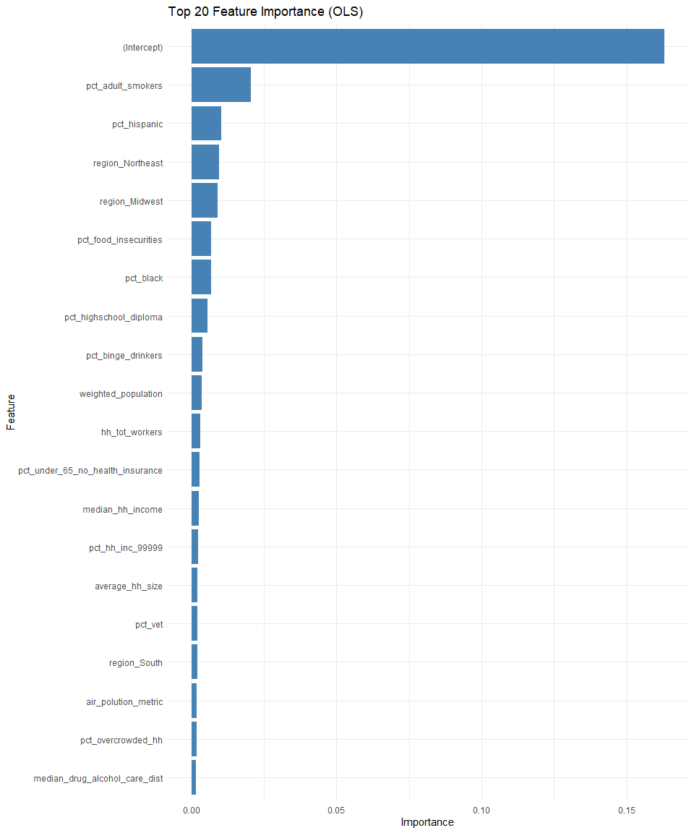

# --- Assumptions Diagnostics for OLS Model ---  
  
# Residuals plot  
ggplot(data.frame(residuals = residuals(ols_model),  
 fitted = fitted(ols_model)),  
 aes(x = fitted, y = residuals)) +  
 geom_point() +  
 geom_smooth(method = "lm",  
 se = FALSE,  
 color = "red") +  
 labs(title = "Residuals vs Fitted",  
 x = "Fitted values",  
 y = "Residuals") +  
 theme_minimal()

## `geom_smooth()` using formula = 'y ~ x'

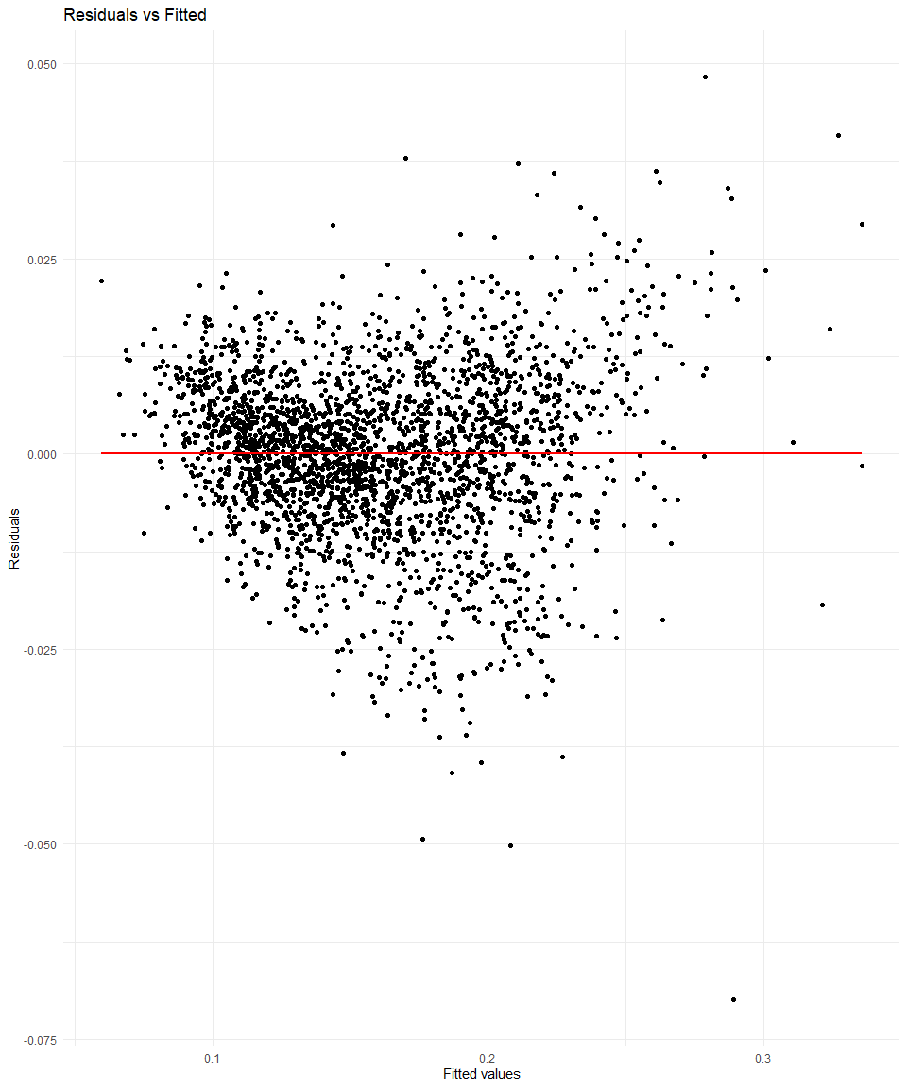

# Q-Q plot  
ggplot(data.frame(sample = residuals(ols_model)),  
 aes(sample = sample)) +  
 stat_qq() +  
 stat_qq_line() +  
 labs(title = "Q-Q Plot",  
 x = "Theoretical Quantiles",  
 y = "Sample Quantiles") +  
 theme_minimal()

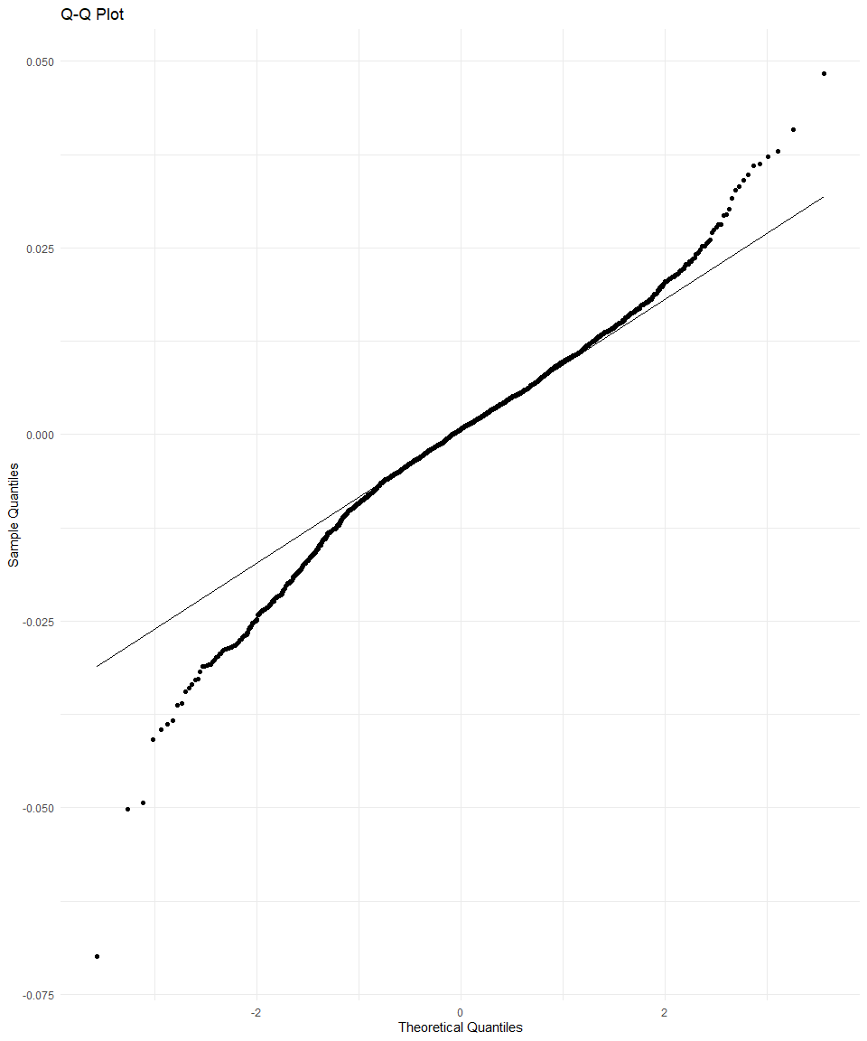

#Durbin-Watson test  
lmtest::dwtest(ols_model)

## Warning in sqrt(dvar): NaNs produced

##   
## Durbin-Watson test  
##   
## data: ols_model  
## DW = 0.79957, p-value = NA  
## alternative hypothesis: true autocorrelation is greater than 0

# Perform the Breusch-Godfrey test for autocorrelation  
bg_test <- lmtest::bgtest(  
 ols_model,  
 order = 1 # You can change the order as needed  
 )   
  
# Print the test results  
print(bg_test)

##   
## Breusch-Godfrey test for serial correlation of order up to 1  
##   
## data: ols_model  
## LM test = 1037.1, df = 1, p-value < 2.2e-16

set.seed(42)  
# Create design matrices (excluding response variable)  
x_train <- model.matrix(  
 pct_poor_to_fair_health ~ .,  
 data = qol_train)[, -1]  
  
x_test <- model.matrix(  
 pct_poor_to_fair_health ~ .,  
 data = qol_test)[, -1]  
  
# Fit the Lasso model  
lasso_model <- glmnet::glmnet(  
 x_train,  
 qol_train$pct_poor_to_fair_health,  
 alpha = 1  
 )  
  
# Find optimal lambda using cross-validation  
cv_lasso <- glmnet::cv.glmnet(  
 x_train,  
 qol_train$pct_poor_to_fair_health,  
 alpha = 1  
 )  
  
# Predict on the test set using the optimal lambda  
predictions_lasso <- predict(lasso_model, newx = x_test, s = cv_lasso$lambda.min)  
  
# Evaluate the Lasso model  
mse_lasso <- mean((qol_test$pct_poor_to_fair_health - predictions_lasso)^2)  
rmse_lasso <- sqrt(mse_lasso)  
r2_lasso <- 1 - (sum((qol_test$pct_poor_to_fair_health - predictions_lasso)^2) / sum((qol_test$pct_poor_to_fair_health - mean(qol_test$pct_poor_to_fair_health))^2))  
print(paste("MSE (Lasso):", mse_lasso))

## [1] "MSE (Lasso): 0.000125332655001026"

print(paste("RMSE (Lasso):", rmse_lasso))

## [1] "RMSE (Lasso): 0.011195206786881"

print(paste("R-squared (Lasso):", r2_lasso))

## [1] "R-squared (Lasso): 0.938981940311687"

set.seed(42)  
# Prepare data for xgboost  
dtrain <- xgboost::xgb.DMatrix(  
 data = as.matrix(  
 qol_train[, -which(names(qol_train) == "pct_poor_to_fair_health")]  
 ),  
 label = qol_train$pct_poor_to_fair_health)  
  
dtest <- xgboost::xgb.DMatrix(  
 data = as.matrix(  
 qol_test[, -which(names(qol_test) == "pct_poor_to_fair_health")]  
 ),  
 label = qol_test$pct_poor_to_fair_health)  
  
# Set parameters for xgboost  
params <- list(  
 objective = "reg:squarederror",  
 eta = 0.1,  
 max_depth = 6,  
 subsample = 0.8,  
 colsample_bytree = 0.8  
)  
  
# Train the GBM model with evaluation metrics at each iteration  
gbm_model <- xgboost::xgb.train(  
 params,  
 dtrain,  
 nrounds = 100,  
 watchlist = list(train = dtrain, eval = dtest),  
 print_every_n = 10,  
 eval_metric = "rmse",  
 early_stopping_rounds = 10  
)

## [1] train-rmse:0.308474 eval-rmse:0.308643   
## Multiple eval metrics are present. Will use eval_rmse for early stopping.  
## Will train until eval_rmse hasn't improved in 10 rounds.  
##   
## [11] train-rmse:0.109068 eval-rmse:0.110050   
## [21] train-rmse:0.039527 eval-rmse:0.041200   
## [31] train-rmse:0.015850 eval-rmse:0.018473   
## [41] train-rmse:0.008330 eval-rmse:0.011926   
## [51] train-rmse:0.006060 eval-rmse:0.010398   
## [61] train-rmse:0.005148 eval-rmse:0.009864   
## [71] train-rmse:0.004494 eval-rmse:0.009583   
## [81] train-rmse:0.003957 eval-rmse:0.009484   
## [91] train-rmse:0.003591 eval-rmse:0.009377   
## [100] train-rmse:0.003284 eval-rmse:0.009319

# Extract the evaluation metrics from the watchlist  
eval_metrics <- gbm_model$evaluation_log  
  
# Create a data frame for plotting the learning curve  
learning_curve <- data.frame(  
 Iteration = 1:nrow(eval_metrics),  
 Train_RMSE = eval_metrics$train_rmse,  
 Test_RMSE = eval_metrics$eval_rmse  
)  
  
# Plot the learning curve  
ggplot(  
 learning_curve,  
 aes(x = Iteration)  
 ) +  
 geom_line(  
 aes(  
 y = Train_RMSE,  
 color = "Train RMSE")  
 ) +  
 geom_line(  
 aes(  
 y = Test_RMSE,  
 color = "Test RMSE"  
 )  
 ) +  
 labs(  
 title = "Learning Curve (GBM)",  
 x = "Number of Boosting Iterations",  
 y = "RMSE"  
 ) +  
 theme_minimal() +  
 scale_color_manual(  
 values = c(  
 "Train RMSE" = "blue",  
 "Test RMSE" = "red"  
 )  
 )

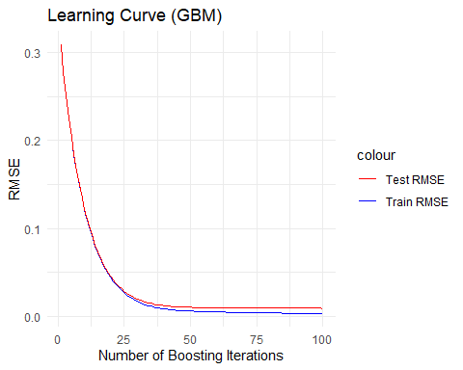

# Make predictions  
predictions_gbm <- predict(gbm_model, dtest)  
  
# Evaluate the GBM model  
mse_gbm <- mean((qol_test$pct_poor_to_fair_health - predictions_gbm)^2)  
rmse_gbm <- sqrt(mse_gbm)  
r2_gbm <- 1 - (sum((qol_test$pct_poor_to_fair_health - predictions_gbm)^2) / sum((qol_test$pct_poor_to_fair_health - mean(qol_test$pct_poor_to_fair_health))^2))  
  
# Print the evaluation metrics  
print(paste("MSE (GBM):", mse_gbm))

## [1] "MSE (GBM): 8.68445996745972e-05"

print(paste("RMSE (GBM):", rmse_gbm))

## [1] "RMSE (GBM): 0.00931904499799186"

print(paste("R-squared (GBM):", r2_gbm))

## [1] "R-squared (GBM): 0.95771980601138"

set.seed(42)  
# Train a random forest model for classification  
model_rf <- randomForest::randomForest(  
 pct_poor_to_fair_health ~ .,  
 data = qol_train,  
 ntree = 500  
 )  
  
# Predict the response variable for the testing set  
predictions_rf <- predict(  
 model_rf,  
 qol_test,  
 type = "response"  
 )  
  
# Calculate Mean Squared Error (MSE) for Random Forest model  
mse_rf <- mean(  
 (qol_test$pct_poor_to_fair_health - predictions_rf)^2  
 )  
  
# Calculate Root Mean Squared Error (RMSE) for Random Forest model  
rmse_rf <- sqrt(mse_rf)  
  
# Calculate R-squared (R^2) for Random Forest model  
ss_total <- sum(  
 (qol_test$pct_poor_to_fair_health - mean(qol_train$pct_poor_to_fair_health))^2  
 )  
ss_residual <- sum(  
 (qol_test$pct_poor_to_fair_health - predictions_rf)^2  
 )  
r2_rf <- 1 - (ss_residual / ss_total)  
  
# Print the results  
print(paste("MSE (Random Forest):", mse_rf))

## [1] "MSE (Random Forest): 0.00012289285803182"

print(paste("RMSE (Random Forest):", rmse_rf))

## [1] "RMSE (Random Forest): 0.0110857051210927"

print(paste("R-squared (Random Forest):", r2_rf))

## [1] "R-squared (Random Forest): 0.940169931412358"

# Calculate feature importance  
importance_rf <- randomForest::importance(model_rf)  
importance_df <- data.frame(  
 Feature = rownames(importance_rf),  
 Importance = importance_rf[, 1])  
  
# Select top 20 important features  
top_20_importance <- importance_df[order(-importance_df$Importance), ][1:20, ]  
  
# Plot top 20 feature importance using ggplot2  
ggplot(top_20_importance, aes(x = reorder(Feature, Importance), y = Importance)) +  
 geom_bar(stat = "identity") +  
 coord_flip() +  
 xlab("Feature") +  
 ylab("Importance") +  
 ggtitle("Top 20 Feature Importance from Random Forest Model")

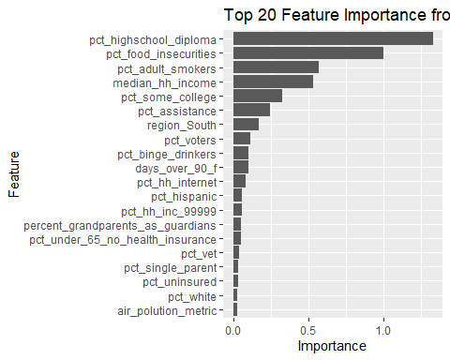

# Create a data frame to store the results  
results <- data.frame(  
 Model = c(  
 "OLS",  
 "Lasso",  
 "GBM",  
 "RF"  
 ),  
 MSE = c(  
 mse_ols,  
 mse_lasso,  
 mse_gbm,  
 mse_rf  
 ),  
 RMSE = c(  
 rmse_ols,  
 rmse_lasso,  
 rmse_gbm,  
 rmse_rf  
 ),  
 R_squared = c(  
 r2_ols,  
 r2_lasso,  
 r2_gbm,  
 r2_rf  
 )  
 )  
  
# Print the results  
print(results)

## Model MSE RMSE R_squared  
## 1 OLS 0.0039191529 0.062603138 0.9419975  
## 2 Lasso 0.0001253327 0.011195207 0.9389819  
## 3 GBM 0.0000868446 0.009319045 0.9577198  
## 4 RF 0.0001228929 0.011085705 0.9401699

# Plot the results  
library(ggplot2)  
  
# MSE Comparison  
ggplot(  
 results,  
 aes(  
 x = Model,  
 y = MSE,  
 fill = Model  
 )  
 ) +  
 geom_bar(stat = "identity") +  
 labs(  
 title = "MSE Comparison",  
 x = "Model",  
 y = "Mean Squared Error"  
 ) +  
 theme_minimal()

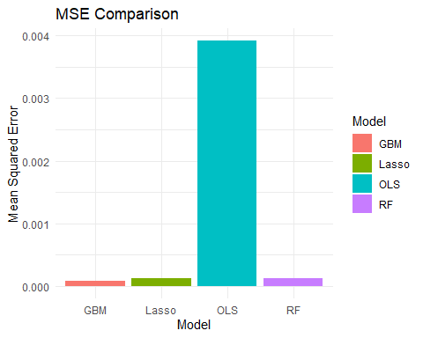

# RMSE Comparison  
ggplot(  
 results,  
 aes(  
 x = Model,  
 y = RMSE,  
 fill = Model  
 )  
 ) +  
 geom_bar(stat = "identity") +  
 labs(  
 title = "RMSE Comparison",  
 x = "Model",  
 y = "Root Mean Squared Error"  
 ) +  
 theme_minimal()

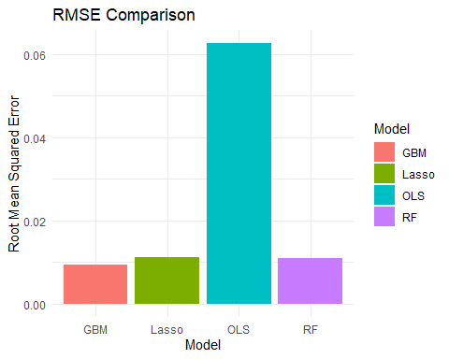

# R-squared Comparison  
ggplot(  
 results,  
 aes(  
 x = Model,  
 y = R_squared,  
 fill = Model  
 )  
 ) +  
 geom_bar(stat = "identity") +  
 labs(  
 title = "R-squared Comparison",  
 x = "Model",  
 y = "R-squared"  
 ) +  
 theme_minimal()

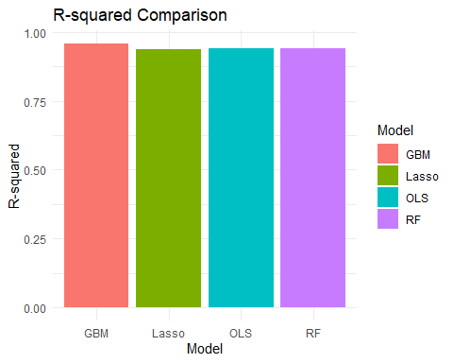

# Lower MSE and RMSE indicate better model performance.  
# Higher R-squared indicates better model performance.  
# The model with the lowest MSE and RMSE and the highest R-squared would be the recommended choice, the GBM model

set.seed(42)  
# Combine training and testing data for cross-validation  
data <- rbind(  
 qol_train,  
 qol_test  
 )  
  
# Define cross-validation method  
train_control <- trainControl(  
 method = "repeatedcv",  
 number = 10, # 10-fold cross-validation  
 repeats = 5  
 )   
  
# OLS Model  
ols_model_cv <- train(  
 pct_poor_to_fair_health ~ .,  
 data = data,  
 method = "lm",  
 trControl = train_control  
 )  
  
ols_predicted_cv <- predict(  
 ols_model_cv,  
 data  
 )  
  
mse_ols_cv <- mean(  
 (data$pct_poor_to_fair_health - ols_predicted_cv)^2  
 )  
rmse_ols_cv <- sqrt(mse_ols_cv)  
r2_ols_cv <- R2(  
 ols_predicted_cv,  
 data$pct_poor_to_fair_health  
 )  
  
# Lasso Model  
lasso_model_cv <- train(  
 pct_poor_to_fair_health ~ .,  
 data = data,  
 method = "glmnet",  
 trControl = train_control,  
 tuneGrid = expand.grid(  
 alpha = 1,  
 lambda = seq(  
 0.001,  
 0.1,  
 by = 0.001  
 )  
 )  
 )

## Warning in nominalTrainWorkflow(x = x, y = y, wts = weights, info = trainInfo,  
## : There were missing values in resampled performance measures.

lasso_predicted_cv <- predict(  
 lasso_model_cv,  
 data  
 )  
  
mse_lasso_cv <- mean(  
 (data$pct_poor_to_fair_health - lasso_predicted_cv)^2  
 )  
rmse_lasso_cv <- sqrt(mse_lasso_cv)  
  
r2_lasso_cv <- R2(  
 lasso_predicted_cv,  
 data$pct_poor_to_fair_health  
 )  
  
# GBM Model  
gbm_model_cv <- train(  
 pct_poor_to_fair_health ~ .,  
 data = data,  
 method = "xgbTree",  
 trControl = train_control,  
 tuneGrid = expand.grid(  
 nrounds = 100,  
 max_depth = 6,  
 eta = 0.1,  
 gamma = 0,  
 colsample_bytree = 0.8,  
 min_child_weight = 1,  
 subsample = 0.8  
 )  
 )  
  
gbm_predicted_cv <- predict(  
 gbm_model_cv,  
 data  
 )  
  
mse_gbm_cv <- mean(  
 (data$pct_poor_to_fair_health - gbm_predicted_cv)^2  
 )  
  
rmse_gbm_cv <- sqrt(mse_gbm_cv)  
  
r2_gbm_cv <- R2(  
 gbm_predicted_cv,  
 data$pct_poor_to_fair_health  
 )  
  
# Create a data frame to store the results  
cv_results <- data.frame(  
 Model = rep(  
 c(  
 "OLS",  
 "Lasso",  
 "GBM"),  
 each = 2  
 ),  
 Type = rep(  
 c(  
 "Initial",  
 "Cross-Validated"  
 ),  
 times = 3  
 ),  
 MSE = c(  
 mse_ols,  
 mse_ols_cv,  
 mse_lasso,  
 mse_lasso_cv,  
 mse_gbm,  
 mse_gbm_cv  
 ),  
 RMSE = c(  
 rmse_ols,  
 rmse_ols_cv,  
 rmse_lasso,  
 rmse_lasso_cv,  
 rmse_gbm,  
 rmse_gbm_cv  
 ),  
 R_squared = c(  
 r2_ols,  
 r2_ols_cv,  
 r2_lasso,  
 r2_lasso_cv,  
 r2_gbm,  
 r2_gbm_cv  
 )  
)  
  
# Print the results  
print(cv_results)

## Model Type MSE RMSE R_squared  
## 1 OLS Initial 3.919153e-03 0.062603138 0.9419975  
## 2 OLS Cross-Validated 1.149833e-04 0.010723026 0.9417311  
## 3 Lasso Initial 1.253327e-04 0.011195207 0.9389819  
## 4 Lasso Cross-Validated 1.336389e-04 0.011560231 0.9335559  
## 5 GBM Initial 8.684460e-05 0.009319045 0.9577198  
## 6 GBM Cross-Validated 1.203421e-05 0.003469035 0.9939595

# Plot the results  
# MSE Comparison  
ggplot(  
 cv_results,  
 aes(  
 x = Model,  
 y = MSE,  
 fill = Type  
 )  
 ) +  
 geom_bar(  
 stat = "identity",  
 position = position_dodge(  
 width = 0.9  
 )  
 ) +  
 labs(  
 title = "MSE Comparison",  
 x = "Model",  
 y = "Mean Squared Error"  
 ) +  
 theme_minimal() +  
 scale_fill_manual(  
 values = c(  
 "Initial" = "steelblue",  
 "Cross-Validated" = "darkorange"  
 )  
 )

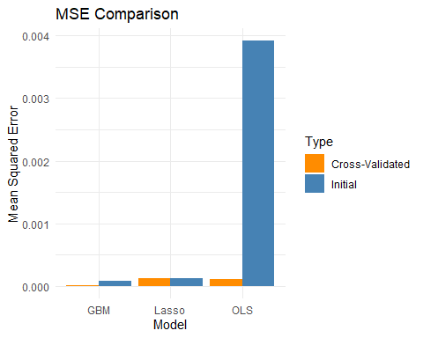

# RMSE Comparison  
ggplot(  
 cv_results,  
 aes(  
 x = Model,  
 y = RMSE,  
 fill = Type  
 )  
 ) +  
 geom_bar(  
 stat = "identity",  
 position = position_dodge(  
 width = 0.9  
 )  
 ) +  
 labs(  
 title = "RMSE Comparison",  
 x = "Model",  
 y = "Root Mean Squared Error"  
 ) +  
 theme_minimal() +  
 scale_fill_manual(  
 values = c(  
 "Initial" = "steelblue",  
 "Cross-Validated" = "darkorange"  
 )  
 )

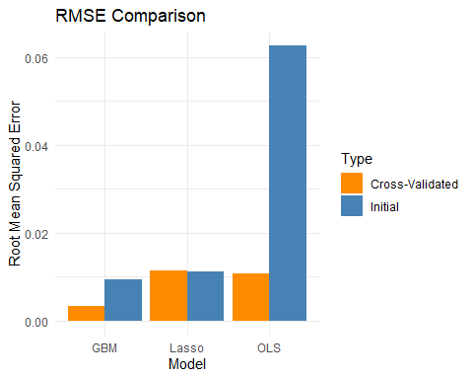

# R-squared Comparison  
ggplot(  
 cv_results,  
 aes(  
 x = Model,  
 y = R_squared,  
 fill = Type  
 )  
 ) +  
 geom_bar(  
 stat = "identity",  
 position = position_dodge(  
 width = 0.9  
 )  
 ) +  
 labs(  
 title = "R-squared Comparison",  
 x = "Model",  
 y = "R-squared"  
 ) +  
 theme_minimal() +  
 scale_fill_manual(  
 values = c(  
 "Initial" = "steelblue",  
 "Cross-Validated" = "darkorange"  
 )  
 )

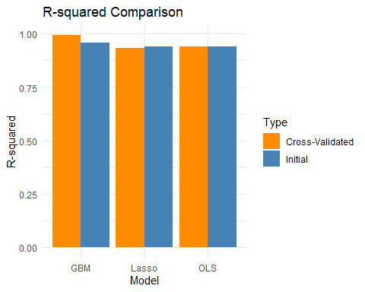

# MSE, RMSE, and R-squared Comparison Side by Side  
cv_results_long <- reshape2::melt(  
 cv_results,  
 id.vars = c(  
 "Model",  
 "Type"  
 ),   
 variable.name = "Metric",  
 value.name = "Value"  
 )  
  
ggplot(  
 cv_results_long,  
 aes(  
 x = Model,  
 y = Value,  
 fill = Type  
 )  
 ) +  
 geom_bar(  
 stat = "identity",  
 position = position_dodge(  
 width = 0.9  
 )  
 ) +  
 facet_wrap(  
 ~ Metric,  
 scales = "free_y"  
 ) +  
 labs(  
 title = "Model Performance Comparison",  
 x = "Model",  
 y = "Value"  
 ) +  
 theme_minimal() +  
 scale_fill_manual(  
 values = c(  
 "Initial" = "steelblue",  
 "Cross-Validated" = "darkorange"  
 )  
 )

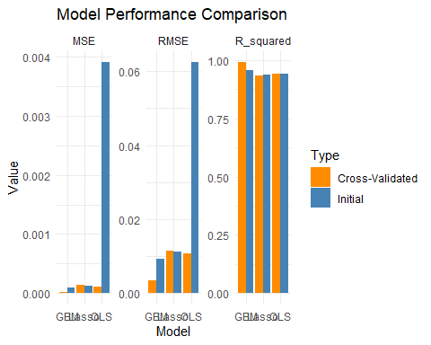

# cross validation confirms that the GBM model performs the best

# Combine training and testing data for cross-validation  
data <- rbind(  
 qol_train,  
 qol_test)  
  
# Define cross-validation method  
train_control <- trainControl(  
 method = "cv",  
 number = 10 # 10-fold cross-validation  
 )  
  
# OLS Model  
ols_model <- train(  
 pct_poor_to_fair_health ~ .,  
 data = data,  
 method = "lm",  
 trControl = train_control  
 )  
# Predicted values and residuals for OLS model  
ols_predicted <- predict(ols_model, data)  
ols_residuals <- data$pct_poor_to_fair_health - ols_predicted  
  
# Lasso Model  
lasso_model <- train(  
 pct_poor_to_fair_health ~ .,  
 data = data,  
 method = "glmnet",  
 trControl = train_control,  
 tuneGrid = expand.grid(  
 alpha = 1,  
 lambda = seq(0.001, 0.1, by = 0.001)  
 )  
 )

## Warning in nominalTrainWorkflow(x = x, y = y, wts = weights, info = trainInfo,  
## : There were missing values in resampled performance measures.

# Predicted values and residuals for Lasso model  
lasso_predicted <- predict(lasso_model, data)  
lasso_residuals <- data$pct_poor_to_fair_health - lasso_predicted  
  
# GBM Model  
gbm_model <- train(  
 pct_poor_to_fair_health ~ .,  
 data = data,  
 method = "xgbTree",  
 trControl = train_control,  
 tuneGrid = expand.grid(  
 nrounds = 100,  
 max_depth = 6,  
 eta = 0.1,  
 gamma = 0,  
 colsample_bytree = 0.8,  
 min_child_weight = 1,  
 subsample = 0.8  
 )  
 )  
  
# Predicted values and residuals for GBM model  
gbm_predicted <- predict(  
 gbm_model,  
 data  
 )  
  
gbm_residuals <- data$pct_poor_to_fair_health - gbm_predicted  
  
# Create ggplot objects for each model  
p1 <- ggplot(  
 data,  
 aes(  
 x = ols_predicted,  
 y = pct_poor_to_fair_health  
 )  
 ) +  
 geom_point() +  
 geom_abline(  
 slope = 1,  
 intercept = 0,  
 color = "red"  
 ) +  
 labs(  
 title = "OLS: Predicted vs Actual Values",  
 x = "Predicted",  
 y = "Actual"  
 )  
  
p2 <- ggplot(  
 data,  
 aes(  
 x = ols_predicted,  
 y = ols_residuals  
 )  
 ) +  
 geom_point() +  
 geom_hline(  
 yintercept = 0,  
 color = "red"  
 ) +  
 labs(  
 title = "OLS: Residuals vs Predicted Values",  
 x = "Predicted",  
 y = "Residuals")  
  
  
p5 <- ggplot(  
 data,  
 aes(  
 x =  
 lasso_predicted,  
 y = pct_poor_to_fair_health  
 )  
 ) +  
 geom_point() +  
 geom_abline(  
 slope = 1,  
 intercept = 0,  
 color = "red"  
 ) +  
 labs(  
 title = "Lasso: Predicted vs Actual Values",  
 x = "Predicted",  
 y = "Actual"  
 )  
  
p6 <- ggplot(  
 data,  
 aes(  
 x = lasso_predicted,  
 y = lasso_residuals  
 )  
 ) +  
 geom_point() +  
 geom_hline(  
 yintercept = 0,  
 color = "red"  
 ) +  
 labs(  
 title = "Lasso: Residuals vs Predicted Values",  
 x = "Predicted",  
 y = "Residuals"  
 )  
  
p7 <- ggplot(  
 data,  
 aes(  
 x = gbm_predicted,  
 y = pct_poor_to_fair_health  
 )  
 ) +  
 geom_point() +  
 geom_abline(  
 slope = 1,  
 intercept = 0,  
 color = "red"  
 ) +  
 labs(  
 title = "GBM: Predicted vs Actual Values",  
 x = "Predicted",  
 y = "Actual")  
  
p8 <- ggplot(  
 data,  
 aes(  
 x = gbm_predicted,  
 y = gbm_residuals  
 )  
 ) +  
 geom_point() +  
 geom_hline(  
 yintercept = 0,  
 color = "red"  
 ) +  
 labs(  
 title = "GBM: Residuals vs Predicted Values",  
 x = "Predicted",  
 y = "Residuals"  
 )  
  
# Combine plots into one  
library(gridExtra)

##   
## Attaching package: 'gridExtra'

## The following object is masked from 'package:dplyr':  
##   
## combine

grid.arrange(  
 p1,  
 p2,  
 p5,  
 p6,  
 p7,  
 p8,  
 ncol = 2  
 )

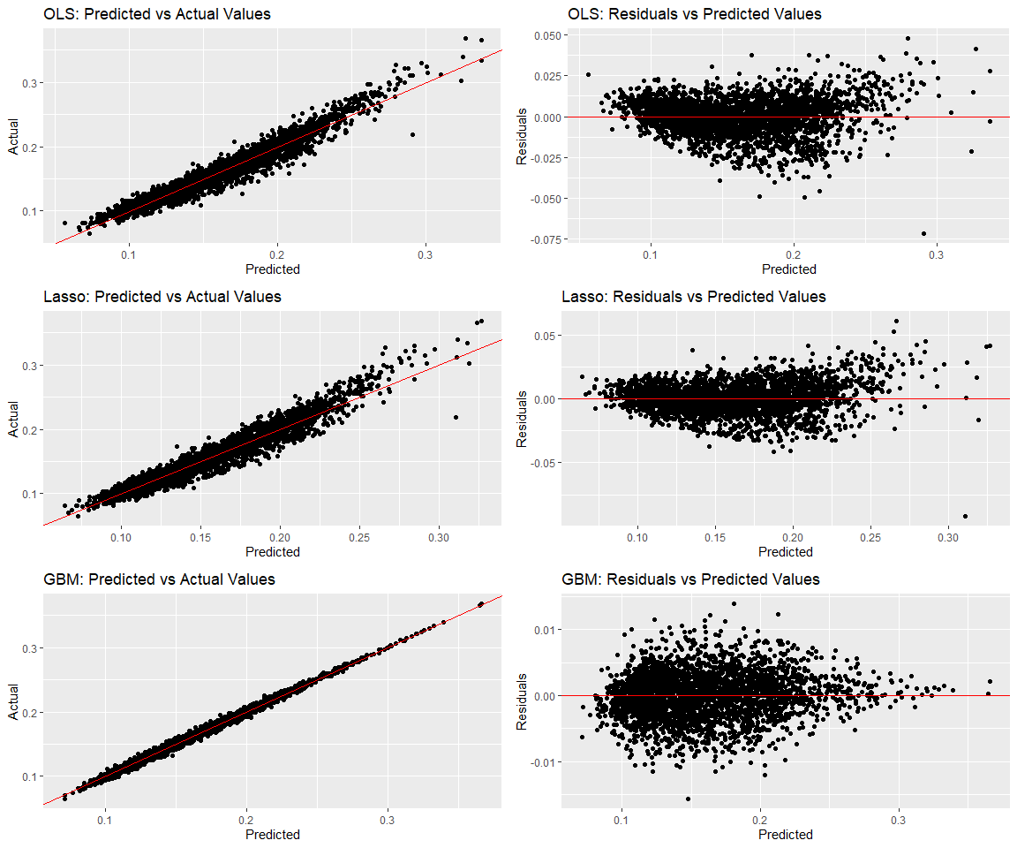

# Extract coefficients from the Lasso model  
lasso_coefficients <- coef(  
 lasso_model_cv$finalModel,  
 s = lasso_model_cv$bestTune$lambda  
 )  
  
lasso_coefficients <- as.data.frame(as.matrix(lasso_coefficients))  
lasso_coefficients$Feature <- rownames(lasso_coefficients)  
colnames(lasso_coefficients)[1] <- "Coefficient"  
  
# Filter non-zero coefficients and exclude the intercept  
lasso_coefficients <- lasso_coefficients[lasso_coefficients$Coefficient != 0 & lasso_coefficients$Feature != "(Intercept)", ]  
  
# Sort by magnitude  
lasso_coefficients <- lasso_coefficients[order(abs(lasso_coefficients$Coefficient), decreasing = TRUE), ]  
  
# Plot the feature importance with color  
ggplot(  
 lasso_coefficients,  
 aes(  
 x = reorder(Feature, Coefficient),  
 y = Coefficient,  
 fill = Coefficient  
 )  
 ) +  
 geom_bar(stat = "identity") +  
 coord_flip() +  
 labs(  
 title = "Feature Importance (Lasso)",  
 x = "Feature",  
 y = "Coefficient"  
 ) +  
 theme_minimal() +  
 scale_fill_viridis_c(  
 option = "viridis",   
 direction = 1,  
 name = "Coefficient"  
 )

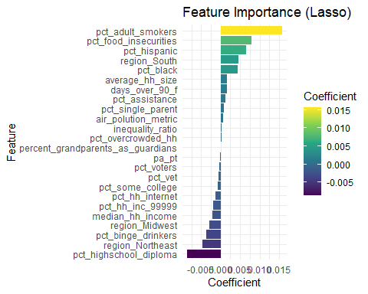

# Extract feature importance  
gbm_feature_importance_cv <- varImp(  
 gbm_model_cv,  
 scale = FALSE  
)  
  
# Convert to a data frame  
gbm_feature_importance_cv_df <- as.data.frame(gbm_feature_importance_cv$importance)  
  
# Add feature names  
gbm_feature_importance_cv_df$Feature <- rownames(gbm_feature_importance_cv_df)  
  
# Rename columns for clarity  
colnames(gbm_feature_importance_cv_df) <- c(  
 "Importance",  
 "Feature"  
 )  
  
# Sort by importance  
gbm_feature_importance_cv_df <- gbm_feature_importance_cv_df %>%  
 arrange(desc(Importance))  
  
# Export to a CSV file  
#write.csv(  
# gbm_feature_importance_cv_df,  
# "gbm_feature_importance.csv",  
# row.names = FALSE  
# )  
  
# Print the feature importance table  
print(gbm_feature_importance_cv_df)

## Importance  
## pct_highschool_diploma 4.643326e-01  
## pct_food_insecurities 2.297069e-01  
## median_hh_income 6.727079e-02  
## pct_adult_smokers 6.441548e-02  
## pct_some_college 2.592092e-02  
## region_South 2.253109e-02  
## pct_assistance 2.201346e-02  
## days_over_90_f 1.801302e-02  
## pct_binge_drinkers 1.488110e-02  
## pct_hispanic 6.557120e-03  
## pct_under_65_no_health_insurance 6.374268e-03  
## pct_voters 5.878899e-03  
## pct_hh_inc_99999 5.689507e-03  
## pct_black 3.468132e-03  
## pct_white 3.450485e-03  
## air_polution_metric 3.250158e-03  
## pct_vet 3.075703e-03  
## pct_single_parent 2.367880e-03  
## pa_pt 2.046616e-03  
## percent_grandparents_as_guardians 2.028129e-03  
## pct_uninsured 1.821077e-03  
## average_hh_size 1.736171e-03  
## pct_overcrowded_hh 1.441646e-03  
## pct_65_plus 1.190921e-03  
## population_density 1.171810e-03  
## pct_other_race 1.129866e-03  
## pct_native_american 1.127381e-03  
## median_er_dist 1.102490e-03  
## pct_hh_other_computer 1.098252e-03  
## social_clubs_per_10k 9.887691e-04  
## weighted_population 9.279541e-04  
## median_drug_alcohol_care_dist 9.147313e-04  
## pct_home_owner 8.694203e-04  
## pct_hh_internet 8.486502e-04  
## pct_employed 8.414767e-04  
## pct_male 8.223924e-04  
## median_pediatric_icu_dist 8.152863e-04  
## pct_high_housing_costs 8.130358e-04  
## pct_w_medicare 8.114936e-04  
## inequality_ratio 7.974180e-04  
## hh_tot_workers 7.473830e-04  
## pct_30_min_plus_commute 7.458699e-04  
## pct_rural_population 7.451414e-04  
## region_Midwest 6.122739e-04  
## pct_asian 5.155501e-04  
## median_health_clinic_dist 4.873042e-04  
## region_West 4.423313e-04  
## dentist_pt 4.297006e-04  
## mental_health_faciliy_pt 3.225875e-04  
## clinical_nurse_pt 1.730318e-04  
## region_Northeast 1.639439e-04  
## water_quality 7.238083e-05  
## Feature  
## pct_highschool_diploma pct_highschool_diploma  
## pct_food_insecurities pct_food_insecurities  
## median_hh_income median_hh_income  
## pct_adult_smokers pct_adult_smokers  
## pct_some_college pct_some_college  
## region_South region_South  
## pct_assistance pct_assistance  
## days_over_90_f days_over_90_f  
## pct_binge_drinkers pct_binge_drinkers  
## pct_hispanic pct_hispanic  
## pct_under_65_no_health_insurance pct_under_65_no_health_insurance  
## pct_voters pct_voters  
## pct_hh_inc_99999 pct_hh_inc_99999  
## pct_black pct_black  
## pct_white pct_white  
## air_polution_metric air_polution_metric  
## pct_vet pct_vet  
## pct_single_parent pct_single_parent  
## pa_pt pa_pt  
## percent_grandparents_as_guardians percent_grandparents_as_guardians  
## pct_uninsured pct_uninsured  
## average_hh_size average_hh_size  
## pct_overcrowded_hh pct_overcrowded_hh  
## pct_65_plus pct_65_plus  
## population_density population_density  
## pct_other_race pct_other_race  
## pct_native_american pct_native_american  
## median_er_dist median_er_dist  
## pct_hh_other_computer pct_hh_other_computer  
## social_clubs_per_10k social_clubs_per_10k  
## weighted_population weighted_population  
## median_drug_alcohol_care_dist median_drug_alcohol_care_dist  
## pct_home_owner pct_home_owner  
## pct_hh_internet pct_hh_internet  
## pct_employed pct_employed  
## pct_male pct_male  
## median_pediatric_icu_dist median_pediatric_icu_dist  
## pct_high_housing_costs pct_high_housing_costs  
## pct_w_medicare pct_w_medicare  
## inequality_ratio inequality_ratio  
## hh_tot_workers hh_tot_workers  
## pct_30_min_plus_commute pct_30_min_plus_commute  
## pct_rural_population pct_rural_population  
## region_Midwest region_Midwest  
## pct_asian pct_asian  
## median_health_clinic_dist median_health_clinic_dist  
## region_West region_West  
## dentist_pt dentist_pt  
## mental_health_faciliy_pt mental_health_faciliy_pt  
## clinical_nurse_pt clinical_nurse_pt  
## region_Northeast region_Northeast  
## water_quality water_quality

# Select the top 20 features based on importance  
top_20_features <- gbm_feature_importance_cv_df %>%  
 arrange(desc(Importance)) %>%  
 head(20)  
  
# Plot the top 20 feature importances with color  
ggplot(  
 top_20_features,  
 aes(  
 x = reorder(Feature, Importance),  
 y = Importance,  
 fill = Importance  
 )  
) +  
 geom_bar(stat = "identity") +  
 coord_flip() +  
 labs(  
 title = "Top 20 Feature Importance (GBM)",  
 x = "Feature",  
 y = "Importance"  
 ) +  
 theme_minimal() +  
 scale_fill_viridis_c(  
 option = "viridis",   
 direction = 1,  
 name = "Importance"  
 )

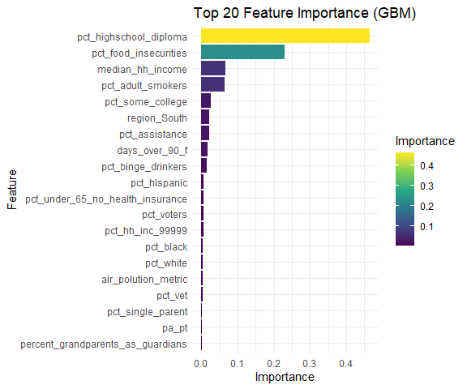

# Define the predictors  
predictors <- c(  
 "pct_highschool_diploma",  
 "pct_food_insecurities",  
 "median_hh_income",  
 "pct_adult_smokers",  
 "pct_some_college",  
 "pct_assistance",  
 "days_over_90_f",  
 "pct_binge_drinkers"  
)  
  
# Set up plotting area with a grid layout  
par(  
 mfrow = c(2, 4),  
 oma = c(0, 0, 2, 0) # 'oma' for outer margins  
 )   
  
# Create and plot partial dependence plots for each predictor  
for (predictor in predictors) {  
 # Generate partial dependence data  
 partial_plot <- partial(  
 gbm_model_cv,  
 pred.var = predictor,  
 train = qol_train # Use preprocessed data if needed  
 )  
   
 plot_data <- as.data.frame(partial_plot)  
   
 # Plot partial dependence  
 plot(  
 plot_data[[predictor]], # x-axis  
 plot_data$yhat, # y-axis  
 type = "l", # Line plot  
 col = "blue", # Line color  
 xlab = predictor, # X-axis label  
 ylab = "Predicted Response", # Y-axis label  
 )  
  
}  
  
# Add a main title to the entire plotting area  
mtext(  
 "Partial Dependence Plots",  
 outer = TRUE,  
 line = -1,  
 cex = 1.5  
 )

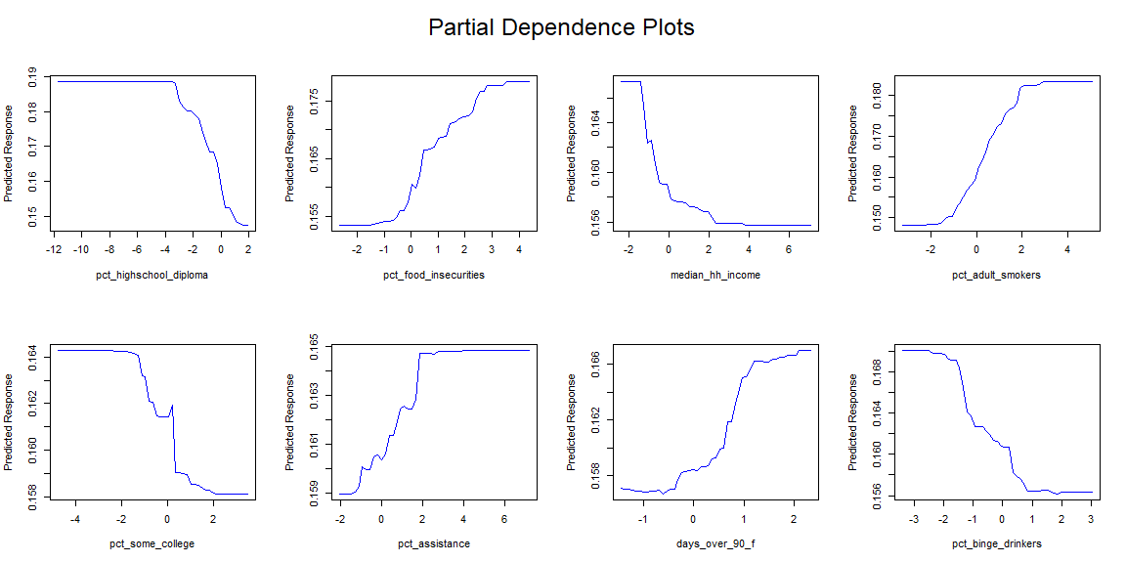

gbm_feature_importance_cv_df <- gbm_feature_importance_cv_df %>%   
 mutate(  
 Category = case_when(  
 Feature == "pct_no_exercise" ~ "Health Care Access and Quality",  
 Feature == "pct_highschool_diploma" ~ "Education Access and Quality",  
 Feature == "pct_food_insecurities" ~ "Economic Stability",  
 Feature == "pct_adult_smokers" ~"Health Care Access and Quality",  
 Feature == "pct_obese_adults" ~ "Health Care Access and Quality",  
 Feature == "life_expectancy_years" ~ "Other",  
 Feature == "median_hh_income" ~ "Economic Stability",  
 Feature == "pct_binge_drinkers" ~ "Health Care Access and Quality",  
 Feature == "region_Midwest" ~ "Other",  
 Feature == "region_South" ~ "Other",  
 Feature == "pct_under_65_no_health_insurance" ~ "Health Care Access and Quality",  
 Feature == "pct_hispanic" ~ "Other",  
 Feature == "days_over_90_f" ~ "Neighborhood and Built Enviroment",  
 Feature == "pct_assistance" ~ "Economic Stability",  
 Feature == "pct_some_college" ~ "Education Access and Quality",  
 Feature == "air_polution_metric" ~ "Neighborhood and Built Enviroment",  
 Feature == "pct_employed" ~ "Economic Stability",  
 Feature == "region_West" ~ "Other",  
 Feature == "pct_hh_inc_99999" ~ "Economic Stability",  
 Feature == "percent_grandparents_as_guardians" ~ "Social and Community Context",  
 Feature == "pct_uninsured" ~ "Health Care Access and Quality",  
 Feature == "pct_native_american" ~ "Other",   
 Feature == "region_Northeast" ~ "Other",  
 Feature == "pct_overcrowded_hh" ~ "Social and Community Context",  
 Feature == "pct_white" ~ "Other",  
 Feature == "median_drug_alcohol_care_dist" ~ "Health Care Access and Quality",  
 Feature == "pct_black" ~ "Other",  
 Feature == "average_hh_size" ~ "Social and Community Context",  
 Feature == "pct_high_housing_costs" ~ "Social and Community Context",  
 Feature == "social_clubs_per_10k" ~ "Social and Community Context",  
 Feature == "hh_tot_workers" ~ "Economic Stability",  
 Feature == "pct_home_owner" ~ "Social and Community Context",  
 Feature == "pa_pt" ~ "Health Care Access and Quality",  
 Feature == "pct_30_min_plus_commute" ~ "Neighborhood and Built Enviroment",  
 Feature == "pct_hh_other_computer" ~ "Education Access and Quality",  
 Feature == "pct_vet" ~ "Neighborhood and Built Enviroment",  
 Feature == "pct_voters" ~ "Neighborhood and Built Enviroment",  
 Feature == "pct_hh_internet" ~ "Education Access and Quality",  
 Feature == "median_pediatric_icu_dist" ~ "Health Care Access and Quality",  
 Feature == "population_density" ~ "Other",  
 Feature == "pct_other_race" ~ "Other",  
 Feature == "pct_male" ~ "Other",  
 Feature == "pct_asian" ~ "Other",  
 Feature == "pct_single_parent" ~ "Neighborhood and Built Enviroment",  
 Feature == "median_er_dist" ~ "Health Care Access and Quality",  
 Feature == "inequality_ratio" ~ "Economic Stability",  
 Feature == "median_health_clinic_dist" ~ "Health Care Access and Quality",  
 Feature == "weighted_population" ~ "Other",  
 Feature == "mental_health_faciliy_pt" ~ "Health Care Access and Quality",  
 Feature == "dentist_pt" ~ "Health Care Access and Quality",  
 Feature == "pct_rural_population" ~ "Other",  
 Feature == "clinical_nurse_pt" ~ "Health Care Access and Quality",  
 Feature == "pct_w_medicare" ~ "Health Care Access and Quality",  
 Feature == "pct_65_plus" ~ "Other",  
 Feature == "water_quality" ~ "Neighborhood and Built Enviroment",  
 Feature == "percent_grandparents_as_guardians" ~ "Neighborhood and Built Enviroment",  
 TRUE ~ NA_character_ # Default case if no conditions are met  
 ),  
 Explanation = case_when(  
 Feature == "pct_no_exercise" ~ "Percentage of adults not exercising increases the percentage of adults reporting poor or fair health.",  
 Feature == "pct_highschool_diploma" ~ "Higher percentage of adults with a high school diploma decreases the percentage of adults reporting poor or fair health.",  
 Feature == "pct_food_insecurities" ~ "Higher food insecurity increases the percentage of adults reporting poor or fair health.",  
 Feature == "pct_adult_smokers" ~"Higher smoking prevalence among adults increases the percentage of adults reporting poor or fair health.",  
 Feature == "pct_obese_adults" ~ "Higher obesity among adults increases the percentage of adults reporting poor or fair health.",  
 Feature == "life_expectancy_years" ~ "Higher life expectancy decreases the percentage of adults reporting poor or fair health.",  
 Feature == "median_hh_income" ~ "Higher median household income decreases the percentage of adults reporting poor or fair health.",  
 Feature == "pct_binge_drinkers" ~ "Less binge drinking prevalence among adults increases the percentage of adults reporting poor or fair health.",  
 Feature == "region_Midwest" ~ "Living in the Midwest region increases the percentage of adults reporting poor or fair health.",  
 Feature == "region_South" ~ "Living in the South region increases the percentage of adults reporting poor or fair health.",  
 Feature == "pct_under_65_no_health_insurance" ~ "Higher percentage of adults under 65 without health insurance increases the percentage of adults reporting poor or fair health.",  
 Feature == "pct_hispanic" ~ "Higher percentage of Hispanic population increases the percentage of adults reporting poor or fair health.",  
 Feature == "days_over_90_f" ~ "More days over 90°F increases the percentage of adults reporting poor or fair health.",  
 Feature == "pct_assistance" ~ "Higher percentage of population receiving assistance increases the percentage of adults reporting poor or fair health.",  
 Feature == "pct_some_college" ~ "Higher percentage of adults with some college education decreases the percentage of adults reporting poor or fair health.",  
 Feature == "air_polution_metric" ~ "Higher air pollution metric increases the percentage of adults reporting poor or fair health.",  
 Feature == "pct_employed" ~ "Higher employment rate decreases the percentage of adults reporting poor or fair health.",  
 Feature == "region_West" ~ "Living in the West region decreases the percentage of adults reporting poor or fair health.",  
 Feature == "pct_hh_inc_99999" ~ "Higher percentage of households with income over $99,999 decreases the percentage of adults reporting poor or fair health.",  
 Feature == "percent_grandparents_as_guardians" ~ "Higher percentage of grandparents as guardians increases the percentage of adults reporting poor or fair health.",  
 Feature == "pct_uninsured" ~ "Higher percentage of uninsured population increases the percentage of adults reporting poor or fair health.",  
 Feature == "pct_native_american" ~ "Higher percentage of Native American population increases the percentage of adults reporting poor or fair health.",   
 Feature == "region_Northeast" ~ "Living in the Northeast region decreases the percentage of adults reporting poor or fair health.",  
 Feature == "pct_overcrowded_hh" ~ "Higher percentage of overcrowded households increases the percentage of adults reporting poor or fair health.",  
 Feature == "pct_white" ~ "Higher percentage of White population decreases the percentage of adults reporting poor or fair health.",  
 Feature == "median_drug_alcohol_care_dist" ~ "Greater distance to drug and alcohol care facilities increases the percentage of adults reporting poor or fair health.",  
 Feature == "pct_black" ~ "Higher percentage of Black population increases the percentage of adults reporting poor or fair health.",  
 Feature == "average_hh_size" ~ "Larger average household size increases the percentage of adults reporting poor or fair health.",  
 Feature == "pct_high_housing_costs" ~ "Higher percentage of households with high housing costs increases the percentage of adults reporting poor or fair health.",  
 Feature == "social_clubs_per_10k" ~ "More social clubs per 10,000 population decreases the percentage of adults reporting poor or fair health.",  
 Feature == "hh_tot_workers" ~ "Higher total number of workers in households decreases the percentage of adults reporting poor or fair health.",  
 Feature == "pct_home_owner" ~ "Higher percentage of home owners decreases the percentage of adults reporting poor or fair health.",  
 Feature == "pa_pt" ~ "More physician assistants per population decreases the percentage of adults reporting poor or fair health.",  
 Feature == "pct_30_min_plus_commute" ~ "Higher percentage of adults with 30+ minute commute increases the percentage of adults reporting poor or fair health.",  
 Feature == "pct_hh_other_computer" ~ "Higher percentage of households with other computers decreases the percentage of adults reporting poor or fair health.",  
 Feature == "pct_vet" ~ "Higher percentage of veterans decreases the percentage of adults reporting poor or fair health.",  
 Feature == "pct_voters" ~ "Higher percentage of voters decreases the percentage of adults reporting poor or fair health.",  
 Feature == "pct_hh_internet" ~ "Higher percentage of households with internet access decreases the percentage of adults reporting poor or fair health.",  
 Feature == "median_pediatric_icu_dist" ~ "Greater distance to pediatric ICU increases the percentage of adults reporting poor or fair health.",  
 Feature == "population_density" ~ "Higher population density increases the percentage of adults reporting poor or fair health.",  
 Feature == "pct_other_race" ~ "Higher percentage of other races increases the percentage of adults reporting poor or fair health.",  
 Feature == "pct_male" ~ "Higher percentage of male population increases the percentage of adults reporting poor or fair health.",  
 Feature == "pct_asian" ~ "Higher percentage of Asian population increases the percentage of adults reporting poor or fair health.",  
 Feature == "pct_single_parent" ~ "Higher percentage of single-parent households increases the percentage of adults reporting poor or fair health.",  
 Feature == "median_er_dist" ~ "Greater distance to emergency room increases the percentage of adults reporting poor or fair health.",  
 Feature == "inequality_ratio" ~"Higher inequality ratio increases the percentage of adults reporting poor or fair health.",  
 Feature == "median_health_clinic_dist" ~ "Greater distance to health clinics increases the percentage of adults reporting poor or fair health.",  
 Feature == "weighted_population" ~ "Higher weighted population increases the percentage of adults reporting poor or fair health.",  
 Feature == "mental_health_faciliy_pt" ~ "More mental health facilities per population decreases the percentage of adults reporting poor or fair health.",  
 Feature == "dentist_pt" ~ "More dentists per population decreases the percentage of adults reporting poor or fair health.",  
 Feature == "pct_rural_population" ~ "Higher percentage of rural population increases the percentage of adults reporting poor or fair health.",  
 Feature == "clinical_nurse_pt" ~ "More clinical nurses per population decreases the percentage of adults reporting poor or fair health.",  
 Feature == "pct_w_medicare" ~ "Higher percentage of population with Medicare decreases the percentage of adults reporting poor or fair health.",  
 Feature == "pct_65_plus" ~ "Higher percentage of population aged 65+ increases the percentage of adults reporting poor or fair health.",  
 Feature == "water_quality" ~ "Better water quality decreases the percentage of adults reporting poor or fair health.",  
 Feature == "percent_grandparents_as_guardians" ~ "More grandparents as guardians increaces the percentage of adults reporting poor or fair health.",  
 TRUE ~ NA_character_ # Default case if no conditions are met  
 )  
 )  
  
  
# Export to an Excel file  
openxlsx::write.xlsx(gbm_feature_importance_cv_df, "gbm_feature_importance_explanations.xlsx")  
  
# Print the feature importance table with explanations  
print(gbm_feature_importance_cv_df)

## Importance  
## pct_highschool_diploma 4.643326e-01  
## pct_food_insecurities 2.297069e-01  
## median_hh_income 6.727079e-02  
## pct_adult_smokers 6.441548e-02  
## pct_some_college 2.592092e-02  
## region_South 2.253109e-02  
## pct_assistance 2.201346e-02  
## days_over_90_f 1.801302e-02  
## pct_binge_drinkers 1.488110e-02  
## pct_hispanic 6.557120e-03  
## pct_under_65_no_health_insurance 6.374268e-03  
## pct_voters 5.878899e-03  
## pct_hh_inc_99999 5.689507e-03  
## pct_black 3.468132e-03  
## pct_white 3.450485e-03  
## air_polution_metric 3.250158e-03  
## pct_vet 3.075703e-03  
## pct_single_parent 2.367880e-03  
## pa_pt 2.046616e-03  
## percent_grandparents_as_guardians 2.028129e-03  
## pct_uninsured 1.821077e-03  
## average_hh_size 1.736171e-03  
## pct_overcrowded_hh 1.441646e-03  
## pct_65_plus 1.190921e-03  
## population_density 1.171810e-03  
## pct_other_race 1.129866e-03  
## pct_native_american 1.127381e-03  
## median_er_dist 1.102490e-03  
## pct_hh_other_computer 1.098252e-03  
## social_clubs_per_10k 9.887691e-04  
## weighted_population 9.279541e-04  
## median_drug_alcohol_care_dist 9.147313e-04  
## pct_home_owner 8.694203e-04  
## pct_hh_internet 8.486502e-04  
## pct_employed 8.414767e-04  
## pct_male 8.223924e-04  
## median_pediatric_icu_dist 8.152863e-04  
## pct_high_housing_costs 8.130358e-04  
## pct_w_medicare 8.114936e-04  
## inequality_ratio 7.974180e-04  
## hh_tot_workers 7.473830e-04  
## pct_30_min_plus_commute 7.458699e-04  
## pct_rural_population 7.451414e-04  
## region_Midwest 6.122739e-04  
## pct_asian 5.155501e-04  
## median_health_clinic_dist 4.873042e-04  
## region_West 4.423313e-04  
## dentist_pt 4.297006e-04  
## mental_health_faciliy_pt 3.225875e-04  
## clinical_nurse_pt 1.730318e-04  
## region_Northeast 1.639439e-04  
## water_quality 7.238083e-05  
## Feature  
## pct_highschool_diploma pct_highschool_diploma  
## pct_food_insecurities pct_food_insecurities  
## median_hh_income median_hh_income  
## pct_adult_smokers pct_adult_smokers  
## pct_some_college pct_some_college  
## region_South region_South  
## pct_assistance pct_assistance  
## days_over_90_f days_over_90_f  
## pct_binge_drinkers pct_binge_drinkers  
## pct_hispanic pct_hispanic  
## pct_under_65_no_health_insurance pct_under_65_no_health_insurance  
## pct_voters pct_voters  
## pct_hh_inc_99999 pct_hh_inc_99999  
## pct_black pct_black  
## pct_white pct_white  
## air_polution_metric air_polution_metric  
## pct_vet pct_vet  
## pct_single_parent pct_single_parent  
## pa_pt pa_pt  
## percent_grandparents_as_guardians percent_grandparents_as_guardians  
## pct_uninsured pct_uninsured  
## average_hh_size average_hh_size  
## pct_overcrowded_hh pct_overcrowded_hh  
## pct_65_plus pct_65_plus  
## population_density population_density  
## pct_other_race pct_other_race  
## pct_native_american pct_native_american  
## median_er_dist median_er_dist  
## pct_hh_other_computer pct_hh_other_computer  
## social_clubs_per_10k social_clubs_per_10k  
## weighted_population weighted_population  
## median_drug_alcohol_care_dist median_drug_alcohol_care_dist  
## pct_home_owner pct_home_owner  
## pct_hh_internet pct_hh_internet  
## pct_employed pct_employed  
## pct_male pct_male  
## median_pediatric_icu_dist median_pediatric_icu_dist  
## pct_high_housing_costs pct_high_housing_costs  
## pct_w_medicare pct_w_medicare  
## inequality_ratio inequality_ratio  
## hh_tot_workers hh_tot_workers  
## pct_30_min_plus_commute pct_30_min_plus_commute  
## pct_rural_population pct_rural_population  
## region_Midwest region_Midwest  
## pct_asian pct_asian  
## median_health_clinic_dist median_health_clinic_dist  
## region_West region_West  
## dentist_pt dentist_pt  
## mental_health_faciliy_pt mental_health_faciliy_pt  
## clinical_nurse_pt clinical_nurse_pt  
## region_Northeast region_Northeast  
## water_quality water_quality  
## Category  
## pct_highschool_diploma Education Access and Quality  
## pct_food_insecurities Economic Stability  
## median_hh_income Economic Stability  
## pct_adult_smokers Health Care Access and Quality  
## pct_some_college Education Access and Quality  
## region_South Other  
## pct_assistance Economic Stability  
## days_over_90_f Neighborhood and Built Enviroment  
## pct_binge_drinkers Health Care Access and Quality  
## pct_hispanic Other  
## pct_under_65_no_health_insurance Health Care Access and Quality  
## pct_voters Neighborhood and Built Enviroment  
## pct_hh_inc_99999 Economic Stability  
## pct_black Other  
## pct_white Other  
## air_polution_metric Neighborhood and Built Enviroment  
## pct_vet Neighborhood and Built Enviroment  
## pct_single_parent Neighborhood and Built Enviroment  
## pa_pt Health Care Access and Quality  
## percent_grandparents_as_guardians Social and Community Context  
## pct_uninsured Health Care Access and Quality  
## average_hh_size Social and Community Context  
## pct_overcrowded_hh Social and Community Context  
## pct_65_plus Other  
## population_density Other  
## pct_other_race Other  
## pct_native_american Other  
## median_er_dist Health Care Access and Quality  
## pct_hh_other_computer Education Access and Quality  
## social_clubs_per_10k Social and Community Context  
## weighted_population Other  
## median_drug_alcohol_care_dist Health Care Access and Quality  
## pct_home_owner Social and Community Context  
## pct_hh_internet Education Access and Quality  
## pct_employed Economic Stability  
## pct_male Other  
## median_pediatric_icu_dist Health Care Access and Quality  
## pct_high_housing_costs Social and Community Context  
## pct_w_medicare Health Care Access and Quality  
## inequality_ratio Economic Stability  
## hh_tot_workers Economic Stability  
## pct_30_min_plus_commute Neighborhood and Built Enviroment  
## pct_rural_population Other  
## region_Midwest Other  
## pct_asian Other  
## median_health_clinic_dist Health Care Access and Quality  
## region_West Other  
## dentist_pt Health Care Access and Quality  
## mental_health_faciliy_pt Health Care Access and Quality  
## clinical_nurse_pt Health Care Access and Quality  
## region_Northeast Other  
## water_quality Neighborhood and Built Enviroment  
## Explanation  
## pct_highschool_diploma Higher percentage of adults with a high school diploma decreases the percentage of adults reporting poor or fair health.  
## pct_food_insecurities Higher food insecurity increases the percentage of adults reporting poor or fair health.  
## median_hh_income Higher median household income decreases the percentage of adults reporting poor or fair health.  
## pct_adult_smokers Higher smoking prevalence among adults increases the percentage of adults reporting poor or fair health.  
## pct_some_college Higher percentage of adults with some college education decreases the percentage of adults reporting poor or fair health.  
## region_South Living in the South region increases the percentage of adults reporting poor or fair health.  
## pct_assistance Higher percentage of population receiving assistance increases the percentage of adults reporting poor or fair health.  
## days_over_90_f More days over 90°F increases the percentage of adults reporting poor or fair health.  
## pct_binge_drinkers Less binge drinking prevalence among adults increases the percentage of adults reporting poor or fair health.  
## pct_hispanic Higher percentage of Hispanic population increases the percentage of adults reporting poor or fair health.  
## pct_under_65_no_health_insurance Higher percentage of adults under 65 without health insurance increases the percentage of adults reporting poor or fair health.  
## pct_voters Higher percentage of voters decreases the percentage of adults reporting poor or fair health.  
## pct_hh_inc_99999 Higher percentage of households with income over $99,999 decreases the percentage of adults reporting poor or fair health.  
## pct_black Higher percentage of Black population increases the percentage of adults reporting poor or fair health.  
## pct_white Higher percentage of White population decreases the percentage of adults reporting poor or fair health.  
## air_polution_metric Higher air pollution metric increases the percentage of adults reporting poor or fair health.  
## pct_vet Higher percentage of veterans decreases the percentage of adults reporting poor or fair health.  
## pct_single_parent Higher percentage of single-parent households increases the percentage of adults reporting poor or fair health.  
## pa_pt More physician assistants per population decreases the percentage of adults reporting poor or fair health.  
## percent_grandparents_as_guardians Higher percentage of grandparents as guardians increases the percentage of adults reporting poor or fair health.  
## pct_uninsured Higher percentage of uninsured population increases the percentage of adults reporting poor or fair health.  
## average_hh_size Larger average household size increases the percentage of adults reporting poor or fair health.  
## pct_overcrowded_hh Higher percentage of overcrowded households increases the percentage of adults reporting poor or fair health.  
## pct_65_plus Higher percentage of population aged 65+ increases the percentage of adults reporting poor or fair health.  
## population_density Higher population density increases the percentage of adults reporting poor or fair health.  
## pct_other_race Higher percentage of other races increases the percentage of adults reporting poor or fair health.  
## pct_native_american Higher percentage of Native American population increases the percentage of adults reporting poor or fair health.  
## median_er_dist Greater distance to emergency room increases the percentage of adults reporting poor or fair health.  
## pct_hh_other_computer Higher percentage of households with other computers decreases the percentage of adults reporting poor or fair health.  
## social_clubs_per_10k More social clubs per 10,000 population decreases the percentage of adults reporting poor or fair health.  
## weighted_population Higher weighted population increases the percentage of adults reporting poor or fair health.  
## median_drug_alcohol_care_dist Greater distance to drug and alcohol care facilities increases the percentage of adults reporting poor or fair health.  
## pct_home_owner Higher percentage of home owners decreases the percentage of adults reporting poor or fair health.  
## pct_hh_internet Higher percentage of households with internet access decreases the percentage of adults reporting poor or fair health.  
## pct_employed Higher employment rate decreases the percentage of adults reporting poor or fair health.  
## pct_male Higher percentage of male population increases the percentage of adults reporting poor or fair health.  
## median_pediatric_icu_dist Greater distance to pediatric ICU increases the percentage of adults reporting poor or fair health.  
## pct_high_housing_costs Higher percentage of households with high housing costs increases the percentage of adults reporting poor or fair health.  
## pct_w_medicare Higher percentage of population with Medicare decreases the percentage of adults reporting poor or fair health.  
## inequality_ratio Higher inequality ratio increases the percentage of adults reporting poor or fair health.  
## hh_tot_workers Higher total number of workers in households decreases the percentage of adults reporting poor or fair health.  
## pct_30_min_plus_commute Higher percentage of adults with 30+ minute commute increases the percentage of adults reporting poor or fair health.  
## pct_rural_population Higher percentage of rural population increases the percentage of adults reporting poor or fair health.  
## region_Midwest Living in the Midwest region increases the percentage of adults reporting poor or fair health.  
## pct_asian Higher percentage of Asian population increases the percentage of adults reporting poor or fair health.  
## median_health_clinic_dist Greater distance to health clinics increases the percentage of adults reporting poor or fair health.  
## region_West Living in the West region decreases the percentage of adults reporting poor or fair health.  
## dentist_pt More dentists per population decreases the percentage of adults reporting poor or fair health.  
## mental_health_faciliy_pt More mental health facilities per population decreases the percentage of adults reporting poor or fair health.  
## clinical_nurse_pt More clinical nurses per population decreases the percentage of adults reporting poor or fair health.  
## region_Northeast Living in the Northeast region decreases the percentage of adults reporting poor or fair health.  
## water_quality Better water quality decreases the percentage of adults reporting poor or fair health.

sdoh_category_data <- gbm_feature_importance_cv_df %>%   
 group_by(Category) %>%   
 summarize(  
 total_importance = sum(Importance)  
 ) %>%   
 arrange(desc(total_importance))  
  
  
ggplot(  
 data = sdoh_category_data,  
 aes(  
 x = reorder(Category, total_importance), # Reorder categories based on total importance  
 y = total_importance  
 )  
) +  
 geom_bar(stat = "identity", fill = "skyblue") + # Use stat = "identity" for actual values  
 labs(  
 x = "",  
 y = "Total Importance",  
 title = "Total Importance by Domain"  
 ) +  
 theme_minimal() +  
 theme(  
 axis.text.x = element_text(  
 angle = 45,  
 hjust = 0.8,  
 vjust = 0.8) # Adjust margins to move labels left or right  
 )

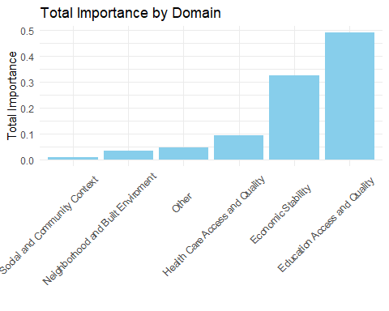

# create linear model for VIF (collinearity) analysis, no scaling, no centering, numeric values only  
qol_numeric <- qol_data %>%   
 select(where(is.numeric))  
  
qol_lm <- lm(  
 pct_poor_to_fair_health ~ .,  
 qol_numeric  
)  
  
vif_values <- car::vif(qol_lm)  
  
vif_values

## weighted_population average_hh_size   
## 380.541480 3.685275   
## pct_male pct_native_american   
## 1.577336 19.342350   
## pct_asian pct_black   
## 4.620903 72.376721   
## pct_hispanic pct_other_race   
## 5.709361 7.042548   
## pct_white pct_single_parent   
## 93.813894 2.976729   
## pct_hh_other_computer pct_hh_internet   
## 1.086193 3.457420   
## pct_employed pct_hh_inc_99999   
## 2.253738 2.228843   
## pct_w_medicare clinical_nurse_pt   
## 2.175950 1.140358   
## dentist_pt pa_pt   
## 1.779709 1.363687   
## mental_health_faciliy_pt population_density   
## 1.126729 1.347411   
## days_over_90_f median_hh_income   
## 2.871957 5.882129   
## median_er_dist median_pediatric_icu_dist   
## 1.611019 1.665478   
## median_health_clinic_dist median_drug_alcohol_care_dist   
## 1.171135 1.734912   
## hh_tot_workers pct_vet   
## 383.791581 1.707336   
## pct_uninsured pct_assistance   
## 5.260978 4.603439   
## percent_grandparents_as_guardians pct_adult_smokers   
## 1.924987 7.068890   
## pct_binge_drinkers pct_under_65_no_health_insurance   
## 2.166994 6.129473   
## pct_highschool_diploma pct_some_college   
## 5.703708 4.183170   
## inequality_ratio social_clubs_per_10k   
## 2.366425 1.632428   
## air_polution_metric water_quality   
## 2.157830 1.100237   
## pct_high_housing_costs pct_overcrowded_hh   
## 2.419277 2.665506   
## pct_30_min_plus_commute pct_food_insecurities   
## 2.534443 4.731278   
## pct_voters pct_home_owner   
## 3.471844 3.589868   
## pct_65_plus pct_rural_population   
## 5.071392 3.806509

# Create a data frame with GVIF and Df  
vif_df <- data.frame(  
 Feature = names(vif_values),  
 GVIF = vif_values,  
 Df = rep(1, length(vif_values)) # Df is typically 1 for univariate cases  
)  
  
# Calculate GVIF^(1/(2*Df)) and add it to the data frame  
vif_df$Adjusted_VIF <- vif_df$GVIF^(1/(2 * vif_df$Df))  
  
# Sort the data frame by Adjusted VIF in ascending order  
vif_df <- vif_df[order(vif_df$Adjusted_VIF, decreasing = TRUE), ]  
  
# Set a threshold for high collinearity   
high_vif_threshold <- 5  
  
# Filter for features with high collinearity values  
high_vif_features <- vif_df[vif_df[, "Adjusted_VIF"] > high_vif_threshold, ]  
  
# Print the table  
print(high_vif_features)

## Feature GVIF Df Adjusted_VIF  
## hh_tot_workers hh_tot_workers 383.79158 1 19.590599  
## weighted_population weighted_population 380.54148 1 19.507472  
## pct_white pct_white 93.81389 1 9.685757  
## pct_black pct_black 72.37672 1 8.507451

# `sp500` table data  
high_vif_features %>%   
 gt::gt() %>%   
 gt::tab_header(  
 title = "Predictors With High Collineariy",  
 )

Table 1: Predictors With High Collineariy

| Feature | GVIF | Df | Adjusted_VIF |
| --- | --- | --- | --- |
| hh_tot_workers | 383.79158 | 1 | 19.590599 |
| weighted_population | 380.54148 | 1 | 19.507472 |
| pct_white | 93.81389 | 1 | 9.685757 |
| pct_black | 72.37672 | 1 | 8.507451 |

# Extract feature importance  
gbm_feature_importance <- varImp(  
 gbm_model_cv,  
 scale = FALSE  
 )  
  
# Convert to a data frame  
gbm_feature_importance_df <- as.data.frame(  
 gbm_feature_importance$importance  
 )  
  
# Add feature names  
gbm_feature_importance_df$Feature <- rownames(  
 gbm_feature_importance_df  
 )  
  
# Rename columns for clarity  
colnames(gbm_feature_importance_df) <- c(  
 "Importance",  
 "Feature"  
 )  
  
# Sort by importance  
gbm_feature_importance_df <- gbm_feature_importance_df %>%  
 arrange(desc(Importance))  
  
# Export to a CSV file  
write.csv(  
 gbm_feature_importance_df,  
 "gbm_feature_importance.csv",  
 row.names = FALSE  
 )  
  
# Print the feature importance table  
print(gbm_feature_importance_df)

## Importance  
## pct_highschool_diploma 4.643326e-01  
## pct_food_insecurities 2.297069e-01  
## median_hh_income 6.727079e-02  
## pct_adult_smokers 6.441548e-02  
## pct_some_college 2.592092e-02  
## region_South 2.253109e-02  
## pct_assistance 2.201346e-02  
## days_over_90_f 1.801302e-02  
## pct_binge_drinkers 1.488110e-02  
## pct_hispanic 6.557120e-03  
## pct_under_65_no_health_insurance 6.374268e-03  
## pct_voters 5.878899e-03  
## pct_hh_inc_99999 5.689507e-03  
## pct_black 3.468132e-03  
## pct_white 3.450485e-03  
## air_polution_metric 3.250158e-03  
## pct_vet 3.075703e-03  
## pct_single_parent 2.367880e-03  
## pa_pt 2.046616e-03  
## percent_grandparents_as_guardians 2.028129e-03  
## pct_uninsured 1.821077e-03  
## average_hh_size 1.736171e-03  
## pct_overcrowded_hh 1.441646e-03  
## pct_65_plus 1.190921e-03  
## population_density 1.171810e-03  
## pct_other_race 1.129866e-03  
## pct_native_american 1.127381e-03  
## median_er_dist 1.102490e-03  
## pct_hh_other_computer 1.098252e-03  
## social_clubs_per_10k 9.887691e-04  
## weighted_population 9.279541e-04  
## median_drug_alcohol_care_dist 9.147313e-04  
## pct_home_owner 8.694203e-04  
## pct_hh_internet 8.486502e-04  
## pct_employed 8.414767e-04  
## pct_male 8.223924e-04  
## median_pediatric_icu_dist 8.152863e-04  
## pct_high_housing_costs 8.130358e-04  
## pct_w_medicare 8.114936e-04  
## inequality_ratio 7.974180e-04  
## hh_tot_workers 7.473830e-04  
## pct_30_min_plus_commute 7.458699e-04  
## pct_rural_population 7.451414e-04  
## region_Midwest 6.122739e-04  
## pct_asian 5.155501e-04  
## median_health_clinic_dist 4.873042e-04  
## region_West 4.423313e-04  
## dentist_pt 4.297006e-04  
## mental_health_faciliy_pt 3.225875e-04  
## clinical_nurse_pt 1.730318e-04  
## region_Northeast 1.639439e-04  
## water_quality 7.238083e-05  
## Feature  
## pct_highschool_diploma pct_highschool_diploma  
## pct_food_insecurities pct_food_insecurities  
## median_hh_income median_hh_income  
## pct_adult_smokers pct_adult_smokers  
## pct_some_college pct_some_college  
## region_South region_South  
## pct_assistance pct_assistance  
## days_over_90_f days_over_90_f  
## pct_binge_drinkers pct_binge_drinkers  
## pct_hispanic pct_hispanic  
## pct_under_65_no_health_insurance pct_under_65_no_health_insurance  
## pct_voters pct_voters  
## pct_hh_inc_99999 pct_hh_inc_99999  
## pct_black pct_black  
## pct_white pct_white  
## air_polution_metric air_polution_metric  
## pct_vet pct_vet  
## pct_single_parent pct_single_parent  
## pa_pt pa_pt  
## percent_grandparents_as_guardians percent_grandparents_as_guardians  
## pct_uninsured pct_uninsured  
## average_hh_size average_hh_size  
## pct_overcrowded_hh pct_overcrowded_hh  
## pct_65_plus pct_65_plus  
## population_density population_density  
## pct_other_race pct_other_race  
## pct_native_american pct_native_american  
## median_er_dist median_er_dist  
## pct_hh_other_computer pct_hh_other_computer  
## social_clubs_per_10k social_clubs_per_10k  
## weighted_population weighted_population  
## median_drug_alcohol_care_dist median_drug_alcohol_care_dist  
## pct_home_owner pct_home_owner  
## pct_hh_internet pct_hh_internet  
## pct_employed pct_employed  
## pct_male pct_male  
## median_pediatric_icu_dist median_pediatric_icu_dist  
## pct_high_housing_costs pct_high_housing_costs  
## pct_w_medicare pct_w_medicare  
## inequality_ratio inequality_ratio  
## hh_tot_workers hh_tot_workers  
## pct_30_min_plus_commute pct_30_min_plus_commute  
## pct_rural_population pct_rural_population  
## region_Midwest region_Midwest  
## pct_asian pct_asian  
## median_health_clinic_dist median_health_clinic_dist  
## region_West region_West  
## dentist_pt dentist_pt  
## mental_health_faciliy_pt mental_health_faciliy_pt  
## clinical_nurse_pt clinical_nurse_pt  
## region_Northeast region_Northeast  
## water_quality water_quality

# Plot the feature importance  
ggplot(  
 gbm_feature_importance_df,  
 aes(  
 x = reorder(Feature, Importance),  
 y = Importance)  
 ) +  
 geom_bar(  
 stat = "identity",  
 fill = "steelblue"  
 ) +  
 coord_flip() +  
 labs(  
 title = "Feature Importance from GBM Model",  
 x = "Feature",  
 y = "Importance"  
 ) +  
 theme_minimal()

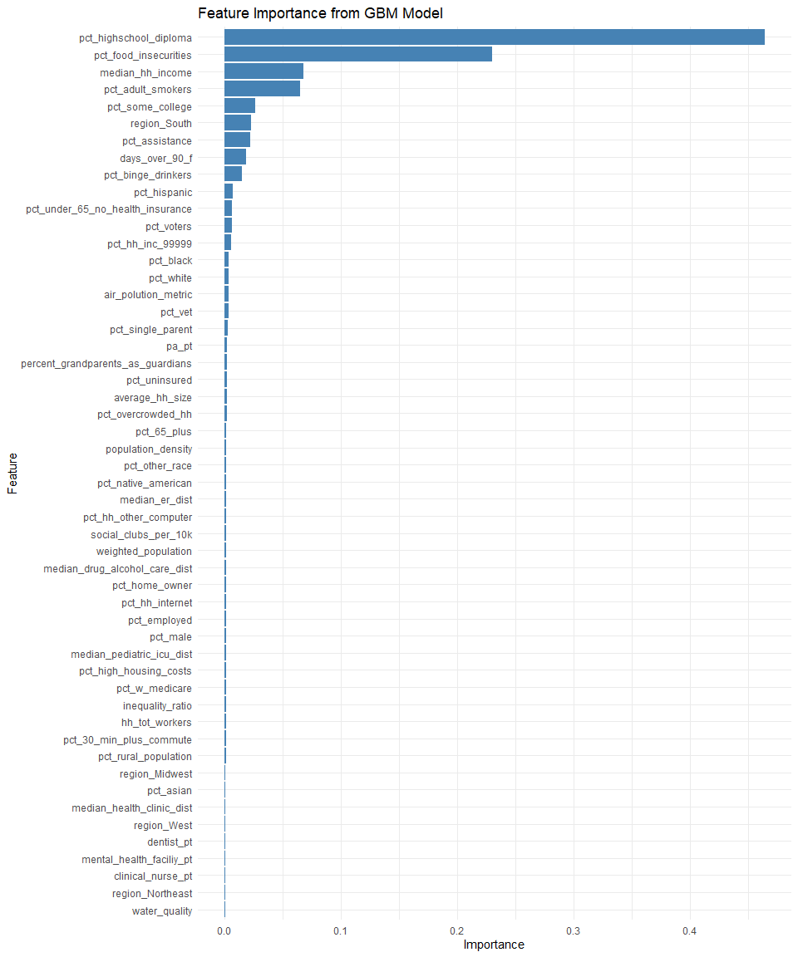

# Train the SVM model  
svm_model <- e1071::svm(  
 pct_poor_to_fair_health ~ .,  
 data = qol_train  
 )  
  
# Evaluate the model on the test data  
svm_pred <- predict(  
 svm_model,  
 qol_test  
 )  
  
# Calculate evaluation metrics  
svm_mse <- mean(  
 (svm_pred - qol_test$pct_poor_to_fair_health)^2  
 )  
  
svm_rmse <- sqrt(  
 svm_mse  
 )  
  
svm_r_squared <- 1 - sum(  
 (svm_pred - qol_test$pct_poor_to_fair_health)^2  
 ) /   
 sum(  
 (qol_test$pct_poor_to_fair_health - mean(qol_test$pct_poor_to_fair_health))^2  
 )  
  
# Print the evaluation metrics  
cat("SVM MSE:", svm_mse, "\n")

## SVM MSE: 0.0001215293

cat("SVM RMSE:", svm_rmse, "\n")

## SVM RMSE: 0.01102403

cat("SVM R-squared:", svm_r_squared, "\n")

## SVM R-squared: 0.9408336

# Compute variable importance  
svm_importance <- vip::vip(  
 svm_model,  
 train = qol_train,  
 target = "pct_poor_to_fair_health",  
 method = "permute",  
 metric = "rmse",  
 pred_wrapper = function(  
 model,  
 newdata  
 )   
 predict(  
 model  
 ,  
 newdata  
 ),   
 num_features = ncol(qol_train) - 1  
 )  
  
plot(svm_importance)

