
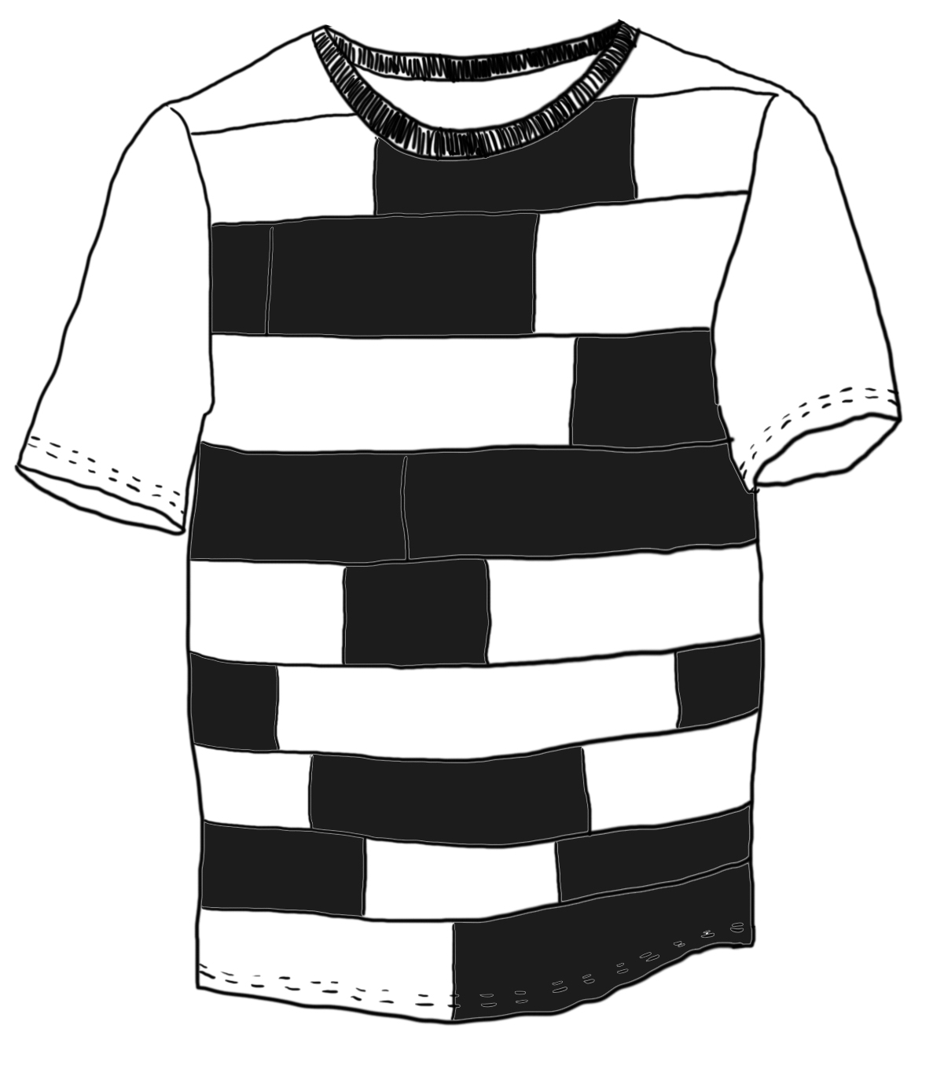
Unitee

Design by: Mika Modiggård, Cecilia Palmer
Collection: Queens & Kings
http://pamoyo.com/open-design/unitee

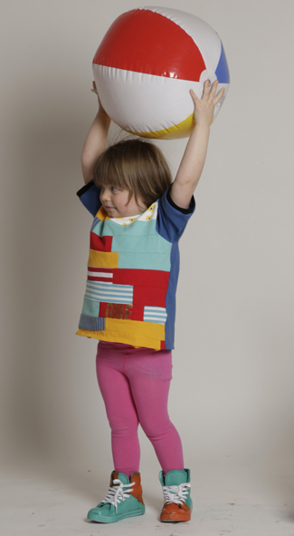
Please note: Pattern pieces are WITHOUT seam allowance included, add required amount of seam allowance when cutting pattern/fabric (0.5-1 cm, depending on the material & assembly)

Pattern pieces and material:

1/4 Sleeve
2/4 Underskirt
3/4 Back
4/4 Front
5/ Upperskirt 1
6/ Upperskirt 2
7/ Underskirt tulle
8/8 Collar ribbing

The original design uses jersey (upcycled vintage tees) for back and front, satin weave for the underskirt and sleeves, satin scraps pieces and cuttings for the upper skirts (patchwork), and tulle.




This work is licensed under the Creative Commons Attribution (CC-BY) license.
You are free to distribute, remix, tweak, and build upon this work, as long as you credit Pamoyo for the original creation, and share derivative works under the same, or equal, license. More information and full legal code here: http://creativecommons.org/licenses/by/3.0/de/deed.en

