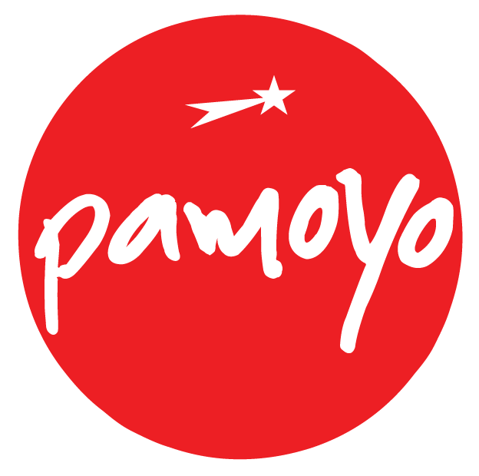
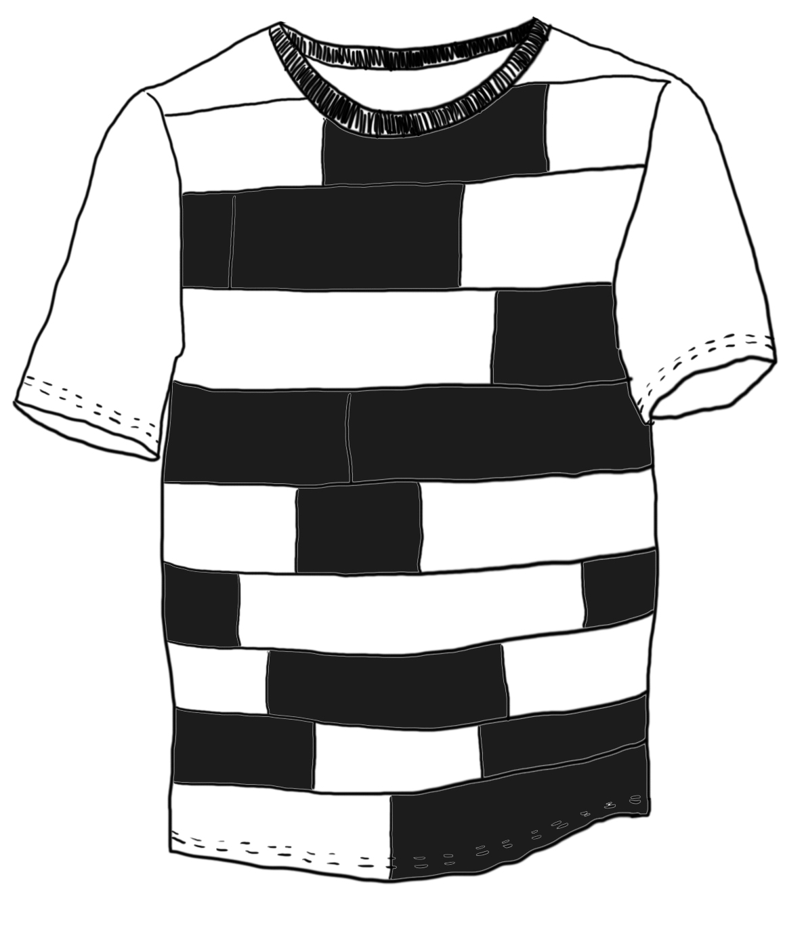
Unitee

Design by: Mika Modiggård
Collection: Queens & Kings

http://pamoyo.com/open-design/unitee

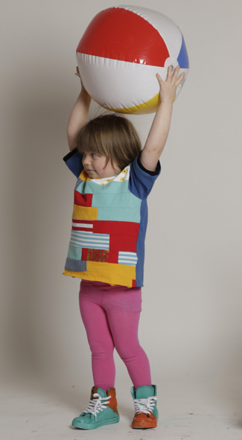
Please note: Pattern pieces are WITHOUT seam allowance included, add required amount of seam allowance when cutting pattern/fabric (0.5-1 cm, depending on the needs)

Pattern pieces and material:

1/4 Sleeve
2/4 Underskirt
3/4 Back
4/4 Front
5/ Upperskirt 1
6/ Upperskirt 2
7/ Underskirt tulle
8/8 Collar ribbing

The original design uses organic cotton jersey for the back and sleeves, and patchwork from left-over jersey pieces for the front. Cotton ribbing for collar.





This work is licensed under the Creative Commons Attribution Share Alike (CC-BY-SA) license.
You are free to distribute, remix, tweak, and build upon this work, as long as you credit Pamoyo for the original creation, and share derivative works under the same, or equal, license. For more information: http://creativecommons.org/licenses/by/3.0/

