1. File uploaded by the client.

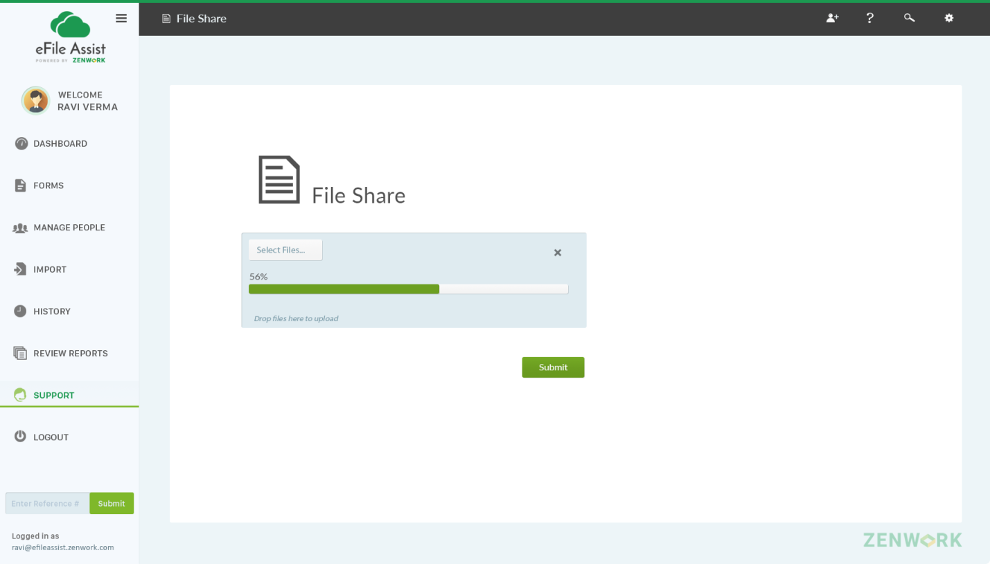

1. File uploaded successfully and the reference number will be generated.

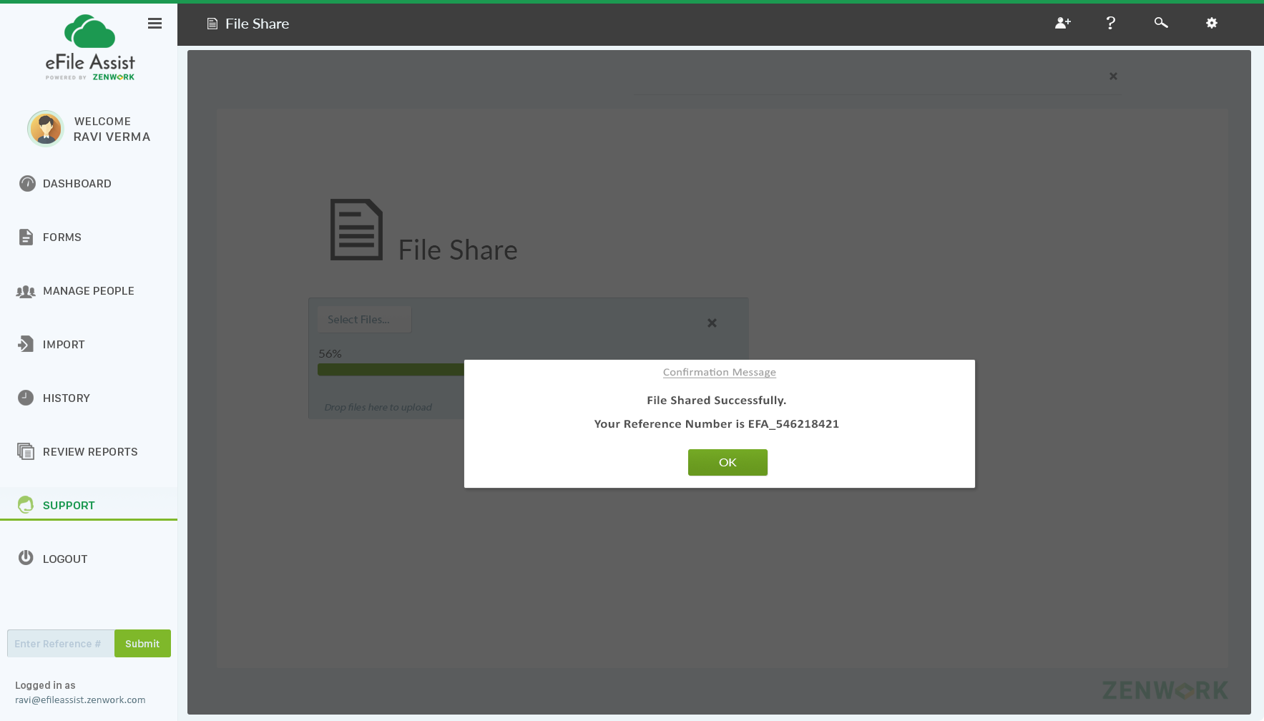

1. This is a support’s screen.

**Support team will notify the customer by clicking on “Submit for Verification” button.**

**Clarification for Developer - This button is available ONLY to the EFA support team So support team logging from Admin Tool will only see this button the first time. Once user takes action. Rest of the buttons will appear.**

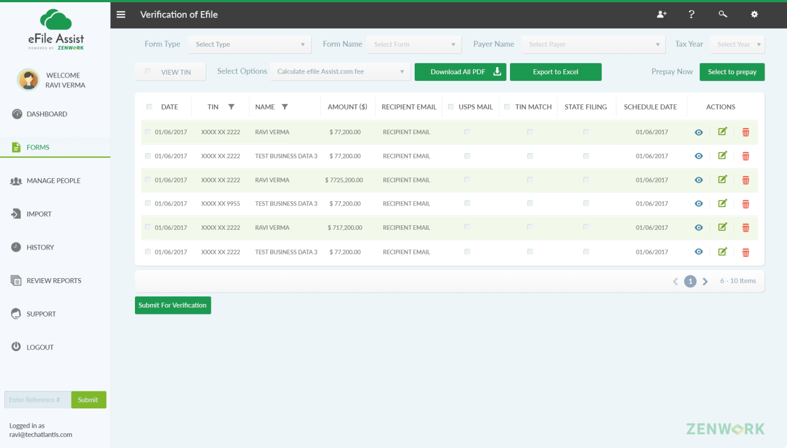

1. On clicking on “Submit for verification” pop up message will be generated and customer will get an email / a link to verify & Approve or reject. ( all emails should be sent to efa_ops@zenwork.com)

Query 1: Please let me know how I can sign up or login with support team user?

Query 2 : What should be status of the forms before 'Send for Verification' and what is the status after

send for verification?

Here is the Screen Shot for status table, please correct me if I am setting status from wrong table.

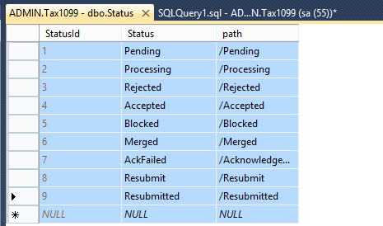

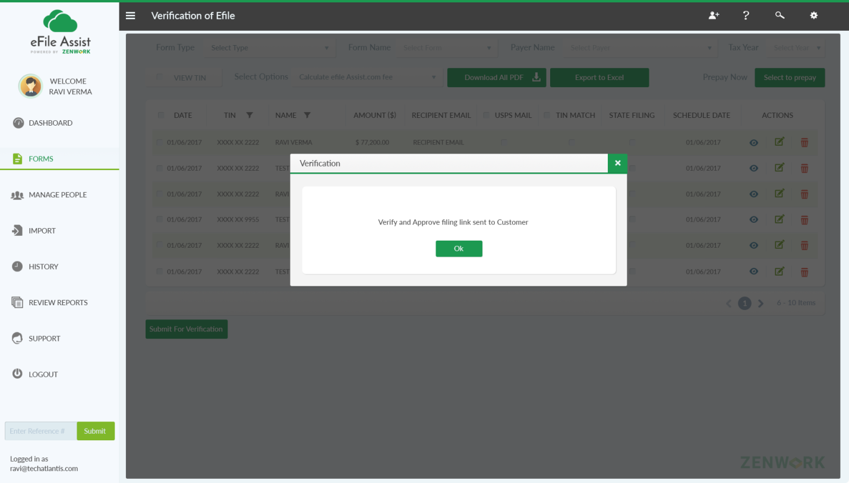

1. Client’s screen: Screen with “Verify & Approve”, reject and submit. Submit button will be inactive until the client clicks on “verify &approve”.

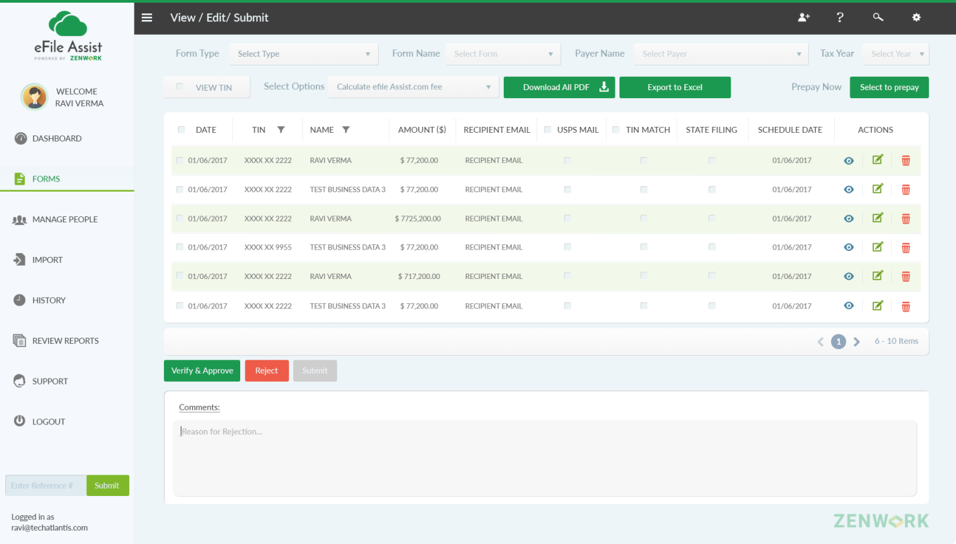

Remove - Comment button should be hidden for this screen and it should only expand or show up when customer clicks on Reject button

1. On clicking on “verify & approve” button, pop up message will be displayed for confirmation.

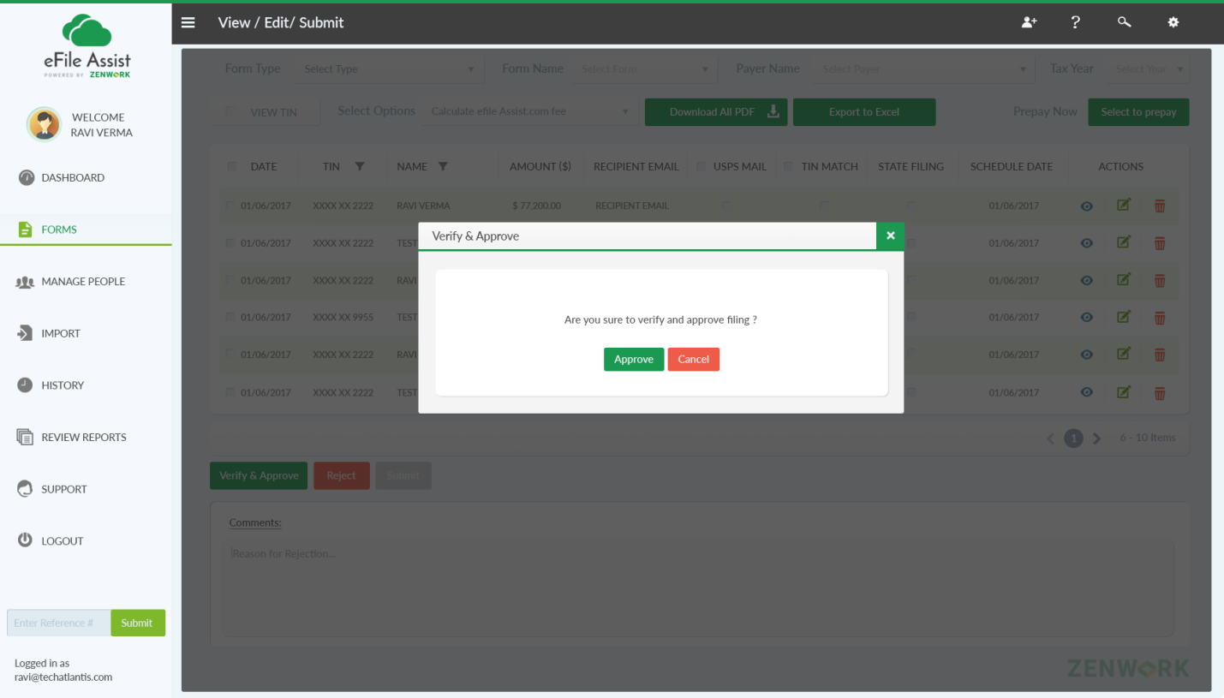

Query 3 : After verify or reject should these listed forms disappear from the list or move to some other screens? If user refresh the page after 'Verify & Approve' what should happened?

1. If clicked on “Approve” button on the pop up message-> it will ask to client to “submit form to EFA team” or “Submit”(submission by client).

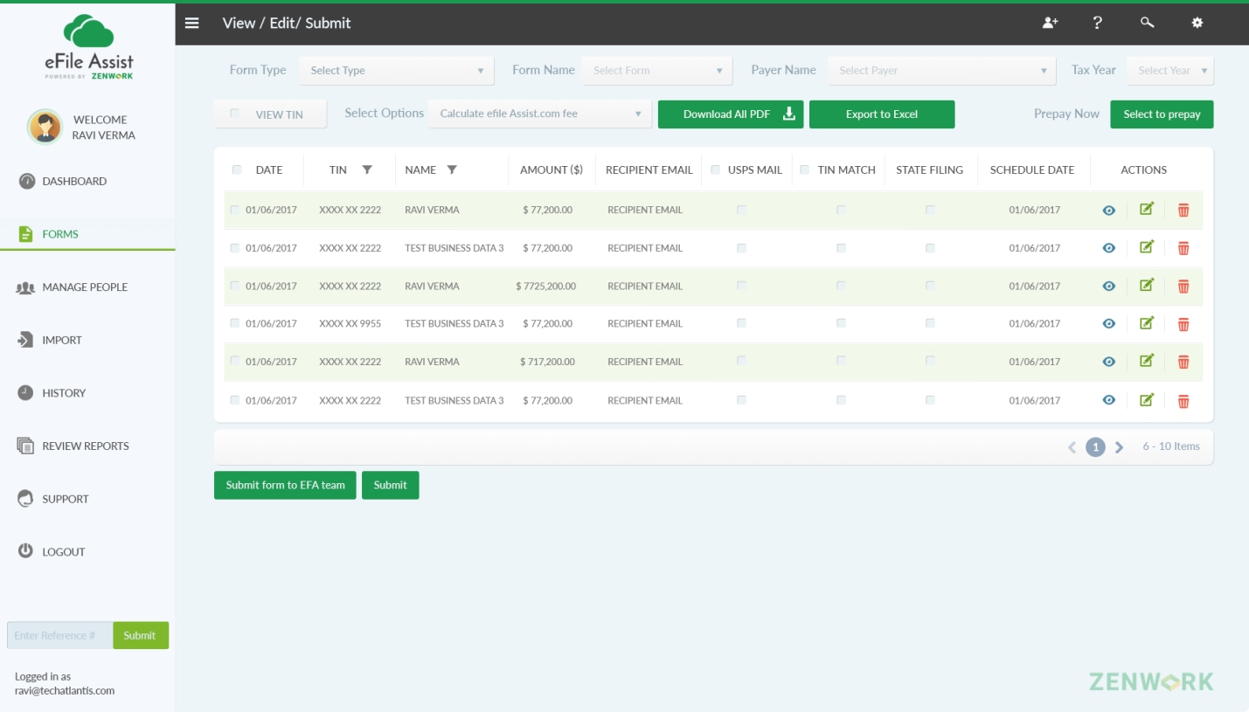

Query 4 : What we need to do at backend when user click on "Submit Form to EFA team" or "Submit" button? What is the status for "Submit form to EFA team" and "Submit".

8. If client select “submit” button then the confirmation pop up message will be displayed and reference number will be generated by the system.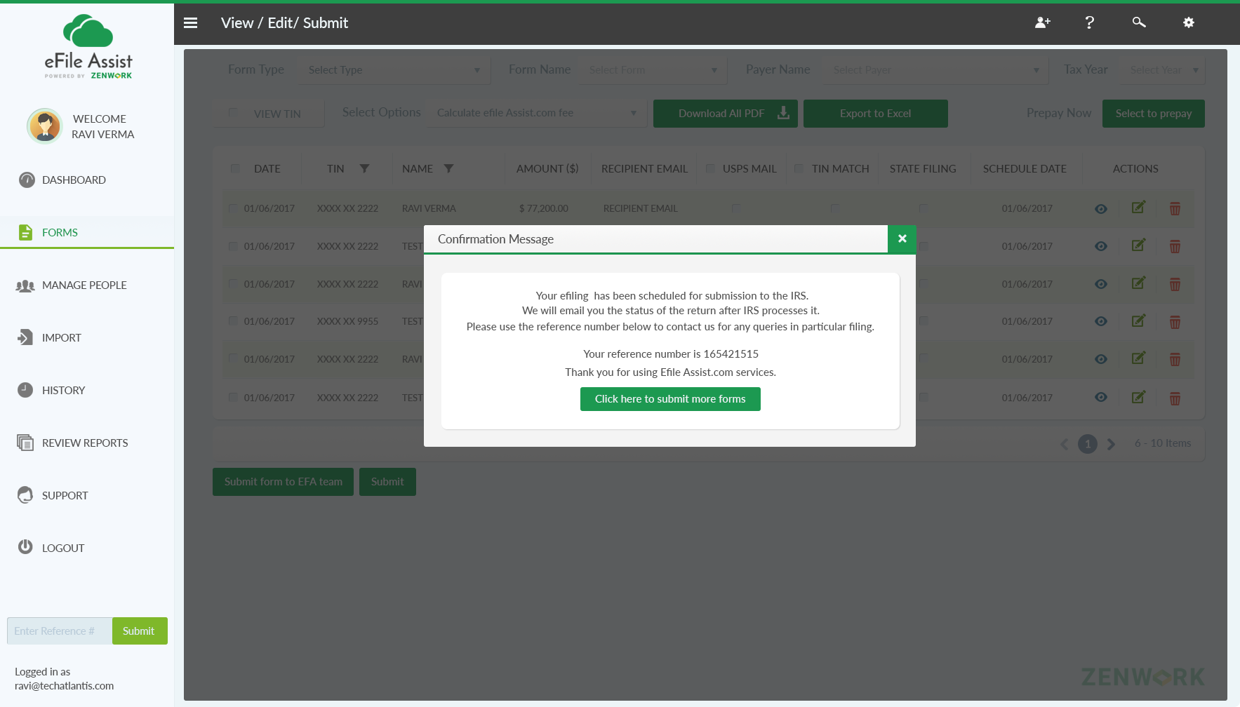

Query 5 : Where we need to store this new reference number. Reference number already generated when user click on 'Verify and Approve' as ReferenceID(ie Primary Key).

9. On clicking on “submit form to EFA team” the pop up message will be displayed.

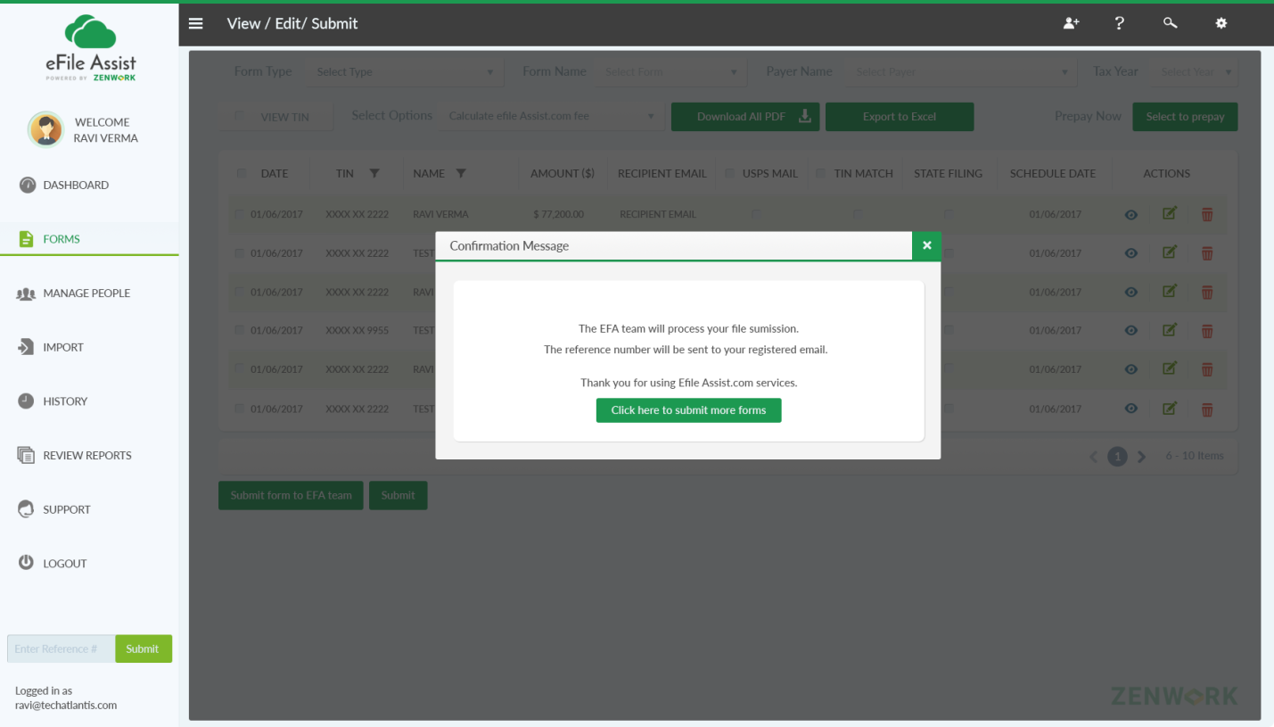

10. If the client selects “Reject” button follow the next screen.



11. If “Reject” button is selected and if no comments are added then the following pop up message will be displayed asking to mention the reason for rejection.

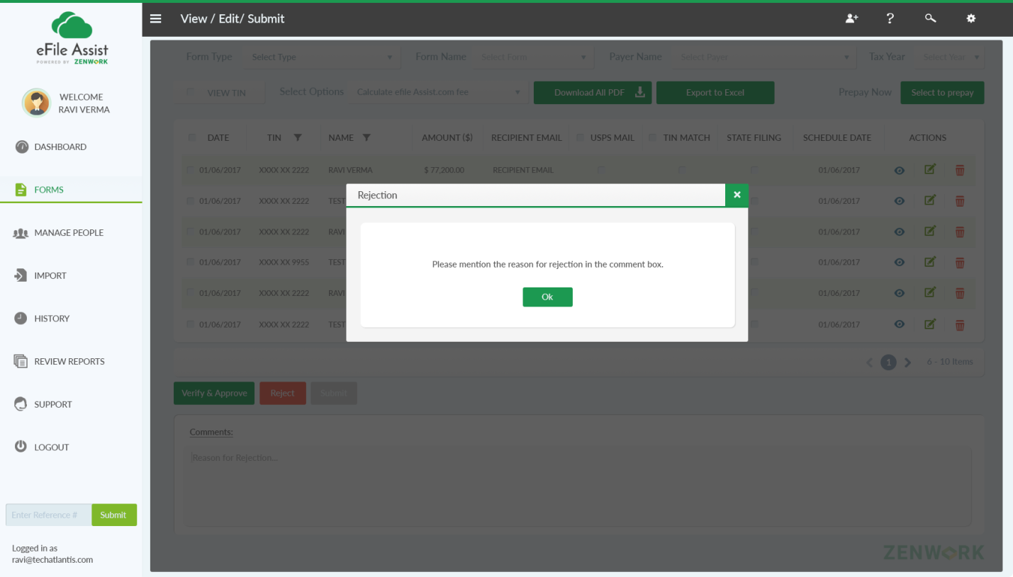

12. After writing the reason for rejection in the comment box then the following pop up message will be displayed. And an email will be sent to the support team for file rejection. On this page “Verify &approve” & “Submit buttons will remain inactive.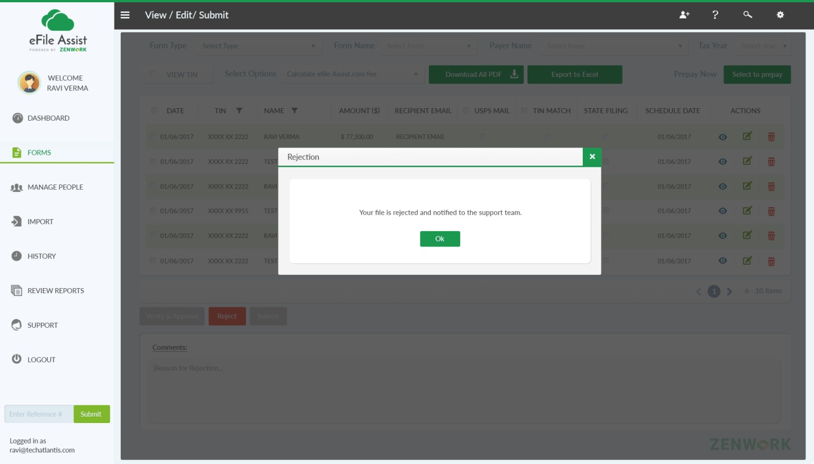

Query 6 : If user select first 2 forms from the list and click on 'Reject' button then what for others? If user wants to verify the others then buttons need to be enabled. Is this functionality (Verify and Reject) only work for all the forms displayed in the list?