|  |
| --- |
|  |
| ResearchDB |
| By Scott Vallery |

|  |
| --- |
| Scott Vallery  6/19/2019 |

Table of Contents

Welcome! 3

Getting Started 4

About Window 4

Sample.db and Blank.db 4

Menu Bar 5

Header 7

Tabs 7

Search 7

Search Tab: Searching 7

Search Tab: Select a Note 8

Search Tab: Edit or Update 9

Search Tab: Quote and Term / Files Tab 10

Search Tab: Commit an Update or Edit 10

Search Tab: Print Note 10

Entry 11

Entry Tab 11

Entry Tab: Source Type 11

Entry Tab: Source Area 12

Entry Tab: Source Field Meanings 12

Entry Tab: Source Area and the Source dropdown 13

Entry Tab: Source Area and the Author fields and dropdown 13

Entry Tab: Topic, Question, and Summary Fields 14

Entry Tab: Attaching or Removing Files 14

Entry Tab: Comment, Quote, and Term Fields 14

Down and Dirty Quick Start 16

Enter a new note 16

Query a Note 17

Edit a Note 17

Delete a Note 17

Open a Database 17

Create a New Database 18

Import a Note(s) 18

Export a Note(s) 18

# Welcome!

Thanks for choosing ResearchDB. Originally, created as an apologetics database, the purpose of ResearchDB is simply to help people to document important credible sources which support their beliefs or interest – and maybe even important research. You can simply copy and paste in links, comments, important information and sources which bring credibility to you and your information. A conversation like the following no longer a struggle trying to recall facts about the point you are making.

|  |  |
| --- | --- |
| Friend:  You:  Friend:  You:  Friend:  You: | *I watched a New Testament Bible scholar on the news explaining all the corruption in the Bible.*  *I've heard them and their arguments are impressive but weak. The Bible can be demonstrated to be as accurate today as it was 2000 years ago.*  *That's impossible! It was copied and copied and corrupted by those with an agenda. It's all heresy! Besides, this scholar said there are well over 100,000 differences in all the manuscripts and no two are identical.*  *I listened to a seminar on Bible corruption addressing questions and other arguments by other*  *Scholars, skeptics and cynics. BTW, it is more like 500,000 differences and is easily explained away. We can trust it to be 99.8% accurate in interpretation and 100% in meaning and doctrine.*  *I don't believe that at all. How can you have 500,000 differences and be that accurate.*  *Well, I listened to it about a year ago but I can't remember exactly where. I will have to find it.* |

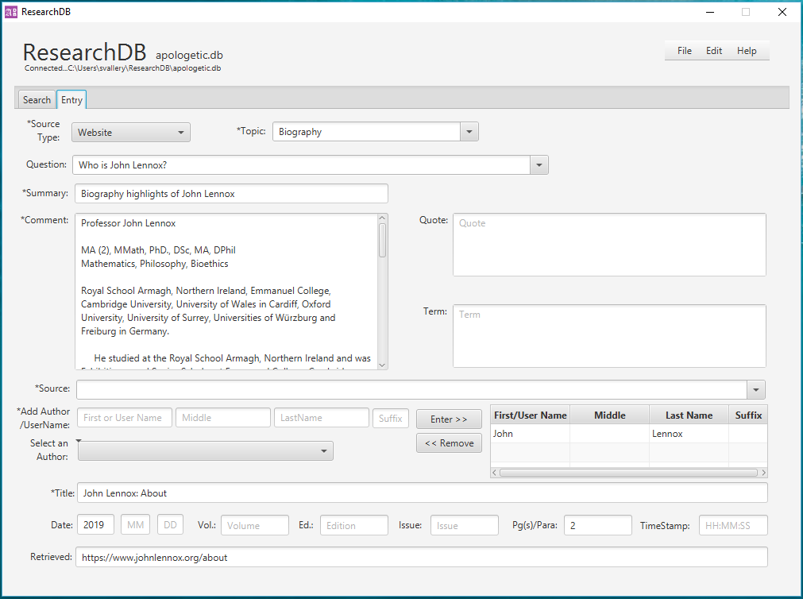 Wouldn't it be nice for once if you could simple say, *"Sure, I got it right here. Do you want to listen?",* then open the app, find the note, click the link and you begin to listen. Now you can! As previously stated, the purpose is to provide a simple app to help you document your sources and comments in a way that will help you remember and recall them.

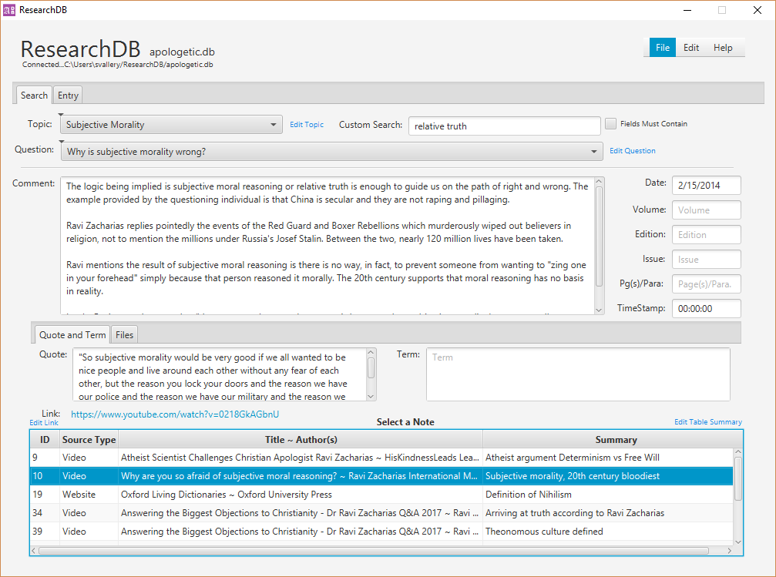

# Getting Started

## About Window

When the ResearchDB application is launched for the first time the ‘About’ window will come up briefly describing the app and its purpose. It will no longer come up unless you select it from the menu under **Help**, which you will also find a link to this document. Click the red ‘X’ in the upper right corner to close the about window.

## Sample.db and Blank.db

A default sample database will be loaded with 1-2 topics for demonstration the first time the application is launched. We will use this sample.db to learn how to use ResearchDB. The sample.db should never be deleted and the application will not allow you to do so. Once you create a database or select an existing database the application will open the database last viewed when the application was closed.

Deleting either the **sample**.db or **blank.db** databases manually will not allow your application to work or could wipe out your current databases.

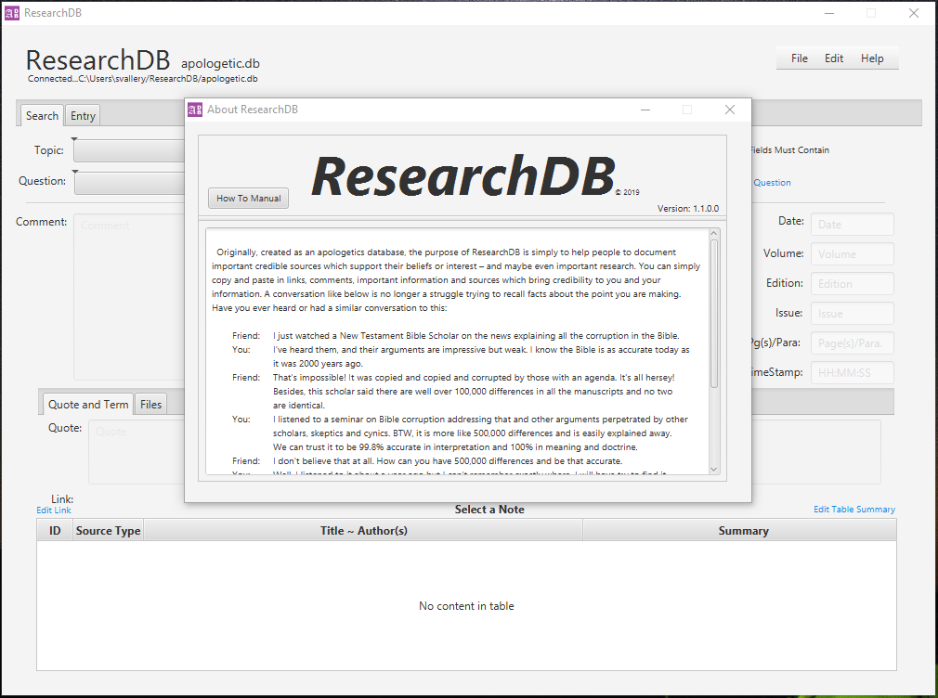

# Menu Bar

The **Menu Bar** is used to Open or Close databases, to **Add** or **Commit** updates to notes, or to **Delete** notes or Databases. The Menu Bar options available are determined by the tab you are currently using. For example, a new source and note can only be added when the Entry tab is in use. Otherwise, the Add Note option is unavailable if the Search tab is in use.

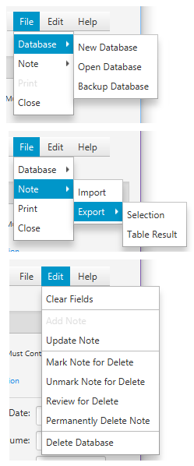**New Database**: Prompts you to enter a name for the new database and uses **blank.db** in the template folder to create the new database. It will then open it for use.

**Open Database**: Prompts you to select an existing database to open in place of the current one.

**Backup Database**: Allows you to backup the currently opened database to the backup folder as ‘backup_[my_data].db.’

**Import:** Import allows you to import notes and their attachments exported from another ResearchDB database into your own. You can share notes with other ResearchDB users or move notes from one database to another.

**Export**: Exports notes and their attachments to an XML to import into another ResearchDB database.

* **Selection**: Only exports a single selected note.
* **Table** **Result**: Exports all notes listed in the search table.

**Print:** Opens a print preview of the note selected with options to print all pages or a single page with printer options.

**Close**: Will close the application.

**\*Note**: There is not a **Save** or **Close Database** option. When you add or commit updates the database saves them. Opening a database closes the existing. A database is always open at any given time in the application.

**Add Note**: Checks all required fields on the Entry tab contain data then saves the source and data in the database.

**Clear Fields**: Clears all the fields on the tab currently selected

**Mark Note for Delete**: This marks a note for review before deleting as a safety measure in case you are not sure. Notes marked will not show in searches and can be reviewed by selecting Review for Delete before deleting.

**Unmark Note for Delete**: Unmarks the selected note for delete and the note will be available for searching.

**Review for Delete**: Searches all the notes marked for delete and will provide a list in the table for selection to review.

**Permanently Delete Note**: This permanently deletes a note after prompting for a confirmation.

**Delete Database**: Will allow you to delete any database not currently open, but will not allow you to delete the **sample**.db or **blank.db**. Deleting either of these databases manually will not allow your application to work or could wipe out your current databases. These are used for teaching and creating new databases. Notice the **sample.db** is not listed in the Delete Databases window though it is listed with the other databases in the ResearchDB folder.

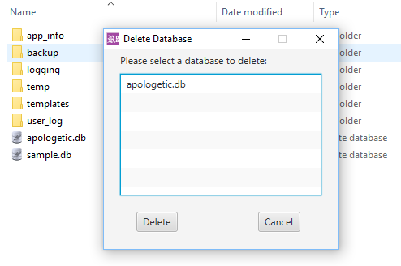

# Header

The name of the current database open is to the right of the ResearchDB logo (see image below). Below the logo is the connection status and location of the database. These update when databases change.

# Tabs

There are two tabs used in the application. The **Entry** tab is specifically for entering new sources and any notes related to those sources. The **Search** tab is used to review, search, edit, update or to delete a note.

## Search

### Search Tab: Searching

The **Search** tab is where most interaction occurs once notes and sources are established. The application will always open to a blank Search tab. At the top of the tab you can search by **Topic**, **Question** or **Custom Search** on a specific word or phrase. If a field must contain all words in a database field such as **Comments**, simply check the box **Fields Must Contain**.

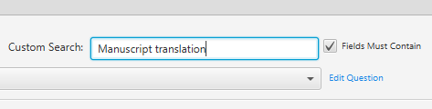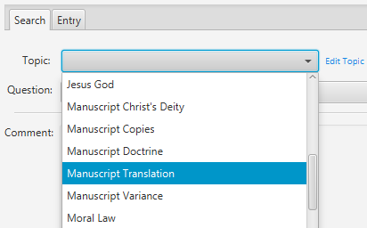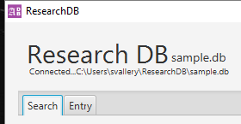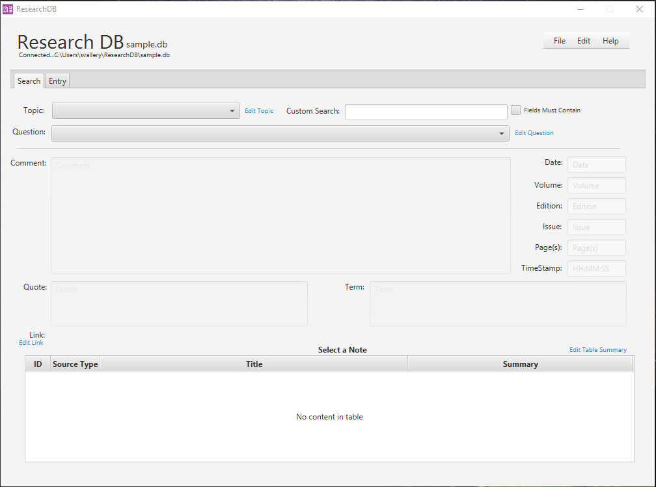

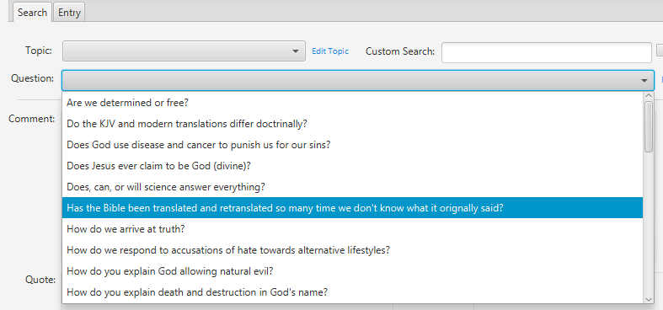

### Search Tab: Select a Note

At the bottom of the Search tab is a table section named **Select a Note**. After a search criterion is selected, any source note pertaining to that criterion will appear here. Simply click on a row containing a source reference and the details will populate in the fields above the table, including the Topic and Question Files table fields depending upon how the search was performed.

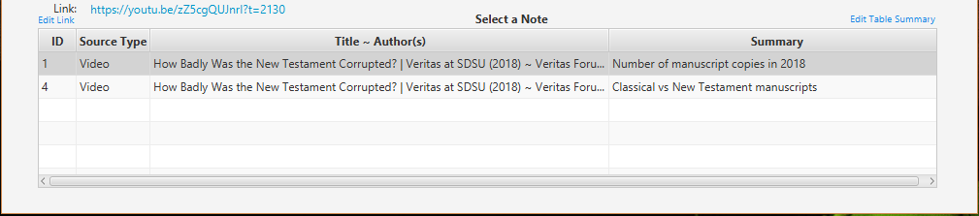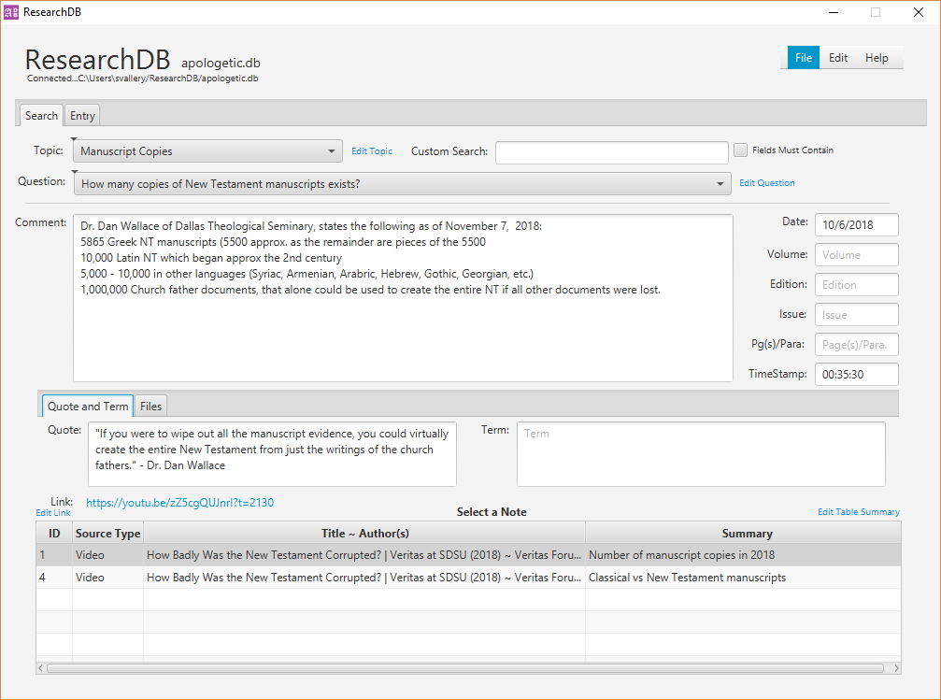

### Search Tab: Edit or Update

If you notice a mistake, changes are made through the Search tab. Text fields such as **Comment**, **Quote**, **Term** and **Date** through **TimeStamp** can be edited directly by simply clicking on them and making a change. The **Topic**, **Question**, **Hyperlink**, and table **Summary** can only be edited through an input box by clicking the **light blue edit for each**.

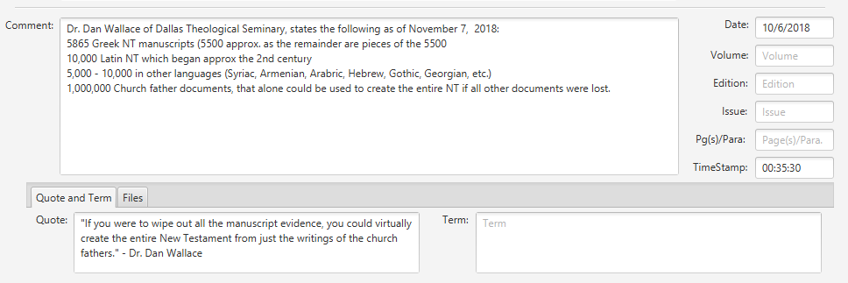

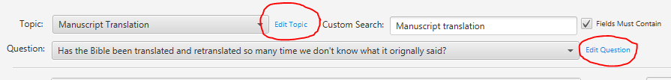

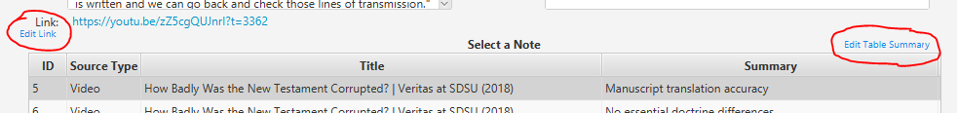

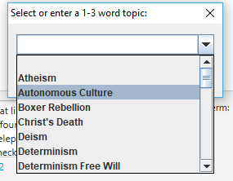**Topic** and **Question** will allow you to select an existing option or create a new one by simply typing the new topic or question in the blank. **Question**, **Hyperlink** and **Summary** will let you edit or clear but **Topic** will always require a value.

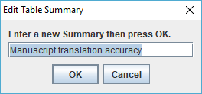

### Search Tab: Quote and Term / Files Tab

The Search tab includes two additional tabs: **Quote and Term** and **Files** tabs. The Quote and Term can be edited and updated as stated above. The **Files** tab also exists for opening, adding, or removing files associated to the existing note displayed.

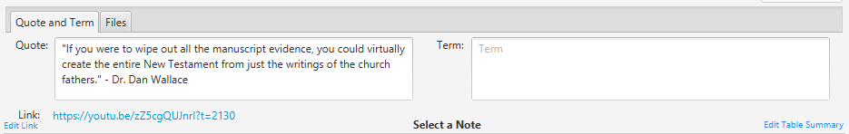

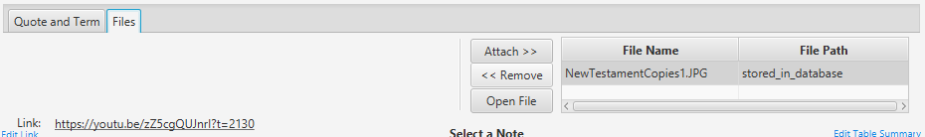

### Search Tab: Commit an Update or Edit

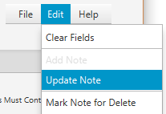 In order to commit an update or edit select **Edit** from the menu in the upper right corner and select **Update Note**. The app will simply check every field for a change and update them as needed.

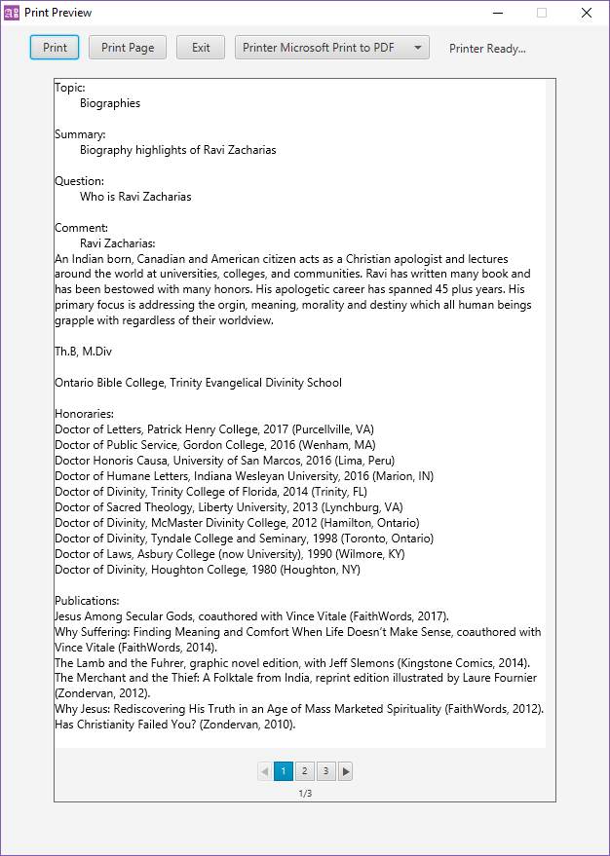

### Search Tab: Print Note

The Print Preview page allows you to see the page before it is printed. This simply prints out the details about the note selected but allows you to select a specific page without printing out everything. The window closes automatically unless there is a print error.

**Print:** Prints all available pages.

**Print Page:** Prints the selected page using the page range selector at the bottom of the window.

**Exit:** Simply exists without printing.

**Printer List:** Shows the default printer and allows for other printer options on your system.

## Entry

### Entry Tab

The **Entry** tab is used to document notes and sources. Once a note is documented, it is immediately available on the search tab. There is no need to close and reopen the application. When you discover a source supporting your interests include it here with the initial details. A source only needs to be entered once and then it can be recalled and linked to additional notes using the **Source** dropdown.

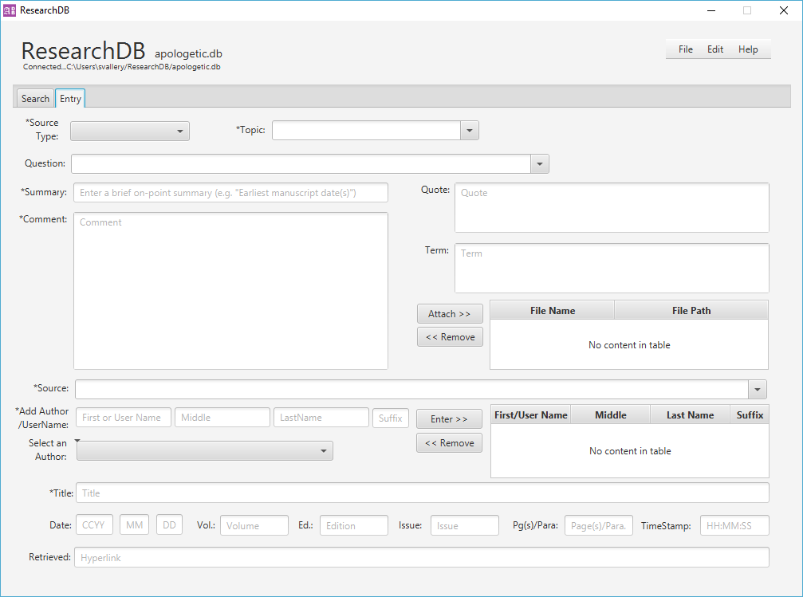

### Entry Tab: Source Type

The **Source Type** is a fixed list of common sources of information. Most sources will fall in these categories. For example, a journal article is still a journal article whether it is online or in a physical journal. Online there will be a link and a paragraph as opposed to a physical journal and page.

**Source Type** is a required field. You will be prompted to make a selection if you don’t. Once you know the source type select it here.

### Entry Tab: Source Area

**The First Time a Source is Entered**

At the bottom of the Entry tab is the source area. In this area you will enter information about your source the first time. After you have entered your source and the first corresponding note, the source will then be available by selecting it from the Source dropdown (mentioned below).

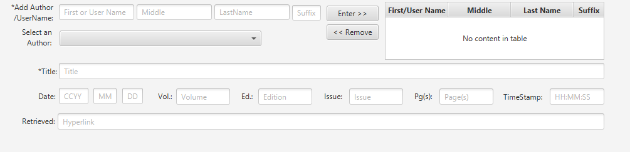

Required fields in the Source area are: **Title** and **Author** including **Source Type**. There are other required fields to complete the note also marked with an asterisk (*)

The **Source** dropdown below will display all sources previously entered by either selecting the dropdown button on the right or by simply typing key words in the blank space provided.



### Entry Tab: Source Field Meanings

**Add Author/UserName**: A required field. Use the First Name field for a UserName or author First Name. Use the remaining Middle, Last Name and Suffix as you would for any author name. Use these fields to add all the authors of a particular source.

**Enter**: Press this every time you enter an author for a source.

**Remove**: Press this to remove any authors you accidentally add or enter incorrectly in the author table.

**Author Table**: Authors you add will be listed here and the application will use this list for the source you enter.

**Title**: A required field. Enter the appropriate title for the source.

**Date**: Enter a year or full date. For example a book will be a year only, a periodical a full date or month/year.

**Vol** (Volume): If your source is a part of a volume enter it here.

**Ed** (Edition): If your source is a part of an edition enter it here.

**Issue**: If your source is an issue enter it here.

**Pg(s)/Para.**: If your source note is on a particular page(s) or paragraph(s) enter them here.

**TimeStamp**: If your source is a particular part of audio or video or source with a time stamp, enter it here only in the format as **HH:MM:SS** (hours : minutes : seconds).

**Hyperlink**: If your source is online, copy and paste the web address here. (Note: right clicking an audio or video source may provide the option to copy a link with a timestamp.

### Entry Tab: Source Area and the Source dropdown

After you have entered a source for the first time, you use the **Source** drop down to select it for additional notes. You can also select a source by typing a keyword(s) in the bar.

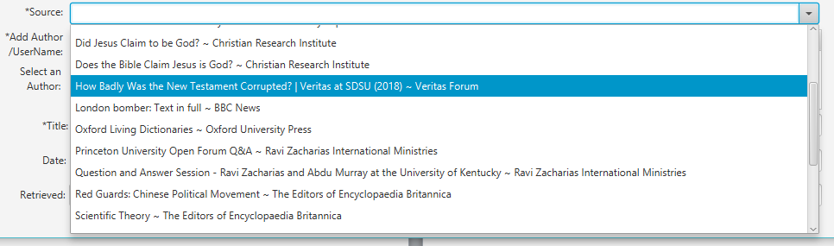

### Entry Tab: Source Area and the Author fields and dropdown

Just like a source, after an Author is entered once, an Author can be selected from the **Select an Author** dropdown and entered into the table.

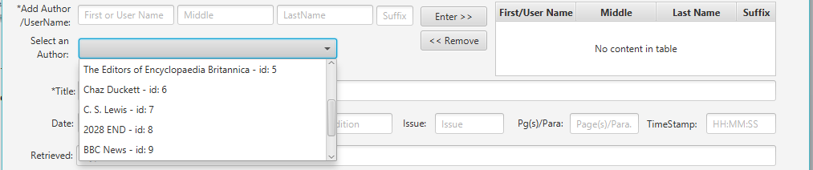

### Entry Tab: Topic, Question, and Summary Fields

The **Topic**, **Summary** and **Question** fields are a way to tie your notes back to applicable specifics. A **Topic** should only be 1-3 words. A **Summary** should expand on the topic and be a brief statement emphasizing a specific point related to the topic. The **Question** field is optional but could be a way to tie your Topic and Summary back to a common question on the topic. All three of these fields can make finding your specific note and source more accessible when accurately tying these fields together.

Again, just as with the Source and Author dropdowns, the **Topic** and **Question** boxes perform in the same manner to help tie Topics and Questions back across multiple notes to help reduce redundancy in similar topics or questions.

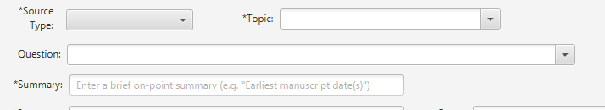

**Topic**: A required field. Enter a topic but you are limited to 1-3 words. After entering a topic it is retained for referencing other notes to the same topic. It will allow most scripture references.

**Summary**: A required field. Enter a brief point specific summary statement that will help in identifying a particular note in the Notes table resulting from a search.

**Question**: An optional field which you may enter a common question associated to a topic or a number of topics.

### Entry Tab: Attaching or Removing Files

There is an area to attach files related to a note. This area allows for removal of any file prior to selecting “Add” when you officially add a note to the database. You do have the ability to view, attach or remove files attachments on the Search tab.

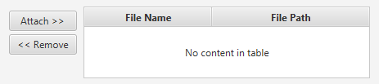

### Entry Tab: Comment, Quote, and Term Fields

The **Comment**, **Quote** and **Term** fields are where your details reside. Though they can be as long or as short as you like, being on point and avoiding to much elaboration will make understanding and reading your note much easier. You aren’t writing a book, you are taking a note which will help you elaborate in your discussion. Think of all these fields as reminders about the point you are trying to make.

**Comment**: A required field. This area is for noting the point and information that will help you remember details.

**Quote**: There may be a specific quote addressing the point you want to make and you can enter it here.

**Term**: There may be a term specific to the point you are making or better explains the meaning of the point being made.

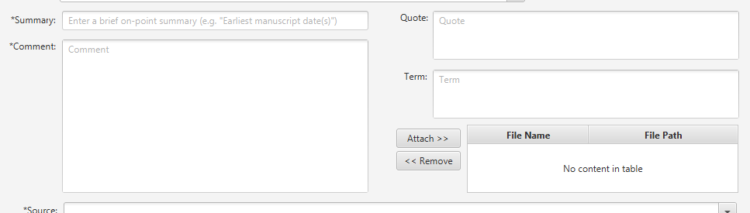

# Down and Dirty Quick Start

Use the **sample.db** provided to start learning to use ResearchDB. The first time you launch the application it will install all components and open with the sample.db.

## Enter a new note

We will use the Encyclopedia Britannica online: Go to <https://www.britannica.com/> and enter ‘**Stalinism**’ in the search and press enter. If ResearchDB is not already running, launch it.

1. Select the Entry tab
2. Source Type: select Article
3. Topic: enter Stalinism
4. Summary: enter Political Doctrine and belief of Stalinism
5. Question: What is Stalinism?
6. Term: enter the following: Totalitarian: Relating to a system of government that is centralized and dictatorial and requires complete subservience to the state.
7. FirstName/UserName: copy from the website who the article is by: [The Editors of Encyclopedia Britannica](https://www.britannica.com/editor/The-Editors-of-Encyclopaedia-Britannica/4419)
   1. If you scroll down, you see Michael Ray. You could add him as a second author for practice
8. Press enter to add this author to the author table and the FirstName/UserName will populate
9. Title: copy and or enter the article title: Stalinism
10. Date: this article does not have a complete date but the copyright for this page on the site is 2019 so enter: 2019 under the year.
11. Pg(s)/Parra.: 1-4 (we are referencing paragraphs)
12. Hyperlink: copy the link in the address bar and paste in the field
13. Comments:
    1. Joseph Stalin fought against former Soviet powers and developed his owns system of rule which became known as Stalinism. Stalinism was a form of totalitarian rule with had many facets. Stalinism began with rejecting ideological sentiment or morality and fought against classes, particularly wealthy classes to remove all levels of class and establish a classless society and institute a socialistic structure and ideology with an emphasis on establishing power through industry and technology. Class wars were created as the poor against the rich so power could be established. If any group or individual were found to be against the Stalin regime and this growing ideology were guilty of treason facing possible death or a sentence into forced-labor camps. It is estimated that 7-15 million were victims of Stalinism. In 1989, it is estimated Stalin killed over 20 million of his own people through forced-labor camps, famine or outright execution. Another 20 million were imprisoned, exiled or relocated.
14. Click File > Add Note. A popup message will appear if successful.

## Query a Note

1. Topic: select Stalinism
   1. A note should appear in the **Select a Note** table. Notice the Source Type, Title and Summary
2. Click on row the note appears on
   1. All the details you entered should appear.
3. Click Edit > Clear Fields
4. Try searching using the Question field and the Custom Search field

## Edit a Note

1. Fix any typos or make any changes you like.
   1. **Topic**, **Question**, **Hyperlink** and **Summary** require clicking on the “Edit” labels and use a prompt window to edit
   2. For **Comment**, **Quote**, **Term**, and **source information** fields, simply click your cursor in the text fields to make updates or changes.
   3. **Files** can be opened, attached or removed by clicking the related buttons.

## Delete a Note

1. Select a Search tab
2. Click Edit > Clear Fields
3. Query the note you just created selecting Stalinism as the topic
4. Click Edit > **Mark Note for Delete**
   1. Ok through the prompts.
5. Clear the fields and try to query by topic again
   1. The table field should remain empty
6. Click Edit > **Review for Delete**
   1. The deleted note should reappear
   2. Select the note
7. Click Edit > **Unmark Note for Delete**
   1. Click Ok on the prompts
8. Clear the fields
9. Use Topic field to query Stalinism again.

Selecting “**Permanently Delete Note**” will do just that…. Be careful!

## Open a Database

1. Click File > Open Database
2. Select a database from the ResearchDB folder (../ResearchDB)
3. Click Open
4. The database name and connection message should change under the application name

## Create a New Database

1. Click File > Database > New Database
2. Enter a name in the prompt and click Ok - you will be prohibited in using **sample** or **blank**
3. A message should appear confirming

## Import a Note(s)

1. Click File > Notes > Import
2. Use the open dialog box to navigate to navigate and select the XML containing the notes you want to import.
3. As a note(s) are imported, messages will appear to the status/result of each note imported. If an imported note source already exists in your database a message will indicate it does and continue.

## Export a Note(s)

1. At least one note should be selected
2. Click File > Note > Export
   1. Select “**Selection**” to export a single note selected in the search table result
   2. Select “**Table Result**” to export all the search table results
3. An XML file will be created on your Desktop formatted with the database name which the note was residing and a date/time stamp, for example:
   1. [database]_notes_yyyy_MM_dd_hh_mm_ss.xml sample.db_notes_2019_12_31_01_15_55.xml