1. Setup the environment as described in Task Solution.
2. Run the Application.
3. Go to <http://localhost:9200/_cat/indices>.

You should see something like this:

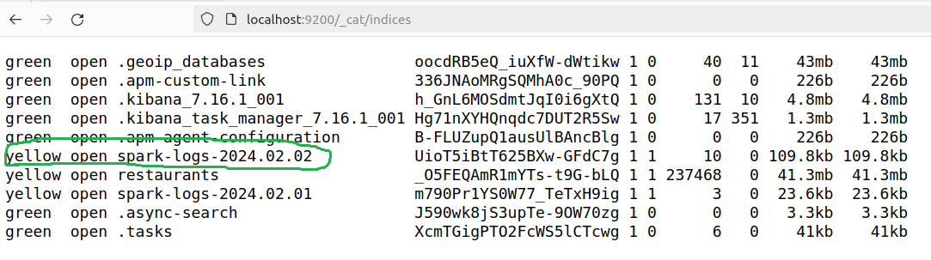

1. Go to <http://localhost:5601/app/management/data/index_management/indices>.
2. You’ll see something like this:

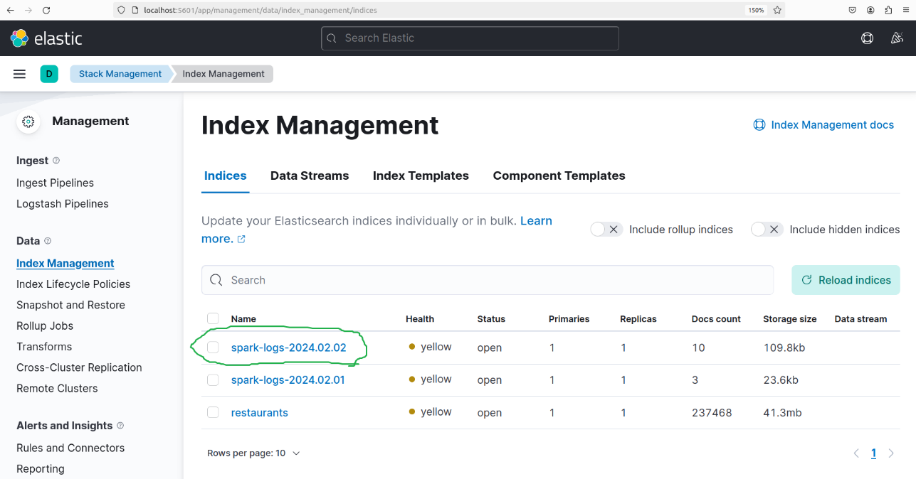

1. Go to <http://localhost:5601/app/management/kibana/indexPatterns> to create an index pattern based on available indexes (use "spark-logs-\*"). The result should look similar to this:

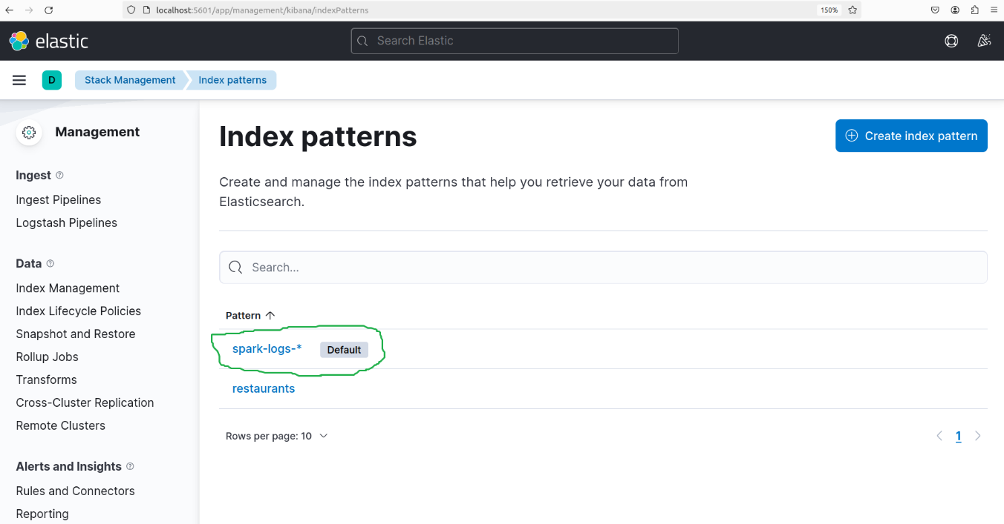

1. Go to <http://localhost:5601/app/visualize#/>.
2. Click “Create your first visualization”, choose “Aggregation based”, choose “Line”.
3. Choose “spark-logs-\*”.
4. Configure the X-Axis (Time Axis):
   1. Under the “Buckets” section, click “Add” and choose “X-Axis.”
   2. Select “Date Histogram” from the aggregation list.
   3. Choose the field that represents the time in your data (e.g., timestamp).
   4. Set the interval to an appropriate time frame (e.g., auto, daily, hourly).
5. Configure the Y-Axis (Count by Event Type)
   1. In the “Metrics” section, the Y-axis should be set to "Count" by default, which is what you want for the count metric.
   2. To break down the count by Event Type, you need to add a sub-bucket.
   3. Click on “Add” under “Buckets” and select “Split Series.”
   4. For the sub-aggregation, choose “Terms.”
   5. Select the field that represents the Event Type in your data (“level.keyword”).
   6. You can set the “Size” to control the number of countries to display.
6. Save the Visualization and (optionally) create a Dashboard. The result should look like this:

