Student Number: [Your Student Number]

GitHub Repository: [Link to your GitHub repository]

Introduction:

In this report, we will explore and analyze the dataset containing the price of used Toyota Corolla cars. The dataset provides information about various features of the cars along with their prices. Our goal is to gain insights into the relationships between different features and the price of the cars.

1. Dataset Overview:

Let's start by loading the dataset and getting an overview of its structure and contents.

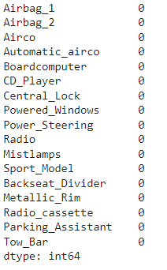

2. Exploratory Data Analysis:

Now, let's visualize some relationships within the dataset using different types of plots.

2.1 Histogram of Car Prices:

2.2 Scatter Plot of Car Age vs. Mileage:

Conclusion:

In this report, we explored the dataset containing the price of used Toyota Corolla cars. We visualized the distribution of car prices, analyzed the relationship between car age and mileage, and examined the correlation between different features. These insights can be valuable for understanding the factors influencing the price of used cars.