

BHARTI SCHOOL OF ENGINEERING AND COMPUTER SCIENCE

Design LU based Forensic Network for detecting Unauthorized Remote Access (RDP, SSH, Telnet)

Network Forensics (CPSC_5207EL_02_2026W)

Faculty Advisor:
Dr. Williams Nwadiugwu

Winter, 2026.

Submitted By GROUP NUMBER:12

Name | Student ID
Sandeep Vaddeymanu | 0474504
Shirish Pokharel | 0469932
Prabin Prasain | 0467810

DATE SUBMITTED: April-04-2026

Chapter 1 – Project Synopsis, and Literature Review.

1.1. Project Synopsis:
1.1.1 Project Abstract and Literature Review:
The current project is aimed at a design of a lightweight forensic network environment used to identify unauthorized remote access activity with a main emphasis on the Secure Shell (SSH) communication. SSH, Telnet and Remote Desktop Protocol (RDP) are common remote access protocols that are used to administer a system but can equally serve as a point of attack by the attacker unless monitored properly [1][3]. This project aims to examine network-level evidence of remote access attempts and determine suspicious trends based on techniques of analyzing packets.
Oracle VirtualBox was used to create a controlled virtual environment, in which a target machine based on Ubuntu was set up and a Windows host machine. A host-only adapter was used to set up the network which was isolated and allowed proper packet capture. As the major tool of capturing and analyzing network traffic created during SSH connection attempts [2][4], Wireshark was utilized.
The implementation comprises of successful and unsuccessful cases of SSH connections. Several attempts to log into the host system were created to create the effect of brute-force behavior at the network level. A set of filters was used to analyze the captured traffic and extract connection attempts (SYN packets), successful handshakes and failed connections (TCP reset (RST) flags) [2][3]. Wireshark I/O graphs were also used to see the patterns in the traffic and identify abnormal spikes that represented repeated access.
In literature, a previous study points out that SSH encrypts the payload information, thus, it is hard to view credentials at all. Nevertheless, metadata like packet frequency, connection patterns, and protocol behavior can nevertheless be used to identify suspicious activity by network forensics [1][2]. By contrast, more basic protocols such as Telnet are sent in plaintext and are thus susceptible to attacks and simpler to analyze but more vulnerable to attacks. Although safe in the contemporary applications, RDP also needs to be monitored because it is often used in cases of unauthorized access [3][4].
The project also shows that network-level analysis can be successfully used to identify attempts of unauthorized access even in encrypted communication contexts. The results support the significance of tracking traffic patterns, examining the actions of protocols, and using tools such as Wireshark to conduct a forensic analysis of the use of remote access [1][2][3].
1.1.2 Projects vision and goals/objectives:
The vision of this project is to come up with a simple but efficient forensic network monitoring environment which can detect unauthorized remote access efforts by analyzing the network traffic. The project will show how security events could be identified without the use of deep packet inspection and how this could be done in situations where communication is encrypted like in SSH.
It is mostly aimed at modeling the remote access situation in a virtual environment and viewing the resulting traffic with the help of forensic tools. In so doing, the project will aim at completing the gap between theoretical understanding of network security and practical applications of traffic analysis techniques.
The precise goals of this project are as follows:
- To create a virtualized network environment on the Oracle VirtualBox to conduct a controlled experiment.
- To si tcp.flags.reset == 1mulate remote access attentions with the use of SSH between a host computer and a target Ubuntu system.
- To analyze Wireshark network traffic and capture it.
- To trace connection attempts via TCP SYN packets and trace successful session establishment.
- To notice the connection attempts that have not been successful with TCP reset (RST) packets.
- In order to emulate repeated attempts at logging in to see brute force-like behavior at the network level.
- To graphically visualize the traffic trends and anomalies in Wireshark I/O graphs.
- To learn about the drawbacks of analyzing encrypted protocols like SSH and compare them conceptually with protocols like Telnet and RDP.
In general, the project should help to gain some background knowledge about network forensics and illustrate how the indicators at the network level could be applied to the detection of suspicious remote access activity in real-life situations.
1.1.3 System Flowchart:
The system flowchart demonstrates the general processes of work within the forensic network of the environment utilized in this project. It symbolizes the chain of actions which are performed in order to simulate the attempts of remote access, capture network traffic, and conduct forensic analysis.
The first step is that the host machine launches SSH connection requests to the target Ubuntu virtual machine. These requests pass in the virtual network space set up by Oracle VirtualBox using a host-only adapter.
During the communication process, Wireshark on the host machine traces every packet on the network in real time. The data obtained is analyzed in the form of particular filters to determine connection attempts, successful connections and failed connections. TCP flags include SYN and RST which is used to distinguish between normal and failed access attempts.
Also, multiple attempts to log in are created to replicate the behavior of a brute force to observe abnormal traffic patterns. The analysis outputs such as packet-level evidence, session data and traffic pattern are then utilized in producing the final forensic report.
The flow diagram gives a clear representation of the flow of the data within the system, since the initiation of a connection through to forensic analysis and reporting.

Figure 1.1: System Architecture / Flow of Forensic Network Setup
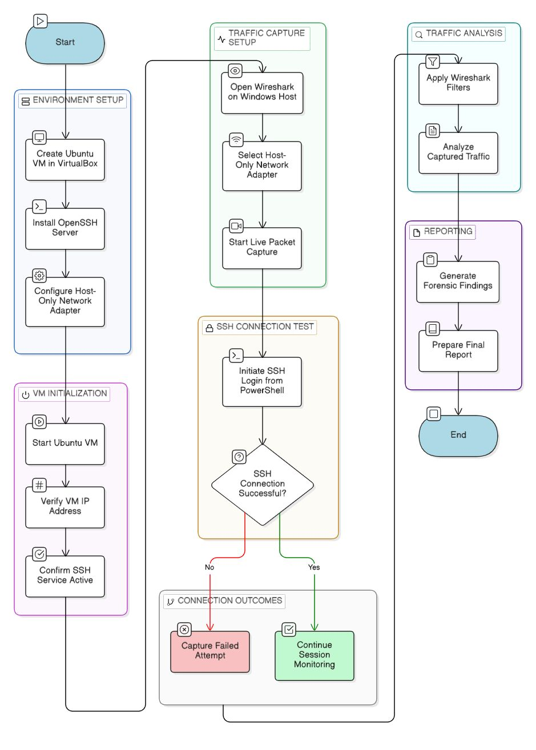

Chapter 2 – System Model.

2.1. Technology Stack and System Requirements:
2.1.1 Project requirements:
This project was successful because it needed to be implemented using both software and hardware resources to develop a controlled virtual forensic environment.
The hardware specifications consist of a standard personal computer that can be used to run the virtualization software. This system is expected to have enough processing power, minimum 8 GB RAM and storage capacity to run virtual machine and packet capture activities.
The software requirements are the Oracle VirtualBox to do the virtualization, Ubuntu operating system to run the target machine and the windows operating system to run the host machine. The Ubuntu virtual machine had to have openSSH server so that it could be accessed remotely using SSH protocol. Wireshark was the main tool to capture and analyze the network traffic.
Also, a VirtualBox host-only network adapter was needed to create an independent communication path between the host machine and the virtual machine. This provided a safe and controlled background in which network forensic analysis can be conducted without interference with the external network.
All these conditions allowed developing a light and efficient environment to simulate remote access conditions and analyze packets at the level.

2.1.2 Technologies/Tools Stack:
In this project, virtualization tools, operating system, and network analysis software were applied as a combination to simulate and analyze remote access activity.
The virtual environment was created and managed with the help of Oracle VirtualBox. The target system was a virtual machine running Ubuntu, and a host machine with Windows was the one that started remote access attempts and examined traffic.
The virtual machine is an Ubuntu machine, which was installed with OpenSSH server in order to allow SSH communication on port 22. The Windows host was initiated to SSH login attempts with the use of PowerShell.
Wireshark was the main network analysis tool, which enabled real-time packet capture, filtering, and examination. Connection attempts and failed sessions were analyzed using various filters which included tcp.port == 22 and tcp.flags.reset == 1.
To have the virtual machine and the host in a private network so that packet capture is accurate in an isolated environment, the VirtualBox host-only adapter was employed.
Collectively these technologies were a complete installation to carry out a network forensic analysis on remote access traffic.
Table 2.1: Technology Stack
Component | Purpose
Windows Host | SSH client and Packet Capture
Oracle VirtualBox | Virtualization
Ubuntu VM | Target system
OpenSSH Server | Remote access service
PowerShell | SSH command execution
Wireshark | Packet capture analysis
Host-Only Adapter | Private network

2.1.3 Project scheduling and Tasks/Function Distribution:
The group members worked together in the execution of the project, and the roles were shared among the members according to their respective roles to facilitate effective execution of the project. This was done in stages, beginning with setting up of the environment, through to final analysis and documentation.
The first step was the installation of the virtual machine in the Oracle VirtualBox and the Ubuntu virtual machine. This was succeeded by making the OpenSSH server available as well as connecting the host and the virtual machine using a host-only network connection.
In the second stage, the PowerShell was used to simulate remote access attempts by the Windows host system. To capture network traffic during these sessions Wireshark was used. Several attempts to log in were made to monitor the connection patterns and behave like the brute force.
The analysis step involved the use of Wireshark filters to extract connection attempts, successful connection and failed connections. The TCP handshake packets and the reset packets were analyzed to interpret the manner in which the network traffic behaved.
Lastly, the findings were captured such as packet-level evidence, graphs, and observations. The results were summarized in the ultimate report with figures and descriptions of the system workflow. The team members were assigned the tasks to provide a balanced input and a successful project implementation.
Table 2.2: Task Distribution
Team Member | Role | Responsibilities
Sandeep Vaddeymanu | Traffic Simulation & Testing | Wireshark capture, multiple login attempts, traffic generation, graph analysis, packet analysis
Shirish Pokharel | Network Setup and analysis | VM setup, SSH Configuration, Wireshark setup and Capture
Parbin Prasain | Documentation & Reporting | Report Writing, formatting, diagrams, final submission

2.2. DFDs, Class Diagrams and Entity Relationships (ERs):
2.2.1 Project Data Flow Diagrams (DFDs):
Data flow diagram (DFD) is a depiction of the flow of data within the forensic network analysis system employed in this project. It shows the communication between the user and the system processes as well as the data storage entities in remote access detection. With this system the user sends remote access attempts to the target machine.
Wireshark is used to capture the network traffic created by these attempts. The retrieved information is saved in the form of packet capture data and it contains data like the IP address of the source, the IP address of the destination, and the TCP packet data.
The captured packets are then processed by the system to examine connection attempts, successful connections and failed connections. The given analysis is premised on TCP flags, including SYN and RST, session behavior, and traffic patterns.
Analysis results are generated on the processed data which are then compiled to final forensic report. The report is informative on the activity of remote access and assists in detecting suspicious or unauthorized activity.
The DFD gives a good overview of the flow of data within the system, both at the input and the final output, and it is easier to see how the entire process of the forensic analysis works.
Figure 2.1: Data Flow Diagram of the Forensic Analysis System
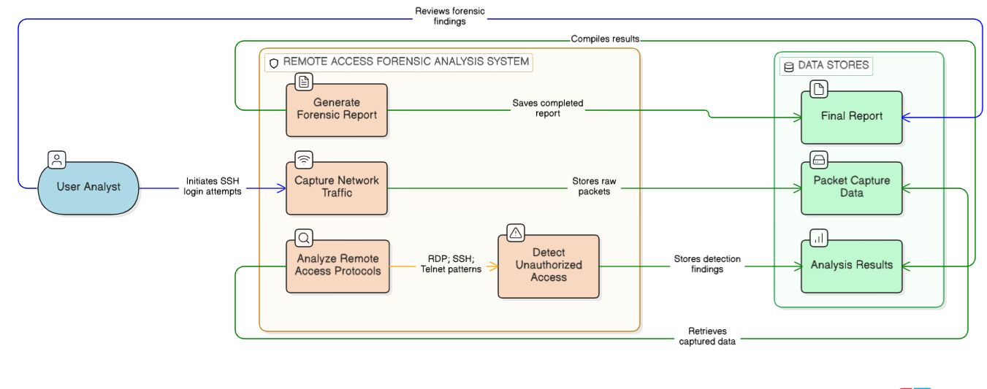

2.2.2 Project Class Diagrams:
Figure 2.2.1: UML Class Diagram of the Remote Access Forensic System
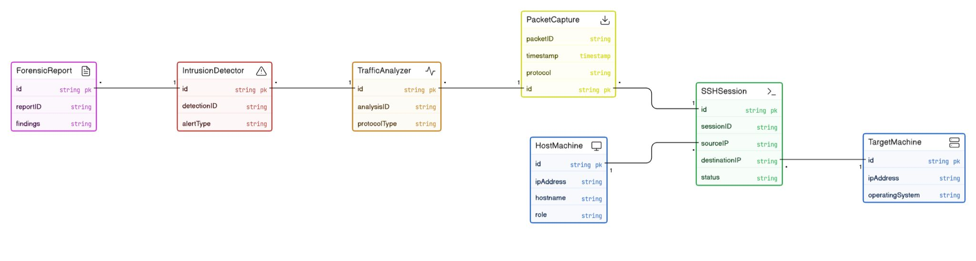

2.2.3 Project ERs:
Entity Relationship (ER) diagram is used to show the logical relationship among the major data entities in the forensic analysis system. It depicts the relationship among users, machines, sessions, packets, findings and reports in the project environment.
A user in this system initiates remote access sessions in the host machine to the target machine. Each session includes packet-level data that is captured by the network communication. These packets are the raw evidence on which suspicious activity patterns are determined and forensic findings are produced. These results are then summarized into a final report to be documented and reviewed.
The ER diagram is a convenient way to present the data structure and relationships between entities that facilitate in the description of how the forensic evidence is gathered, examined, and recorded in the project.
Figure 2.2.2: Project ER Diagram
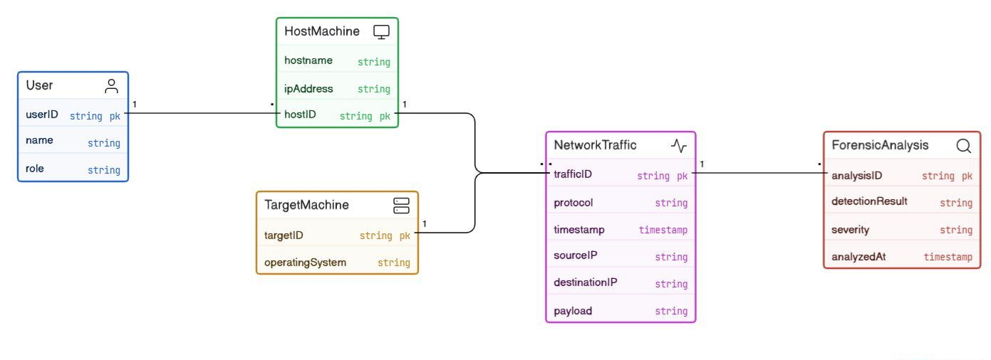

Chapter 3 – Implementation, Results and Conclusion.

3.1. System Methods/Functions Implementation:
3.1.1 All Methods/Functions Implementation:
A virtual environment has been used to implement the forensic network system in controlled environment using Oracle VirtualBox. The source system was a windows host machine and the target system was a Ubuntu based virtual machine. A host-only network was used to link the two systems and make sure that the communication was isolated.
To enable remote log in via TCP port 22, the target machine was set up to use OpenSSH service. PowerShell was used to start SSH connections on the host machine and replicate normal and unauthorized access attempts. Several attempts to log in were made to simulate brute-force behavior.
Live network traffic was captured on the host using Wireshark. The SSH traffic, connection attempt and failed session traffic were analyzed using specific filters to filter out SSH traffic, connection attempt and failed session like, tcp.port = 22, tcp.flag.syn = 1 and tcp.flag.reset = 1.
The packets obtained were examined to determine communication patterns, such as TCP handshake sequence and failed login attempts, which were repeated. This arrangement enabled good surveillance and identifying of suspicious remote access.
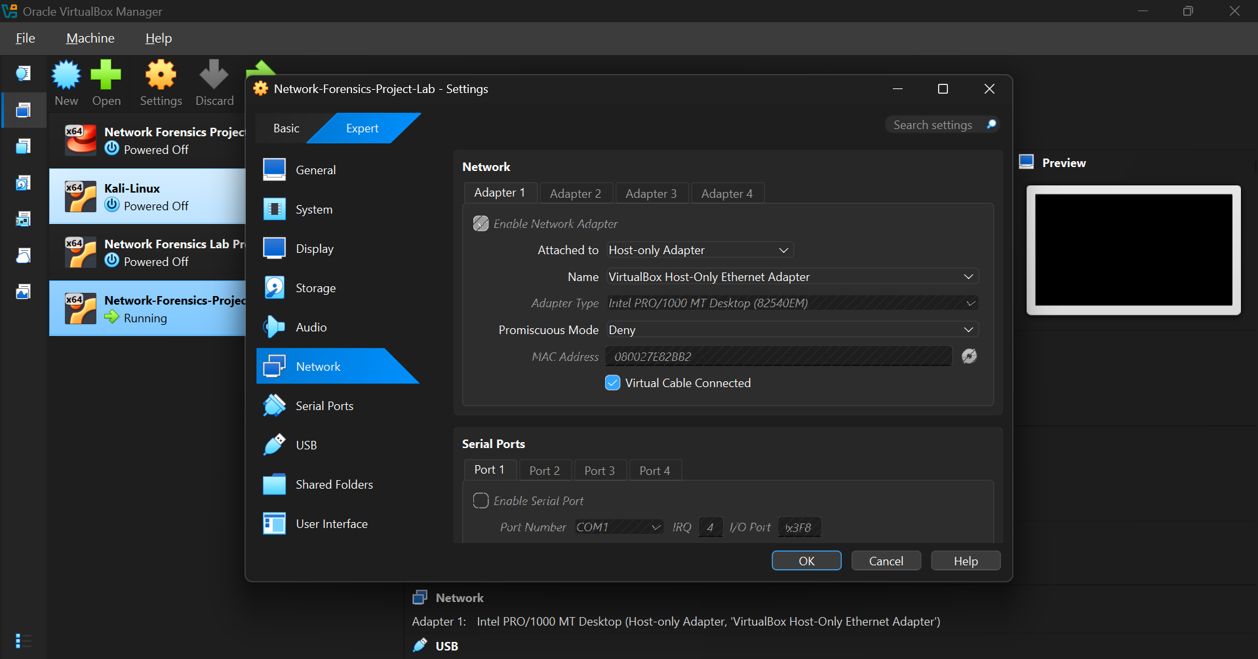
Wireshark filter isolating SSH traffic on TCP port 22.
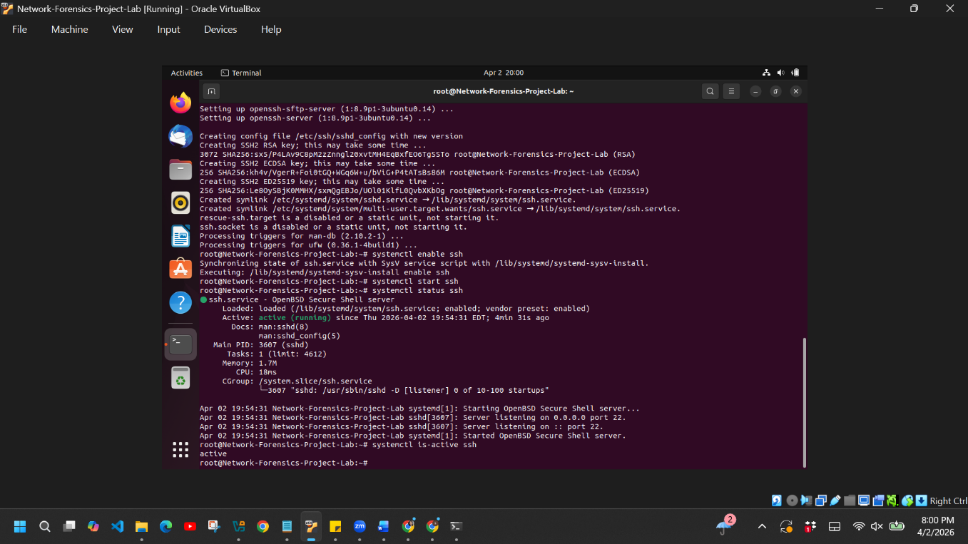
VirtualBox host-only network configuration used for the forensic lab.
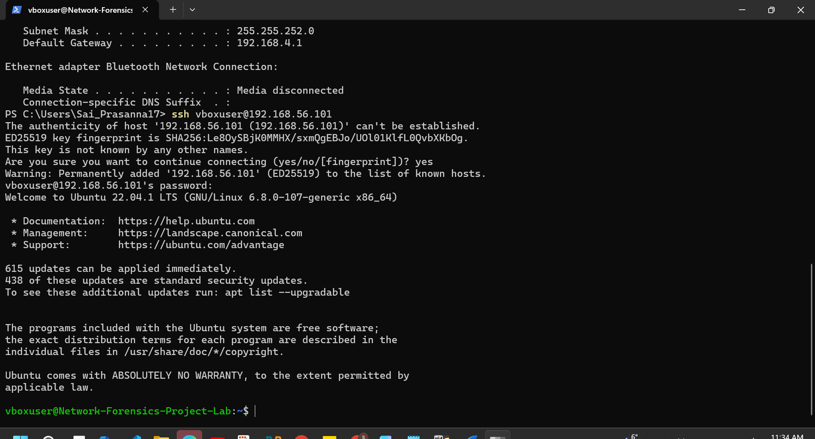
SSH connection initiated from Windows host to Ubuntu target machine.

3.1.2 Project Methods/Functions code snippets:
Simulating SSH connections and using the resulting traffic to analyze it was done using the following commands:
- Connection between target and host (SSH): ssh vboxuser@192.168.56.101
- The brute force simulation of making many attempts to log in: for ($i=0; $i -lt 20; $i++) { ssh vboxuser@192.168.56.101 }
These directions were used to create normal and suspicious SSH traffic, which was also recorded and examined with the help of Wireshark.

3.2. System Results:
    - Project results/Outputs (all methods/functions):
Wireshark was able to capture and analyze SSH traffic using the system. Several attempts of login were created between the target machine and the host machine. Connection attempts are shown by TCP SYN packets, whereas failed login attempts are manifested by repeated RST packets.
I/O graph reveals spikes in the traffic during these attempts, which points to abnormal behavior related to the activity of the brute force. TCP conversation analysis also verifies redundant communication amongst the same source and receiver.
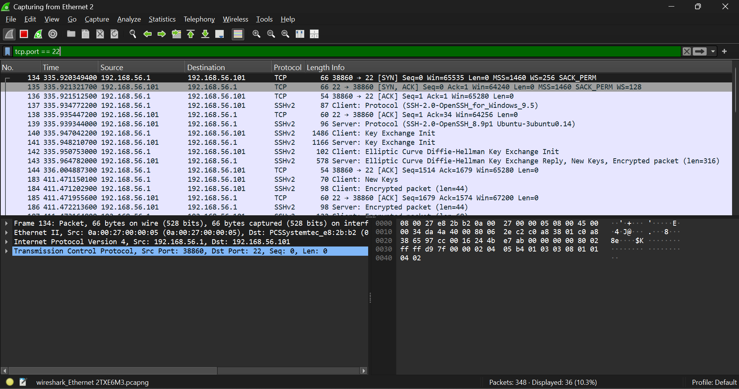
Wireshark filter isolating SSH traffic on TCP port 22.
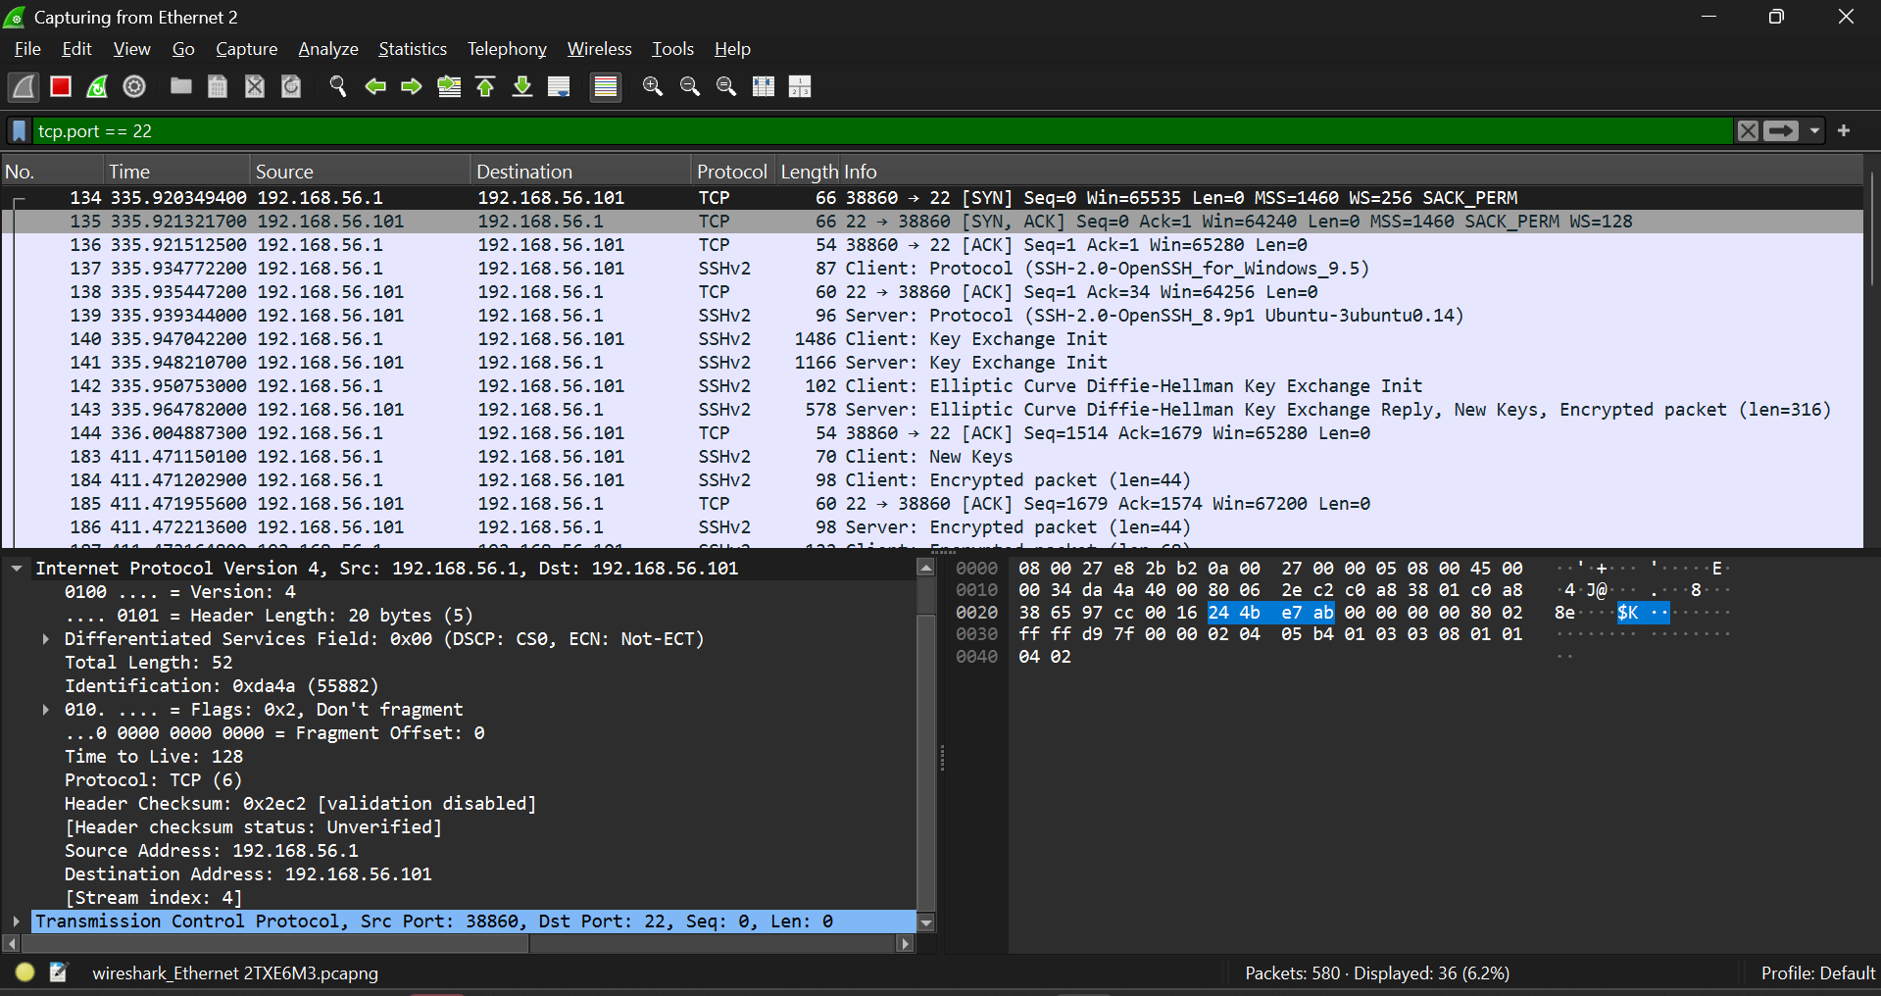
TCP SYN packet showing the beginning of SSH connection establishment.
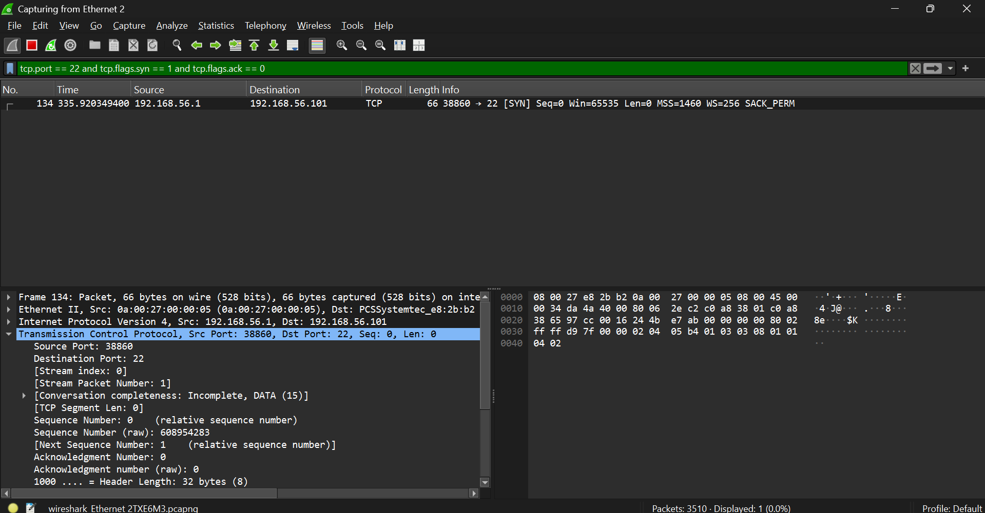
Wireshark filter showing all SSH login attempts using SYN packets.
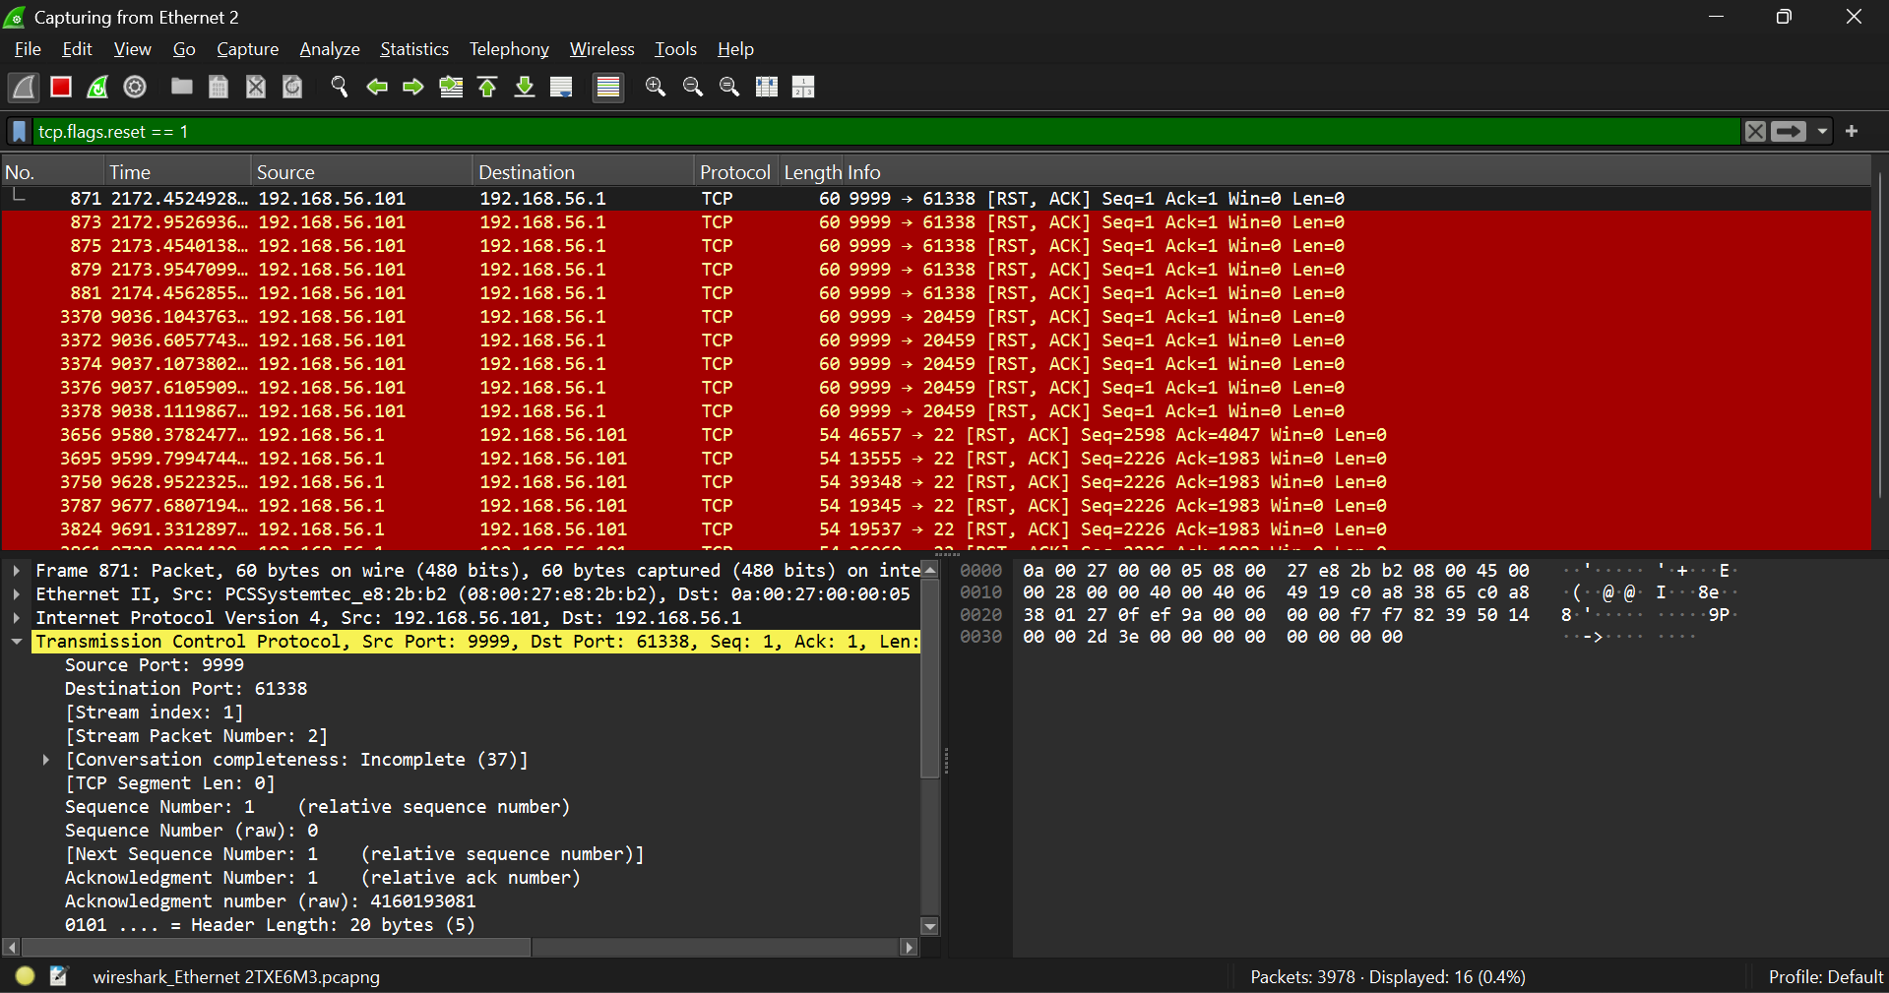
Wireshark filter showing TCP reset packets indicating failed SSH login attempts.
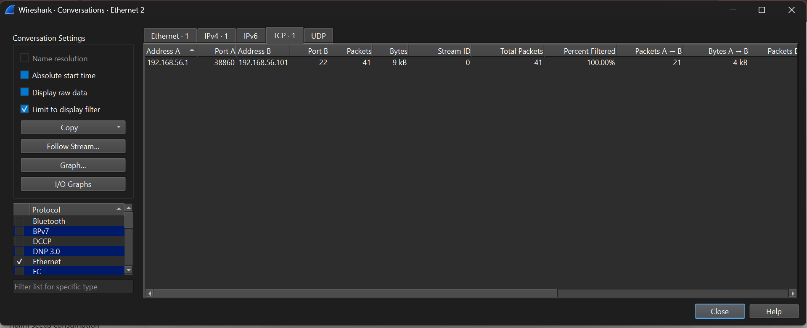
TCP conversations showing repeated SSH connection attempts between host and target.
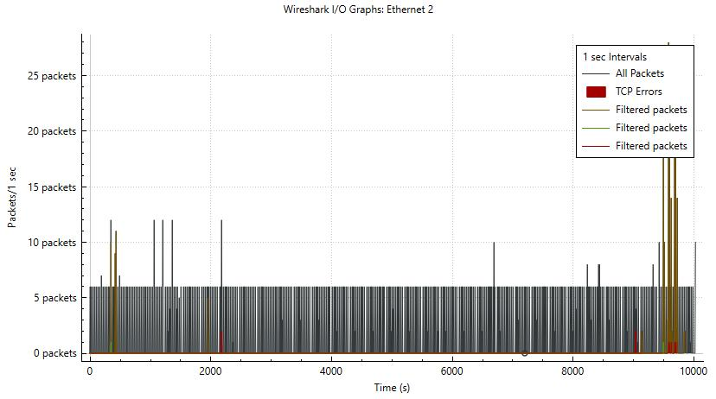
Wireshark I/O graph showing spikes in SSH traffic during repeated login attempts.

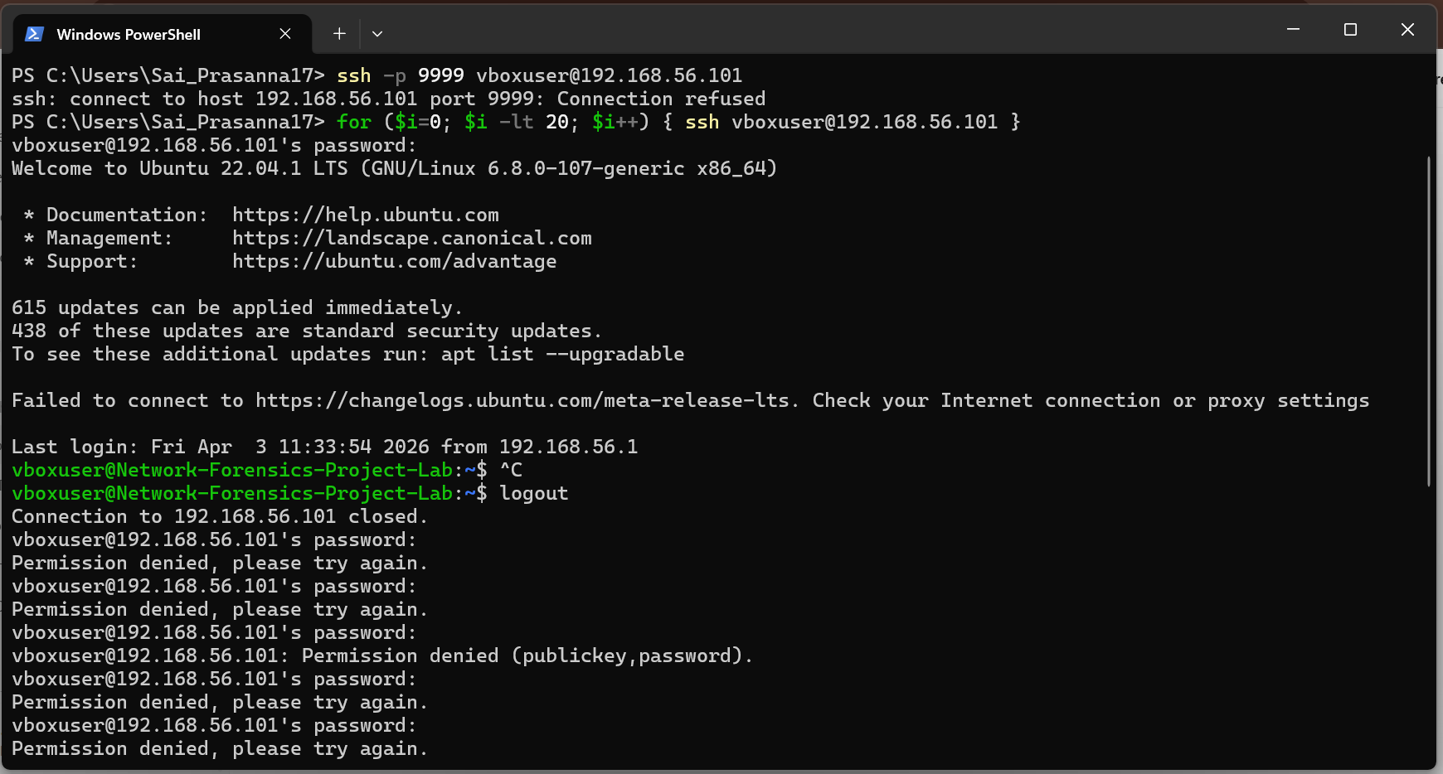
Repeated SSH login attempts generated from PowerShell to simulate brute-force-like behavior.
3.2.2 System Results/Output Constraints/Parameters:
i). Operational/Transitional Efficiency: The system works well under virtual environment having real time packet capture and filtering.
ii). Risk Assessment: The repeated logins mean that there may be brute-force attacks and security threats in remote access systems.
iii). System Reliability and Downtime: The system was stable when tested, however, it needs appropriate network configuration.
iv). Data Security & Privacy: The recurring attempts of logins confirm that there may be brute-force attacks and security threats to remote access systems.
Conclusion: The project was able to demonstrate how a lightweight forensic network environment can be designed and implemented to detect an unauthorized remote access attempt. The Wireshark was used to capture and analyze SSH traffic to identify connection attempts, failed logins and other suspicious patterns like repeated requests. The findings indicate that the packet-level analysis can be used to detect possible security threats such as brute-force attacks. On the whole, the project gives a good insight into how a remote access system can be monitored and secured with the help of network forensics.
Future Enhancements: It is possible to further enhance the current system with the support of other protocols like RDP and Telnet to analyze it more thoroughly. Brute-force attacks can be detected as they occur and not manually, through the integration of automation tools. Besides, intrusion detection systems (IDS) and alert mechanisms should be implemented to improve security monitoring. The system can be also scaled to support bigger networks and real-world traffic to perform more sophisticated forensic analysis.

References:
[1] Bejtlich, R., The Practice of Network Security Monitoring, No Starch Press, 2013.
[2] Sanders, C., Practical Packet Analysis, 3 rd Edition, No Starch Press, 2017.
[3] Wireshark Foundation, Wireshark User Guide.
[4] Ubuntu Documentation, OpenSSH Server Documentation.
[5] Oracle, Oracle VM VirtualBox Documentation.

