**ASSIGNMENT 7 – Package Diagram and Component Diagram**

**BookMyEvent**

***TEAM 5***

1. VISHAL T - 185001199
2. TARUN V - 185001184
3. VAIBHAV S – 185001186

**Package Diagram:**

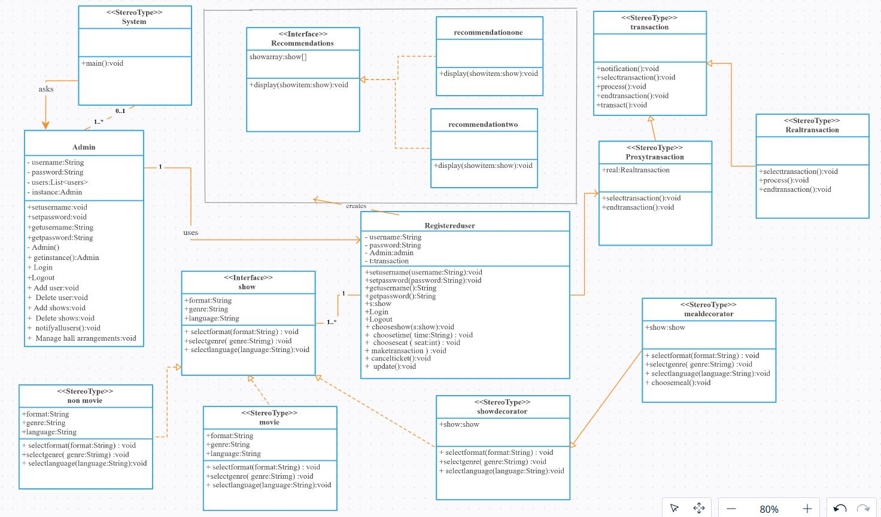

Package Diagram Team5

**Component Diagram:**

