Project Submission – Fundamentals of Web Development
Online Quiz Application – QuizNova

Student Details
Student Name | Sarva Vaishnavi K
Register Number | 36725U18036
Department | B.Sc Computer Science (II Year)
ID | astvu36710
College | Global College of Arts and Science, Veppur
Date of Submission | 24-10-2026

1. Problem Statement & Objectives

Problem Statement
Students preparing for web-development and computer-science examinations still depend on printed question papers or scattered websites that ask for sign-ups, load slowly or give no immediate feedback. A paper test has to be corrected by hand, nothing tells the student how fast or how consistently they answer, and there is no simple way to see progress over time.
The objective of this project is to build QuizNova, a fast and attractive online quiz application that runs completely in the browser using only HTML, CSS and JavaScript. It lets a learner choose a subject and difficulty, answer timed questions, get instant right/wrong feedback and see a detailed result with an answer review and a leaderboard, all without any installation, login or server.
Objectives
- Design a clean, user-friendly home dashboard with category and difficulty selection.
- Serve randomised questions and shuffled options so that no two attempts look the same.
- Add a per-question countdown timer, a scoring system with speed and streak bonuses, and a 50:50 lifeline.
- Give instant visual feedback (green for correct, red for wrong) and a full answer review at the end.
- Store player history, best score, best streak and theme preference in the browser using localStorage.
- Make the interface fully responsive so it works on desktops, tablets and mobile phones.

2. Architecture

2.1 Application Flow
The user opens the application, fills in the name, category and difficulty and starts the quiz. Each question is loaded with a 20-second timer; the answer is checked, the score is updated and the loop continues until all questions are finished. The result is then saved to localStorage and the user can review answers, play again or open the leaderboard.
Diagram:
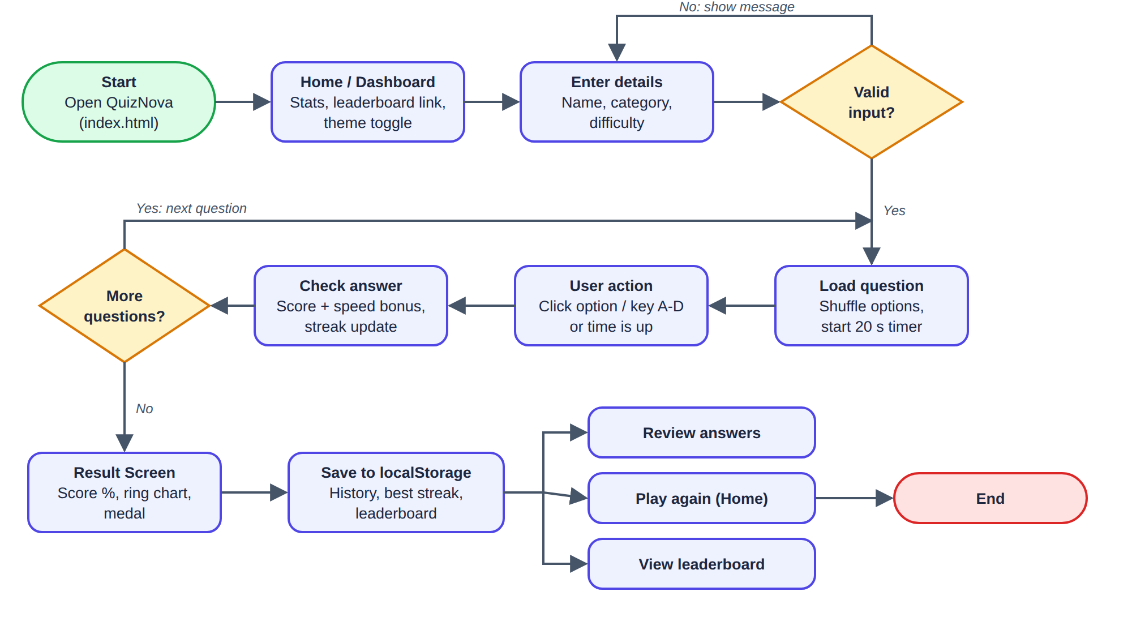

2.2 Technologies Used
Technology | Purpose
HTML5 | Builds the structure of every screen (home, quiz, result, leaderboard) using semantic elements such as header, main, section, nav, table, button and input.
CSS3 | Styling and layout with Flexbox and Grid, CSS variables for light/dark themes, transitions, keyframe animations, conic-gradient score ring and media queries for responsiveness.
JavaScript (ES6) | All quiz logic: question selection, shuffling, countdown timer, answer checking, scoring, lifeline, DOM updates, event handling and keyboard shortcuts.
Web Storage API (localStorage) | Saves the player name, quiz history, best streak, leaderboard and dark-mode choice so they remain after the browser is closed.
Visual Studio Code | Code editor used to write and organise index.html, style.css and script.js.
Google Chrome + DevTools | Used to run the application and to test the responsive layout in device mode.

3. Practical Implementation

3.1 Features Implemented
Feature | Description
Home/Dashboard | Landing screen with statistics (quizzes played, best score, best streak), name field, four category cards, three difficulty levels and a Start Quiz button with validation.
Quiz Categories | HTML, CSS, JavaScript and Computer Basics, each holding 17 questions split across Easy, Medium and Hard (68 questions in total).
Question & Options | Five random questions per attempt with shuffled options, a progress bar and live question counter.
Timer & Scoring | 20-second countdown that turns red in the last 5 seconds. Each correct answer gives 10 points plus a speed bonus; three correct answers in a row add a streak bonus.
50:50 Lifeline | One lifeline per quiz that removes two wrong options from the current question.
JavaScript Interaction | Screen switching without page reload, instant answer feedback, keyboard shortcuts (A–D to answer, Enter for next), review toggle and dark/light theme switch.
Result & Review | Percentage ring chart, medal, correct / wrong / best-streak cards and an answer-by-answer review.
Leaderboard | Top 10 scores with player, category and level, saved in localStorage with a clear button.
Responsive Design | Fluid grid and a mobile media query that stacks cards, resizes text and hides non-essential table columns on small screens.

3.2 Source Code
The project has three files – index.html (structure), style.css (design) and script.js (logic). The important sections are shown below with their purpose.
HTML: Home / Dashboard section (index.html)
<!-- HOME / DASHBOARD -->
<section id="home" class="screen active">
<div class="hero">
<h1>Test Your Knowledge</h1>
<p>Pick a category, choose a level and beat the clock.</p>
</div>
<div class="stats">
<div class="stat"><b id="statPlayed">0</b><span>Quizzes Played</span></div>
<div class="stat"><b id="statBest">0%</b><span>Best Score</span></div>
<div class="stat"><b id="statStreak">0</b><span>Best Streak</span></div>
</div>
<label class="field">Your Name
<input id="playerName" type="text" placeholder="Enter your name" maxlength="20">
</label>
<h2>Choose a Category</h2>
<div id="categories" class="grid"></div>
<h2>Choose Difficulty</h2>
<div id="levels" class="levels">
<button class="level active" data-level="easy">Easy</button>
<button class="level" data-level="medium">Medium</button>
<button class="level" data-level="hard">Hard</button>
</div>
<button id="startBtn" class="primary big">Start Quiz</button>
<p id="homeMsg" class="msg"></p>
</section>
Purpose: defines the dashboard with the statistics cards, the name input, the container that JavaScript fills with category cards, the difficulty buttons and the Start button.
HTML: Quiz section (index.html)
<!-- QUIZ -->
<section id="quiz" class="screen">
<div class="quiz-head">
<span id="qCount">Question 1 / 5</span>
<span id="timer" class="timer">20s</span>
<span id="scoreLive">Score: 0</span>
</div>
<div class="bar"><div id="progress"></div></div>
<h2 id="question"></h2>
<div id="options" class="options"></div>
<div class="quiz-foot">
<button id="fiftyBtn" class="ghost">50 : 50 (1)</button>
<span id="streakLive" class="streak"></span>
<button id="nextBtn" class="primary" disabled>Next</button>
</div>
</section>
Purpose: holds the question counter, timer, live score, progress bar, question text, options container, 50:50 button, streak label and Next button. Options are created dynamically by JavaScript.
CSS: Theme variables, layout, answer states, ring chart and responsive rules (style.css)
:root{
--bg:#f3f6fb; --card:#ffffff; --text:#1d2840; --muted:#6a7690;
--primary:#4f46e5; --primary-2:#7c3aed; --ok:#16a34a; --bad:#dc2626;
}
body.dark{ --bg:#0f172a; --card:#1e293b; --text:#e6ecf8; --muted:#9aa8c4; }

.grid{
display:grid;
grid-template-columns:repeat(auto-fill,minmax(160px,1fr));
gap:12px;
}
.opt{
display:flex; gap:12px; align-items:center;
padding:14px 16px; border:2px solid var(--line);
border-radius:12px; background:var(--bg); cursor:pointer;
transition:.2s;
}
.opt.correct{ border-color:var(--ok); background:rgba(22,163,74,.14); }
.opt.wrong { border-color:var(--bad); background:rgba(220,38,38,.13); }
.opt.hide { visibility:hidden; } /* used by the 50:50 lifeline */

.timer.low{ background:var(--bad); animation:pulse .6s infinite alternate; }

.ring{
width:150px; height:150px; border-radius:50%;
background:conic-gradient(var(--primary) calc(var(--p)*1%), var(--line) 0);
}

@media (max-width:640px){
.topbar{ padding:12px 14px; justify-content:center; }
.screen{ padding:18px; }
#question{ font-size:1.1rem; }
.table th:nth-child(3), .table td:nth-child(3){ display:none; }
}
Purpose: CSS variables switch the whole site between light and dark mode; Grid and Flexbox arrange the cards and options; the .correct, .wrong and .hide classes give instant feedback and power the lifeline; conic-gradient draws the result ring; the media query adapts the layout for phones.
JavaScript: Storage and screen-switch helpers (script.js)
const $ = id => document.getElementById(id);
const store = {
get(k, d){ try { return JSON.parse(localStorage.getItem(k)) ?? d; } catch { return d; } },
set(k, v){ localStorage.setItem(k, JSON.stringify(v)); }
};

/* ---------- Screen helper ---------- */
function show(id){
document.querySelectorAll(".screen").forEach(s => s.classList.remove("active"));
$(id).classList.add("active");
if (id !== "quiz") clearInterval(state.tId);
}
Purpose: short helper functions for selecting elements, safely reading and writing JSON data in localStorage, and switching between the Home, Quiz, Result and Leaderboard screens.
JavaScript: Starting a quiz (script.js)
function startQuiz(){
const name = $("playerName").value.trim();
if (!name){ $("homeMsg").textContent = "Please enter your name to begin."; $("playerName").focus(); return; }
if (!state.cat){ $("homeMsg").textContent = "Please select a category."; return; }
store.set("qn_name", name);
const pool = bank[state.cat][state.level].map(q => ({ q: q[0], o: q[1], a: q[2] }));
state.list = shuffle(pool).slice(0, QUESTIONS_PER_QUIZ).map(item => {
// shuffle options but keep track of the right one
const right = item.o[item.a];
const opts = shuffle([...item.o]);
return { q: item.q, o: opts, a: opts.indexOf(right) };
});
Object.assign(state, { i: 0, score: 0, streak: 0, best: 0, fifty: true, log: [] });
$("fiftyBtn").disabled = false;
show("quiz");
loadQuestion();
}
Purpose: validates the name and category, picks five random questions for the chosen difficulty, shuffles the options while remembering the correct one, resets the score and opens the quiz screen.
JavaScript: Countdown timer (script.js)
function startTimer(){
clearInterval(state.tId);
state.timeLeft = QUESTION_TIME;
paintTimer();
state.tId = setInterval(() => {
state.timeLeft--;
paintTimer();
if (state.timeLeft <= 0){ clearInterval(state.tId); choose(-1); } // time up
}, 1000);
}
Purpose: setInterval reduces the time every second; when it reaches zero the question is automatically marked as unanswered.
JavaScript: Checking the answer and scoring (script.js)
function choose(idx){
if (state.locked) return;
state.locked = true;
clearInterval(state.tId);
const q = state.list[state.i];
const buttons = [...document.querySelectorAll(".opt")];
buttons.forEach(b => b.disabled = true);
buttons[q.a].classList.add("correct");
const ok = idx === q.a;
if (ok){
state.streak++; state.best = Math.max(state.best, state.streak);
state.score += 10 + Math.floor(state.timeLeft / 4) + (state.streak >= 3 ? 5 : 0); // speed + streak bonus
} else {
state.streak = 0;
if (idx >= 0) buttons[idx].classList.add("wrong");
}
state.log.push({ q: q.q, your: idx >= 0 ? q.o[idx] : "No answer (time up)", right: q.o[q.a], ok });
$("scoreLive").textContent = `Score: ${state.score}`;
$("streakLive").textContent = state.streak >= 2 ? `Streak x${state.streak}` : "";
$("nextBtn").disabled = false;
}
Purpose: locks the options, highlights the correct and wrong choices, updates the streak, adds points with a speed bonus and a streak bonus and stores the attempt for the final review.
JavaScript: 50:50 lifeline (script.js)
function useFifty(){
if (!state.fifty || state.locked) return;
state.fifty = false;
$("fiftyBtn").disabled = true;
const q = state.list[state.i];
const buttons = [...document.querySelectorAll(".opt")];
const wrong = shuffle(q.o.map((_, i) => i).filter(i => i !== q.a)).slice(0, 2);
wrong.forEach(i => buttons[i].classList.add("hide"));
}
Purpose: hides two randomly chosen wrong options, allowed only once per quiz.
JavaScript: Finishing the quiz and saving the result (script.js)
function finish(){
const correct = state.log.filter(x => x.ok).length;
const total = state.list.length;
const pct = Math.round(correct / total * 100);
show("result");
$("progress").style.width = "100%";
$("medal").textContent = pct >= 80 ? "🏆" : pct >= 50 ? "🎯" : "📘";
$("resultTitle").textContent = pct >= 80 ? "Outstanding!" : pct >= 50 ? "Good Job!" : "Keep Practising!";
$("resultText").textContent = `${store.get("qn_name", "Player")}, you scored ${state.score} points in ${bank[state.cat].name} (${state.level}).`;
$("ring").style.setProperty("--p", pct);
$("ringText").textContent = pct + "%";
$("rCorrect").textContent = correct;
$("rWrong").textContent = total - correct;
$("rStreak").textContent = state.best;
$("review").classList.add("hidden");

const hist = store.get("qn_history", []);
hist.push({ name: store.get("qn_name", "Player"), cat: bank[state.cat].name, level: state.level, score: state.score, pct });
store.set("qn_history", hist);
store.set("qn_streak", Math.max(store.get("qn_streak", 0), state.best));
refreshStats();
}
Purpose: calculates the percentage, shows the medal, ring chart and statistics, then saves the attempt and best streak in localStorage for the dashboard and leaderboard.

3.3 Project Execution
- Open index.html in any modern browser (no server or internet connection is required).
- The dashboard appears with the saved statistics. Enter a name, choose a category and a difficulty and click Start Quiz. A message is shown if the name or category is missing.
- Five questions are displayed one by one with a 20-second timer. Click an option (or press A–D); the correct answer turns green and a wrong choice turns red. The 50:50 lifeline can be used once.
- Click Next to continue. After the last question the result screen shows the score, percentage ring, correct / wrong counts and best streak.
- Use Review Answers to see every question with the chosen and correct answer, Play Again to return to the dashboard, or Leaderboard to see the top 10 scores.
- The Dark Mode button switches the theme and the choice is remembered for the next visit.

4. Output Screenshots
The following screenshots were taken from the working application.

Screenshot 1 – Home/Dashboard
Dashboard with statistics, name field, category cards and difficulty levels.
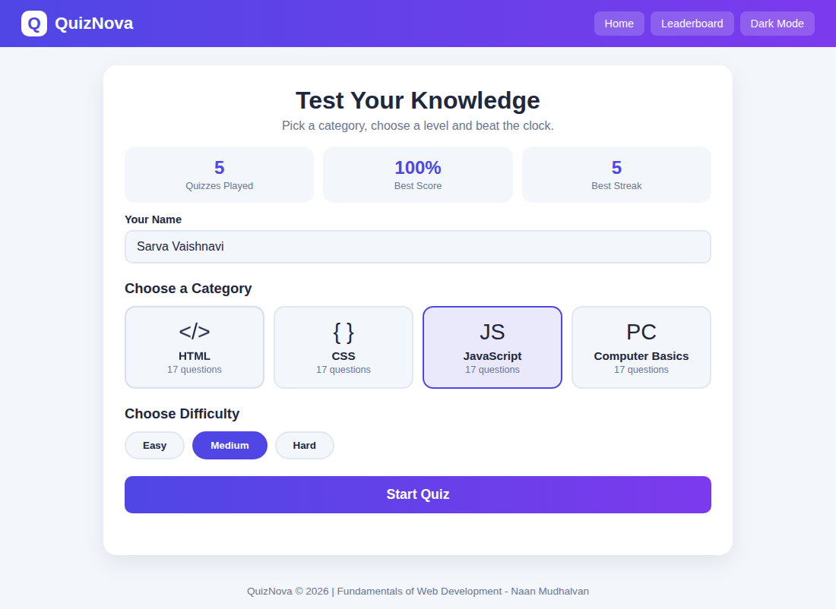

Screenshot 2 – Quiz Question & Options
Question screen with timer, live score, progress bar and four shuffled options.
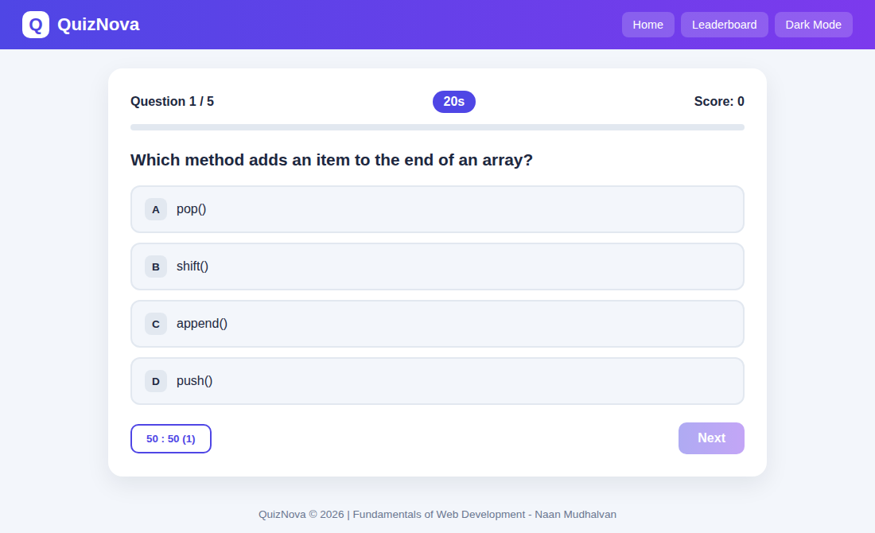

Screenshot 3 – JavaScript Interaction: 50:50 Lifeline
Two wrong options are removed dynamically when the lifeline is used.
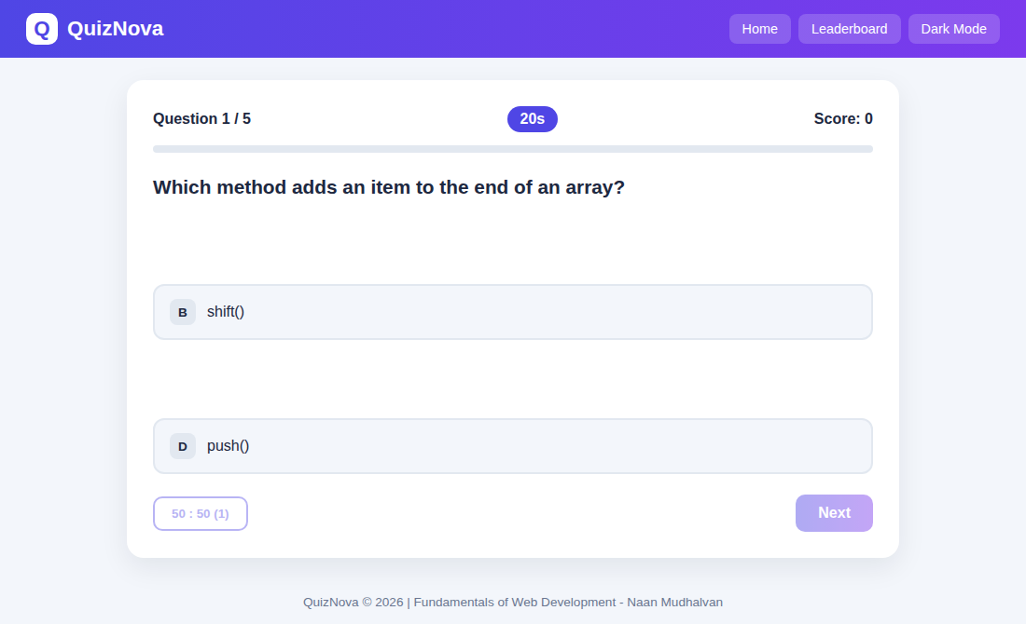

Screenshot 4 – Correct Answer Feedback
The correct option turns green and the score is updated instantly.
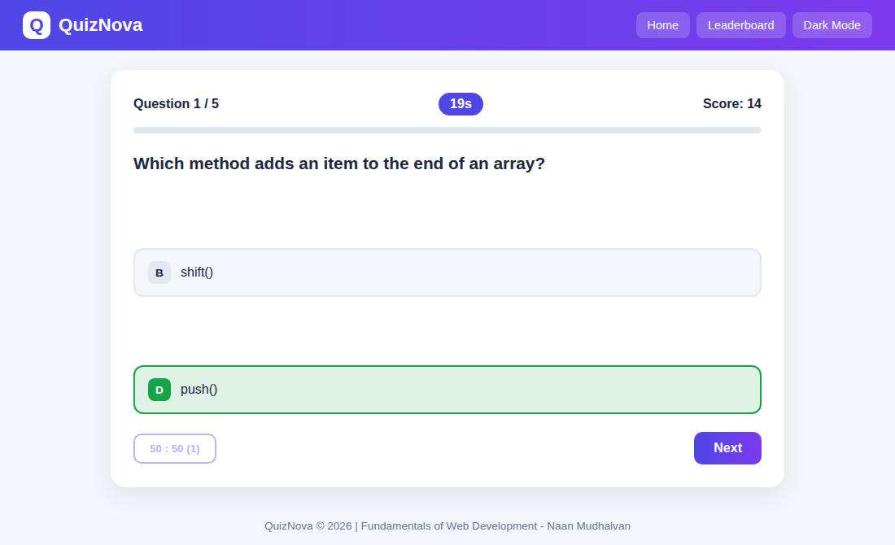

Screenshot 5 – Wrong Answer Feedback
A wrong choice turns red while the right answer is revealed in green.
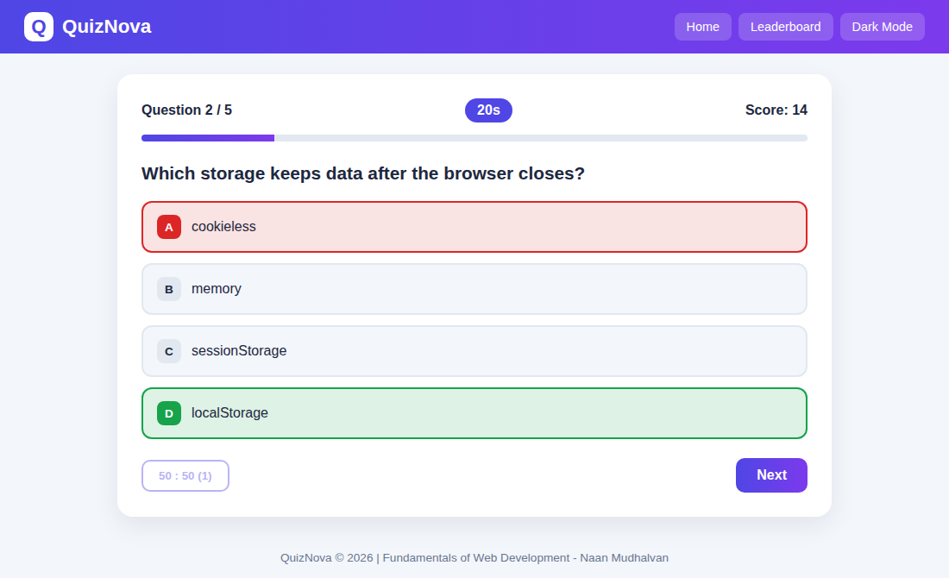

Screenshot 6 – Result Summary
Result screen with medal, percentage ring and correct / wrong / best-streak cards.
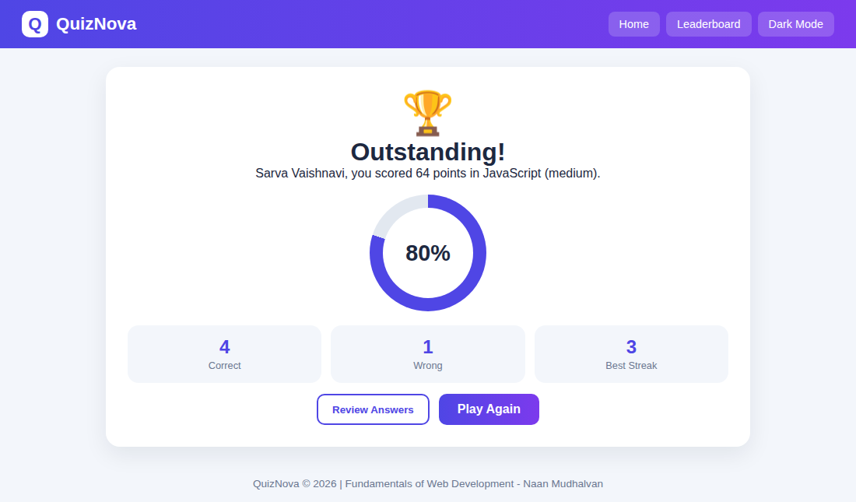

Screenshot 7 – Answer Review
Question-by-question review showing the chosen answer and the correct answer.
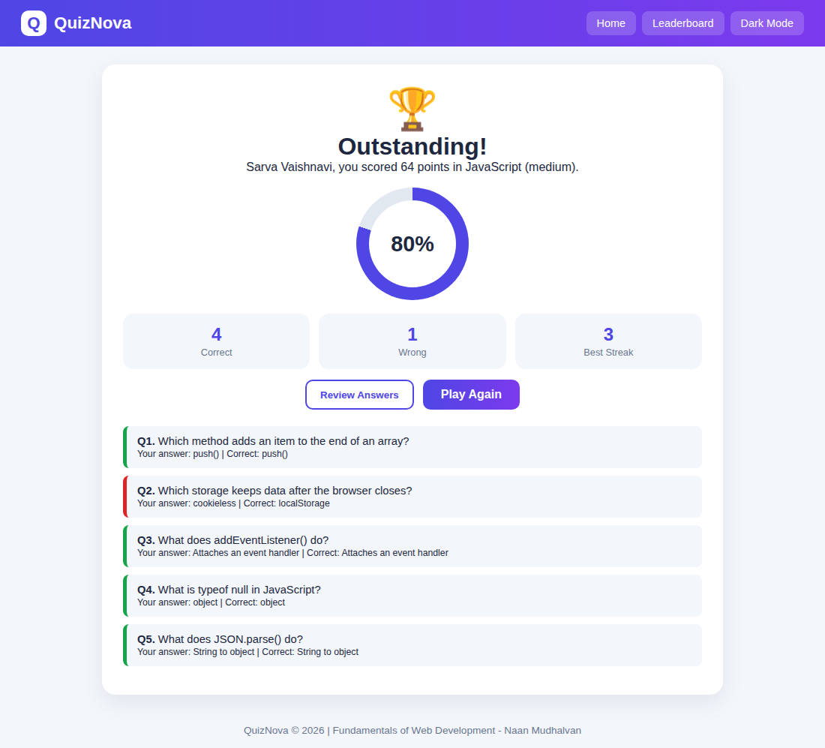

Screenshot 8 – Leaderboard
Top scores stored in localStorage, sorted from highest to lowest.
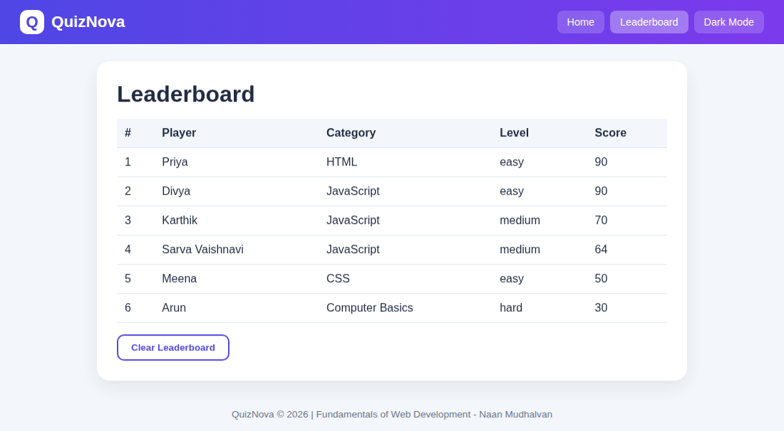

Screenshot 9 – Dark Mode
Dark theme created with CSS variables and toggled with JavaScript.
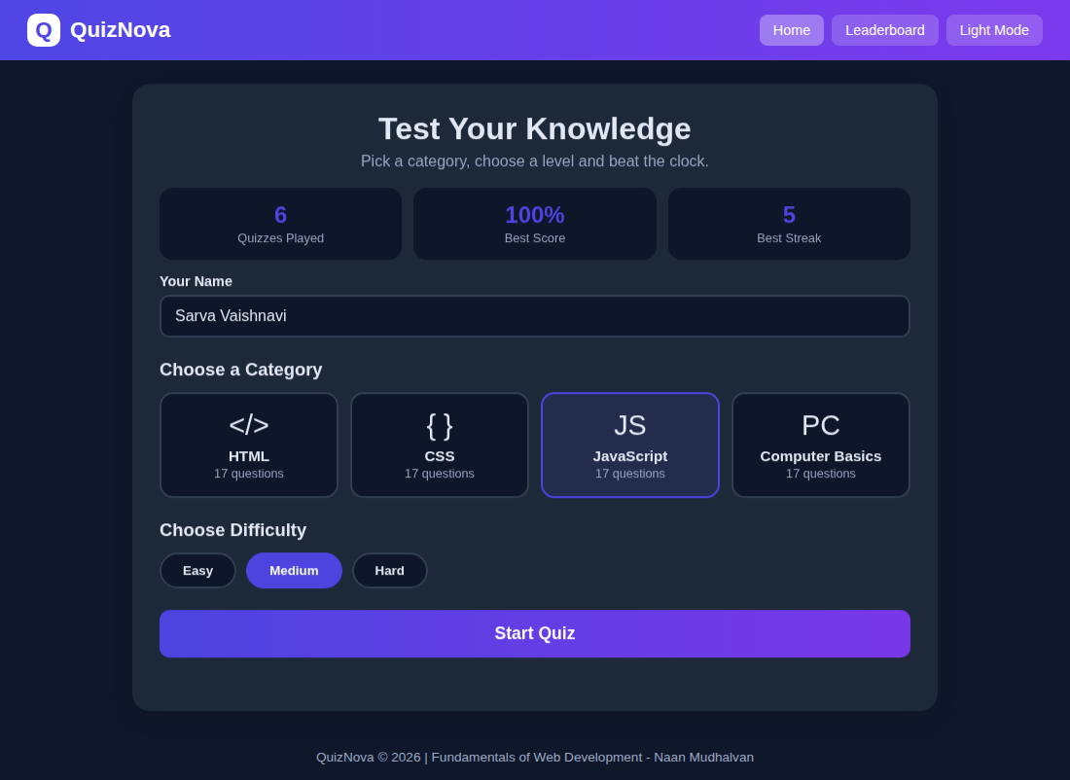

Screenshot 10 – Responsive View (Mobile)
Dashboard and quiz screens on a 390 px wide mobile display.
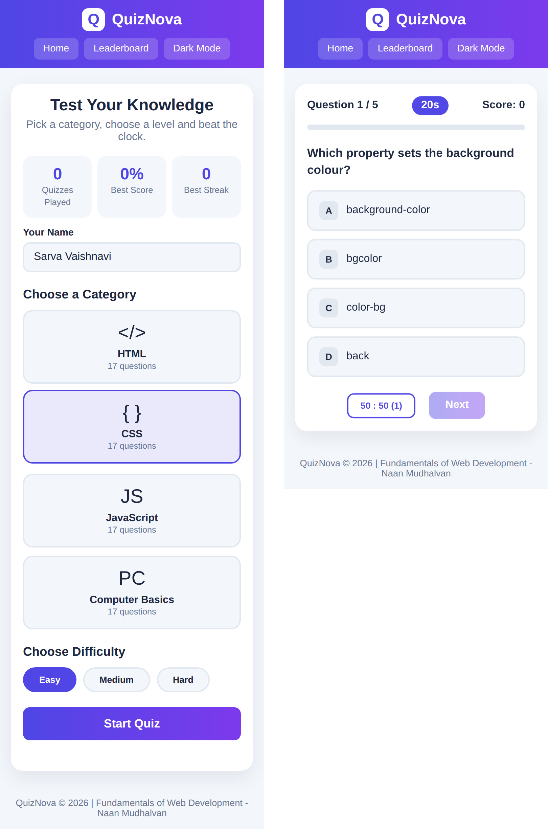

5. Technical Explanation
Explanation of the technologies and logic used in QuizNova:

HTML
index.html uses one page with four <section> blocks – home, quiz, result and board – inside a <main> element, a <header> with the brand and <nav> buttons, and a <footer>. Only one section has the class "active" at a time. Important elements are <input> for the name, <button> for categories, levels, options and actions, <label> for accessibility, <table> for the leaderboard and <meta name="viewport"> for mobile scaling. Category cards, options and review items are generated from JavaScript, keeping the HTML short and clean.

CSS
style.css defines colour variables on :root and overrides them in body.dark so that a single class change re-themes the entire page. CSS Grid builds the category cards (auto-fill with minmax) and the three statistic cards, while Flexbox aligns the top bar, options and buttons. Transitions, a fade-in keyframe on screens and a pulsing timer add motion. The result ring is drawn with conic-gradient and a CSS custom property (--p) set from JavaScript. Responsiveness comes from fluid widths, max-width containers, relative units and a @media (max-width:640px) block that reduces padding and font size and hides the category column in the table.

JavaScript
script.js stores the question bank as an object (category > level > [question, options, answer index]) and keeps the running quiz in a single state object. It uses DOM methods (getElementById, createElement, classList, innerHTML, textContent) to build screens, event handlers (onclick, keydown) for interaction, setInterval for the timer, array methods (map, filter, slice, sort) for data handling and JSON with localStorage for persistence. Screens are switched without reloading the page.

Key Functions
Function | Purpose
show(id) | Hides all screens, shows the requested one and stops the timer when leaving the quiz.
buildCategories() | Creates the category cards from the question bank and highlights the selected one.
shuffle(array) | Fisher–Yates algorithm that randomises questions and options.
startQuiz() | Validates input, prepares five random questions and starts the first one.
loadQuestion() | Displays the question, creates option buttons, updates progress and starts the timer.
startTimer() / paintTimer() | Runs the 20-second countdown, updates the badge and auto-submits when time is up.
choose(index) | Checks the selected option, applies colours, updates score and streak.
useFifty() | Implements the 50:50 lifeline by hiding two wrong options.
finish() | Computes the percentage, shows the result and saves history and best streak.
toggleReview() | Builds and shows or hides the answer review list.
showBoard() | Sorts saved attempts by score and fills the leaderboard table.

6. Conclusion

Conclusion
QuizNova successfully delivers a complete online quiz experience using only core web technologies. The project provides four subject categories, three difficulty levels, a timed question flow, instant feedback, a 50:50 lifeline, scoring with speed and streak bonuses, an answer review, a locally stored leaderboard, dark mode and a responsive layout that works on all screen sizes.
While building it, I learned how to structure a multi-screen interface with semantic HTML, create reusable themes with CSS variables, use Flexbox, Grid and media queries for responsive design, and apply JavaScript concepts such as objects, arrays, DOM manipulation, events, timers and the Web Storage API. The project also improved my skills in debugging, testing on different screen sizes and organising code into separate files.

Future Enhancements
Possible future improvements include:
- Back-end with a database and user login so scores are shared across devices.
- Admin dashboard for adding, editing and deleting quiz questions.
- Online multiplayer mode and a global leaderboard.
- More categories (Python, DBMS, Aptitude) and loading questions from an online API.
- Sound effects, animations and badges or achievements for streaks.
- Downloadable result certificate in PDF format.
- Progressive Web App (PWA) support for offline use on mobile phones.

