**CURRENT TRAFFIC MODULE POC**

**TOPOLOGY IN GNS3:**

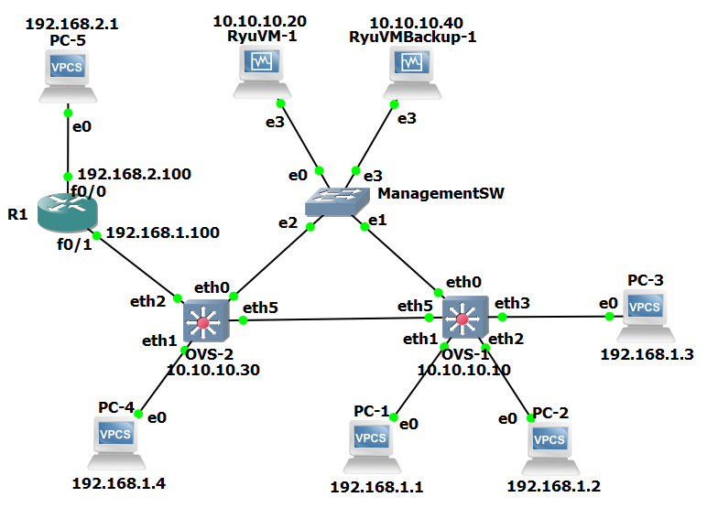

The above topology simulates a switched network like the ISP backbone and uses Open vSwitches (OvS). We are considering the customers and content provider to be in different networks and hence to route traffic across networks, we will be using a modified version of simple_switch_13.py ryu application to route based on IP addresses instead of MAC addresses.

Assumptions taken into consideration:

* The flows will be removed after an idle timeout of 5 seconds. This will be done so that packet ins would be sent to the controller which would determine the lowest latency path at that instant.
* Forwarding based on IP addresses in the OvS would help design applications such as current traffic and top talkers which would need source and destination IP address information.

The following document is a Proof of Concept (POC) based on a backend routing application which is not yet operational. We have created an application for testing of the current traffic measurement module and can be used further if deemed fit.

The IP addresses of each component is depicted in the figure above. We are using two ubuntu VMs hosting ryu controllers, acting as primary and backup servers. Several VPCs are connected to OvS’s to depict traffic sources and sinks. A router separates the networks 192.168.1.0/24 and 192.168.2.0/24.

**OVS-1 configuration:**

IP address assignment:

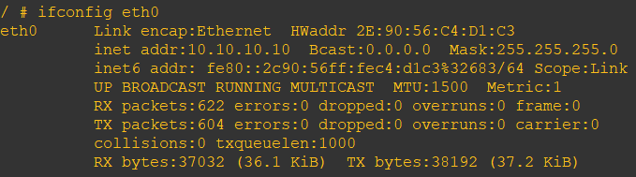

OvS configuration:

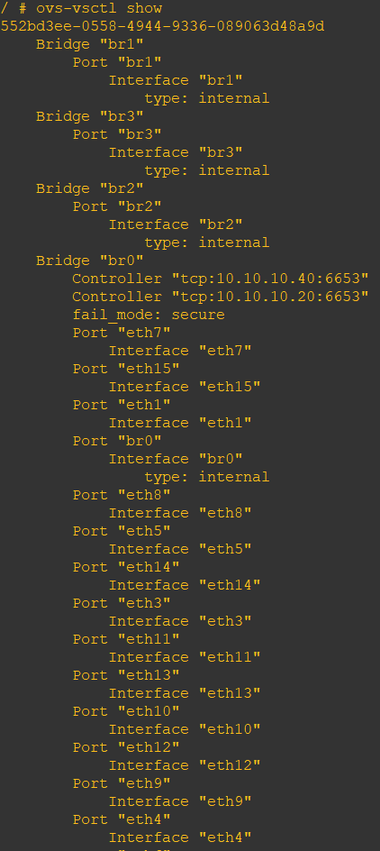

Ryu Controllers are hosted in 10.10.10.20 and 10.10.10.40 servers. The failover mode configured is “Secure”.

**OVS-2 configuration:**

IP address assignment:

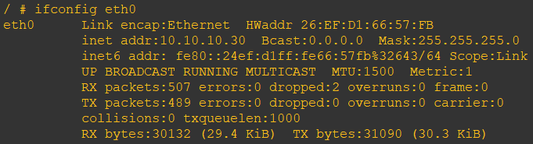

OvS configuration:

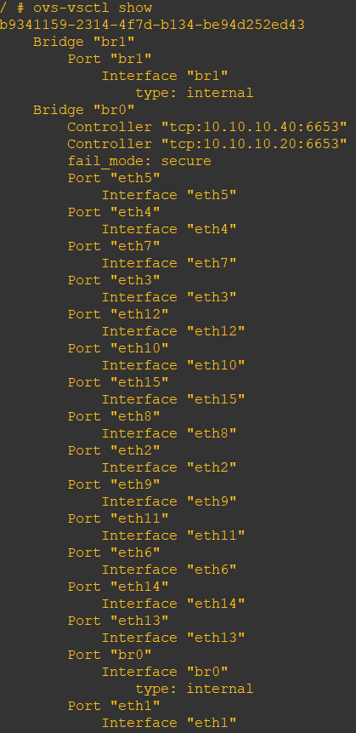

Ryu Controllers are hosted in 10.10.10.20 and 10.10.10.40 servers. The failover mode configured is “Secure”.

**Hosts configuration:**

The VPCs are configured with the IP addresses shown in the topology with the default gateway as the router interface.

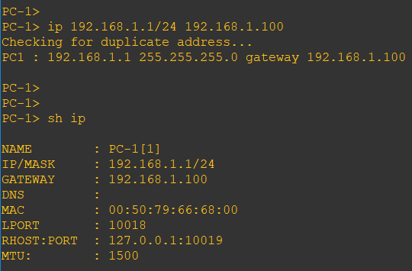

**Ryu Primary Server:**

The application running on 10.10.10.20 is considered as the primary server. Here, we run the applications **ip_simple_switch_13.py** and **ofctl_rest.py**. The ofctl_rest application listens for api requests and ip_simple_switch_13 forwards packets based on IP addresses and installs flows on the OvS accordingly.

The below screenshot shows the debug output of the ryu controller. At each packet in, we are printing the state of the application (dictionary values).

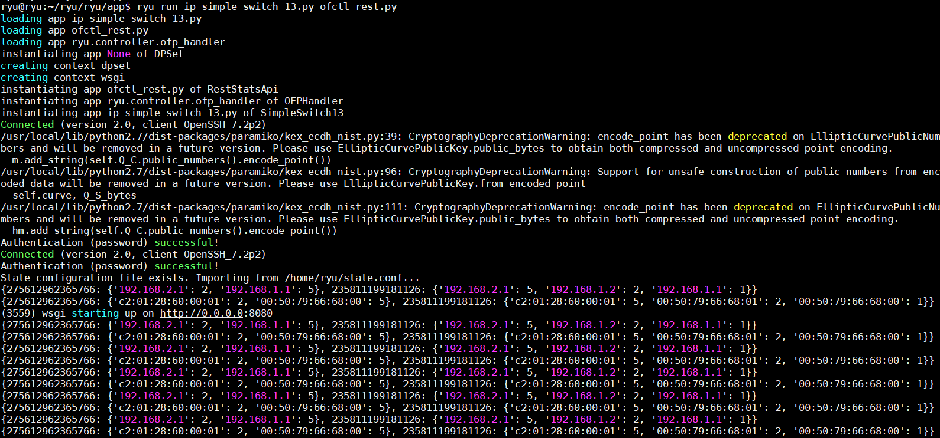

Flows installed on OvS:



Ping output:

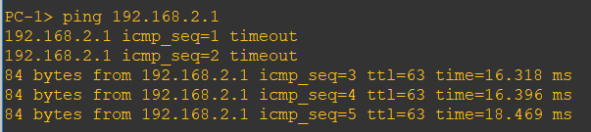

**Ryu backup server:**

The application running on 10.10.10.40 is considered as the primary server. Here, we run the applications **backup_ip_simple_switch.py** and **ofctl_rest.py**. The ofctl_rest application listens for api requests and backup_ip_simple_switch is used as a backup server. The packet ins are ignored on the backup server if the API of the primary server is accessible.

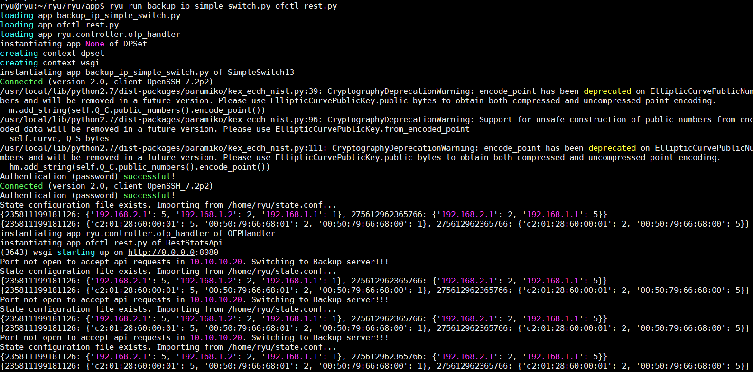

When the API is not accessible, it starts accepting packet ins. If there is a configuration file, the state is then imported into the application variables.

**Current Traffic program:**

The current_traffic.py application gets the flow information from ryu application using APIs. The APIs calls get “n_bytes” field from the flows which give the number of bytes of traffic traversing the flow. The values are displayed real time when the application is run.

Ping output: 98 bytes transmitted per ping

Source: 192.168.1.1 Destination: 192.168.1.2 Number of pings: 3 Packet size: 294 bytes

Source: 192.168.1.1 Destination: 192.168.1.3 Number of pings: 4 Packet size: 392 bytes

Source: 192.168.1.1 Destination: 192.168.1.4 Number of pings: 1 Packet size: 98 bytes

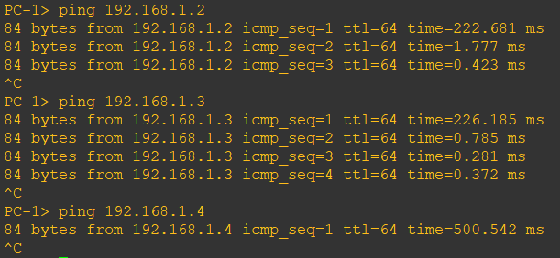

Output of the application current_traffic.py:

The number of bytes in the application output matches the number of pings sent for each source-destination pair. As the flows expire in 5 seconds, the output no longer contains the flow information and comes up as empty, signifying that the link is no longer being used i.e. current traffic is zero.

