**create an app using android studio for login page**

**AIM:**

**To create an app using android studio for login page**

**ALGORITHM:**

Start a new project.

Select "Empty Activity" and configure your project with:

* Name: LoginPageApp
* Package Name: com.example.loginpageapp
* Language: Kotlin or Java (choose Kotlin for this example).
* Click Finish.

CODE:

<?xml version="1.0" encoding="utf-8"?>

<androidx.constraintlayout.widget.ConstraintLayout

xmlns:android="http://schemas.android.com/apk/res/android"

xmlns:app="http://schemas.android.com/apk/res-auto"

xmlns:tools="http://schemas.android.com/tools"

android:layout_width="match_parent"

android:layout_height="match_parent"

tools:context=".MainActivity">

<TextView

android:id="@+id/titleText"

android:layout_width="wrap_content"

android:layout_height="wrap_content"

android:text="Login"

android:textSize="24sp"

android:textStyle="bold"

android:layout_marginTop="48dp"

app:layout_constraintTop_toTopOf="parent"

app:layout_constraintStart_toStartOf="parent"

app:layout_constraintEnd_toEndOf="parent" />

<EditText

android:id="@+id/usernameInput"

android:layout_width="0dp"

android:layout_height="wrap_content"

android:hint="Username"

android:inputType="text"

android:layout_marginTop="24dp"

app:layout_constraintTop_toBottomOf="@id/titleText"

app:layout_constraintStart_toStartOf="parent"

app:layout_constraintEnd_toEndOf="parent"

app:layout_constraintWidth_percent="0.8" />

<EditText

android:id="@+id/passwordInput"

android:layout_width="0dp"

android:layout_height="wrap_content"

android:hint="Password"

android:inputType="textPassword"

android:layout_marginTop="16dp"

app:layout_constraintTop_toBottomOf="@id/usernameInput"

app:layout_constraintStart_toStartOf="parent"

app:layout_constraintEnd_toEndOf="parent"

app:layout_constraintWidth_percent="0.8" />

<Button

android:id="@+id/loginButton"

android:layout_width="wrap_content"

android:layout_height="wrap_content"

android:text="Login"

android:layout_marginTop="24dp"

app:layout_constraintTop_toBottomOf="@id/passwordInput"

app:layout_constraintStart_toStartOf="parent"

app:layout_constraintEnd_toEndOf="parent" />

</androidx.constraintlayout.widget.ConstraintLayout>

OUTPUT:

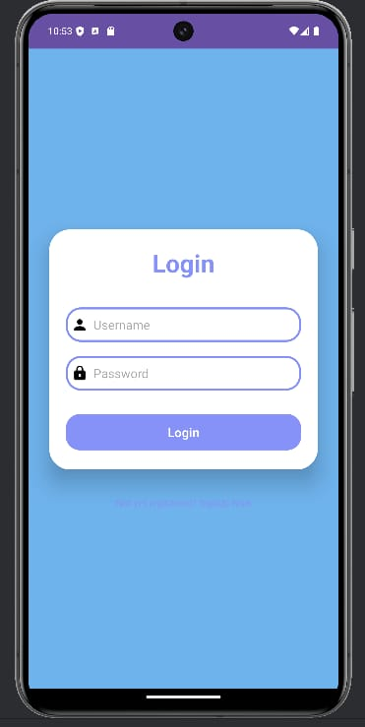

RESULT:

**The program To create an app using android studio for login page is successfully created.**