**Develop an application to change the font and color of the text and display toast message when the user presses the button.**

**AIM:**

**To Develop an application to change the font and color of the text and display toast message when the user presses the button.**

PROCEDURE:

Step 1: File → NewProject Provide the application name and Click “Next” Step 2: Select the target android devices, Select the minimum SDK to run the application. Click “Next”.

Step 3: Choose the activity for the application (By default choose “Blank Activity). Click “Next”.

Step 4: Enter activity name and click "Finish".

Step 5: Edit the program.

Step 6: Run the application, 2-ways to run the application

1. Running through emulator
2. 2. Running through mobile device.

PROGRAM:

AndroidManifest.xml

<?xml version="1.0" encoding="utf-8"?>

<androidx.constraintlayout.widget.ConstraintLayout

xmlns:android="http://schemas.android.com/apk/res/android"

xmlns:app="http://schemas.android.com/apk/res-auto"

xmlns:tools="http://schemas.android.com/tools"

android:layout_width="match_parent"

android:layout_height="match_parent"

tools:context=".MainActivity">

<TextView

android:id="@+id/textView"

android:layout_width="wrap_content"

android:layout_height="wrap_content"

android:text="Hello, World!"

android:textSize="24sp"

android:layout_marginBottom="24dp"

app:layout_constraintTop_toTopOf="parent"

app:layout_constraintStart_toStartOf="parent"

app:layout_constraintEnd_toEndOf="parent"

app:layout_constraintBottom_toTopOf="@+id/changeTextButton" />

<Button

android:id="@+id/changeTextButton"

android:layout_width="wrap_content"

android:layout_height="wrap_content"

android:text="Change Text"

app:layout_constraintBottom_toBottomOf="parent"

app:layout_constraintStart_toStartOf="parent"

app:layout_constraintEnd_toEndOf="parent" />

</androidx.constraintlayout.widget.ConstraintLayout>

MainActivity.java:

package com.example.textchangerapp;

import android.graphics.Color;

import android.graphics.Typeface;

import android.os.Bundle;

import android.widget.Button;

import android.widget.TextView;

import android.widget.Toast;

import androidx.appcompat.app.AppCompatActivity;

public class MainActivity extends AppCompatActivity {

@Override

protected void onCreate(Bundle savedInstanceState) {

super.onCreate(savedInstanceState);

setContentView(R.layout.activity_main);

// Find views by their IDs

TextView textView = findViewById(R.id.textView);

Button changeTextButton = findViewById(R.id.changeTextButton);

// Set an OnClickListener for the button

changeTextButton.setOnClickListener(v -> {

// Change text color

textView.setTextColor(Color.parseColor("#FF5722")); // Orange color

// Change text font (make it bold)

textView.setTypeface(textView.getTypeface(), Typeface.BOLD);

// Display a Toast message

Toast.makeText(MainActivity.this, "Text updated successfully!", Toast.LENGTH_SHORT).show();

});

}

}

OUTPUT:

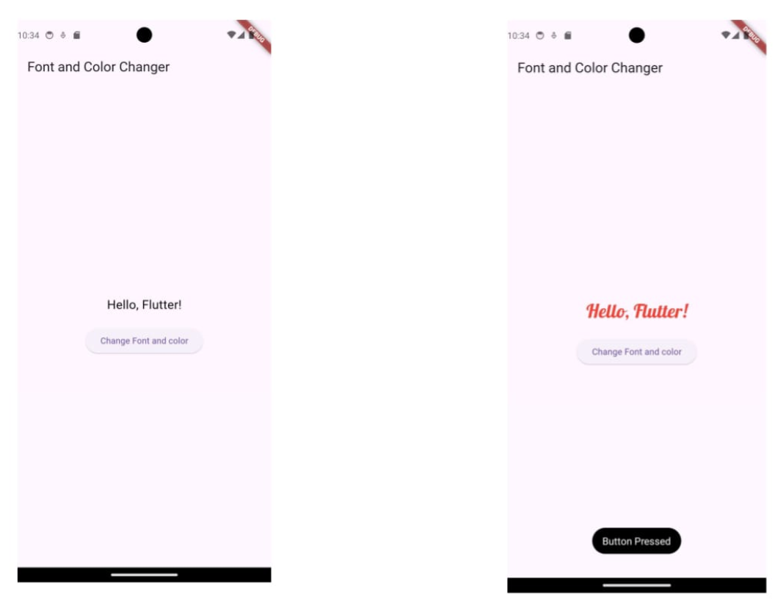

RESULT:

The program is created and executed successfully…