**CREATE AND APPLICATION TO IMPLEMENT USING OCR TO CLASSIFY THE TRAFFIC SIGNAL**

**AIM:**

**TO CREATE AND APPLICATION TO IMPLEMENT USING OCR TO CLASSIFY THE TRAFFIC SIGNAL.**

**PROCEDURE:**

**Step 1: File → New Project Provide the application name and Click “Next”**

**Step 2: Select the target android devices, Select the minimum SDK to run the application. Click “Next”.**

**Step 3: Choose the activity for the application (By default choose “Blank Activity). Click “Next”.**

**Step 4: Enter activity name and click "Finish".**

**Step 5: Edit the program.**

**Step 6: Run the application, 2-ways to run the application**

**1. Running through emulator**

**2. Running through mobile device**

**CODE:**

**activity_main.xml:**

**<?xml version="1.0" encoding="utf-8"?>**

**<androidx.constraintlayout.widget.ConstraintLayout**

**xmlns:android="http://schemas.android.com/apk/res/android"**

**xmlns:app="http://schemas.android.com/apk/res-auto"**

**xmlns:tools="http://schemas.android.com/tools"**

**android:layout_width="match_parent"**

**android:layout_height="match_parent"**

**tools:context=".MainActivity">**

**<ImageView**

**android:id="@+id/imageView"**

**android:layout_width="0dp"**

**android:layout_height="0dp"**

**android:contentDescription="Selected Image"**

**android:scaleType="centerCrop"**

**app:layout_constraintTop_toTopOf="parent"**

**app:layout_constraintBottom_toTopOf="@+id/buttonSelectImage"**

**app:layout_constraintStart_toStartOf="parent"**

**app:layout_constraintEnd_toEndOf="parent"**

**app:layout_constraintHeight_percent="0.6" />**

**<Button**

**android:id="@+id/buttonSelectImage"**

**android:layout_width="wrap_content"**

**android:layout_height="wrap_content"**

**android:text="Select Image"**

**app:layout_constraintTop_toBottomOf="@id/imageView"**

**app:layout_constraintStart_toStartOf="parent"**

**app:layout_constraintEnd_toEndOf="parent"**

**android:layout_marginTop="16dp" />**

**<TextView**

**android:id="@+id/textViewResult"**

**android:layout_width="0dp"**

**android:layout_height="wrap_content"**

**android:text="Result will appear here"**

**android:padding="16dp"**

**android:textSize="16sp"**

**android:textColor="@android:color/black"**

**app:layout_constraintTop_toBottomOf="@id/buttonSelectImage"**

**app:layout_constraintStart_toStartOf="parent"**

**app:layout_constraintEnd_toEndOf="parent" />**

**</androidx.constraintlayout.widget.ConstraintLayout>**

**MainActivity.java:**

**package com.example.trafficsignalocr;**

**import android.content.Intent;**

**import android.graphics.Bitmap;**

**import android.graphics.BitmapFactory;**

**import android.net.Uri;**

**import android.os.Bundle;**

**import android.provider.MediaStore;**

**import android.widget.Button;**

**import android.widget.ImageView;**

**import android.widget.TextView;**

**import android.widget.Toast;**

**import androidx.annotation.Nullable;**

**import androidx.appcompat.app.AppCompatActivity;**

**import com.google.mlkit.vision.common.InputImage;**

**import com.google.mlkit.vision.text.Text;**

**import com.google.mlkit.vision.text.TextRecognition;**

**import com.google.mlkit.vision.text.TextRecognizer;**

**import java.io.IOException;**

**public class MainActivity extends AppCompatActivity {**

**private static final int SELECT_IMAGE_REQUEST = 1;**

**private ImageView imageView;**

**private TextView textViewResult;**

**@Override**

**protected void onCreate(Bundle savedInstanceState) {**

**super.onCreate(savedInstanceState);**

**setContentView(R.layout.activity_main);**

**imageView = findViewById(R.id.imageView);**

**textViewResult = findViewById(R.id.textViewResult);**

**Button buttonSelectImage = findViewById(R.id.buttonSelectImage);**

**buttonSelectImage.setOnClickListener(v -> selectImage());**

**}**

**private void selectImage() {**

**Intent intent = new Intent(Intent.ACTION_PICK, MediaStore.Images.Media.EXTERNAL_CONTENT_URI);**

**startActivityForResult(intent, SELECT_IMAGE_REQUEST);**

**}**

**@Override**

**protected void onActivityResult(int requestCode, int resultCode, @Nullable Intent data) {**

**super.onActivityResult(requestCode, resultCode, data);**

**if (requestCode == SELECT_IMAGE_REQUEST && resultCode == RESULT_OK && data != null) {**

**Uri imageUri = data.getData();**

**try {**

**Bitmap bitmap = MediaStore.Images.Media.getBitmap(this.getContentResolver(), imageUri);**

**imageView.setImageBitmap(bitmap);**

**processImage(bitmap);**

**} catch (IOException e) {**

**e.printStackTrace();**

**Toast.makeText(this, "Error loading image", Toast.LENGTH_SHORT).show();**

**}**

**}**

**}**

**private void processImage(Bitmap bitmap) {**

**InputImage image = InputImage.fromBitmap(bitmap, 0);**

**TextRecognizer recognizer = TextRecognition.getClient();**

**recognizer.process(image)**

**.addOnSuccessListener(this::analyzeText)**

**.addOnFailureListener(e -> Toast.makeText(this, "Failed to recognize text", Toast.LENGTH_SHORT).show());**

**}**

**private void analyzeText(Text result) {**

**StringBuilder recognizedText = new StringBuilder();**

**for (Text.TextBlock block : result.getTextBlocks()) {**

**recognizedText.append(block.getText()).append("\n");**

**}**

**String text = recognizedText.toString();**

**textViewResult.setText(classifyTrafficSignal(text));**

**}**

**private String classifyTrafficSignal(String text) {**

**text = text.toLowerCase();**

**if (text.contains("stop")) {**

**return "Traffic Signal: STOP";**

**} else if (text.contains("yield")) {**

**return "Traffic Signal: YIELD";**

**} else if (text.contains("speed")) {**

**return "Traffic Signal: SPEED LIMIT";**

**} else if (text.contains("no entry")) {**

**return "Traffic Signal: NO ENTRY";**

**} else {**

**return "Traffic Signal: Unrecognized Signal";**

**}**

**}**

**}**

**OUTPUT:**

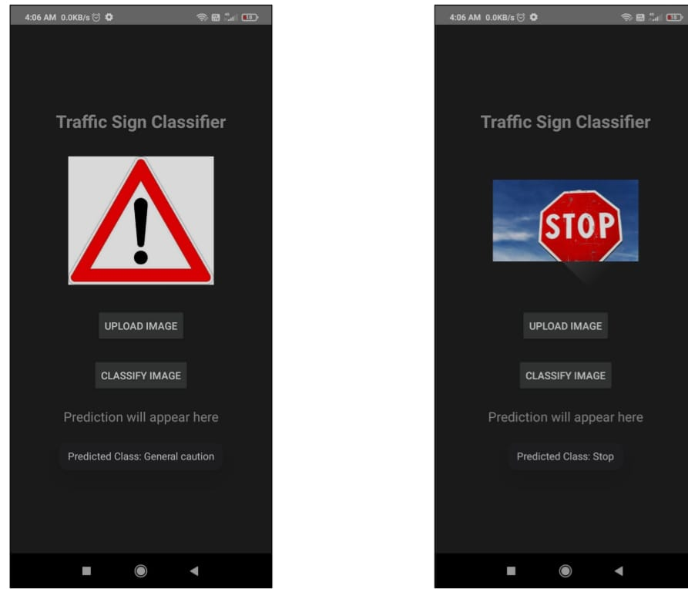

**RESULT:**

**THE PROGRAM IS CREATED AND EXECUTED SUCCESSFULLY.**