**CREATE AN BAR CODE DETECTION APPLICATION USING ANDROID STUDIO**

**AIM:**

**TO CREATE AN BAR CODE DETECTION APPLICATION USING ANDROID STUDIO.**

**ALGORITHM:**

**Step 1: File → New Project Provide the application name and Click “Next”**

**Step 2: Select the target android devices, Select the minimum SDK to run the application. Click “Next”.**

**Step 3: Choose the activity for the application (By default choose “Blank Activity). Click “Next”.**

**Step 4: Enter activity name and click "Finish".**

**Step 5: Edit the program.**

**Step 6: Run the application, 2-ways to run the application**

**1. Running through emulator**

**2. Running through mobile device**

**CODE:**

**AndroidManifest.xml**

**<manifest xmlns:android="http://schemas.android.com/apk/res/android"**

**package="com.example.qrbarcodescanner">**

**<uses-permission android:name="android.permission.CAMERA" />**

**<uses-feature android:name="android.hardware.camera" android:required="false"></uses**

**feature>**

**<application**

**android:allowBackup="true"**

**android:label="@string/app_name"**

**android:supportsRtl="true"**

**android:theme="@style/Theme.Qrbarcodescanner">**

**<!-- Main activity -->**

**<activity android:name=".MainActivity"**

**android:exported="true">**

**<intent-filter>**

**<action android:name="android.intent.action.MAIN" />**

**<category android:name="android.intent.category.LAUNCHER" />**

**</intent-filter>**

**</activity>**

**</application>**

**</manifest>**

**Activity_main.xml**

**<!-- res/layout/activity_main.xml -->**

**<LinearLayout xmlns:android="http://schemas.android.com/apk/res/android"**

**android:layout_width="match_parent"**

**android:layout_height="match_parent"**

**android:background="@drawable/gradient_background"**

**android:gravity="center"**

**android:orientation="vertical"**

**android:padding="20dp">**

**<Button**

**android:id="@+id/scanButton"**

**android:layout_width="wrap_content"**

**android:layout_height="wrap_content"**

**android:background="@drawable/rounded_button"**

**android:text="Scan QR/Barcode"**

**android:textColor="#FFFFFF"**

**android:textSize="18sp" />**

**<TextView**

**android:id="@+id/resultTextView"**

**android:layout_width="wrap_content"**

**android:layout_height="wrap_content"**

**android:layout_marginTop="20dp"**

**android:text="Scan result will appear here"**

**android:textColor="#FFFFFF"**

**android:textSize="16sp" />**

**<TextView**

**android:id="@+id/author"**

**android:layout_width="wrap_content"**

**android:layout_height="wrap_content"**

**android:layout_marginTop="20dp"**

**android:text="by Abdul Jameel"**

**android:textColor="#00BCD4"**

**android:textSize="32sp" />**

**</LinearLayout>**

**Main.java**

**// MainActivity.java**

**package com.example.qrbarcodescanner;**

**import android.content.Intent;**

**import android.os.Bundle;**

**import android.widget.Button;**

**import android.widget.TextView;**

**import androidx.annotation.Nullable;**

**import androidx.appcompat.app.AppCompatActivity;**

**import com.google.zxing.integration.android.IntentIntegrator;**

**import com.google.zxing.integration.android.IntentResult;**

**public class MainActivity extends AppCompatActivity {**

**private TextView resultTextView;**

**private Button scanButton;**

**@Override**

**protected void onCreate(Bundle savedInstanceState) {**

**super.onCreate(savedInstanceState);**

**setContentView(R.layout.activity_main);**

**resultTextView = findViewById(R.id.resultTextView);**

**scanButton = findViewById(R.id.scanButton);**

**// Set up the button click listener**

**scanButton.setOnClickListener(v -> startScanner());**

**}**

**private void startScanner() {**

**IntentIntegrator integrator = new IntentIntegrator(this);**

**integrator.setOrientationLocked(true);**

**integrator.setPrompt("Scan a QR Code or Barcode");**

**integrator.initiateScan(); // Starts the default scan activity without CaptureActivity**

**}**

**@Override**

**protected void onActivityResult(int requestCode, int resultCode, @Nullable Intent data) {**

**super.onActivityResult(requestCode, resultCode, data);**

**IntentResult result = IntentIntegrator.parseActivityResult(requestCode, resultCode, data);**

**if (result != null) {**

**if (result.getContents() != null) {**

**resultTextView.setText("Result: " + result.getContents());**

**} else {**

**resultTextView.setText("No result found");**

**}**

**} else {**

**super.onActivityResult(requestCode, resultCode, data);**

**}**

**}**

**OUTPUT:**

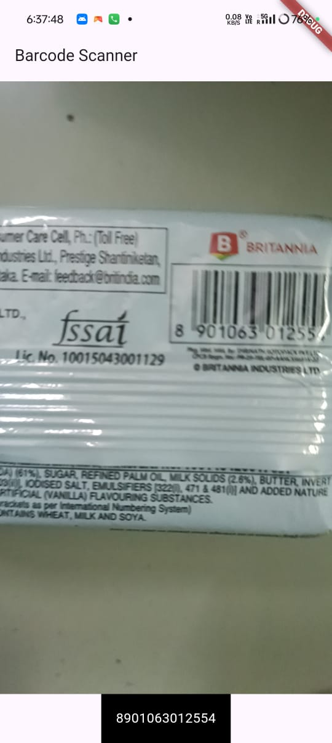

**RESULT:**

**THE PROGRAM IS CREATED AND EXECUTED SUCCESSFULLY.**