**EX:No.10 VAR MODEL FOR MULTIVARIATE TIME SERIES**

**221501016**

**AIM :** To create a variable autoregression model for multivariate time series data.

**PROCEDURE:**

#### **1. Prepare the Data**

#### **2. Make the Data Stationary**

#### **3. Select the Lag Order (p)**

#### **4. Fit the VAR Model**

#### **5. Diagnose the Model**

#### **6. Forecast Future Values**

**IMPLEMENTATION :**

**Import libraries**

import pandas as pd

import numpy as np

import matplotlib.pyplot as plt

from statsmodels.tsa.api import VAR

from sklearn.metrics import mean_squared_error

from math import sqrt

**Load the dataset**

df = pd.read_csv('/content/Electric_Production.csv')

df.columns = ['Date', 'Production']

df['Date'] = pd.to_datetime(df['Date'])

df.set_index('Date', inplace=True)

**Create synthetic second variable (e.g., rolling mean or shifted)**

df['Production_shifted'] = df['Production'].shift(1).fillna(method='bfill')

**Plot the variables**

df[['Production', 'Production_shifted']].plot(figsize=(12, 5), title='Multivariate Time Series')

plt.show()

**Split into train and test sets**

train_size = int(len(df) * 0.8)

train, test = df.iloc[:train_size], df.iloc[train_size:]

**Fit VAR model**

model = VAR(train)

fitted_model = model.fit(maxlags=15, ic='aic') # auto-select best lag using AIC

**Forecast**

forecast_input = train.values[-fitted_model.k_ar:]

forecast_steps = len(test)

forecast = fitted_model.forecast(y=forecast_input, steps=forecast_steps)

**Convert forecast to DataFrame**

forecast_df = pd.DataFrame(forecast, index=test.index, columns=['Production_forecast', 'Production_shifted_forecast'])

**Plot actual vs forecast**

plt.figure(figsize=(12, 6))

plt.plot(test['Production'], label='Actual Production')

plt.plot(forecast_df['Production_forecast'], label='VAR Forecast', color='red')

plt.title('VAR Forecast vs Actual')

plt.legend()

plt.show()

**Evaluate**

rmse = sqrt(mean_squared_error(test['Production'], forecast_df['Production_forecast']))

print(f'RMSE (Production Forecast): {rmse:.2f}')

**OUTPUT:**

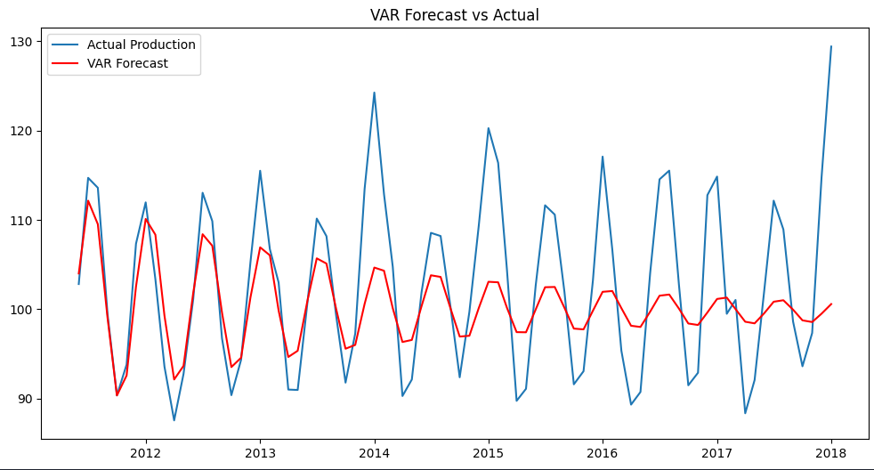

**RESULT :** Thus variable autoregression has been successfully implemented for multivariate time series data.