**EX:No.2 Implement programs for visualizing time series data 31/01/25**

**Aim:** To implement visualisation programs on time series datasets.

**Implementation :**

import pandas as pd

import matplotlib.pyplot as plt

import seaborn as sns

**Load the dataset**

file_path = "/mnt/data/Electric_Production.csv"

df = pd.read_csv(file_path)

# Convert DATE column to datetime format

df["DATE"] = pd.to_datetime(df["DATE"])

# Set DATE as index

df.set_index("DATE", inplace=True)

**Scatter Plot**

plt.figure(figsize=(10, 4))

plt.scatter(df.index, df["IPG2211A2N"], color='blue', alpha=0.5)

plt.title("Scatter Plot of Electric Production Over Time")

plt.xlabel("Year")

plt.ylabel("Electric Production")

plt.xticks(rotation=45)

plt.show()

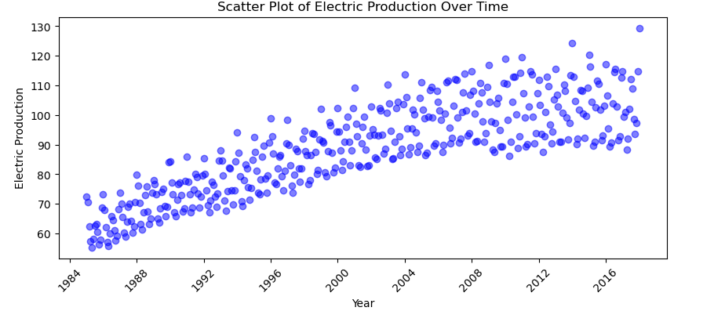

**Bar Chart (Yearly Aggregation)**

df_yearly = df.resample('Y').mean()

plt.figure(figsize=(10, 4))

plt.bar(df_yearly.index.year, df_yearly["IPG2211A2N"], color='green', alpha=0.7)

plt.title("Yearly Average Electric Production")

plt.xlabel("Year")

plt.ylabel("Average Production")

plt.show()

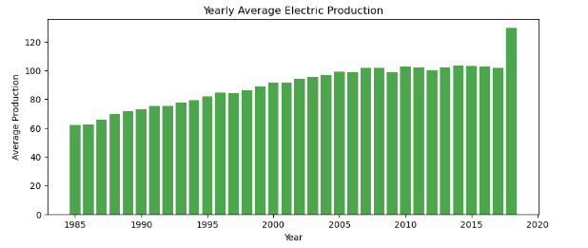

**Histogram**

plt.figure(figsize=(8, 4))

plt.hist(df["IPG2211A2N"], bins=30, color='purple', alpha=0.7)

plt.title("Distribution of Electric Production")

plt.xlabel("Electric Production")

plt.ylabel("Frequency")

plt.show()

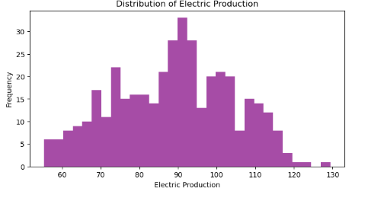

**Box Plot (Monthly Trends**)

df["Month"] = df.index.month

plt.figure(figsize=(10, 4))

sns.boxplot(x=df["Month"], y=df["IPG2211A2N"], palette="coolwarm")

plt.title("Monthly Distribution of Electric Production")

plt.xlabel("Month")

plt.ylabel("Electric Production")

plt.show()

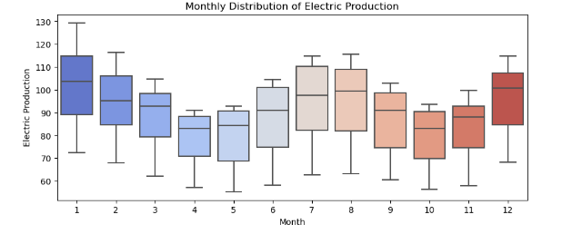

**Heatmap (Year-Month Aggregation)**

df["Year"] = df.index.year

df_pivot = df.pivot_table(values="IPG2211A2N", index="Year", columns="Month", aggfunc="mean")

plt.figure(figsize=(10, 6))

sns.heatmap(df_pivot, cmap="coolwarm", annot=True, fmt=".1f")

plt.title("Heatmap of Monthly Average Electric Production")

plt.xlabel("Month")

plt.ylabel("Year")

plt.show()

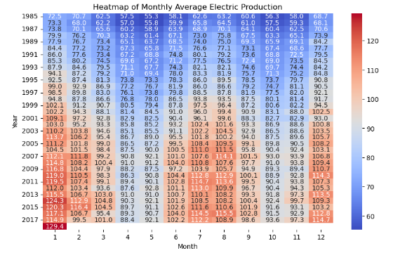

RESULT : Thus time series visualisation has been implemented successfully.