**EX:No.4 STATIONARITY CHECK 221501006 04/03/25**

**AIM :** To implement stationarity check using Augmented Dickey Fuller test and Visualise it.

**PROCEDURE:**

1. Read the time-series data from the CSV file.

2. Convert the date column to datetime format and set it as the index.

3. Visualize the data using a line graph.

4. Apply the Augmented Dickey-Fuller (ADF) test to check stationarity.

5. Print the ADF statistic, p-value, and critical values.

6. Determine if the series is stationary based on the p-value.

**IMPLEMENTATION :**

import pandas as pd

import numpy as np

import matplotlib.pyplot as plt

from statsmodels.tsa.stattools import adfuller

**# Load dataset**

file_path = "C:/Users/Lenovo/Downloads/DailyDelhiClimateTrain.csv"

df = pd.read_csv(file_path)

**# Convert 'date' to datetime and set as index**

df["date"] = pd.to_datetime(df["date"])

df.set_index("date", inplace=True)

**# Function to perform ADF Test**

def adf_test(series):

result = adfuller(series.dropna()) # Drop NaN values

print("ADF Statistic:", result[0])

print("p-value:", result[1])

print("Critical Values:")

for key, value in result[4].items():

print(f" {key}: {value}")

if result[1] <= 0.05:

print("Conclusion: The series is stationary.")

else:

print("Conclusion: The series is non-stationary.")

**# Plot original data**

plt.figure(figsize=(10, 5))

plt.plot(df["meantemp"], label="Mean Temperature", color="blue")

plt.title("Mean Temperature Over Time")

plt.xlabel("Year")

plt.ylabel("Temperature (°C)")

plt.legend()

plt.show()

**# ADF Test on original data**

print("ADF Test on Original Data:")

adf_test(df["meantemp"])

**# Apply first-order differencing**

df["meantemp_diff"] = df["meantemp"].diff()

**# ADF Test after differencing**

print("\nADF Test After First-Order Differencing:")

adf_test(df["meantemp_diff"])

**# Apply log transformation followed by differencing**

df["meantemp_log"] = np.log(df["meantemp"])

df["meantemp_log_diff"] = df["meantemp_log"].diff()

**# ADF Test after log transformation + differencing**

print("\nADF Test After Log Transformation + Differencing:")

adf_test(df["meantemp_log_diff"])

**# Plot transformed data**

plt.figure(figsize=(10, 5))

plt.plot(df["meantemp_diff"], label="First-Order Differenced", color="red")

plt.title("First-Order Differencing of Mean Temperature")

plt.xlabel("Year")

plt.ylabel("Differenced Value")

plt.legend()

plt.show()

plt.figure(figsize=(10, 5))

plt.plot(df["meantemp_log_diff"], label="Log Transformed + Differenced", color="green")

plt.title("Log Transformation + Differencing of Mean Temperature")

plt.xlabel("Year")

plt.ylabel("Transformed Value")

plt.legend()

plt.show()

**OUTPUT:**

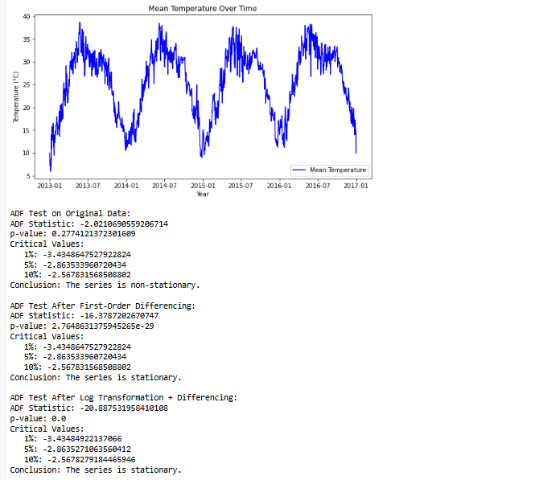

**RESULT :** Thus stationarity check has been implemented successfully using Augmented Dickey Fuller Test.