**EX:No.7 DECOMPOSING TIME SERIES FOR TRENDS AND SEASONALITY**

**221501006**

**AIM :** To decompose time series for trends and seasonality.

**PROCEDURE:**

• Read the dataset and convert the date column to datetime format.

• Set the date column as the index for time series analysis.

• Aggregate the data to a uniform time frequency (e.g., monthly mean).

• Apply seasonal decomposition using seasonal_decompose.

• Plot the decomposition result.

• Interpret the components to understand the structure of the time series.

**IMPLEMENTATION :**

**Import necessary libraries**

import pandas as pd

import matplotlib.pyplot as plt

from statsmodels.tsa.seasonal import seasonal_decompose

**Load the dataset**

df = pd.read_csv('/mnt/data/Electric_Production.csv')

df.columns = ['Date', 'Production']

df['Date'] = pd.to_datetime(df['Date'])

df.set_index('Date', inplace=True)

**Resample monthly (optional, in case data is weekly or daily)**

If data is already monthly, skip this step

df = df.resample('M').mean()

**Apply seasonal decomposition**

result = seasonal_decompose(df['Production'], model='additive', period=12) # monthly data => period=12

**Plot the decomposition**

plt.figure(figsize=(14, 10))

result.plot()

plt.suptitle('Seasonal Decomposition of Electric Production', fontsize=16)

plt.tight_layout()

plt.show()

**OUTPUT:**

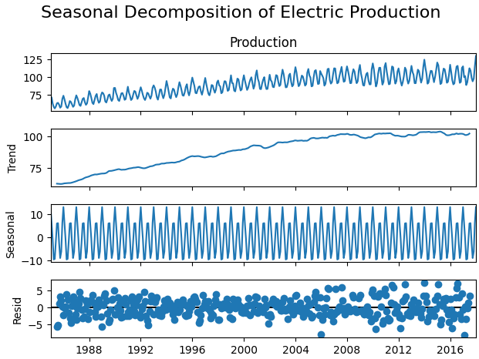

**RESULT :** Thus decomposition for trends and seasonality has been executed successfully.