**EX:No.8 ARIMA FOR TIME SERIES FORECASTING**

**221501016**

**AIM :** To create an ARIMA model for time series forecasting.

**PROCEDURE:**

• Read the dataset and convert the date column to datetime format.

• Set the date column as the index for time series analysis.

• Aggregate the data to monthly mean (if not already monthly).

• Check for stationarity.

• Determine optimal ARIMA parameters (p, d, q).

• Fit the ARIMA model using the training data.

• Make predictions and compare with actual values.

**IMPLEMENTATION :**

**Import libraries**

import pandas as pd

import matplotlib.pyplot as plt

from statsmodels.tsa.arima.model import ARIMA

from sklearn.metrics import mean_squared_error

from math import sqrt

**Load dataset**

df = pd.read_csv('/content/Electric_Production.csv')

df.columns = ['Date', 'Production']

df['Date'] = pd.to_datetime(df['Date'])

df.set_index('Date', inplace=True)

**Plot original data**

plt.figure(figsize=(12, 6))

plt.plot(df['Production'], label='Electric Production')

plt.title('Original Time Series')

plt.xlabel('Date')

plt.ylabel('Production')

plt.legend()

plt.show()

**Train-test split (80% train, 20% test)**

train_size = int(len(df) * 0.8)

train, test = df['Production'][:train_size], df['Production'][train_size:]

**Fit ARIMA model**

# ARIMA(p,d,q) -> p=AR lags, d=differencing, q=MA lags

model = ARIMA(train, order=(2, 1, 2)) # You can experiment with (p,d,q)

model_fit = model.fit()

**Forecast**

forecast = model_fit.forecast(steps=len(test))

forecast = pd.Series(forecast, index=test.index)

**Plot actual vs forecast**

plt.figure(figsize=(12, 6))

plt.plot(train, label='Training Data')

plt.plot(test, label='Actual Test Data')

plt.plot(forecast, label='Forecast', color='red')

plt.title('ARIMA Forecast vs Actuals')

plt.xlabel('Date')

plt.ylabel('Production')

plt.legend()

plt.show()

**Evaluation**

rmse = sqrt(mean_squared_error(test, forecast))

print(f'Root Mean Squared Error (RMSE): {rmse:.2f}')

**OUTPUT:**

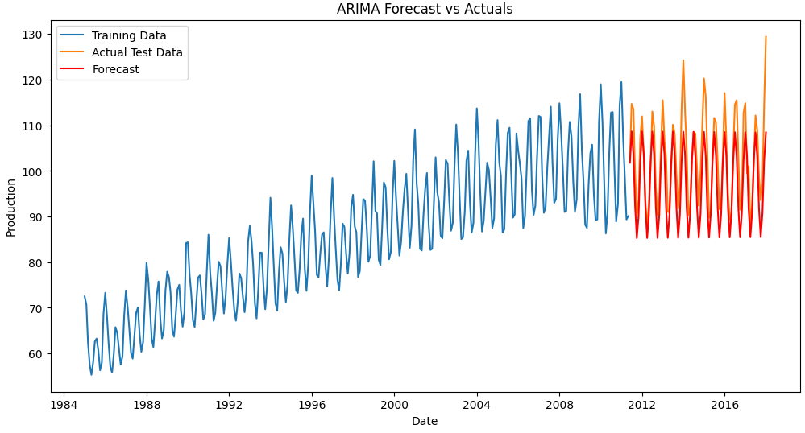

**RESULT :** Thus ARIMA model has been successfully created for time series forecasting.