**EX:No.9 NEURAL NETWORK BASED MODEL**

**221501016**

**AIM :** To create an neural network based model for time series forecasting using LSTM.

**PROCEDURE:**

• Read the dataset and convert the date column to datetime format.

• Set the date column as the index for time series analysis.

• Resample or aggregate the data monthly (if needed).

• Normalize the data to scale values between 0 and 1.

• Prepare the data for LSTM.

• Split the data into training and testing sets.

• Build and compile the LSTM model.

• Train the model.

• Make predictions and inverse transform to original scale.

**IMPLEMENTATION :**

**Import libraries**

import pandas as pd

import numpy as np

import matplotlib.pyplot as plt

from sklearn.preprocessing import MinMaxScaler

from sklearn.metrics import mean_squared_error

from tensorflow.keras.models import Sequential

from tensorflow.keras.layers import LSTM, Dense

from math import sqrt

**Load dataset**

df = pd.read_csv('/content/Electric_Production.csv')

df.columns = ['Date', 'Production']

df['Date'] = pd.to_datetime(df['Date'])

df.set_index('Date', inplace=True)

**Normalize the data**

scaler = MinMaxScaler()

scaled_data = scaler.fit_transform(df[['Production']])

**Create sequences**

def create_sequences(data, seq_length):

X, y = [], []

for i in range(seq_length, len(data)):

X.append(data[i-seq_length:i])

y.append(data[i])

return np.array(X), np.array(y)

sequence_length = 12 # previous 12 months to predict next month

X, y = create_sequences(scaled_data, sequence_length)

**Train-test split**

train_size = int(len(X) * 0.8)

X_train, y_train = X[:train_size], y[:train_size]

X_test, y_test = X[train_size:], y[train_size:]

**Reshape for LSTM [samples, timesteps, features]**

X_train = X_train.reshape((X_train.shape[0], X_train.shape[1], 1))

X_test = X_test.reshape((X_test.shape[0], X_test.shape[1], 1))

**Build LSTM model**

model = Sequential()

model.add(LSTM(64, activation='relu', return_sequences=False, input_shape=(sequence_length, 1)))

model.add(Dense(1))

model.compile(optimizer='adam', loss='mse')

**Train the model**

history = model.fit(X_train, y_train, epochs=50, batch_size=16, validation_split=0.1, verbose=1)

**Predict and inverse transform**

y_pred = model.predict(X_test)

y_pred_inv = scaler.inverse_transform(y_pred)

y_test_inv = scaler.inverse_transform(y_test)

**Plot results**

plt.figure(figsize=(12,6))

plt.plot(y_test_inv, label='Actual')

plt.plot(y_pred_inv, label='LSTM Forecast', color='red')

plt.title('LSTM Forecast vs Actual')

plt.legend()

plt.show()

**Evaluate performance**

rmse = sqrt(mean_squared_error(y_test_inv, y_pred_inv))

print(f'RMSE: {rmse:.2f}')

**OUTPUT:**

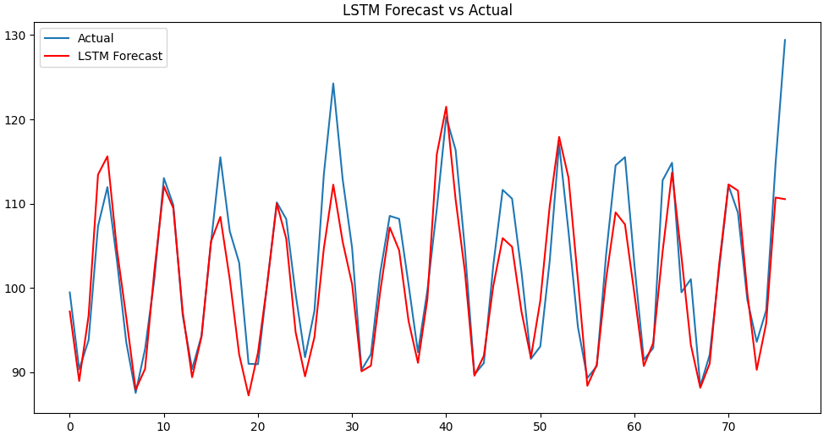

**RESULT :** Thus neural network has been successfully created using LSTM for time series forecasting.