Revised 13 Sept 2014 - had to go offline to revise so text below is just pasted above old versions - Steph built on Sarah’s suggested revision - old text and comments still live below last figure

The Tao of Open Science for Ecology
s.hampton@wsu.edu; sean.anderson@csuci.edu; bagby@geol.ucsb.edu; xueyinghan85@gmail.com; edmund.m.hart@gmail.com; jones@nceas.ucsb.edu; clenhardt@renci.org; aammacdonald@gmail.com; william.michener@gmail.com; joe.mudge@ttu.edu; apourmok@bu.edu; schild@nceas.ucsb.edu; woo.kara@gmail.com; naupaka@gmail.com; cgries@wisc.edu

Stephanie E. Hampton, Center for Environmental Research, Education and Outreach, Washington State University, Pullman WA 99164 s.hampton@wsu.edu
Sean S. Anderson, Environmental Science and Resource Management Program & Pacific Institute for Restoration Ecology, California State University Channel Islands, Camarillo, CA 93012 sean.anderson@csuci.edu
Sarah C. Bagby, Marine Science Institute and Department of Earth Science, University of California, Santa Barbara, 93106 bagby@geol.ucsb.edu
Xueying “Shirley” Han: xueyinghan85@gmail.com, Center for Nanotechnology in Society, University of California, Santa Barbara, CA 93106
Edmund M. Hart, National Ecological Observatory Network, 1685 38th St., Suite 100, Boulder, CO 80301 edmund.m.hart@gmail.com
Matthew B. Jones, National Center for Ecological Analysis and Synthesis, University of California, Santa Barbara jones@nceas.ucsb.edu
W. Christopher Lenhardt: clenhardt@renci.org, Renaissance Computing Institute (RENCI), University of North Carolina at Chapel Hill.
Andrew MacDonald macdonald@zoology.ubc.ca, Department of Zoology, University of British Columbia, Canada
William K. Michener, College of University Libraries and Learning Science, MSC05 3020, University of New Mexico, Albuquerque, NM 87131 william.michener@gmail.com
Joe Mudge: joe.mudge@ttu.edu, The Institute of Environmental and Human Health, Department of Environmental Toxicology, Texas Tech University, Lubbock, TX 79416
Afshin Pourmokhtarian: apourmok@bu.edu Department of Earth & Environment, Rm 130, 685 Commonwealth Avenue, Boston University, Boston, MA 02215
Mark Schildhauer, National Center for Ecological Analysis and Synthesis, University of California, Santa Barbara schild@nceas.ucsb.edu
Kara Woo, National Center for Ecological Analysis and Synthesis, UC Santa Barbara, 735 State St. Suite 300, Santa Barbara, CA 93101 woo.kara@gmail.com
Naupaka Zimmerman naupaka@gmail.com School of Plant Sciences, University of Arizona, 1145 E 4th St., Tucson, AZ 85721

Abstract (350 words)

some text goes here...

Ecology stands at the threshold of a potentially profound change. The combination of ever-increasing computational power, coupled with advances in Internet technologies and tools, is catalyzing new ways of pursuing ecological investigations. These emerging approaches facilitate greater communication, cooperation, collaboration, and sharing, not only of results, but also of data, analytical and modeling code, and potentially even fully documented workflows of the processes---warts and all---that lead to scientific insights. This vision of free and unfettered access to all stages of the scientific endeavor has been called "open science" (Nielsen 2011). As an integrative and highly multidisciplinary field, ecology particularly stands to benefit from this open science revolution, and many ecologists have expressed interest in enhancing the openness of ecology. To date, such conversations among ecologists have largely occurred online (e.g., discussed in Darling et al 2013); thus it seems timely to present an introduction of open science for ecologists who may or may not currently be active in social media where the discussion is evolving. We give an overview of the rise of open science, the changes in mindset that open science requires, and the digital tools that can enable ecologists to put the open science mindset into practice.

The exchange of scientific information was first institutionalized in the 1660s with the establishment of the Philosophical Transactions of the Royal Society of London and the Journal des Sçavans, the first scientific journals (Beaver and Rosen 1978). While these journals provided platforms for scientists to share their results and ideas, they were largely accessible only to elites---those who could afford a subscription themselves, or those who belonged to an institution that held copies (Nielsen 2011). Scientists published in these journals to establish precedence of discovery; the notion of collaboration among scientists does not seem to have taken hold until the 1800s (Beaver and Rosen 1978).

The scientific world looks very different now. Advances in computing accelerated not only individual scientists’ discoveries but also their collaborative potential (Box 1). Modern scientists constitute a new invisible college with global reach, its philosophical transactions enabled by the Internet (Wagner 2008). Collaboration has become the predominant norm for high-impact research (Wuchty et al 2007). Technological developments also have enabled the capture of a previously unimaginable volume of data and metadata at ever increasing rates (Reichman et al 2011, Dietze, M.C., D. LeBauer, R. Kooper. 2013), and the deployment of greater computational power to run models and analyze data. Traditional paper notebooks cannot meet the challenges of increased accumulation, sharing, and recombination of ideas, research logs, data sets and analyses (Strasser and Hampton 2012). Nor can a non-networked computer. The tools and approaches that together constitute open science can help ecologists to meet these challenges, by amplifying opportunities for collaboration and demanding consistent machine-readable documentation necessary for rapid reproducibility in complex projects.

While interest in this new paradigm is on the rise (Fig. 1), it must be acknowledged that both technical and sociocultural obstacles impede adoption for some ecologists. For example, precedence, attribution, investment, and payoff are high-stakes issues for professional scientists (Hackett 2005). Adopting open practices means ceding some control of these issues, and devoting precious time to learning new modes of research and communication in a seemingly foreign language (Box 2). Yet hewing to traditional practices carries its own risks for the individual investigators. Errors and oversights can persist far longer when experimental design and data analysis are held in private; weeks and months can be wasted in chasing reproduction of results because methods are documented only as fully as a journal word count permits; labs can become isolated, their advancement slowed, for lack of substantive interaction with others. Open science can help to mitigate these risks, to the immediate benefit of the individual practitioner, as she builds an active community around her.

Moreover, open science promises many longer term benefits to the scientific community. The adoption of standard best practices and cultural norms for public archiving of data and code will speed discovery and promote fairness in attribution. The use of open-source tools and open-access data and journals will help to further democratize science, diversifying perspectives and knowledge by promoting broader access for scientists in developing countries and at under-resourced institutions, and fostering citizen science which is already a major source of data in some ecological sub-disciplines (Cooper 2014).

Here, we discuss the changes in mindset and the tools that can help interested ecologists move toward practicing open science themselves, facilitate its practice by their students and other colleagues, or both.

Changes in mindset
Data stewardship, not data ownership
Traditional views on data ownership hold that data are proprietary products of the researcher (Sieber 1989). By definition, this data ownership mindset limits the potential for data sharing as a given researcher can restrict the conditions and circumstances by which their data are disseminated. These views have persisted for a variety of reasons (Sieber 1989, Hampton et al 2013, Lindenmeyer and Likens 2013) and ecologists historically have treated data as proprietary whether or not the data collection has been funded by taxpayers and might reasonably be considered public property (Executive Order 2013).

Under the principles of open science, data are generated with the expectation of unfettered public dissemination. This fundamental shift in thinking from "I own the data" to "I collect and share the data on behalf of the scientific community" is essential to the transparency and reproducibility of the open science framework. When data are available, discoverable, and well-described, scientists can avoid “reinventing the wheel” and instead build directly on those products to innovate. For example, authors’ reluctance to submit null results for publication leads to a "file-drawer" effect that can not only systematically bias the published literature (Iyengar and Greenhouse 1988, Franco et al. 2014) but also allows independent scientists to go repeatedly down the same blind alleys. Structures to store, share, and integrate data contribute to avoiding such waste of scientific resources. Beyond this greater efficiency, data sharing also contributes to the production of entirely new scientific products that were not envisioned at the time data were collected (Carpenter et al 2009).

Norms have yet to be established in ecology for how soon after collection data should be shared in order to promote openness and a healthy scientific culture, and a range of data sharing practices is currently employed by scientists who are philosophically aligned with open science (Figure 2). A full embrace of open science data would mean sharing data instantaneously, or upon completion of initial quality assurance checks or other pre-processing (e.g., NEON; ref). In other cases, researchers have made an argument for a constrained period of exclusive access by researchers directly involved in data collection (e.g. Sloan Digital Sky Survey; ref). In any case, it is increasingly recognized in the requirements of funding agencies that full data sharing in established repositories should begin no later than the publication of results.

Transparency throughout the data life-cycle
Scientists publish their methodology with reproducibility by others in mind, but have traditionally had to judge which details were important to transmit within limitations imposed by print journals. The availability of online supplementary methods sections gives scientists scope to detail their methods more fully, and a broader suite of online tools now creates opportunity to share the code, data, and detailed decision making. Taking advantage of these opportunities to make tacit knowledge explicit to others is a crucial part of performing reproducible research (Collins 2001, Ellison 2010), and has the substantial additional benefit of making such knowledge explicit to oneself, with the potential to shed light on untested assumptions and unidentified confounding effects.

Workflow tools (Table 1) now make it possible for scientists to make every stage of the research process transparent, from sharing the detailed rationale for an approach to publishing the data and code that generated analyses and figures. Detailed sharing of methods and code improves clarity; personal communications regarding methods crucially improves trust (Collins 2001), and social media permit these communications too to happen in the open. Openness throughout the data life-cycle also provides the scientist with the opportunity to receive extensive feedback from the rest of the scientific community and can improve the quality of that feedback (Byrnes et al 2014). Whereas formal peer review provides feedback only at the project’s proposal phase (for those seeking grant support) and conclusion, open science provides an avenue for scientists to receive feedback at key junctures, e.g., before experiments are performed.

Additionally, transparency encourages researchers to converge on standard structures for data and code archiving (Table 1). Such convergence is particularly important for interdisciplinary science, in which the fragmentation of resources and practices along disciplinary boundaries can substantially hinder research. Common standards and a shared, searchable infrastructure help make data sets not merely open but also discoverable, improving their reach and impact and helping scientists identify potential new collaborators.

Having said all this, scientists need not fear that open science is only for the exhibitionists among us; we recognize that there are many points in the scientific process when deep, sometimes solitary reflection is invigorating and productive.

Acceptance of critique
Failure is recognized as a normal and necessary part of the scientific process, and yet academic science is structured to reward only being right in public (Merton 1957 [?]), creating tension in practicing open science. The more open our science, the greater the chance that our mistakes as well as our insights will be publicly available. This prospect can be frightening to contemplate; one study of physicists found that those practicing secrecy prior to publication often did so to avoid the risk of looking foolish (Gaston 1971). We suggest that embracing this tension gives us the opportunity to be better and more productive scientists. The only way to protect our ideas and methods from criticism indefinitely is to refrain from publication, hardly a desirable outcome. Even delaying exposure until peer review manages only to limit the possible range of feedback to being told what could have been done better. By contrast, adopting open practices throughout the scientific endeavor makes it possible to receive and incorporate critiques before our research products are complete. That is, by risking the possibility of being briefly wrong in public, we improve our chances of being lastingly, usefully right.

Tools and best practices to enable shifts in mindset and practice
An open science mindset affects the entire scientific process, carrying responsibilities and offering benefits at each stage along the way (Figure 2). If we are committed to data stewardship, planning an experiment entails not only thinking through the physical manipulations involved but also working out how to capture and share the data and metadata that will enable others to effectively re-use that information. The open-source DMPTool (Table 1) offers guidance to scientists creating data-management plans---now often a prerequisite for funding---and helps scientists find institutional resources for implementation. At the same time, ready access to data sets collected by other scientists can help focus our questions, by identifying gaps and opportunities, and improve our ability to answer them (e.g., by allowing us to estimate and plan for experimental uncertainties). Once data has been collected, the open scientist prepares the data set for use by others and documents its provenance (e.g., with tools from rOpenSci), then deposits it in a community-endorsed repository (e.g., Knowledge Network for Biocomplexity, Dryad). This process ensures that the data will remain usable and accessible for years to come, allowing our work to be integrated into the body of knowledge and ensuring that, when we return to a project after a period away, we can pick up where we left off.

If we are committed to transparency, we document and share as much information about the process as feasible. Electronic lab notebooks (e.g., using IPython notebooks) help track and share the reasoning behind our experimental and analytical decisions, as well as the final protocol and any deviations, and can be linked to the resulting data files to keep research organized. Adhering to the discipline of consistently, carefully, and thoroughly documenting the research process is an exercise in critical thinking, a constant reminder to check our assumptions and clarify our thinking. During data analysis, reproducible, script-based methods (e.g., in R or Python) can be used for every step from importing raw, uncleaned data to analysis and production of figures and final manuscripts (e.g., FitzJohn et al 2014). Such tools are essentially self-documenting along the way, providing a complete record of data manipulations that is impossible to generate for point-and-click analyses in a graphical user interface (GUI). While errors can be made in both scripted and GUI-based analyses, the existence of a record makes errors in the former far easier to detect and correct, protecting the integrity of the analysis. Tools such as markdown and knitr facilitate integration of data analysis into manuscript production, making it easier to keep figures and reported results current as an analysis is refined. All of these steps are undertaken with an eye to making our work reproducible and open to others, but all offer the immediate benefit of making our work reproducible and open to ourselves. Many of the tools mentioned in Table 1 have proprietary analogs (e.g. as SAS is to R), and afford many similar advantages, but exclusive use of open-source, free software maximizes access by other researchers.

If we are committed to openness to critique, we make documentation public as early as possible in the development of a project (Figure 2). Experiments can be discussed using the features of publicly available electronic lab notebooks or on social media (Gewin 2013, Darling et al 2013); code can be examined and potentially improved in public code repositories (e.g. Github); figures and movies can be opened for comment on public websites (e.g. Figshare). In all cases, the open scientist seeks repositories with stable identifiers (e.g., stable URLs and DOIs) rather than relying more than necessary on one’s own servers. All of these tools give us access to a research group far bigger than a single lab, helping experimental designs to be improved and stimulating discussion of worthwhile new directions, connections, and approaches. As a project draws to a close, preprints can be posted for comment from a broader audience than a journal's handful of peer reviewers; preprints also improve a project's visibility and, with the addition of a date stamp, establish precedence (Desjardins-Proulx et al 2013). Publishing final papers in open-access journals ("gold" open access) or self-archiving manuscripts ("green" open access) makes the final products available to a wide audience, including the taxpayers who funded the research.

Version control (e.g., Git, SVN) at every stage is a highly recommended best practice (Noble 2009, Wilson et al 2014), supporting every aspect of the open science mindset. Version control systems, accessible through user-friendly tools like GitHub, allow scientists to retain snapshots of previous analyses for future reference, collaborate easily and track contributions, record ideas, and safeguard against the loss of code and data (Ram 2013), thus preserving the long-term integrity of the project even as collaborations form and shift.

Conclusions
Online tools make possible a future in which not only scientific practice but also scientific culture are transformed by openness (Hey et al 2009, Nielsen 2011). Fully open science would be apparent from end to end of discovery, from the sharing of nascent ideas that can be improved upon by active discussion, to the instantaneous upload of data at the moment of capture, through the full development of "living papers" in an open forum in which the details of analysis and reasoning are completely transparent. Subsequent generations of ecologists will build their work on what we leave. If instead of paywalled journal archives we leave them open-access repositories of data, code, and papers, they will be far better equipped to push new frontiers in science and create solutions to pressing societal problems.

Very real technological and cultural hurdles still stand between us and this future: investigators must be willing to invest time in learning the tools that facilitate open science, and in re-learning them as the tools evolve, while the scientific community must collectively establish new norms for collegiality and reproducibility in the digital age. Nevertheless, we can all move our research toward this future by adopting the aspects of open science that are currently feasible for our labs (e.g., publishing open-access articles; sharing all data and code used in publications) and by supporting our students and junior colleagues in developing the skills that will best prepare them for the responsibilities, opportunities, and rewards of practicing ecology in an open environment.

References
https://www.zotero.org/groups/osecology

Table 1: A table showing the range of tools available to researchers at each stage of the research lifecycle.
in progress here: https://docs.google.com/spreadsheets/d/1j3bZIm1NPR6hW4TRhJ8O1CsavkbEKAJ3r5MZQbevl-E/edit#gid=0

------
Box 1: technological advances driven by scientists
Every scientist now uses the Internet, but few are aware of how the Internet grew out of a highly collaborative and open process involving development of publicly available and commentable standard protocols which in turn spawned a vast, highly interoperable, international, communications network [http://www.fcc.gov/openinternet; RFC3271]. First coined in the 1990s, the term "open source" encompasses not only compilers and applications but also protocols and specifications such as the domain name system (DNS) that allows pinpointing specific networked computers ("hosts") around the world, and HTTP/HTML specifications that provide the basis for the World Wide Web. The availability of open source software radically democratized and expanded participation in the Internet community in the late 1980s-early 1990s.

Members of the scientific research community were early recipients of these advantages, with the National Science Foundation supporting and nurturing growth of the Internet-based NSFNET from roughly 1985-1995 (http://www.nsf.gov/news/special_reports/nsf-net/). In that era, it was scientists who were largely communicating through the Internet (gopher, email), transferring their data (FTP), and running analyses on remote servers (telnet, shell access, X11), often with privileged access to fast networks and accounts on powerful computational servers. Within this computer savvy community, "power users" leveraged the Internet most effectively via learning computational skills that were largely command-line based. The legendary, free GNU suite of software was standard issue for many computers joining the Internet in the late 1980s, and made that early generation of networked "scientific workstations" (from Sun, SGI, DEC, or NeXT) the sought-after systems of their day.

These early forays into powerful software helped birth the plethora of tools now available to the modern scientist. Today, free, multi-platform, open source tools from the Linux Foundation (free operating system), the Apache Software Foundation (free Web server), the Mozilla Foundation (free Web, email, and other applications), the PostgreSQL Global Development Group (free enterprise database), the Python Software Foundation (free programming language), and the R Foundation for Statistical Computing (analysis and statistical language) are enabling researchers across the globe to dialog with one another via cutting edge communication, execute powerful data manipulation, and develop community-vetted modeling and analysis tools at little or no cost.

------------------------
Box -2: “A glossary of open science for ecologists”
citizen science: enabling interested citizens to contribute their time, observations, and expertise such that these assist and inform the scientific research process; may be an aspect of crowd-sourcing
code repository: an accessible, central place where computer code is stored to facilitate the collection, manipulation, analysis, or display of data.
crowd-sourcing: leveraging the expertise and participation of many individuals, to provide more perspectives, critiques, data contributions, code contributions, etc. to advance a (scientific) process
data lifecycle: the pathway researchers trace when documenting the natural world from idea generation through to making observations and drawing inference. It is popularly dissected into eight intergrading phases: Plan, Collect, Assure, Describe, Preserve, Discover, Integrate, Analyze (Michener et al 2012)
data management: the development and execution of architectures, policies, practices and procedures that properly manage the full data lifecycle needs of an enterprise (ref: http://www.dama.org/i4a/pages/index.cfm?pageid=1)
data repository: an accessible, central place where accumulated files containing collected information are permanently stored; typically these house multiple sets of databases and/or files.
open access: providing free and unrestricted access research products, especially journal articles and white papers-- to be read, downloaded, distributed, reanalyzed, or used for any other legal purpose, while affording authors control over the integrity of their work and the right to be acknowledged and cited. (adapted from the Budapest Open Access Initiative definition http://legacy.earlham.edu/~peters/fos/boaifaq.htm#openaccess) ;
open data: data that can be freely used, reused, and redistributed without restrictions beyond a requirement for attribution and share-alike (Molloy 2011)
open science: Open Science is the idea that scientific knowledge, including data, observational and experimentational design and methods, analytical and modeling code, as well as results and interpretations of these (e.g. reported in publications)-- are made freely accessible to anyone, and represented in transparent and reusable formats as early as practical in the discovery process by employing standards-based technology tools. open science frequently encompasses all of open access, open data and open source and, minimally, facilitates reproducibility of results.
open source: computer code (software) that is available for free distribution and re-use, with source code unobscured, and explicit acknowledgement of the right to create derived works by modifying the code (Gacek and Arief 2004)
pre-print: a draft version of a paper distributed (usually in an online repository such as arXiv) before a final, peer-reviewed journal or reporting agency has accepted or formally published the paper (Desjardins-Proulx et al, 2013).
reproducibility, replicability, and repeatability: while formal definitions of these terms vary widely and across disciplines, these all point to a hallmark of science, which is the ability to repeatedly generate or observe outcomes consistent with scientific understanding, based on explicit specification of theories, models, and methods, and their expected material realizations or outcomes. This prescribes a need for sufficient access to data and analytical code to verify that a purported result is valid, as well as to examine these for errors and biases (Jasny et al 2011; Peng 2009; Stodden et al. 2013; Stodden 2009; but note Drummond 2009 and Camilli 2010 use somewhat different definitions)
transparency: a scientific process is described in enough detail that it is open to public scrutiny and examination; nothing is intentionally obscured by technology or process
version control: a system that manages snapshots (and hence “revisions” or “versioning”) of code and data for a project (Wilson et al 2014). It facilitates detailed documentation to enable tracing any significant changes over a project’s lifetime.

----------------------------------------------------

Figure 1. Increase in “open science” in literature…
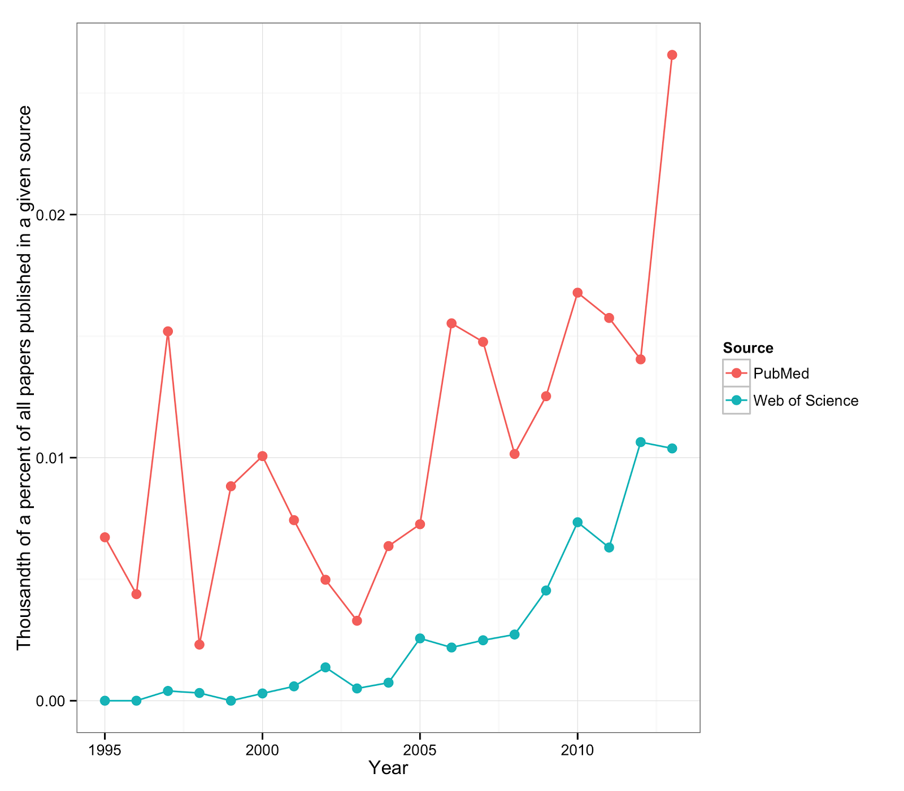

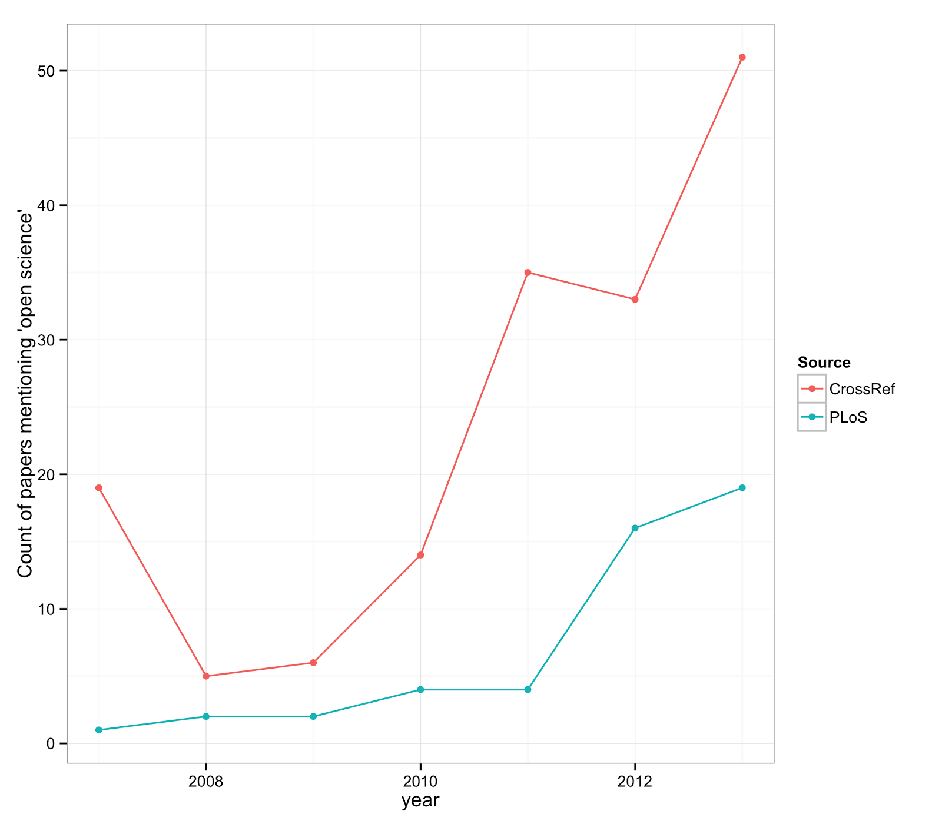

In Web of Science:
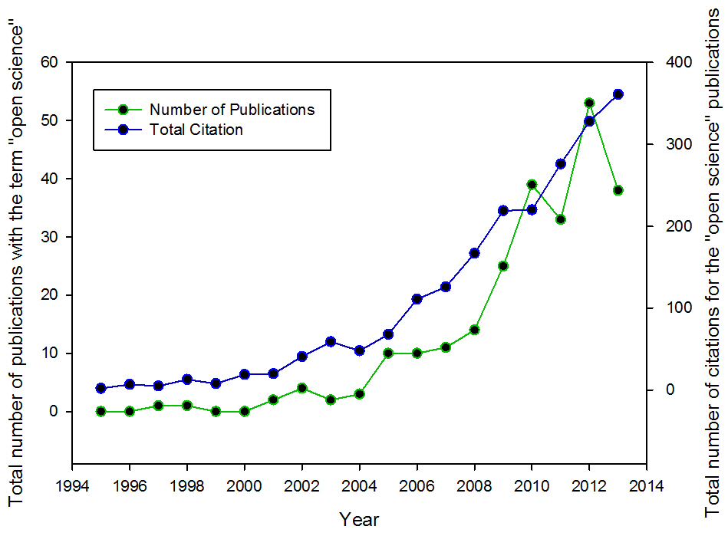

Figure 2: Three examples of possible open science workflows. In each workflow illustration, the grey box surrounds activities which are not openly accessible for researchers who are not directly involved. Activities outside these boxes are open and available, representing how the individual researcher is influenced by other scholars, or is able to communicate their research before and after publication. White boxes represent distinct research products available for reference for and feedback from other researchers.
In progress here: https://github.com/naupaka/open_sci_manuscript_figure

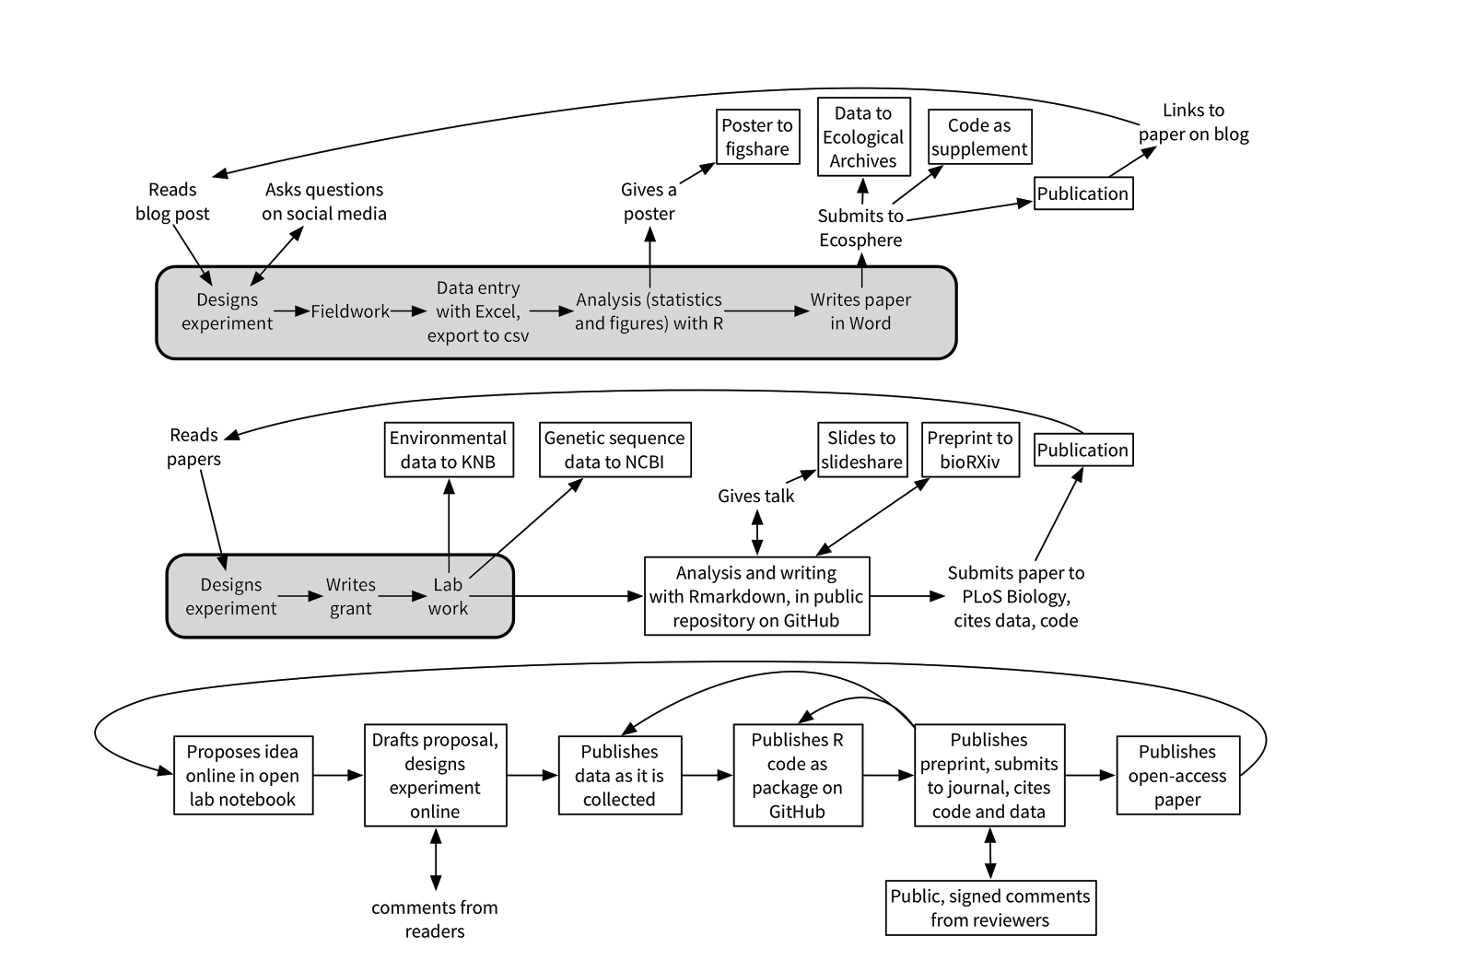

-------- Text below is from versions prior to 13 Sept 2014 8pm -------------
Notes: https://etherpad.mozilla.org/osmanuscript
Zotero library for bibliography: https://www.zotero.org/groups/osecology/items
#OSCodefest 2-4 Sept 2014
Target: Innovative Viewpoint in Ecosphere (http://esapubs.org/esapubs/AuthorInstructionsESP.htm)
3000 words?!

The Tao of Open Science for Ecology

Ecology stands at the threshold of a potentially profound change. The combination of ever-increasing computational power, coupled with advances in Internet technologies and tools, is catalyzing new ways of pursuing ecological investigations. These emerging approaches call for greater communication, cooperation, collaboration, and sharing, not only of “scientific results”, but also of data, analytical and modeling code, and potentially even fully documented workflows of the processes (warts and all) that lead to scientific insights. We call this vision of free and unfettered access to ALL useful products of the scientific endeavor, “Open Science” (sensu Nielsen 2011). As an integrative and highly multidisciplinary field, ecology particularly stands to benefit from this Open Science revolution. In this paper we describe why we believe this to be so, and identify particular advantages that an Open Science model will likely bring to our field, ultimately benefiting all researchers.

Science meets technology
Open Science has only recently entered the scientific zeitgeist, with almost no papers publishing as “open science” before 2000 and a steady rise since 2005 (Figure 1). However open science capitalizes on the remarkable advances in technology over the past few decades, especially aspects of the Internet coupled with decreasing storage costs and ever-faster computers. Every scientist now uses the Internet, but few are aware of how the Internet grew out of a highly collaborative and open process involving development of publicly available and commentable standard protocols which in turn spawned a vast, highly interoperable, international, communications network [http://www.fcc.gov/openinternet; RFC3271]. First coined in the 1990s, “Open source” refers not only to free access to protocols and specifications such as the domain name system (DNS) that allows pinpointing specific networked computers (“hosts”) around the world, and HTTP/HTML specifications that provide the basis for the World Wide Web, but also to free compilers and applications. Availability of open source software radically democratized and expanded participation in the Internet community in the late 1980s-early 1990’s. Members of the scientific research community were early recipients of these advantages, with the National Science Foundation supporting and nurturing growth of the Internet-based NSFNET from roughly 1985-1995 (http://www.nsf.gov/news/special_reports/nsf-net/). In that era, it was primarily academic scientists who were communicating through the Internet (gopher, email), transferring their data (FTP), and running analyses on “remote servers” (telnet, shell access, X11), often with privileged access to fast networks and accounts on powerful computational servers. The lay public remained in the proverbial wilderness, largely relegated to slow dial-in networks from home (AOL, Prodigy).

It was thus the scientific community that initially supported and transformed the use of the Internet. Within this computer savvy community, “power users” leveraged the Internet most effectively via learning computational skills that were largely command-line based. The legendary, free GNU suite of software was standard issue for many computers joining the Internet back in the late 1980’s, and made that early generation of networked “scientific workstations”, bearing labels like Sun, SGI, DEC,or NeXT, the most sought-after systems of their day. These early forays into powerful software helped birth the plethora of tools now available to the modern scientist. Today, free, multi-platform, open source tools from the Linux Foundation (free operating system), the Apache Software Foundation (free Web server), the Mozilla Foundation (free Web and email clients, and other applications), the PostgreSQL Global Development Group (free enterprise database), the Python Software Foundation (free programming language), and the R Foundation for Statistical Computing (analysis and statistical language) are enabling researchers across the globe to dialog with one another via cutting edge communication, execute powerful data manipulation, and develop community-vetted modeling and analysis tools at little or no cost.

Technological advances have thus played critical roles in enabling the increasing rates of dissemination of scientific knowledge, and acceleration of scientific discovery through discussion and collaboration (Atkins 2003). We are now in the midst of the next major advance of the scientific progress wherein online tools allow knowledge to be exchanged with a volume, variety and velocity that was not possible, even a decade ago.

Science takes the next step
The beginnings of open science can be traced to the establishment of the first scientific journals in the 1660s, the British Philosophical Transactions of the Royal Society, and the French Journal des Sçavans, which provided platforms for scientists to share their results and ideas (Beaver and Rosen 1978). While such journals clearly were an initial step towards “openness” in the sense of sharing ideas and findings, they were nevertheless largely accessible only to an elite group in a position to afford a subscription or who belonged to an institution that possessed copies (Nielsen 2011). And one motivation for publication that was evident in the earliest papers was to establish precedence of discovery; the notion of collaboration among scientists does not seem to have taken hold more broadly until the 1800s (Beaver and Rosen 1978). Collaboration is now the predominant norm for the most impactful research (Wuchty et al 2007).

The practical aspects of scientific openness are inevitably very different today for a modern “invisible college” that welcomes all comers than for a handful of Western European gentlemen of leisure (Crane 1972, Wagner 2008). Traditional notebooks cannot meet the challenges of increased accumulation, sharing, and recombination of ideas, research logs, data sets and analyses (Strasser and Hampton 2012). Nor can a non-networked computer. The global Internet and the World Wide Web have combined with several key digital technologies to enable ecologists to make every section of their data life-cycle public and transparent if they so wish. Ironically, the technologies enabling modern, Open Science have also raised a barrier to entry: the need for greater fluency with a diverse and ever-evolving array of digital tools and resources.

Despite the growing need for technical proficiency, the necessary launching point for a would be Open Scientist is not a particular computer skill. Rather, the most important prerequisite for Open Science is the researcher’s mindset: the belief that openness accelerates the pace of scientific advancement, expands the scale and robustness of investigations, and greatly enhances reproducibility of results, while also directly benefitting the researcher in terms of their scientific productivity, and intellectual growth and satisfaction.
Additional community-wide benefits of Open Science would include: promoting fairness in attribution, taking greater care in experimental design and data analysis, and democratizing the community who can participate in science, especially researchers at under-resourced institutions and developing countries, or increasingly, citizen scientists (http://www.nytimes.com/2010/12/28/science/28citizen.html?pagewanted=all&_r=0).

We believe that the benefits of Open Science accrue so compellingly from both a personal as well as community perspective, that it is well worth the time for researchers to keep abreast of new and emerging digital tools that facilitate the practice of Open Science. We discuss the ways in which a variety of well-established and emerging digital tools can facilitate open science, and the value of incorporating these tools into the scientific process. We hope this article is useful to ecologists interested in how Open Science principles and techniques can enrich their own research aspirations.

------------------------
[Box - definitions] -titled: “Key Concepts in Open Science” ?
citizen science: enabling interested citizens to contribute their time, observations, and expertise such that these assist and inform the scientific research process; may be an aspect of crowd-sourcing
code repository: an accessible, central place where computer code is stored to facilitate the collection, manipulation, analysis, or display of data.
crowd-sourcing: leveraging the expertise and participation of many individuals, to provide more perspectives, critiques, data contributions, code contributions, etc. to advance a (scientific) process
data lifecycle: the pathway researchers trace when documenting the natural world from idea generation through to making observations and drawing inference. It is popularly dissected into eight intergrading phases: Plan, Collect, Assure, Describe, Preserve, Discover, Integrate, Analyze (Michener et al 2012)
data management: the development and execution of architectures, policies, practices and procedures that properly manage the full data lifecycle needs of an enterprise (ref: http://www.dama.org/i4a/pages/index.cfm?pageid=1)
data repository: an accessible, central place where accumulated files containing collected information are permanently stored; typically these house multiple sets of databases and/or files.
open access: providing free and unrestricted access research products, especially journal articles and white papers-- to be read, downloaded, distributed, reanalyzed, or used for any other legal purpose, while affording authors control over the integrity of their work and the right to be acknowledged and cited. (adapted from the Budapest Open Access Initiative definition http://legacy.earlham.edu/~peters/fos/boaifaq.htm#openaccess) ;
open data: data that can be freely used, reused, and redistributed without restrictions beyond a requirement for attribution and share-alike (Molloy 2011)
open science: Open Science is the idea that scientific knowledge, including data, observational and experimentational design and methods, analytical and modeling code, as well as results and interpretations of these (e.g. reported in publications)-- are made freely accessible to anyone, and represented in transparent and reusable formats as early as practical in the discovery process by employing standards-based technology tools. open science frequently encompasses all of open access, open data and open source and, minimally, facilitates reproducibility of results.
open source: computer code (software) that is available for free distribution and re-use, with source code unobscured, and explicit acknowledgement of the right to create derived works by modifying the code (Gacek and Arief 2004)
pre-print: a draft version of a paper distributed (usually in an online repository such as arXiv) before a final, peer-reviewed journal or reporting agency has accepted or formally published the paper (Desjardins-Proulx et al, 2013).
reproducibility, replicability, and repeatability: while formal definitions of these terms vary widely and across disciplines, these all point to a hallmark of science, which is the ability to repeatedly generate or observe outcomes consistent with scientific understanding, based on explicit specification of theories, models, and methods, and their expected material realizations or outcomes. This prescribes a need for sufficient access to data and analytical code to verify that a purported result is valid, as well as to examine these for errors and biases (Jasny et al 2011; Peng 2009; Stodden et al. 2013; Stodden 2009; but note Drummond 2009 and Camilli 2010 use somewhat different definitions)
transparency: a scientific process is described in enough detail that it is open to public scrutiny and examination; nothing is intentionally obscured by technology or process
version control: a system that manages snapshots (and hence “revisions” or “versioning”) of code and data for a project (Wilson et al 2014). It facilitates detailed documentation to enable tracing any significant changes over a project’s lifetime.

----------------------------------------------------

Changes in Mindset

Hey et al. [2009] argued we are entering an era of “eScience”. There is a keen interest in a paradigm shift that encourages more scientists to join the Open Science movement, and as a result, Open Science, and particularly Open Data, have gained increasing traction in the scientific community over the past decade (Figure X - frequency of “Open Science” and “Open Data” terms in web of science - see below). In ecology, the surge in Open Science participation has been driven not only by new policies instituted by funders, but also by the development of technologies that have facilitated the sharing and transparency of data throughout its life-cycle (Reichman et al 2011, Michener et al 2012).

As Open Science becomes more prevalent, a fundamental shift in how ecologists engage and interact with science is taking place. This shift involves coming to see every scientist as a member of a larger scientific group in which individuals share resources and expertise to address complex research questions that are impossible to tackle alone. Cultivating this mindset can lead to benefits for all collaborators and may contribute to increased public confidence in the societal benefits of scientific research. In this section, we describe specific elements of the change in mindset that are essential to the advancement of open science in ecology.
Data ownership
The amount of scientific data generated is increasing dramatically each year (Reichman et al 2011, Dietze, M.C., D. LeBauer, R. Kooper. 2013). Traditional views on data ownership hold that data are proprietary products of the researcher (Sieber 1989). By definition, this data ownership mindset limits the potential for data sharing as a given researcher can restrict the conditions and circumstances by which their data are disseminated. These views have persisted for a variety of obvious reasons: fear of being “scooped” should the data be made public; a lack of proper attribution or professional reward for data collection efforts; a desire to publish from the dataset throughout one’s career; feelings of ownership arising from the financial cost or other personal investments associated with the data collection effort itself; fear of criticism over “messy” data; and fear of misinterpretation of data and hence bad science (Sieber 1989, Hampton et al 2013, Lindenmeyer and Likens 2013).

Under the principles of Open Science, however, data are generated with the expectation of unfettered public dissemination. This fundamental shift in thinking from “I own the data” to “I collect and share the data on behalf of the scientific community” is a challenging process but one that is essential to the transparency and reproducibility of the open science framework. One benefit of data sharing relates to avoidance of the common problem of “reinventing the wheel.” Research has shown that authors’ reluctance to submit null results for publication leads to a “file-drawer” effect that can not only systematically bias the published literature (Iyengar and Greenhouse 1988, Franco et al. 2014) but also allows independent scientists to go repeatedly down the same blind alleys. Structures to store, share, and integrate data contribute to avoiding such waste of scientific resources. Beyond this greater efficiency, data sharing also contributes to the production of entirely new scientific products that were not envisioned at the time data were collected (Carpenter et al 2009).

There are circumstances when extended, privileged access to one’s “personal” data seems more justifiable: e.g. when the conceptualization and successful acquisition of some data depends on overcoming highly challenging circumstances, or requires advanced and specialized skill-sets -- e.g. taking observations on insect behavior from within the high canopy of a remote Brazilian rain forest. Another case might be when intensive, expensive, or complicated logistics necessary for acquiring data are accomplished by researchers early in their career, who are still learning skills as to how to analyze and organize those data. These situations must be taken into account relative to “openness” and “data-sharing”, and are addressable through potentially more extended embargo periods of “exclusive access” for the data collector. In both these scenarios, however, a requirement of immediately providing the data supporting any published results, seems reasonable.

Transparency throughout the data lifecycle

Reproducibility and transparency have long been central to the development, advancement, and foundation of science. Scientists publish their methodology with reproducibility by others in mind. The traditional mindset has made it the responsibility of every researcher to vet which of their methodological details are necessary for other scientists to understand, and publishing only those details deemed important. This mindset was largely motivated, however, by constraints on page length established by journals due to hardcopy production expenses. Digital formats afford far more flexibility as to how much methodological and other detail an investigator might wish to provide, and an interested reader might want to review. Page constraints from traditional publishing considerations are thus no longer of concern.
Present tools (Table 1) have advanced enough such that scientists can take the next step in making science more reproducible by providing a greater extent of transparency across multiple stages of the research process, from sharing detailed rationale for an approach to publishing thet data and the code that generated analyses and figures (e.g., datadryad.org). Detailed sharing of methods and code improves the clarity of the data and research process for other scientists as well as provides the opportunity to receive extensive feedback from the rest of the scientific community. Some journals have recently started (e.g. PeerJ) encouraging pre-print posting online to provide authors with feedback from other scientists before manuscripts are finalized in publication; increasing transparency can improve the quality of peer feedback on a manuscript (Byrnes et al. 2014).

Another benefit of the transparency of open science is that it encourages researchers to converge upon standard structures to archive their data (e.g., Ameriflux protocols; CF conventions; EML metadata; ISO 19115). As scientists, we are often unaware of similar research, datasets, and results produced by other researchers especially if published outside of our disciplines. This fragmentation could be avoided by using shared cyberinfrastructure in which all the datasets are searchable (e.g. DataONE) and stored using recognized formats, paving the path to greater collaboration and creating partnerships that might not have happened otherwise.

Acceptance of critique
We learn as graduate students to accept constructive criticism from our advisors, peers, committee members, and senior faculty, but the underlying fear of being looked down upon for our ideas or for being “wrong” never goes away. We as scientists understand that failure is a normal part of the scientific process, but failure in private and failure in public are as different as night and day. The shift from publishing one’s results to making every key step of the data life-cycle transparent speaks to the core of our fears as scientists working collaboratively, with concerns about risk and loss of control and identity in pursuing one’s individual work as opposed to the goals or perspectives of a larger group or community (Hackett 2005). A fundamental step towards building an open science community requires viewing increased transparency as providing constructive feedback opportunities that improve our ability to do science, rather than leading to public exposures of failure, or loss of identity and control over one’s science due to community pressures.

Openness to learning and using new digital technologies
There is value to scientists using common and standardized methods; however, this value lessens when traditional ways of practicing and communicating science prevent the adoption of useful new scientific technologies. A belief that traditional ways of doing science are the best ways of doing science is an unscientific way of thinking. The shift in mindset for practicing Open Science requires more than just recognizing the benefits of scientific applications of new digital technologies. It requires that scientists believe that the benefits of using these new digital technologies outweigh the time and effort costs associated with learning and using the technique. Moreover, because the toolset of digital technologies that facilitate open science are ever-evolving, continued dedication to practicing Open Science requires that scientists dedicate some time and energy toward keeping abreast of these new and changing technologies.

Tools and Best Practices to Enable Shifts in Mindset and Practice

An Open Science mindset affects the entire scientific process, carrying responsibilities and offering benefits at each stage along the way (Figure 1). When an experiment is still in the planning stages, a commitment to open research requires us to consider not only how to perform the experiment but also how to capture the data and metadata that will enable others to effectively re-use that information. The same commitment gives us access to a research group far bigger than a single lab; experimental designs can be improved, and better controls and new directions suggested, when inchoate ideas are posted for discussion on blogs and social media. When data are being collected and organized, a commitment to Open Science requires explicit documentation of every step and decision along the way; producing such documentation is an exercise in critical thinking, a constant reminder to check our assumptions and clarify our reasoning. When data are being described and preserved, a commitment to Open Science requires us to choose methods and repositories that will make our data usable and accessible for years to come, allowing our work to be integrated into the body of knowledge and ensuring that, when we return to a project after a period away, we can pick up where we left off. When data are being analyzed, a commitment to Open Science requires us to use reproducible, script-based (e.g. R, Python) methods as far as possible, and to share our scripts, not only giving other researchers new tools to use in their own projects but also reducing our work's vulnerability to hard-to-trace errors that creep into GUI-based analyses. Version control (e.g. Git, SVN) at every stage helps us track the evolution of our ideas and methods and preserves the long-term integrity of the project even as collaborations form and shift and is a highly recommended best practice (Noble 2009, Wilson et al. 2014).

Ultimately the steps we take to clarify our science for others have the immense benefits of making work reproducible and reusable in our own future research as well. Figure 1 illustrates scenarios in which researchers variously participate in Open Science, to the extent that each may feel empowered. Table 1 provides examples of the tools available to participate in Open Science at each step in research. While the combinations of tools that practitioners of Open Science use to expose their research seem nearly endless, some standards are nevertheless emerging in ecology.

At every step of the research process it is possible to make one's work more open to feedback, critiques, and new ideas. During the early stages of research, this openness may take the form of electronic lab notebooks (e.g. IPython Notebooks) that document one's work through blog posts (Gewin 2013). Social networking tools (e.g. Twitter; Darling et al 2013) also provide a platform for the dissemination of ideas, methods, and results. A key facet of open science is clear documentation of the steps taken in an analysis. One of the most important steps one can take in making one's research more reproducible is transitioning from point-and-click analytical tools to scripted ones like R and Python. These tools can be used to import raw, uncleaned data, clean it, analyze it, and produce figures or even final manuscripts (e.g. FitzJohn et al. 2014). They essentially self-document each step of the process, allowing greater transparency and reproducibility in analyses.

Tools exist to facilitate the scripting of the entire data life-cycle process as well. For instance the rOpenSci project provides R packages to access, document and share data. Furthermore these can be used seamlessly within the article writing process by using some markdown language (or LaTeX) to write a manuscript and integrate code and text using knitr. All of these steps can be put under version control, which in turn documents the provenance of data access, analysis, sharing and even the manuscript. Version control systems like Git (accessed through user-friendly tools like GitHub) allow scientists to retain snapshots of previous analyses for future reference, collaborate easily and track contributions, record ideas, and safeguard against the loss of code and data (Ram 2013).

In the late stages of the research process the publication of preprints and open access papers are important components of open science. Desjardins-Proulx et al. (2013) highlighted several arguments for posting preprints, including the ability to quickly communicate with a broad audience; gain immediate visibility of one’s work; obtain feedback from a broad community of researchers, not just the formal peer reviewers; and as a way to establish precedence of one’s findings. Publishing final papers in open access journals ("gold" open access) or self-archiving manuscripts ("green" open access) gives access of the final products to a wide audience, some of whom may be the taxpayers who funded the research.

Conclusion

Online tools make possible a future in which not only scientific practice but also scientific culture are transformed by openness (Hey et al 2009, Nielsen 2011). Fully open science would be apparent from end to end of discovery, from the sharing of nascent ideas that can be improved upon by active discussion, to the instantaneous upload of data at the moment of capture, through the full development of "living papers" in an open forum in which the details of analysis and reasoning are completely transparent. The archives constitute the raw materials on which subsequent generations will actively build to push new frontiers in science and to create solutions to pressing societal problems. For many ecologists, such a future is exciting, but their present constraints - whether technological or cultural - may prevent the full realization of an open process; nevertheless, we can all move our science toward this future by adopting aspects of open science that are currently feasible for ourselves (e.g., publishing open access articles and data) and promoting skills in our students and junior colleagues that will best prepare them for the opportunities and rewards of practicing ecology in an open environment.

Figure 1: Three examples of possible open science workflows. In each workflow illustration, the grey box surrounds activities which are not openly accessible for researchers who are not directly involved. Activities outside these boxes are open and available, representing how the individual researcher is influenced by other scholars, or is able to communicate their research before and after publication. White boxes represent distinct research products available for reference for and feedback from other researchers.
In progress here: https://github.com/naupaka/open_sci_manuscript_figure

(Supplementary?) Table 1: A table showing the range of tools available to researchers at each stage of the research lifecycle.
in progress here: https://docs.google.com/spreadsheets/d/1j3bZIm1NPR6hW4TRhJ8O1CsavkbEKAJ3r5MZQbevl-E/edit#gid=0

References
Open science and the evolving concept of scientific publication
https://github.com/NCEAS/training/blob/master/2014-oss/day-18/jones-reprosci.pdf?raw=true

Author Contacts
Stephanie E. Hampton, Center for Environmental Research, Education and Outreach, Washington State University, Pullman WA 99164 s.hampton@wsu.edu
Kara Woo, National Center for Ecological Analysis and Synthesis, UC Santa Barbara, 735 State St. Suite 300, Santa Barbara, CA 93101 woo.kara@gmail.com
Corinna Gries cgries@wisc.edu
Sean S. Anderson, Environmental Science and Resource Management Program & Pacific Institute for Restoration Ecology, California State University Channel Islands, Camarillo, CA 93012 sean.anderson@csuci.edu
Andrew MacDonald aammacdonald@gmail.com
William K. Michener, College of University Libraries and Learning Science, MSC05 3020, University of New Mexico, Albuquerque, NM 87131 william.michener@gmail.com
Naupaka Zimmerman naupaka@gmail.com School of Plant Sciences, University of Arizona, 1145 E 4th St., Tucson, AZ 85721
Afshin Pourmokhtarian: apourmok@bu.edu Department of Earth & Environment, Rm 130
685 Commonwealth Avenue, Boston University, Boston, MA 02215
Joe Mudge: joe.mudge@ttu.edu, The Institute of Environmental and Human Health, Department of Environmental Toxicology, Texas Tech University, Lubbock, TX 79416
W. Christopher Lenhardt: clenhardt@renci.org, Renaissance Computing Institute (RENCI), University of North Carolina at Chapel Hill.
Xueying “Shirley” Han: xueyinghan85@gmail.com, Center for Nanotechnology in Society, University of California, Santa Barbara, CA 93106
Sarah C. Bagby, Marine Science Institute and Department of Earth Science, University of California, Santa Barbara, 93106 bagby@geol.ucsb.edu
Mark Schildhauer, National Center for Ecological Analysis and Synthesis, University of California, Santa Barbara schild@nceas.ucsb.edu
Edmund M. Hart, National Ecological Observatory Network, 1685 38th St., Suite 100
Boulder, CO 80301 edmund.m.hart@gmail.com
Matthew B. Jones, National Center for Ecological Analysis and Synthesis, University of California, Santa Barbara jones@nceas.ucsb.edu

Email list includes everyone who attended initial meeting
woo@nceas.ucsb.edu, s.hampton@wsu.edu, naupaka@gmail.com, lwinslow@usgs.gov, apourmok@bu.edu, william.michener@gmail.com, couture@nceas.ucsb.edu, bagby@geol.ucsb.edu, sean.anderson@csuci.edu, xueyinghan85@gmail.com, aammacdonald@gmail.com, cgranade@cgranade.com, emh@emhart.info, stevan.earl@asu.edu, joe.mudge@ttu.edu, jai.ranganathan@gmail.com, cgries@wisc.edu, clenhardt@renci.org, walker@nceas.ucsb.edu, jones@nceas.ucsb.edu, schild@nceas.ucsb.edu

Contributions: [please list what you did to create this ms]
Steph - idea for ms, writing, coordination, intention to shepherd toward publication
Sarah - discussion, writing
Bill - discussion, writing, version 1 of Table 1
Joe - discussion, writing (Changes in mindset, part of intro)
Shirley - discussion, writing (Changes in mindset, “open science” figure)
Afshin - Discussion, writing (Changes in mindset)
Kara - discussion, writing (part of Tools & Best Practices)
Naupaka - discussion, figure and table (tools) development
Andrew - discussion, figure and table (tools) development
Sean - writing (parts of changes in mindset, introduction), definitions, humor/obnoxiousness
Mark Schildhauer - writing (intro, edits throughout), discussion, terms, refs, and lots of contentious comments
Edmund - Discussion, writing (definitions, tools), Figures
Chris - discussion, tangents, outlining, writing
Matt - writing, figure revisions

Potential Figures
Web of Science Publication and Citation Results
(I’ve taken a crack at this using search results from WoS and PubMed. See a version on plot.ly here: https://plot.ly/~emhart/1/thousandth-of-a-percent-of-all-papers-published-in-a-given-source-vs-year/ and full code in the git repo: http://github.com/naupaka/open_sci_manuscript_figure)

(relative counts)

(Raw counts, different sources)

Search Topic: “Open Data”
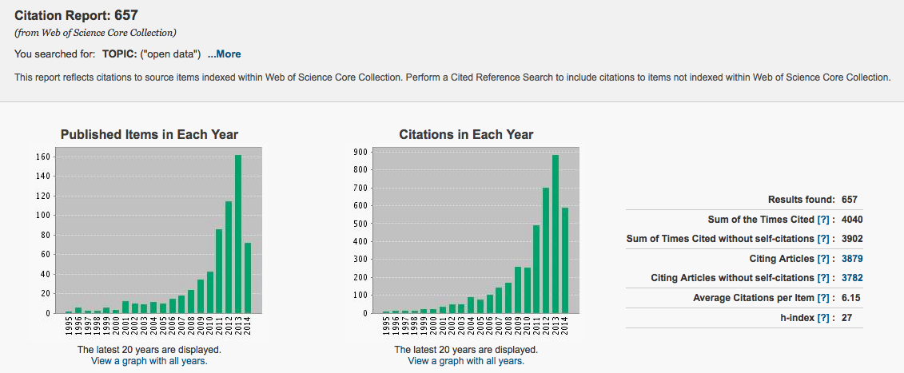

Search Topic: “Open Science”
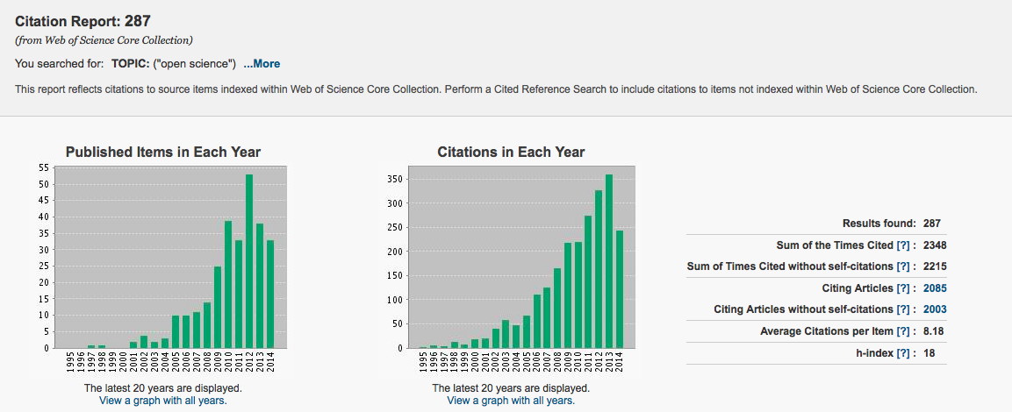

Search Topic: “Open data” AND “Ecology”
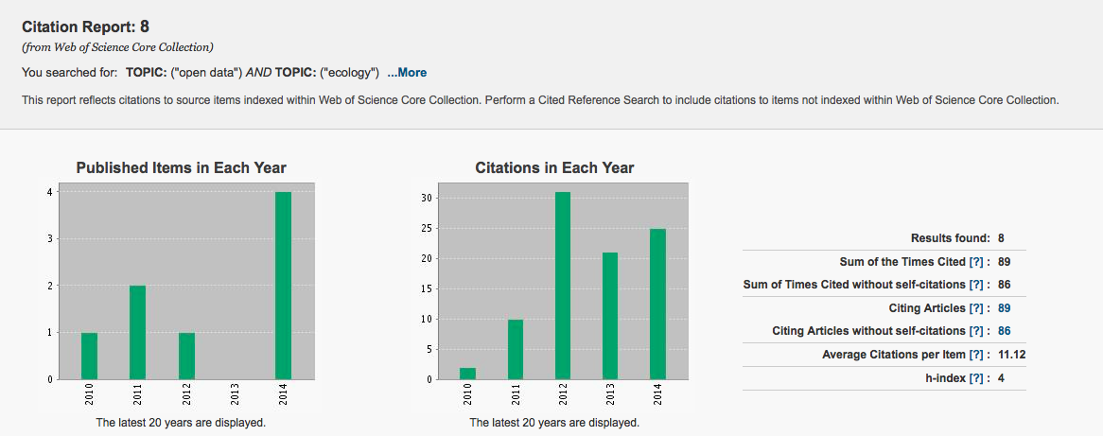

Search topic: “Open Science” AND “Ecology”
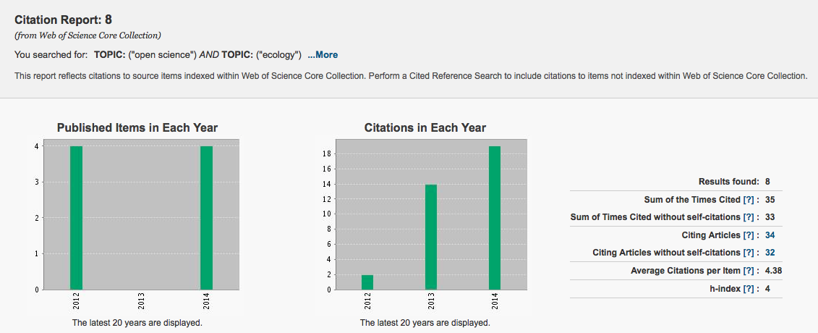

Search topic: “Data sharing” AND “Open Science”
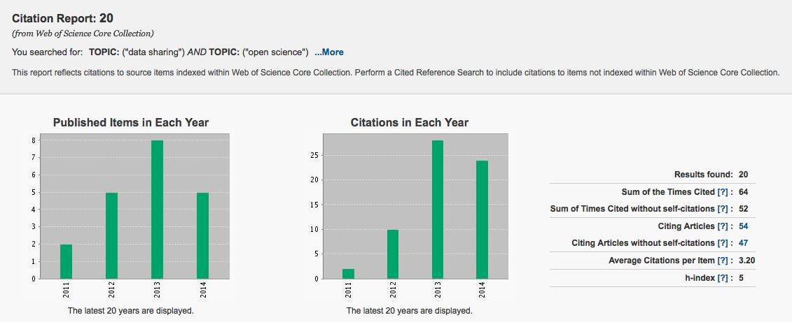
Proposed Bagby fork
Ecology stands at the threshold of a potentially profound change. The combination of ever-increasing computational power, coupled with advances in Internet technologies and tools, is catalyzing new ways of pursuing ecological investigations. These emerging approaches call for greater communication, cooperation, collaboration, and sharing, not only of results, but also of data, analytical and modeling code, and potentially even fully documented workflows of the processes---warts and all---that lead to scientific insights. We call this vision of free and unfettered access to stages of the scientific endeavor "open science" (Nielsen 2011). We argue that, as an integrative and highly multidisciplinary field, ecology particularly stands to benefit from this open science revolution. We give an overview of digital tools that can enable ecologists to put the open science mindset into practice.

Introduction
The exchange of scientific information was first formalized in the 1660s with the establishment of the Philosophical Transactions of the Royal Society of London and the Journal des Sçavans, the first scientific journals. While these journals provided platforms for scientists to share their results and ideas (Beaver and Rosen 1978), they were largely accessible only to elites---those who could afford a subscription themselves, or those who belonged to an institution that held copies (Nielsen 2011). Scientists published in these journals to establish precedence of discovery; the notion of collaboration among scientists does not seem to have taken hold until the 1800s (Beaver and Rosen 1978).

The scientific world looks very different now. Modern scientists constitute a new invisible college (Crane 1972) with global reach, its philosophical transactions made possible by the internet (Wagner 2008). Collaboration has become the predominant norm for high-impact research (Wuchty et al 2007). But it's not just the community that has changed. Technological developments, often driven by scientists [BOX], mean the accumulation of ever more data and metadata at ever greater rates (Reichman et al 2011, Dietze, M.C., D. LeBauer, R. Kooper. 2013), and the deployment of greater computational power to run models and analyze data. Traditional notebooks cannot meet the challenges of increased accumulation, sharing, and recombination of ideas, research logs, data sets and analyses (Strasser and Hampton 2012). Nor can a non-networked computer. Open science promises to meet these challenges.

While interest in this new paradigm is on the rise (fig. X), there are cultural hurdles for the scientific community that might make individuals question whether it's wise to invest time in learning the digital tools that make open science possible. For instance, precedence, attribution, investment, and payoff are high-stakes issues for professional scientists (Hackett 2005); adopting open practices means ceding some control of these issues. Yet hewing to traditional practices carries its own risks. Errors and oversights can persist far longer when experimental design and data analysis are held private; weeks and months can be wasted in chasing reproduction of results because methods are documented only as fully as a journal word count permits; labs can become isolated, their thinking stagnated, for lack of ongoing communication with others. We argue that open science mitigates all these risks, to the immediate benefit of the individual practitioner.

Moreover, open science promises many longer term benefits to the scientific community. The adoption of standard practices for public archiving of data and code will promote fairness in attribution. The use of open-source tools and open-access data and journals will democratize science, not only giving access to scientists in developing countries and at under-resourced institutions but also fostering citizen science (already a major source of data in some ecological sub-disciplines; Cooper 2014). The acceptance of norms for sharing and collaboration will enable our community to make the most of available resources, helping us to advance science faster.

Both the risks of traditional research and the rewards of open science are heightened in ecology. Our work often relies on many different kinds of data, drawn from different sources, requiring diverse expertise to interpret. Traditional practices offer no way to make the necessary data sets discoverable or to ensure their provenance, making it very difficult for other scientists to use these data sets at all, let alone to be confident that their use is appropriate. Our work is challenged by natural variation across field sites and over time. Open science offers tools to support complete documentation of methods; greater reproducibility offers the ability to distinguish between artifacts and true natural variation with greater confidence. Our work is often of pressing interest for policymakers, for the public, and for people in developing nations. Open science makes our work more robust, more transparent, and more readily available to the broader society we serve.

In ecology, the surge in open science participation has been driven not only by new policies instituted by funders, but also by the development of technologies that have facilitated the sharing and transparency of data throughout its life-cycle (Reichman et al 2011, Michener et al 2012). Here, we discuss the changes in mindset and the tools that can help ecologists make the leap to practicing open science.

Changes in mindset
Data stewardship, not data ownership
Traditional views on data ownership hold that data are proprietary products of the researcher (Sieber 1989). By definition, this data ownership mindset limits the potential for data sharing as a given researcher can restrict the conditions and circumstances by which their data are disseminated. These views have persisted for a variety of obvious reasons: fear of being "scooped" should the data be made public; a lack of proper attribution or professional reward for data collection efforts; a desire to publish from the dataset throughout one’s career; feelings of ownership arising from the financial cost or other personal investments associated with the data collection effort itself; fear of criticism over "messy" data; and fear of misinterpretation of data and hence bad science (Sieber 1989, Hampton et al 2013, Lindenmeyer and Likens 2013).

Under the principles of open science, however, data are generated with the expectation of unfettered public dissemination. This fundamental shift in thinking from "I own the data" to "I collect and share the data on behalf of the scientific community" is a challenging process but one that is essential to the transparency and reproducibility of the open science framework. One benefit of data sharing relates to avoidance of the common problem of reinventing the wheel. Research has shown that authors' reluctance to submit null results for publication leads to a "file-drawer" effect that can not only systematically bias the published literature (Iyengar and Greenhouse 1988, Franco et al. 2014) but also allows independent scientists to go repeatedly down the same blind alleys. Structures to store, share, and integrate data contribute to avoiding such waste of scientific resources. Beyond this greater efficiency, data sharing also contributes to the production of entirely new scientific products that were not envisioned at the time data were collected (Carpenter et al 2009).

How complete does this shift need to be? In some circumstances, it seems more justifiable to grant extended, privileged access to a data set to the originating lab; for instance, when acquisition of the data required unusual skill or heroic measures (e.g., observing insect behavior from within the high canopy of a remote rain forest) or an unusually large commitment of time or resources, or when early-career researchers still honing their skills need extra time to organize or analyze the data. Such situations should be taken into account in establishing norms for openness and data-sharing, and could be addressed by policies extending the embargo period for scientific platforms (e.g., NDSF facilities) under specific circumstances. In any case, as is increasingly recognized in the requirements of funding agencies, full data-sharing in established repositories should begin no later than the publication of results.
Transparency throughout the data life-cycle
Scientists publish their methodology with reproducibility by others in mind, but have traditionally had to judge which details were important to transmit. Insofar as this selectivity arose from the length limitations imposed by print journals, the availability of online supplementary methods sections gives scientists scope to detail their methods fully. Taking advantage of this opportunity to make tacit knowledge explicit to others is a crucial part of performing reproducible research (Collins 2001), and has the substantial additional benefit of making such knowledge explicit to oneself, with the potential to shed light on untested assumptions and unidentified confounding effects.

Workflow tools (Table 1) now make it possible for scientists to make every stage of the research process transparent, from sharing the detailed rationale for an approach to publishing the data and code that generated analyses and figures. Detailed sharing of methods and code improves clarity; personal communications regarding methods crucially improves trust (Collins 2001), and social media permit these communications too to happen in the open. Openness throughout the data life-cycle also provides the scientist with the opportunity to receive extensive feedback from the rest of the scientific community and can improve the quality of that feedback (Byrnes et al 2014). Whereas formal peer review provides feedback only at a project's end, open science provides an avenue for scientists to receive feedback at a far more useful juncture, i.e., before experiments are performed.

Additionally, transparency encourages researchers to converge on standard structures for data archiving (Table 1). This is particularly important for interdisciplinary science, where the fragmentation of resources and practices along disciplinary boundaries can substantially hinder research. Common standards and a shared, searchable infrastructure help make data sets not merely technically open but practically discoverable, improving their reach and impact and helping scientists identify potential new collaborators.

Acceptance of critique
Traditional views recognize failure as a normal and necessary part of the scientific process, and yet academic science is structured to reward only being right in public (Merton 1957 [?]). But the more open our science, the greater the chance that our mistakes as well as our insights will be publicly available. This can be frightening to contemplate; one study of physicists found that those practicing secrecy prior to publication often did so to avoid the risk of looking foolish (Gaston 1971). We suggest that embracing this tension gives us the opportunity to be better and more productive scientists. The only way to protect our ideas and methods from criticism indefinitely is to refrain from publication, hardly a desirable outcome. Even delaying exposure until peer review manages only to limit the possible range of feedback to being told what could have been done better.
By contrast, adopting open practices throughout the data life-cycle makes it possible to receive and incorporate critiques in time to collect a more informative and higher-impact data set. That is, by risking the possibility of being briefly wrong in public, we improve our chances of being lastingly, usefully right.

Tools and best practices to enable shifts in mindset and practice
An open science mindset affects the entire scientific process, carrying responsibilities and offering benefits at each stage along the way (Figure 1). If we are committed to data stewardship, planning an experiment entails not only thinking through the physical manipulations involved but also working out how to capture and share the data and metadata that will enable others to effectively re-use that information. The open-source DMPTool (Table 1) offers guidance to scientists creating data-management plans---now often a prerequisite for funding---and helps scientists find institutional resources that can help see the plan through. At the same time, ready access to data sets collected by other scientists can help focus our questions (what data is needed to move the field forward?) and improve our ability to answer (e.g., by allowing us to estimate experimental uncertainties and plan accordingly). Once data has been collected, the open scientist prepares the data set for use by others and documents its provenance (e.g., with tools from rOpenSci), then deposits it in a community-endorsed repository (e.g., DataONE, Dryad). This process ensures that the data will remain usable and accessible for years to come, allowing our work to be integrated into the body of knowledge and ensuring that, when we return to a project after a period away, we can pick up where we left off.

If we are committed to transparency, we document everything and share that documentation. Electronic lab notebooks (e.g., iPython notebooks) help track and share the reasoning behind our experimental and analytical decisions, as well as the final protocol and any deviations, and can be linked to the resulting data files to keep research organized. Adhering to the discipline of consistently, carefully, and thoroughly documenting the research process is an exercise in critical thinking, a constant reminder to check our assumptions and clarify our thinking. During data analysis, reproducible, script-based methods (e.g., in R or Python) can be used for every step from importing raw, uncleaned data to analysis and production of figures and final manuscripts (e.g., FitzJohn et al 2014). Such tools are essentially self-documenting along the way, providing a complete record of data manipulations that is impossible to generate for GUI-based analyses. While errors can be made in both scripted and GUI-based analyses, the existence of a record makes errors in the former far easier to detect and correct, protecting the integrity of the analysis. Tools such as markdown and knitr facilitate integration of data analysis into manuscript production, making it easier to keep figures and reported results current as an analysis is refined. All of these steps are undertaken with an eye to making our work reproducible and open to others, but all offer the immediate benefit of making our work reproducible and open to ourselves.

If we are committed to openness to critique, we make this transparent documentation public as early as possible in the development of a project (Figure 1). Experiments can be discussed in the comments to publicly available electronic lab notebooks or on social media (Gewin 2013, Darling et al 2013); code can be forked and potentially improved on Github; figures and movies can be opened for comment on Figshare. All of these tools give us access to a research group far bigger than a single lab, helping our experimental designs to be improved and stimulating discussion of worthwhile new directions, connections, and approaches. As a project draws to a close, preprints can be posted for comment from a broader audience than a journal's handful of peer reviewers; preprints also improve a project's visibility and, with the addition of a date stamp, establish precedence (Desjardins-Proulx et al 2013). Publishing final papers in open-access journals ("gold" open access) or self-archiving manuscripts ("green" open access) makes the final products available to a wide audience, including the taxpayers who funded the research.

Version control (e.g., Git, SVN) at every stage is a highly recommended best practice (Noble 2009, Wilson et al 2014), supporting every aspect of the open science mindset. Version control systems, accessible through user-friendly tools like GitHub, allow scientists to retain snapshots of previous analyses for future reference, collaborate easily and track contributions, record ideas, and safeguard against the loss of code and data (Ram 2013), thus preserving the long-term integrity of the project even as collaborations form and shift.

Conclusions
Online tools make possible a future in which not only scientific practice but also scientific culture are transformed by openness (Hey et al 2009, Nielsen 2011). Fully open science would be apparent from end to end of discovery, from the sharing of nascent ideas that can be improved upon by active discussion, to the instantaneous upload of data at the moment of capture, through the full development of "living papers" in an open forum in which the details of analysis and reasoning are completely transparent. Subsequent generations of ecologists will build their work on what we leave. If instead of paywalled journal archives we leave them open-access repositories of data, code, and papers, they will be far better equipped to push new frontiers in science and create solutions to pressing societal problems.

Very real technological and cultural hurdles still stand between us and this future: investigators must be willing to invest time in learning the tools that facilitate open science, and in re-learning them as the tools evolve, while the scientific community must collectively establish new norms for collegiality and reproducibility in the digital age. Nevertheless, we can all move our research toward this future by adopting the aspects of open science that are currently feasible for our labs (e.g., publishing open-access articles; sharing all data and code used in publications) and by supporting our students and junior colleagues in developing the skills that will best prepare them for the responsibilities, opportunities, and rewards of practicing ecology in an open environment.

------
Box: technological advances driven by scientists
Every scientist now uses the Internet, but few are aware of how the Internet grew out of a highly collaborative and open process involving development of publicly available and commentable standard protocols which in turn spawned a vast, highly interoperable, international, communications network [http://www.fcc.gov/openinternet; RFC3271]. First coined in the 1990s, the term "open source" encompasses not only compilers and applications but also protocols and specifications such as the domain name system (DNS) that allows pinpointing specific networked computers ("hosts") around the world, and HTTP/HTML specifications that provide the basis for the World Wide Web. The availability of open source software radically democratized and expanded participation in the Internet community in the late 1980s-early 1990s.

Members of the scientific research community were early recipients of these advantages, with the National Science Foundation supporting and nurturing growth of the Internet-based NSFNET from roughly 1985-1995 (http://www.nsf.gov/news/special_reports/nsf-net/). In that era, it was scientists who were largely communicating through the Internet (gopher, email), transferring their data (FTP), and running analyses on remote servers (telnet, shell access, X11), often with privileged access to fast networks and accounts on powerful computational servers. Within this computer savvy community, "power users" leveraged the Internet most effectively via learning computational skills that were largely command-line based. The legendary, free GNU suite of software was standard issue for many computers joining the Internet in the late 1980s, and made that early generation of networked "scientific workstations" (from Sun, SGI, DEC, or NeXT) the sought-after systems of their day.

These early forays into powerful software helped birth the plethora of tools now available to the modern scientist. Today, free, multi-platform, open source tools from the Linux Foundation (free operating system), the Apache Software Foundation (free Web server), the Mozilla Foundation (free Web, email, and other applications), the PostgreSQL Global Development Group (free enterprise database), the Python Software Foundation (free programming language), and the R Foundation for Statistical Computing (analysis and statistical language) are enabling researchers across the globe to dialog with one another via cutting edge communication, execute powerful data manipulation, and develop community-vetted modeling and analysis tools at little or no cost.
------

