Floyds pipeline
The floyds pipeline is a python module that depends on the following 4 modules

Pyraf
numpy
pyfits
pylab

Floyds Structure
The floyds distribution directory includes :

src including the core of the pipeline
bin directory with the executable python script
README readmefile for installation
CHANGES.txt last changes in the pipeline
Setup.py script for installation
doc documentation
build building directory
dist distribution directory

Once the pipeline is installed, you will have a floyds directory in the PYTHONPATH directory includes:
archive (directories with archive data: flat, bias.arc)
standard (dir. with calibration files: standards, extinction curve, ecc)
+ several python definition files (*.py,*pyc in the ntt directory)

and one python executable script in the ~/bin directory: floydsspec

Type on the terminal:

Python executable script

$ floydsspec -h
Usage: floydsspec [listfile -B bias (use this bias) -F flatlist (use these flats) .....]

> Specroscopic pre-reduction of floyds data

Options:
--version show program's version number and exit
-h, --help show this help message and exit
-i, --interactive run the script in interactive mode [recommended]
-c, --classify try to classifyed the reduced spectrum using SNID (if
installed)
-C, --cosmic using this option cosmic rays are removed from the
images
-v, --verbose
-f, --flat skip flat correction
-F LISTFLAT, --listflat=LISTFLAT
use flat in the flat list []
-b, --bias skip bias corection
-B LISTBIAS, --listbias=LISTBIAS
use bias in the list []
-l LISTARC, --listarc=LISTARC
use arc from the list []
-A, --Automatic extract spectrum with previous parameters in the
database
-a LISTATMO, --atmo=LISTATMO
use sensitivity curve from this list
-t, --trace trace extraction with another frame
-d, --dispersion chose interctively the disperasion line
-s LISTSTAND, --standard=LISTSTAND
use sensitivity curve from this list

The recommended syntax is:
~$ floydsspec -i

option listfiles (list of all the files, if no list is specified, all the raw efosc spectroscopic data in the directory will be included )
option –i is to make some choice interactively
option –f is to skip the flat field correction
option –F listflat (list of flat or a single flat) is to use a specific flat
option –b is to skip the bias correction
option –B listbias (list of bias or a single bias) is to use a specific bias file
option –a listarc is to use a particular arc to wavelength calibration

output running the program in red color

1) recognize the different types of files
making the list with raw data in the current directory ...... please wait

2) reduction for each setup
The program print the object to be reduced for each setup and ask to proceed:

### setup= ('red', '2.0')
### objects= ['LTT3218_fts_20130306_red_2.0_56375_1.fits']

### next object= LTT3218_fts_20130306_red_2.0_56375_1.fits LTT3218

3) extract the spectrum using iraf.apall
a graphic interphase is open showing the section of the spectrum.
Use apall options to select aperture and background regions.
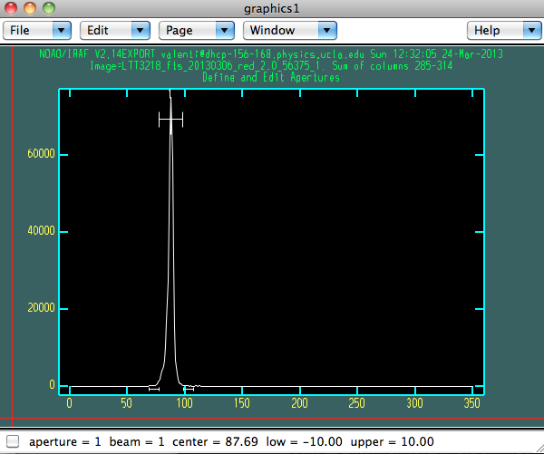

Find apertures for LTT3218_fts_20130306_red_2.0_56375_1? ('yes'): Warning: Image(s) are not two dimensional (ignoring higher dimensions)
Edit apertures for LTT3218_fts_20130306_red_2.0_56375_1? ('yes'):
Trace apertures for LTT3218_fts_20130306_red_2.0_56375_1?Fit traced positions for LTT3218_fts_20130306_red_2.0_56375_1 interactively?Fit curve to aperture 1 of LTT3218_fts_20130306_red_2.0_56375_1 interactivelyWrite apertures for LTT3218_fts_20130306_red_2.0_56375_1 to databaseExtract aperture spectra for LTT3218_fts_20130306_red_2.0_56375_1?Review extracted spectra from LTT3218_fts_20130306_red_2.0_56375_1?Review extracted spectrum for aperture 1 from LTT3218_fts_20130306_red_2.0_56375_1?flat_Mrk1392_fts_20130307_red_2.0_56375_1.fits
flat_Mrk863_fts_20130307_red_2.0_56375_1.fits
flat_Mrk1494_fts_20130307_red_2.0_56375_1.fits

4) fringing correction
The pipeline correct for fringing using the flat observed under the same observation block or the closest in time

### fringing correction
1.16 1

5) wavelength calibration
The pipeline use the iraf task identify to identify the arc lines and perform the wavelength calibration

###ARC WITH SAME GRPID
LTT3218_fts_20130306_red_2.0_56375_1_ex.fits
/Users/sv/lib/python2.7/site-packages/floyds/archive/fts/arc/red/2.0/arc_SN12FR_sky_20121130_red_slit2.0_56309_2_ex.fits
/Users/sv/lib/python2.7/site-packages/floyds/archive/fts/arc/red/2.0/arc_SN12FR_sky_20121130_red_slit2.0_56309_2_ex.fits
/Users/sv/lib/python2.7/site-packages/floyds/archive/fts/arc/red/2.0/arc_SN12FR_sky_20121130_red_slit2.0_56309_2_ex.fits
arc_SN12FR_sky_20121130_red_slit2.0_56309_2_ex.fits arc_LTT3218_fts_20130306_red_2.0_56375_1_ex.fits yes
arc_LTT3218_fts_20130306_red_2.0_56375_1_ex - Ap 1 19/19 19/19 -2. -6.98 -9.5E-4 1.8
Fit dispersion function interactively? (no|yes|NO|YES) ('yes'): arc_LTT3218_fts_20130306_red_2.0_56375_1_ex - Ap 1 19/19 19/19 -2. -6.98 -9.5E-4 1.8
### do you like the identification [[y]/n]
LTT3218_fts_20130306_red_2.0_56375_1_ex.fits: REFSPEC1 = 'arc_LTT3218_fts_20130306_red_2.0_56375_1_ex 1.'
LTT3218_fts_20130306_red_2.0_56375_1_l.fits: ap = 1, w1 = 4732.733, w2 = 11002.1, dw = 3.484915, nw = 1800

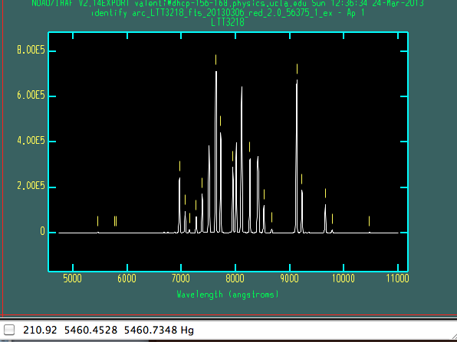
6) check the wavelength calibration
the pipeline check the wavelength calibration sing the sky lines (for the objects) or the tellurich lines (for standard and short exposure)

### check standard wave calib

### Warning: check in wavelenght with sky lines not performed

### Do you want to check the wavelengh calibration with tellurich lines [[y]/n]?

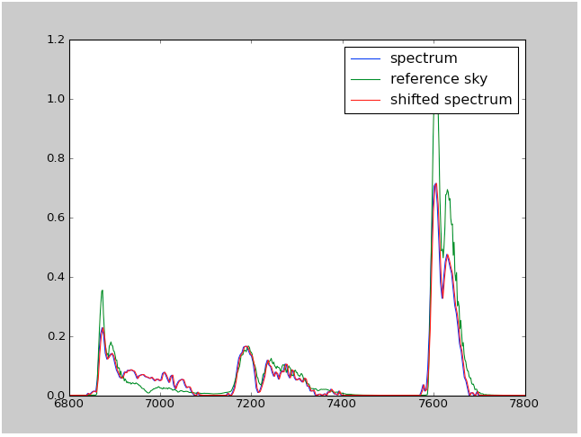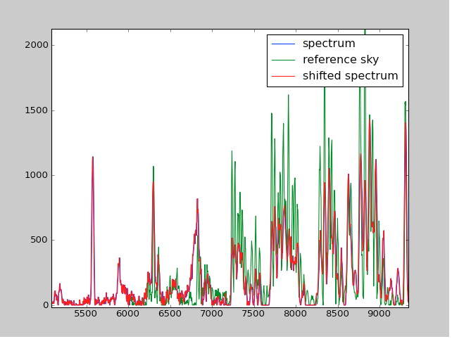
check of wavelength calibration with tellurich lines (on the left) of sky lines (on the right)

7) compute sensitivity function
the pipeline compute the sensitivity functionusing iraf task standard and sensfun

### compute sensitivity function and atmofile
red
LTT3218_fts_20130306_red_2.0_56375_1_clean.fits sens_fts_20130306_red_ltt3218_56375
LTT3218_fts_20130306_red_2.0_56375_1_clean.fits[*,1,1](1): LTT3218
LTT3218_fts_20130306_red_2.0_56375_1_clean.fits[1]: Edit bandpasses? (no|yes|NO|YES|NO!|YES!) ('no'):

The sensitivity function is done in one step (for the red part) and in two steps for the blue part. This is to correct two features in the blue sensitivity function.
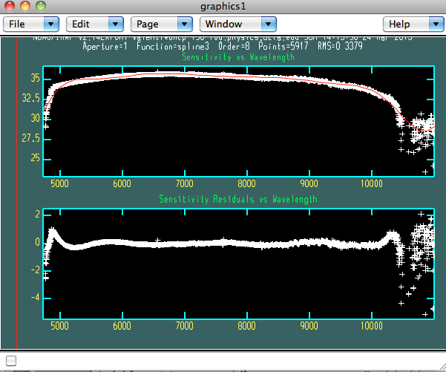
sensitivity function in the red part of the spectrum

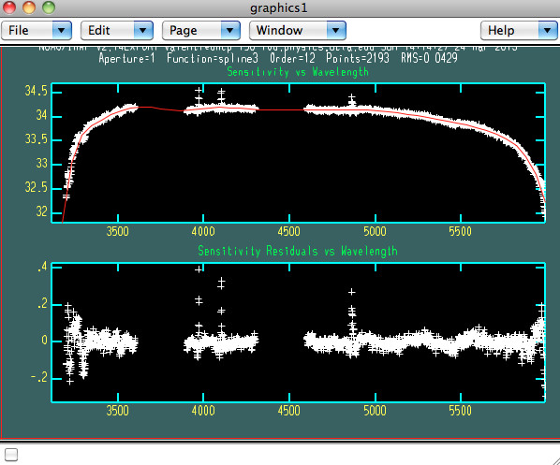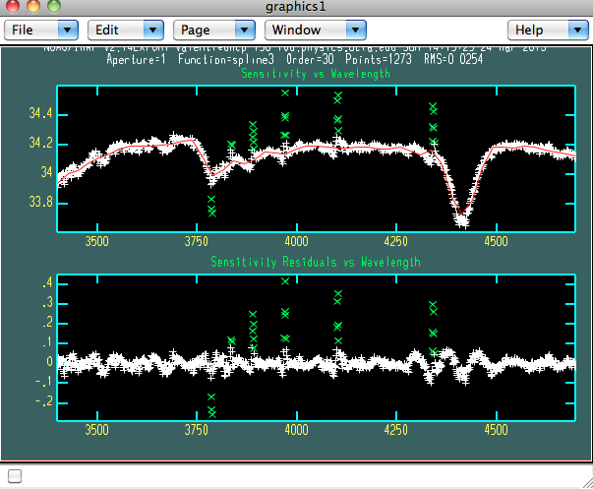
sensitivity function in the blue part

8) Flux calibration and merging of the blue and red part
This part is not interactive.

_stdcut0.fits[*,1,1](1): LTT3218
_stdcut0.fits[1]: Edit bandpasses? (no|yes|NO|YES|NO!|YES!) ('no'):
Fit aperture 1 interactively? (no|yes|NO|YES) (no|yes|NO|YES) ('yes'):
atmo_fts_LTT3218_fts_20130309_red_2.0_56375_1_l.fits
SN12fr_fts_20130309_red_2.0_56375_1_f.fits: SN12fr
Extinction correction applied
Flux calibration applied
atmo_fts_LTT3218_fts_20130309_red_2.0_56375_1_l.fits
SN12hr_fts_20130309_red_2.0_56375_1_f.fits: SN12hr
WARNING: 12 pixels outside of flux calibration limits
Extinction correction applied
Flux calibration applied
SN12fr_fts_20130309_blue_2.0_56375_1_f.fits: SN12fr
WARNING: 32 pixels outside of flux calibration limits
Extinction correction applied
Flux calibration applied
SN12hr_fts_20130309_blue_2.0_56375_1_f.fits: SN12hr
WARNING: 40 pixels outside of flux calibration limits
Extinction correction applied
Flux calibration applied
{56361.386881: ['SN12fr_fts_20130309_red_2.0_56375_1_e.fits', 'SN12fr_fts_20130309_blue_2.0_56375_1_f.fits'], 56361.41231: ['SN12hr_fts_20130309_red_2.0_56375_1_e.fits', 'SN12hr_fts_20130309_blue_2.0_56375_1_f.fits']}

Mar 24 14:15: SCOMBINE
combine = average, scale = none, zero = none, weight = none
blank = 0.
Images
s11.fits[ 1]
s22.fits[ 1]

Output image = SN12fr_fts_20130309_merge_2.0_56375_1_e.fits, ncombine = 2
w1 = 3100.963, w2 = 10999.88, dw = 1.731459, nw = 4563., dtype = 0
SN12fr_fts_20130309_merge_2.0_56375_1_e.fits

Mar 24 14:15: SCOMBINE
combine = average, scale = none, zero = none, weight = none
blank = 0.
Images
s11.fits[ 1]
s22.fits[ 1]

Output image = SN12hr_fts_20130309_merge_2.0_56375_1_e.fits, ncombine = 2
w1 = 3104.038, w2 = 11009.54, dw = 1.735185, nw = 4557., dtype = 0
SN12hr_fts_20130309_merge_2.0_56375_1_e.fits
runnning time 328.611502886

OUTOUT:

Filename_ fts_20130309_merge_2.0_56375_1_e.fits
This is the merge spectrum, wavelength, flux and tellurich corrected spectrum

Filename_ fts_20130309_blu_2.0_56375_1_e.fits
Filename_ fts_20130309_red_2.0_56375_1_e.fits

These are the blue and red spectra, wavelength, flux and tellurich corrected

Filename_ fts_20130309_blu_2.0_56375_1_f.fits
Filename_ fts_20130309_red_2.0_56375_1_f.fits

These are the blue and red spectra, wavelength, flux corrected
The tellurich correction is performed only is a standard in the same night is avaialable

