NTT pipeline
The ntt pipeline is a python module that depends on the following 4 modules

Pyraf
numpy
pyfits
pylab

also sextractor is needed .

NTT STRUCTURE
The ntt distribution directory includes :

src including the core of the pipeline
bin directory with the executable python script
README readmefile for installation
passtobin extra script not yet available to the users.
CHANGES.txt last changes in the pipeline
Setup.py script for installation
doc documentation
build building directory
dist distribution directory

Once the pipeline is installed, you will have a ntt directory in the PYTHONPATH directory includes:
archive (directories with archive data: flat, bias.arc)
standard (dir. with calibration files: standards, extinction curve, ecc)
+ several python definition files (*.py,*pyc in the ntt directory)

and several python executable script in the ~/bin directory.

Type on the terminal:

> PESSTO to get the following help:

############################## PESSTO ##############################
PESSTO -h (show the help message)
PESSTOEFOSC1dSPEC -h (show the help message)
PESSTOEFOSC2dSPEC -h (show the help message)
PESSTOEFOSCPHOT -h (show the help message)
PESSTOFASTSPEC -h (show the help message)
PESSTOSOFI1dSPEC -h (show the help message)
PESSTOSOFI2dSPEC -h (show the help message)
PESSTOSOFIPHOT -h (show the help message)
PESSTOWISE -h (show the help message)
################################################# @stefano

Python executable script

-PESSTOFASTSPEC Fast spectroscopy for classification (no flat, bias correction, calibration from archive)

-PESSTOEFOSCPHOT (photometry efosc pre-reduction)

-PESSTOEFOSC2dSPEC (spectroscopy efosc pre-reduction 2D frames-wavelengh-calibrated)

-PESSTOEFOSC1dSPEC (spectroscopic extraction and flux calibration)

-PESSTOSOFIPHOT (photometry sofi pre-reduction)

-PESSTOSOFI1dSPEC (spectroscopy efosc pre-reduction 2D frames-wavelengh-calibrated)

-PESSTOSOFI2dSPEC (spectroscopic extraction and flux calibration)

- PESSTOWISE (to prepare fast extracted spectra for WISEREP

each of these modules will be explained in detail here:

EFOSC PHOTOMETRY

$ PESSTOEFOSCPHOT -h
Usage: PESSTOEFOSCPHOT [listfile -B bias (use this bias) -F flatlist (use these flats) ...... ]
> Fast photometry reduction of efosc images
Options:
--version show program's version number and exit
-h, --help show this help message and exit
-v, --verbose
-f, --flat do not apply flat correction
-F LISTFLAT, --listflat=LISTFLAT
use flats from this list
-b, --bias do not apply bias correction
-B LISTBIAS, --listbias=LISTBIAS
use this bias
-m, --mask do not apply bad pixel mask correction
-M BADPIXELMASK, --maskbadpixel=BADPIXELMASK
use this bad pixel mask
-r FRINGINGMASK, --fringing=FRINGINGMASK
use this fringing mask
-a, --archive use only calibration from archive
-t TYPE, --type=TYPE file type to be reduced all,calib,science [all]
-c CORRECTOBJ, --correctobj=CORRECTOBJ
file containing name of objects []
-s SYSTEM, --system=SYSTEM
reference photometric system [landolt,sloan,filter]
[filter]

The fundamental input to make the script running is:
$ PESSTOEFOSCPHOT

The recommended syntax is:
$ /home/user/s-p/NTT/bin/PESSTOEFOSCPHOT.py -c list_candidates

option listfiles (list of all the files, if no list is specified, all the raw efosc photometric data in the directory will be included )
option –c listcandidates (Important to replace the correct object name to the acquisition)
option –f is to skip the flat field correction
option –F listflat (list of flat or a single flat) is to use a specific flat
option –b is to skip the bias correction
option –B listbias (list of bias or a single bias) is to use a specific bias file
option –m is to skip the mask correction
option –M listmask (list of masks or a single mask) is to use a specific mask file
option –r fringing mask (use a specific fringing file)
option –a is to copy the combined flatfield and bias images in the NTT archive, to be used for nights with missing flat and bias calibrations

output running the program in red color

1) recognize the different types of files:
making the list with raw data in the current directory ...... please wait

2) make bias
- the program calculate the mean for each bias (Mi), and reject the bias files with a mean 1-sigma-out of mean(Mi)
- ask to the reducer if the other bias file are good (g) or bad (b), all good (G), stop without take next bias (s).
Usually bias after automatic rejection are good, so option ‘G’ is save and anyhow the reducer will eyeball the masterbias and will have the possibility to redu it excluding bad bias.

#### select good bias ######

EFOSC.2012-04-20T21:04:08.579.fits rejected
EFOSC.2012-04-20T21:04:39.711.fits 9.703312
EFOSC.2012-04-20T21:05:10.732.fits 10.58403
EFOSC.2012-04-20T21:07:14.680.fits 12.1439
EFOSC.2012-04-20T21:07:45.682.fits rejected
EFOSC.2012-04-20T21:08:16.683.fits 12.04626
EFOSC.2012-04-20T21:08:47.685.fits 10.04045
EFOSC.2012-04-20T21:09:18.668.fits 11.06336

IMAGE NPIX MEAN STDDEV MIN MAX
EFOSC.2012-04-20T21:04:39.711.fits 1060900 211.4 9.703 0. 290.
good/bad [[g]/b/G(all good)/s(stop) ] ? g
good/bad [[g]/b/G(all good)/s(stop) ] ? b
good/bad [[g]/b/G(all good)/s(stop) ] ? G

3) make flat
the program reject the flat saturated and with low counts automatically.
- ask to the reducer if the other flat file are good or bad all good (G), stop without take nets bias (s).
- Also here the ‘G’ is the standard answer, since the reducer will anyhow check the combined flat later on.

###### check flat with filter B639#####

IMAGE NPIX MEAN STDDEV MIN MAX
EFOSC.2012-04-21T22:36:08.587.fits 1060900 36830. 5721. 0. 65535.
good/bad [[g]/b/G(all good)/s(stop)]? G

###### check flat with filter V641#####

IMAGE NPIX MEAN STDDEV MIN MAX
EFOSC.2012-04-21T22:44:14.462.fits 1060900 5983. 880.3 0. 15966.
good/bad [[g]/b/G(all good)/s(stop)]?G

writing the list in listfiles, if you want to reduce again the data using the files selected use the option
listfiles

a list of raw file is creaeted and can be used as input next time the user run the script

4) check master bias and master flats:

do bias 20120421

EFOSC.2012-04-21T19:57:17.376.fits rejected
EFOSC.2012-04-21T19:57:47.908.fits 13.65841
EFOSC.2012-04-21T19:58:18.880.fits 10.01726
EFOSC.2012-04-21T19:58:49.151.fits 9.440286
EFOSC.2012-04-21T19:59:19.882.fits 9.740063
EFOSC.2012-04-21T19:59:50.164.fits 10.02269
EFOSC.2012-04-21T20:00:20.916.fits 9.515131
EFOSC.2012-04-21T20:00:51.867.fits 9.89354
EFOSC.2012-04-21T20:01:22.889.fits 14.07497
EFOSC.2012-04-21T20:01:53.911.fits 12.17502
EFOSC.2012-04-21T20:02:24.913.fits 12.38961
processing bias .....
is the masterbias ok [[y]/n] ?

do flat r784

processing flat .....
is the masterflat ok [[y]/n] ?
do flat B639

processing flat .....
is the masterflat ok [[y]/n] ?

5) object pre-reduction:
main information on the reduction are reported on the screen

#####################################################################

### input EFOSC.2012-04-21T04:01:54.479.fits LSQ12btw_20120420_r784
### bias yes bias_20120420.fits
### flat yes flat_20120421_r784.fits
### name LSQ12btw_20120420_r784_1.fits

### bad pixel mask correction ..... done

### check astrometry: fine
### rmsx rmsy nstars: 0.382 0.269 6

### standard field: sloan

### zeropoint ..... done
### rri 25.592 0

#####################################################################

### input EFOSC.2012-04-21T04:04:08.599.fits LSQ12btw_20120420_r784
### bias yes bias_20120420.fits
### flat yes flat_20120421_r784.fits
### name LSQ12btw_20120420_r784_2.fits

### bad pixel mask correction ..... done

### check astrometry: fine
### rmsx rmsy nstars: 0.355 0.261 6

### standard field: sloan

### zeropoint ..... done
### rri 25.582 0

EFOSC SPECTROSCOPY

$ PESSTOEFOSC2dSPEC -h
Usage: PESSTOEFOSC2dSPEC [listfile -B bias (use this bias) -F flatlist (use these flats) .....]
> Specroscopic pre-reduction of efosc data
Options:
--version show program's version number and exit
-h, --help show this help message and exit
-i, --interactive
-v, --verbose
-f, --flat
-F LISTFLAT, --listflat=LISTFLAT
name flat list []
-b, --bias
-B LISTBIAS, --listbias=LISTBIAS
name bias list []
-a LISTARC, --listarc=LISTARC
name arc list []

The fundamental input to make the script running is:
~$ PESSTOEFOSC2dSPEC

The recommended syntax is:
~$ PESSTOEFOSC2dSPEC.py -i

option listfiles (list of all the files, if no list is specified, all the raw efosc spectroscopic data in the directory will be included )
option –i is to make some choice interactively
option –f is to skip the flat field correction
option –F listflat (list of flat or a single flat) is to use a specific flat
option –b is to skip the bias correction
option –B listbias (list of bias or a single bias) is to use a specific bias file
option –a listarc is to use a particular arc to wavelength calibration

output running the program in red color

1) recognize the different types of files
making the list with raw data in the current directory ...... please wait

2) make bias
- the program calculate the mean for each bias (Mi), and reject the bias files with a mean 1-sigma-out of mean(Mi)
- ask to the reducer if the other bias file are good (g) or bad (b), all good (G), stop without take next bias (s).
Usually bias after automatic rejection are good, so option ‘G’ is save and anyhow the reducer will eyeball the masterbias and will have the possibility to redu it excluding bad bias.

#### select good bias ######

EFOSC.2012-04-20T21:04:08.579.fits rejected
EFOSC.2012-04-20T21:04:39.711.fits 9.703312
EFOSC.2012-04-20T21:05:10.732.fits 10.58403
EFOSC.2012-04-20T21:07:14.680.fits 12.1439
EFOSC.2012-04-20T21:07:45.682.fits rejected
EFOSC.2012-04-20T21:08:16.683.fits 12.04626

3) reduction for each setup
The program print the object to be reduced for each setup and ask to proceed:

### ['EFOSC.2012-04-20T23:15:33.733.fits', 'EFOSC.2012-04-21T04:32:35.189.fits', 'EFOSC.2012-04-21T06:58:13.809.fits', 'EFOSC.2012-04-21T08:41:11.682.fits']
### ('Gr13', 'Free', 'slit1.0')
### do you want to reduce this setup [[y],n] ?

4) make flat for each setup

For each setup the program ask if the reducer wants to normalize the flat field in the interactive way. Usually there is no need to do that interactively, so standard answer is ‘n’

5) wavelength calibration for each object of the setup:
The program ask if the user wants to check wavelength calibration manually. My standard choise is ‘y’ even though also automatic identification seems to work fine.

### EFOSC.2012-04-20T23:15:33.733.fits -> L745a_20120420_Gr13_Free_slit1.0_1.fits

arc_L745a_20120420_Gr13_Free_slit1.0_1[10,*] 15/16 15/15 2.19 12.2 0.00192 0.159
Fit dispersion function interactively? (no|yes|NO|YES) ('yes'):

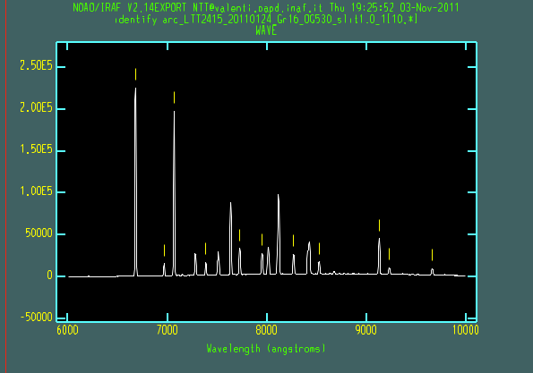

arc_L745a_20120420_Gr13_Free_slit1.0_1[10,*] 15/16 15/15 2.19 12.2 0.00192 0.159
### do you like the identification [[y]/n]

8) wavelength calibration check
Wavelengh calibration is checked comparing the 2D-image sky with a sky from archive (for the same setup). A plot of the sky (observed, template and shifted spectrum) is shown to visually check that the wavelength check is correct.
If the exposure is too short (eg for standard stars )the check will be skipped.

### check wavelengh calibration, found a shift of 11 Angstrom
### do you want to correct the wavelengh calibration with this shift: 11 [[y]/n] ?

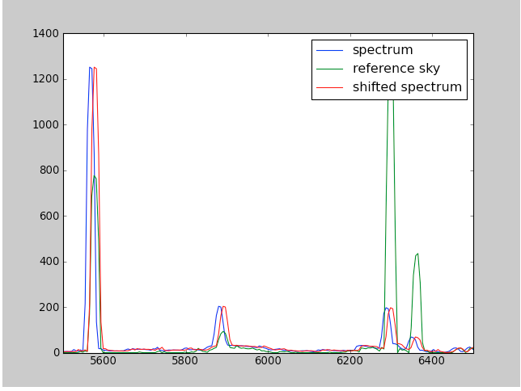

1 to 8 Steps are repeated for all the objects and all the setup

9) output files are the 2D-images wavelength calibrated:

### making the tar file with 2d frames .... please wait

### tar file: logfile_spec2D_apr12_d20to21_efosc_201205281744.tar.gz

### collect all 2d-frames in a list and run: PESSTOEFOSC1dSPEC listfiles
_________________________________________________________

Extraction and calibration

make a list with all the 2D-images (output of the previous command)
$ ls t*.fits > list2D

~$ PESSTOEFOSC1dSPEC -h
Usage: PESSTOEFOSC1dSPEC list2Dfile [options]
> Specroscopic reduction of efosc data (2D->1D)

Options:
--version show program's version number and exit
-h, --help show this help message and exit
-v, --verbose
-i, --interactive
-s LISTSTAND, --standard=LISTSTAND
use sensitivity curve from this list
-a LISTATMO, --atmo=LISTATMO
use sensitivity curve from this list
-t, --trace trace extraction with another frame
-d, --dispersion chose interctively the disperasion line
-A, --Automatic extract spectrum with previous parameters in the
database

The fundamental input to make the script running is:
~$ PESSTOEFOSC1dSPEC list2D

The recommended syntax is:
~$ PESSTOEFOSC1dSPEC list2D –i

list2D (list of 2D wavelength calibrated files)
option –i is to make some choice interactively
option –s use specific standard list
option –a use specific list of frames for atmospheric correction
option –t For very faint object we do the trace with another object
option –d chose interactively the dispersion line will be plotted to chose the aperture and the background region.
option –A VERY IMPORTANT WHEN YOU WANT TO EXSTRACT AGAIN WITH THE SAME PARAMETER USED BEFORE

output running the program in red

1) extraction
Start extracting the first object with the first setup. extraction for all the spectra of each setup.

### next object= tLSQ12btw_20120420_Gr16_OG530_slit1.0_1.fits LSQ12btw
Recenter apertures for tCSS132702m014513_20120420_Gr13_Free_slit1.5_1? ('yes'):
Resize apertures for tCSS132702m014513_20120420_Gr13_Free_slit1.5_1? ('yes'):
Edit apertures for tCSS132702m014513_20120420_Gr13_Free_slit1.5_1? ('yes'):
Trace apertures for tCSS132702m014513_20120420_Gr13_Free_slit1.5_1?Fit traced positions for tCSS132702m014513_20120420_Gr13_Free_slit1.5_1 interactively?Fit curve to aperture 1 of tCSS132702m014513_20120420_Gr13_Free_slit1.5_1 interactivelyWrite apertures for tCSS132702m014513_20120420_Gr13_Free_slit1.5_1 to databaseExtract aperture spectra for tCSS132702m014513_20120420_Gr13_Free_slit1.5_1?Review extracted spectra from tCSS132702m014513_20120420_Gr13_Free_slit1.5_1?Review extracted spectrum for aperture 1 from tCSS132702m014513_20120420_Gr13_Free_slit1.5_1?
…….
### all object with this setup extracted

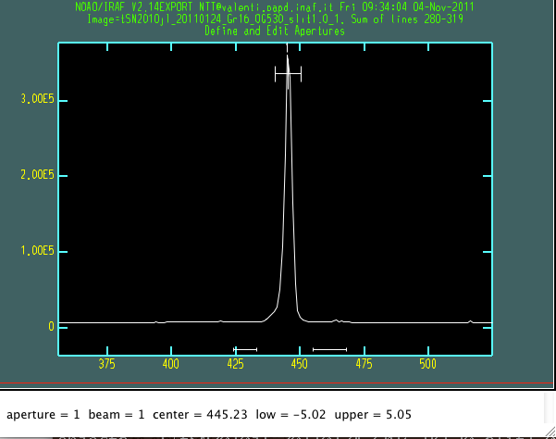

2) standard extraction for each setup.

After exstraction, since the wavelength calibration was probably skipped in the previous step, can be performed using the tellurich lines.

### standard for setup ('Gr13', 'Free', 'slit1.0') = tL745a_20120420_Gr13_Free_slit1.0_1.fits L745a
Find apertures for tL745a_20120420_Gr13_Free_slit1.0_1? ('yes'):
Edit apertures for tL745a_20120420_Gr13_Free_slit1.0_1? ('yes'):
Trace apertures for tL745a_20120420_Gr13_Free_slit1.0_1?Fit traced positions for tL745a_20120420_Gr13_Free_slit1.0_1 interactively?Fit curve to aperture 1 of tL745a_20120420_Gr13_Free_slit1.0_1 interactivelyWrite apertures for tL745a_20120420_Gr13_Free_slit1.0_1 to databaseExtract aperture spectra for tL745a_20120420_Gr13_Free_slit1.0_1?Review extracted spectra from tL745a_20120420_Gr13_Free_slit1.0_1?Review extracted spectrum for aperture 1 from tL745a_20120420_Gr13_Free_slit1.0_1

### Warning: check in wavelenght with sky lines not performed

### Do you want to check the wavelengh calibration with tellurich lines [[y]/n]? ### check wavelength calibration with tellurich lines
### do you want to correct the wavelengh calibration with this shift: 16 [[y]/n] ?

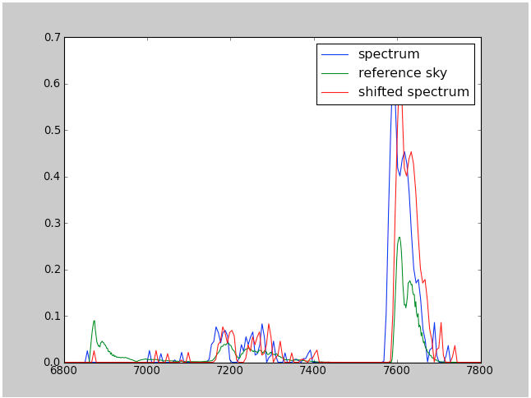

3) Second order correction for grism 13.
If the setup is the grism 13 and the standard was observed also with the blocking filter, the pipeline will extract also that spectrum, to performe the second order correction

### extract standard frame with blocking filter to correct for second order contamination

Find apertures for tL745a_20120420_Gr13_GG495_slit1.0_1? ('yes'):
Edit apertures for tL745a_20120420_Gr13_GG495_slit1.0_1? ('yes'):
Trace apertures for tL745a_20120420_Gr13_GG495_slit1.0_1?Fit traced positions for tL745a_20120420_Gr13_GG495_slit1.0_1 interactively?Fit curve to aperture 1 of tL745a_20120420_Gr13_GG495_slit1.0_1 interactivelyWrite apertures for tL745a_20120420_Gr13_GG495_slit1.0_1 to databaseExtract aperture spectra for tL745a_20120420_Gr13_GG495_slit1.0_1?Review extracted spectra from tL745a_20120420_Gr13_GG495_slit1.0_1?Review extracted spectrum for aperture 1 from tL745a_20120420_Gr13_GG495_slit1.0_1?
### Warning: check in wavelenght with sky lines not performed
### Do you want to check the wavelengh calibration with tellurich lines [[y]/n]?
### check wavelength calibration with tellurich lines
### do you want to correct the wavelengh calibration with this shift: 16 [[y]/n] ?

4) flux calibration:
The standard method, with the sensitivity function computed directly on the extracted standard spectrum using the tasks: standard and sensfunction.

### standard available: ['tL745a_20120420_Gr13_Free_slit1.0_1_ex.fits']
Warning: Could not find task specred.sensfunction to unlearn
tL745a_20120420_Gr13_Free_slit1.0_1_clean.fits[*,1,1](1): L745a
tL745a_20120420_Gr13_Free_slit1.0_1_clean.fits[1]: Edit bandpasses? (no|yes|NO|YES|NO!|YES!) ('tes')
Fit aperture 1 interactively? (no|yes|NO|YES) (no|yes|NO|YES) ('yes'):

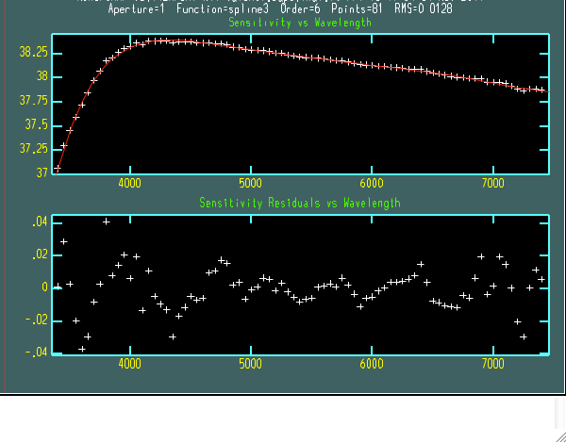
tCSS170824p030104_20120421_Gr13_Free_slit1.0_1_f.fits: CSS170824p030104
WARNING: 4 pixels outside of flux calibration limits
Extinction correction applied
Flux calibration applied
tLSQ12cbn_20120429_Gr13_Free_slit1.0_1_f.fits: LSQ12cbn
WARNING: 4 pixels outside of flux calibration limits
Extinction correction applied
Flux calibration applied

4) telluric correction:
The telluric features correction is performed scaling a theoretical model to O2 and H2O features on the standard spectrum independently.
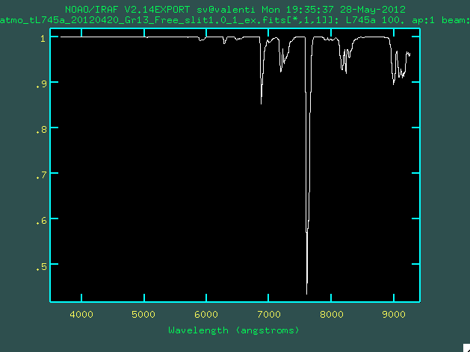
________________________________________________________

SOFI PHOTOMETRY

~$ PESSTOSOFIPHOT -h
Usage: PESSTOSOFIPHOT [listfile ... more options ]
> Fast photometry pre-reduction of sofi images
Options:
-h, --help show this help message and exit
-i, --interactive
-v, --verbose
-f, --flat not apply FLAT corrections
-F LISTFLAT, --listflat=LISTFLAT
use flat from this list
-m, --doill not apply illumination corrections
-M LISTILL, --illuminationlist=LISTILL
use illumination file from this list
-c, --docross not apply cross-talk corrections

The fundamental input to make the script running is:
$ PESSTOSOFIPHOT

The recommended syntax is:
$ PESSTOSOFIPHOT.py -i

option listfiles (list of all the files, if no list is specified, all the raw efosc photometric data in the directory will be included )
option –i is to make some choice interactively
option –f is to skip the flat field correction
option –F listflat (list of flat or a single flat) is to use a specific flat
option –m is to skip the illumination correction
option –M listillumination (list of illumination correction files) is to use a specific illumination file
option –c is to skip the crosstalk correction

output running the program in red
1) splitting the files

the files are splitted reading the setup and the OBs identification number. There is no output on the screen

### making the list with raw data in the current directory ...... please wait

2) pre-reduction one by one the set of files (flatfield, crosstalk, llumination,trim)
In automatic way all the images are reduced. If option –I is used the pipeline ask for each set of image to proceed or not:

### next object
### 2012bl_K_0001.fits 208.333333 208.333333
### 2012bl_K_0002.fits -208.333333 208.333333
### 2012bl_K_0003.fits -208.333333 -208.333333
### 2012bl_K_0004.fits 208.333333 -208.333333
### 2012bl_K_0005.fits 193.333333 184.333333
### 2012bl_K_0006.fits -223.333333 184.333333
### 2012bl_K_0007.fits -223.333333 -232.333333
### 2012bl_K_0008.fits 193.333333 -232.333333

### do you want to reduce this object sn2012bl_1 and filter Ks [[y],n]

### image corrected for cross talk ...... done
### image corrected for illumination correction ...... done
### image corrected for flat field ...... done
### input= 2012bl_K_0001.fits
### output= sn2012bl_20120410_Ks_1.fits

### image corrected for cross talk ...... done
### image corrected for illumination correction ...... done
### image corrected for flat field ...... done
### input= 2012bl_K_0002.fits
### output= sn2012bl_20120410_Ks_2.fits

3) sky-subtraction and merge of dithered images

After all the set of images have been pre-reduced, the images are sky subtracted. For each set of images the observational strategy is recognize and the sky is computed. There are two observational strategies:
a) DITHERING ON SOURCE: dither smaller than 300 arcsec
In this case the sky is computed using all the images of one cycle. Usually each cycle is formed by 4 images
THE MASK USUALLY USED HAS 4 POSITIONS. Dither can be chosen following the observational strategy documentation.

Anyhow, the mask positions are shown for each set of images (and printed on the screen) and the reducer has to confirm interactively the number of position used. For the faint objects the cycle will be repeated several time. In the following example the mask has 4 positions and the cycle has been repeated 2 times. The reducer has to chose 4 positions. In this way, the images will be split in two cycles and two sky images will be produced.

### next set of images sn2012bl_1 Ks

### Dithering on source
### [208.33333300000001, -208.33333300000001, -208.33333300000001, 208.33333300000001, 193.33333300000001, -223.33333300000001, -223.33333300000001, 193.33333300000001] [208.33333300000001, 208.33333300000001, -208.33333300000001, -208.33333300000001, 184.33333300000001, 184.33333300000001, -232.33333300000001, -232.33333300000001]

### How many positions has this mask [8] ? 4
### split lista in sample of 4 images

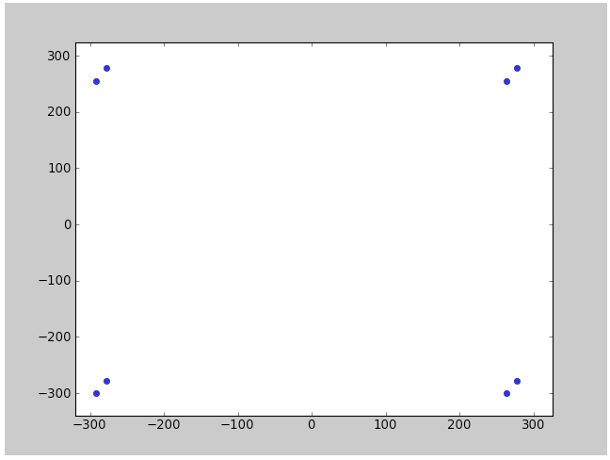
In the second example the mask has 5 positions and one cycle. The reducer has to chose 5 positions

STD_5 Ks
Dithering on source
[0.0, 156.25, -156.25, -156.25, 156.25]
[0.0, 156.25, 156.25, -156.25, -156.25]
how many positions has this mask [5] ?
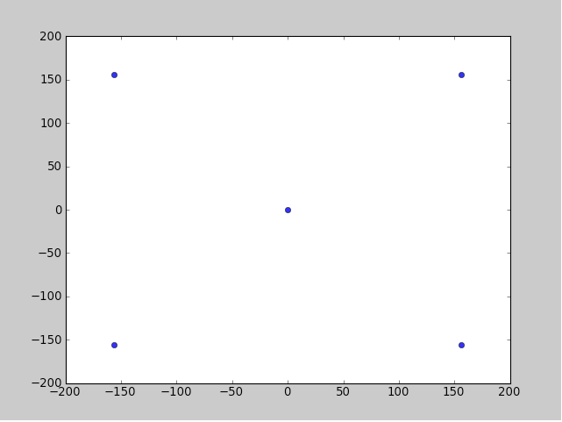

b) ON-OFF: dither larger than 500 arcsec
In this case the sky is computed with the images out of the field (off images). If the option is interactive the reducer has to confirm which are the images ON and OFF. Usually there are at least 3 images ON and 3 OFF.
SN2010el_1 Ks
Warning: ON OFF
SN2010el_20100917_Ks_13.fits 0.0 0.0
is this ON[1] or OFF[2] ? [1]
SN2010el_20100917_Ks_14.fits -181.875042 1236.697808
is this ON[1] or OFF[2] ? [2]
SN2010el_20100917_Ks_15.fits 24.0 -6.0
is this ON[1] or OFF[2] ? [1]
SN2010el_20100917_Ks_16.fits 712.187918 -1027.272296
is this ON[1] or OFF[2] ? [2]
SN2010el_20100917_Ks_17.fits 19.0 23.0
is this ON[1] or OFF[2] ? [1]
SN2010el_20100917_Ks_18.fits 1241.737975 -143.481017
is this ON[1] or OFF[2] ? [2]
SN2010el_20100917_Ks_19.fits -17.0 -12.0
is this ON[1] or OFF[2] ? [1]
SN2010el_20100917_Ks_20.fits 841.883953 -923.975871
is this ON[1] or OFF[2] ? [2]
SN2010el_20100917_Ks_21.fits -20.0 27.0
is this ON[1] or OFF[2] ? [1]
SN2010el_20100917_Ks_22.fits 1172.49344 433.311819
is this ON[1] or OFF[2] ? [2]
SN2010el_20100917_Ks_23.fits -31.0 -31.0
is this ON[1] or OFF[2] ? [1]
SN2010el_20100917_Ks_24.fits 841.883953 -923.975871
is this ON[1] or OFF[2] ? [2]

In both strategy a first sky is subtracted; The object are detected and an object mask is computed (for each image for the dither on source strategy and only for the OFF images in the ON/OFF strategy).
The mask images are used to mask the object in new sky images used to obtain again the final sky-subtracted images.
Using sextractor all the objects of the images are detected and aliened in order to combine the dithered images in a single image.

The images are finally combined using the offset just obtained.
The output images are:

SN2010hp_20100917_Ks_19.fits trimmed image, illum cor., crosstalk
mask_SN2010hp_20100917_Ks_19.fits object mask for the image
sky_SN2010hp_20100917_Ks_19.fits sky-subtracted image
SN2010hp_20100917_Ks_merge_1.fits merged image

4) Combination, astrometry and zeropoint

### measure offsets between frames 0 0
### measure offsets between frames -0.12 -0.34
### measure offsets between frames 0.46 -0.5
### measure offsets between frames 0.82 0.64
### measure offsets between frames -0.08 0.73
### measure offsets between frames -0.1 0.22
### measure offsets between frames 0.34 0.2
### measure offsets between frames 0.43 1.28
### check astrometry: fine
### rmsx rmsy nstars: 0.0762 0.118 6
### standard field: 2mass
### 2mass system
### zeropoint ..... done
### KHK 22.107 0

5) output:

### making a tar with pre-reduced images ........ please wait
### tar file: logfile_phot_apr12_d10to10_sofi_201205281948.tar.gz
____________________________________________________________

SOFI SPECTROSCOPY

~$ PESSTOSOFI2dSPEC -h
Usage: PESSTOSOFI2dSPEC [listfile ... more options]

> Specroscopic pre-reduction of sofi data (2D)

Options:
--version show program's version number and exit
-h, --help show this help message and exit
-i, --interactive
-v, --verbose
-f, --flat do not apply flat correction
-F LISTFLAT, --listflat=LISTFLAT
use flat from this list
-c, --docross do not apply cross-talk correction

option listfiles (list of all files)
option –i is to make some choice interactively
option –f is to skip the flat field correction
option –F listflat (list of flat or a single flat) is to use a specific flat
option –c is to skip the crosstalk correction

output running the program in red:

### making the list with raw data in the current directory ...... please wait

1) spectroscopic flatfield:
the reducer has to identify interactively, which flat filed are with the Lamp ON and Lamp OFF since there are no information in the header.
Note: the flat field will be computed only if the number of ON and OFF images are the same (in the example 2 ON and 2 OFF)
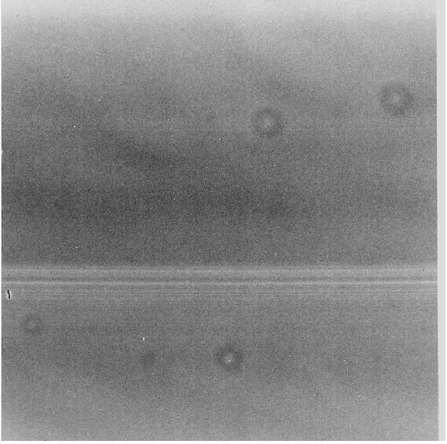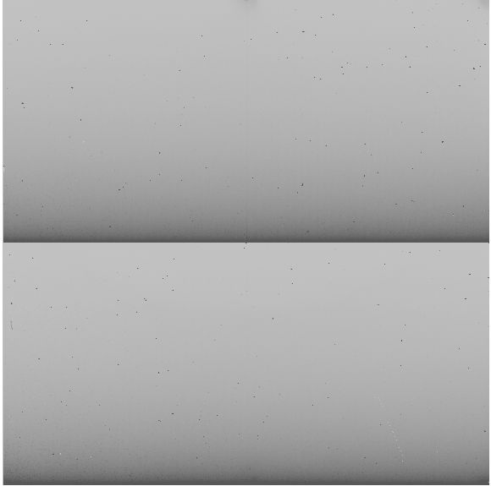
FLAT LAMP ON FLAT LAMP OFF

### list of available spectroscopic flats (ON,OFF):
SOFI_BG_0001.fits GB 20120410 OFF ?
SOFI_BG_0002.fits GB 20120410 ON ?
SOFI_BG_0003.fits GB 20120410 OFF ?
SOFI_BG_0004.fits GB 20120410 ON ?
SOFI_BG_0005.fits GB 20120410 ON ?
SOFI_BG_0006.fits GB 20120410 OFF ?
SOFI_RG_0001.fits GR 20120410 OFF ?
SOFI_RG_0002.fits GR 20120410 ON ?
SOFI_RG_0003.fits GR 20120410 OFF ?
SOFI_RG_0004.fits GR 20120410 ON ?
SOFI_RG_0005.fits GR 20120410 ON ?
SOFI_RG_0006.fits GR 20120410 OFF ?

### number of flat already selected (ON,OFF):
### please select same number of ON and OFF flats
0 0

### image SOFI_BG_0001.fits
ON/OFF/REJECT/STOP [OFF] ok [[y]/n/r/s]?
….

ON/OFF/REJECT/STOP [OFF] ok [[y]/n/r/s]?
ON GB
SOFI.2010-09-16T20:54:23.262.fits
ON OFF
2 2
ON/OFF/REJECT/STOP [ON] ok [[y]/n/r/s]? s

### master flat ........... done
Fit the normalization spectrum for flat_20120410_GB.fits interactively (yes):
Once the flat field are computed, the flat are normalized 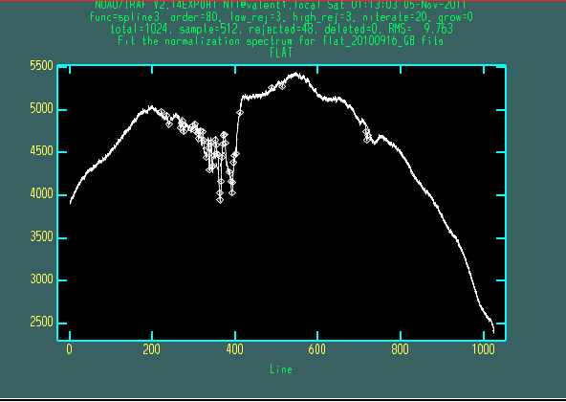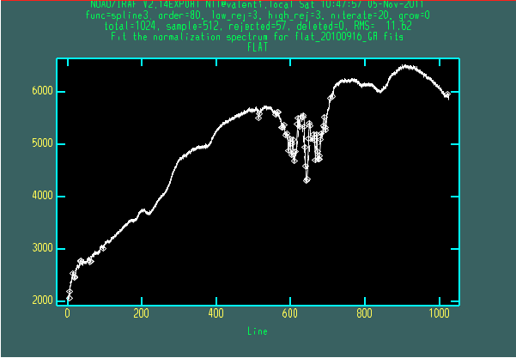

### flat available:
### ['nflat_20120410_GB.fits', 'nflat_20120410_GR.fits']

2) arc wavelength calibration
For each set of images (each OBs), the closest ARC is selected and wavelength calibrated along one line. The line identification is then propagated along the 2D image and the wavelength calibration is performed (fitcoords)

arc_GB_20120410[10,*] 15/15 15/15 -3.22 21.9 0.00184 0.314
Fit dispersion function interactively? (no|yes|NO|YES) ('yes'):
arc_GB_20120410[10,*] 15/15 15/15 -3.22 21.9 0.00184 0.314
### do you like the identification [[y]/n]

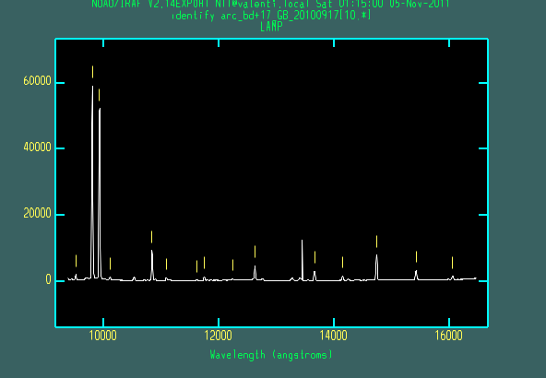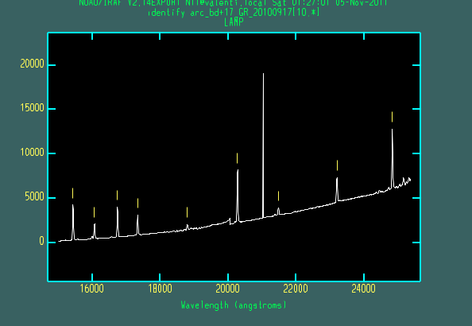

3) object pre-reduction and wavelength calibration
The spectra of each OB are first corrected for CROSSTALK and than for FLATFIELD.

### input image: hip0640_0001.fits
### correct for cross talk ..... done
### correct for flat field ..... done
### output image: Rhip0640_0001.fits

### input image: hip0640_0002.fits
### correct for cross talk ..... done
### correct for flat field ..... done
### output image: Rhip0640_0002.fits

For each exposure, the closest (in time) exposure is subtracted. If the option interactive is used the reducer has to confirm with is the image that should be subtracted.
### Select Frames to be subtracted (eg A-B, B-A, C-D, D-C, ....)
### frame1 frame2 offset1 offset2 JD1 JD2

### Rhip101815_0001.fits Rhip101815_0002.fits -104.166667 35.667308 56028.8466178 56028.8466178

### ok [[y]/n] ?
### Rhip101815_0002.fits Rhip101815_0001.fits 35.667308 -104.166667 56028.8467642 56028.8467642

### ok [[y]/n] ?

### 2D frame thip101815_1_20120410_GB_0_1.fits wavelengh calibrated ............ done

### 2D frame thip101815_1_20120410_GB_1_0.fits wavelengh calibrated ............ done

If the exposure is long enough a wavelength calibration check is performed

do you want to correct the wavelengh calibration with this shift: -6 [[y]/n] ?

### check wavelengh calibration with sky lines ..... done

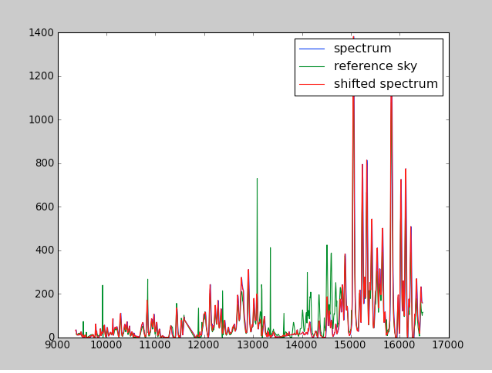

The output have the following form:

### making the tar file with 2d frames .... please wait

### tar file: logfile_spec2d_apr12_d10to10_sofi_201205282005.tar.gz

### collect all 2d-frames in a list and run: PESSTOSOFI1dSPEC listfiles
_________________________________________________________________

SOFI SPECTROSCOPY 1D

/redu2/20120410_SOFI$ PESSTOSOFI1dSPEC -h
Usage: PESSTOSOFI1dSPEC list2Dfile [options]

> Specroscopic reduction of sofi data (2D -> 1D)

Options:
--version show program's version number and exit
-h, --help show this help message and exit
-i, --interactive
-v, --verbose
-s LISTSTAND, --standard=LISTSTAND
use stadnard from this list (to be tested)
-t, --trace trace extraction with another frame
-d, --dispersion chose interactively the dispersion line
-A, --Automatic extract spectrum with previous parameters in the
database

The fundamental input to make the script running is:
$/home/user/site-packages/NTT/bin/PESSTOSOFI1dSPEC list2D

The recommended syntax is:
~$/home/user/site-packages/NTT/bin/PESSTOSOFI1dSPEC list2D -i

listfiles (list of 2D wavelength calibrated files)
option –i is to make some choice interactively
option –s use specific standard list (NOT IMPLEMENTED YET )
option –t For very faint object we do the trace with another object
option –d chose interactively the dispersion line will be plotted to chose the aperture and the background region.

output running the program in red

The 2D wavelength-calibrated spectra are divided in
Objects,
vega type standard
sun type standard
photometric type standard

there are only (up to now) 3 photometric standard in the infrared

gd71_stsci.dat 05 52 27.51 +15 53 16.6 13.03
gd153_003.dat 12 57 02.34 +22 01 52.7 13.40
bd174708003.dat 22 11 31.37 +18 05 34.174 9.45
also available at this link
https://psweb.mp.qub.ac.uk/pesstowiki/index.php/File:Standard_phot.pdf

the standard sun type and vega type are mainly used for telluric corrections, while the photometric standards (if available) are used to check the flux calibration.

A list of telluric standard vega type and solar type is available at the following links:

Sun type standard:
https://psweb.mp.qub.ac.uk/pesstowiki/index.php/File:Standard_sun.pdf

Vega type standard:
https://psweb.mp.qub.ac.uk/pesstowiki/index.php/File:Standard_vega.pdf

### warning: not photometric standard
### telluric G standard (sun type) in the list of object
### telluric A standard (vega type) in the list of object

1) merge of dithered exposure in one

### Try to merge spectra considering their offset along x axes .......
### automatic merge .......... done
### setup= ('GR', 'GRF') name field= hip0640_1 merge image= hip0640_1_GR_merge.fits

If the mere doesn’t work automatically, the user has to identify manually the spectra position in the different frames.

2) extraction object spectrum, telluric standard spectrum
If the option interactive is used, the spectrum is extracted interactively.
If the spectrum has been already extracted, there is the possibility to skip this step.

############################################
### extract the spectra

### next object
sn2012A_1_GR_merge.fits sn2012A
Recenter apertures for sn2012A_1_GR_merge? ('yes'):
Resize apertures for sn2012A_1_GR_merge? ('yes'):
Edit apertures for sn2012A_1_GR_merge? ('yes'):
Trace apertures for sn2012A_1_GR_merge?Fit traced positions for sn2012A_1_GR_merge interactively?Fit curve to aperture 1 of sn2012A_1_GR_merge interactivelyWrite apertures for sn2012A_1_GR_merge to databaseExtract aperture spectra for sn2012A_1_GR_merge?Review extracted spectra from sn2012A_1_GR_merge?Review extracted spectrum for aperture 1 from sn2012A_1_GR_merge?

##### closer standard for telluric corrections ####

hip635_1_GR_merge.fits 1.572
Recenter apertures for hip635_1_GR_merge? ('yes'):
Edit apertures for hip635_1_GR_merge? ('yes'):
Trace apertures for hip635_1_GR_merge?Fit traced positions for hip635_1_GR_merge interactively?Fit curve to aperture 1 of hip635_1_GR_merge interactivelyWrite apertures for hip635_1_GR_merge to databaseExtract aperture spectra for hip635_1_GR_merge?Review extracted spectra from hip635_1_GR_merge?Review extracted spectrum for aperture 1 from hip635_1_GR_merge?
### photometric calibrated not performed

3) photometric calibration

If a photometric standard has been observed, the flux calibration is checked with those of the standard.

##### photometric calibration ######

3) output:
The flux calibrated spectrum will end with ‘_sc.fits’
If the photometric standard is not available the output spectrum will end with ‘_f.fits’

This steps are repeated for each spectrum and setup.

### make a tar with images final product ....... please wait

### tar file: logfile_spec1d_apr12_d10to10_sofi_201205282223.tar.gz

_________________________________________________________________

FAST EXTRACTION

~$ PESSTOFASTSPEC -h
Usage: PESSTOFASTSPEC raw_spectrum [option]

> Fast reduction of efosc spectra

Options:
--version show program's version number and exit
-h, --help show this help message and exit
-d, --dispersion chose interactively dispersion line
-t, --trace trace extraction with another frame
-s SENS, --sens=SENS use sensitivity curve from this list
-a ARC, --arc=ARC use arc from this list
-i, --interactive

The fundamental input to make the script running is:
$ PESSTOFASTSPEC raw_spectrum

The recommended syntax is:
$ PESSTOFASTSPEC raw_spectrum –i

option –i is to make some choice interactively
option –s use specific standard list
option –a use specific arc list
option –t For very faint object we do the trace with another object
option –d chose interactively the dispersion line will be plotted to chose the aperture and the background region.

output running the program in red:

1) the user has to do only the extraction with apall task (with option –i).
The spectrum will be flux calibrated using sensitivity function from archive. Fringing and atmospheric features are not corrected.

#### image name = EFOSC.2012-04-30T07:07:15.420.fits

EFOSC.2012-04-30T07:07:15.420.fits -> tMLS134155m143539_20120429_Gr13_Free_slit1.5_1.fits
cp: ./arc_20110212_Gr13_Free_slit1.5_1.fits and arc_20110212_Gr13_Free_slit1.5_1.fits are identical (not copied).

### check in wavelengh performed ...... spectrum shifted of 4 Angstrom

### EXTRACTION USING IRAF TASK APALL

Recenter apertures for tMLS134155m143539_20120429_Gr13_Free_slit1.5_1? ('yes'):
Resize apertures for tMLS134155m143539_20120429_Gr13_Free_slit1.5_1? ('yes'):
Edit apertures for tMLS134155m143539_20120429_Gr13_Free_slit1.5_1? ('yes'):
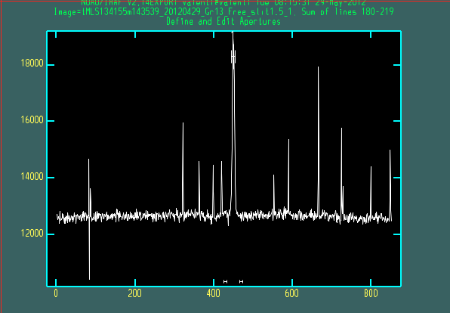

Trace apertures for tMLS134155m143539_20120429_Gr13_Free_slit1.5_1?Fit traced positions for tMLS134155m143539_20120429_Gr13_Free_slit1.5_1 interactively?Fit curve to aperture 1 of tMLS134155m143539_20120429_Gr13_Free_slit1.5_1 interactivelyWrite apertures for tMLS134155m143539_20120429_Gr13_Free_slit1.5_1 to databaseExtract aperture spectra for tMLS134155m143539_20120429_Gr13_Free_slit1.5_1?Review extracted spectra from tMLS134155m143539_20120429_Gr13_Free_slit1.5_1?Review extracted spectrum for aperture 1 from tMLS134155m143539_20120429_Gr13_Free_slit1.5_1?tMLS134155m143539_20120429_Gr13_Free_slit1.5_1_f.fits: MLS134155m143539
Extinction correction applied
Flux calibration applied

2) Ending of the program

#######################################
### end of reduction
### output files:
tMLS134155m143539_20120429_Gr13_Free_slit1.5_1_ex.fits
tMLS134155m143539_20120429_Gr13_Free_slit1.5_1_f.fits
tMLS134155m143539_20120429_Gr13_Free_slit1.5_1_2df.fits
tMLS134155m143539_20120429_Gr13_Free_slit1.5_1_f.asci

Preparing data for WISEREP

$ PESSTOWISE –h

Usage: PESSTOWISE listspectra [option]
> archiving spectra in WISE
Options:
--version show program's version number and exit
-h, --help show this help message and exit
-c CORRECTOBJ, --correctobj=CORRECTOBJ
file containing name of objects []

The fundamental input to make the script running is:
$ PESSTOWISE listspectra

The recommended syntax is:
$ PESSTOWISE listspectra –c listcandidates

listspectra is a list containg all the spectra obtained from the fast reduction (xxx_f.fits, yyy_f.fits, ecc)
option –c listcandidates (Important to replace the correct object name and coordinate in WISEREP)

output running the program in red:

Please give (at least), the family name of the observer
who observed the spectrum tCSS132702m014513_20120420_Gr13_Free_slit1.5_1_f.fits [UNKNOWN] ? VALENTI
Please give (at least), the family name of the reducer
who reduce the spectrum tCSS132702m014513_20120420_Gr13_Free_slit1.5_1_f.fits [NULL] ? VALENTI

### 201.758333333 -1.75361111111 CSS132702m014513
this line means that the object has been found in the list of candidates and those coordinates and name will be used in WISEREP
Now a number for different type of object has to be selected:

1 SN
2 SNI
3 SNIa
4 SNIb
5 SNIc
6 SNIb/c
7 SNIc-BL
8 SNIb-Ca-rich
9 SNIbn
10 SNII
11 SNIIP
12 SNII
13 SNIIn
14 SNIIb
20 PISN Pair Instability SN
24 LBV Luminous Blue Variable
25 ILRT Intermediate Luminosity Red Transient (=LRN)
26 CN Classical Nova
27 CV Cataclysmic Variable
28 Varstar Variable Star
29 AGN
30 Galax
50 Std-spec Spectrophotometric standard star
100 SN Ia-pec Peculiar Ia
101 SLSN-I
102 SN Ia-SC
103 SN Ia-91bg-like
104 SN Ia-91T-like
105 SN Ia-02cx-like
108 SN Ic-pec
110 SN II-pec
111 SLSN-II
112 SN IIn-pec
998 Unknown
999 Other

which kind of object tCSS132702m014513_20120420_Gr13_Free_slit1.5_1_f.fits [NULL] ?
which is the redshift of the host tCSS132702m014513_20120420_Gr13_Free_slit1.5_1_f.fits [NULL] ? 0.01
which type of spectra [[Object]/Host/Sky,Arcs] ?

All the information that will stored in WISEREP

CSS132702m014513 tCSS132702m014513_20120420_Gr13_Free_slit1.5_1_f.asci tCSS132702m014513_20120420_Gr13_Free_slit1.5_1_f.fits 2012-04-21 05:43:02.569 31 VALENTI 900 1.5 VALENTI NULL Final Object NULL NULL NULL 1.219 NULL Gr13 Free 201.758333333 -1.75361111111 NULL 3 0.01 NULL NULL tCSS132702m014513_20120420_Gr13_Free_slit1.5_1_2df.fits

__________________________________________________________________

