QUBA – Pipeline – spectra reduction
PURPOSE: Pipeline to reduce spectroscopy data (already pre-reduced)
DATE: 11th March 2009

PROGRAM NAMES:
qubaspectraredu.py

(working with NOT/AFOSC, WHT/ISIS, TNG/Dolores and Ekar/AFOSC)

> cd $USERPATH/data/qubaspectra/

- Create input list for qubaspectraredu.py

qubaprespec_v1.py created pre-reduced images with objects name e.g.:
HZ44_LR-B_1.0_arcsec_1.fits
HZ44_LR-R_1.0_arcsec_1.fits
HZ44_VHR-R_1.0_arcsec_1.fits
HZ44_VHR-V_1.0_arcsec_1.fits
SN2008aw_LR-B_1.0_arcsec_1.fits
SN2008aw_LR-R_1.0_arcsec_1.fits
SN2008ax_LR-B_1.0_arcsec_1.fits
SN2008ax_LR-R_1.0_arcsec_1.fits

The reducer should be able to disentangle the standard files and the SN files:

ls HZ*.fits > listastd (list of standard’s files)
ls SN*.fits > listasn (list of supernova’s files)

- Run qubaspectraredu.py first on the standard’s files, then on the SNe files:

If quba sourced
> qubaspectraredu.py @listastd -i

OR if quba not sourced
> /home/sne/QUBA/site-packages/pipeline/bin/qubaspectraredu.py listastd –I

on the screen (help of the program):
*******************************************************************************
*****************THIS IS THE STARTING PROGRAM FOR SPECTRA REDUCTION********************
****VERSION 1.1.1 C.TRUNDLE, S.VALENTINI 10/07 Original incomplete program****
*******************************************************************************
qubaspectraredu.py namelist
options:
-r = reverse dispersion axis
-i = interactive mode
-d = interactive dispersion line
-t = trace with a bright object
-s listsens = use specific sensitivity function (listsens is a list within the file name)
-a listarc = use specific arc file (listarc is a list within the file name)

the options:
–i is to reduce the spectra in an interactive way (better to use it)
-d give you the possibility to chose interactively where to chose the
profile(good for faint spectra with only few emission lines)
-r useful when they rotate the ccd (sometimes at NOT)
-t ask you interactively the file to trace (for faint objects)
-a useful if one wants to use particular arc (chosen interactively)
-s useful if one wants to use particular sens (chosen interactively)

the program summarize the reduction status of each file: extraction, wavelength calibration, flux calibration, atmospheric features correction.
The program search first in the same directory, than in the archive, a sensible curve and an arc with the same setup of each file And summarize the sensible curve and the arc available for each object.

on the screen:
####################################################################### OBJECT EXTRACTION WAV_CAL FLUX_CALIB ATMOSPHERIC_FEATURES HZ44_LR-B_1.0_arcsec_1.fits none none none none
HZ44_LR-R_1.0_arcsec_1.fits none none none none
HZ44_VHR-R_1.0_arcsec_1.fits none none none none
HZ44_VHR-V_1.0_arcsec_1.fits none none none none ###########################################################################

##################################################################
OBJECT SENSITIVITY CURVE AVAILABLE ARC AVAILABLE
HZ44_LR-B_1.0_arcsec_1.fits Available in the archive arc_HZ44_LR-B_1.0_arcsec_1.fits
HZ44_LR-R_1.0_arcsec_1.fits Available in the archive arc_HZ44_LR-R_1.0_arcsec_1.fits
HZ44_VHR-R_1.0_arcsec_1.fits WARNING sens not found arc_HZ44_VHR-R_1.0_arcsec_1.fits
HZ44_VHR-V_1.0_arcsec_1.fits WARNING sens not found arc_HZ44_VHR-V_1.0_arcsec_1.fits
#######################################################################

Starting from the first file of the list, the program asks if the object is a standard or not:

###################################################################
##### HZ44_LR-B_1.0_arcsec_1.fits
###################################################################
Is this object a standard [y/n] ? [y]

If the answer is ‘y’ the program will EXSTRACT the spectrum, wavelength CALIBRATE the spectrum, PRODUCE the SENSITIVITY curve , otherwise (if the object is not a standard) and the answer is ‘n’, The program will EXSTRACT, wavelength CALIBRATE, FLUX CALIBRATE and CORRECT for atmospheric features.

-EXTRATTION:
The extraction is performed using apall (optimizing the exstraction along the profile, subtracting the background and fitting the trace along the dispersion axis). If the option ‘–i’ is used all the parameters can be changed manually during the extraction.
On the screen:
### EXTRACTION IN INTERACTIVE MODE
Find apertures for Feige34_Grism_4_Slit_1.0_1? ('yes'):
Number of apertures to be found automatically (1):
Resize apertures for Feige34_Grism_4_Slit_1.0_1? ('yes'):
Edit apertures for Feige34_Grism_4_Slit_1.0_1? ('yes'):
Edit apertures for Feige34_Grism_4_Slit_1.0_1? ('yes'):
Trace apertures for Feige34_Grism_4_Slit_1.0_1?
Fit traced positions for Feige34_Grism_4_Slit_1.0_1 interactively?
Fit curve to aperture 1 of Feige34_Grism_4_Slit_1.0_1 interactively
Write apertures for Feige34_Grism_4_Slit_1.0_1 to database
Extract aperture spectra for Feige34_Grism_4_Slit_1.0_1?
Review extracted spectra from Feige34_Grism_4_Slit_1.0_1?
Review extracted spectrum for aperture 1 from Feige34_Grism_4_Slit_1.0_1?

- CALIBRATION 1:
the calibration is performed using the task reident and one arc file (with the same configuration) taken from archive (if more arc with the same configuration are available in the archive the closest in time is chosen)
on the screen:
######################################
### WAVELENGH CALIBRATION
LAMP EXTRACTION AND IDENTIFICATION
##### setup ['Grism_4', 'Slit_1.0']
##### lamp NeHe
arc_Feige34_Grism_4_Slit_1.0_1.fits Feige34_Grism_4_Slit_1.0_1.fits
add arc_20080114_Grism_4_Slit_1.0_1_ex.fits,lampid = NeHe
arc_20080114_Grism_4_Slit_1.0_1_ex.fits updated
arc_Feige34_Grism_4_Slit_1.0_1_ex - Ap 1 26/26 26/26 0.811 -2.52 -4.3E-4 0.22
Fit dispersion function interactively? (no|yes|NO|YES) ('yes'):
##########################################################################
WARNING: THE REDUCER HAS TO PRESS ‘f’ and ‘q’ to write the identification file in the database
##########################################################################

ask you if the identification is good. If in the pre-reduction the image was trimmed as the one in the archive, the identification probably will be good.

#### REIDENT FROM DATABASE
do you like the reidentification [y/n] [y] ?
example of good identification (RMS small)
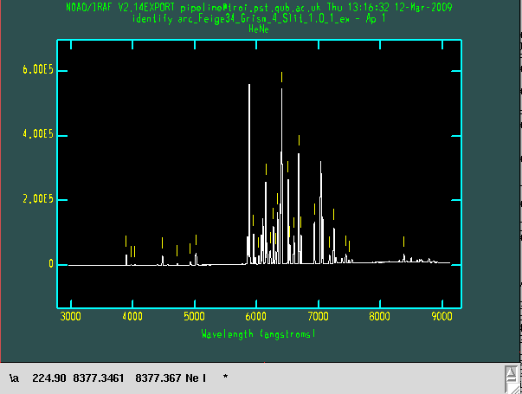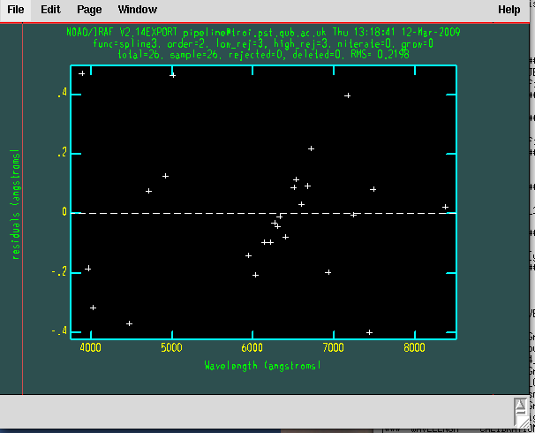

if the image was trimmed in a different way (respect the defoult trim or for other reasons the identification could be not good.
example of not good identification (RMS large)

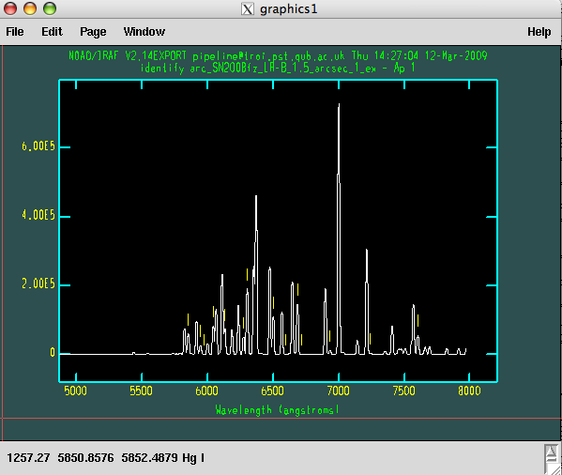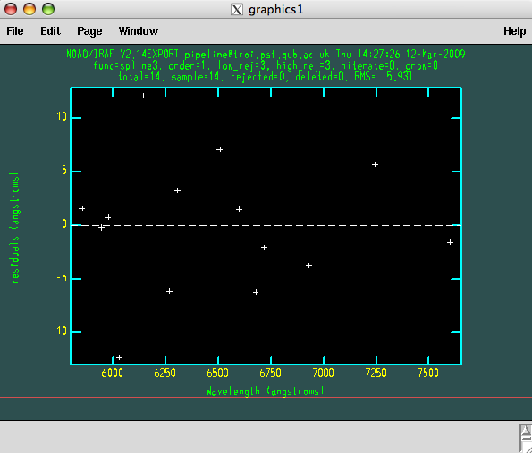

The program try to find a shift between the 2 configurations (archive and new data). If a shift is found ask you to identify again using this shift. Usually at this point the identification should be fine.
On the screen:
arc_Feige34_Grism_4_Slit_1.0_1_ex.fits,REFSPEC1: arc_Feige34_Grism_4_Slit_1.0_1_ex -> arc_20080114_Grism_4_Slit_1.0_1_ex.fits
arc_Feige34_Grism_4_Slit_1.0_1_ex.fits updated
arc_20080114_Grism_4_Slit_1.0_1_ex.fits,REFSPEC1: arc_SN2007rt_Grism_4_Slit_1.0_1_ex -> arc_20080114_Grism_4_Slit_1.0_1_ex.fits
arc_20080114_Grism_4_Slit_1.0_1_ex.fits updated
arc_Feige34_Grism_4_Slit_1.0_1_ex.fits: REFSPEC1 = 'arc_20080114_Grism_4_Slit_1.0_1_ex.fits 1.'
arc_Feige34_Grism_4_Slit_1.0_1_l.fits: ap = 1, w1 = 2964.021, w2 = 9120.722, dw = 3.001805, nw = 2052
arc_20080114_Grism_4_Slit_1.0_1_ex.fits: REFSPEC1 = 'arc_20080114_Grism_4_Slit_1.0_1_ex.fits 1.'
arc_20080114_Grism_4_Slit_1.0_1_l.fits: ap = 1, w1 = 2964.021, w2 = 9120.722, dw = 3.001805, nw = 2052
3
### Try again with the shift
#### automatic shift 3
cp: ./arc_20080114_Grism_4_Slit_1.0_1_ex.fits and arc_20080114_Grism_4_Slit_1.0_1_ex.fits are identical (not copied).
arc_Feige34_Grism_4_Slit_1.0_1_ex - Ap 1 26/26 26/26 0.811 -2.52 -4.3E-4 0.22
Fit dispersion function interactively? (no|yes|NO|YES) ('yes'):

if there are not arc file in the archive with the same configuration the program will use the task identify and the reducer has to identify all the lines manually.

-CALIBRATION CHECK:
after the spectrum is wavelength calibrated, the program check the wavelength calibration:
-if the object is a standard the calibration check is done using the atmospheric features. In particular, the program cut the atmospheric features from the standard spectrum and maximize the convolution with an archive file of amospheric features shifting back and forward the spectrum.

Warning: the wavelength calibration check is not performed for the blue arm of WHT since the spectrum does not extend enough in the red part (where the atmospheric features are prominent)

-if the object is not a standard the check is performed using the skylines present in the 3th dimension of the object file. In this case the program maximize the convolution of the sky lines of the object with one file from the archive.
The shift in wavelength found by the check is applied only if request.
On the screen:
### check wavelenght calibration

9125.48718527
SHIFT SPECTRUM OF 6
do you want to shift the spectrum [y/n] [y]? n
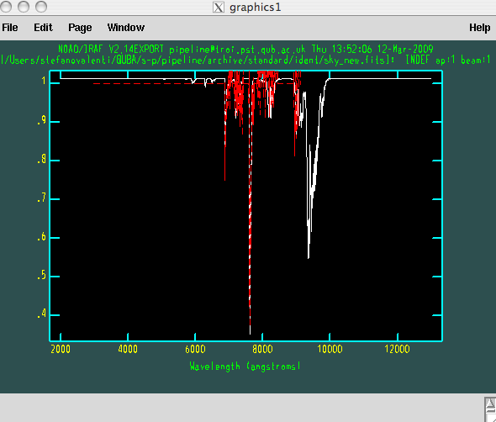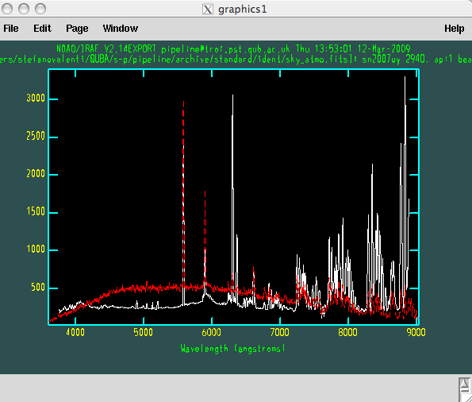

If the Telescoep is the NOT, the second order correction is applied
on the screen:
######################################################
########### SECOND ORDER CORRECTION
######################################################
c.Feige34_Grism_4_Slit_1.0_1_l.fits: REFSPEC1 = 'iraf1231k 1.'
c.Feige34_Grism_4_Slit_1.0_1_l.fits: ap = 1, w1 = 2963.78, w2 = 9125.49, dw = 3.004247, nw = 2052

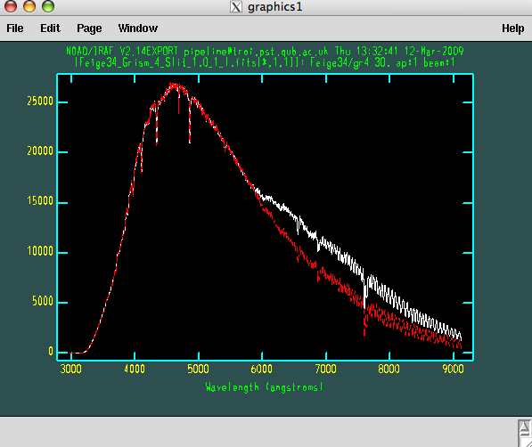

- PRODUCE THE SENSITIVITY CURVE:
If the object is a standard the sensitivity curve is produced. The program try to identify the standard from a list. If it does not find it, you should add the standard (asci) in: /pipeline/archive/standard/fluxstandard/
And the coordinate in:
/pipeline/archive/standard/fluxstandard/standardlist.txt
Then run again the pipeline. Once the standard is identified the program ask to split the sensitivity curve in 2 pieces or not. (still some problems, better select NO)

on the screen:
###############################################
###### SENSITIVITY CURVE
10.660414539 43.0992031527
mfeige34.dat 10.660414539 43.0992031527 0.00360895177639
############################################
Is this the right file ? [y/n] [y]
############################################
Do you want to compute the sensitivity curve in 2 ranges [y/n] [y]? n
cc.Feige34_Grism_4_Slit_1.0_1_l.fits(1): Feige34/gr4
cc.Feige34_Grism_4_Slit_1.0_1_l.fits[1]: Edit bandpasses? (no|yes|NO|YES|NO!|YES!) ('yes'):
Fit aperture 1 interactively? (no|yes|NO|YES) (no|yes|NO|YES) ('yes'):
add sens_cc.Feige34_Grism_4_Slit_1.0_1,TELESCOP = NOT
sens_cc.Feige34_Grism_4_Slit_1.0_1 updated
add sens_cc.Feige34_Grism_4_Slit_1.0_1,INSTRUME = ALFOSC_FASU
sens_cc.Feige34_Grism_4_Slit_1.0_1 updated
add sens_cc.Feige34_Grism_4_Slit_1.0_1,ALAPRTNM = Slit_1.0
sens_cc.Feige34_Grism_4_Slit_1.0_1 updated
add sens_cc.Feige34_Grism_4_Slit_1.0_1,ALGRNM = Grism_4
sens_cc.Feige34_Grism_4_Slit_1.0_1 updated
sens_cc.Feige34_Grism_4_Slit_1.0_1,OBJECT: "Sensitivity function for all apertures" -> Feige34/gr4
sens_cc.Feige34_Grism_4_Slit_1.0_1 updated
add sens_cc.Feige34_Grism_4_Slit_1.0_1,JD = 54477.69
sens_cc.Feige34_Grism_4_Slit_1.0_1 updated
add sens_cc.Feige34_Grism_4_Slit_1.0_1,DATE-OBS = 20080112
sens_cc.Feige34_Grism_4_Slit_1.0_1 updated
#### SENSITIVITY CURVE -> sens_cc.Feige34_Grism_4_Slit_1.0_1
#######################################################################
OBJECT EXTRACTION WAV_CAL FLUX_CALIB ATMOSPHERIC_FEATURES
Feige34_Grism_4_Slit_1.0_1.fits YES YES none none
#######################################################################
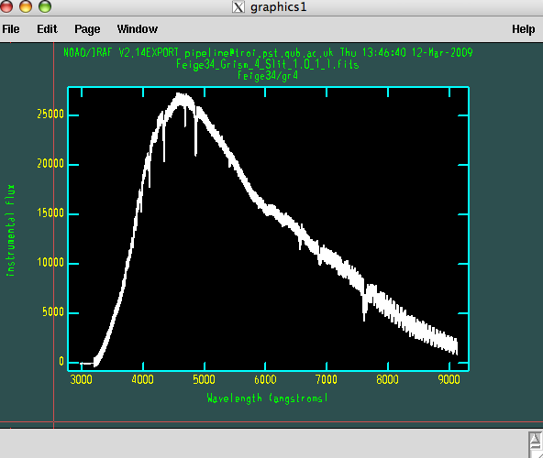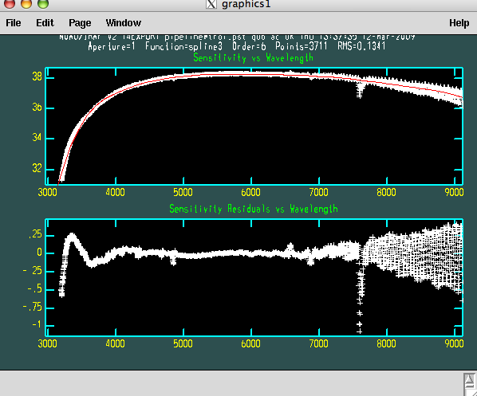

FLUX CALIBRATION:

If the object is not a standard the spectra will be flux calibrated using the sensitivity curve in the directory. If not sensitivity curve is available in the directory, the program will search in the archive.

ATMOSPHERIC FEATURES CORRECTION:
The pipeline try to correct also for atmospheric features asking for a file (usually the standard) that has to be used.
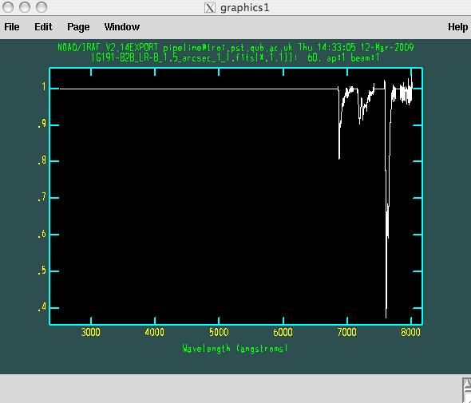
On the screen:

###################################################
##### FLUX CALIBRATION
SN2007uy_08D_Grism_4_Slit_1.0_1_l.fits sens_cc.Feige34_Grism_4_Slit_1.0_1.fits
SN2007uy_08D_Grism_4_Slit_1.0_1_f.fits: SN2007uy_08D/gr4
WARNING: 4 pixels outside of flux calibration limits
Extinction correction applied
Flux calibration applied
CALIBRATED SPECTRUM -> SN2007uy_08D_Grism_4_Slit_1.0_1_f.fits
Do you want to correct the spectrum from atmospheric features [y/n] [y] ?
cc.Feige34_Grism_4_Slit_1.0_1_l.fits
cc.SN2007uy_08D_Grism_4_Slit_1.0_1_l.fits
Feige34_Grism_4_Slit_1.0_1_l.fits
SN2007uy_08D_Grism_4_Slit_1.0_1_l.fits
which is the standard file you want to use [arc_20080114_Grism_4_Slit_1.0_1_l.fits] ? Feige34_Grism_4_Slit_1.0_1_l.fits
SN2007uy_08D_Grism_4_Slit_1.0_1_f.fits[*,1,2] -> SN2007uy_08D_Grism_4_Slit_1.0_1_e.fits[*,1,2]
SN2007uy_08D_Grism_4_Slit_1.0_1_f.fits[*,1,3] -> SN2007uy_08D_Grism_4_Slit_1.0_1_e.fits[*,1,3]
SN2007uy_08D_Grism_4_Slit_1.0_1_f.fits[*,1,4] -> SN2007uy_08D_Grism_4_Slit_1.0_1_e.fits[*,1,4]
#######################################################################
OBJECT EXTRACTION WAV_CAL FLUX_CALIB ATMOSPHERIC_FEATURES
SN2007uy_08D_Grism_4_Slit_1.0_1.fits YES YES YES YES
SN2007uy_08D_Grism_4_Slit_1.0_2.fits none none none none
SN2007uy_08D_Grism_4_Slit_1.0_3.fits none none none none
#######################################################################

do you want to go on with the next object [yes/no]? [yes]

All the steps are repeated for all the file in the list. The program will finish once all the file are reduced or if the reducer stop the reduction answering ‘no’:

#######################################################################
OBJECT EXTRACTION WAV_CAL FLUX_CALIB ATMOSPHERIC_FEATURES
SN2007uy_08D_Grism_4_Slit_1.0_1.fits YES YES YES YES
SN2007uy_08D_Grism_4_Slit_1.0_2.fits YES YES YES YES
SN2007uy_08D_Grism_4_Slit_1.0_3.fits YES YES YES YES
#######################################################################

END

