QUBA – Pipeline

Index
1) Introduction
2) Installation
3) Pre-reduction:
3.1) qubareduorganize.py
3.2) qubaprespec_v1.py
3.3) qubaprephot_v1.py
3.4) qubaregister.py

4) Spectra-reduction
4.1) qubaspectraredu.py

5) Photometry-reduction
5.1) qubaref
5.2) qubastd
5.3) qubapsf
5.4) qubasn
5.5) qubaph
5.6) qubaresnoopy
5.7) resnoopy
5.8) exa

1) Introduction
The Queen’s University python package (PPQUB) is a set of commands developed to allow fast spectroscopic and photometric reduction of raw (or pre-reduced) data coming from several telescopes. It has been written in python using the following basic packages: pyraf, scipy, matplotlib, wx. These modules are included in the scisoft package distributed by ESO, or they can be easily installed on other operative systems. The pipeline has been tested on the following OS: Mac, fedora, centos and ubuntu; but it should work also on all the other system where scisoft can be installed. In section 1 we will describe how the install the pipeline.
There are 3 main part of the pipeline: Prereduction (section 2),
Spectra reduction (section 3) and photometry reduction (section 4)

2) Installation
The complete tar of the pipeline is avavailable at the following link:
xxx
xxx

3) Pre-reduction.
This part of the pipeline has been developed for the following telescope-instrument configurations: TNG+Dolores, Ekar+Afosc, NOT+Afosc, NTT+Efosc, WHT+ISIS, Calaralto+Cafosc.
The pipeline should be able to recognize the different file and leads the reducer to a complete prereduction: trimming,overscan,bias correction, flatfielding correction.

PURPOSE: Pipeline to do pre-reductions steps for spectroscopy and photometry
DATE: 11th March 2009

PROGRAM NAMES:
qubareduorganize.py,
qubaprespec_v1.py,
qubaprephot_v1.py

-qubareduorganize.py - split data into spectroscopy and photometry directories
(working for telescopes WHT,NOT,EKAR,TNG)

qubareduorganize.py @listimages -> qubaspectra/
qubaimages/

listimages = list of images (fits,fit,fts; one/multi-dimensional files)

-qubaprespec_v1.py - basic reduction procedures for spectroscopy

qubaprespec_v1.py @listfiles
options: -r reverse dispersion direction
-b no bias correction
-f no flat correction
-i interactively

(works for the Telescope setups
WHT/ISIS, TNG/Dolores, NOT/ALFOSC, Ekar/AFOSC, NTT+EFOSC?)

-qubprephot_v1.py - basic reduction procedures for photometry

qubaprephot_v1.py @listimages
options: -i interactive way (strongly suggested, give the possibility to
check the flats,trim and overscan)
-b no bias correction
-f no flat correction
-F chose Flat (interactively)
-B chose Bias (interactively)

(works forTelescope setups.
WHT/AUX, TNG/Dolores, NOT/ALFOSC, Asiago/AFOSC)
!!!!!!!!!!!!!!!!!!!!!!!!!!!!!!! WARNING !!!!!!!!!!!!!!!!!!!!!!!!!!!!!!!!!!!!!!!!
THIS IS A PIPELINE BUT SHOULD NOT TO BE USED ENTIRELY AS A BLACK BOX.
OFTEN TEST IMAGES ARE TAKEN DURING THE NIGHT AND SO YOU SHOULD ALWAYS CHECK THAT THE
CALIBRATION FILES THE PIPELINE USES ARE THE APPROPRIATE ONES. EVEN BETTER MOVE ANY
USELESS FILE INTO ANOTHER DIRECTORY
STEP by STEP

The following notes assume you are running the pipeline from QUB ARC
computers.

Getting Started:
- You should source quba or set an alias in your .tcshrc file

source /home/sne/bin/qubastart_tcsh or export /home/sne/bin/qubastart_bash
eg. setting alias: alias quba source /home/sne/bin/qubastart_tcsh

You need to have only one nights observations in a directory in your scratch or
home space.eg $USERPATH/data

ie. > cd $USERPATH/data/

Prior to running the main program, the following program should be used to separate
photometric and spectroscopic data.

- Create input list for qubareduorganize.py

> ls *.fits > lista
lista is the input file for qubareduorganize.py. It should contain only raw spectral
frames. You should use iraf and imhead to check these files to remove and test images
that may have been taken during the night.
(also easy to use is eclipse dfits & fitsort)

QUBAREDUORGANIZE
- If quba sourced
>qubareduorganize @lista (or image1.fits,image2.fits,image3.fits…)

- OR if quba not sourced

> /home/sne/QUBA/site-packages/pipeline/bin/qubareduorganize.py lista

This separates the photometry and spectroscopy related files in to different
folders. It also checks which files are good or not. If it doesn't recognise a
file type it will display this in ds9 and ask you what type of file it is. You
will get the options below:
BIAS [1] IMAGE [2] SPECTRUM [3] or NOT GOOD [4] ? [0] 4

mostly this occurs for images which are corrupt and best to use option 4.

- Do an 'ls' on your $USERPATH/data/ directory.
>ls $USERPATH/data/

Aside from the raw data files you should now have two directories
qubaimages and qubaspectra. The reductions for each should be carried out in the appropriate directory. Bias frames are copied to both directories. This also
removes any frames which cannot be opened by iraf eg. null frames.

on the screen:
ALsb210004.fits[1][200,2052][ushort]: HeNe
### ok use first dimension of file ALsb210004.fits[1]
ALsb210005.fits[1][200,2052][ushort]: HeNe
### ok use first dimension of file ALsb210005.fits[1]
…
### TELESCOPE= NOT
3.0 Grism_4 200.0 2052.0
ALsb210004.fits[1] -> SPECTRUM
3.0 Grism_4 200.0 2052.0
ALsb210005.fits[1] -> SPECTRUM
....
ALsb210454.fits[1] -> qubaimages/qu_ALsb210454
ALsb210455.fits[1] -> qubaspectra/qu_ALsb210455
…

QUBAPRESPEC
> cd $USERPATH/data/qubaspectra

- Create input list for qubaprespec_v1.py

> ls *.fits > lista

lista is the input file for qubaprespec. It should contain only raw spectral
frames.

- If quba sourced
> qubaprespec @lista

- OR if quba not sourced

> /home/sne/QUBA/site-packages/pipeline/bin/qubaprespec_v1.py lista

A log file is open and written to qubaccdreduc.log

STEP0: Check dimension
The program list all the file and check if the dimensions are different.
If files have different dimensions it will ask to go on or stop.
Sometimes NOT and WHT objects are trimmed, while bias not.
The pipeline should be able to go on also with different dimensions but please take a look the list of files before go on and eventually cancel from the list files you don’t need.

On the screen:
qu_ALsb210467.fits[2198,2052][ushort]: 1510-089
qu_ALsb210468.fits[2198,2052][ushort]: 1510-089
### Warning: images with different dimensions !!!
Do you want to go on [y/n] ? [y]

STEP1: Preparing lists

The program first checks all files are creates lists of flats, bias, arcs,
science frames. The program also check if the images are all of te same size.
If the spectra are trimmed, the program try to repeat the operation on the bias,flat,arc (if those are not trimmed).
In the early stages you should check that these are appropriate
as they are organised using Keywords and these can be tempermental.
These should produce files such as
arclist_[TELESCOPE]
flatlist_[TELESCOPE]
biaslist_[TELESCOPE]
objlist_[TELESCOPE]

on the screen:
STEP 1: Creating lists of flats, bias, arcs, science frames.....
### TELESCOPE= WHT

If files have different dimension will check that there are bias,flat and arc with same dimensions than objects

on the screen:
check dimension arc, flat, bias .....
#######
dimension and window for objects = ['536,2350', '1071,4700',
'611,2100', '1221,4200'] ['[500:1570,1:4700]', '[500:1570,1:4700]',
'[460:1680,1:4200]', '[460:1680,1:4200]']
dimensnion bias = ['536,2350', '611,2100']
dimension flat = ['536,2350', '1071,4700', '611,2100', '1221,4200']
dimension arc = ['536,2350', '611,2100']
######
536,2350
######
## arc with objects dimension .536,2350... ok
flat with objects dimension .... ok
bias with objects dimension .... ok
######
1221,4200
######
No bias with objects dimension 1221,4200 …
Try to cut bias ….
Do you want to try to cut [xx:yy,xx:yy] bias with dimension 2048,2048 [y] ?

STEP2: Preparing lists contd.

The flat and arc frames will then be split in to lists depending on the grism
and slitwidths you should now have files such as
flatlist_[grism]
arclist_[grism]_[slitw]

The bias and flat field files are then split into files depending on time, as
multiple groups of flats and biases can be taken during the night. Usually at
the beginning and end. These are numbered 1 to x and you get something like:
biaslist_[TELESCOPE]_1
biaslist_[TELESCOPE]_2
flatlist_[grism]_1
flatlist_[grism]_2

This accounts for nodichroic and dichroic for the WHT and is recorded in the
naming of the files.

On the screen:
STEP 2: Completed.
################Splitting bias files############################
First file: biaslist_20090222_NOT_1
################Split bias files############################
################Splitting flat files############################
flatlist_20090222_NOT
flatlist_Grism_4
First file: flatlist_Grism_4_1
Creating new file: flatlist_Grism_4_2
Creating new file: flatlist_Grism_4_3
################Split flat files############################

STEP3:Creating Masterbias

All bias files are used to create masterbiases. If the stddev is too large a
file will be omitted. The biases are combined using the median. If there are
less than 3 biases in the file you will be asked if you want to create a bias.
This is up to you, generally these are test biases and not worth it. Default
answer is n.

LESS THAN 3 BIASES DO YOU STILL WANT TO CONTINUE? [y/n]

On the screen:
STEP 3: Creating Masterbias.....
biaslist_20090222_NOT_1
2198,2052 20090222 #######
**********Creating masterbias**********
qu_ALsb210465.fits 366.3357 9.723936
qu_ALsb210466.fits 365.5299 13.60359
qu_ALsb210467.fits 365.0984 12.33536
qu_ALsb210468.fits 364.877 10.85242
removed qu_ALsb210456.fits
File stddev
masterbias_20090222_NOT_1.fits 367.745 7.983512
********** masterbias created **********

STEP4: Timming, debiasing, flatfielding

Once completed the object file will be read and for each object the code checks
for wether or not there is a bias, arc and flat available in the directory
with the same set up. You can have different outcomes:

STATUS=0) If there is an appropriate bias,arc and flat are available in the directory it will
carryout the reductions with theses

STATUS=1) if bias ,arc or flat are not available in the working directory but are available in the archive

STATUS=-1) If there is a bias and flat field in the directory but no arc with the same slit
it will say that there is an arc but with different slit and will display them
for you to check if you want to use one.

Bias, Flat available in this directory !!
Warning: arc not available with the same slit
checking if arc available with a different slit......
['LR-B']
arclist_LR-R_1.5_arcsec
arclist_20071216_TNG
arclist_VHR-V_1.5_arcsec
Do you want to use an arc from one of these lists [y/n]? [y]

if you answer n then it will check the archive if no appropriate arc is
available it will not reduce the object but will create a file with
[objname]_[grism]_[slitw]_x.fits. x being the number of the exposures for the
object.

IF STATUS=0 it will select and trim the masterbias and create a masterflat.
It selects the closest in time masterbias frame to the observation.
It will tell you the default trim parameters and ask you if you want to change
them.
#### trim = [70:2090,50:1200]
#### overscan = [1:2100,2060:2100]

Do you want to select different trim and overscan [y,n] ? [n]

If you enter 'y' it will display the frame and you can use iraf/imexam to check
out the parameters you want. After using 'q' to exit imexam mode you will be
asked to input new values. this must be done with the iraf format shown above.

If you enter 'n' it will trim everything with these values.
It first trims the masterbias and creates the file 't'+masterbias

Next it will search for the nearest in time file of flats. It will then combine
these and create a masterflat unless one already exists with the same setup in
the directory.

If the object has the same setup as the previous object it will just use the
flat from that setup

if the next object has a different setup it will appear a ### ‘NEW SETUP’
and the trimming and overscan will be resetted as default.

After trimming and debiassing the flat it will ask you wether or not you wish to
normalise the flat. For spectroscopy it is unwise not to.

DO YOU WISH TO NORMALISE THE MASTERFLAT (only say yes for spectra)[y/n] [y]

This brings you into iraf/response interactive mode. To change the order of the
fit enter ':o xx' where xx is the order number. enter 'f' to fit the polynomial.
'q' to exit.

It will then trim, debias, and flatfield the object and nearest in time arc to
the object with the trimmed masterbias and flatfield. If more arc are available the program asks which one to use (with also the possibility to use more than one arc)

The output is then the:
[objname]_[grism]_[slitw]_x.fits.
x being the number of the exposures for the object.
arc_[objname]_[grism]_[slitw]_x.fits

After each object you have the option to exit or not.

Do you want to pre-reduce next object [y/n] ? [y]
if 'y' then it will continue to reduce the next object.
if 'n' it will ask wether or not you wish to exit the program.
Do you want to terminate the reduction process [y/n] ? [y]

If you manage to exit cleanly you should obtain the following message:
END OF CCD REDUCTION

On the screen:
WAIT ....checking bias,flat,arc for each object
it can take couple of minutes
#################### SN2000ch SETUP: ['Grism_4', 'Slit_1.3']
Bias, Flat and Arc available in this directory !!
reduction possible without using archive data !!
Search for the bias or for the bias list
Search for the flat or for the flat list
Search for the arclist
…
########################################################
#### OBJECT = qu_ALsb210441.fits
#### OBJECT NAME = BD332642
#### SETUP = ['Grism_4', 'Slit_1.3']
#### STATUS = 0
#### BIAS = masterbias_20090222_NOT_2.fits
#### NEW SETUP #####
### Overscan (default)
#### trim = [10:190,1:2052]
#### overscan =
Do you want to select different trim and overscan [y,n] ? [n]
#### trim = [10:190,1:2052]
#### overscan =
masterbias_20090222_NOT_2.fits -> tmasterbias_20090222_NOT_2.fits
tmasterbias_20090222_NOT_2.fits: Mar 12 10:49 Trim data section is [10:190,1:2052]
### Same configuration as previous object
### USE SAME FLAT
### TRIM OBJECT FILE: BD332642_Grism_4_Slit_1.3 qu_ALsb210441.fits
### more than one lamp available
### chose which one you want to use for the spectrum:
BD332642_Grism_4_Slit_1.3
#### lamps available ####
qu_ALsb210004.fits NeHe
qu_ALsb210005.fits NeHe
qu_ALsb210006.fits NeHe
### closest one: qu_ALsb210006.fits NeHe
### if you want to sum 2 arc report both separated by "," ###
which lamp do you want to use [qu_ALsb210006.fits] ?
qu_ALsb210441.fits -> BD332642_Grism_4_Slit_1.3_1.fits
BD332642_Grism_4_Slit_1.3_1.fits: Mar 12 10:49 Trim data section is [10:190,1:2052]
BD332642_Grism_4_Slit_1.3_1.fits: Mar 12 10:49 Zero level correction image is tmasterbias_20090222_NOT_2.fits
BD332642_Grism_4_Slit_1.3_1.fits: Mar 12 10:49 Flat field image is ntmasterflat_20090222_NOT_Grism_4_2.fits with scale=1.000075
#################### ARC FILE USED:qu_ALsb210006.fits
qu_ALsb210006.fits: Mar 12 10:49 Trim data section is [10:190,1:2052]
qu_ALsb210006.fits: Mar 12 10:49 Zero level correction image is tmasterbias_20090222_NOT_2.fits
qu_ALsb210006.fits: Mar 12 10:49 Flat field image is ntmasterflat_20090222_NOT_Grism_4_2.fits with scale=1.000075
#### OUTPUT -> BD332642_Grism_4_Slit_1.3_1.fits
##############################################
next object = qu_ALsb210332.fits
Do you want to pre-reduce next object [y/n] ? [y]

QUBAPREPHOT

> cd $USERPATH/data/qubaimages

- Create input list for qubprephot_v1.py

> ls *.fits > lista

lista is the input file for qubaprephot. It should contain only raw imaging
frames.

- If quba sourced
>qubaprephot @lista

- OR if quba not sourced

> /home/sne/QUBA/site-packages/pipeline/bin/qubaprephot_v1.py lista

A log file is open and written to qubaprephot.log

STEP1: Preparing lists
The program first checks all files are creates lists of flats, bias, and
science frames. In the early stages you should check that these are appropriate
as they are organised using Keywords and these can be tempermental.
These should produce files such as
flatlist_[DATE]_[TELESCOPE]
biaslist_[DATE]_[TELESCOPE]
objlist_[DATE]_[TELESCOPE]

on the screen:
qu_ALra110167.fits[2198,2052][ushort]: skyflat
qu_ALra110168.fits[2198,2052][ushort]: skyflat
qu_ALra110169.fits[2198,2052][ushort]: skyflat
qu_ALra110170.fits[2198,2052][ushort]: skyflat
STEP 1: Creating lists of flats, bias, science frames.....
### TELESCOPE= NOT

STEP2: Preparing lists contd.
The flat frames will then be split in to lists depending on the filter. You
should now have files such as
flatlist_[filter]

The bias and flat field files are then split into files depending on time, as
multiple groups of flats and biases can be taken during the night. Usually at
the beginning and end. These are numbered 1 to x and you get something like:
biaslist_[DATE]_[TELESCOPE]_1
biaslist_[DATE]_[TELESCOPE]_2
flatlist_[filter]_1
flatlist_[filter]_2
on the screen:
STEP 2: Create list for each object setup based on filter.
########### Setting up lists for objlist_20080112_NOT##################
STEP 2: Completed.
################Splitting bias files############################
First file: biaslist_20080111_NOT_1
Creating new file: biaslist_20080111_NOT_2
################Split bias files############################
################Splitting flat files############################
Flatfile to split: flatlist_20080111_NOT
Flatfile to split: flatlist_B
First file: flatlist_B_1
Flatfile to split: flatlist_I
First file: flatlist_I_1
Creating new file: flatlist_I_2
Creating new file: flatlist_I_3
################Split flat files############################

STEP3:Creating Masterbias
All bias files are used to create masterbiases. If the stddev is too large a
file will be omitted. The biases are combined using the median. If there are
less than 3 biases in the file you will be asked if you want to create a bias.
This is up to you, generally these are test biases and not worth it. Default
answer is n.

LESS THAN 3 BIASES DO YOU STILL WANT TO CONTINUE? [y/n]
On the screen
STEP 3: Creating Masterbias.....
biaslist_20080111_NOT_2
**********Creating masterbias**********
qu_ALra110002.fits 357.3237 9.878704
qu_ALra110003.fits 362.1845 8.891912
qu_ALra110004.fits 365.6215 9.821987
qu_ALra110005.fits 368.6716 13.5901
qu_ALra110006.fits 370.6486 9.224317
removed qu_ALra110005.fits
File stddev
masterbias_20080111_NOT_1.fits 363.9546 8.219254
********** masterbias created **********
biaslist_20080111_NOT_1

STEP4: Timming, debiasing, flatfielding

Once completed the object file will be read and for each object the code checks
for wether or not there is a bias, and flat available in the directory
with the same set up. You can have different outcomes:

STATUS=0) If there is an appropriate bias and flat available in the directory it will
carryout the reductions with these

STATUS=-1)If there no bias and flat field in the directory it will check the archive
if no appropriate files are available it will not reduce the object but will create
a file with [objname]_[filter]_x.fits. x being the number of the exposures
for the object.

IF STATUS=0 it will select and trim the masterbias and create a masterflat.
It selects the closest in time masterbias frame to the observation.
It will tell you the default trim parameters and ask you if you want to change
them.
#### trim = [70:2090,50:1200]
#### overscan = [1:2100,2060:2100]

Do you want to select different trim and overscan [y,n] ? [n]

If you enter 'y' it will display the frame and you can use iraf/imexam to check
out the parameters you want. After using 'q' to exit imexam mode you will be
asked to input new values. this must be done with the iraf format shown above.

If you enter 'n' it will trim everything with these values.
It first trims the masterbias and creates the file 't'+masterbias

Next it will search for the nearest in time file of flats. It will then combine
these and create a masterflat unless one already exists with the same setup in
the directory.
On the screen:

########################################################
#### OBJECT = qu_ALra110090.fits
#### OBJECT NAME = SN2007uy_08D/V
#### SETUP = ['V']
#### STATUS = 0
#### BIAS = masterbias_20080111_NOT_1.fits
#### trim = [55:2100,1:2037]
#### overscan = [3:50,1:2037]
masterbias_20080111_NOT_1.fits -> tmasterbias_20080111_NOT_1.fits
tmasterbias_20080111_NOT_1.fits: Mar 12 12:31 Trim data section is [55:2100,1:2037]
tmasterbias_20080111_NOT_1.fits: Mar 12 12:31 Overscan section is [3:50,1:2037] with mean=364.2956
### Same configuration as previous object
### USE SAME FLAT
### TRIM OBJECT FILE: SN2007uy_08D_20080112_V qu_ALra110090.fits
qu_ALra110090.fits -> SN2007uy_08D_20080112_V_3.fits
SN2007uy_08D_20080112_V_3.fits: Mar 12 12:31 Trim data section is [55:2100,1:2037]
SN2007uy_08D_20080112_V_3.fits: Mar 12 12:31 Overscan section is [3:50,1:2037] with mean=364.8301
SN2007uy_08D_20080112_V_3.fits: Mar 12 12:31 Zero level correction image is tmasterbias_20080111_NOT_1.fits
SN2007uy_08D_20080112_V_3.fits: Mar 12 12:31 Flat field image is tmasterflat_20080112_NOT_V_1.fits with scale=17403.54
#### OUTPUT -> SN2007uy_08D_20080112_V_3.fits
##############################################

If option –i is selected it will show all the flat asking to accept or not the file.
If more set of flat are available will also print the first file of each set and ask which one to use (or all)
on the screen:
flat list: flatlist_V_1
z1=13829.36 z2=20300.
Is it this flat ok ? [y/n] [y] ?
z1=13013.91 z2=19221.
Is it this flat ok ? [y/n] [y] ?
z1=13136.68 z2=19446.
Is it this flat ok ? [y/n] [y] ?
#### masterflat masterflat_20080112_NOT_V_1.fits
--------
################################
more than one set of flat available .... interactive chosen !!!
################################
### First flat of list flatlist_I_1 ####
### skyflat ###
z1=10635.07 z2=16124.
################################
more than one set of flat available .... interactive chosen !!!
################################
### First flat of list flatlist_I_2 ####
### skyflat ###
z1=429.4302 z2=654.7954
################################
more than one set of flat available .... interactive chosen !!!
################################
### First flat of list flatlist_I_3 ####
### skyflat ###
z1=9087.821 z2=13840.
flatlist_I (select this one to use all images)
flatlist_I_1
flatlist_I_2
flatlist_I_3
Which list do you want to use [flatlist_I_2]? flatlist_I_2
COMBINE FLAT FILES (without trim and bias)

If the object has the same setup as the previous object it will just use the
flat from that setup

After trimming and debiassing the flat it will ask you wether or not you wish to
normalise the flat. For spectroscopy it is unwise not to.

DO YOU WISH TO NORMALISE THE MASTERFLAT (only say yes for spectra)[y/n] [y]

This brings you into iraf/response interactive mode. To change the order of the
fit enter ':o xx' where xx is the order number. enter 'f' to fit the polynomial.
'q' to exit.

It will then trim, debias, and flatfield the object with the trimmed masterbias
and flatfield.

The output is then the [objname]_[filter]_x.fits. x being the number of
the exposures for the object.

After each object you have the option to exit or not.

Do you want to pre-reduce next object [y/n] ? [y]
if 'y' then it will continue to reduce the next object.
if 'n' it will ask wether or not you wish to exit the program.
Do you want to terminate the reduction process [y/n] ? [y]

If you manage to exit cleanly you should obtain the following message:
END OF CCD REDUCTION

QUBA – Pipeline – spectra reduction
PURPOSE: Pipeline to reduce spectroscopy data (already pre-reduced)
DATE: 11th March 2009

PROGRAM NAMES:
qubaspectraredu.py

(working with NOT/AFOSC, WHT/ISIS, TNG/Dolores and Ekar/AFOSC)

> cd $USERPATH/data/qubaspectra/

- Create input list for qubaspectraredu.py

qubaprespec_v1.py created pre-reduced images with objects name e.g.:
HZ44_LR-B_1.0_arcsec_1.fits
HZ44_LR-R_1.0_arcsec_1.fits
HZ44_VHR-R_1.0_arcsec_1.fits
HZ44_VHR-V_1.0_arcsec_1.fits
SN2008aw_LR-B_1.0_arcsec_1.fits
SN2008aw_LR-R_1.0_arcsec_1.fits
SN2008ax_LR-B_1.0_arcsec_1.fits
SN2008ax_LR-R_1.0_arcsec_1.fits

The reducer should be able to disentangle the standard files and the SN files:

ls HZ*.fits > listastd (list of standard’s files)
ls SN*.fits > listasn (list of supernova’s files)

- Run qubaspectraredu.py first on the standard’s files, then on the SNe files:

If quba sourced
> qubaspectraredu.py @listastd -i

OR if quba not sourced
> /home/sne/QUBA/site-packages/pipeline/bin/qubaspectraredu.py listastd –I

on the screen (help of the program):
*******************************************************************************
*****************THIS IS THE STARTING PROGRAM FOR SPECTRA REDUCTION********************
****VERSION 1.1.1 C.TRUNDLE, S.VALENTINI 10/07 Original incomplete program****
*******************************************************************************
qubaspectraredu.py namelist
options:
-r = reverse dispersion axis
-i = interactive mode
-d = interactive dispersion line
-t = trace with a bright object
-s listsens = use specific sensitivity function (listsens is a list within the file name)
-a listarc = use specific arc file (listarc is a list within the file name)

the options:
–i is to reduce the spectra in an interactive way (better to use it)
-d give you the possibility to chose interactively where to chose the
profile(good for faint spectra with only few emission lines)
-r useful when they rotate the ccd (sometimes at NOT)
-t ask you interactively the file to trace (for faint objects)
-a useful if one wants to use particular arc (chosen interactively)
-s useful if one wants to use particular sens (chosen interactively)

the program summarize the reduction status of each file: extraction, wavelength calibration, flux calibration, atmospheric features correction.
The program search first in the same directory, than in the archive, a sensible curve and an arc with the same setup of each file And summarize the sensible curve and the arc available for each object.

on the screen:
####################################################################### OBJECT EXTRACTION WAV_CAL FLUX_CALIB ATMOSPHERIC_FEATURES HZ44_LR-B_1.0_arcsec_1.fits none none none none
HZ44_LR-R_1.0_arcsec_1.fits none none none none
HZ44_VHR-R_1.0_arcsec_1.fits none none none none
HZ44_VHR-V_1.0_arcsec_1.fits none none none none ###########################################################################

##################################################################
OBJECT SENSITIVITY CURVE AVAILABLE ARC AVAILABLE
HZ44_LR-B_1.0_arcsec_1.fits Available in the archive arc_HZ44_LR-B_1.0_arcsec_1.fits
HZ44_LR-R_1.0_arcsec_1.fits Available in the archive arc_HZ44_LR-R_1.0_arcsec_1.fits
HZ44_VHR-R_1.0_arcsec_1.fits WARNING sens not found arc_HZ44_VHR-R_1.0_arcsec_1.fits
HZ44_VHR-V_1.0_arcsec_1.fits WARNING sens not found arc_HZ44_VHR-V_1.0_arcsec_1.fits
#######################################################################

Starting from the first file of the list, the program asks if the object is a standard or not:

###################################################################
##### HZ44_LR-B_1.0_arcsec_1.fits
###################################################################
Is this object a standard [y/n] ? [y]

If the answer is ‘y’ the program will EXSTRACT the spectrum, wavelength CALIBRATE the spectrum, PRODUCE the SENSITIVITY curve , otherwise (if the object is not a standard) and the answer is ‘n’, The program will EXSTRACT, wavelength CALIBRATE, FLUX CALIBRATE and CORRECT for atmospheric features.

-EXTRATTION:
The extraction is performed using apall (optimizing the exstraction along the profile, subtracting the background and fitting the trace along the dispersion axis). If the option ‘–i’ is used all the parameters can be changed manually during the extraction.
On the screen:
### EXTRACTION IN INTERACTIVE MODE
Find apertures for Feige34_Grism_4_Slit_1.0_1? ('yes'):
Number of apertures to be found automatically (1):
Resize apertures for Feige34_Grism_4_Slit_1.0_1? ('yes'):
Edit apertures for Feige34_Grism_4_Slit_1.0_1? ('yes'):
Edit apertures for Feige34_Grism_4_Slit_1.0_1? ('yes'):
Trace apertures for Feige34_Grism_4_Slit_1.0_1?
Fit traced positions for Feige34_Grism_4_Slit_1.0_1 interactively?
Fit curve to aperture 1 of Feige34_Grism_4_Slit_1.0_1 interactively
Write apertures for Feige34_Grism_4_Slit_1.0_1 to database
Extract aperture spectra for Feige34_Grism_4_Slit_1.0_1?
Review extracted spectra from Feige34_Grism_4_Slit_1.0_1?
Review extracted spectrum for aperture 1 from Feige34_Grism_4_Slit_1.0_1?

- CALIBRATION 1:
the calibration is performed using the task reident and one arc file (with the same configuration) taken from archive (if more arc with the same configuration are available in the archive the closest in time is chosen)
on the screen:
######################################
### WAVELENGH CALIBRATION
LAMP EXTRACTION AND IDENTIFICATION
##### setup ['Grism_4', 'Slit_1.0']
##### lamp NeHe
arc_Feige34_Grism_4_Slit_1.0_1.fits Feige34_Grism_4_Slit_1.0_1.fits
add arc_20080114_Grism_4_Slit_1.0_1_ex.fits,lampid = NeHe
arc_20080114_Grism_4_Slit_1.0_1_ex.fits updated
arc_Feige34_Grism_4_Slit_1.0_1_ex - Ap 1 26/26 26/26 0.811 -2.52 -4.3E-4 0.22
Fit dispersion function interactively? (no|yes|NO|YES) ('yes'):
##########################################################################
WARNING: THE REDUCER HAS TO PRESS ‘f’ and ‘q’ to write the identification file in the database
##########################################################################

ask you if the identification is good. If in the pre-reduction the image was trimmed as the one in the archive, the identification probably will be good.

#### REIDENT FROM DATABASE
do you like the reidentification [y/n] [y] ?
example of good identification (RMS small)
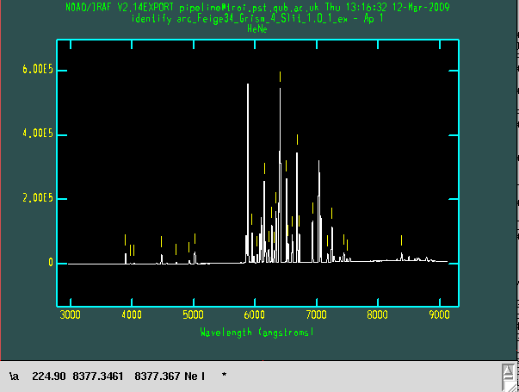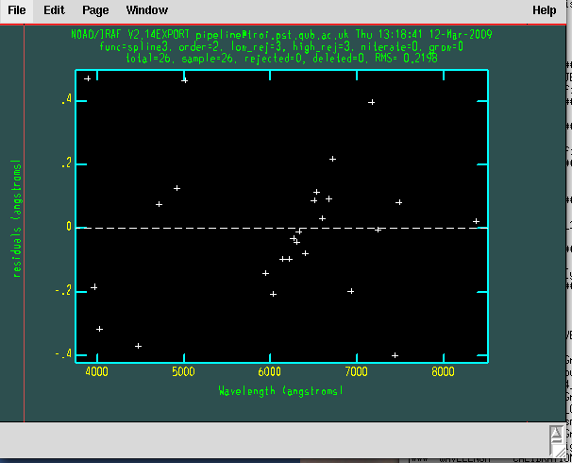

if the image was trimmed in a different way (respect the defoult trim or for other reasons the identification could be not good.
example of not good identification (RMS large)

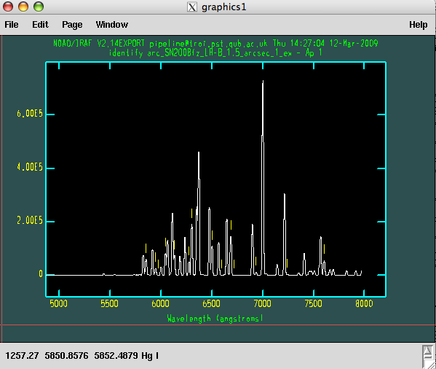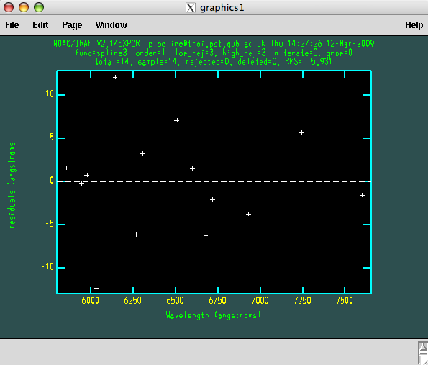

The program try to find a shift between the 2 configurations (archive and new data). If a shift is found ask you to identify again using this shift. Usually at this point the identification should be fine.
On the screen:
arc_Feige34_Grism_4_Slit_1.0_1_ex.fits,REFSPEC1: arc_Feige34_Grism_4_Slit_1.0_1_ex -> arc_20080114_Grism_4_Slit_1.0_1_ex.fits
arc_Feige34_Grism_4_Slit_1.0_1_ex.fits updated
arc_20080114_Grism_4_Slit_1.0_1_ex.fits,REFSPEC1: arc_SN2007rt_Grism_4_Slit_1.0_1_ex -> arc_20080114_Grism_4_Slit_1.0_1_ex.fits
arc_20080114_Grism_4_Slit_1.0_1_ex.fits updated
arc_Feige34_Grism_4_Slit_1.0_1_ex.fits: REFSPEC1 = 'arc_20080114_Grism_4_Slit_1.0_1_ex.fits 1.'
arc_Feige34_Grism_4_Slit_1.0_1_l.fits: ap = 1, w1 = 2964.021, w2 = 9120.722, dw = 3.001805, nw = 2052
arc_20080114_Grism_4_Slit_1.0_1_ex.fits: REFSPEC1 = 'arc_20080114_Grism_4_Slit_1.0_1_ex.fits 1.'
arc_20080114_Grism_4_Slit_1.0_1_l.fits: ap = 1, w1 = 2964.021, w2 = 9120.722, dw = 3.001805, nw = 2052
3
### Try again with the shift
#### automatic shift 3
cp: ./arc_20080114_Grism_4_Slit_1.0_1_ex.fits and arc_20080114_Grism_4_Slit_1.0_1_ex.fits are identical (not copied).
arc_Feige34_Grism_4_Slit_1.0_1_ex - Ap 1 26/26 26/26 0.811 -2.52 -4.3E-4 0.22
Fit dispersion function interactively? (no|yes|NO|YES) ('yes'):

if there are not arc file in the archive with the same configuration the program will use the task identify and the reducer has to identify all the lines manually.

-CALIBRATION CHECK:
after the spectrum is wavelength calibrated, the program check the wavelength calibration:
-if the object is a standard the calibration check is done using the atmospheric features. In particular, the program cut the atmospheric features from the standard spectrum and maximize the convolution with an archive file of amospheric features shifting back and forward the spectrum.

Warning: the wavelength calibration check is not performed for the blue arm of WHT since the spectrum does not extend enough in the red part (where the atmospheric features are prominent)

-if the object is not a standard the check is performed using the skylines present in the 3th dimension of the object file. In this case the program maximize the convolution of the sky lines of the object with one file from the archive.
The shift in wavelength found by the check is applied only if request.
On the screen:
### check wavelenght calibration

9125.48718527
SHIFT SPECTRUM OF 6
do you want to shift the spectrum [y/n] [y]? n
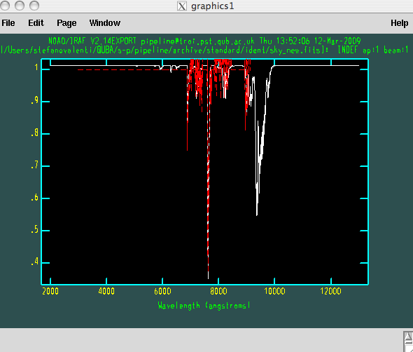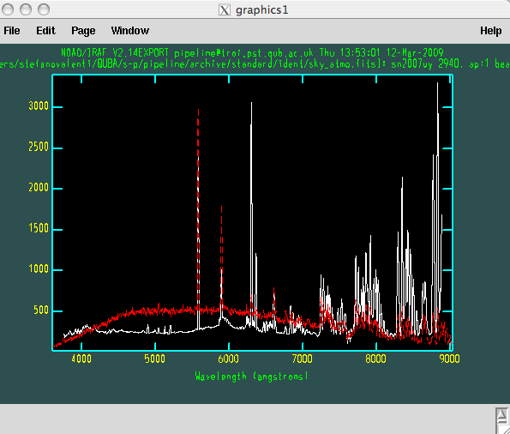

If the Telescoep is the NOT, the second order correction is applied
on the screen:
######################################################
########### SECOND ORDER CORRECTION
######################################################
c.Feige34_Grism_4_Slit_1.0_1_l.fits: REFSPEC1 = 'iraf1231k 1.'
c.Feige34_Grism_4_Slit_1.0_1_l.fits: ap = 1, w1 = 2963.78, w2 = 9125.49, dw = 3.004247, nw = 2052

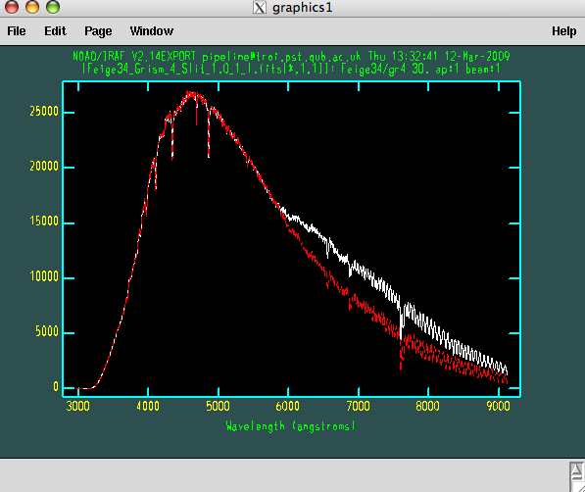

- PRODUCE THE SENSITIVITY CURVE:
If the object is a standard the sensitivity curve is produced. The program try to identify the standard from a list. If it does not find it, you should add the standard (asci) in: /pipeline/archive/standard/fluxstandard/
And the coordinate in:
/pipeline/archive/standard/fluxstandard/standardlist.txt
Then run again the pipeline. Once the standard is identified the program ask to split the sensitivity curve in 2 pieces or not. (still some problems, better select NO)

on the screen:
###############################################
###### SENSITIVITY CURVE
10.660414539 43.0992031527
mfeige34.dat 10.660414539 43.0992031527 0.00360895177639
############################################
Is this the right file ? [y/n] [y]
############################################
Do you want to compute the sensitivity curve in 2 ranges [y/n] [y]? n
cc.Feige34_Grism_4_Slit_1.0_1_l.fits(1): Feige34/gr4
cc.Feige34_Grism_4_Slit_1.0_1_l.fits[1]: Edit bandpasses? (no|yes|NO|YES|NO!|YES!) ('yes'):
Fit aperture 1 interactively? (no|yes|NO|YES) (no|yes|NO|YES) ('yes'):
add sens_cc.Feige34_Grism_4_Slit_1.0_1,TELESCOP = NOT
sens_cc.Feige34_Grism_4_Slit_1.0_1 updated
add sens_cc.Feige34_Grism_4_Slit_1.0_1,INSTRUME = ALFOSC_FASU
sens_cc.Feige34_Grism_4_Slit_1.0_1 updated
add sens_cc.Feige34_Grism_4_Slit_1.0_1,ALAPRTNM = Slit_1.0
sens_cc.Feige34_Grism_4_Slit_1.0_1 updated
add sens_cc.Feige34_Grism_4_Slit_1.0_1,ALGRNM = Grism_4
sens_cc.Feige34_Grism_4_Slit_1.0_1 updated
sens_cc.Feige34_Grism_4_Slit_1.0_1,OBJECT: "Sensitivity function for all apertures" -> Feige34/gr4
sens_cc.Feige34_Grism_4_Slit_1.0_1 updated
add sens_cc.Feige34_Grism_4_Slit_1.0_1,JD = 54477.69
sens_cc.Feige34_Grism_4_Slit_1.0_1 updated
add sens_cc.Feige34_Grism_4_Slit_1.0_1,DATE-OBS = 20080112
sens_cc.Feige34_Grism_4_Slit_1.0_1 updated
#### SENSITIVITY CURVE -> sens_cc.Feige34_Grism_4_Slit_1.0_1
#######################################################################
OBJECT EXTRACTION WAV_CAL FLUX_CALIB ATMOSPHERIC_FEATURES
Feige34_Grism_4_Slit_1.0_1.fits YES YES none none
#######################################################################
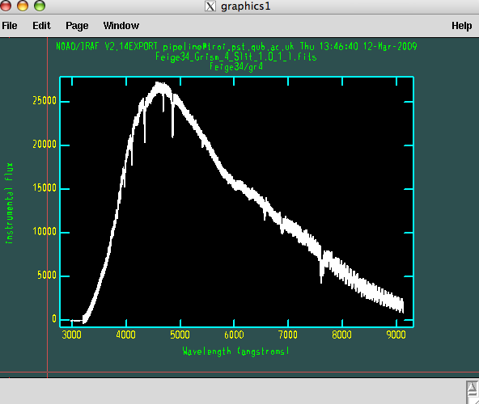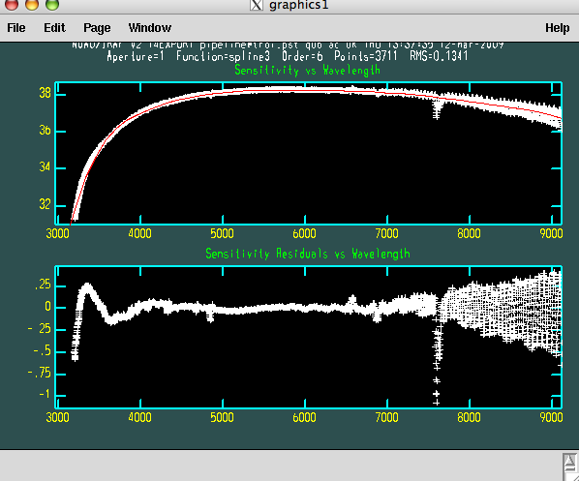

FLUX CALIBRATION:

If the object is not a standard the spectra will be flux calibrated using the sensitivity curve in the directory. If not sensitivity curve is available in the directory, the program will search in the archive.

ATMOSPHERIC FEATURES CORRECTION:
The pipeline try to correct also for atmospheric features asking for a file (usually the standard) that has to be used.
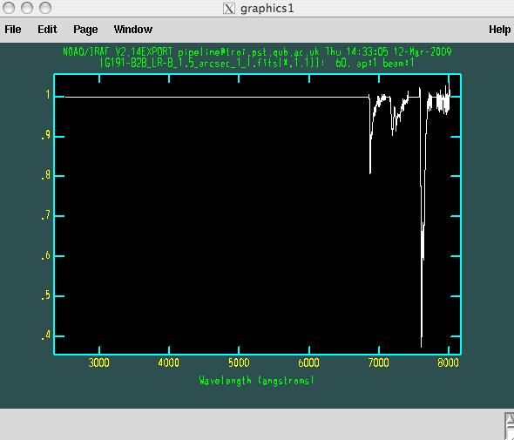
On the screen:

###################################################
##### FLUX CALIBRATION
SN2007uy_08D_Grism_4_Slit_1.0_1_l.fits sens_cc.Feige34_Grism_4_Slit_1.0_1.fits
SN2007uy_08D_Grism_4_Slit_1.0_1_f.fits: SN2007uy_08D/gr4
WARNING: 4 pixels outside of flux calibration limits
Extinction correction applied
Flux calibration applied
CALIBRATED SPECTRUM -> SN2007uy_08D_Grism_4_Slit_1.0_1_f.fits
Do you want to correct the spectrum from atmospheric features [y/n] [y] ?
cc.Feige34_Grism_4_Slit_1.0_1_l.fits
cc.SN2007uy_08D_Grism_4_Slit_1.0_1_l.fits
Feige34_Grism_4_Slit_1.0_1_l.fits
SN2007uy_08D_Grism_4_Slit_1.0_1_l.fits
which is the standard file you want to use [arc_20080114_Grism_4_Slit_1.0_1_l.fits] ? Feige34_Grism_4_Slit_1.0_1_l.fits
SN2007uy_08D_Grism_4_Slit_1.0_1_f.fits[*,1,2] -> SN2007uy_08D_Grism_4_Slit_1.0_1_e.fits[*,1,2]
SN2007uy_08D_Grism_4_Slit_1.0_1_f.fits[*,1,3] -> SN2007uy_08D_Grism_4_Slit_1.0_1_e.fits[*,1,3]
SN2007uy_08D_Grism_4_Slit_1.0_1_f.fits[*,1,4] -> SN2007uy_08D_Grism_4_Slit_1.0_1_e.fits[*,1,4]
#######################################################################
OBJECT EXTRACTION WAV_CAL FLUX_CALIB ATMOSPHERIC_FEATURES
SN2007uy_08D_Grism_4_Slit_1.0_1.fits YES YES YES YES
SN2007uy_08D_Grism_4_Slit_1.0_2.fits none none none none
SN2007uy_08D_Grism_4_Slit_1.0_3.fits none none none none
#######################################################################

do you want to go on with the next object [yes/no]? [yes]

All the steps are repeated for all the file in the list. The program will finish once all the file are reduced or if the reducer stop the reduction answering ‘no’:

#######################################################################
OBJECT EXTRACTION WAV_CAL FLUX_CALIB ATMOSPHERIC_FEATURES
SN2007uy_08D_Grism_4_Slit_1.0_1.fits YES YES YES YES
SN2007uy_08D_Grism_4_Slit_1.0_2.fits YES YES YES YES
SN2007uy_08D_Grism_4_Slit_1.0_3.fits YES YES YES YES
#######################################################################

END

TO DO:

- Check gain and readnoise in headers are what you get from ratios of flats
- Spectral extractions optimum/average
- Additional options for reductions in qubaccdreduc and qubaprephot
qubaprephot:
- if only bias or only flat do reductions with these.
qubaccdreduc:
- if no arc use bias and flat.
- if no arc and flat use bias
- if no arc and bias use flat
- if no bias and flat use arc
- Note some problems with dome and skyflats. Need to be able to distinguish or choose
which to use.

- tidy up on directories

- Dealing with different sized frames eg. asiago test directory.

PROGRAMS INDEX:
qubareduorganize.py: This program divides the spectroscopic and photometric raw files in two directories: qubaimage and qubaspecta.
This is the first program it should be run on the raw date
qubaprespec_v1.py:
qubaprephot_v1.py
qubaregister.py
qubaspectraredu.py
qubaref
qubastd
qubapsf
qubasn
qubaph
qubaresnoopy
resnoopy
5.8) exa

A number of don'ts for observing:

This pipeline relies heavily on Keyword parameters. Below are a list of things to check for
while observing.

-The OBJECT keyword in a fits header generally contains the name you enter with the exposure
command at a telescope. This contain simply the object name and possibly filter,but should
NOT contain ' ', '.','/','\' or any other symbols which unix may have problem with for file
names. For example: objectname_filter or objectname-filter are acceptable

-The headers should contain as much info as possible in particular:
- Grism
- Central wavelength
- slit width
- Filter, if imaging
- Object name
- image type i.e arc,object,flat,bias,sky
- Exp time
- readnoise
- gain
- RA, DEC
- Julian Date
- Instrument
- Telescope

- test images should be removed or put in seperate directory if possible

