Shelby Laquitara

//screenshot of About Page in Browser

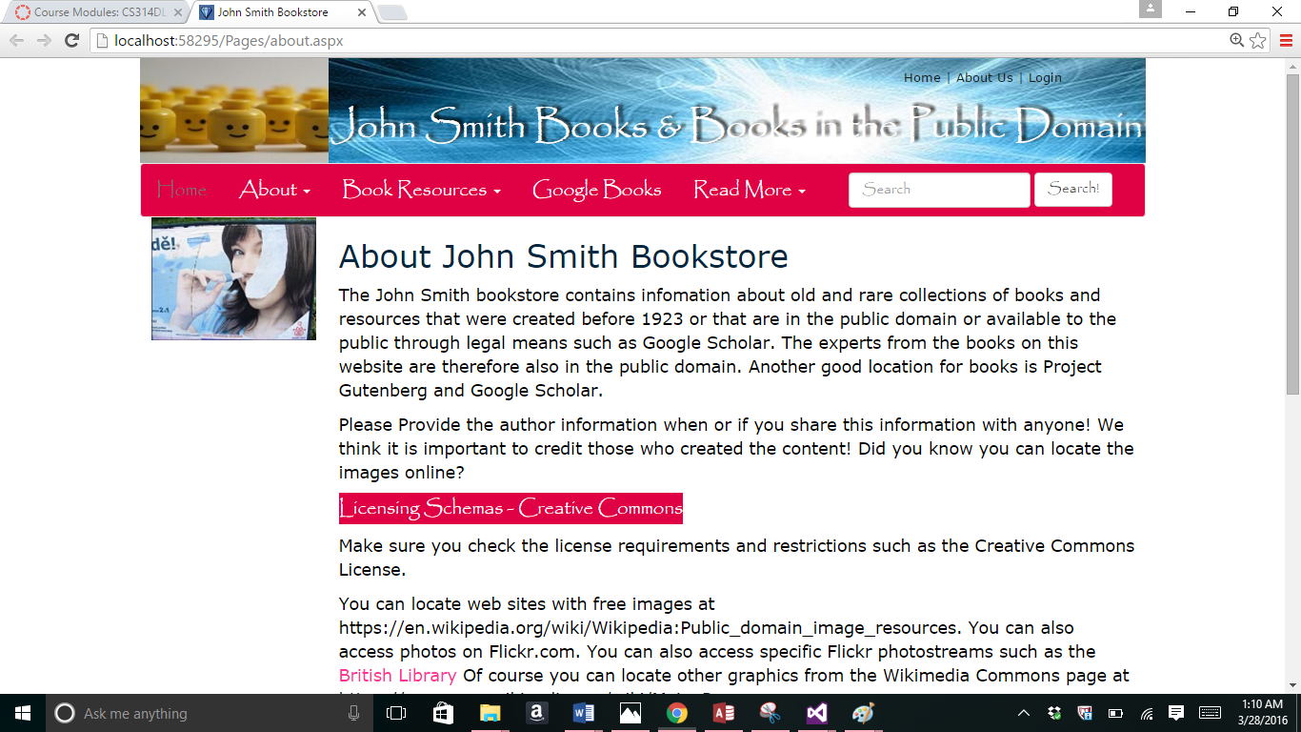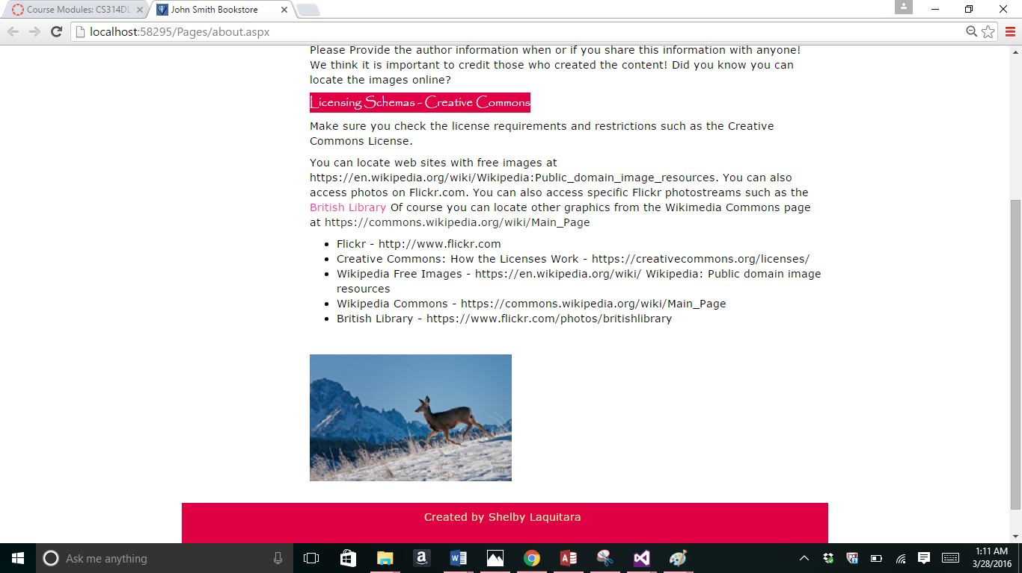

//Code for about.aspx page

<%@ Page Title="" Language="C#" MasterPageFile="~/Homework.Master" AutoEventWireup="true" CodeBehind="about.aspx.cs" Inherits="Project.Pages.about" %>

<asp:Content ID="Content1" ContentPlaceHolderID="HeadSection" runat="server">

</asp:Content>

<asp:Content ID="Content2" ContentPlaceHolderID="ContentSection" runat="server">

<h2>About John Smith Bookstore</h2>

<p>The John Smith bookstore contains infomation about

old and rare collections of books and resources that were

created before 1923 or that are in the public domain or available to the public

through legal means such as Google Scholar. The experts from the books on

this website are therefore also in the public domain. Another good

location for books is Project Gutenberg and Google Scholar.

</p>

<p>Please Provide the author information when or if you share this information

with anyone! We think it is important to credit those who created

the content! Did you know you can locate the images online?

</p>

<p><asp:Label ID="Label1" runat="server"

Text="Licensing Schemas - Creative Commons"

CssClass="navbar-default"></asp:Label></p>

<p>Make sure you check the license requirements and restrictions such as the

Creative Commons License.

</p>

<p>You can locate web sites with free images at https://en.wikipedia.org/wiki/Wikipedia:Public_domain_image_resources.

You can also access photos on Flickr.com. You can also access specific Flickr photostreams such as the

<asp:HyperLink ID="HyperLink1" NavigateUrl="https://www.flickr.com/photos/britishlibrary"

runat = "server" Target ="_blank" ForeColor="#FF3399">British Library</asp:HyperLink>

Of course you can locate other graphics from the Wikimedia

Commons page at <a href = "https://commons.wikimedia.org/wiki/Main_page">https://commons.wikipedia.org/wiki/Main_Page</a></p>

<asp:BulletedList ID="BulletedList1" runat="server">

<asp:ListItem>Flickr - http://www.flickr.com

</asp:ListItem>

<asp:ListItem>Creative Commons: How the Licenses Work -

https://creativecommons.org/licenses/

</asp:ListItem>

<asp:ListItem>Wikipedia Free Images - https://en.wikipedia.org/wiki/

Wikipedia: Public domain image resources

</asp:ListItem>

<asp:ListItem>Wikipedia Commons - https://commons.wikipedia.org/wiki/Main_Page

</asp:ListItem>

<asp:ListItem>British Library - https://www.flickr.com/photos/britishlibrary

</asp:ListItem>

</asp:BulletedList>

<p><br /></p>

<p><asp:Image ID="Image1" runat="server"

AlternateText="Flickr Image - State Library of New South Wales"

ImageUrl ="~/Images/deerpic.png" />

</p>

<p></p>

</asp:Content>

//about.apsx.cs code

using System;

using System.Collections.Generic;

using System.Linq;

using System.Web;

using System.Web.UI;

using System.Web.UI.WebControls;

namespace Project.Pages

{

public partial class about : System.Web.UI.Page

{

protected void Page_Load(object sender, EventArgs e)

{

}

}

}

Part 2-

//feedback.apsx screenshot in Browser 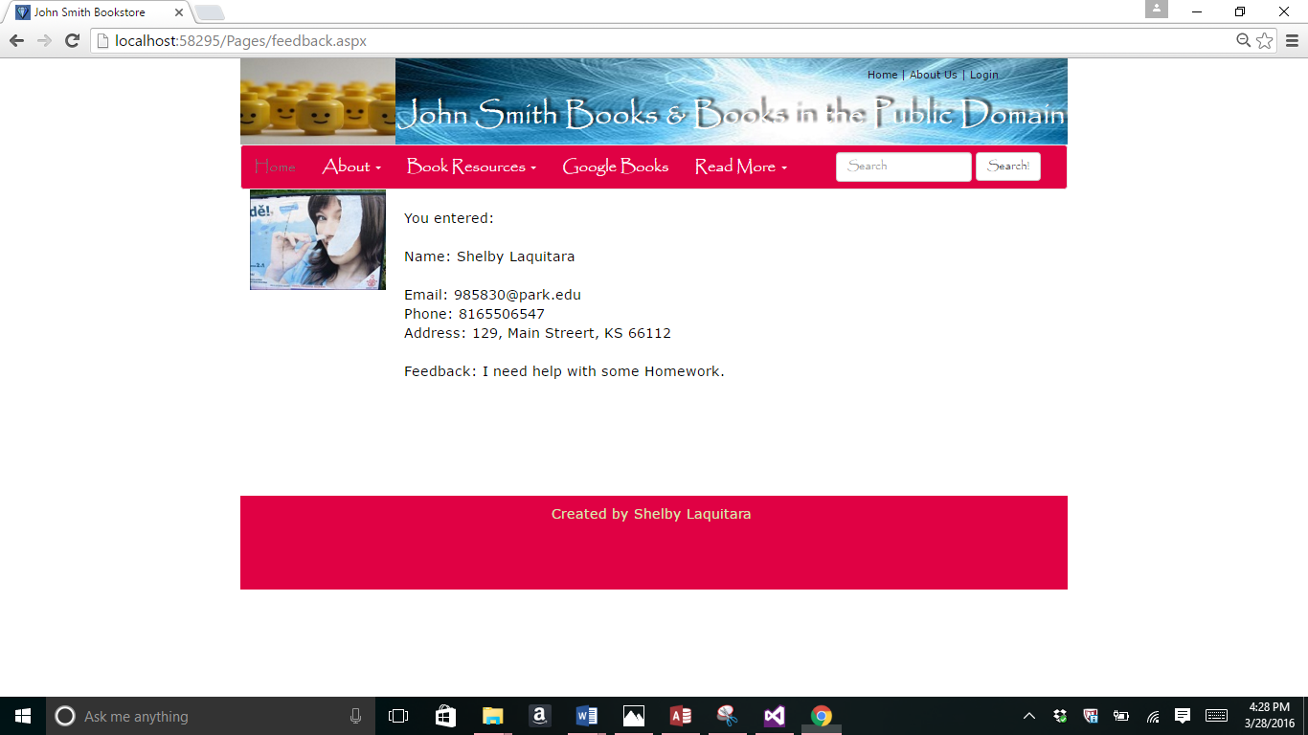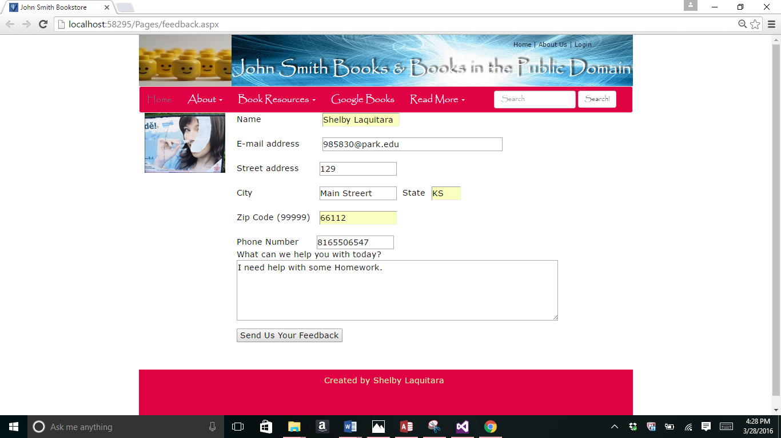

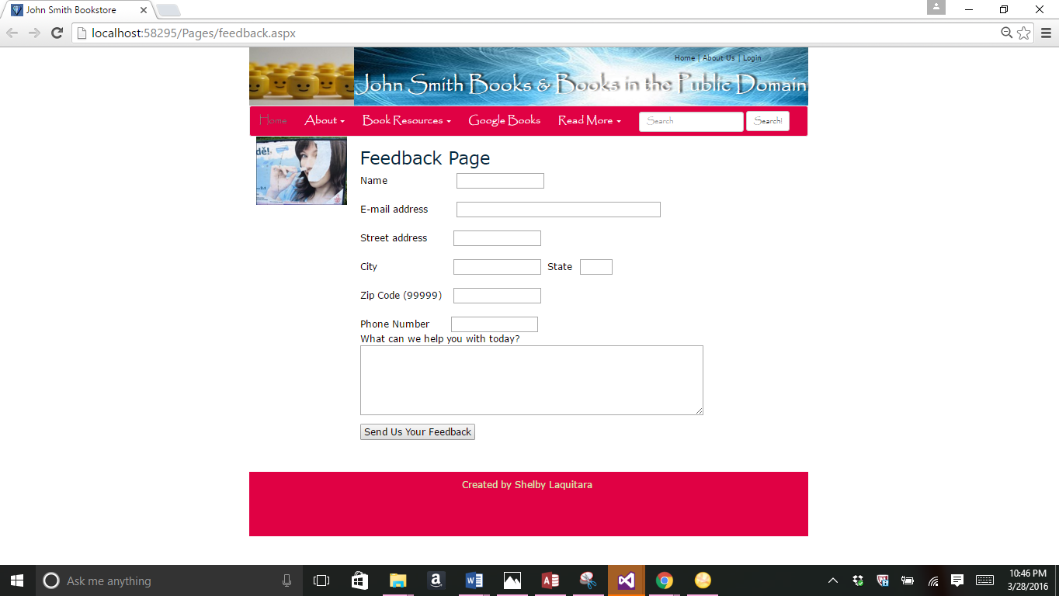

//feedback.aspx code

<%@ Page Title="" Language="C#" MasterPageFile="~/Homework.Master" AutoEventWireup="true" CodeBehind="feedback.aspx.cs" Inherits="Project.Pages.feedback" %>

<asp:Content ID="Content1" ContentPlaceHolderID="HeadSection" runat="server">

</asp:Content>

<asp:Content ID="Content2" ContentPlaceHolderID="ContentSection" runat="server">

<asp:Panel ID="PanelForm" runat="server">

<asp:Label ID="lblName" runat="server" Text="Name" Width="150px"></asp:Label>

&nbsp;

<asp:TextBox ID="txtName" runat="server" TabIndex="1" Width="150px"></asp:TextBox>

&nbsp;&nbsp;&nbsp;&nbsp;&nbsp;&nbsp;&nbsp;&nbsp;&nbsp;

<br />

<br />

<asp:Label ID="lblEmail" runat="server" Text="E-mail address" Width="150px"></asp:Label>

&nbsp;

<asp:TextBox ID="txtEmail" runat="server" TabIndex="2" TextMode="Email" Width="350px"></asp:TextBox>

<br />

<br />

<asp:Label ID="lblStreetAddress" runat="server" Text="Street address" Width="150px"></asp:Label>

&nbsp;<asp:TextBox ID="txtStreet" runat="server" TabIndex="3" Width="150px"></asp:TextBox>

<br />

<br />

<asp:Label ID="lblCity" runat="server" Text="City" Width="150px"></asp:Label>

&nbsp;<asp:TextBox ID="txtCity" runat="server" TabIndex="4" Width="150px"></asp:TextBox>

&nbsp;<asp:Label width="40px" ID="lblState" runat="server" Text="State"></asp:Label>

&nbsp;

<asp:TextBox ID="txtState" runat="server" MaxLength="2" TabIndex="5" Width="57px"></asp:TextBox>

<br />

<br />

<asp:Label ID="lblZip" runat="server" Text="Zip Code (99999)" Width="150px"></asp:Label>

&nbsp;<asp:TextBox ID="txtZip" runat="server" TabIndex="6" TextMode="Number" Width="150px"></asp:TextBox>

<br />

<br />

<asp:Label ID="lblPhoneNumber" runat="server" Text="Phone Number" Width="151px"></asp:Label>

<asp:TextBox ID="txtPhone" runat="server" TabIndex="7" TextMode="Phone" Width="150px"></asp:TextBox>

<p><asp:Label Width="300px" ID="lblFeedback" runat="server" Text="What can we help you with today?">

</asp:Label>

<asp:TextBox ID="txtFeedback" runat="server" TabIndex="8" TextMode="MultiLine"

Rows="5" Columns="60"></asp:TextBox>

</p>

<p><asp:Button ID="btnSubmit" runat="server" Text="Send Us Your Feedback" OnClick="btnSumbit_Click"/>

</p>

<asp:Label ID="lblErrors" runat="server" Text=""></asp:Label>

</asp:Panel>

<br />

<asp:Panel ID="PanelResponse" runat="server">

<asp:Label ID="lblResults" runat="server" Text="[lblResults]"></asp:Label>

<br /><br /><br /><br /><br />

</asp:Panel>

</asp:Content>

//feedback.aspx.cs code

using System;

using System.Collections.Generic;

using System.Linq;

using System.Web;

using System.Web.UI;

using System.Web.UI.WebControls;

namespace Project.Pages

{

public partial class feedback : System.Web.UI.Page

{

protected void Page_Load(object sender, EventArgs e)

{

if (!Page.IsPostBack)

{

PanelForm.Visible = true;

PanelResponse.Visible = false;

}

else

{

PanelForm.Visible = false;

PanelResponse.Visible = true;

}

}

protected void btnSumbit_Click(object sender, EventArgs e)

{

lblResults.Text = "You entered: " + "<br /><br />"

+ "Name: " + txtName.Text + "<br /><br />"

+ "Email: " + txtEmail.Text + "<br />"

+ "Phone: " + txtPhone.Text + "<br />"

+ "Address: " + txtStreet.Text + ", "

+ txtCity.Text + ", " + txtState.Text + " "

+ txtZip.Text + "<br /><br />"

+ "Feedback: " + txtFeedback.Text

+ "<br />";

}

}

}

//Registration.aspx screenshots in browser

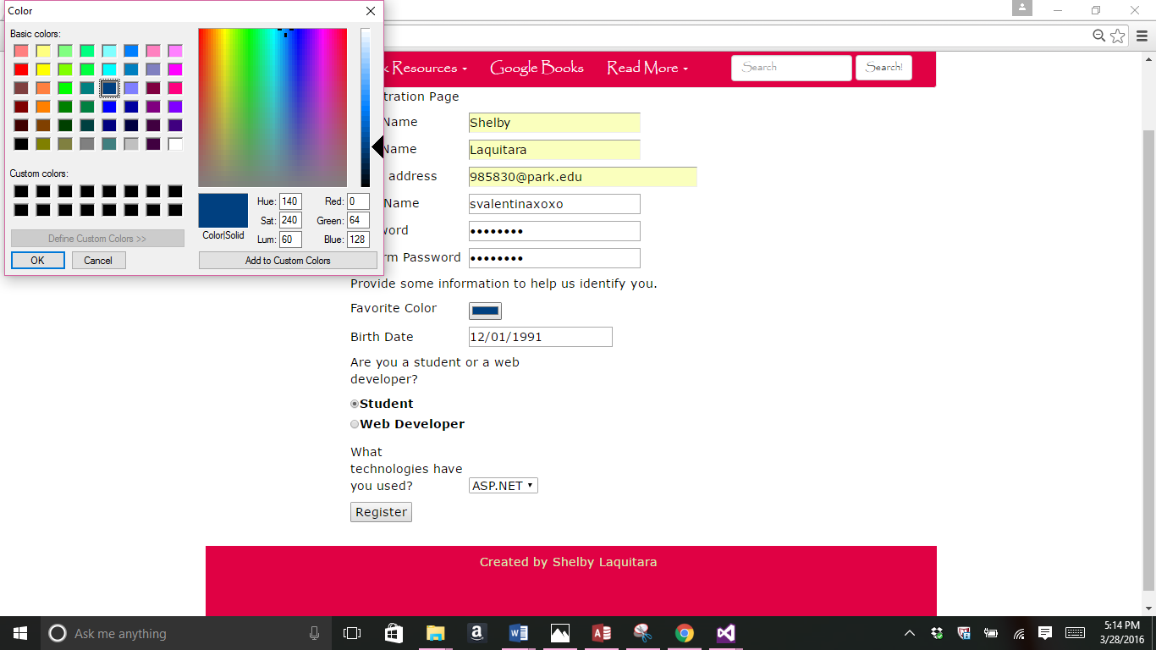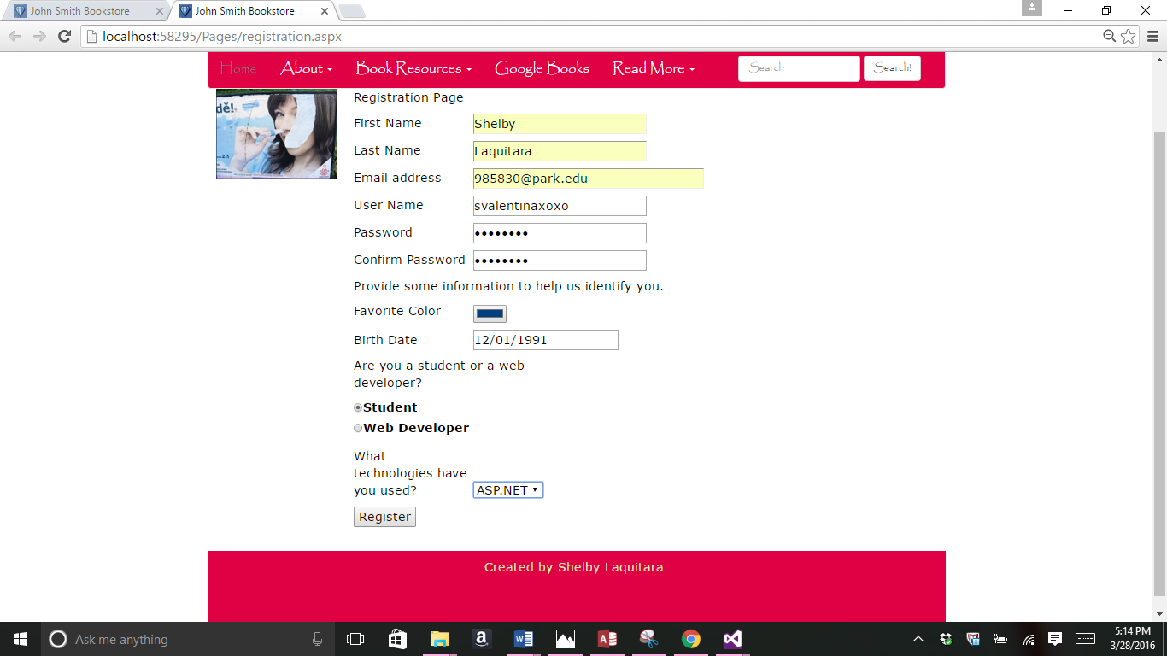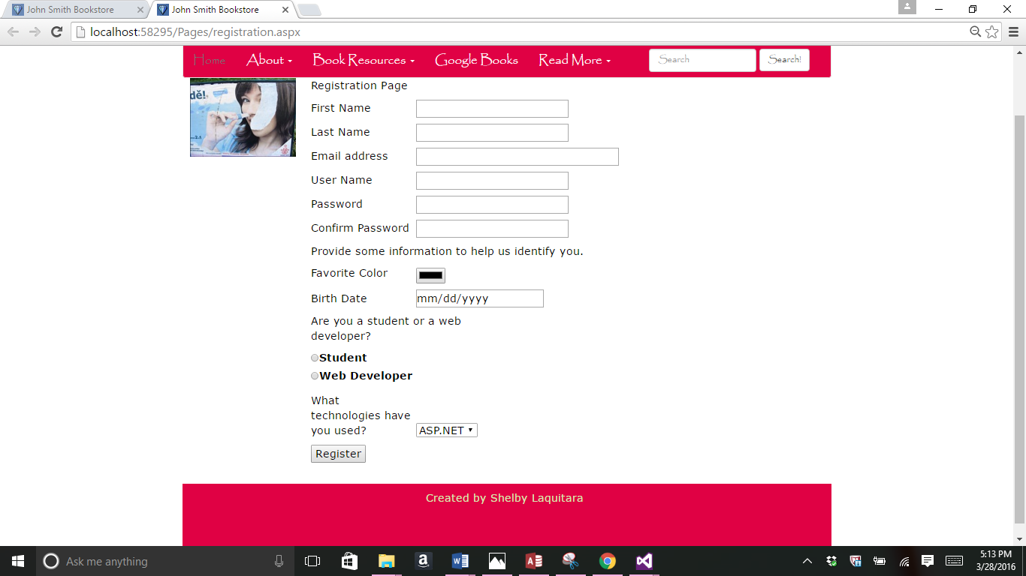

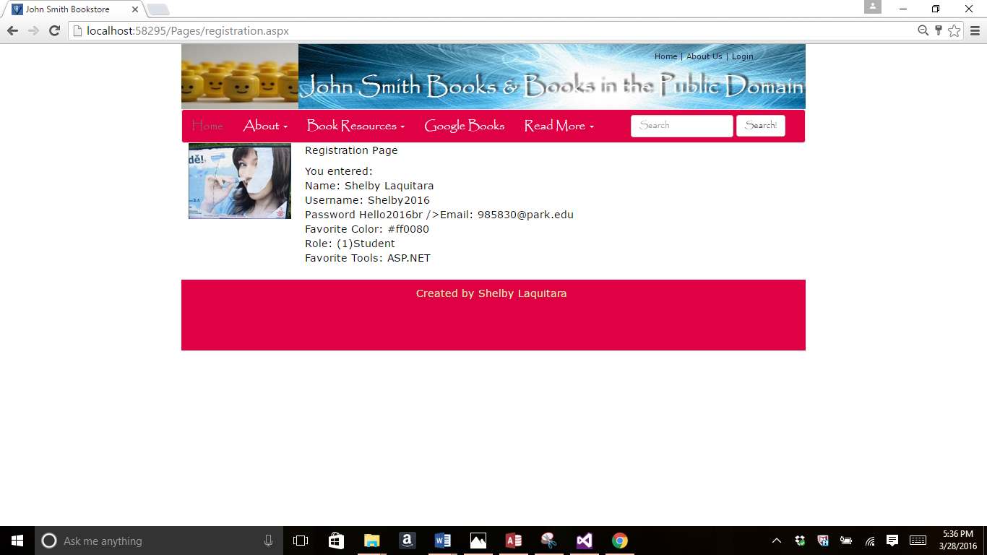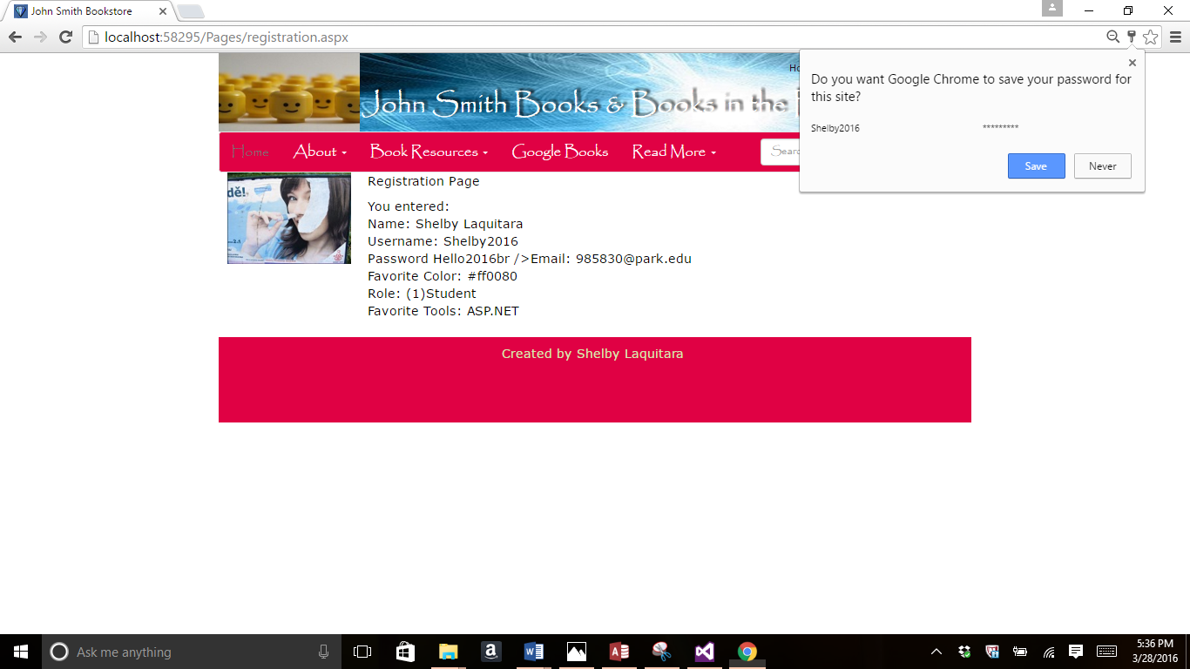

//code for registration.aspx

<%@ Page Title="" Language="C#" MasterPageFile="~/Homework.Master" AutoEventWireup="true" CodeBehind="registration.aspx.cs" Inherits="Project.Pages.registration" %>

<asp:Content ID="Content1" ContentPlaceHolderID="HeadSection" runat="server">

</asp:Content>

<asp:Content ID="Content2" ContentPlaceHolderID="ContentSection" runat="server">

<p class="RegForm">Registration Page</p>

<asp:Panel ID="PanelForm" runat="server">

<p><asp:Label Width="150px" ID="lblFirstName" runat="server" Text="First Name"></asp:Label>

<asp:TextBox ID="txtFirstName" runat="server" TabIndex="1"></asp:TextBox>

</p>

<p><asp:Label Width="150px" ID="lblLastName" runat="server" Text="Last Name"></asp:Label>

<asp:TextBox ID="txtLastName" runat="server" TabIndex="2"></asp:TextBox>

</p>

<p><asp:Label Width="150px" ID="lblEmail" runat="server" Text="Email address"></asp:Label>

<asp:TextBox ID="txtEmail" runat="server" Width="300px" TabIndex="3" TextMode="Email"></asp:TextBox>

</p>

<p><asp:Label Width="150px" ID="lblUserName" runat="server" Text="User Name"></asp:Label>

<asp:TextBox ID="txtUserName" runat="server" TabIndex="4"></asp:TextBox>

</p>

<p><asp:Label Width="150px" ID="lblPassword" runat="server" Text="Password"></asp:Label>

<asp:TextBox ID="txtPassword" TextMode="Password" runat="server" TabIndex="5"></asp:TextBox>

</p>

<p><asp:Label Width="150px" ID="lblConfirm" runat="server" Text="Confirm Password"></asp:Label>

<asp:TextBox ID="txtConfirm" runat="server" TabIndex="6" TextMode="Password"></asp:TextBox>

</p>

<p>Provide some information to help us identify you.</p>

<p><asp:Label Width="150px" ID="lblColor" runat="server" Text="Favorite Color"></asp:Label>

<asp:TextBox ID="txtColor" runat="server" TabIndex="7" TextMode="Color"></asp:TextBox>

</p>

<p><asp:Label Width="150px" ID="lblBirthDate" runat="server" Text="Birth Date"></asp:Label>

<asp:TextBox ID="txtBirthDate" runat="server" TabIndex="8" TextMode="Date"></asp:TextBox>

</p>

<p><asp:Label Width="300px" ID="lblRole" runat="server"

Text="Are you a student or a web developer?"></asp:Label>

<asp:RadioButtonList ID="rblRole" runat="server"

RepeatDirection="Vertical" TabIndex="9">

<asp:ListItem Text="Student" Value="1" />

<asp:ListItem Text="Web Developer" Value="2" />

</asp:RadioButtonList>

</p>

<p><asp:Label Width="150px" ID="Label2" runat="server"

Text="What technologies have you used?"></asp:Label>

<asp:DropDownList ID="ddlTools" runat="server" TabIndex="10">

<asp:ListItem Text="ASP.NET" Value="ASP.NET" />

<asp:ListItem Text="PHP" Value="PHP" />

<asp:ListItem Text="Java" Value="Java" />

<asp:ListItem Text="Perl" Value="Perl" />

<asp:ListItem Text="XML" Value="XML" />

</asp:DropDownList>

</p>

<p><asp:Button ID="btnSumbit" runat="server" Text="Register" OnClick="btnSumbit_Click" />

</p>

<asp:Label ID="lblErrors" runat="server" Text=""></asp:Label>

</asp:Panel>

<asp:Panel ID="PanelResponse" runat="server">

<asp:Label ID="lblResults" runat="server" Text=""></asp:Label>

</asp:Panel>

</asp:Content>

//code for registration.aspx.cs

using System;

using System.Collections.Generic;

using System.Linq;

using System.Web;

using System.Web.UI;

using System.Web.UI.WebControls;

namespace Project.Pages

{

public partial class registration : System.Web.UI.Page

{

protected void Page_Load(object sender, EventArgs e)

{

this.UnobtrusiveValidationMode =

System.Web.UI.UnobtrusiveValidationMode.None;

if (!Page.IsPostBack)

{

PanelForm.Visible = true;

PanelResponse.Visible = false;

}

else

{

PanelForm.Visible = false;

PanelResponse.Visible = true;

}

}

protected void btnSumbit_Click(object sender, EventArgs e)

{

lblResults.Text = "You entered: " + "<br />"

+ "Name: "

+ txtFirstName.Text + " " + txtLastName.Text

+ "<br />"

+ "Username: " + txtUserName.Text + "<br />"

+ "Password " + txtPassword.Text + "br />"

+ "Email: " + txtEmail.Text + "<br />"

+ "Favorite Color: " + txtColor.Text + "<br />"

+ "Role: (" + rblRole.SelectedValue + ")"

+ rblRole.SelectedItem + "<br />"

+ "Favorite Tools: "

+ ddlTools.SelectedValue.ToString()

+ "<br />";

}

}

}

Part3-

Read the OWASP page on **Injection** at <https://www.owasp.org/index.php/Top_10_2013-A1-Injection>

Answer these questions:

1. *Explain how injection attacks work.*

Hackers can send text based attacks that can affect internal users, external users, and administrators. It happens when untrusted data is sent to the interpreter and changed or manipulated. The attacks can result in data loss, denial of access, corruption and can even take over the host.

1. *Provide an example, demonstrating how injection works.*

Injection can work by a <script> block so that the code gets blocked or you could use SQL statements to exploit the database and manipulate the data. An example is when a hacker comes in and adds a ('' OR 1=1) to an SQL statement where it doesn’t belong.

1. *Describe the risks to a company associated with invalidated data*

If you do not valid the data within a form, make risks can develop. When you do validate, the user will know if they made any mistakes immediately. The application will also become vulnerable to attacks if the data is not validated and injection attacks could easily take place. Validating protects the users and the developers.

1. *Provide one suggestion of how web developers could to prevent injection attacks.*

A way to prevent injection attacks is to make sure strings are properly escaped and escape user input and make sure data types are not constrained. You should also make you to always validate your forms and data.

Part 4-

//Registration.aspx validation screenshot in browser

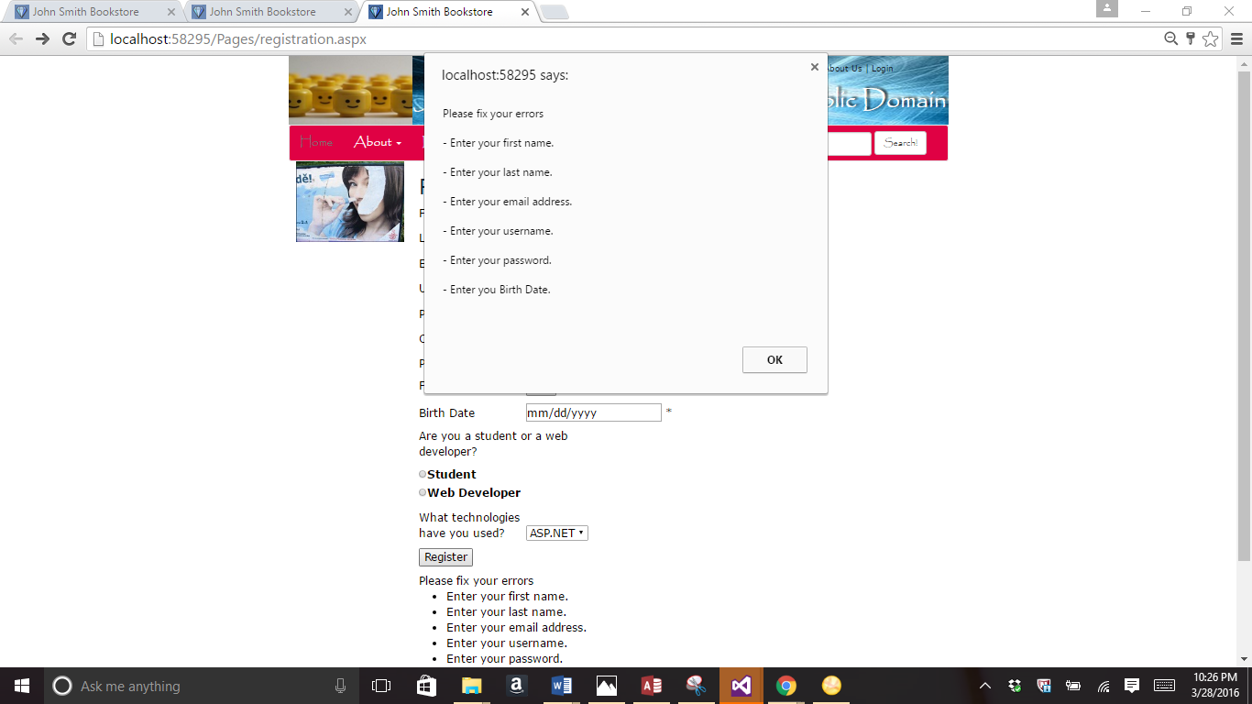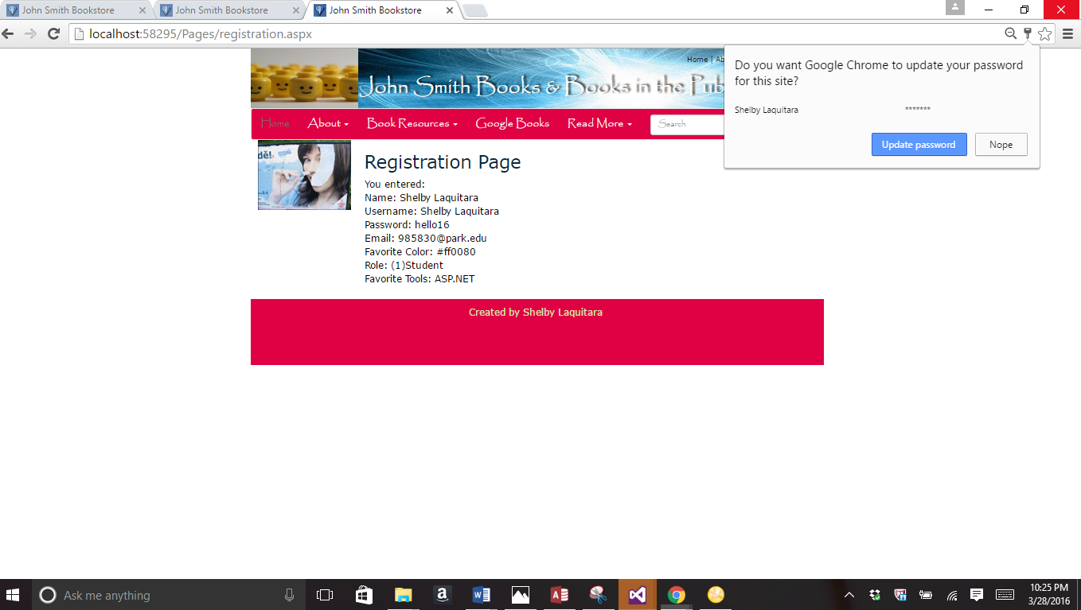

//validated registration.aspx code

<%@ Page Title="" Language="C#" MasterPageFile="~/Homework.Master" AutoEventWireup="true" CodeBehind="registration.aspx.cs" Inherits="Project.Pages.registration" %>

<asp:Content ID="Content1" ContentPlaceHolderID="HeadSection" runat="server">

</asp:Content>

<asp:Content ID="Content2" ContentPlaceHolderID="ContentSection" runat="server">

<h2 class="RegForm">Registration Page</h2>

<asp:Panel ID="PanelForm" runat="server">

<p><asp:Label Width="150px" ID="lblFirstName" runat="server" Text="First Name"></asp:Label>

<asp:TextBox ID="txtFirstName" runat="server" TabIndex="1"></asp:TextBox>

<asp:RequiredFieldValidator ID="RequiredFieldValidator1" runat="server" ControlToValidate="txtFirstName" Display="Dynamic" ErrorMessage="Enter your first name.">*</asp:RequiredFieldValidator>

</p>

<p><asp:Label Width="150px" ID="lblLastName" runat="server" Text="Last Name"></asp:Label>

<asp:TextBox ID="txtLastName" runat="server" TabIndex="2"></asp:TextBox>

<asp:RequiredFieldValidator ID="RequiredFieldValidator2" runat="server" Display="Dynamic" ErrorMessage="Enter your last name." ControlToValidate="txtLastName">*</asp:RequiredFieldValidator>

</p>

<p><asp:Label Width="150px" ID="lblEmail" runat="server" Text="Email address"></asp:Label>

<asp:TextBox ID="txtEmail" runat="server" Width="306px" TabIndex="3" TextMode="Email"></asp:TextBox>

<asp:RequiredFieldValidator ID="RequiredFieldValidator3" runat="server" ErrorMessage="Enter your email address." ControlToValidate="txtEmail" Display="Dynamic">*</asp:RequiredFieldValidator>

<asp:RegularExpressionValidator ID="RegularExpressionValidator1" runat="server" ErrorMessage="Use a valid email address" ControlToValidate="txtEmail" Display="Dynamic" ValidationExpression="\w+([-+.']\w+)*@\w+([-.]\w+)*\.\w+([-.]\w+)*">*</asp:RegularExpressionValidator>

</p>

<p><asp:Label Width="150px" ID="lblUserName" runat="server" Text="User Name"></asp:Label>

<asp:TextBox ID="txtUserName" runat="server" TabIndex="4"></asp:TextBox>

<asp:RequiredFieldValidator ID="RequiredFieldValidator4" runat="server" ErrorMessage="Enter your username." ControlToValidate="txtUserName" Display="Dynamic">*</asp:RequiredFieldValidator>

</p>

<p><asp:Label Width="150px" ID="lblPassword" runat="server" Text="Password"></asp:Label>

<asp:TextBox ID="txtPassword" TextMode="Password" runat="server" TabIndex="5"></asp:TextBox>

<asp:RequiredFieldValidator ID="RequiredFieldValidator5" runat="server" ErrorMessage="Enter your password." ControlToValidate="txtPassword" Display="Dynamic">*</asp:RequiredFieldValidator>

</p>

<p><asp:Label Width="150px" ID="lblConfirm" runat="server" Text="Confirm Password"></asp:Label>

<asp:TextBox ID="txtConfirm" runat="server" TabIndex="6" TextMode="Password"></asp:TextBox>

<asp:CompareValidator ID="CompareValidator1" runat="server" ErrorMessage="Confirm your password" ControlToCompare="txtPassword" Display="Dynamic" ControlToValidate="txtConfirm">*</asp:CompareValidator>

</p>

<p>Provide some information to help us identify you.</p>

<p><asp:Label Width="150px" ID="lblColor" runat="server" Text="Favorite Color"></asp:Label>

<asp:TextBox ID="txtColor" runat="server" TabIndex="7" TextMode="Color"></asp:TextBox>

</p>

<p><asp:Label Width="150px" ID="lblBirthDate" runat="server" Text="Birth Date"></asp:Label>

<asp:TextBox ID="txtBirthDate" runat="server" TabIndex="8" TextMode="Date"></asp:TextBox>

<asp:RequiredFieldValidator ID="RequiredFieldValidator6" runat="server" ErrorMessage="Enter you Birth Date." ControlToValidate="txtBirthDate" Display="Dynamic">*</asp:RequiredFieldValidator>

<asp:CompareValidator ID="CompareValidator2" runat="server" ErrorMessage="Use must choose a date" ControlToValidate="txtBirthDate" Operator="DataTypeCheck">*</asp:CompareValidator>

</p>

<p><asp:Label Width="300px" ID="lblRole" runat="server"

Text="Are you a student or a web developer?"></asp:Label>

<asp:RadioButtonList ID="rblRole" runat="server"

RepeatDirection="Vertical" TabIndex="9">

<asp:ListItem Text="Student" Value="1" />

<asp:ListItem Text="Web Developer" Value="2" />

</asp:RadioButtonList>

</p>

<p><asp:Label Width="150px" ID="Label2" runat="server"

Text="What technologies have you used?"></asp:Label>

<asp:DropDownList ID="ddlTools" runat="server" TabIndex="10">

<asp:ListItem Text="ASP.NET" Value="ASP.NET" />

<asp:ListItem Text="PHP" Value="PHP" />

<asp:ListItem Text="Java" Value="Java" />

<asp:ListItem Text="Perl" Value="Perl" />

<asp:ListItem Text="XML" Value="XML" />

</asp:DropDownList>

</p>

<p><asp:Button ID="btnSumbit" runat="server" Text="Register" OnClick="btnSumbit_Click" />

</p>

<asp:Label ID="lblErrors" runat="server" Text=""></asp:Label>

<asp:ValidationSummary ID="ValidationSummary1" runat="server" HeaderText="Please fix your errors" ShowMessageBox="True" />

</asp:Panel>

<asp:Panel ID="PanelResponse" runat="server">

<asp:Label ID="lblResults" runat="server" Text=""></asp:Label>

</asp:Panel>

</asp:Content>

//part 5

//screenshot of results of Registration.aspx page

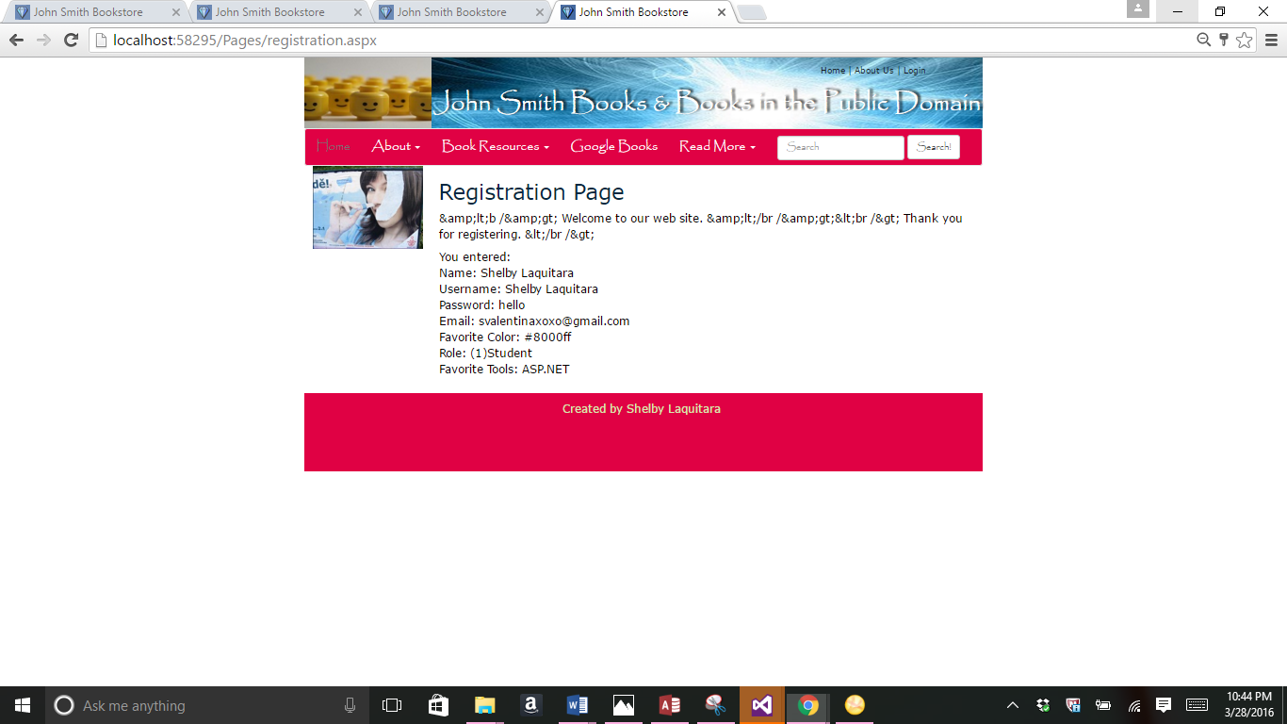

//Registration.aspx code

using System;

using System.Collections.Generic;

using System.Linq;

using System.Web;

using System.Web.UI;

using System.Web.UI.WebControls;

namespace Project.Pages

{

public partial class registration : System.Web.UI.Page

{

protected void Page_Load(object sender, EventArgs e)

{

this.UnobtrusiveValidationMode =

System.Web.UI.UnobtrusiveValidationMode.None;

if (!Page.IsPostBack)

{//First time the page is loaded

Message.InnerText = Server.HtmlEncode(Message.InnerText

+ "<b /> Welcome to our web site. </br />");

PanelForm.Visible = true;

PanelResponse.Visible = false;

}

else

{// page was posted back

Message.InnerText = Server.HtmlEncode(Message.InnerText

+ "<br /> Thank you for registering. </br />");

PanelForm.Visible = false;

PanelResponse.Visible = true;

}

}

protected void btnSumbit_Click(object sender, EventArgs e)

{

Page.Validate();

if (Page.IsValid == true)

{

lblResults.Text = "You entered: " + "<br />"

+ "Name: "

+ txtFirstName.Text + " " + txtLastName.Text

+ "<br />"

+ "Username: " + txtUserName.Text + "<br />"

+ "Password: " + txtPassword.Text + "<br />"

+ "Email: " + txtEmail.Text + "<br />"

+ "Favorite Color: " + txtColor.Text + "<br />"

+ "Role: (" + rblRole.SelectedValue + ")"

+ rblRole.SelectedItem + "<br />"

+ "Favorite Tools: "

+ ddlTools.SelectedValue.ToString()

+ "<br />";

}

}

}

}

//Registration.aspx.cs code

using System;

using System.Collections.Generic;

using System.Linq;

using System.Web;

using System.Web.UI;

using System.Web.UI.WebControls;

namespace Project.Pages

{

public partial class registration : System.Web.UI.Page

{

protected void Page_Load(object sender, EventArgs e)

{

this.UnobtrusiveValidationMode =

System.Web.UI.UnobtrusiveValidationMode.None;

if (!Page.IsPostBack)

{//First time the page is loaded

Message.InnerText = Server.HtmlEncode(Message.InnerText

+ "<b /> Welcome to our web site. </br />");

PanelForm.Visible = true;

PanelResponse.Visible = false;

}

else

{// page was posted back

Message.InnerText = Server.HtmlEncode(Message.InnerText

+ "<br /> Thank you for registering. </br />");

PanelForm.Visible = false;

PanelResponse.Visible = true;

}

}

protected void btnSumbit_Click(object sender, EventArgs e)

{

Page.Validate();

if (Page.IsValid == true)

{

lblResults.Text = "You entered: " + "<br />"

+ "Name: "

+ txtFirstName.Text + " " + txtLastName.Text

+ "<br />"

+ "Username: " + txtUserName.Text + "<br />"

+ "Password: " + txtPassword.Text + "<br />"

+ "Email: " + txtEmail.Text + "<br />"

+ "Favorite Color: " + txtColor.Text + "<br />"

+ "Role: (" + rblRole.SelectedValue + ")"

+ rblRole.SelectedItem + "<br />"

+ "Favorite Tools: "

+ ddlTools.SelectedValue.ToString()

+ "<br />";

}

}

}

}