//Part 1-

A)

* 1. JQuery is a JavaScript Library that helps simplify JavaScript programming and its purpose is to make javascipt easier to use on a website. It also helps make HTML documents, event handling, and AJAX much easier to use. It is an API that will work on several different browsers. It will take a bunch of common tasks that would require a lot of code, and puts them all together into a method that you can call on with single lines of code. The Query library has many features such as HTML, CSS and DOM manipulation, HTML event methods, AJAX, Utilities, effects, and animations. According to w3Schools, “There are a lot of other JavaScript frameworks out there, but JQuery seems to be the most popular, and also the most extendable” (W3Schools, 2016). A negative consequence for using JQuery is that the code could get hacked. The security issue is that there has been an increase in JavaScript attacks using injection where the hackers will manipulate, delete, copy, or steal JavaScript files. This type of attack can be used to redirect users to a site with a virus or steal important information or shut down the application. JQuery is also a target for hackers because most people using JQuery files aren’t frequently reviewing the code and it’s a great place for malicious code to hide.
  2. $("p").hide() – (This is a JQuery method used to hide all the <p> element tags.)

$(this).hide() – (This is a JQuery method used to hide the current HTML element.)

jQuery val() - Get content (You can use this val() method to get the value of a form field.)

B)

1. AJAX allows you to update a page without reloading the page, send data to a server in the background, and after the page loads you can request and receive data from a server.
2. AJAX relies on asynchronous communication between the browser and server by using the XMLHTTP object that is builder into browsers. It can exchange information between server and the web page usually in XML or JSON format. Data can be presented in the browser using HTML, XHTML, and CSS.
3. ASP.NET AJAX communication layer lets a web page call web service methods on the sever using JavaScript. It exposes APIs that JavaScript functions can use in any browser to call web service methods on the server.
4. <body>

<div id=”example”>

<h2>AJAX can change text</h2>

</div>

<button type=”button” onclick=”loadDoc()”>Change Content</button>

</body>

The button calls the function if it is clicked and the function then requests data from a web server and can display the data.

C.)

References-

W3Schools. (2016). *JQuery Introduction*. Retrieved from W3Schools.com: http://www.w3schools.com/jquery/jquery_intro.asp

//Part 2-

//AJAX_JQueryAccordion.aspx code

<%@ Page Title="" Language="C#" MasterPageFile="~/Homework.Master" AutoEventWireup="true" CodeBehind="AJAX_JQueryAccordion.aspx.cs" Inherits="Project.Pages.AJAX_JQueryAccordion" %>

<asp:Content ID="Content1" ContentPlaceHolderID="HeadSection" runat="server">

<link href="/css/jquery-ui.css" rel="stylesheet" />

<link href="/css/jquerystyle.css" rel="stylesheet" />

</asp:Content>

<asp:Content ID="Content2" ContentPlaceHolderID="ContentSection" runat="server">

<!-- Accordion -->

<h2 class="uiAccordion">JQueryUI Accordion With An ASP Page</h2>

<div id="accordion">

<h3>ALICE'S ADVENTURES IN WONDERLAND</h3>

<div>

<img src="../Images/Ads/alice.jpg" style="float: right; height:125px; width: 80px;" />

<p>Project Gutenberg's Alice's Adventures in Wonderland, by Lewis Carroll</p>

<p>Alice's Adventures in Wonderland is about a girl who follows a rabbit into a secret world

called Wonderland. She runs into many trippy creatures such as a cat with a hookah and

the animals tell her that she must defeat the evil queen to save wonderland.

</p>

<p>You can read the book at <asp:HyperLink ID="HyperLink1" runat="server" NavigateUrl="https://www.gutenberg.org/files/28885/28885-h/28885-h.htm"

ForeColor="#ff66cc">https://www.gutenberg.org/files/28885/28885-h/28885-h.htm</asp:HyperLink></p>

</div>

<h3>THE ANIMAL STORY BOOK</h3>

<div>

<img src="../Images/Ads/lion.jpg" style="float: right; height: 125px; width: 180px;" />

<p>The Project Gutenberg EBook of The Animal Story Book, by Various</p>

<p>The book has several different short stories about animals such as "AN ADVENTURE IN THE LIFE OF A BEAR IN PARIS"

and "SAÏ THE PANTHER".

</p>

<p>You can read the book at <asp:HyperLink ID="HyperLink2" runat="server" NavigateUrl="https://www.gutenberg.org/files/38208/38208-h/38208-h.htm"

ForeColor="#ff66cc">https://www.gutenberg.org/files/38208/38208-h/38208-h.htm</asp:HyperLink></p>

</div>

<h3>OZMA OF OZ</h3>

<div>

<img src="../Images/Ads/ozmaOfOz.jpg" style="float: right; height: 125px; width: 180px;" />

<p>The Project Gutenberg EBook of Ozma of Oz, by L. Frank Baum</p>

<p>This is a childerns book with several different short stories such as "A Yellow Hen" and "The girl in the chicken coop"</p>

<p>You can read the book at <asp:HyperLink ID="HyperLink3" runat="server" NavigateUrl="https://www.gutenberg.org/files/33361/33361-h/33361-h.htm"

ForeColor="#ff66cc">https://www.gutenberg.org/files/33361/33361-h/33361-h.htm</asp:HyperLink></p>

</div>

<h4>Little Wizard Stories of Oz</h4>

<div>

<img src="../Images/Ads/storiesOfOz.jpg" style="float: right; height: 125px; width: 180px;" />

<p>The Project Gutenberg eBook, Little Wizard Stories of Oz, by L. Frank Baum, Illustrated by John R. Neill</p>

<p>This book has 6 short stories about the little wizard stores of Oz. The short stories are,

The Cowardly Lion and the Hungry Tiger, Little Dorothy and Toto, Tiktok and the Nome King,

Jack Pumpkinhead and the Sawhorse, and The Scarecrow and the Tin Woodman.

</p>

<p>You can read the book at <asp:HyperLink ID="HyperLink4" runat="server" NavigateUrl="https://www.gutenberg.org/files/25519/25519-h/25519-h.htm"

ForeColor="#ff66cc">https://www.gutenberg.org/files/25519/25519-h/25519-h.htm</asp:HyperLink></p>

</div>

</div>

<script src="/js/jquery.js"></script>

<script src="/js/jquery-ui.js"></script>

<script>

$("#accordion").accordion();

collapsible: true;

heightStyle: "fill"; "content"

$("#accordion-resizer").resizable({

minHeight: 340,

minWidth: 400,

resize: function () {

$("#accordion").accordion("refresh");

}

});

</script>

</asp:Content>

I inserted my style sheet into the code so that I could use the styles that I found from the website. Then created the accordion with 4 sections about different books and a few paragraphs about each book. I also inserted a picture of each book that I was describing. Then I coded the accordion using javascript at the bottom of the page.

//AJAX_JQueryAccordion.aspx screen shots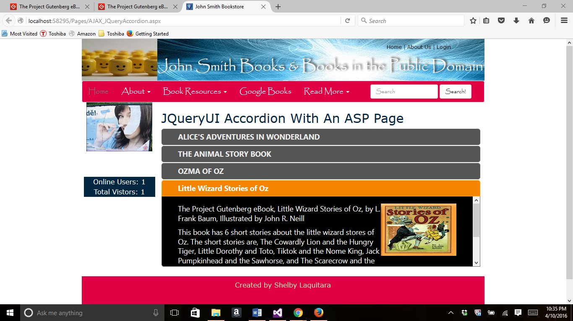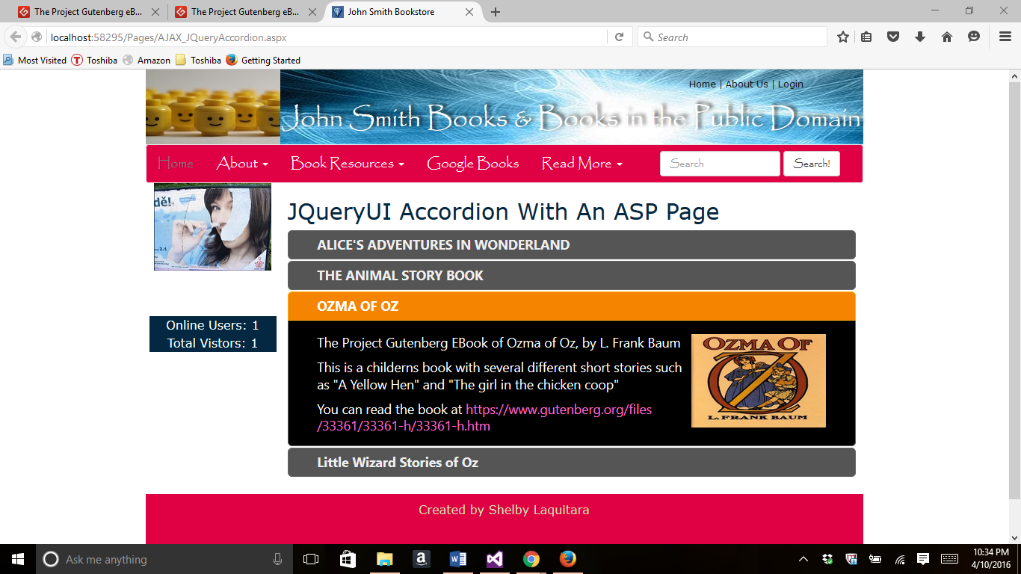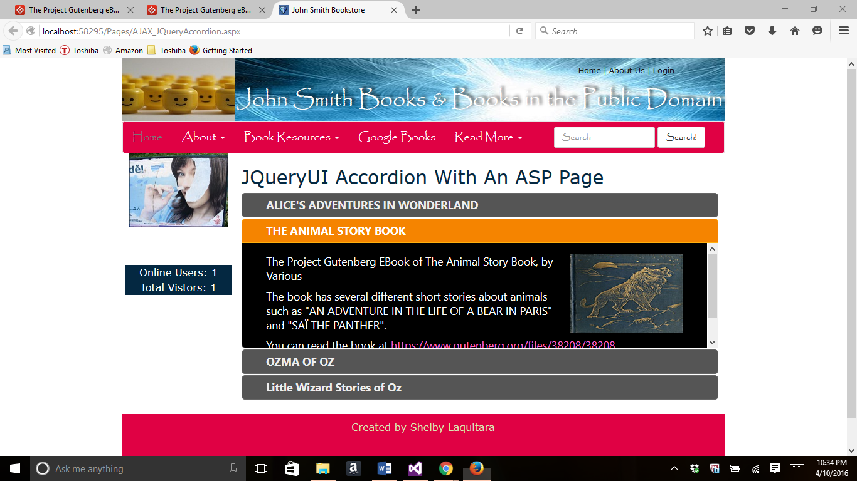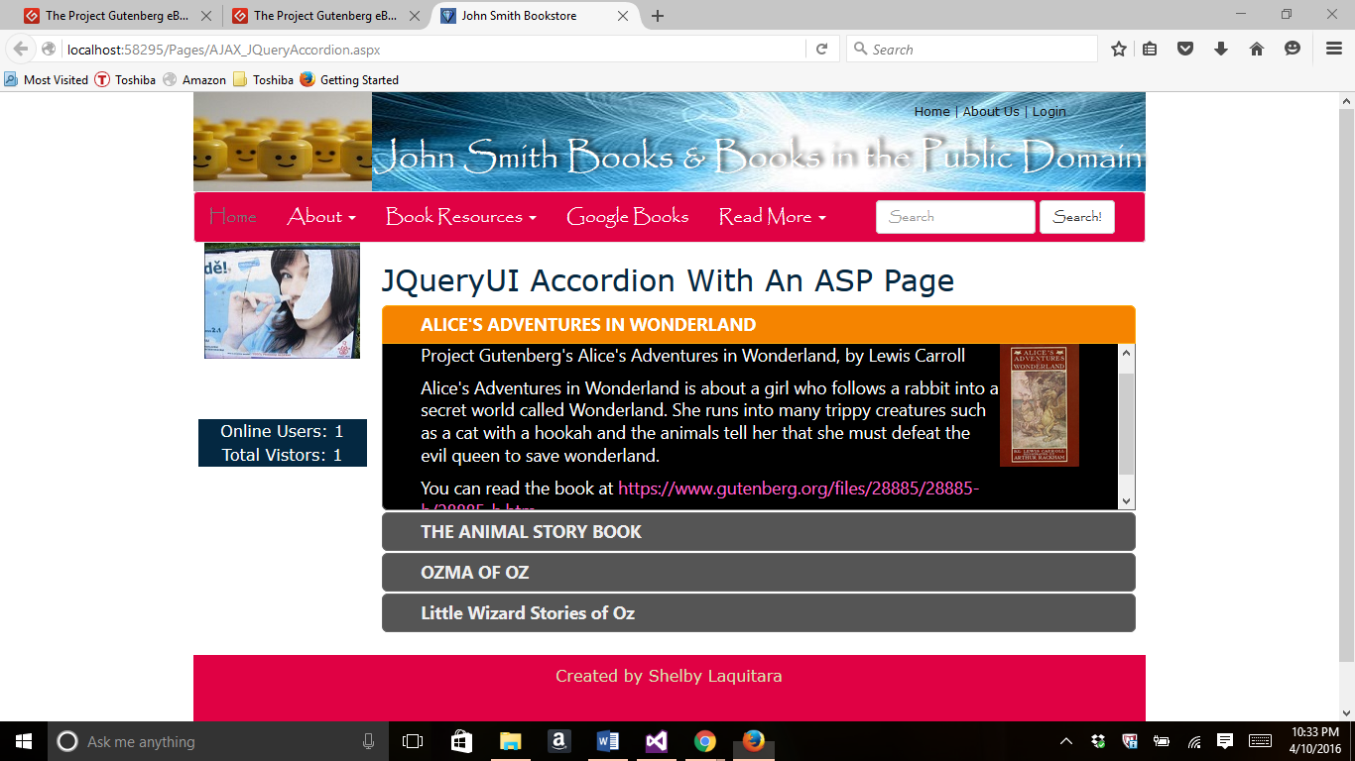

//AJAX_JQueryAutoComplete.aspx screenshots

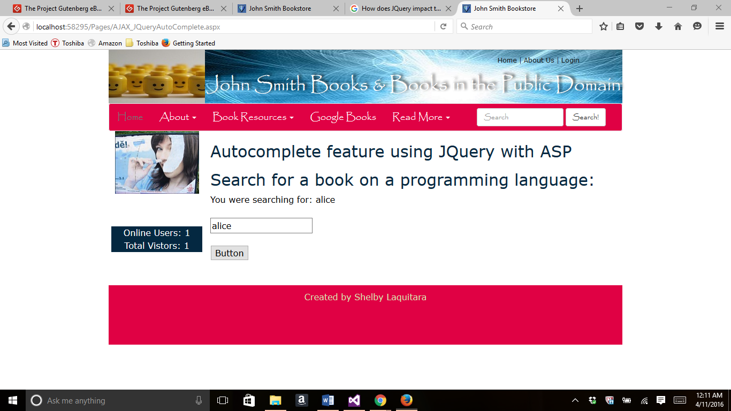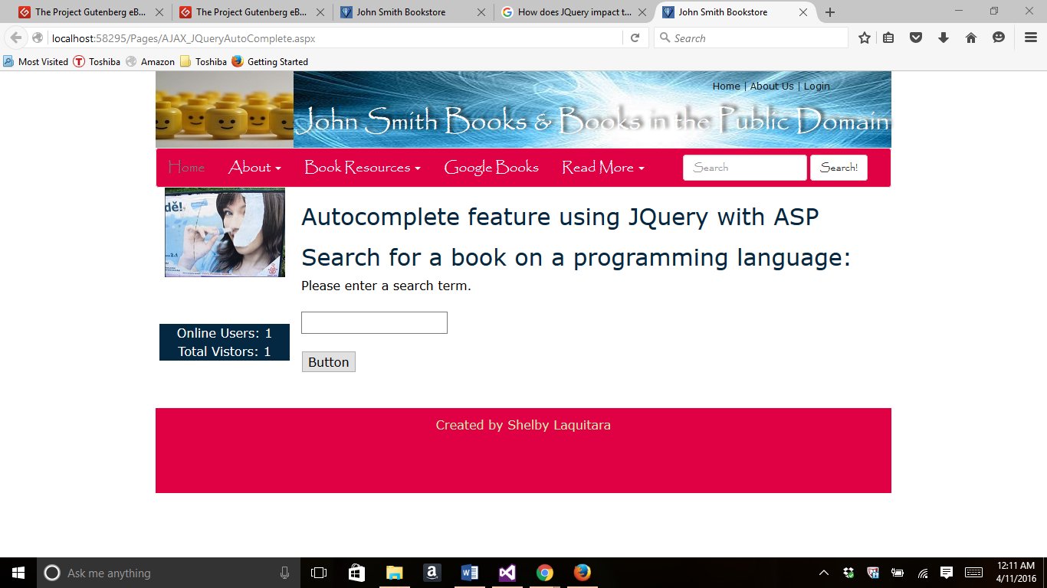

//AJAX_JQueryAutoComplete.aspx code

<%@ Page Title="" Language="C#" MasterPageFile="~/Homework.Master" AutoEventWireup="true" CodeBehind="AJAX_JQueryAutoComplete.aspx.cs" Inherits="Project.Pages.AJAX_JQueryAutoComplete" %>

<asp:Content ID="Content1" ContentPlaceHolderID="HeadSection" runat="server">

<link href="/css/jquery-ui.css" rel="stylesheet" />

<link href="/css/jquerystyle.css" rel="stylesheet" />

</asp:Content>

<asp:Content ID="Content2" ContentPlaceHolderID="ContentSection" runat="server">

<h2>Autocomplete feature using JQuery with ASP</h2>

<!-- Autocomplete -->

<h2 class="demoHeaders">Search for a book on a programming language:</h2>

<div>

<asp:Label ID="Label1" runat="server" Text="Please enter a search term. "></asp:Label>

<br />

<br />

<input runat="server" id="autocomplete"

title="type &quot;a&quot;" />

<br />

<br />

<asp:Button ID="Button1" runat="server" OnClick="Button1_Click" Text="Button" />

<br />

<br />

</div>

<script src="/js/jquery.js"></script>

<script src="/js/jquery-ui.js"></script>

<script>

var availableTags = [

"ActionScript",

"AppleScript",

"Asp",

"BASIC",

"C",

"C++",

"Clojure",

"COBOL",

"ColdFusion",

"Erlang",

"Fortran",

"Groovy",

"Haskell",

"Java",

"JavaScript",

"Lisp",

"Perl",

"PHP",

"Python",

"Ruby",

"Scala",

"Scheme"

];

//create the auto complete using script

$("#autocomplete").autocomplete({

source: availableTags

});

</script>

</asp:Content>

5. I chose to use a JQuery control to create the accordion because I am familiar with it from last semester and I enjoyed doing this.

===========================================================================

//Part 3-

*//AJAX.aspx code*

<%@ Page Title="" Language="C#" MasterPageFile="~/Homework.Master" AutoEventWireup="true" CodeBehind="AJAX.aspx.cs" Inherits="Project.Pages.AJAX" %>

<asp:Content ID="Content1" ContentPlaceHolderID="HeadSection" runat="server">

<link href="/css/jquery-ui.css" rel="stylesheet" />

<link href="/css/jquerystyle.css" rel="stylesheet" />

</asp:Content>

<asp:Content ID="Content2" ContentPlaceHolderID="ContentSection" runat="server">

<h2>ASP AJAX animated Page</h2>

<asp:ScriptManager ID="ScriptManager1" runat="server"></asp:ScriptManager>

<img alt="love" src="../Images/animated-love.gif" style="width: 60px; height: 150px" /><br />

<p>You can find the image at <asp:HyperLink ID="HyperLink1" runat="server" NavigateUrl="http://www.animatedimages.org/img-animated-love-image-0027-105116.htm"

ForeColor="#ff66cc">http://www.animatedimages.org/img-animated-love-image-0027-105116.htm</asp:HyperLink></p>

<asp:UpdatePanel ID="UpdatePanel1" runat="server">

<ContentTemplate>

<div> <img alt="heart" src="../Images/animated-heart.gif" style="width: 60px; height: 150px" /><br />

<p>You can find the image at <asp:HyperLink ID="HyperLink2" runat="server" NavigateUrl="http://www.animatedimages.org/img-animated-love-image-0077-105166.htm"

ForeColor="#ff66cc">http://www.animatedimages.org/img-animated-love-image-0077-105166.htm</asp:HyperLink></p></div>

<div style="background-color:#ffd800;padding: 20px">

<asp:Label ID="lblTime" runat="server" Font-Bold="true"></asp:Label> <br /><br />

<asp:Button ID="cmdRefreshTime" runat="server" Text="Refresh Time" OnClick="cmdRefreshTime_Click" />

</div>

<br />

</ContentTemplate>

</asp:UpdatePanel>

</asp:Content>

//AJAX.aspx screenshot

