I am using 2015 Visual Studio and 2014 SQL Server for my project! I used pink for my main color in page because it is my favorite color and I have been using it since the start of the class.

Part 1-

//Editing the master page code

<!-- Right Menu -->

<ul class="nav navbar-nav navbar-left">

<li class="dropdown"><a href="#" class="dropdown-toggle"

data-toggle="downdown" role="button" aria-expanded="false">

Data & More <span class="caret"></span></a>

<ul class="dropdown-menu" role="menu">

<li class="divider"></li>

<li><a href="#">BIND TO A LIST</a></li>

<li><a href="/Pages/rblist.aspx">List of Topics (RBL)</a></li>

<li><a href="/Pages/ddlist.aspx">List of Topics (DDL)</a></li>

<li class="divider"></li>

<li><a href="#">CONNECTION, COMMAND, DATAREADER</a></li>

<li><a href="/Pages/dbTestConnection.aspx">Test Connection</a></li>

<li><a href="/Pages/dbCategorySelect.aspx">Select a Category</a></li>

<li><a href="/Pages/dbCategoryInsert.aspx">Insert a Category</a></li>

<li><a href="/Pages/dbCategoryUpdate.aspx">Update a Category</a></li>

<li><a href="/Pages/dbCategoryDelete.aspx">Delete a Category</a></li>

<li class="divider"></li>

<li><a href="/Pages/dbStoredProcedure.aspx">Stored Procedure</a></li>

<li><a href="/Pages/dbDataSet.aspx">Data Set</a></li>

<li class="divider"></li>

</ul>

</li>

Part 2-

//rblist.aspx

<%@ Page Title="" Language="C#" MasterPageFile="~/Homework.Master" AutoEventWireup="true" CodeBehind="rblist.aspx.cs" Inherits="Project.Pages.rblist" %>

<asp:Content ID="Content1" ContentPlaceHolderID="HeadSection" runat="server">

<style>

table td {

padding-right: 15px;

padding-left: 15px;

}

.rbl input[type="radio"] {

margin-right: 10px;

}

</style>

</asp:Content>

<asp:Content ID="Content2" ContentPlaceHolderID="ContentSection" runat="server">

<h2>Sample Radio Button List</h2>

<br />

<asp:Label ID="results" runat="server" Text=""></asp:Label>

<br /> <br />

<asp:RadioButtonList ID="rbl" runat="server" RepeatColumns="2"

AutoPostBack="true" CssClass="rbl"></asp:RadioButtonList>

</asp:Content>

//rblist.aspx.cs

using System;

using System.Collections.Generic;

using System.Linq;

using System.Web;

using System.Web.UI;

using System.Web.UI.WebControls;

namespace Project.Pages

{

public partial class rblist : System.Web.UI.Page

{

protected void Page_Load(object sender, EventArgs e)

{

if (!Page.IsPostBack)

{

results.Text = "Choose a topic:";

List<string> topics = new List<string>();

topics.Add("American History");

topics.Add("Arts & Culture");

topics.Add("Biography");

topics.Add("Business");

topics.Add("Fantasy");

topics.Add("Fiction");

topics.Add("Film");

topics.Add("Government, Politics & Law");

topics.Add("Historic Books");

topics.Add("Hobbies");

topics.Add("Manuscripts");

topics.Add("Maps & Geography");

topics.Add("Memoirs");

topics.Add("Newspapers & Journalism");

topics.Add("Prints & Photography");

topics.Add("Religion & Philosophy");

topics.Add("Science Fiction");

topics.Add("Science & Technology");

topics.Add("Sports & Leisure");

topics.Add("World History & Culture");

rbl.DataSource = topics;

this.DataBind();

}

else

{

results.Text = "You choose: " + rbl.SelectedItem.Text.ToString();

}

}

}

}

//rblist.aspx in browser

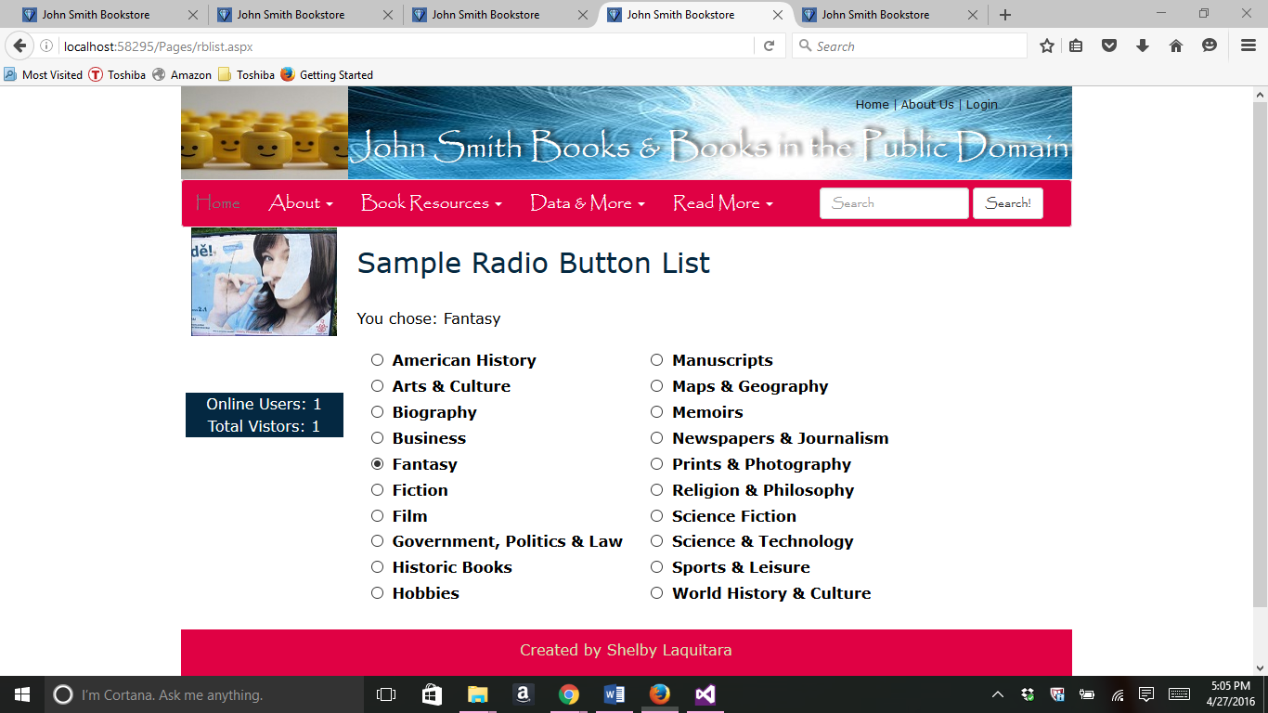

//ddlist.aspx

<%@ Page Title="" Language="C#" MasterPageFile="~/Homework.Master" AutoEventWireup="true" CodeBehind="ddlist.aspx.cs" Inherits="Project.Pages.ddlist" %>

<asp:Content ID="Content1" ContentPlaceHolderID="HeadSection" runat="server">

</asp:Content>

<asp:Content ID="Content2" ContentPlaceHolderID="ContentSection" runat="server">

<h1>Sample Dropdown List</h1>

<br /> <br />

<asp:Label ID="results" runat="server" Text=""></asp:Label>

<br /> <br />

<asp:DropDownList ID="ddl" runat="server" AutoPostBack="True"></asp:DropDownList>

<br /><br /><br />

</asp:Content>

//ddlist.aspx.cs

using System;

using System.Collections.Generic;

using System.Linq;

using System.Web;

using System.Web.UI;

using System.Web.UI.WebControls;

namespace Project.Pages

{

public partial class ddlist : System.Web.UI.Page

{

protected void Page_Load(object sender, EventArgs e)

{

if (!Page.IsPostBack)

{

results.Text = "Choose a topic:";

List<string> topics = new List<string>();

topics.Add("American History");

topics.Add("Arts & Culture");

topics.Add("Biography");

topics.Add("Business");

topics.Add("Fantasy");

topics.Add("Fiction");

topics.Add("Film");

topics.Add("Government, Politics & Law");

topics.Add("Historic Books");

topics.Add("Hobbies");

topics.Add("Manuscripts");

topics.Add("Maps & Geography");

topics.Add("Memoirs");

topics.Add("Newspapers & Journalism");

topics.Add("Prints & Photography");

topics.Add("Religion & Philosophy");

topics.Add("Science Fiction");

topics.Add("Science & Technology");

topics.Add("Sports & Leisure");

topics.Add("World History & Culture");

ddl.DataSource = topics;

this.DataBind();

}

else

{

results.Text = "You choose: " + ddl.SelectedItem.Text.ToString();

}

}

}

}

//ddlist.aspx in browser

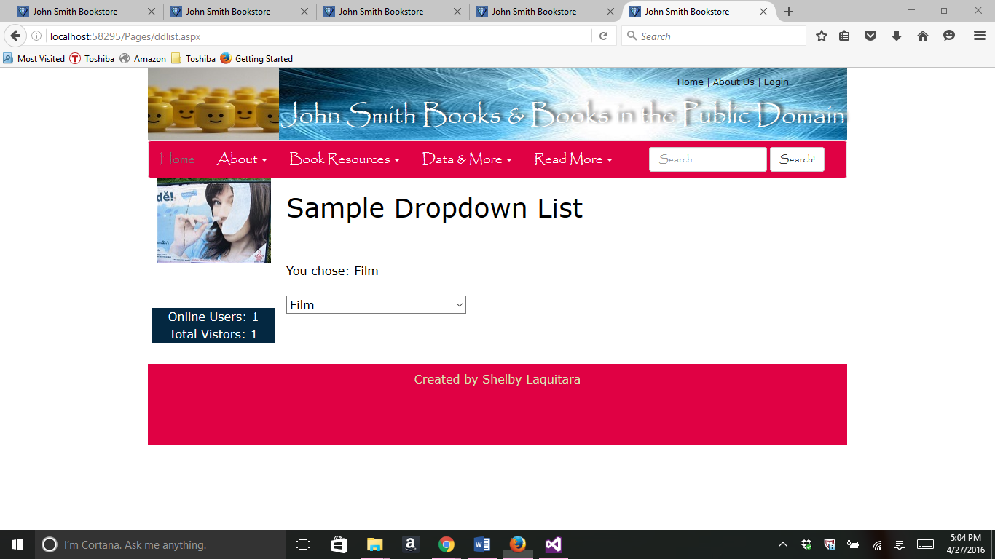

Part 3-

//dbTestConnection.aspx code

<%@ Page Title="" Language="C#" MasterPageFile="~/Homework.Master" AutoEventWireup="true" CodeBehind="dbTestConnection.aspx.cs" Inherits="Project.Pages.dbTestConnection" %>

<asp:Content ID="Content1" ContentPlaceHolderID="HeadSection" runat="server">

</asp:Content>

<asp:Content ID="Content2" ContentPlaceHolderID="ContentSection" runat="server">

<h1>Test Connection</h1>

<br /> <br />

<asp:Label ID="results" runat="server" Text=""></asp:Label>

<br /> <br />

<br /><br /><br />

</asp:Content>

//dbTestConnection.aspx.cs code

using System;

using System.Collections.Generic;

using System.Linq;

using System.Web;

using System.Web.UI;

using System.Web.UI.WebControls;

using System.Data.SqlClient;

using System.Web.Configuration;

namespace Project.Pages

{

public partial class dbTestConnection : System.Web.UI.Page

{

protected void Page_Load(object sender, EventArgs e)

{

string CS = WebConfigurationManager.ConnectionStrings

["MyCS"].ConnectionString;

SqlConnection myConnection = new SqlConnection(CS);

myConnection.Open();

results.Text = "Database Name: <br />" + myConnection.Database + "<br /><br />";

results.Text += "Connection String: <br />" + myConnection.ConnectionString + "<br /><br />";

results.Text += "Data Source: " + myConnection.DataSource + "<br />";

results.Text += "Server Version: " + myConnection.ServerVersion + "<br />";

results.Text += "Connection Timeout: " + myConnection.ConnectionTimeout + "<br /><br />";

results.Text += "Connection State Is: " + myConnection.State.ToString() + "<br />";

myConnection.Close();

results.Text += "Connection State Is: " + myConnection.State.ToString();

}

}

}

//dbTestConnection.aspx in browser

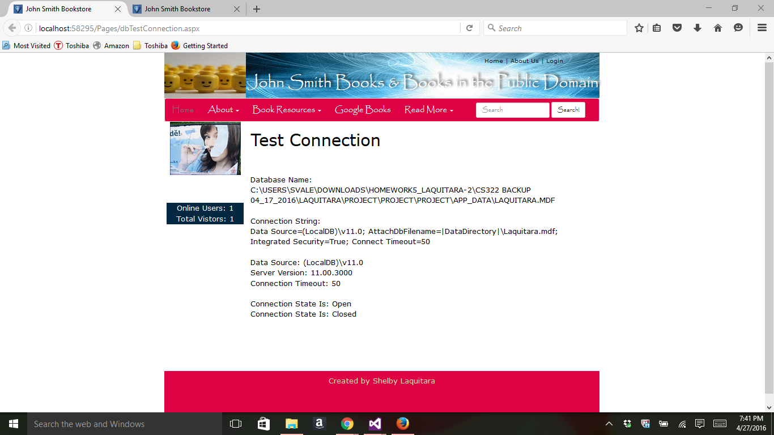

Part 4-

// dbCategorySelect.aspx code

<%@ Page Title="" Language="C#" MasterPageFile="~/Homework.Master" AutoEventWireup="true" CodeBehind="dbCategorySelect.aspx.cs" Inherits="Project.Pages.dbCategorySelect" %>

<asp:Content ID="Content1" ContentPlaceHolderID="HeadSection" runat="server">

<style>

.top {

margin-top: 12px;

padding: 12px;

padding-left: 25px;

height: 250px; width: 650px;

background-color: #e00144;

border-color: #000000;

border-width:thin;

color: #FFFFFF;

}

.top select {

color: #ff006e;

}

.bottom {

padding-left: 22px;

height: 210px;

width: 652px;

background-color: #FEE7FA;

border-color: #000000;

border-width:thin;

padding-right: 12px;

padding-top: 12px;

padding-bottom: 12px;

}

</style>

</asp:Content>

<asp:Content ID="Content2" ContentPlaceHolderID="ContentSection" runat="server">

<div class="top">

<h4>SELECT a Category</h4>

<br />

<!-- Configure the DropDownList Control -->

<br />

<asp:DropDownList ID="ddlCategory" runat="server" Width="300px" Height="45px"

OnSelectedIndexChange = "ddlCategory_SelectedIndexChanged"

AutoPostBack="true" OnSelectedIndexChanged="ddlCategory_SelectedIndexChanged" ></asp:DropDownList>

<br />

</div>

<!-- Configure the form the match the form fields -->

<div class="bottom">

<asp:Label ID="Label1" runat="server" Width="155px">Category ID:</asp:Label>

<asp:TextBox ID="txtCatID" runat="server" Width="100px" BackColor="#f5f1f1"

ForeColor="#666666" ReadOnly="true" MaxLength ="15"></asp:TextBox>&nbsp; <br />

<asp:Label ID="Label2" runat="server" Width="155px">Category Name:</asp:Label>

<asp:TextBox ID="txtCatTitle" runat="server" Width="250px" BackColor="#f5f1f1"

ForeColor="#666666" ReadOnly="true" MaxLength ="45"></asp:TextBox>&nbsp; <br />

<asp:Label ID="Label3" runat="server" Width="155px">Category Description:</asp:Label>

<asp:TextBox ID="txtCatDescription" runat="server" Width="400px" BackColor="#f5f1f1"

ForeColor="#666666" ReadOnly="true" MaxLength ="45"></asp:TextBox>&nbsp; <br />

<br /><br />

<asp:Label ID="lblResults" runat="server" Width="580px" Height="50px"

Font-Bold="true"></asp:Label>

</div>

</asp:Content>

// dbCategorySelect.aspx.cs code

using System;

using System.Collections.Generic;

using System.Linq;

using System.Web;

using System.Web.UI;

using System.Web.UI.WebControls;

using System.Data.SqlClient;

using System.Web.Configuration;

namespace Project.Pages

{

public partial class dbCategorySelect : System.Web.UI.Page

{

public string CS = WebConfigurationManager.ConnectionStrings

["MyCS"].ConnectionString;

protected void Page_Load(object sender, EventArgs e)

{

if (!this.IsPostBack)

{

FillCategoryList();

}

}

//Change category in the dropdown list

protected void ddlCategory_SelectedIndexChanged(object sender, EventArgs e)

{

string selectSQL;

selectSQL = "SELECT * FROM Categories WHERE catid='"

+ ddlCategory.SelectedItem.Value + "'";

SqlConnection con = new SqlConnection(CS);

SqlCommand cmd = new SqlCommand(selectSQL, con);

SqlDataReader reader;

try

{

con.Open();

reader = cmd.ExecuteReader();

reader.Read();

// Fill the controls

txtCatID.Text = reader["catid"].ToString();

txtCatTitle.Text = reader["cattitle"].ToString();

txtCatDescription.Text = reader["catdescription"].ToString();

reader.Close();

lblResults.Text = "The categories are now displayed!";

}

catch (Exception err)

{

lblResults.Text = "Error getting category information: ";

lblResults.Text += err.Message;

}

finally

{

con.Close();

}

}

//Fill Category List for the Dropdown List

private void FillCategoryList()

{

ddlCategory.Items.Clear();

string selectSQL = "SELECT * FROM Categories";

SqlConnection con = new SqlConnection(CS);

SqlCommand cmd = new SqlCommand(selectSQL, con);

SqlDataReader reader;

ListItem firstItem = new ListItem();

firstItem.Text = "Please select a category";

firstItem.Value = "0";

ddlCategory.Items.Add(firstItem);

try

{

con.Open();

reader = cmd.ExecuteReader();

while (reader.Read())

{

ListItem newItem = new ListItem();

newItem.Text = reader["cattitle"].ToString();

newItem.Value = reader["catid"].ToString();

ddlCategory.Items.Add(newItem);

}

reader.Close();

lblResults.Text = "The category list has been populated in the dropdown list.";

}

catch (Exception err)

{

lblResults.Text = "Error Reading list of categories";

lblResults.Text += err.Message;

}

finally

{

con.Close();

}

}

}

}

//dcCategorySelect.aspx.cd in browser

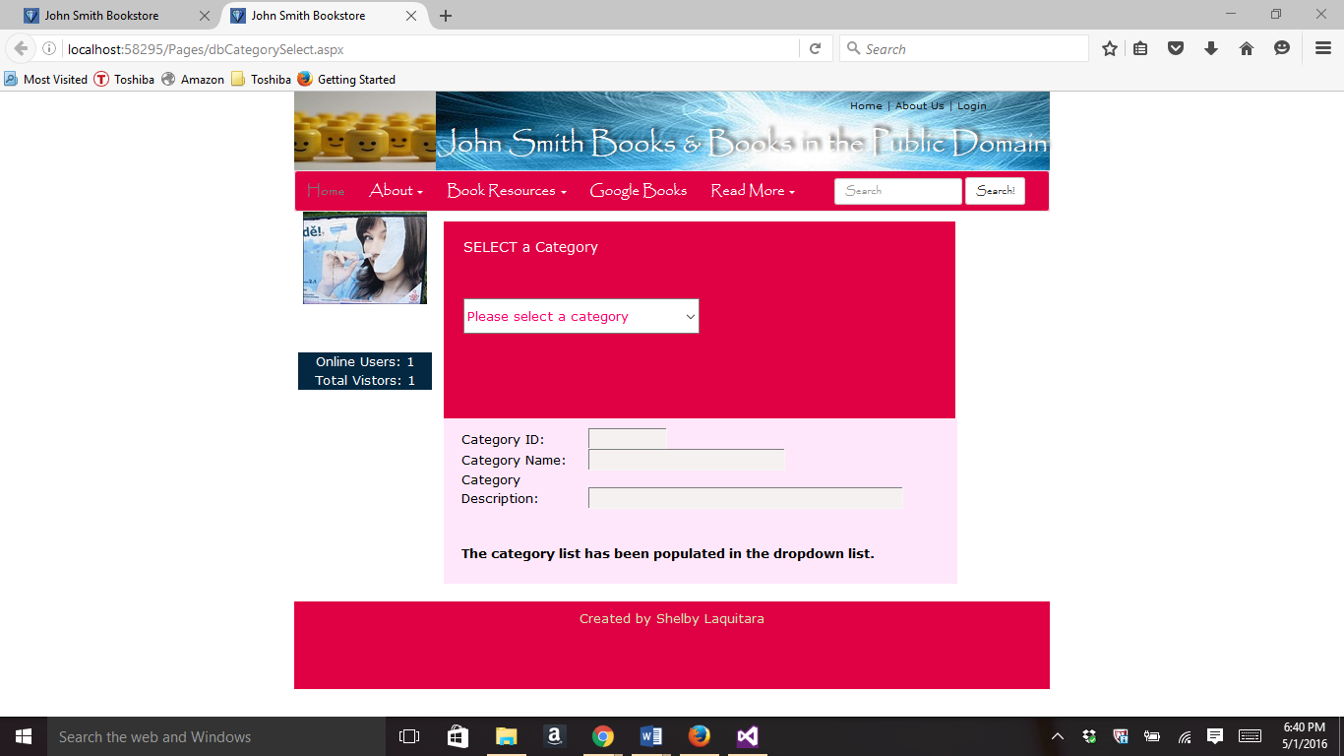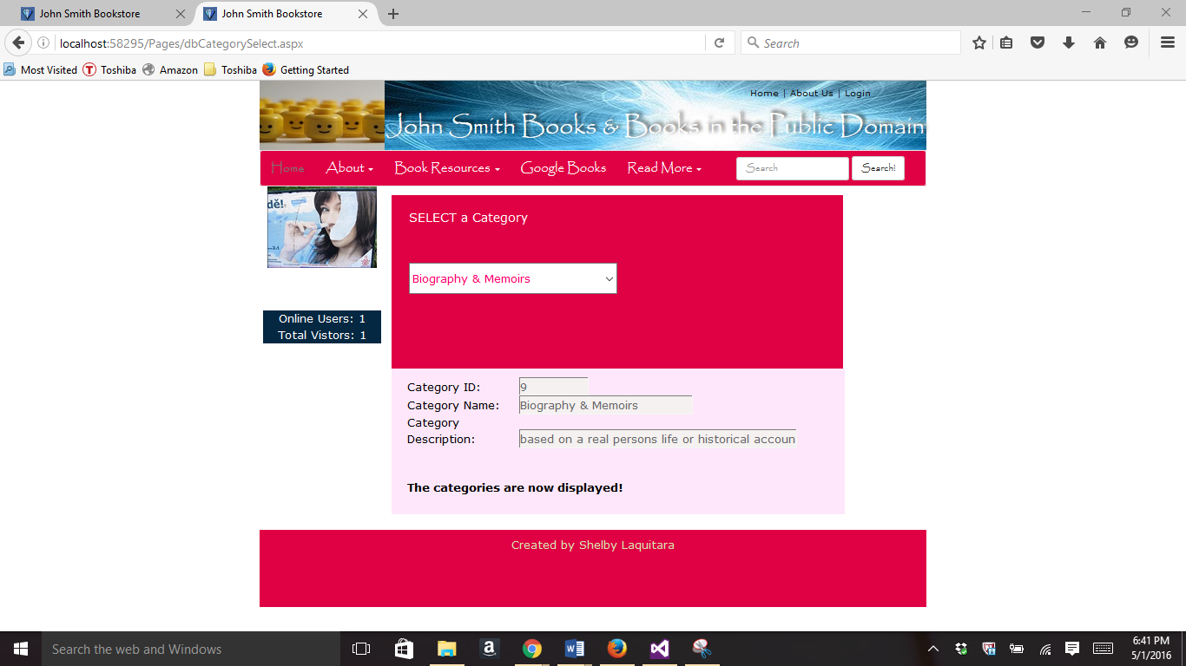

Part 5-

//dbStoredProcedure.aspx

<%@ Page Title="" Language="C#" MasterPageFile="~/Homework.Master" AutoEventWireup="true" CodeBehind="dbStoredProcedure.aspx.cs" Inherits="Project.Pages.dbStoredProcedure" %>

<asp:Content ID="Content1" ContentPlaceHolderID="HeadSection" runat="server">

<style>

.top {

margin-top: 12px;

padding: 12px;

padding-left: 25px;

height: 250px; width: 650px;

background-color: #e00144;

border-color: #000000;

border-width:thin;

color: #FFFFFF;

}

.top select {

color: #ff006e;

}

.bottom {

padding-left: 22px;

height: 210px;

width: 652px;

background-color: #FEE7FA;

border-color: #000000;

border-width:thin;

padding-right: 12px;

padding-top: 12px;

padding-bottom: 12px;

}

</style>

</asp:Content>

<asp:Content ID="Content2" ContentPlaceHolderID="ContentSection" runat="server">

<div class="top">

<h4>SELECT a Category</h4>

<br />

<!-- Configure the DropDownList Control -->

<br />

<asp:DropDownList ID="ddlCategory" runat="server" Width="300px" Height="20px"

OnSelectedIndexChange = "ddlCategory_SelectedIndexChanged"

AutoPostBack="true"></asp:DropDownList>

<br />

</div>

<!-- Display the data -->

<div class="bottom">

<br /><br />

<asp:Label ID="lblResults" runat="server" Width="560px" Height="45px"

font-bold="true"></asp:Label>

<br /><br /><br />

</div>

</asp:Content>

//dbStoredProcedure.aspx.cs

using System;

using System.Collections.Generic;

using System.Linq;

using System.Web;

using System.Web.UI;

using System.Web.UI.WebControls;

using System.Data.SqlClient;

using System.Web.Configuration;

namespace Project.Pages

{

public partial class dbStoredProcedure : System.Web.UI.Page

{

private string CS = WebConfigurationManager.ConnectionStrings

["MyCS"].ConnectionString;

protected void Page_Load(object sender, EventArgs e)

{

if (!this.IsPostBack)

{

FillCategoryList();

}

else

{

lblResults.Text = "You picked: " +

ddlCategory.SelectedItem.Value.ToString();

}

}

//Fill category list for the dropdown list

private void FillCategoryList()

{

ddlCategory.Items.Clear();

SqlConnection con = new SqlConnection(CS);

SqlCommand cmd = new SqlCommand();

cmd.Connection = con;

cmd.CommandType = System.Data.CommandType.StoredProcedure;

cmd.CommandText = "sp_getcat";

SqlDataReader reader;

ListItem firstItem = new ListItem();

firstItem.Text = "Please select a category";

firstItem.Value = "0";

ddlCategory.Items.Add(firstItem);

try

{

con.Open();

reader = cmd.ExecuteReader();

while (reader.Read())

{

ListItem newItem = new ListItem();

newItem.Text = reader["cattitle"].ToString();

newItem.Value = reader["catid"].ToString();

ddlCategory.Items.Add(newItem);

}

reader.Close();

lblResults.Text = "The category list has been populated in the dropdown list.";

}

catch (Exception err)

{

lblResults.Text = "Error Reading list of categories";

lblResults.Text += err.Message;

}

finally

{

con.Close();

}

}

}

}

//dbStoredProcedure in browser

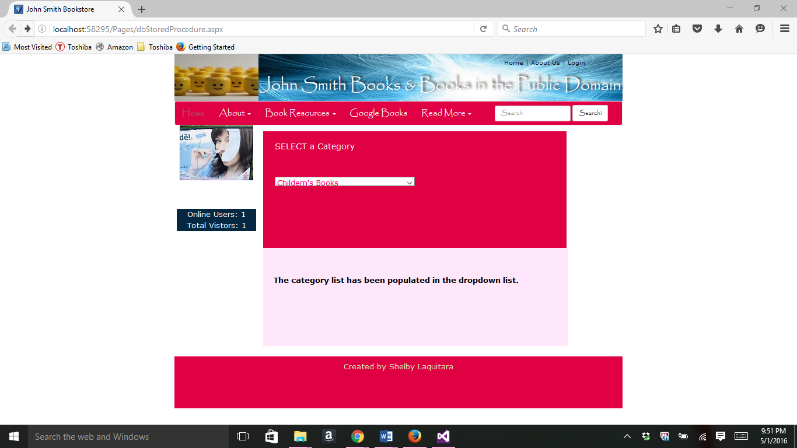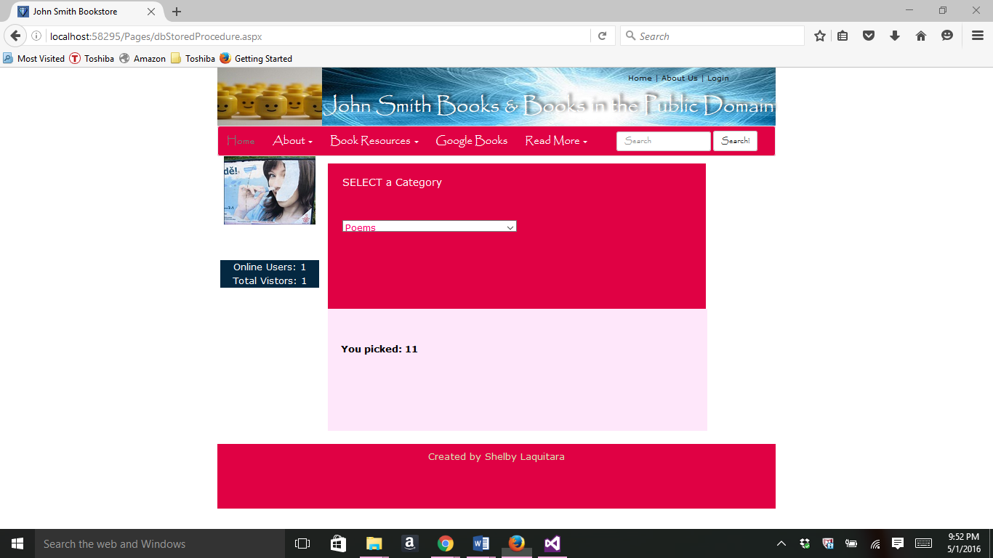

Part 6-

//dbCategoryInsert.aspx

<%@ Page Title="" Language="C#" MasterPageFile="~/Homework.Master" AutoEventWireup="true" CodeBehind="dbCategoryInsert.aspx.cs" Inherits="Project.Pages.dbCategoryInsert" %>

<asp:Content ID="Content1" ContentPlaceHolderID="HeadSection" runat="server">

<style>

.top {

margin-top: 12px;

padding: 12px;

padding-left: 25px;

height: 250px; width: 650px;

background-color: #e00144;

border-color: #000000;

border-width:thin;

color: #FFFFFF;

}

.top select {

color: #ff006e;

}

.bottom {

padding-left: 22px;

height: 272px;

width: 661px;

background-color: #FEE7FA;

border-color: #000000;

border-width:thin;

padding-right: 12px;

padding-top: 12px;

padding-bottom: 12px;

}

</style>

</asp:Content>

<asp:Content ID="Content2" ContentPlaceHolderID="ContentSection" runat="server">

<div class="top">

<h4>Insert a Category</h4>

<br />

<asp:Label ID="Labelheading" runat="server" Width="120px"

Height="25px">&nbsp;</asp:Label>

<!-- configure the DropDownList Control -->

<asp:DropDownList ID="ddlCategory" runat="server" Width="320px"

Height="25px" AutoPostBack="false" ></asp:DropDownList>

<br />

</div>

<!-- Configure the form -->

<div class="bottom">

<asp:Label ID="Label1" runat="server" Width="155px">Category ID:</asp:Label>

<asp:TextBox ID="txtCatID" runat="server" Width="100px" BackColor="#ffffff"

ForeColor="#666666" MaxLength="15"></asp:TextBox>&nbsp; <br />

<asp:Label ID="Label2" runat="server" Width="155px">Category Name:</asp:Label>

<asp:TextBox ID="txtCatTitle" runat="server" Width="250px" BackColor="#ffffff"

ForeColor="#666666" MaxLength="45"></asp:TextBox>&nbsp; <br />

<asp:Label ID="Label3" runat="server" Width="155px">Category Description:</asp:Label>

<asp:TextBox ID="txtCatDescription" runat="server" Width="400px" BackColor="#ffffff"

ForeColor="#666666" MaxLength="45"></asp:TextBox>&nbsp; <br /><br />

<asp:Button ID="btnInsert" runat="server" Text="Insert"

OnClick="btnInsert_Click" />

<br /><br />

<asp:Label ID="lblResults" runat="server" Width="580px" Height="50px"

Font-Bold="true"></asp:Label>

<br /><br /><br /><br />

</div>

</asp:Content>

//dbCategoryInsert.aspx.cs

using System;

using System.Collections.Generic;

using System.Linq;

using System.Web;

using System.Web.UI;

using System.Web.UI.WebControls;

using System.Data.SqlClient;

using System.Web.Configuration;

namespace Project.Pages

{

public partial class dbCategoryInsert : System.Web.UI.Page

{

public string CS = WebConfigurationManager.ConnectionStrings

["MyCS"].ConnectionString;

protected void Page_Load(object sender, EventArgs e)

{

if (!this.IsPostBack)

{

FillCategoryList();

}

}

//Insert Record

protected void btnInsert_Click(object sender, EventArgs e)

{

//perform user defined checks.

if (txtCatID.Text == "" || txtCatTitle.Text == "")

{

lblResults.Text = "Records require category ID and category name.";

return;

}

string insertSQL;

insertSQL = "INSERT INTO Categories ("

+ "catid, cattitle, catdescription)"

+ "VALUES (@catid, @cattitle, @catdescription)";

SqlConnection con = new SqlConnection(CS);

SqlCommand cmd = new SqlCommand(insertSQL, con);

//Add parameters and values

cmd.Parameters.AddWithValue("@catid", txtCatID.Text);

cmd.Parameters.AddWithValue("@cattitle", txtCatTitle.Text);

cmd.Parameters.AddWithValue("@catdescription", txtCatDescription.Text);

//try to open database and excute the update

int returnValue = 0;

try

{

con.Open();

returnValue = cmd.ExecuteNonQuery();

lblResults.Text = returnValue.ToString() + " record inserted.";

}

catch (Exception err)

{

lblResults.Text = "Error inserting record: ";

lblResults.Text += err.Message;

}

finally

{

con.Close();

}

//if insert succeeded, refresh the author list

if (returnValue > 0)

{

FillCategoryList();

txtCatID.Text = "";

txtCatTitle.Text = "";

txtCatDescription.Text = "";

}

}

//FillCategoryList

private void FillCategoryList()

{

ddlCategory.Items.Clear();

//define the select statement

string selectSQL = "SELECT * FROM Categories";

//define the objects

SqlConnection con = new SqlConnection(CS);

SqlCommand cmd = new SqlCommand(selectSQL, con);

SqlDataReader reader;

//Add the first item in the DropDownList

ListItem firstItem = new ListItem();

firstItem.Text = "Please select a category";

firstItem.Value = "0";

ddlCategory.Items.Add(firstItem);

//Try to open the database and read information

try

{

con.Open();

reader = cmd.ExecuteReader();

//each DropDownList store the CompanyName and ContactName using the text property

int nextnumber = 0;

while (reader.Read())

{

ListItem newItem = new ListItem();

newItem.Text = reader["cattitle"].ToString();

newItem.Value = reader["catid"].ToString();

ddlCategory.Items.Add(newItem);

nextnumber++;

}

reader.Close();

nextnumber++;

lblResults.Text = "The category list has been populated in the dropdown list. <br />" +

"The next number in the list is " + nextnumber.ToString();

}

catch (Exception err)

{

lblResults.Text = "Error reading list of categories.";

lblResults.Text += err.Message;

}

finally

{

con.Close();

}

}

}

}

//dbCategoryInsert in Broswer-

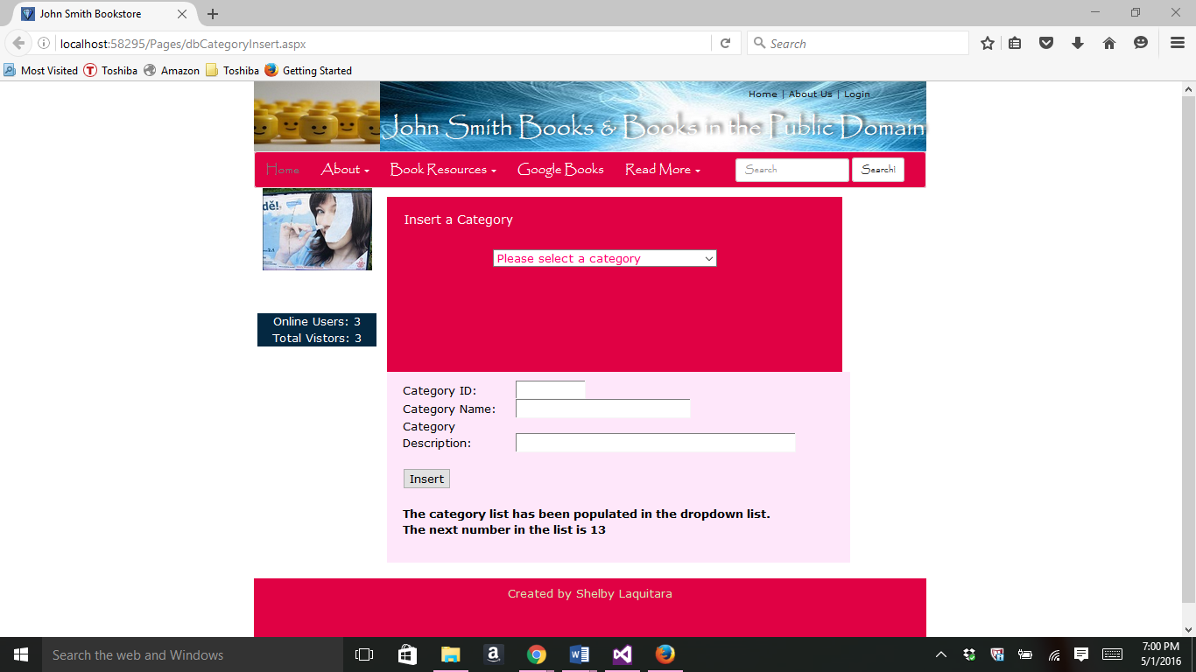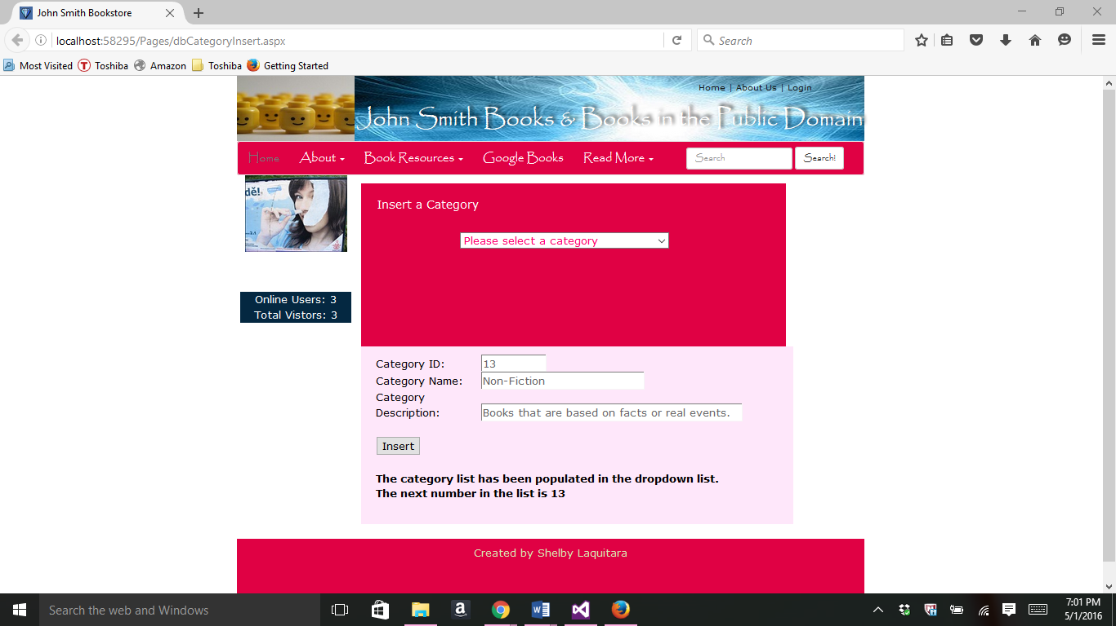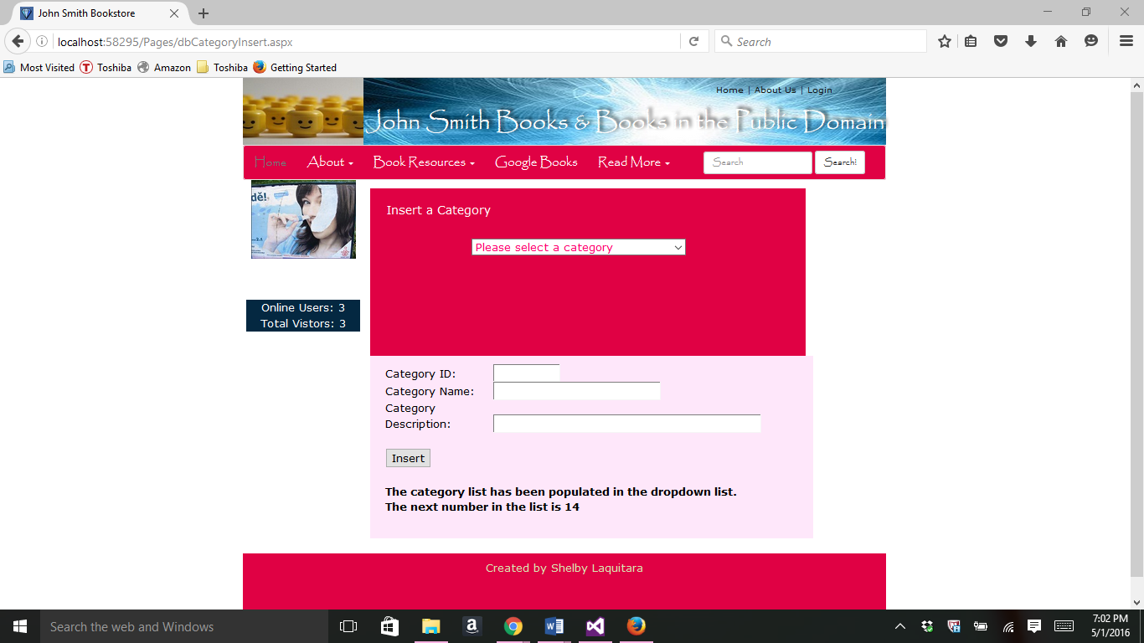

Part 7-

//dbCategoryDelete.aspx

<%@ Page Title="" Language="C#" MasterPageFile="~/Homework.Master" AutoEventWireup="true" CodeBehind="dbCategoryDelete.aspx.cs" Inherits="Project.Pages.dbCategoryDelete" %>

<asp:Content ID="Content1" ContentPlaceHolderID="HeadSection" runat="server">

<style>

.top {

margin-top: 12px;

padding: 12px;

padding-left: 25px;

height: 250px; width: 650px;

background-color: #e00144;

border-color: #000000;

border-width:thin;

color: #FFFFFF;

}

.top select {

color: #ff006e;

}

.bottom {

padding-left: 22px;

height: 237px;

width: 657px;

background-color: #FEE7FA;

border-color: #000000;

border-width:thin;

padding-right: 12px;

padding-top: 12px;

padding-bottom: 12px;

}

</style>

</asp:Content>

<asp:Content ID="Content2" ContentPlaceHolderID="ContentSection" runat="server">

<div class="top">

<h4>SELECT a Category</h4>

<br />

<asp:Label ID="Labelheading" runat="server" Width="100px"

Height="20px">&nbsp;</asp:Label>

<!-- Configure the DropDownList control -->

<asp:DropDownList ID="ddlCategory" runat="server" Width="300px"

Height="21px" OnSelectedIndexChanged ="ddlCategory_SelectedIndexChanged"

AutoPostBack="true"></asp:DropDownList>

<br />

</div>

<!-- Configure the form the match the form fields -->

<div class="bottom">

<asp:Label ID="Label1" runat="server" Width="155px">Category ID:</asp:Label>

<asp:TextBox ID="txtCatID" runat="server" Width="100px" BackColor="#f5f1f1"

ForeColor="#666666" ReadOnly="true" MaxLength ="15"></asp:TextBox>&nbsp; <br />

<asp:Label ID="Label2" runat="server" Width="155px">Category Name:</asp:Label>

<asp:TextBox ID="txtCatTitle" runat="server" Width="250px" BackColor="#f5f1f1"

ForeColor="#666666" ReadOnly="true" MaxLength ="45"></asp:TextBox>&nbsp; <br />

<asp:Label ID="Label3" runat="server" Width="155px">Category Description:</asp:Label>

<asp:TextBox ID="txtCatDescription" runat="server" Width="400px" BackColor="#f5f1f1"

ForeColor="#666666" ReadOnly="true" MaxLength ="45"></asp:TextBox>&nbsp; <br />

<br /><br />

<asp:Button ID="btnDelete" runat="server" Text="Delete" OnClick="btnDelete_Click" />

<br /><br />

<asp:Label ID="lblResults" runat="server" Width="580px" Height="50px"

Font-Bold="true"></asp:Label>

</div>

</asp:Content>

//dbCategoryDelete.aspx.cs

using System;

using System.Collections.Generic;

using System.Linq;

using System.Web;

using System.Web.UI;

using System.Web.UI.WebControls;

using System.Data.SqlClient;

using System.Web.Configuration;

namespace Project.Pages

{

public partial class dbCategoryDelete : System.Web.UI.Page

{

public string CS = WebConfigurationManager.ConnectionStrings

["MyCS"].ConnectionString;

protected void Page_Load(object sender, EventArgs e)

{

if (!this.IsPostBack)

{

FillCategoryList();

}

}

//Delete a Record

protected void btnDelete_Click(object sender, EventArgs e)

{

//perform user defined checks.

if (txtCatID.Text == "" || txtCatTitle.Text == "")

{

lblResults.Text = "Records require category ID and category name.";

return;

}

string deleteSQL;

deleteSQL = "DELETE FROM Categories "

+ "WHERE " + "catid = @catid";

SqlConnection con = new SqlConnection(CS);

SqlCommand cmd = new SqlCommand(deleteSQL, con);

cmd.Parameters.AddWithValue("@catid", txtCatID.Text);

int deleted = 0;

try

{

con.Open();

deleted = cmd.ExecuteNonQuery();

lblResults.Text = deleted.ToString() + "record deleted.";

}

catch (Exception err)

{

lblResults.Text = "Error deleting record: ";

lblResults.Text += err.Message;

}

finally

{

con.Close();

}

//if the record is deleted successfully, refresh the author list

if (deleted > 0)

{

FillCategoryList();

txtCatID.Text = "";

txtCatTitle.Text = "";

txtCatDescription.Text = "";

}

}

protected void ddlCategory_SelectedIndexChanged(object sender, EventArgs e)

{

//Define the ADO.NET objects

string selectSQL;

selectSQL = "SELECT * FROM Categories WHERE catid = '"

+ ddlCategory.SelectedItem.Value + "'";

SqlConnection con = new SqlConnection(CS);

SqlCommand cmd = new SqlCommand(selectSQL, con);

SqlDataReader reader;

try

{

con.Open();

reader = cmd.ExecuteReader();

reader.Read();

// Fill the controls

txtCatID.Text = reader["catid"].ToString();

txtCatTitle.Text = reader["cattitle"].ToString();

txtCatDescription.Text = reader["catdescription"].ToString();

reader.Close();

lblResults.Text = "The categories are now displayed!";

}

catch (Exception err)

{

lblResults.Text = "Error getting category information: ";

lblResults.Text += err.Message;

}

finally

{

con.Close();

}

}

//Fill Category List for the Dropdown List

private void FillCategoryList()

{

ddlCategory.Items.Clear();

string selectSQL = "SELECT * FROM Categories";

SqlConnection con = new SqlConnection(CS);

SqlCommand cmd = new SqlCommand(selectSQL, con);

SqlDataReader reader;

ListItem firstItem = new ListItem();

firstItem.Text = "Please select a category";

firstItem.Value = "0";

ddlCategory.Items.Add(firstItem);

try

{

con.Open();

reader = cmd.ExecuteReader();

while (reader.Read())

{

ListItem newItem = new ListItem();

newItem.Text = reader["cattitle"].ToString();

newItem.Value = reader["catid"].ToString();

ddlCategory.Items.Add(newItem);

}

reader.Close();

lblResults.Text = "The category list has been populated in the dropdown list.";

}

catch (Exception err)

{

lblResults.Text = "Error Reading list of categories";

lblResults.Text += err.Message;

}

finally

{

con.Close();

}

}

}

}

//dbCategoryDelete in browser

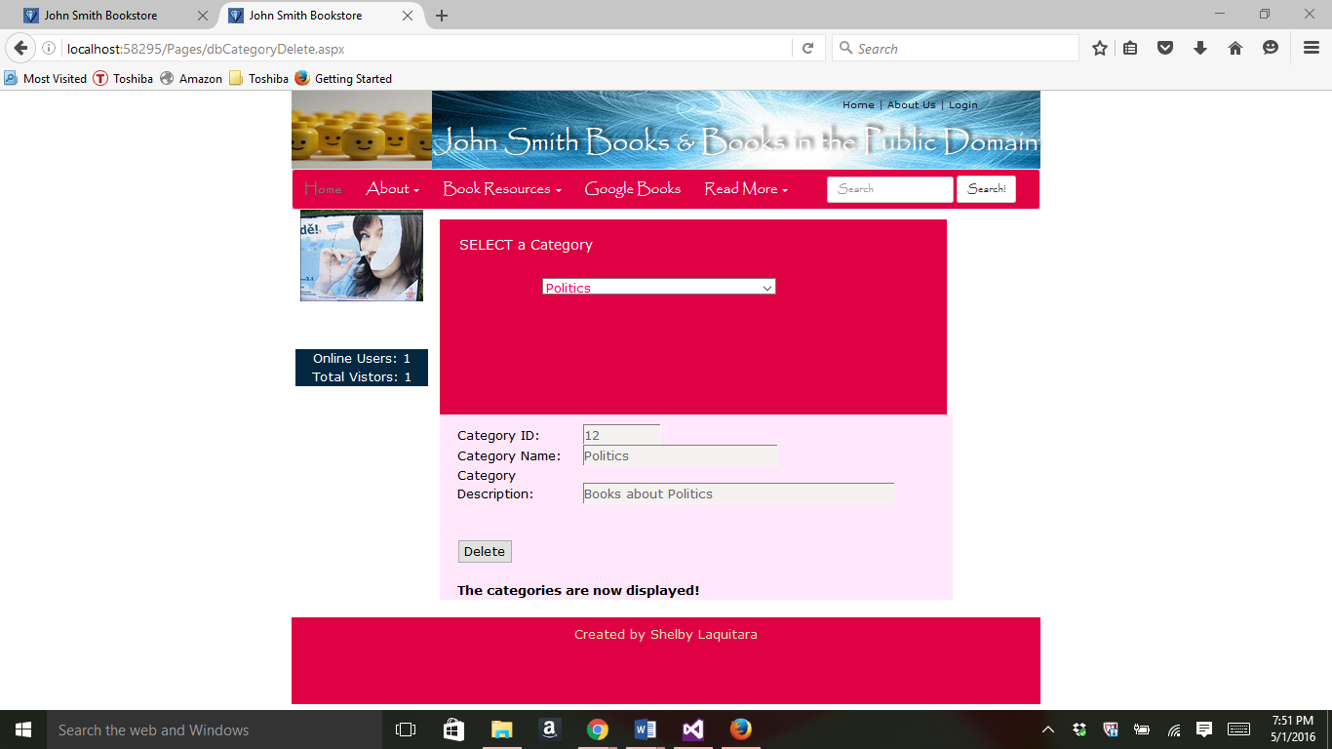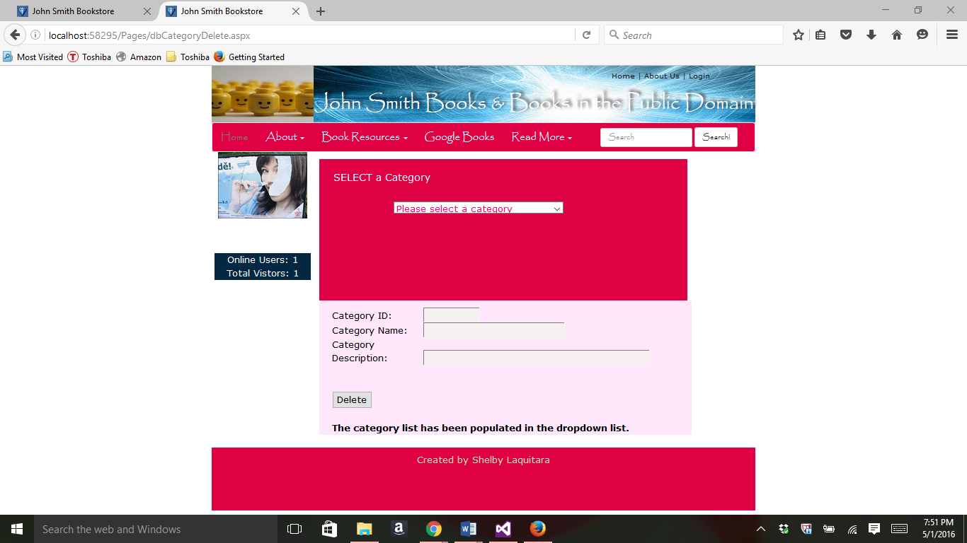

Part 8-

//dbCategoryUpdate.aspx

<%@ Page Title="" Language="C#" MasterPageFile="~/Homework.Master" AutoEventWireup="true" CodeBehind="dbCategoryUpdate.aspx.cs" Inherits="Project.Pages.dbCategoryUpdate" %>

<asp:Content ID="Content1" ContentPlaceHolderID="HeadSection" runat="server">

<style>

.top {

margin-top: 12px;

padding: 12px;

padding-left: 25px;

height: 250px; width: 650px;

background-color: #e00144;

border-color: #000000;

border-width:thin;

color: #FFFFFF;

}

.top select {

color: #ff006e;

}

.bottom {

padding-left: 22px;

height: 265px;

width: 658px;

background-color: #FEE7FA;

border-color: #000000;

border-width:thin;

padding-right: 12px;

padding-top: 12px;

padding-bottom: 12px;

}

</style>

</asp:Content>

<asp:Content ID="Content2" ContentPlaceHolderID="ContentSection" runat="server">

<div class="top">

<h4>SELECT a Category</h4>

<br />

<asp:Label ID="Labelheading" runat="server" Width="100px"

Height="20px">&nbsp;</asp:Label>

<!-- Configure the DropDownList Control -->

<br />

<asp:DropDownList ID="ddlCategory" runat="server" Width="300px" Height="45px"

OnSelectedIndexChange = "ddlCategory_SelectedIndexChanged"

AutoPostBack="true" OnSelectedIndexChanged="ddlCategory_SelectedIndexChanged" ></asp:DropDownList>

<br />

</div>

<!-- Configure the form the match the form fields -->

<div class="bottom">

<asp:Label ID="Label1" runat="server" Width="155px">Category ID:</asp:Label>

<asp:TextBox ID="txtCatID" runat="server" Width="100px" BackColor="#f5f1f1"

ForeColor="#666666" ReadOnly="true" MaxLength ="15"></asp:TextBox>&nbsp; <br />

<asp:Label ID="Label2" runat="server" Width="155px">Category Name:</asp:Label>

<asp:TextBox ID="txtCatTitle" runat="server" Width="250px" BackColor="#ffffff"

ForeColor="#666666" MaxLength ="45"></asp:TextBox>&nbsp; <br />

<asp:Label ID="Label3" runat="server" Width="155px">Category Description:</asp:Label>

<asp:TextBox ID="txtCatDescription" runat="server" Width="400px" BackColor="#ffffff"

ForeColor="#666666" MaxLength ="45"></asp:TextBox>&nbsp; <br />

<br /><br />

<asp:Button ID="btnUpdate" runat="server" Text="Update"

OnClick="btnUpdate_Click" />

<br />

<asp:Label ID="lblResults" runat="server" Text="Label"></asp:Label>

</div>

</asp:Content>

//dbCategoryUpdate.aspx.cs

using System;

using System.Collections.Generic;

using System.Linq;

using System.Web;

using System.Web.UI;

using System.Web.UI.WebControls;

using System.Data.SqlClient;

using System.Web.Configuration;

namespace Project.Pages

{

public partial class dbCategoryUpdate : System.Web.UI.Page

{

public string CS = WebConfigurationManager.ConnectionStrings

["MyCS"].ConnectionString;

protected void Page_Load(object sender, EventArgs e)

{

if (!this.IsPostBack)

{

FillCategoryList();

}

}

protected void btnUpdate_Click(object sender, EventArgs e)

{

//perform user defined checks.

if (txtCatID.Text == "" || txtCatTitle.Text == "")

{

lblResults.Text = "Records require category ID and category name.";

return;

}

//Define the SQL query and data objects

string updateSQL;

updateSQL = "UPDATE Categories SET "

+ "cattitle = @cattitle, "

+ "catdescription = @catdescription "

+ "WHERE " + "catid = @catid" ;

SqlConnection con = new SqlConnection(CS);

SqlCommand cmd = new SqlCommand(updateSQL, con);

//add the parameters and values

//Add parameters and values

cmd.Parameters.AddWithValue("@catid", txtCatID.Text);

cmd.Parameters.AddWithValue("@cattitle", txtCatTitle.Text);

cmd.Parameters.AddWithValue("@catdescription", txtCatDescription.Text);

//try to open database and excute the update

int returnValue = 0;

try

{

con.Open();

returnValue = cmd.ExecuteNonQuery();

lblResults.Text = returnValue.ToString() + " record inserted.";

}

catch (Exception err)

{

lblResults.Text = "Error inserting record: ";

lblResults.Text += err.Message;

}

finally

{

con.Close();

}

//if insert succeeded, refresh the author list

if (returnValue > 0)

{

FillCategoryList();

}

}

protected void ddlCategory_SelectedIndexChanged(object sender, EventArgs e)

{

//Define the ADO.NET objects

string selectSQL;

selectSQL = "SELECT * FROM Categories WHERE catid = '"

+ ddlCategory.SelectedItem.Value + "'";

SqlConnection con = new SqlConnection(CS);

SqlCommand cmd = new SqlCommand(selectSQL, con);

SqlDataReader reader;

try

{

con.Open();

reader = cmd.ExecuteReader();

reader.Read();

// Fill the controls

txtCatID.Text = reader["catid"].ToString();

txtCatTitle.Text = reader["cattitle"].ToString();

txtCatDescription.Text = reader["catdescription"].ToString();

reader.Close();

lblResults.Text = "The categories are now displayed!";

}

catch (Exception err)

{

lblResults.Text = "Error getting category information: ";

lblResults.Text += err.Message;

}

finally

{

con.Close();

}

}

//Fill Category List for the Dropdown List

private void FillCategoryList()

{

ddlCategory.Items.Clear();

string selectSQL = "SELECT * FROM Categories";

SqlConnection con = new SqlConnection(CS);

SqlCommand cmd = new SqlCommand(selectSQL, con);

SqlDataReader reader;

ListItem firstItem = new ListItem();

firstItem.Text = "Please select a category";

firstItem.Value = "0";

ddlCategory.Items.Add(firstItem);

try

{

con.Open();

reader = cmd.ExecuteReader();

while (reader.Read())

{

ListItem newItem = new ListItem();

newItem.Text = reader["cattitle"].ToString();

newItem.Value = reader["catid"].ToString();

ddlCategory.Items.Add(newItem);

}

reader.Close();

lblResults.Text = "The category list has been populated in the dropdown list.";

}

catch (Exception err)

{

lblResults.Text = "Error Reading list of categories";

lblResults.Text += err.Message;

}

finally

{

con.Close();

}

}

}

}

//dbCategoryUpdate in browser

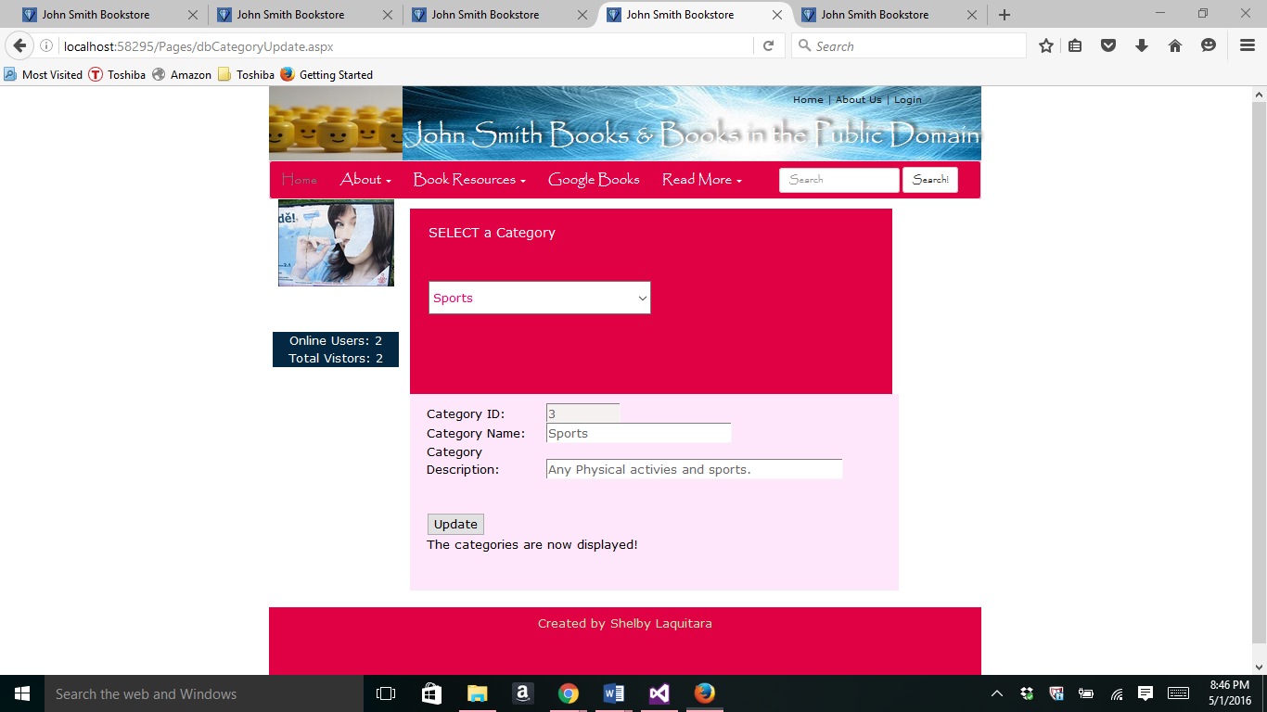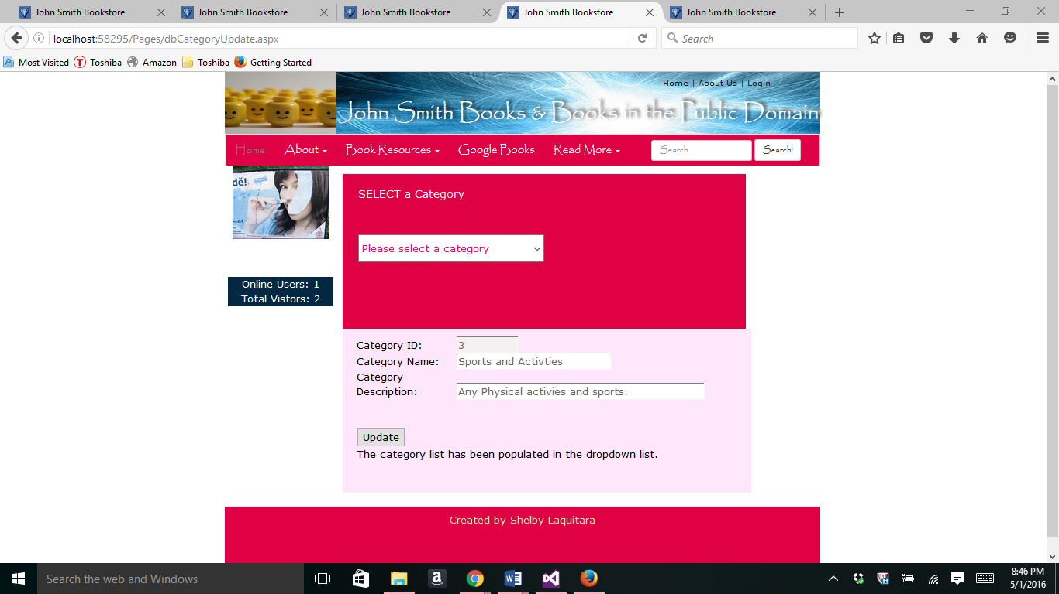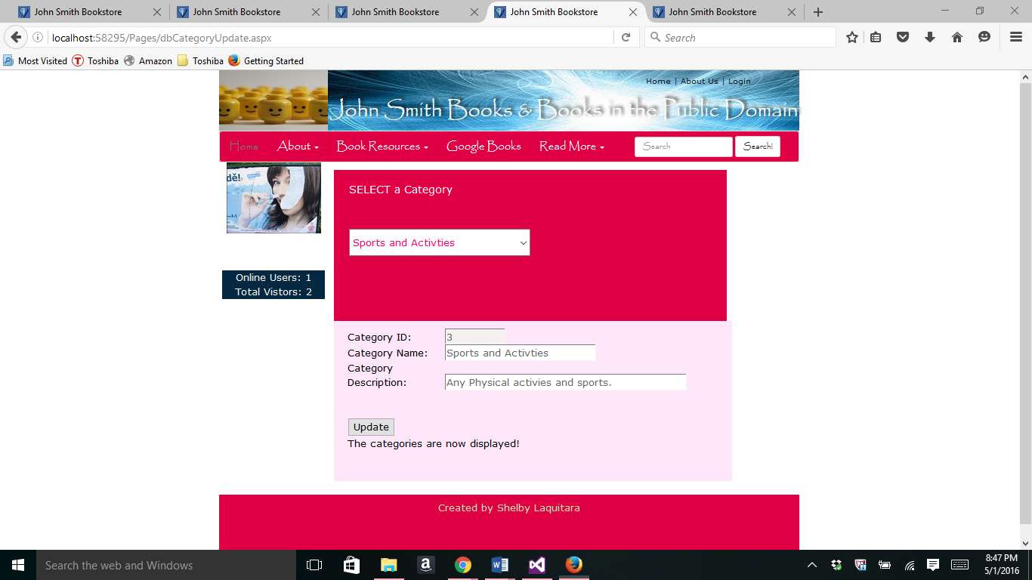

Part 9-

//dbDataSet.aspx

<%@ Page Title="" Language="C#" MasterPageFile="~/Homework.Master" AutoEventWireup="true" CodeBehind="dbDataSet.aspx.cs" Inherits="Project.Pages.dbDataSet" %>

<asp:Content ID="Content1" ContentPlaceHolderID="HeadSection" runat="server">

<style>

/* styles for the gridview pager settings */

.pagination {

font-size: 80%;

color: #FEE7FA;

background-color: #FEE76E;

}

.pagination span {

white-space: nowrap;

padding: 0.3em 05em;

padding: 5px 7px;

margin-right: 5px;

margin-bottom: 5px;

color: #FEE7FA;

background-color: #FF006E;

border: 1px solid #FF006E;

}

.pagination a {

padding:0.3em 0.5em;

margin-right: 5px;

margin-bottom: 5px;

white-space: nowrap;

text-decoration: none;

color: #FEE7FA;

background-color: #FF006E;

border: solid 1px #b11a65;

}

.content a:hover {

color: #FF006E

}

.pagination a:hover {

white-space: nowrap;

color: #FEE7FA;

background-color: #b11a65;

border: 1px solid #FF006E;

}

.pagination .current {

color: #ffd800;

background-color: #ffd800;

border: solid 1px #ffd800;

}

tr.pagination

{

background: none !important;

}

tr.pagination tr {

background: none !important;

}

tr.pagination td {

border: none;

box-sizing: border-box;

width: 50%;

}

</style>

</asp:Content>

<asp:Content ID="Content2" ContentPlaceHolderID="ContentSection" runat="server">

<div class="top">

<h4>SELECT a Category</h4>

<br />

<!-- Configure the DropDownList Control -->

<br />

<asp:DropDownList ID="ddlCategory" runat="server" Width="300px" Height="45px"

OnSelectedIndexChanging = "ddlCategory_SelectedIndexChanged"

AutoPostBack="true"></asp:DropDownList>

<br />

</div>

<!-- configure to match the form fields -->

<div class="bottom">

<asp:Label ID="heading" runat="server" CssClass="heading"

Text="DataSet and DataAdapter" />

<br />

<asp:Label ID="description" runat="server" CssClass="description"

Text="The purpose of this is to show how to display data from a data set." />

<div id="Line" class="line">&nbsp;</div><br />

<asp:Label ID="Label1" runat="server" Font-Size="X-Large"

ForeColor="#004040" Font-Names="Bookman Old Style" Font-Italic="false">

Store Product List

</asp:Label>

<asp:GridView ID="MyGV" runat="server" Height="211px" Width="650px"

CellPadding="5" CellSpacing="2" Font-Size="10pt" GridLines="None"

BorderColor="#ff0066" BorderWidth ="1" BorderStyle="Solid"

AutoGenerateColumns="false" AllowSorting="true" AllowPaging="true"

PageSize="4" PagerSettings-PageButtonCount ="3"

OnSelectedIndexChanging="myGridView_PageIndexChanging" >

<RowStyle HorizontalAlign="Center" BackColor="#FFFFFF" />

<HeaderStyle HorizontalAlign="Center" Font-Bold="True"

ForeColor="White" BackColor="#FF0066" />

<PagerSettings Mode="NumericFirstLast" Position="Bottom"

FirstPageText ="First" LastPageText="Last" />

<PagerStyle CssClass="pagination" ForeColor="White"

BackColor="#FEE7FA" HorizontalAlign="Center"

VerticalAlign="Middle" />

<Columns>

<asp:BoundField DataField="booktitle"

HeaderText="Title" HeaderStyle-Width="150px"

ItemStyle-HorizontalAlign="Left"

ItemStyle-Width="150px" />

<asp:BoundField DataField="bookid"

HeaderText="ID" HeaderStyle-Width="50px"

HeaderStyle-Wrap="false"

ItemStyle-Width="50px"

ItemStyle-Wrap ="false" />

<asp:BoundField DataField="bookdescription"

HeaderText="Description" HeaderStyle-Width="150px"

ItemStyle-HorizontalAlign="Left" ItemStyle-Width="150px" />

<asp:BoundField DataField="catid"

HeaderText="Cat ID" HeaderStyle-Width="50px"

HeaderStyle-HorizontalAlign="Right"

HeaderStyle-Wrap="false"

ItemStyle-Width="50px" />

<asp:BoundField DataField="price"

DataFormatString="{0:c}" ConvertEmptyStringToNull="false"

HeaderText="Price" HeaderStyle-Width="50px"

HeaderStyle-HorizontalAlign ="Right"

ItemStyle-HorizontalAlign="Center"

ItemStyle-Width="50px" />

<asp:BoundField DataField="pubdate"

DataFormatString="{0:d}" ConvertEmptyStringToNull="false"

HeaderText="Pub Date" HeaderStyle-Wrap="false"

HeaderStyle-Width="80px"

HeaderStyle-HorizontalAlign ="Right"

ItemStyle-HorizontalAlign="Center"

ItemStyle-Width="50px" />

<asp:BoundField DataField="picture"

HeaderText="Picture" HeaderStyle-Width="50px" />

<asp:BoundField DataField="authorid"

HeaderText="Author" HeaderStyle-Width="25px" />

</Columns>

<SelectedRowStyle BackColor="#E2DED6" Font-Bold="true" ForeColor="#333333" />

<AlternatingRowStyle BackColor="#FDE1F7" ForeColor="#284775" />

<FooterStyle BackColor="#E00144" Font-Bold="true" ForeColor="White" />

</asp:GridView>

<br /><br />

<asp:Label ID="lblResults" runat="server" Width="580px" Height="45"

Font-Bold="true"></asp:Label>

</div>

</asp:Content>

//dbDataSet.aspx.cs

using System;

using System.Collections.Generic;

using System.Linq;

using System.Web;

using System.Web.UI;

using System.Web.UI.WebControls;

using System.Data.SqlClient;

using System.Web.Configuration;

using System.Data;

namespace Project.Pages

{

public partial class dbDataSet : System.Web.UI.Page

{

public string CS = WebConfigurationManager.ConnectionStrings

["MyCS"].ConnectionString;

DataSet MyDS = new DataSet();

protected void Page_Load(object sender, EventArgs e)

{

if (!Page.IsPostBack)

{

}

BindGCV();

}

//Bind the GridView

private void BindGCV()

{

String MySQL = "SELECT * FROM Books";

SqlConnection con = new SqlConnection(CS);

SqlDataAdapter MyDA = new SqlDataAdapter(MySQL, con);

try {

MyDA.Fill(MyDS, "Books");

MyGV.DataSource = MyDS;

MyGV.DataBind();

}

catch (Exception err)

{

lblResults.Text = "Error inserting record: ";

lblResults.Text += err.Message;

}

finally {

con.Close();

}

}

protected void myGridView_PageIndexChanging(object sender, GridViewSelectEventArgs e)

{

DataTable myDataTable = MyDS.Tables[0];

MyGV.PageIndex = e.NewPageIndex;

MyGV.DataBind();

}

}

}

//dbDataSet in Browser

