Homework 2

Part 1

Directions

**1. Compare web-editing programs and their built in FTP features used to create web pages and transfer files to a web server**

Directions: Look at a video or web site that provides information about publishing a web site with the editor you are using in this class. If it’s a text editor or a web editor that does not have publishing built-in you can look up information on an FTP transfer utility tool such as FileZilla.

a. What features do they have to publish your web pages with FTP and SSH and WebDav?

Scott Hanselman explains in his publishing tutorial at <http://www.asp.net/visual-studio/overview/2013/visual-studio-2013-web-editor-features-publishing> that you can use FTP in visual studio to publish the website.

b. Compare FTP, SFTP, SSH and WebDav.

FTP (File Transfer Protocol)-

According to South River Technologies, “FTP is a very well-established protocol, developed in the 1970s to allow two computers to transfer data over the internet. One computer acts as the server to store information and the other acts as the client to send or request files from the server. The FTP protocol typically uses port 21 as its main means of communication. FTP in its basic form is not secure, FTP/S takes the security up a step in that it allows you to secure all or part of a session (at the cost of speed), and the SFTP protocol is used to ensure that all file transmission will be secure and efficient. ” (What’s the Difference? FTP, SFTP, and FTP/S, 2016).

SFTP (Secure File Transfer Protocol)-

South River Technologies describes SFTP as “a relatively new protocol developed in the 1990s, which allows for the transfer of files and other data over a connection that has previously been secured using the Secure Shell (SSH) protocol. While similar to FTP/S in that both protocols communicate over a secure connection, that’s basically where the similarities end. Unlike FTP, the SFTP protocol is packet-based instead of text-based. Where FTP might send a command such as “DELE file.txt,” SFTP would send a binary 0xBC and then “file.txt.” The key difference is that by sending less data, the SFTP protocol is faster over the long-term as less data is crossing the wire. Another difference is that with SFTP, file transfers are performed in-line over the main Control Connection, thus eliminating the need to open a separate Data Connection for transfers. Since SFTP runs over SSH, it is inherently secure. There is no non-secure version—the encryption cannot be triggered or turned off using AUTH commands, as in FTP/S. This is a plus for system administrators who are trying to enforce corporate security policies” (What’s the Difference? FTP, SFTP, and FTP/S, 2016).

SSH (Secure Shell (SSH) definition)-

Tech Target explains Secure Shell (SSH), as “a UNIX-based command interface and protocol for securely getting access to a remote computer. It is widely used by network administrators to control Web and other kinds of servers remotely. SSH is actually a suite of three utilities - slogin, ssh, and scp - that are secure versions of the earlier UNIX utilities, rlogin, rsh, and rcp. SSH commands are encrypted and secure in several ways. Both ends of the client/server connection are authenticated using a digital certificate, and passwords are protected by being encrypted” (Rouse, 2016).

WebDav (Web-based Distributed Authoring and Versioning)-

South River Technologies confirms that, “Web-based Distributed Authoring and Versioning (WebDAV), by definition, is a set of extensions to the HTTP (Hypertext Transfer Protocol), which allows users to edit and manage files collaboratively on remote Web servers. One of the major features in WebDAV is the ability to lock files automatically to prevent data being overwritten by another user. WebDAV also supports XML properties so users can access data about the file, the author, the date the file was modified and namespace manipulation, which allows resources to be copied or moved” (What’s the Difference? FTP, SFTP, and FTP/S, 2016).

B. Compare web graphic programs used to create images for web pages

Directions:

**2. Describe three things that you learned that you could do with the editor based on the video you watched.**

After watching a video from <http://tv.adobe.com/product/photoshop/>) created by Bryan O'Neil Hughes, I learned that there are several ways to enhance, edit, or mutate photos. Bryan explains how, “with photoshop you can touch up a photo, add, move or remove images, combine images, or add fun and creative effects” (Hughes, 2015). I learned how to combine two photos. I learned how to add a person into a photo that missed the shoot. I learned how to move an object in the picture. To remove something, you use the remove tool and select the object you want to move and then click on it and drag it where you want it to go. Bryan also demonstrates how “you can use photoshop to restore an old photo using the retouching tools, fixing tears and stains, remove creases, and restore colors” (Hughes, 2015). I also watched a video about gimp at https://www.youtube.com/watch?v=NcIPME9X_r4 and learned that there are techniques to adjusting the colors such as if you have too much green in the image you should add more magenta.

**3. Identify industry and legislative accessibility guidelines.**

Directions:

As you learned in your lesson accessibility is an issue today for web developers.

A. Read Introduction to Web Accessibility from WebAim at http://webaim.org/intro/.

B. What are the legal requirements for all web sites with respect to accessibility if you are creating a web site for a local government or state government or federal agency?

WebAim does a good job of explaining the legal requirements for websites that are being made for the government. The main focus is to make sure that the website can be used by anyone with a disability. WebAim explains that, "If you live in the United States, applicable laws include The Americans with Disabilities Act (ADA) and the Rehabilitation Act of 1973” (WebAIM, 2014). The website says that the key principles of accessible design are:

“Providing appropriate alternative text, providing appropriate document structure, providing headers for data tables, ensuring users can complete and submit all forms, ensuring links make sense out of context, Caption and/or provide transcripts for media, (Videos and live audio must have captions and a transcript, ensuring accessibility of non-HTML content, including PDF files, Microsoft Word documents, PowerPoint presentations and Adobe Flash content), Allowing users to skip repetitive elements on the page, Do not rely on color alone to convey meaning, And Making sure content is clearly written and easy to read and to Make JavaScript accessible” (WebAIM, 2014).

C. Describe which Principles of Accessible Design that you think is the most important to comply with and explain why.

The Principle of Accessible Design that I think is the most important to comply with is making sure the content is clearly written and easy for anyone to read. Anyone who accesses the site should have the opportunity to understand its content. If you make the webpage confusing or use a lot of big words, it makes it hard for an average person to follow. I think providing alternative text, captions, and audio is a good idea to include in your website in order to allow people with vision or hearing impairments to enjoy the website like everyone else.

**4. Identify software applications used to create web pages**

Directions:

There are many more software applications used to create web pages beyond Microsoft and Adobe. There are also many online content management systems (CMS) today such as Wix, Webs, Weebly and WordPress. Some are more sophisticated than others. Facebook is becoming a key point of contact for companies, through Facebook pages

1. Compare the platform, costs, support, features and tools, promotional features and customer base between WordPress.org and Facebook pages.

WordPress is a website that allows you to build your own website. You

can build one for free is you use a domain such as example.wordpress.com or you can purchase a domain such as example.com starting at $18 a year. You have an option to upgrade to premium for $8.25/month which include, “Your own domain name, powerful customization options, and lots of space for audio and video, or for $24.92/month you can get access to everything the website has to offer including everything you get with Premium, as well as live chat support, and unlimited access to our premium themes” (Word Press, 2016). Once you chose your plan you can also select a theme and then create a website. By first glance of the webpage, it doesn’t seem very user friendly for a regular person and it looks as though you need to be a skilled programmer to complete the website using WordPress.

Facebook is a popular social media website used to create webpages and

connect with other people. Facebook is always free but you also need to include their name in your domain such as <http://www.facebook.com/example>. Facebook allows you to create a detailed webpage and allows you set up your preferred page audience. Facebook is a great free way to market your business and add pictures and comments to the business.

1. If you have a customer with a small shop, what would you recommend to the shop owner, a WordPress.org web site OR Facebook? Explain your choice.

By first glance of the setup of WordPress, it doesn’t seem very user

friendly for a regular person and it looks as though you need to be a skilled programmer or hire someone to complete the website. I would recommend a Facebook because I am more familiar with it and I have seen people create a successful business using it and everyone has learned to trust it. More people get on Facebook than WordPress and it would be easier to get people to view the page if you created it through Facebook. Facebook has the feature that you can add people as friends and they can view, follow, and like your page. It allows you to get connected with friends of your friends or even strangers without much effort. This gives the business the opportunity to get their name out there and create good feedback on the number one webpage that most people visit daily. I have a friend who started an extremely successful photography business just by starting a Facebook page and posting the pictures she took and getting feedback from people.

Part 1 Submission

• Place all of these screen shots in Part 1 of your Word document.

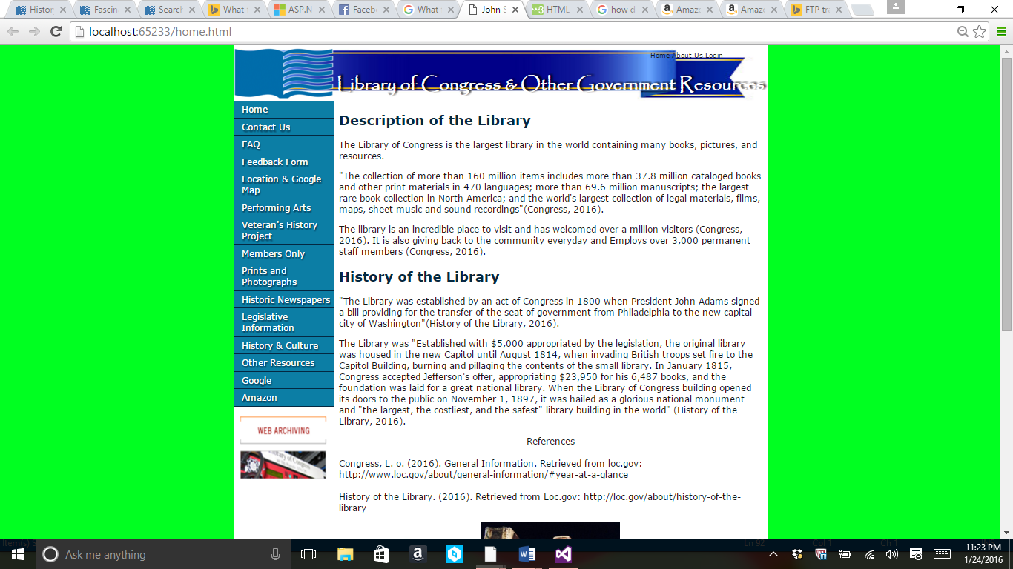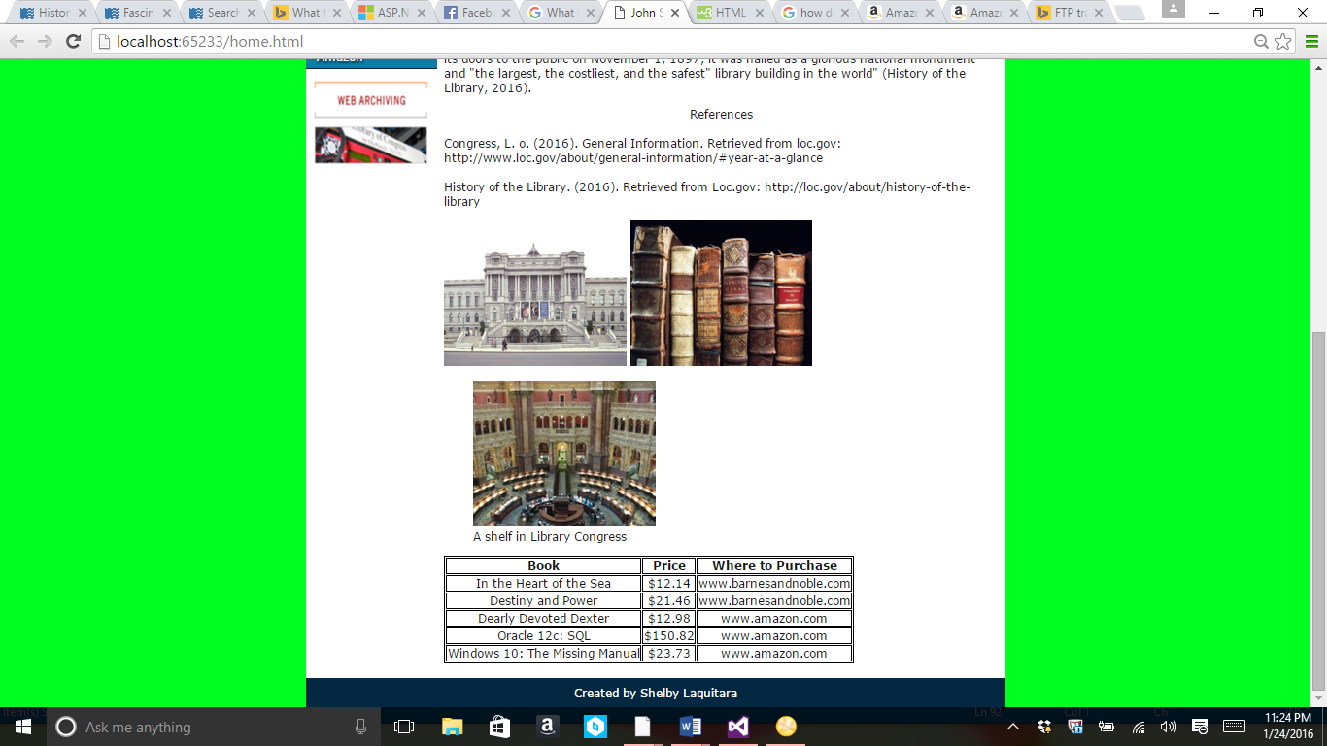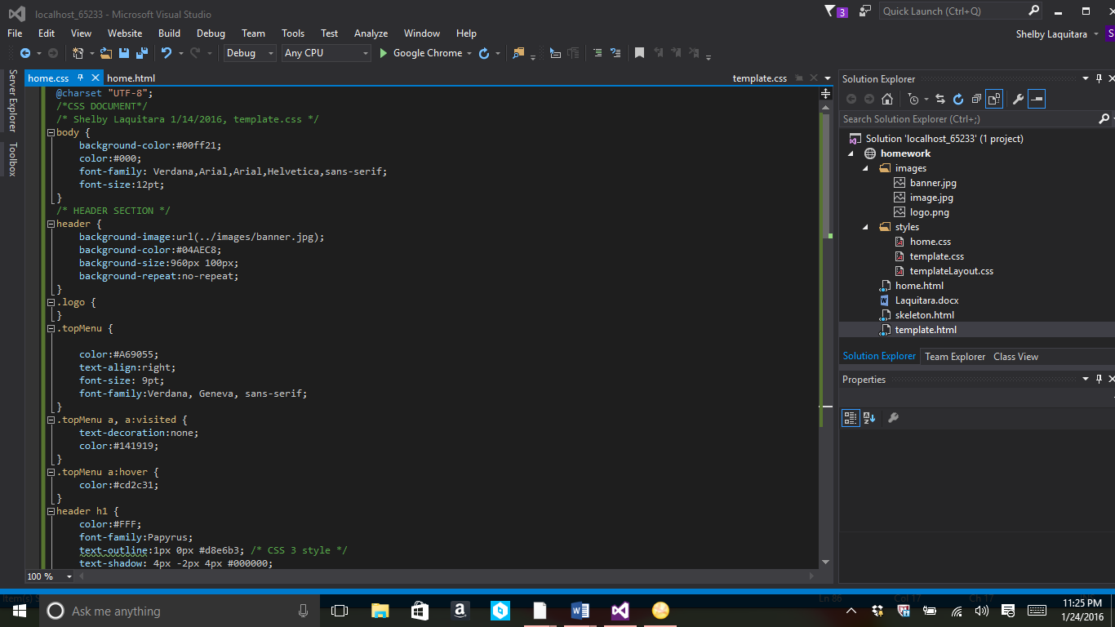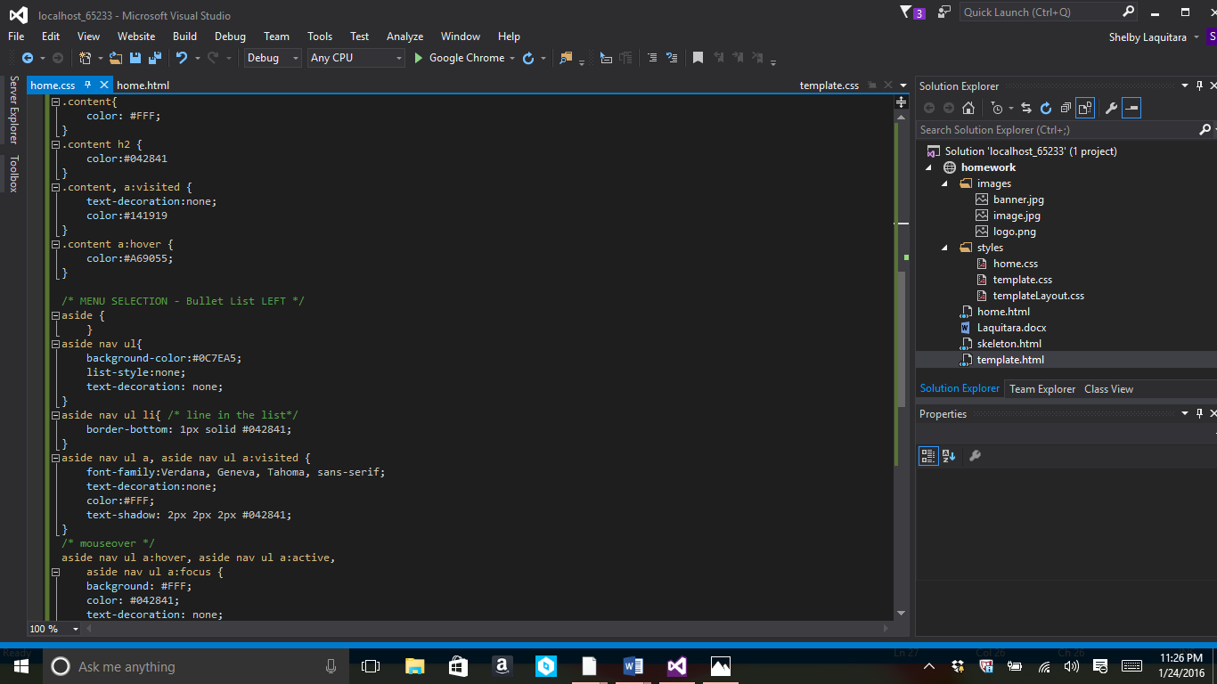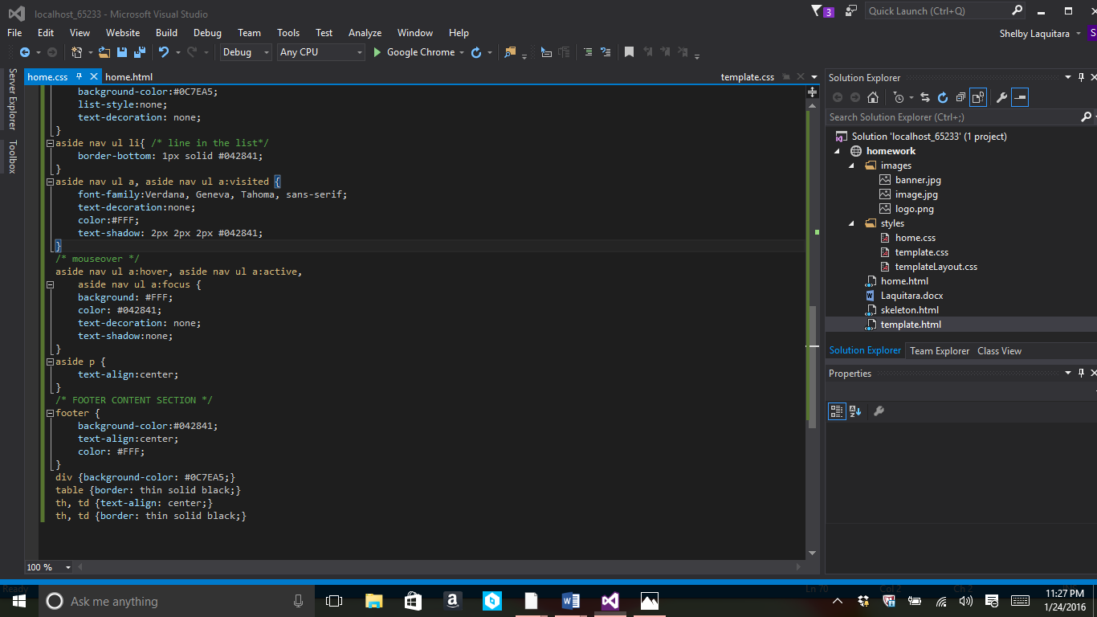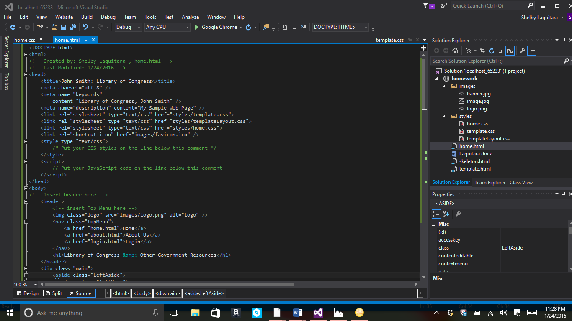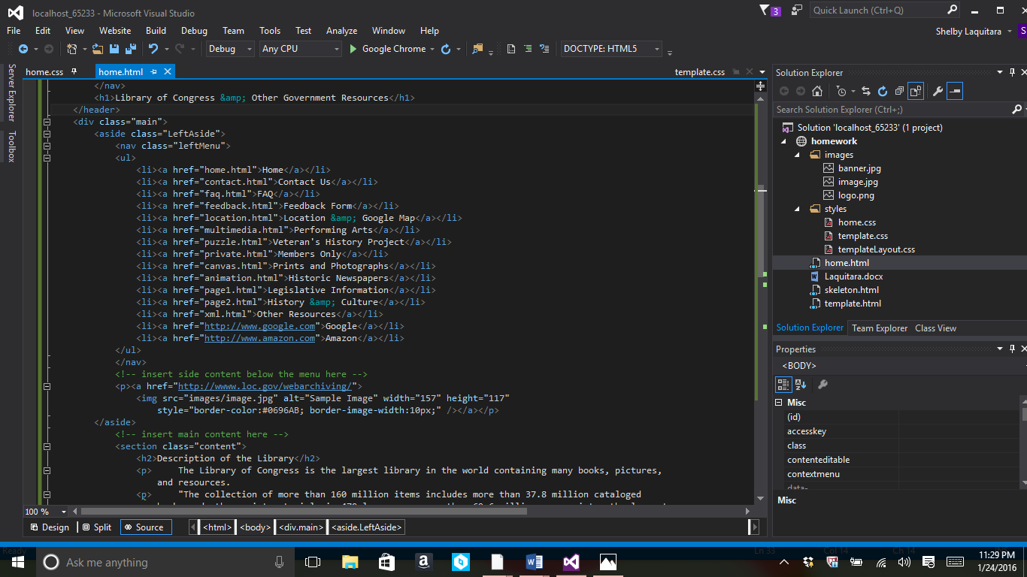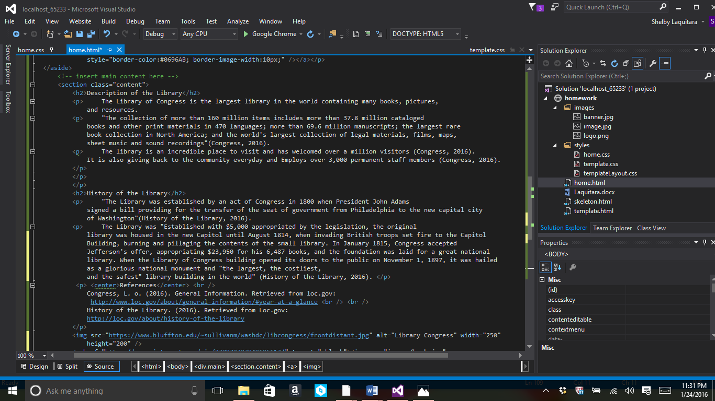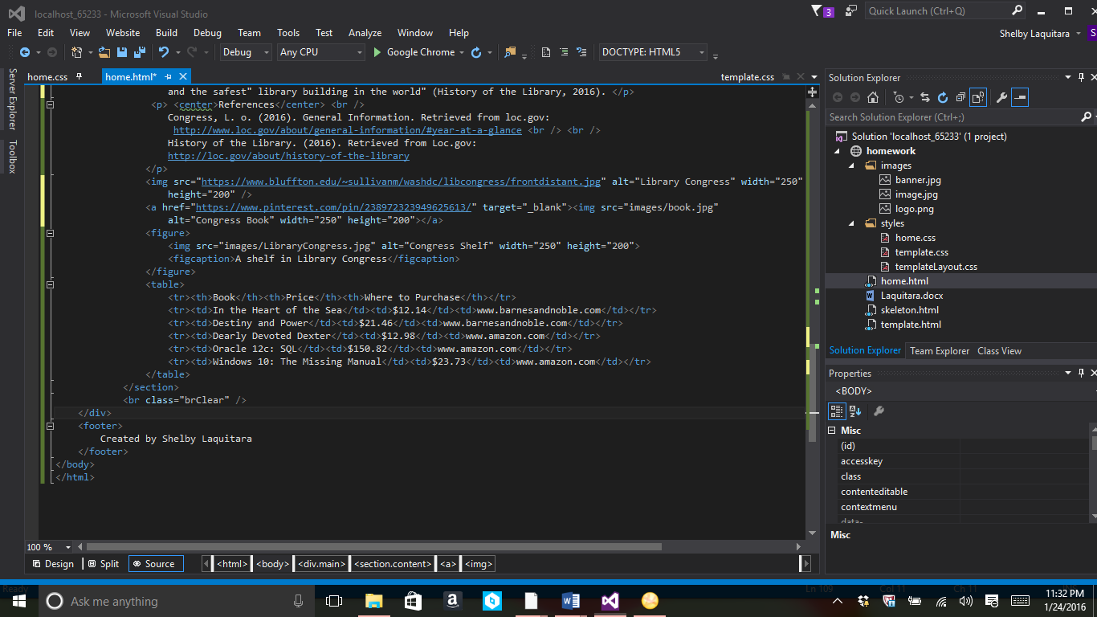

References

Hughes, B. O. (2015, 06 15). *Take your Photography further*. Retrieved from Adobe Photoshop CC: https://helpx.adobe.com/photoshop/how-to/photo-retouching.html

Rouse, M. (2016). *Secure Shell (SSH) definition*. Retrieved from Tech Target: http://searchsecurity.techtarget.com/definition/Secure-Shell

WebAIM. (2014, April 22). *Introduction to Web Accessibility*. Retrieved from WEB AIM: http://webaim.org/intro/

*What’s the Difference? FTP, SFTP, and FTP/S*. (2016). Retrieved from South River Tech: http://southrivertech.com/whats-difference-ftp-sftp-ftps/

Word Press. (2016). *Pick a plan that's right for you.* Retrieved from Word Press: https://wordpress.com/start/themes/en