Part 1

//screenshots of the canvas.html page

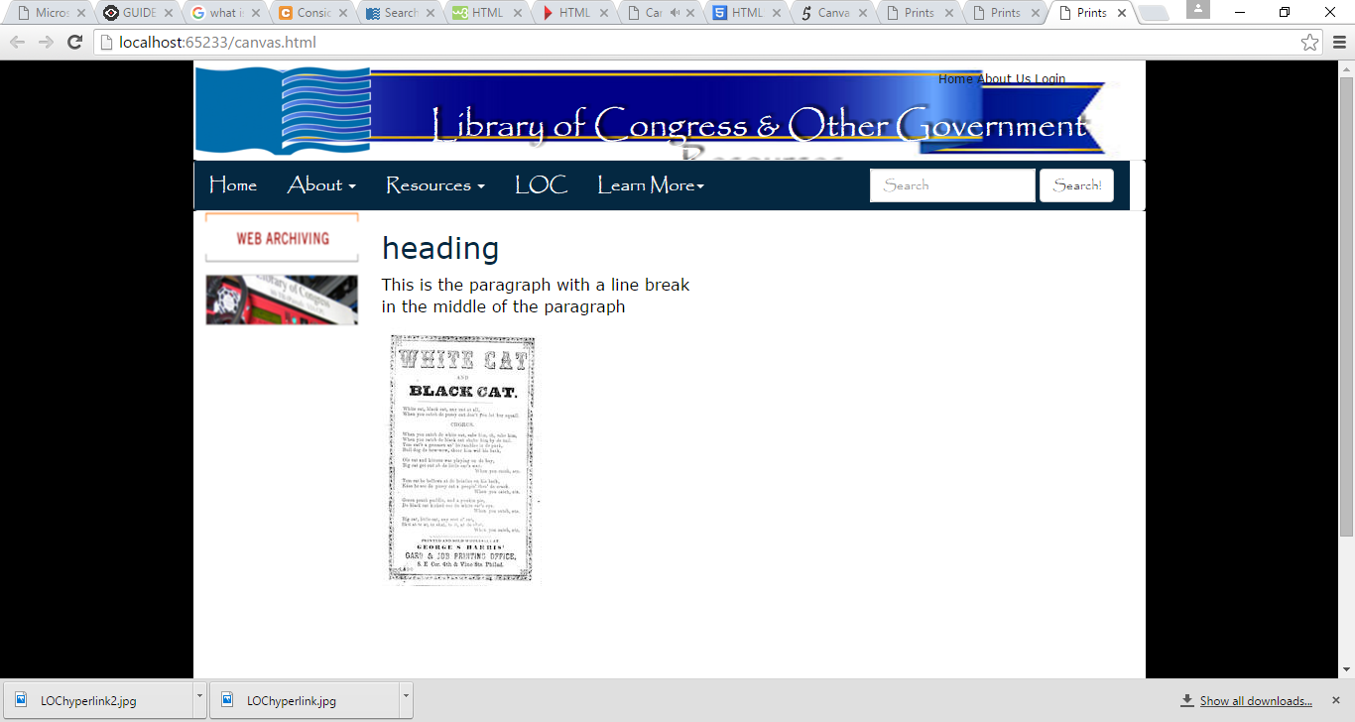

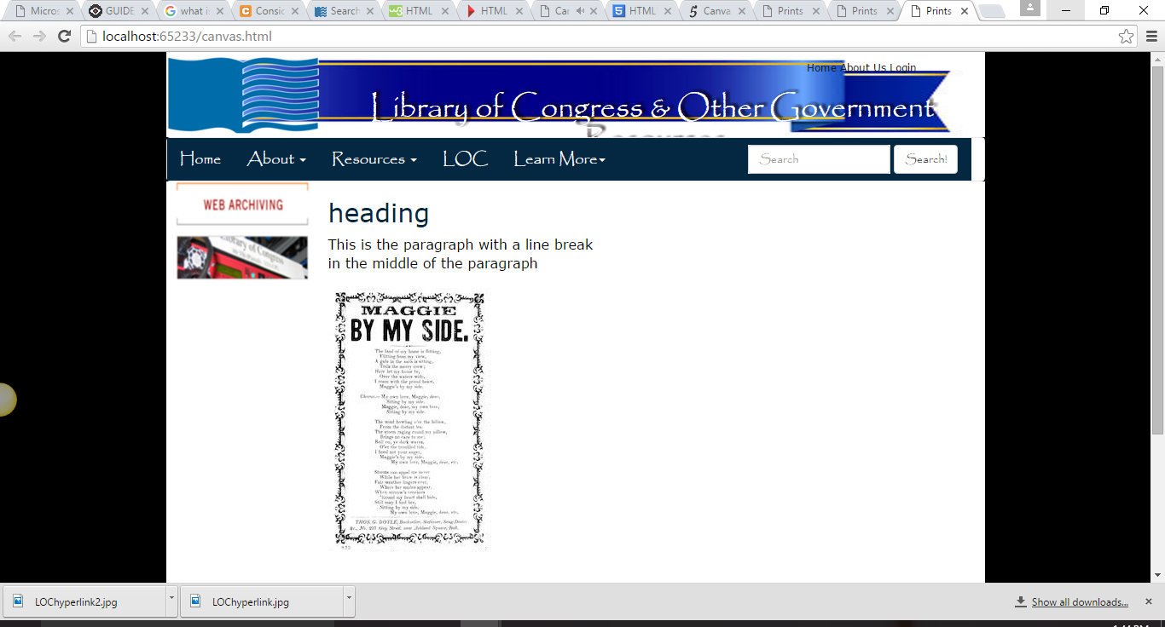

//screenshot of the canvas.html code

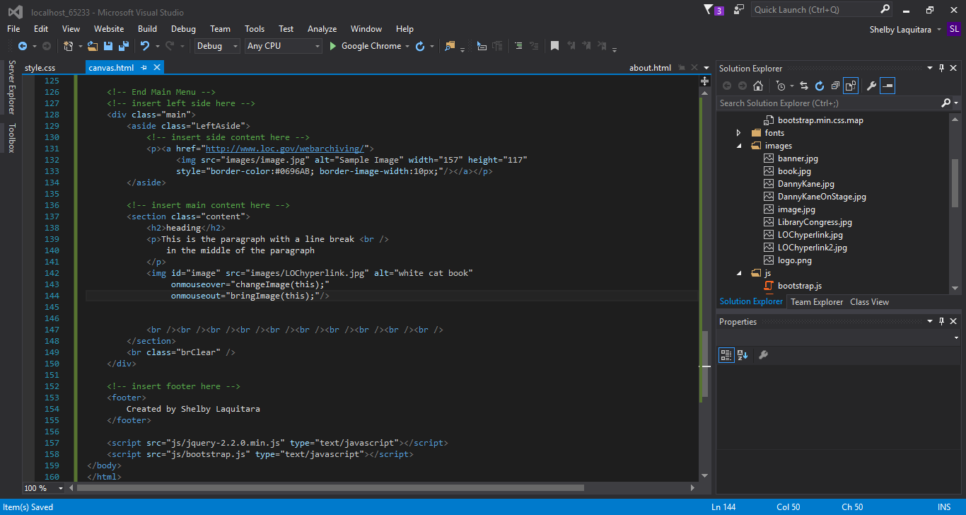

//screenshot of the javascript code

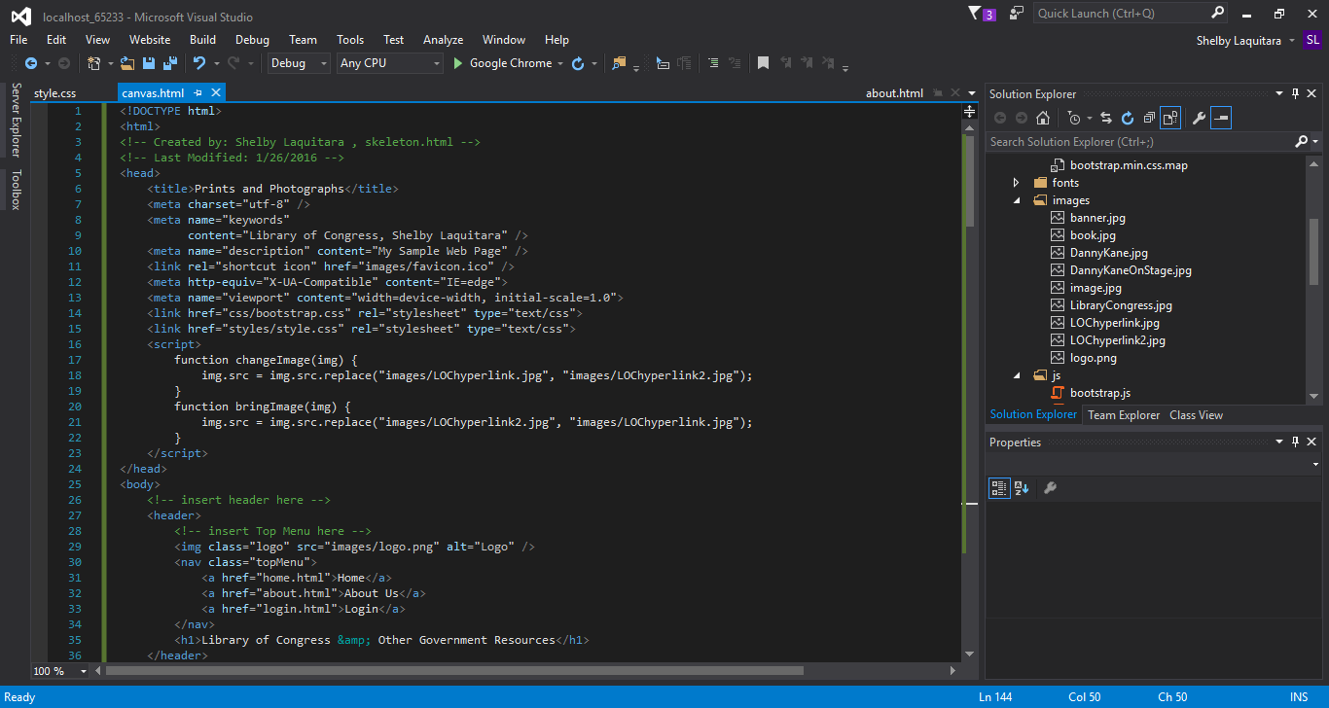

Part 2

//screenshots of the canvas.html page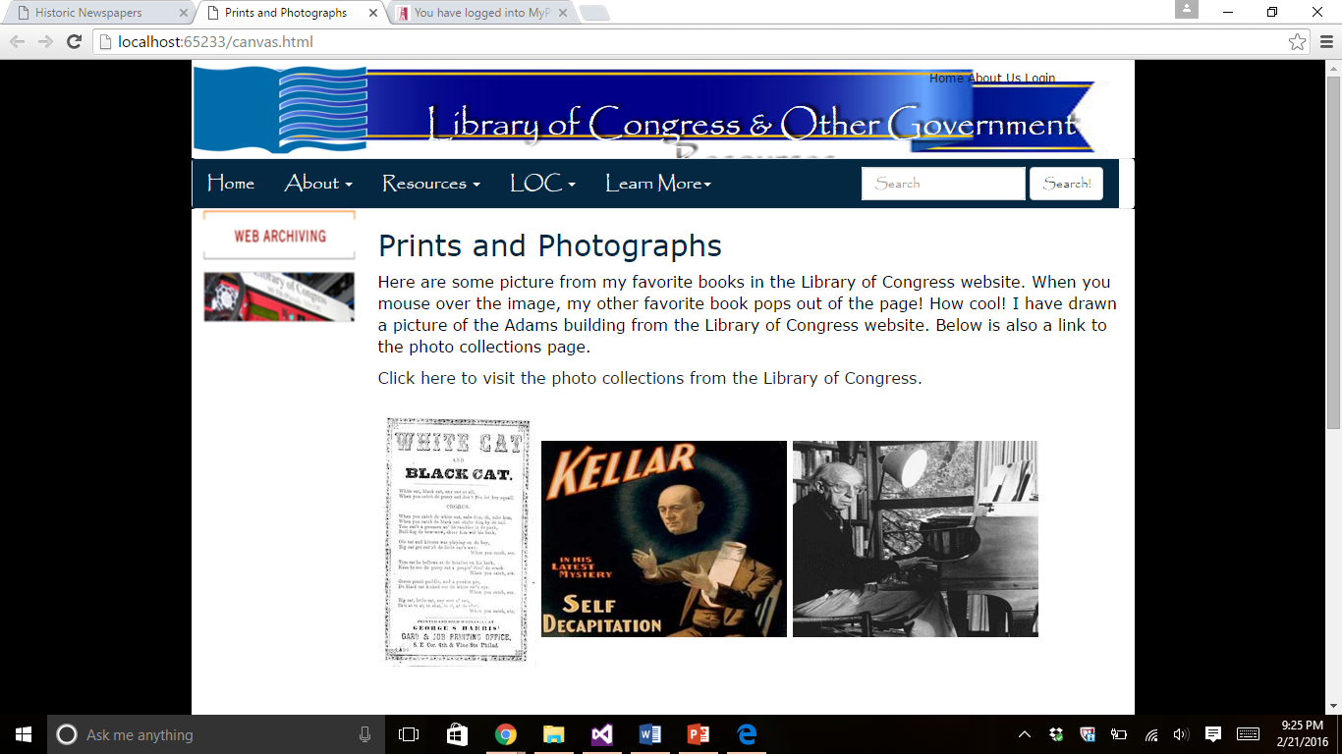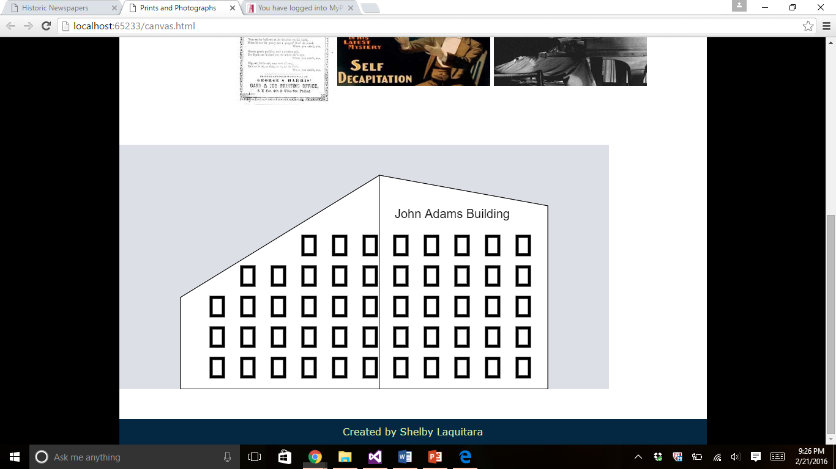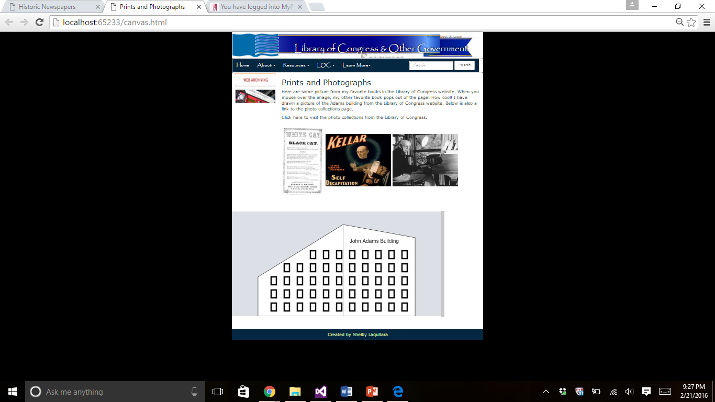

//copy of the code for canvas.html

<!DOCTYPE html>

<html>

<!-- Created by: Shelby Laquitara , canvas.html -->

<!-- Last Modified: 2/21/2016 -->

<head>

<title>Prints and Photographs</title>

<meta charset="utf-8" />

<meta name="keywords"

content="Library of Congress, Shelby Laquitara" />

<meta name="description" content="My Sample Web Page" />

<link rel="shortcut icon" href="images/favicon.ico" />

<meta http-equiv="X-UA-Compatible" content="IE=edge">

<meta name="viewport" content="width=device-width, initial-scale=1.0">

<link href="css/bootstrap.css" rel="stylesheet" type="text/css">

<link href="styles/style.css" rel="stylesheet" type="text/css">

<script type="text/javascript">

var canvas;//variable used for canvas

var ctx; //variable used for context

//function to changeImage

function changeImage(img) {

img.src = img.src.replace("images/LOChyperlink.jpg", "images/LOChyperlink2.jpg");

}

//replace the image

function bringImage(img) {

img.src = img.src.replace("images/LOChyperlink2.jpg", "images/LOChyperlink.jpg");

}

function drawBuilding() {

canvas = document.getElementById("myCanvas");

ctx = canvas.getContext("2d");

ctx.beginPath(); //begin

ctx.moveTo(100, 250); //starting point

ctx.lineTo(425, 50); //ending point

ctx.lineTo(700, 100);

ctx.lineTo(700, 400);

ctx.lineTo(100, 400);

ctx.closePath();

ctx.stroke(); //draws the line

//fill inside canvas white as building color

ctx.fillStyle = "white";

ctx.fill();

//add text

ctx.font = "20px Arial";

ctx.fillStyle = "black";

ctx.fillText("John Adams Building", 450, 120);

//draw line down the middle of building

ctx.moveTo(425, 50);

ctx.lineTo(425, 400);

ctx.stroke();

//rectangle

ctx.lineWidth = 5; //width of the line of border

ctx.strokeStyle = "black"; //color of border default is black

ctx.strokeRect(150, 250, 20, 30); //size and shape of rectangle

ctx.lineWidth = 5; //width of the line of border

ctx.strokeStyle = "black"; //color of border default is black

ctx.strokeRect(250, 250, 20, 30);

ctx.lineWidth = 5; //width of the line of border

ctx.strokeStyle = "black"; //color of border default is black

ctx.strokeRect(350, 250, 20, 30);

ctx.lineWidth = 5; //width of the line of border

ctx.strokeStyle = "black"; //color of border default is black

ctx.strokeRect(450, 250, 20, 30);

ctx.lineWidth = 5; //width of the line of border

ctx.strokeStyle = "black"; //color of border default is black

ctx.strokeRect(550, 250, 20, 30);

ctx.lineWidth = 5; //width of the line of border

ctx.strokeStyle = "black"; //color of border default is black

ctx.strokeRect(650, 250, 20, 30);

ctx.lineWidth = 5; //width of the line of border

ctx.strokeStyle = "black"; //color of border default is black

ctx.strokeRect(250, 200, 20, 30);

ctx.lineWidth = 5; //width of the line of border

ctx.strokeStyle = "black"; //color of border default is black

ctx.strokeRect(350, 200, 20, 30);

ctx.lineWidth = 5; //width of the line of border

ctx.strokeStyle = "black"; //color of border default is black

ctx.strokeRect(450, 200, 20, 30);

ctx.lineWidth = 5; //width of the line of border

ctx.strokeStyle = "black"; //color of border default is black

ctx.strokeRect(550, 200, 20, 30);

ctx.lineWidth = 5; //width of the line of border

ctx.strokeStyle = "black"; //color of border default is black

ctx.strokeRect(650, 200, 20, 30);

ctx.lineWidth = 5; //width of the line of border

ctx.strokeStyle = "black"; //color of border default is black

ctx.strokeRect(350, 150, 20, 30);

ctx.lineWidth = 5; //width of the line of border

ctx.strokeStyle = "black"; //color of border default is black

ctx.strokeRect(450, 150, 20, 30);

ctx.lineWidth = 5; //width of the line of border

ctx.strokeStyle = "black"; //color of border default is black

ctx.strokeRect(550, 150, 20, 30);

ctx.lineWidth = 5; //width of the line of border

ctx.strokeStyle = "black"; //color of border default is black

ctx.strokeRect(650, 150, 20, 30);

ctx.lineWidth = 5; //width of the line of border

ctx.strokeStyle = "black"; //color of border default is black

ctx.strokeRect(150, 300, 20, 30); //(x, y, width, height)

ctx.lineWidth = 5; //width of the line of border

ctx.strokeStyle = "black"; //color of border default is black

ctx.strokeRect(250, 300, 20, 30);

ctx.lineWidth = 5; //width of the line of border

ctx.strokeStyle = "black"; //color of border default is black

ctx.strokeRect(350, 300, 20, 30);

ctx.lineWidth = 5; //width of the line of border

ctx.strokeStyle = "black"; //color of border default is black

ctx.strokeRect(450, 300, 20, 30);

ctx.lineWidth = 5; //width of the line of border

ctx.strokeStyle = "black"; //color of border default is black

ctx.strokeRect(550, 300, 20, 30);

ctx.lineWidth = 5; //width of the line of border

ctx.strokeStyle = "black"; //color of border default is black

ctx.strokeRect(650, 300, 20, 30);

ctx.lineWidth = 5; //width of the line of border

ctx.strokeStyle = "black"; //color of border default is black

ctx.strokeRect(150, 350, 20, 30);

ctx.lineWidth = 5; //width of the line of border

ctx.strokeStyle = "black"; //color of border default is black

ctx.strokeRect(250, 350, 20, 30);

ctx.lineWidth = 5; //width of the line of border

ctx.strokeStyle = "black"; //color of border default is black

ctx.strokeRect(350, 350, 20, 30);

ctx.lineWidth = 5; //width of the line of border

ctx.strokeStyle = "black"; //color of border default is black

ctx.strokeRect(450, 350, 20, 30);

ctx.lineWidth = 5; //width of the line of border

ctx.strokeStyle = "black"; //color of border default is black

ctx.strokeRect(550, 350, 20, 30);

ctx.lineWidth = 5; //width of the line of border

ctx.strokeStyle = "black"; //color of border default is black

ctx.strokeRect(300, 200, 20, 30);

ctx.lineWidth = 5; //width of the line of border

ctx.strokeStyle = "black"; //color of border default is black

ctx.strokeRect(400, 200, 20, 30);

ctx.lineWidth = 5; //width of the line of border

ctx.strokeStyle = "black"; //color of border default is black

ctx.strokeRect(500, 200, 20, 30);

ctx.lineWidth = 5; //width of the line of border

ctx.strokeStyle = "black"; //color of border default is black

ctx.strokeRect(600, 200, 20, 30);

ctx.lineWidth = 5; //width of the line of border

ctx.strokeStyle = "black"; //color of border default is black

ctx.strokeRect(500, 300, 20, 30);

ctx.lineWidth = 5; //width of the line of border

ctx.strokeStyle = "black"; //color of border default is black

ctx.strokeRect(600, 300, 20, 30);

ctx.lineWidth = 5; //width of the line of border

ctx.strokeStyle = "black"; //color of border default is black

ctx.strokeRect(400, 300, 20, 30);

ctx.lineWidth = 5; //width of the line of border

ctx.strokeStyle = "black"; //color of border default is black

ctx.strokeRect(300, 300, 20, 30);

ctx.lineWidth = 5; //width of the line of border

ctx.strokeStyle = "black"; //color of border default is black

ctx.strokeRect(200, 300, 20, 30);

ctx.lineWidth = 5; //width of the line of border

ctx.strokeStyle = "black"; //color of border default is black

ctx.strokeRect(200, 350, 20, 30);

ctx.lineWidth = 5; //width of the line of border

ctx.strokeStyle = "black"; //color of border default is black

ctx.strokeRect(300, 350, 20, 30);

ctx.lineWidth = 5; //width of the line of border

ctx.strokeStyle = "black"; //color of border default is black

ctx.strokeRect(400, 350, 20, 30);

ctx.lineWidth = 5; //width of the line of border

ctx.strokeStyle = "black"; //color of border default is black

ctx.strokeRect(500, 350, 20, 30);

ctx.lineWidth = 5; //width of the line of border

ctx.strokeStyle = "black"; //color of border default is black

ctx.strokeRect(600, 350, 20, 30);

ctx.lineWidth = 5; //width of the line of border

ctx.strokeStyle = "black"; //color of border default is black

ctx.strokeRect(650, 350, 20, 30);

ctx.lineWidth = 5; //width of the line of border

ctx.strokeStyle = "black"; //color of border default is black

ctx.strokeRect(200, 250, 20, 30);

ctx.lineWidth = 5; //width of the line of border

ctx.strokeStyle = "black"; //color of border default is black

ctx.strokeRect(300, 250, 20, 30);

ctx.lineWidth = 5; //width of the line of border

ctx.strokeStyle = "black"; //color of border default is black

ctx.strokeRect(400, 250, 20, 30);

ctx.lineWidth = 5; //width of the line of border

ctx.strokeStyle = "black"; //color of border default is black

ctx.strokeRect(500, 250, 20, 30);

ctx.lineWidth = 5; //width of the line of border

ctx.strokeStyle = "black"; //color of border default is black

ctx.strokeRect(600, 250, 20, 30);

ctx.lineWidth = 5; //width of the line of border

ctx.strokeStyle = "black"; //color of border default is black

ctx.strokeRect(200, 200, 20, 30);

ctx.lineWidth = 5; //width of the line of border

ctx.strokeStyle = "black"; //color of border default is black

ctx.strokeRect(300, 150, 20, 30);

ctx.lineWidth = 5; //width of the line of border

ctx.strokeStyle = "black"; //color of border default is black

ctx.strokeRect(400, 150, 20, 30);

ctx.lineWidth = 5; //width of the line of border

ctx.strokeStyle = "black"; //color of border default is black

ctx.strokeRect(500, 150, 20, 30);

ctx.lineWidth = 5; //width of the line of border

ctx.strokeStyle = "black"; //color of border default is black

ctx.strokeRect(600, 150, 20, 30);

//set background color

document.getElementById("myCanvas").style.backgroundColor

= 'rgba(158, 167, 184, 0.2)';

}

</script>

</head>

<body onload="drawBuilding();"> <!--drawCanvas is a function-->

<!-- insert header here -->

<header>

<!-- insert Top Menu here -->

<img class="logo" src="images/logo.png" alt="Logo" />

<nav class="topMenu">

<a href="home.html">Home</a>

<a href="about.html">About Us</a>

<a href="login.html">Login</a>

</nav>

<h1>Library of Congress &amp; Other Government Resources</h1>

</header>

<!-- insert Horizontal Menu here -->

<nav class="navbar navbar-default">

<div class="container-fluid">

<!-- Brand & toggle get grouped for better mobile display -->

<div class="navbar-header">

<button type="button" class="navbar-toggle collapsed"

data-toggle="collapse" data-target="#defaultNavbar1"><br />

<span class="sr-only">Toggle navigation</span>

<span class="icon-bar"></span>

<span class="icon-bar"></span>

<span class="icon-bar"></span>

</button>

<a class="navbar-brand" href="home.html">Home</a>

</div>

<!-- The nav links, forms, & other content for toggling -->

<div class="collapse navbar-collapse" id="defaultNavbar1">

<!-- First Drop Down -->

<ul class="nav navbar-nav">

<!-- Old code <li class="active"><br>

<a href="about.html"><br>About<span

class="sr-only"> (current) </span></a></li> -->

<li class="dropdown"><a href="about.html" class="dropdown-toggle"

data-toggle="dropdown" role="button"

aria-expanded="false">About <span class="caret"></span></a>

<ul class="dropdown-menu" role="menu">

<li><a href="faq.html">FAQ</a></li>

<li><a href="feedback.html">Feedback</a></li>

<li><a href="login.html">Login</a></li>

<li><a href="location.html">Location</a></li>

<li><a href="http://www.loc.gov/" target="_blank">

Library of Congress</a></li>

</ul>

</li>

<!-- Second Drop Down -->

<li class="dropdown"><a href="#" class="dropdown-toggle"

data-toggle="dropdown" role="button" aria-expanded="false">

Resources <span class="caret"></span></a>

<ul class="dropdown-menu" role="menu">

<li><a href="multimedia.html">Performing Arts</a></li>

<li><a href="puzzle.html">Veteran's History Project</a></li>

<li><a href="private.html">Members Only</a></li>

<!-- Line Dividers -->

<li class="divider"></li>

<li><a href="page1.html">Legislative Information</a></li>

<li><a href="page2.html">History &amp; Culture</a></li>

<li><a href="canvas.html">Prints and Photographs</a></li>

<li><a href="animation.html">Historic Newspaper</a></li>

<li class="divider"></li>

<li><a href="xml.html">Other</a></li> Resources</a></li>

</ul>

</li>

</ul>

<!-- Right Menu -->

<ul class="nav navbar-nav navbar-left">

<!-- OLD <li><a href="http://www.google.com/">Google</a></li> -->

<li class="dropdown">

<a href="#" class="dropdown-toggle"

data-toggle="dropdown" role="button" aria-expanded="false">

LOC <span class="caret"></span>

</a>

<ul class="dropdown-menu" role="menu">

<li><ahref="http://www.loc.gov/photos/collections/">

Prints and Photographs</a></li>

</ul>

<!-- Third Drop Down -->

<li class="dropdown">

<a href="#" class="dropdown-toggle" data-toggle="dropdown" role="button" aria-expanded="false">Learn More<span class="caret"></span></a>

<ul class="dropdown-menu" role="menu">

<li><ahref="https://www.archive.org/details/library_of_congress">Archive.org</a></li>

<li class="divider"></li>

<li><a href="https://www.en.wikipedia.org/wiki/Library_of_Congress">Wikipedia LOC </a></li>

</ul>

</li>

</ul>

<!-- Search Tools -->

<form class="navbar-form navbar-right" role="search">

<div class="form-group">

<input type="text" class="form-control" placeholder="Search">

</div>

<button type="submit" class="btn btn-default">Search!</button>

</form>

</div> <!-- end navbar-collapse-->

</div> <!-- end container-fluid -->

</nav>

<!-- End Main Menu -->

<!-- insert left side here -->

<div class="main">

<aside class="LeftAside">

<!-- insert side content here -->

<p><a href="http://www.loc.gov/webarchiving/">

<img src="images/image.jpg" alt="Sample Image" width="157" height="117"

style="border-color:#0696AB; border-image-width:10px;"/></a></p>

</aside>

<!-- insert main content here -->

<section class="content">

<h2>Prints and Photographs</h2>

<p>Here are some picture from my favorite books in the Library of Congress

website. When you mouse over the image, my other favorite book

pops out of the page! How cool! I have drawn a picture of the Adams building

from the Library of Congress website. Below is also a link to the photo

collections page. </p>

<a href="http://www.loc.gov/photos/collections/">

Click here to visit the photo collections from the Library of Congress.

</a>

<br /><br />

<!-- changing the images -->

<img id="image" src="images/LOChyperlink.jpg" alt="white cat book"

onmouseover="changeImage(this);"

onmouseout="bringImage(this);"/>

<img src="images/featured-kellar.jpg" alt="pic from library"

width="250" height="200"/>

<img src="images/copland-piano.jpg" alt="second pic from library"

width="250" height="200" />

<br /><br /><br />

</section>

<br class="brClear" />

<canvas id="myCanvas" width="800" height="400";></canvas>

<br /><br /><br />

</div>

<!-- insert footer here -->

<footer>

Created by Shelby Laquitara

</footer>

<script src="js/jquery-2.2.0.min.js" type="text/javascript"></script>

<script src="js/bootstrap.js" type="text/javascript"></script>

</body>

</html>

//screenshots of the animated.html

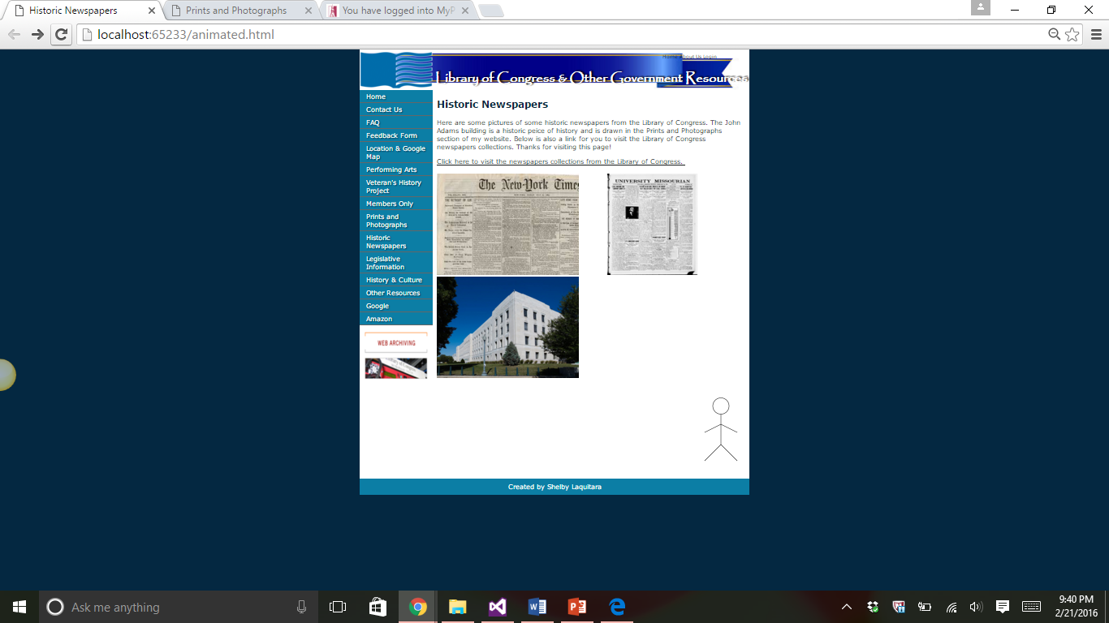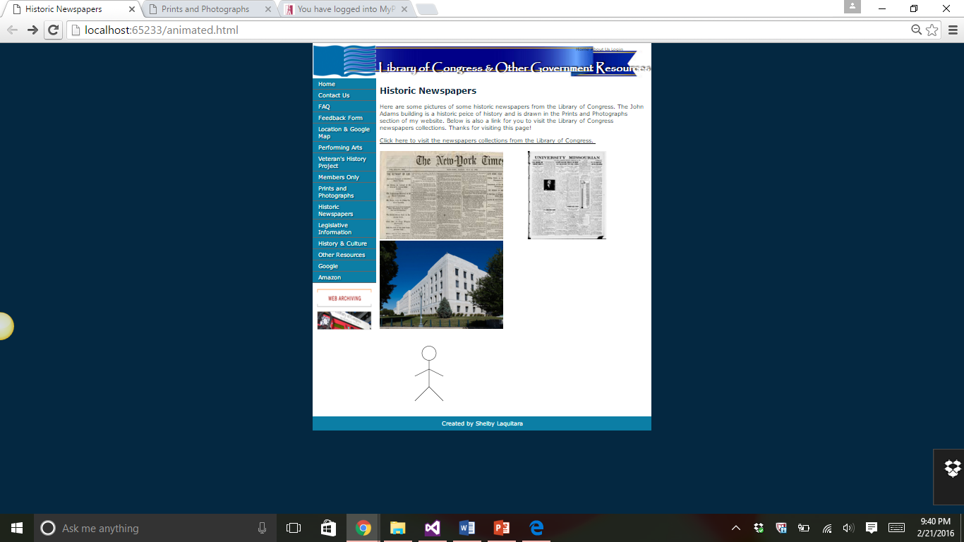

//Copy of code for the animated.html page

<!DOCTYPE html>

<html>

<!-- Created by: Shelby Laquitara , animated.html -->

<!-- Last Modified: 2/21/2016 -->

<head>

<title>Historic Newspapers</title>

<meta charset="utf-8" />

<meta name="keywords"

content="Library of Congress, John Smith" />

<meta name="description" content="My Sample Web Page" />

<link rel="stylesheet" type="text/css" href="styles/template.css">

<link rel="stylesheet" type="text/css" href="styles/templateLayout.css">

<link rel="shortcut icon" href="images/favicon.ico" />

<style type="text/css">

/* Put your CSS styles on the line below this comment */

</style>

<script>

function drawStudent() { //function to draw the student

//creating variable canvas and assigning it to the ID myCanvas

var canvas = document.getElementById("myCanvas");

//creating variable for context and assigning it to 2d

var ctx = canvas.getContext("2d");

ctx.moveTo(100, 100 - 75);

ctx.beginPath();//begin

ctx.arc(100, 100 - 75, 20, 0, 2 * Math.PI, true);//circle

ctx.moveTo(100, 45);//moving to..

ctx.lineTo(100, 120);//connecting a line to..

ctx.lineTo(60, 160);

ctx.moveTo(100, 120);

ctx.lineTo(140, 160);

ctx.moveTo(60, 90);

ctx.lineTo(100, 70);

ctx.lineTo(140, 90);

ctx.stroke();

}

function walk() { //created function to make student walk

var canvas = document.getElementById("myCanvas");

var ctx = canvas.getContext("2d");

ctx.save();

ctx.setTransform(1, 0, 0, 1, 0, 0);

ctx.clearRect(0, 0, canvas.width, canvas.height);

ctx.restore();

ctx.translate(20, 0);

drawStudent();

}

function makeWalk() {

var i = 100;

for (var j = 0; j < 30; j++) { //for loop to repeat the steps he takes

setTimeout(walk, i);

i += 100;

}

}

</script>

</head>

<body onload="makeWalk();">

<!-- insert header here -->

<header>

<!-- insert Top Menu here -->

<img class="logo" src="images/logo.png" alt="Logo" />

<nav class="topMenu">

<a href="home.html">Home</a>

<a href="about.html">About Us</a>

<a href="login.html">Login</a>

</nav>

<h1>Library of Congress &amp; Other Government Resources</h1>

</header>

<div class="main">

<aside class="LeftAside">

<nav class="leftMenu">

<ul>

<li><a href="home.html">Home</a></li>

<li><a href="contact.html">Contact Us</a></li>

<li><a href="faq.html">FAQ</a></li>

<li><a href="feedback.html">Feedback Form</a></li>

<li><a href="location.html">Location &amp; Google Map</a></li>

<li><a href="multimedia.html">Performing Arts</a></li>

<li><a href="puzzle.html">Veteran's History Project</a></li>

<li><a href="private.html">Members Only</a></li>

<li><a href="canvas.html">Prints and Photographs</a></li>

<li><a href="animation.html">Historic Newspapers</a></li>

<li><a href="page1.html">Legislative Information</a></li>

<li><a href="page2.html">History &amp; Culture</a></li>

<li><a href="xml.html">Other Resources</a></li>

<li><a href="http://www.google.com">Google</a></li>

<li><a href="http://www.amazon.com">Amazon</a></li>

</ul>

</nav>

<!-- insert side content below the menu here -->

<p>

<a href="http://wwww.loc.gov/webarchiving/">

<img src="images/image.jpg" alt="Sample Image" width="157" height="117"

style="border-color:#0696AB; border-image-width:10px;" />

</a>

</p>

</aside>

<!-- insert main content here -->

<section class="content">

<h2>Historic Newspapers</h2>

<p>Here are some pictures of some historic newspapers from the Library

of Congress. The John Adams building is a historic peice of history and

is drawn in the Prints and Photographs section of my website. Below is also

a link for you to visit the Library of Congress newspapers collections.

Thanks for visiting this page! </p>

<a href="http://www.loc.gov/newspapers/collections/">

Click here to visit the newspapers collections from the Library of Congress.

</a>

<br /><br />

<img src="images/historicnewspaper.jpg" alt="pic from library"

width="350" height="250" />

<img src="images/download.png" alt="second pic from library"

width="350" height="250" />

<img src="images/adamsBuilding.jpg" alt="second pic from library"

width="350" height="250" />

<br /><br />

<br class="brClear" />

<!--creating the canvas in html-->

<canvas id="myCanvas" width="750" height="200"></canvas>

</section>

</div>

<footer>

Created by Shelby Laquitara

</footer>

</body>

</html>