Homework 3

 Part 1

*Learning Outcome*

1. Create web pages that have consistent and easy to locate navigation

*Directions*

The readings will show you how**to create links, menus, and evaluate the navigation, page layout and user design of web sites that work across browser, platforms and devices**. As you learned in the readings and lecture and the homework in lesson 1, you can create web sites with HTML and CSS that are aesthetically pleasing and functional. The key is to make the web sites easy to navigate and consistent. End-users must be able to locate information quickly. Web developers use **web server** **log files** to identify information about the client software viewing the web pages such as how they maneuver within the web site. Some third party companies have APIs that evaluate the log files faster and with better analytical tools such as **WebTrends**.

The **three-click rule** was a guideline to help developers learn that end users need to locate information quickly. The first page on the site is often called the splash page.

**Splash** **pages** may contain navigation, images and text. They are usually meant to catch the eye of the visitor, and content often changes to keep them interesting to visitors. Many web sites help you build splash pages and banners such as **banner**.fotor.com.

1. Look at **two web pages with very different navigation methods**. Is their web site easy to locate content? Does the web site follow the three-click rule? Is the navigation consistent and easy to locate? What navigation method would you pick and why?  
     
    The first website I looked at is our school website- [www.park.edu](http://www.park.edu). I find this website to be fairly easy to locate the content. The home page is great because it has everything that one would need to find. It has main categories such as academics, admissions, athletics, and news. The navigation is consistent and always allows gives the user the opportunity search for something located in the top right corner (no matter where you are on the site.) It also has the easy navigation for MyPark login and to apply at the bottom right corner no matter what. It does follow the three-click rule because I can get to almost anything I need within 3 clicks. I can appreciate Parks website because I have been on other college websites that were very confusing and hard to find what I was looking for.

The second website I looked at is [www.homedepot.com](http://www.homedepot.com). Home depot’s website makes it very easy to locate content with the categories broken up into entities on the left side and the search option at the top that says “what can I help you find?” You can either browse by categories or type in the exact part number or item to get immediate results of what you are looking for. The Home Depot website definitely follows the three click rule because I can easily find what I am looking for within three clicks or just one if I type what I want. It also gives an option to search by brand or even search by price, color, length, width, etc. This makes it very easy to find what I am looking for because I can say I want a white ceramic tile within $2/sqft and it will narrow the search so that I don’t have to search through endless pages. This makes lives easier for the customer and employees to pinpoint exactly what we need within a few seconds.

The type of navigation I would pick would be very easy to find, have main sections that are the most popular and contain links to more popular content. I would use obvious name that everyone would understand and keep it consistent no matter where they were on the site.

1. There are many different ways to create navigation menus. **Visit 2 of these sites and describe in detail** **how they create their menus**. Provide examples or snippets of code. Some use CSS alone, some use JavaScript and CSS and some use templates and applications to generate the menus.
   1. JQuery UI - <http://jqueryui.com/demos/>
   2. Bootstrap - <http://getbootstrap.com/getting-started/>
   3. W3Schools - <http://www.w3schools.com/css/css_navbar.asp>
   4. Menu Cool - <http://www.menucool.com/horizontal/css-menus>
   5. HTML Goodies - <http://www.htmlgoodies.com/beyond/css/how-to-create-horizontal-navigation-with-css3.html>
   6. CSS Menu Maker - <http://cssmenumaker.com/>
   7. Dynamic Drive - <http://www.dynamicdrive.com/style/csslibrary/category/C1/>
   8. CSS3 Menu - <http://css3menu.com/>

The first site I looked at is <http://css3menu.com/>. They create their menus using CSS alone. JavaScript is not required and I think that is cool because it helps keep it simple and avoid mistakes. Here is an example of the navigation menu-

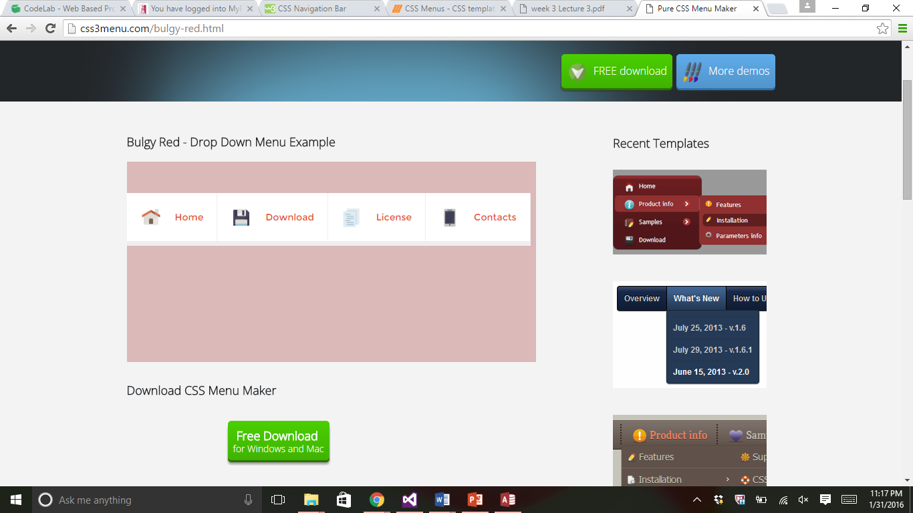

It is very simple and easy to follow. They are several options and colors to choose from. I also like how the download is free for windows and mac. According to the site, their navigation menus are, “SE friendly, do not require Javascript, have a responsive menu, doesn’t require hard coding, and are 100% CSS designs” (Menu, 2016). They have tons of designs to pick from and even offer symbols and emoji’s.

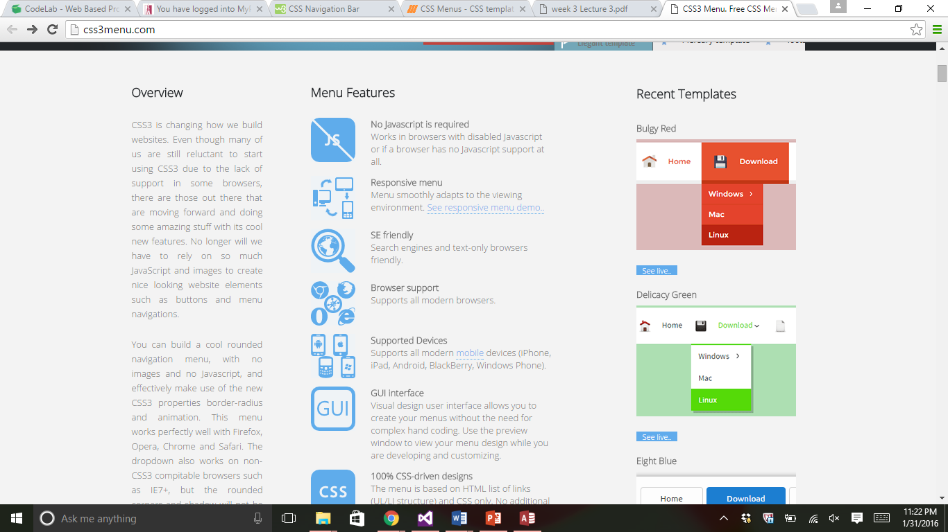

The second navigation site I chose to look at was

<http://www.w3schools.com/css/css_navbar.asp>. W3Schools is cool because it shows you how to hard code a navigation bar using CSS. W3Schools is basically the mother of all HTML websites and is a great resource to use. It provides you with the codes, examples, screen shots of what it should look like in the browser, and gives a direct link to let you try it yourself right on the website. You can take the code that they provide and change it and see what changes immediately. Although it doesn’t provide you with as many fancy options, you can play around with it yourself and create anything you want.

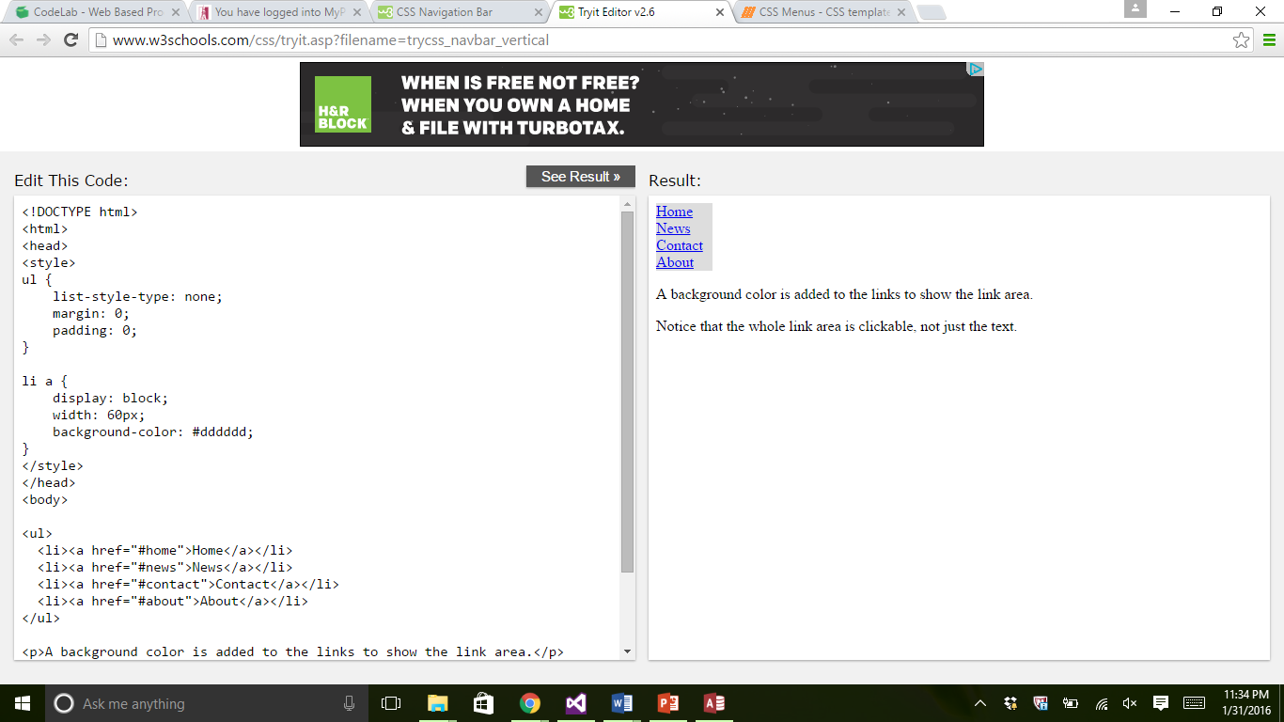

(W3schools, 2016)

References

Menu, C. (2016). *Fancy Drop Down Menus*. Retrieved from CSS3 : http://css3menu.com/

W3schools. (2016). *CSS Navigation Bar*. Retrieved from W3schools.com: http://www.w3schools.com/css/css_navbar.asp

