Part 1

1. Should web development be considered an emerging profession? Why or why not?

Yes, web development should definitely be considered an emerging profession. According to the occupational outlook handbook, the job outlook from now until 2014 is supposed to increase at a rate of 27% which is much faster than average (Statistics, 2015). As we continue to grow into this technology age, more jobs in all technology fields will be created. Companies these days will want a good web developer to market and control their websites.

1. Why would you choose or not choose to be a web professional?

There are many reason why I would choose to be a web professional. So far what I have learned this semester has lead me to believe that being a web professional is a fun and rewarding career. The jobs are growing much faster than usual, it only required an associate degree, and it pays a competitive salary. I would be rewarding to create websites and be able to find ways to use websites to help make people’s lives easier!

References

Statistics, B. o. (2015, December 17). *Web Developers*. Retrieved from U.S. Department of Labor Occupational Outlook Handbook: http://www.bls.gov/ooh/computer-and-information-technology/web-developers.htm

Part 2

//faq.html

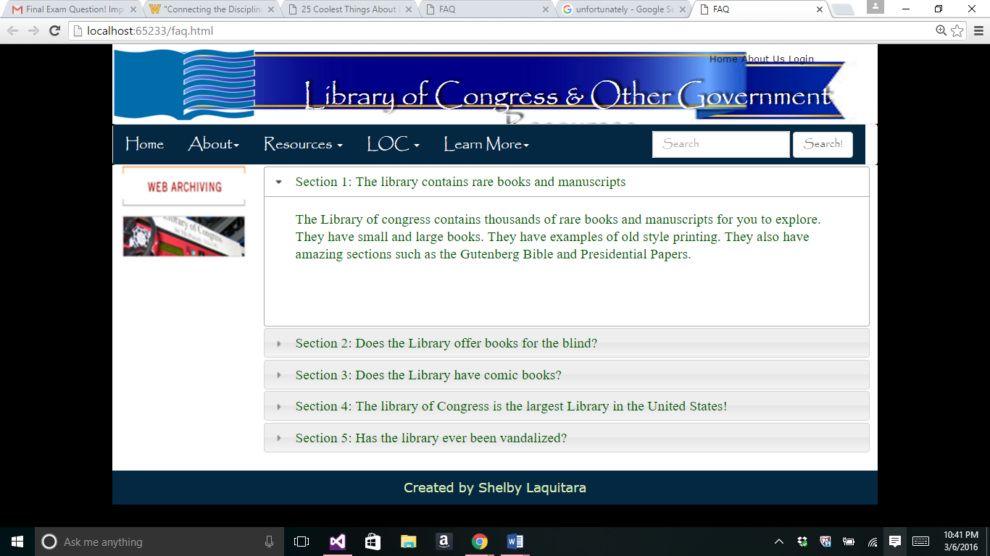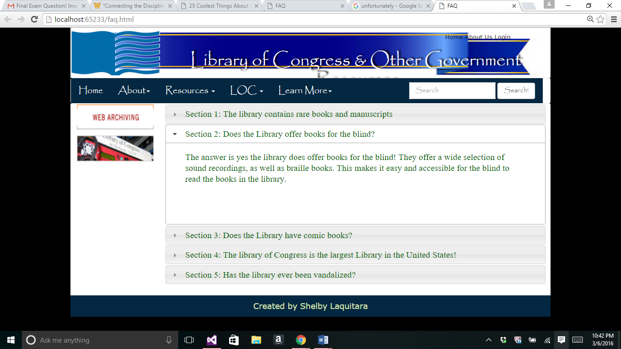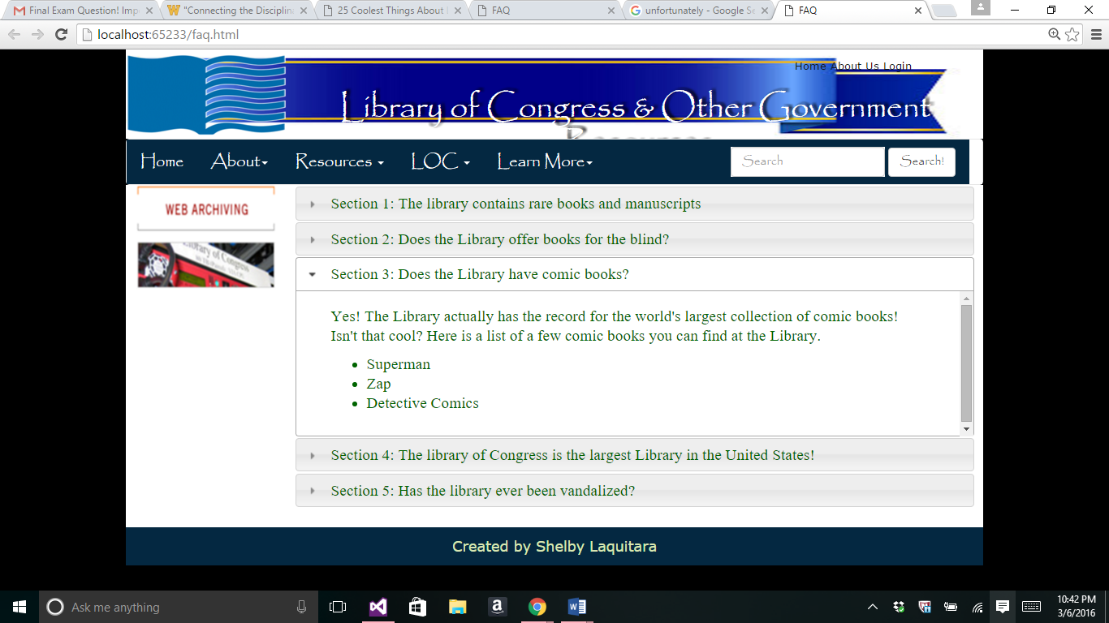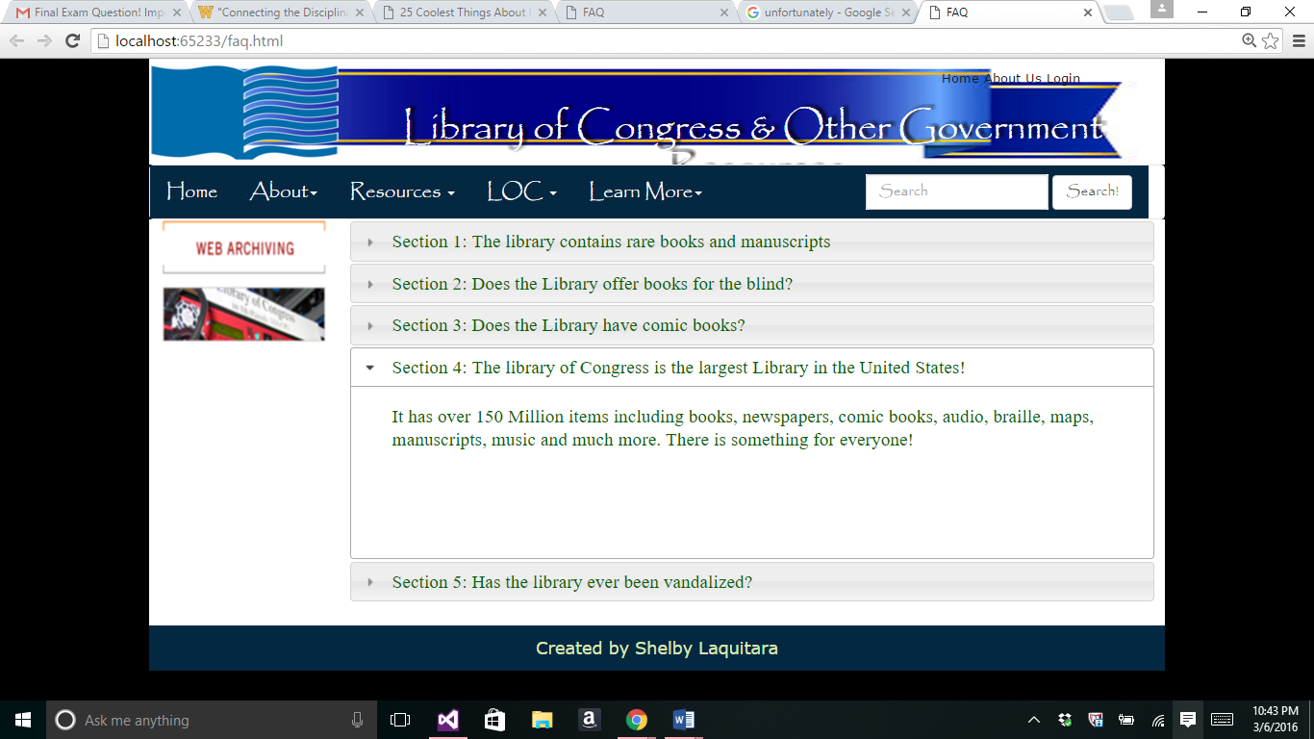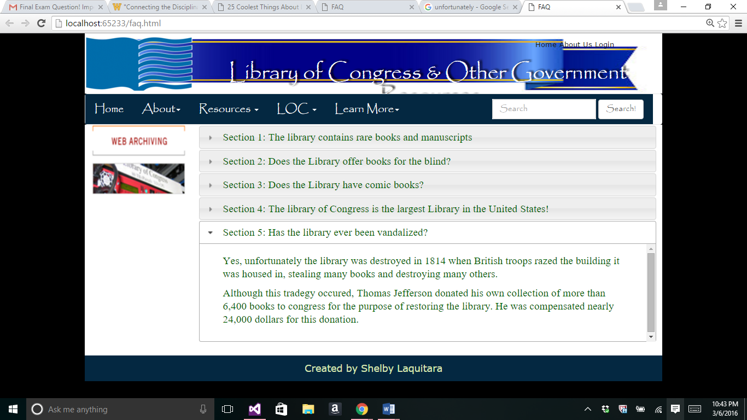

<!DOCTYPE html>

<html>

<!-- Created by: Shelby Laquitara , faq.html -->

<!-- Last Modified: 3/6/2016 -->

<head>

<title>FAQ</title>

<meta charset="utf-8" />

<meta name="keywords"

content="Library of Congress, Shelby Laquitara" />

<meta name="description" content="My Sample Web Page" />

<link rel="shortcut icon" href="images/favicon.ico" />

<meta http-equiv="X-UA-Compatible" content="IE=edge">

<meta name="viewport" content="width=device-width, initial-scale=1.0">

<link href="css/bootstrap.css" rel="stylesheet" type="text/css">

<link href="styles/style.css" rel="stylesheet" type="text/css">

<link rel="stylesheet" href="//code.jquery.com/ui/1.11.4/themes/smoothness/jquery-ui.css">

<script src="//code.jquery.com/jquery-1.10.2.js"></script>

<script src="//code.jquery.com/ui/1.11.4/jquery-ui.js"></script>

<script type="text/javascript">

$(function () {

$("#accordion").accordion();

});

</script>

<style>

#accordion * {font-family: "Times New Roman", serif;

color: darkgreen;

}

</style>

</head>

<body onload="drawBuilding();">

<!--drawCanvas is a function-->

<!-- insert header here -->

<header>

<!-- insert Top Menu here -->

<img class="logo" src="images/logo.png" alt="Logo" />

<nav class="topMenu">

<a href="home.html">Home</a>

<a href="about.html">About Us</a>

<a href="login.html">Login</a>

</nav>

<h1>Library of Congress &amp; Other Government Resources</h1>

</header>

<!-- insert Horizontal Menu here -->

<nav class="navbar navbar-default">

<div class="container-fluid">

<!-- Brand & toggle get grouped for better mobile display -->

<div class="navbar-header">

<button type="button" class="navbar-toggle collapsed"

data-toggle="collapse" data-target="#defaultNavbar1">

<br />

<span class="sr-only">Toggle navigation</span>

<span class="icon-bar"></span>

<span class="icon-bar"></span>

<span class="icon-bar"></span>

</button>

<a class="navbar-brand" href="home.html">Home</a>

</div>

<!-- The nav links, forms, & other content for toggling -->

<div class="collapse navbar-collapse" id="defaultNavbar1">

<!-- First Drop Down -->

<ul class="nav navbar-nav">

<!-- Old code <li class="active"><br>

<a href="about.html"><br>About<span

class="sr-only"> (current) </span></a></li> -->

<li class="dropdown">

<a href="about.html" class="dropdown-toggle"

data-toggle="dropdown" role="button"

aria-expanded="false">About<span class="caret"></span></a>

<ul class="dropdown-menu" role="menu">

<li><a href="faq.html">FAQ</a></li>

<li><a href="feedback.html">Feedback</a></li>

<li><a href="login.html">Login</a></li>

<li><a href="location.html">Location</a></li>

<li>

<a href="http://www.loc.gov/" target="_blank">

Library of Congress

</a>

</li>

</ul>

</li>

<!-- Second Drop Down -->

<!-- Second Drop Down -->

<li class="dropdown">

<a href="#" class="dropdown-toggle"

data-toggle="dropdown" role="button" aria-expanded="false">

Resources <span class="caret"></span>

</a>

<ul class="dropdown-menu" role="menu">

<li><a href="multimedia.html">Performing Arts</a></li>

<li><a href="puzzle.html">Veteran's History Project</a></li>

<li><a href="private.html">Members Only</a></li>

<!-- Line Dividers -->

<li class="divider"></li>

<li><a href="page1.html">Legislative Information</a></li>

<li><a href="page2.html">History &amp; Culture</a></li>

<li><a href="canvas.html">Prints and Photographs</a></li>

<li><a href="animation.html">Historic Newspaper</a></li>

<li class="divider"></li>

<li><a href="xml.html">Performing Arts</a></li>

</ul>

</li>

</ul>

<!-- Right Menu -->

<ul class="nav navbar-nav navbar-left">

<!-- OLD <li><a href="http://www.google.com/">Google</a></li> -->

<li class="dropdown">

<a href="#" class="dropdown-toggle"

data-toggle="dropdown" role="button" aria-expanded="false">

LOC <span class="caret"></span>

</a>

<ul class="dropdown-menu" role="menu">

<li><a href="http://www.loc.gov/photos/collections/">Prints and Photographs</a></li>

</ul>

<!-- Third Drop Down -->

<li class="dropdown">

<a href="#" class="dropdown-toggle" data-toggle="dropdown" role="button"

aria-expanded="false">Learn More<span class="caret"></span></a>

<ul class="dropdown-menu" role="menu">

<li><a href="https://www.archive.org/details/library_of_congress">Archive.org</a></li>

<li class="divider"></li>

<li><a href="https://www.en.wikipedia.org/wiki/Library_of_Congress">Wikipedia LOC </a></li>

</ul>

</li>

</ul>

<!-- Search Tools -->

<form class="navbar-form navbar-right" role="search">

<div class="form-group">

<input type="text" class="form-control" placeholder="Search">

</div>

<button type="submit" class="btn btn-default">Search!</button>

</form>

</div> <!-- end navbar-collapse-->

</div> <!-- end container-fluid -->

</nav>

<!-- End Main Menu -->

<!-- insert left side here -->

<div class="main">

<aside class="LeftAside">

<!-- insert side content here -->

<p>

<a href="http://www.loc.gov/webarchiving/">

<img src="images/image.jpg" alt="Sample Image" width="157" height="117"

style="border-color:#0696AB; border-image-width:10px;" />

</a>

</p>

</aside>

<!-- insert main content here -->

<section class="content">

<div id="accordion">

<h3>Section 1: The library contains rare books and manuscripts</h3>

<div>

<p>

The Library of congress contains thousands of rare books and manuscripts

for you to explore. They have small and large books. They have examples of

old style printing. They also have amazing sections such as the

Gutenberg Bible and Presidential Papers.

</p>

</div>

<h3>Section 2: Does the Library offer books for the blind? </h3>

<div>

<p>

The answer is yes the library does offer books for the blind!

They offer a wide selection of sound recordings, as well as

braille books. This makes it easy and accessible for the blind

to read the books in the library.

</p>

</div>

<h3>Section 3: Does the Library have comic books? </h3>

<div>

<p>

Yes! The Library actually has the record for the world's

largest collection of comic books! Isn't that cool? Here is a list

of a few comic books you can find at the Library.

</p>

<ul>

<li>Superman</li>

<li>Zap</li>

<li>Detective Comics</li>

</ul>

</div>

<h3>Section 4: The library of Congress is the largest Library in the

United States!</h3>

<div>

<p>

It has millions of items including books, newspapers,

comic books, audio, braille, maps, manuscripts, music and much more.

There is something for everyone!

</p>

</div>

<h3>Section 5: Has the library ever been vandalized?</h3>

<div>

<p>

Yes, unfortunately the library was destroyed when British

troops razed the building it was housed in,

stealing many books and destroying many others.

</p>

<p>

Although this tradegy occured, Thomas Jefferson donated his

own collection of more than 6,000 books to the congress for the

purpose of restoring the library. He was compensated nearly

24,000 dollars for this donation.

</p>

</div>

</div>

</section>

<br class="brClear" />

</div>

<!-- insert footer here -->

<footer>

Created by Shelby Laquitara

</footer>

</body>

</html>

//page1.html

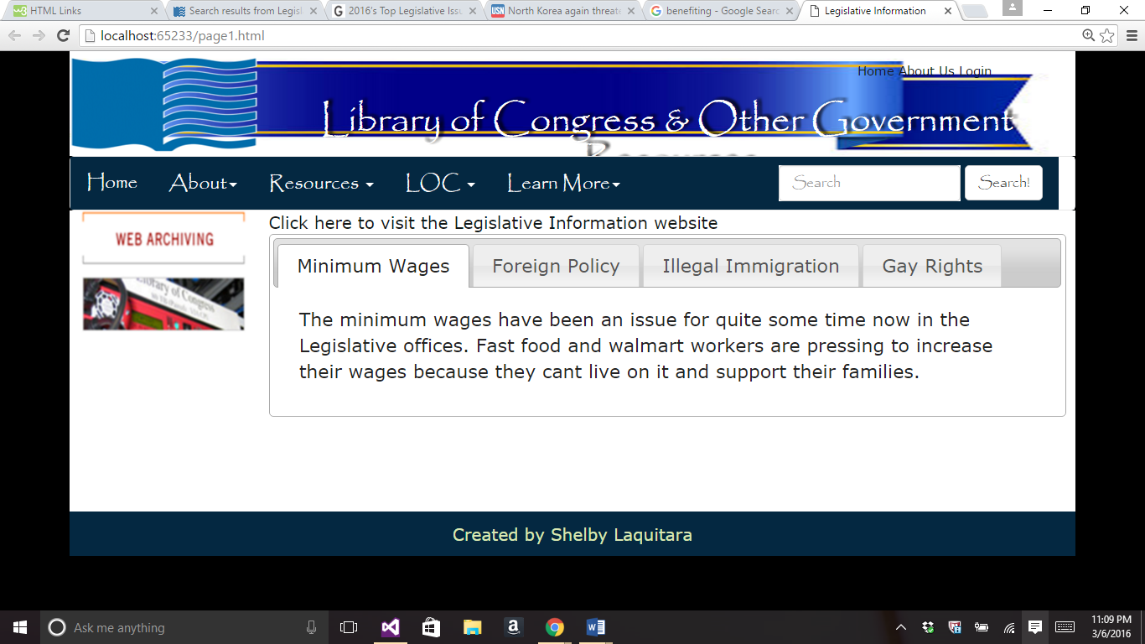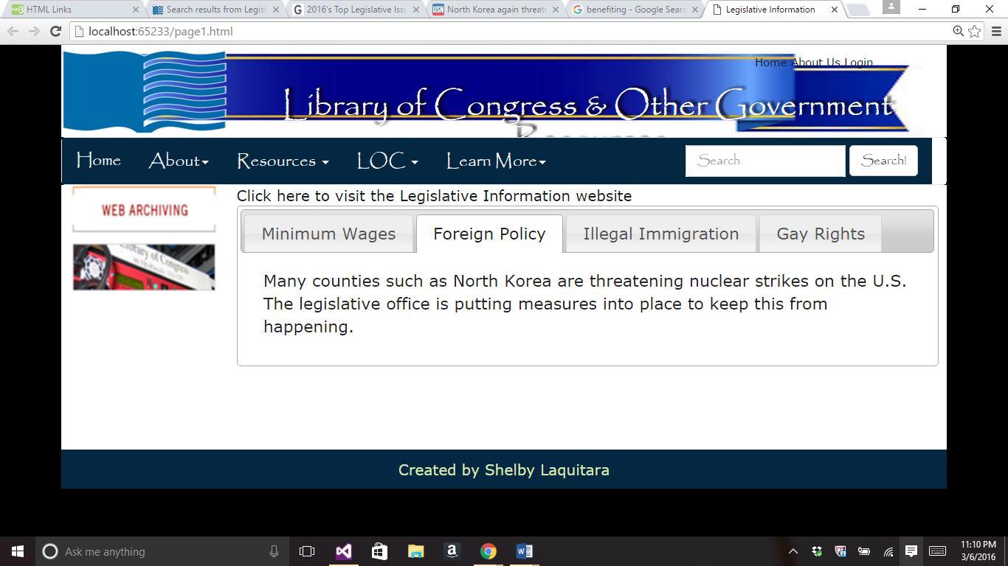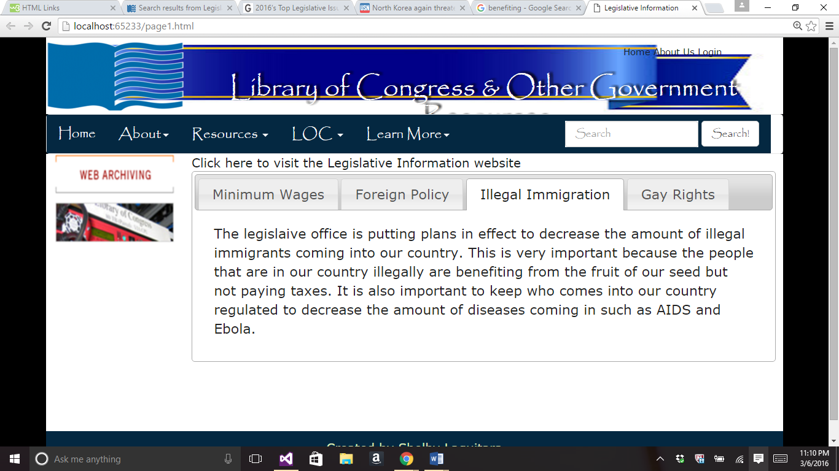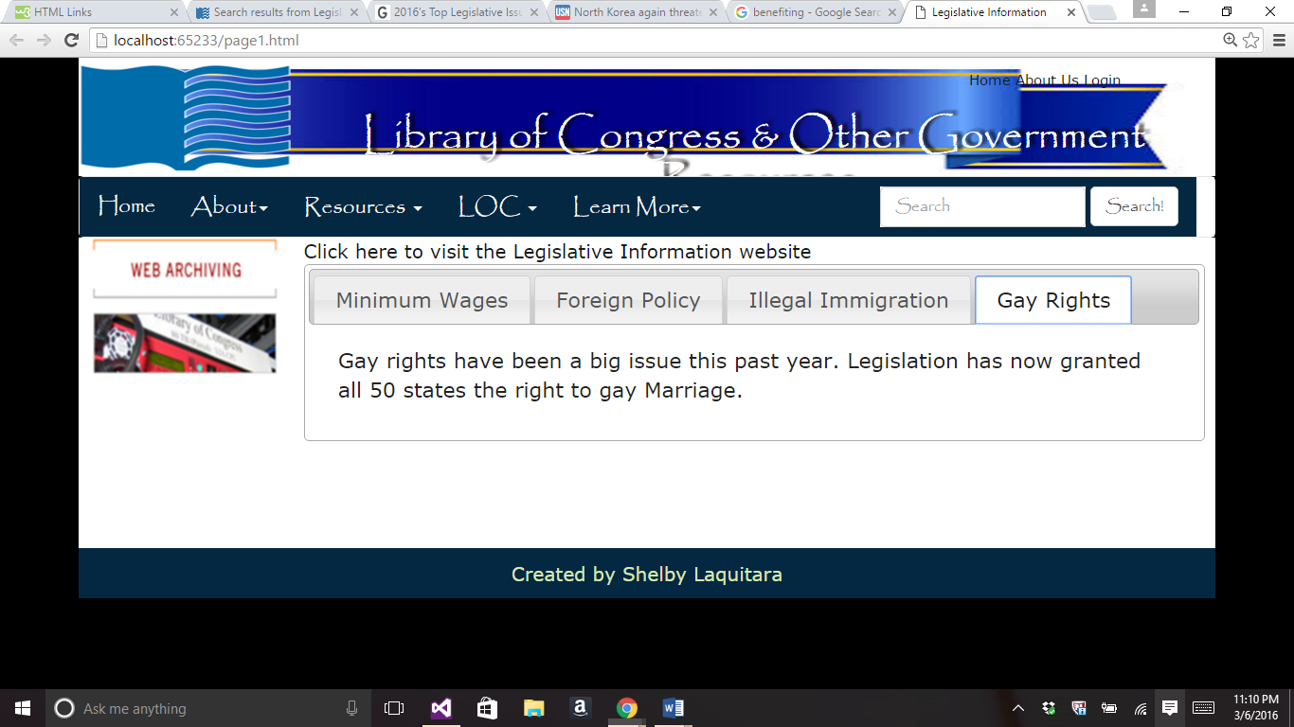

<!DOCTYPE html>

<html>

<!-- Created by: Shelby Laquitara , page1.html -->

<!-- Last Modified: 3/6/2016 -->

<head>

<title>Legislative Information</title>

<meta charset="utf-8" />

<meta name="keywords"

content="Library of Congress, Shelby Laquitara" />

<meta name="description" content="My Sample Web Page" />

<link rel="shortcut icon" href="images/favicon.ico" />

<meta http-equiv="X-UA-Compatible" content="IE=edge">

<meta name="viewport" content="width=device-width, initial-scale=1.0">

<script src="js/jquery-2.2.0.min.js" type="text/javascript"></script>

<script src="js/bootstrap.js" type="text/javascript"></script>

<link rel="stylesheet" href="//code.jquery.com/ui/1.11.4/themes/smoothness/jquery-ui.css">

<script src="//code.jquery.com/jquery-1.10.2.js"></script>

<script src="//code.jquery.com/ui/1.11.4/jquery-ui.js"></script>

<link href="css/bootstrap.css" rel="stylesheet" type="text/css">

<link href="styles/style.css" rel="stylesheet" type="text/css">

<script type="text/javascript">

$(function () {

$("#tabs").tabs();

});

</script>

</head>

<body>

<!-- insert header here -->

<header>

<!-- insert Top Menu here -->

<img class="logo" src="images/logo.png" alt="Logo" />

<nav class="topMenu">

<a href="home.html">Home</a>

<a href="about.html">About Us</a>

<a href="login.html">Login</a>

</nav>

<h1>Library of Congress &amp; Other Government Resources</h1>

</header>

<!-- insert Horizontal Menu here -->

<nav class="navbar navbar-default">

<div class="container-fluid">

<!-- Brand & toggle get grouped for better mobile display -->

<div class="navbar-header">

<button type="button" class="navbar-toggle collapsed"

data-toggle="collapse" data-target="#defaultNavbar1">

<br />

<span class="sr-only">Toggle navigation</span>

<span class="icon-bar"></span>

<span class="icon-bar"></span>

<span class="icon-bar"></span>

</button>

<a class="navbar-brand" href="home.html">Home</a>

</div>

<!-- The nav links, forms, & other content for toggling -->

<div class="collapse navbar-collapse" id="defaultNavbar1">

<!-- First Drop Down -->

<ul class="nav navbar-nav">

<!-- Old code <li class="active"><br>

<a href="about.html"><br>About<span

class="sr-only"> (current) </span></a></li> -->

<li class="dropdown">

<a href="about.html" class="dropdown-toggle"

data-toggle="dropdown" role="button"

aria-expanded="false">About<span class="caret"></span></a>

<ul class="dropdown-menu" role="menu">

<li><a href="faq.html">FAQ</a></li>

<li><a href="feedback.html">Feedback</a></li>

<li><a href="login.html">Login</a></li>

<li><a href="location.html">Location</a></li>

<li>

<a href="http://www.loc.gov/" target="_blank">

Library of Congress

</a>

</li>

</ul>

</li>

<!-- Second Drop Down -->

<!-- Second Drop Down -->

<li class="dropdown">

<a href="#" class="dropdown-toggle"

data-toggle="dropdown" role="button" aria-expanded="false">

Resources <span class="caret"></span>

</a>

<ul class="dropdown-menu" role="menu">

<li><a href="multimedia.html">Performing Arts</a></li>

<li><a href="puzzle.html">Veteran's History Project</a></li>

<li><a href="private.html">Members Only</a></li>

<!-- Line Dividers -->

<li class="divider"></li>

<li><a href="page1.html">Legislative Information</a></li>

<li><a href="page2.html">History &amp; Culture</a></li>

<li><a href="canvas.html">Prints and Photographs</a></li>

<li><a href="animation.html">Historic Newspaper</a></li>

<li class="divider"></li>

<li><a href="xml.html">Performing Arts</a></li>

</ul>

</li>

</ul>

<!-- Right Menu -->

<ul class="nav navbar-nav navbar-left">

<!-- OLD <li><a href="http://www.google.com/">Google</a></li> -->

<li class="dropdown">

<a href="#" class="dropdown-toggle"

data-toggle="dropdown" role="button" aria-expanded="false">

LOC <span class="caret"></span>

</a>

<ul class="dropdown-menu" role="menu">

<li><a href="http://www.loc.gov/photos/collections/">Prints and Photographs</a></li>

</ul>

<!-- Third Drop Down -->

<li class="dropdown">

<a href="#" class="dropdown-toggle" data-toggle="dropdown" role="button"

aria-expanded="false">Learn More<span class="caret"></span></a>

<ul class="dropdown-menu" role="menu">

<li><a href="https://www.archive.org/details/library_of_congress">Archive.org</a></li>

<li class="divider"></li>

<li><a href="https://www.en.wikipedia.org/wiki/Library_of_Congress">Wikipedia LOC </a></li>

</ul>

</li>

</ul>

<!-- Search Tools -->

<form class="navbar-form navbar-right" role="search">

<div class="form-group">

<input type="text" class="form-control" placeholder="Search">

</div>

<button type="submit" class="btn btn-default">Search!</button>

</form>

</div> <!-- end navbar-collapse-->

</div> <!-- end container-fluid -->

</nav>

<!-- End Main Menu -->

<!-- insert left side here -->

<div class="main">

<aside class="LeftAside">

<!-- insert side content here -->

<p>

<a href="http://www.loc.gov/webarchiving/">

<img src="images/image.jpg" alt="Sample Image" width="157" height="117"

style="border-color:#0696AB; border-image-width:10px;" />

</a>

</p>

</aside>

<!-- insert main content here -->

<section class="content">

<a href="http://www.loc.gov/search/?in=original-format%3Alegislation">

Click here to visit the Legislative Information website</a>

<div id="tabs">

<ul>

<li><a href="#tabs-1">Minimum Wages</a></li>

<li><a href="#tabs-2">Foreign Policy</a></li>

<li><a href="#tabs-3">Illegal Immigration</a></li>

<li><a href="#tabs-4">Gay Rights</a></li>

</ul>

<div id="tabs-1">

<p>The minimum wages have been an issue for quite some time now

in the Legislative offices. Fast food and walmart workers are

pressing to increase their wages because they cant live on it

and support their families. </p>

</div>

<div id="tabs-2">

<p>Many counties such as North Korea are threatening nuclear

strikes on the U.S. The legislative office is putting measures into

place to keep this from happening. </p>

</div>

<div id="tabs-3">

<p>The legislaive office is putting plans in effect to decrease the

amount of illegal immigrants coming into our country. This is

very important because the people that are in our country illegally

are benefiting from the fruit of our seed but not paying taxes.

It is also important to keep who comes into our country regulated to

decrease the amount of diseases coming in such as AIDS and Ebola.</p>

</div>

<div id="tabs-4">

<p>Gay rights have been a big issue this past year. Legislation

has now granted all 50 states the right to gay Marriage.</p>

</div>

</div>

</section>

<br class="brClear" />

<br /><br /><br />

</div>

<!-- insert footer here -->

<footer>

Created by Shelby Laquitara

</footer>

</body>

</html>

//page2.html

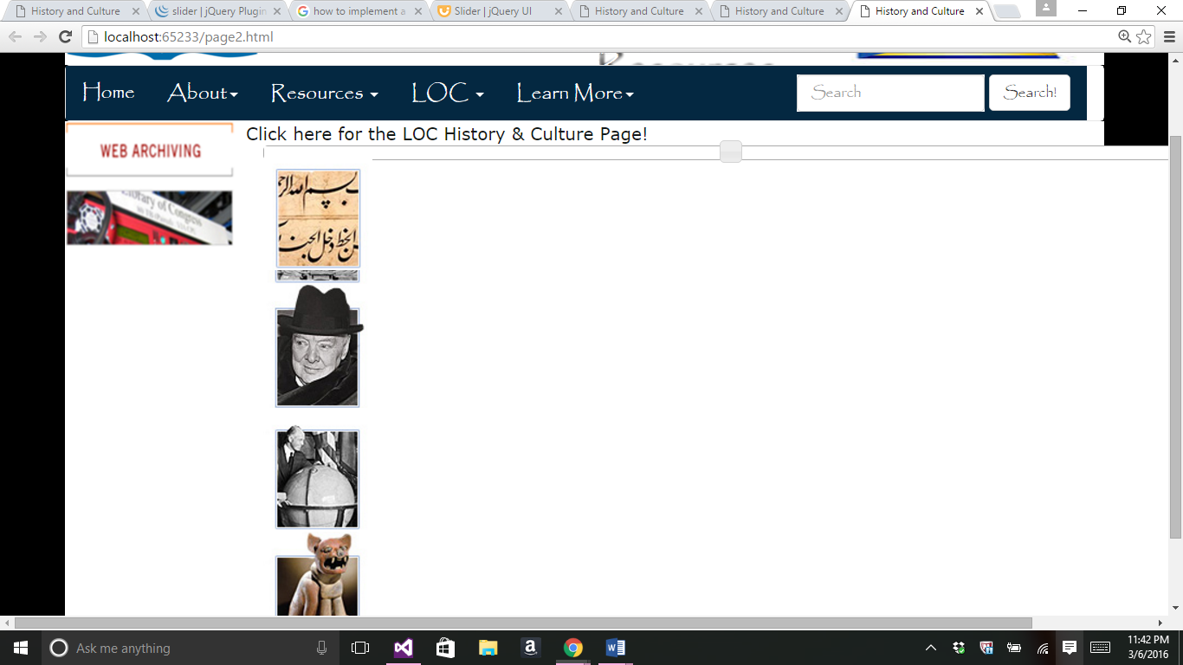

<!DOCTYPE html>

<html>

<!-- Created by: Shelby Laquitara , page2.html -->

<!-- Last Modified: 3/6/2016 -->

<head>

<title>History and Culture</title>

<meta charset="utf-8" />

<meta name="keywords"

content="Library of Congress, Shelby Laquitara" />

<meta name="description" content="My Sample Web Page" />

<link rel="shortcut icon" href="images/favicon.ico" />

<meta http-equiv="X-UA-Compatible" content="IE=edge">

<meta name="viewport" content="width=device-width, initial-scale=1.0">

<link rel="stylesheet" href="//code.jquery.com/ui/1.11.4/themes/smoothness/jquery-ui.css">

<script src="//code.jquery.com/jquery-1.10.2.js"></script>

<script src="//code.jquery.com/ui/1.11.4/jquery-ui.js"></script>

<link href="css/bootstrap.css" rel="stylesheet" type="text/css">

<link href="styles/style.css" rel="stylesheet" type="text/css">

<script src="jquery.min.js"></script>

<script src="jssor.slider.mini.js"></script>

<script>

$(function () {

$("#slider").slider();

});

</script>

</head>

<body>

<header>

<!-- insert Top Menu here -->

<img class="logo" src="images/logo.png" alt="Logo" />

<nav class="topMenu">

<a href="home.html">Home</a>

<a href="about.html">About Us</a>

<a href="login.html">Login</a>

</nav>

<h1>Library of Congress &amp; Other Government Resources</h1>

</header>

<!-- insert Horizontal Menu here -->

<nav class="navbar navbar-default">

<div class="container-fluid">

<!-- Brand & toggle get grouped for better mobile display -->

<div class="navbar-header">

<button type="button" class="navbar-toggle collapsed"

data-toggle="collapse" data-target="#defaultNavbar1">

<br />

<span class="sr-only">Toggle navigation</span>

<span class="icon-bar"></span>

<span class="icon-bar"></span>

<span class="icon-bar"></span>

</button>

<a class="navbar-brand" href="home.html">Home</a>

</div>

<!-- The nav links, forms, & other content for toggling -->

<div class="collapse navbar-collapse" id="defaultNavbar1">

<!-- First Drop Down -->

<ul class="nav navbar-nav">

<li class="dropdown">

<a href="about.html" class="dropdown-toggle"

data-toggle="dropdown" role="button"

aria-expanded="false">About<span class="caret"></span></a>

<ul class="dropdown-menu" role="menu">

<li><a href="faq.html">FAQ</a></li>

<li><a href="feedback.html">Feedback</a></li>

<li><a href="login.html">Login</a></li>

<li><a href="location.html">Location</a></li>

<li>

<a href="http://www.loc.gov/" target="_blank">

Library of Congress

</a>

</li>

</ul>

</li>

<!-- Second Drop Down -->

<li class="dropdown">

<a href="#" class="dropdown-toggle"

data-toggle="dropdown" role="button" aria-expanded="false">

Resources <span class="caret"></span>

</a>

<ul class="dropdown-menu" role="menu">

<li><a href="multimedia.html">Performing Arts</a></li>

<li><a href="puzzle.html">Veteran's History Project</a></li>

<li><a href="private.html">Members Only</a></li>

<!-- Line Dividers -->

<li class="divider"></li>

<li><a href="page1.html">Legislative Information</a></li>

<li><a href="page2.html">History &amp; Culture</a></li>

<li><a href="canvas.html">Prints and Photographs</a></li>

<li><a href="animation.html">Historic Newspaper</a></li>

<li class="divider"></li>

<li><a href="xml.html">Performing Arts</a></li>

</ul>

</li>

</ul>

<!-- Right Menu -->

<ul class="nav navbar-nav navbar-left">

<!-- OLD <li><a href="http://www.google.com/">Google</a></li> -->

<li class="dropdown">

<a href="#" class="dropdown-toggle"

data-toggle="dropdown" role="button" aria-expanded="false">

LOC <span class="caret"></span>

</a>

<ul class="dropdown-menu" role="menu">

<li><a href="http://www.loc.gov/photos/collections/">Prints and Photographs</a></li>

</ul>

<!-- Third Drop Down -->

<li class="dropdown">

<a href="#" class="dropdown-toggle" data-toggle="dropdown" role="button"

aria-expanded="false">Learn More<span class="caret"></span></a>

<ul class="dropdown-menu" role="menu">

<li><a href="https://www.archive.org/details/library_of_congress">Archive.org</a></li>

<li class="divider"></li>

<li><a href="https://www.en.wikipedia.org/wiki/Library_of_Congress">Wikipedia LOC </a></li>

</ul>

</li>

</ul>

<!-- Search Tools -->

<form class="navbar-form navbar-right" role="search">

<div class="form-group">

<input type="text" class="form-control" placeholder="Search">

</div>

<button type="submit" class="btn btn-default">Search!</button>

</form>

</div> <!-- end navbar-collapse-->

</div> <!-- end container-fluid -->

</nav>

<!-- End Main Menu -->

<!-- insert left side here -->

<div class="main">

<aside class="LeftAside">

<!-- insert side content here -->

<p>

<a href="http://www.loc.gov/webarchiving/">

<img src="images/image.jpg" alt="Sample Image" width="157" height="117"

style="border-color:#0696AB; border-image-width:10px;" />

</a>

</p>

</aside>

<section class="content">

<a href="http://www.loc.gov/topics/worldhistory.php">

Click here for

the LOC History & Culture Page!

</a><br />

<div class="container">

<div id="slider"> <!--creating the id of the slider-->

<img src="/images/africaAndTheMiddleEast.jpg"

title="Africa and The Middle East" />

</div>

<div>

<img src="/images/AsiaAndThePacific.jpg"

title="Asia and The Pacific" />

</div>

<div>

<img src="/images/Europe.jpg" title="Europe" />

</div>

<div>

<img src="/images/multipleRegions.jpg" title="Multiple Regions" />

</div>

<div>

<img src="/images/TheAmericans.jpg" title="The Americans"/>

</div>

</div>

</section>

</div>

<!-- insert footer here -->

<footer>

Created by Shelby Laquitara

</footer>

</body>

</html>

//xml.html

<!DOCTYPE html>

<html>

<!-- Created by: Shelby Laquitara , xml.html -->

<!-- Last Modified: 3/6/2016 -->

<head>

<title>Prints and Photographs</title>

<meta charset="utf-8" />

<meta name="keywords"

content="Library of Congress, Shelby Laquitara" />

<meta name="description" content="My Sample Web Page" />

<link rel="shortcut icon" href="images/favicon.ico" />

<meta http-equiv="X-UA-Compatible" content="IE=edge">

<meta name="viewport" content="width=device-width, initial-scale=1.0">

<script src="js/jquery-2.2.0.min.js" type="text/javascript"></script>

<script src="js/bootstrap.js" type="text/javascript"></script>

<link href="css/bootstrap.css" rel="stylesheet" type="text/css">

<link href="styles/style.css" rel="stylesheet" type="text/css">

<script type="text/javascript">

</script>

</head>

<body>

<header>

<!-- insert Top Menu here -->

<img class="logo" src="images/logo.png" alt="Logo" />

<nav class="topMenu">

<a href="home.html">Home</a>

<a href="about.html">About Us</a>

<a href="login.html">Login</a>

</nav>

<h1>Library of Congress &amp; Other Government Resources</h1>

</header>

<!-- insert Horizontal Menu here -->

<nav class="navbar navbar-default">

<div class="container-fluid">

<!-- Brand & toggle get grouped for better mobile display -->

<div class="navbar-header">

<button type="button" class="navbar-toggle collapsed"

data-toggle="collapse" data-target="#defaultNavbar1">

<br />

<span class="sr-only">Toggle navigation</span>

<span class="icon-bar"></span>

<span class="icon-bar"></span>

<span class="icon-bar"></span>

</button>

<a class="navbar-brand" href="home.html">Home</a>

</div>

<!-- The nav links, forms, & other content for toggling -->

<div class="collapse navbar-collapse" id="defaultNavbar1">

<!-- First Drop Down -->

<ul class="nav navbar-nav">

<!-- Old code <li class="active"><br>

<a href="about.html"><br>About<span

class="sr-only"> (current) </span></a></li> -->

<li class="dropdown">

<a href="about.html" class="dropdown-toggle"

data-toggle="dropdown" role="button"

aria-expanded="false">About<span class="caret"></span></a>

<ul class="dropdown-menu" role="menu">

<li><a href="faq.html">FAQ</a></li>

<li><a href="feedback.html">Feedback</a></li>

<li><a href="login.html">Login</a></li>

<li><a href="location.html">Location</a></li>

<li>

<a href="http://www.loc.gov/" target="_blank">

Library of Congress

</a>

</li>

</ul>

</li>

<!-- Second Drop Down -->

<!-- Second Drop Down -->

<li class="dropdown">

<a href="#" class="dropdown-toggle"

data-toggle="dropdown" role="button" aria-expanded="false">

Resources <span class="caret"></span>

</a>

<ul class="dropdown-menu" role="menu">

<li><a href="multimedia.html">Performing Arts</a></li>

<li><a href="puzzle.html">Veteran's History Project</a></li>

<li><a href="private.html">Members Only</a></li>

<!-- Line Dividers -->

<li class="divider"></li>

<li><a href="page1.html">Legislative Information</a></li>

<li><a href="page2.html">History &amp; Culture</a></li>

<li><a href="canvas.html">Prints and Photographs</a></li>

<li><a href="animation.html">Historic Newspaper</a></li>

<li class="divider"></li>

<li><a href="xml.html">Performing Arts</a></li>

</ul>

</li>

</ul>

<!-- Right Menu -->

<ul class="nav navbar-nav navbar-left">

<!-- OLD <li><a href="http://www.google.com/">Google</a></li> -->

<li class="dropdown">

<a href="#" class="dropdown-toggle"

data-toggle="dropdown" role="button" aria-expanded="false">

LOC <span class="caret"></span>

</a>

<ul class="dropdown-menu" role="menu">

<li><a href="http://www.loc.gov/photos/collections/">Prints and Photographs</a></li>

</ul>

<!-- Third Drop Down -->

<li class="dropdown">

<a href="#" class="dropdown-toggle" data-toggle="dropdown" role="button"

aria-expanded="false">Learn More<span class="caret"></span></a>

<ul class="dropdown-menu" role="menu">

<li><a href="https://www.archive.org/details/library_of_congress">Archive.org</a></li>

<li class="divider"></li>

<li><a href="https://www.en.wikipedia.org/wiki/Library_of_Congress">Wikipedia LOC </a></li>

</ul>

</li>

</ul>

<!-- Search Tools -->

<form class="navbar-form navbar-right" role="search">

<div class="form-group">

<input type="text" class="form-control" placeholder="Search">

</div>

<button type="submit" class="btn btn-default">Search!</button>

</form>

</div> <!-- end navbar-collapse-->

</div> <!-- end container-fluid -->

</nav>

<!-- End Main Menu -->

<!-- insert left side here -->

<div class="main">

<aside class="LeftAside">

<!-- insert side content here -->

<p>

<a href="http://www.loc.gov/webarchiving/">

<img src="images/image.jpg" alt="Sample Image" width="157" height="117"

style="border-color:#0696AB; border-image-width:10px;" />

</a>

</p>

</aside>

<!-- insert main content here -->

<section class="content">

<h2></h2>

<p></p>

#include file="resources.xml"

</section>

<br class="brClear" />

</div>

<!-- insert footer here -->

<footer>

Created by Shelby Laquitara

</footer>

</body>

</html>

//resources.xml

<?xml version="1.0" encoding="UTF-8"?>

<?xml-stylesheet type="text/html" href="xml.html"?>

<rss> version="2.0">

<library>

<resource>

<title>Christian womanhood</title>

<author>William Wallace</author>

<synopsis>Religious book about the life of Mrs. M. K. Everts</synopsis>

<type>book</type>

<link>https://lccn.loc.gov/36019856</link>

<year>1868</year>

</resource>

<resource>

<title>Woman suffrage in New Jersey</title>

<author>Lucy Stone</author>

<synopsis>An address delivered by Lucy Stone,

at a hearing before the New Jersey Legislature</synopsis>

<type>book</type>

<link>https://lccn.loc.gov/09032760</link>

<year>1867</year>

</resource>

<resource>

<title>Developing an airport performance-measurement system</title>

<author>Washington, D.C. : Transportation Research Board</author>

<synopsis> Developing an airport performance-measurement system /

Infrastructure Management Group, Inc., </synopsis>

<type>book</type>

<link>https://lccn.loc.gov/2010928847</link>

<year>2010</year>

</resource>

<resource>

<title>The Fleet : its river, prison and marriages </title>

<author>Ashton, John</author>

<synopsis></synopsis>

<type>book</type>

<link>https://lccn.loc.gov/15019012</link>

<year>1888</year>

</resource>

<resource>

<title>The journal of the Federal convention of 1787 analyzed</title>

<author>Richardson, Hamilton P.</author>

<synopsis>The journal of the Federal convention of 1787 analyzed</synopsis>

<type>book</type>

<link>https://lccn.loc.gov/99005457</link>

<year>1899</year>

</resource>

</library>

</rss>

//location.html

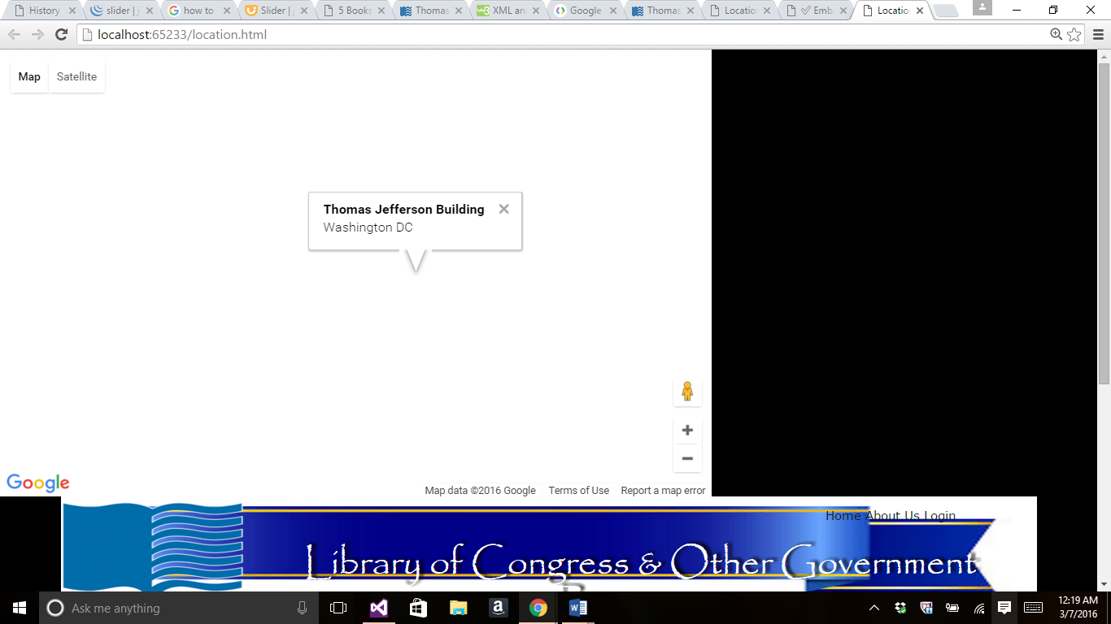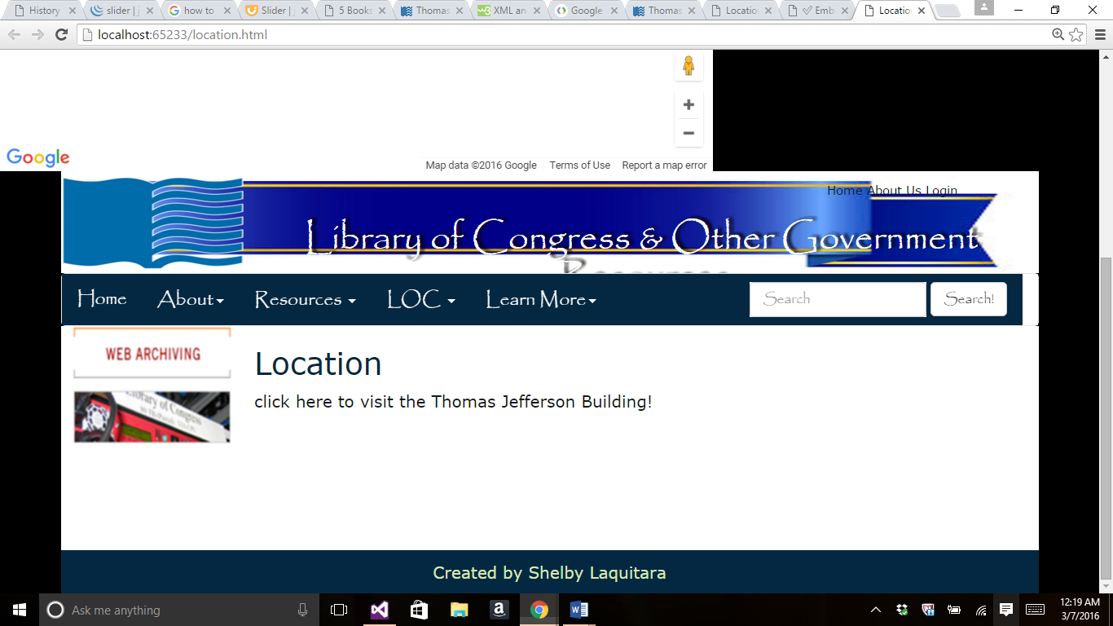

<!DOCTYPE html>

<html>

<!-- Created by: Shelby Laquitara , location.html -->

<!-- Last Modified: 3/6/2016 -->

<head>

<title>Location</title>

<meta charset="utf-8" />

<meta name="keywords"

content="Library of Congress, Shelby Laquitara" />

<meta name="description" content="My Sample Web Page" />

<link rel="shortcut icon" href="images/favicon.ico" />

<meta http-equiv="X-UA-Compatible" content="IE=edge">

<meta name="viewport" content="width=device-width, initial-scale=1.0">

<link href="css/bootstrap.css" rel="stylesheet" type="text/css">

<link href="styles/style.css" rel="stylesheet" type="text/css" />

<script src='https://maps.googleapis.com/maps/api/js?v=3.exp'></script>

<div style='overflow:hidden;height:440px;width:700px;'><div id='gmap_canvas' style='height:440px;width:700px;'></div><div><small><a href="http://embedgooglemaps.com"> embed google map </a></small></div><div><small><a href="http://www.freedirectorysubmissionsites.com/">link directories</a></small></div>

<style>

#gmap_canvas img {

max-width: none !important;

background: none !important;

}

</style></div>

<script type='text/javascript'>function init_map(){var myOptions = {zoom:10,center:new google.maps.LatLng(38.88474718571238,-76.66676877128909),mapTypeId: google.maps.MapTypeId.ROADMAP};map = new google.maps.Map(document.getElementById('gmap_canvas'), myOptions);marker = new google.maps.Marker({map: map,position: new google.maps.LatLng(38.88474718571238,-76.66676877128909)});infowindow = new google.maps.InfoWindow({content:'<strong>Thomas Jefferson Building</strong><br>Washington DC<br>'});google.maps.event.addListener(marker, 'click', function(){infowindow.open(map,marker);});infowindow.open(map,marker);}google.maps.event.addDomListener(window, 'load', init_map);</script>

</head>

<body>

<!--drawCanvas is a function-->

<!-- insert header here -->

<header>

<!-- insert Top Menu here -->

<img class="logo" src="images/logo.png" alt="Logo" />

<nav class="topMenu">

<a href="home.html">Home</a>

<a href="about.html">About Us</a>

<a href="login.html">Login</a>

</nav>

<h1>Library of Congress &amp; Other Government Resources</h1>

</header>

<!-- insert Horizontal Menu here -->

<nav class="navbar navbar-default">

<div class="container-fluid">

<!-- Brand & toggle get grouped for better mobile display -->

<div class="navbar-header">

<button type="button" class="navbar-toggle collapsed"

data-toggle="collapse" data-target="#defaultNavbar1">

<br />

<span class="sr-only">Toggle navigation</span>

<span class="icon-bar"></span>

<span class="icon-bar"></span>

<span class="icon-bar"></span>

</button>

<a class="navbar-brand" href="home.html">Home</a>

</div>

<!-- The nav links, forms, & other content for toggling -->

<div class="collapse navbar-collapse" id="defaultNavbar1">

<!-- First Drop Down -->

<ul class="nav navbar-nav">

<li class="dropdown">

<a href="about.html" class="dropdown-toggle"

data-toggle="dropdown" role="button"

aria-expanded="false">About<span class="caret"></span></a>

<ul class="dropdown-menu" role="menu">

<li><a href="faq.html">FAQ</a></li>

<li><a href="feedback.html">Feedback</a></li>

<li><a href="login.html">Login</a></li>

<li><a href="location.html">Location</a></li>

<li>

<a href="http://www.loc.gov/" target="_blank">

Library of Congress

</a>

</li>

</ul>

</li>

<!-- Second Drop Down -->

<!-- Second Drop Down -->

<li class="dropdown">

<a href="#" class="dropdown-toggle"

data-toggle="dropdown" role="button" aria-expanded="false">

Resources <span class="caret"></span>

</a>

<ul class="dropdown-menu" role="menu">

<li><a href="multimedia.html">Performing Arts</a></li>

<li><a href="puzzle.html">Veteran's History Project</a></li>

<li><a href="private.html">Members Only</a></li>

<!-- Line Dividers -->

<li class="divider"></li>

<li><a href="page1.html">Legislative Information</a></li>

<li><a href="page2.html">History &amp; Culture</a></li>

<li><a href="canvas.html">Prints and Photographs</a></li>

<li><a href="animation.html">Historic Newspaper</a></li>

<li class="divider"></li>

<li><a href="xml.html">Performing Arts</a></li>

</ul>

</li>

</ul>

<!-- Right Menu -->

<ul class="nav navbar-nav navbar-left">

<!-- OLD <li><a href="http://www.google.com/">Google</a></li> -->

<li class="dropdown">

<a href="#" class="dropdown-toggle"

data-toggle="dropdown" role="button" aria-expanded="false">

LOC <span class="caret"></span>

</a>

<ul class="dropdown-menu" role="menu">

<li><a href="http://www.loc.gov/photos/collections/">Prints and Photographs</a></li>

</ul>

<!-- Third Drop Down -->

<li class="dropdown">

<a href="#" class="dropdown-toggle" data-toggle="dropdown" role="button"

aria-expanded="false">Learn More<span class="caret"></span></a>

<ul class="dropdown-menu" role="menu">

<li><a href="https://www.archive.org/details/library_of_congress">Archive.org</a></li>

<li class="divider"></li>

<li><a href="https://www.en.wikipedia.org/wiki/Library_of_Congress">Wikipedia LOC </a></li>

</ul>

</li>

</ul>

<!-- Search Tools -->

<form class="navbar-form navbar-right" role="search">

<div class="form-group">

<input type="text" class="form-control" placeholder="Search">

</div>

<button type="submit" class="btn btn-default">Search!</button>

</form>

</div> <!-- end navbar-collapse-->

</div> <!-- end container-fluid -->

</nav>

<!-- End Main Menu -->

<!-- insert left side here -->

<div class="main">

<aside class="LeftAside">

<!-- insert side content here -->

<p>

<a href="http://www.loc.gov/webarchiving/">

<img src="images/image.jpg" alt="Sample Image" width="157" height="117"

style="border-color:#0696AB; border-image-width:10px;" />

</a>

</p>

</aside>

<!-- insert main content here -->

<section class="content">

<h2>Location</h2>

<a href="https://loc.gov/visit/tours/guided-tours/thomas-jefferson-building/">

click here to visit the Thomas Jefferson Building!

</a>

<br /><br /><br />

</section>

<br class="brClear" />

<br /><br /><br />

</div>

<!-- insert footer here -->

<footer>

Created by Shelby Laquitara

</footer>

</body>

</html>

References- code for the map was located at <http://embedgooglemaps.com/en/>.