[](https://www.linkedin.com/in/sebastian-valenzuela-ballesteros-4ba32795/?locale=en_US) [](https://svalenzu2112.github.io/Resume/)

 svalenzu2112@gmail.com

 +56 9 64893571

Valenzuela B.

Sebastian

**Telecommunications Engineer**

**DIPLOMAS Y HOBBIES**

**Formaciones :** Diplomados, Congresos, xxxxxxxxxx xxxxxx xxxxxxxxx xxxxxxxxxxxxxxxxx

**Hobbies:** xxxxxxxxxxxxxxxxxxxxxxxxxxxxxx



**WHO AM I?**

**PROFESSIONAL EXPERIENCE**

A Tech-Lover who for more than 13 years has been developing in the telecommunications market with focus on Networking and Data Center environments.

Highly committed and effective in achieving organizational and individual goals, able to train and lead interdisciplinary work teams, skilled in negotiating effectively in order to accomplish projects, and communicate effectively with technical and non-technical teams and very good interpersonal relationship.

Oct 2020/

Today

(Stgo. -Chile)



July 2018/

June 2020

(Stgo. -Chile)

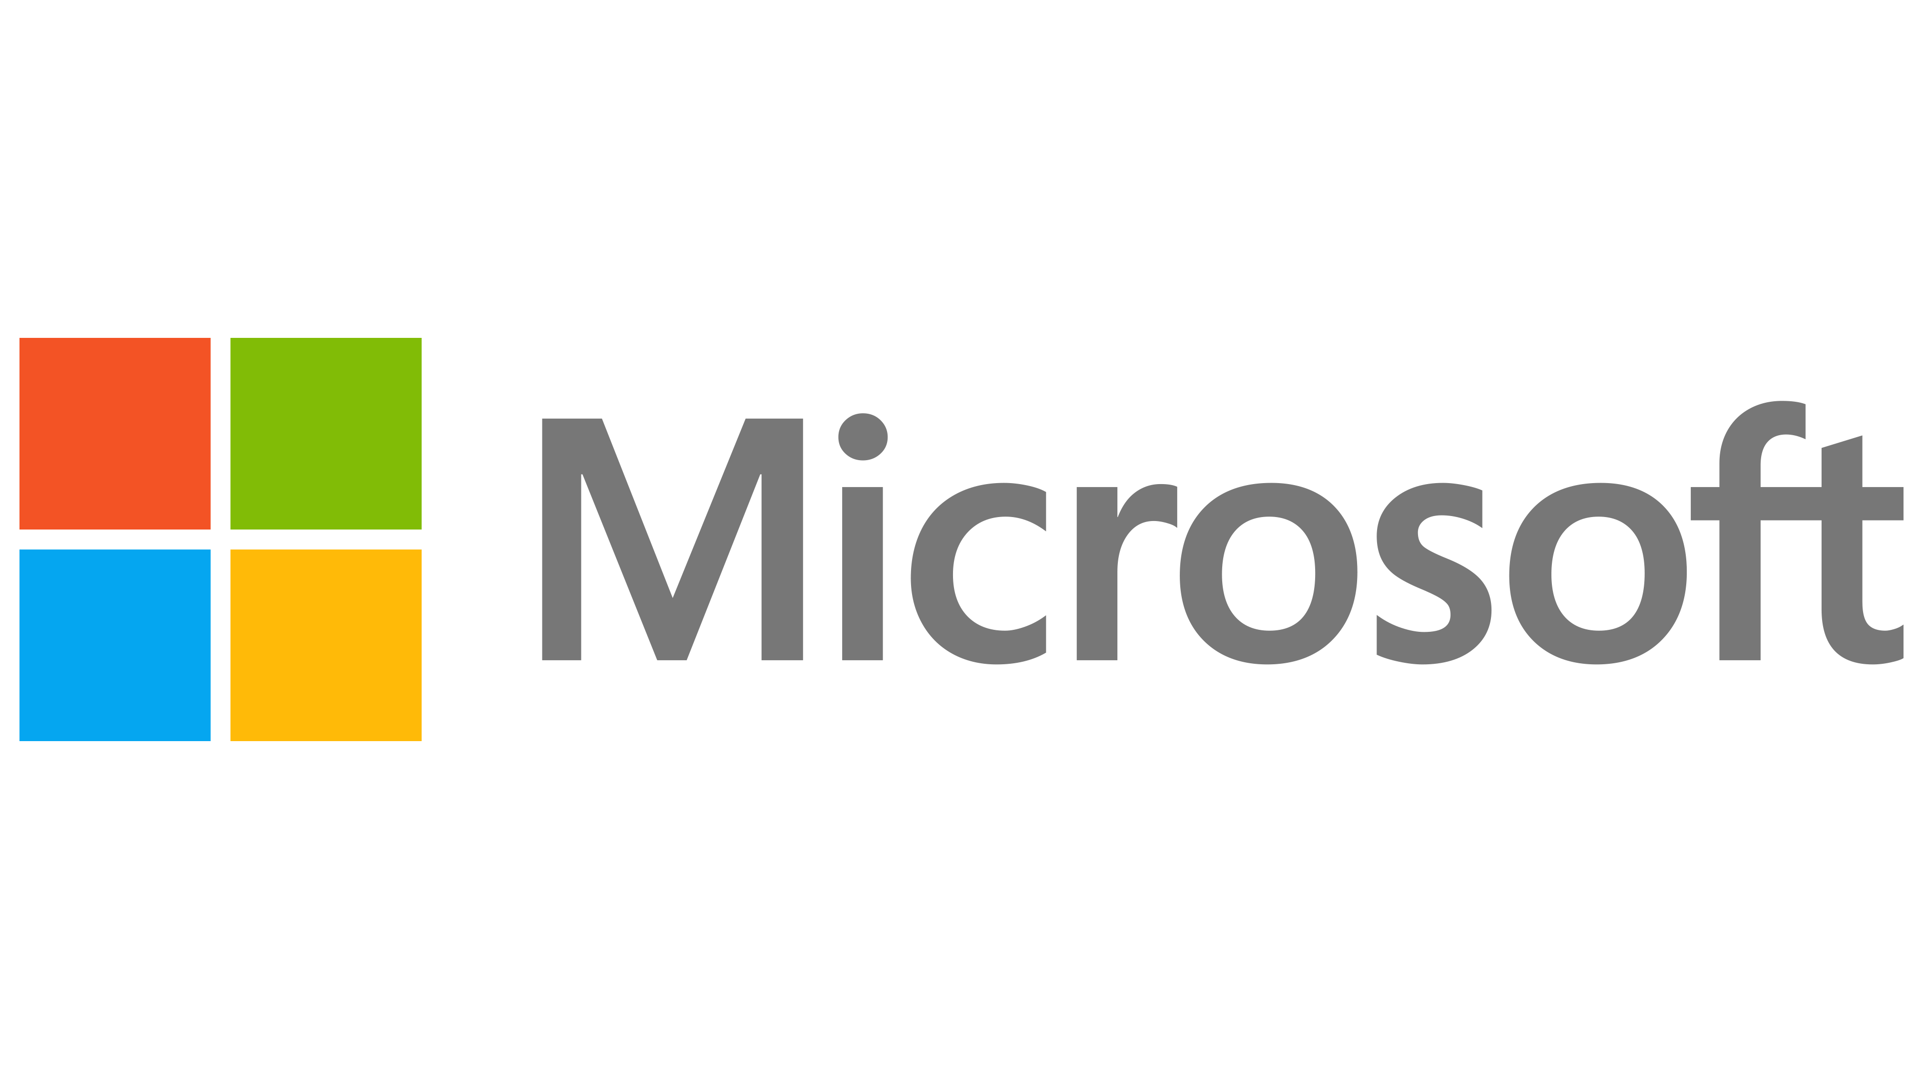

August 2010/

March 2017

(Stgo. - Chile)

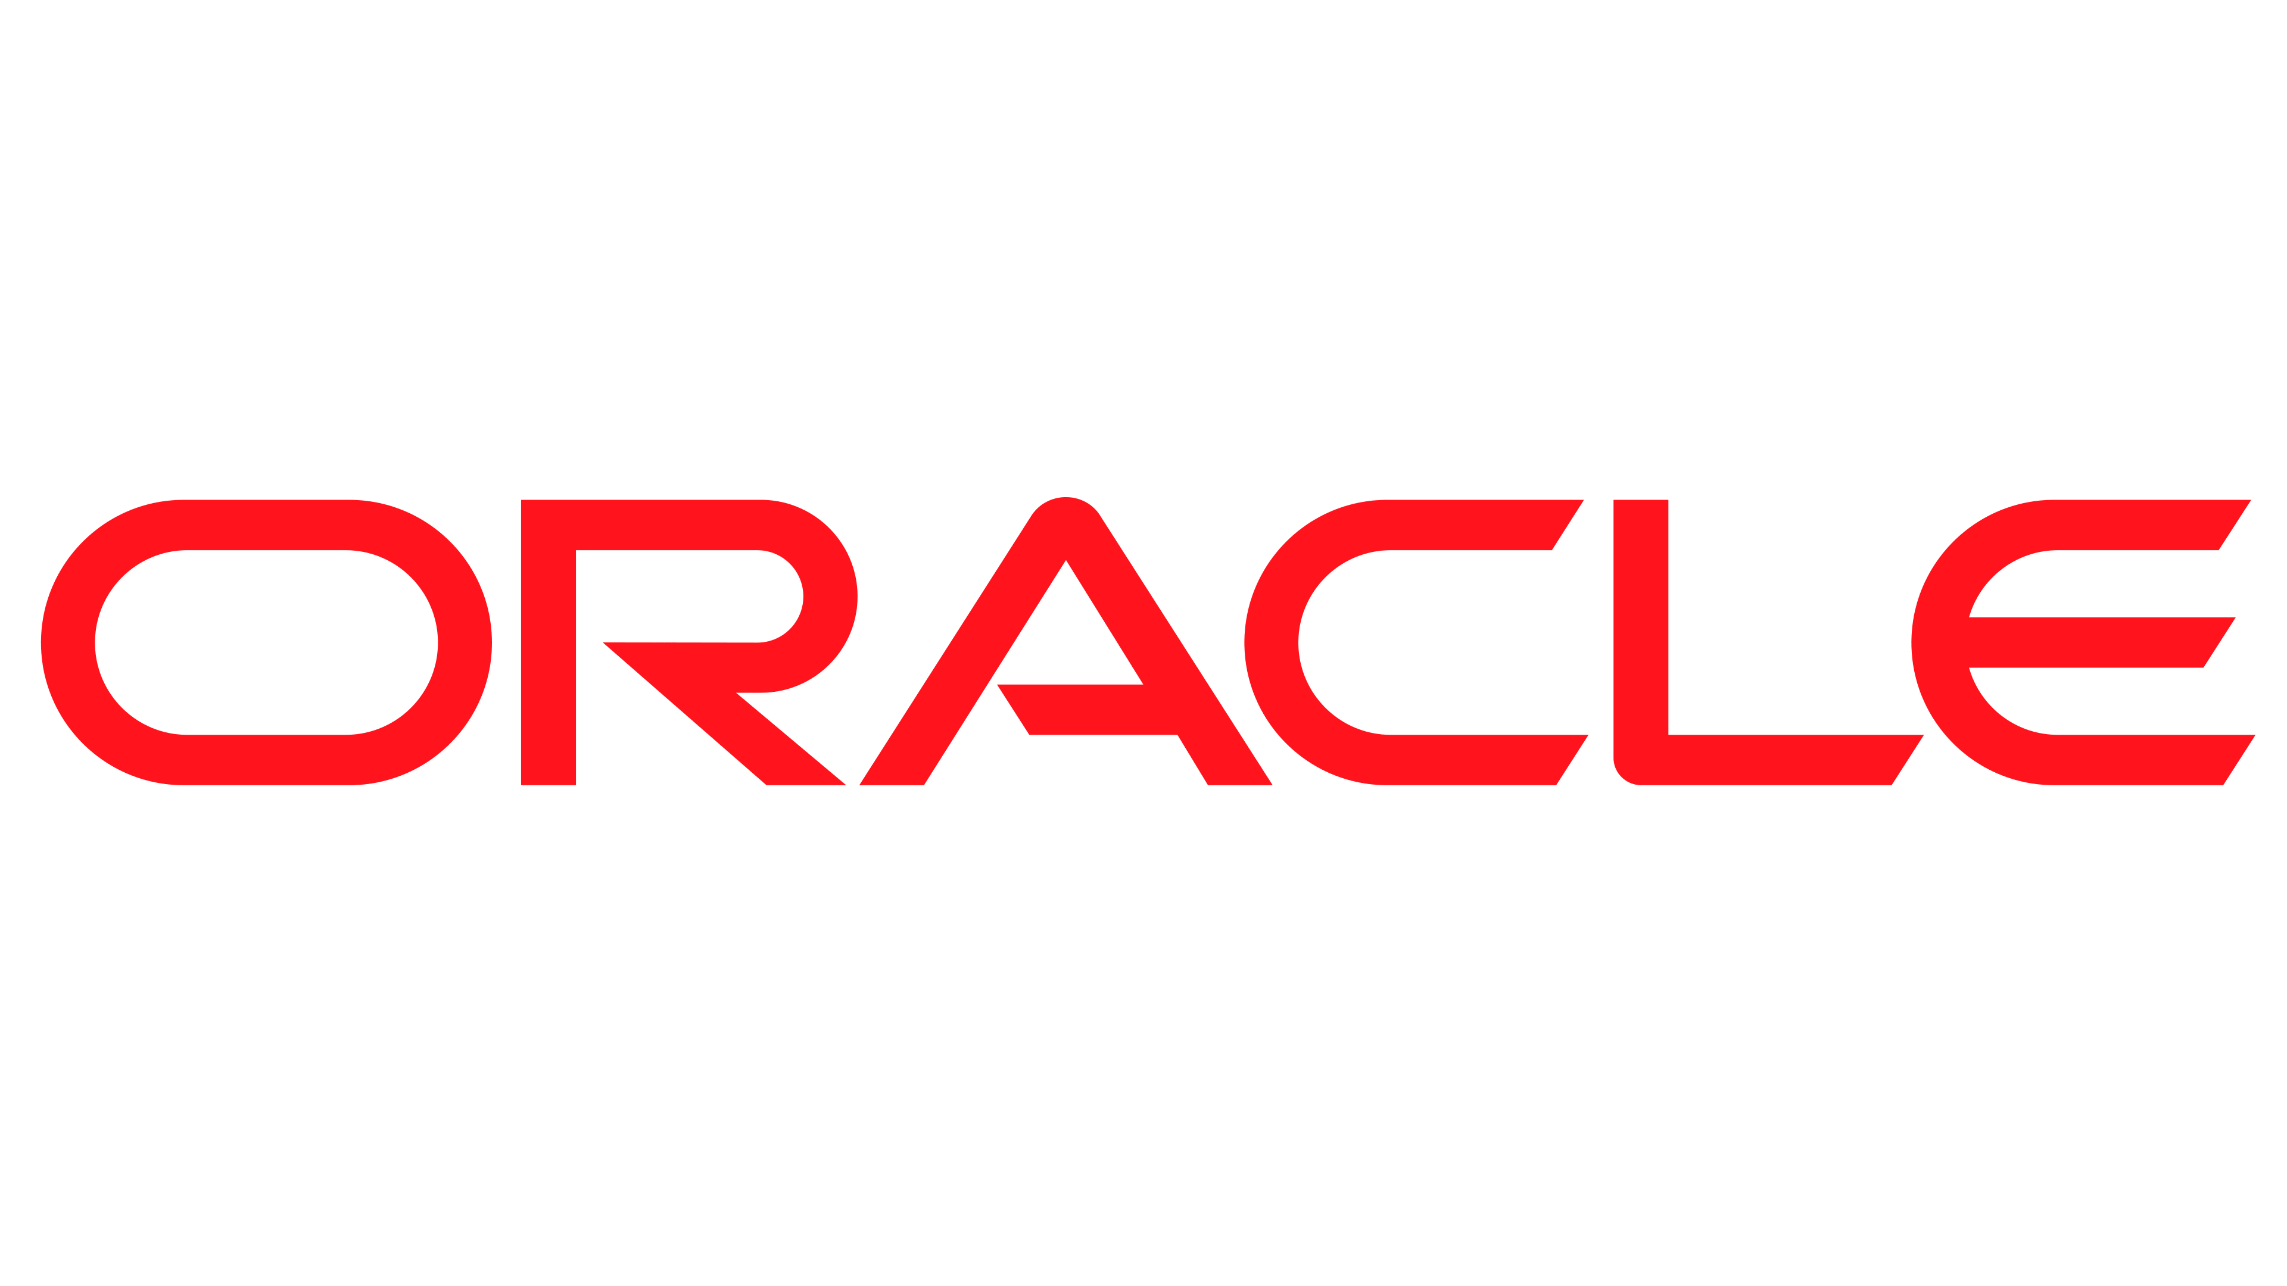

**EDGEUNO - Data Center Engineer**

**Duties:** Responsible for all operations required across LATAM but focused and based in SCL1 site; in charge of design, manage, maintenance and deploy of all racks and devices in our sites, doing physical troubleshooting, working together with different teams inside the company. Create documentation and new procedures, maintain our inventory. Basic servers’ configuration on site.

**MICROSOFT - Data Center Engineer**

**Duties:** Responsible for all the operations needed to run the physical infrastructure (including supply chain, hardware, power, security, and workflow teams). Diagnose and troubleshoot, documenting and repairing hardware issues including PS, CPU’s, MB, HDD’s, SDD’s, RAM’s, etc. Work with fiber optics related technologies, such as single and multi-mode fibers, MTP, SC and LC Connectors, Fluke certification tools.

**ORACLE - Network Support Engineer**

**Duties:** Provide direct support to customers, solving Hardware issues regarding Network cards. Job includes technical support and troubleshoot all network related issues, software and hardware oriented, quick failure detection and replacing defective parts, mostly NIC cards. Quick problem identification, either software or hardware issue, routing the customer to the proper team for assistance, accomplishing the team’s TTR.

39 years old / Chilean / Single.

Driver License Class B

Valid Passport (2024)

Valid USA Visa B1/B2 (2024)

**I LIKE**

Listen to Music

Watch Movies & Series.

Play and Watch Sports

Travel around the World.

**EDUCATION & CERTIFICATIONS**

2017.  Telecommunications Engineer Degree

Santiago*Universidad Andrés Bello*

2005.  Telecommunications Technician Degree

Santiago*Universidad de Santiago de Chile*

2019.  MTA – Security Fundamentals Cert.

Santiago*Microsoft*

2019.  MTA – Network Fundamentals Cert.

Santiago*Microsoft*

2019.  Azure Fundamentals

Santiago*Microsoft*

**KNOWLEDGE & SKILLS**

**PERSONAL INFORMATION**

**LANGUAGES (Spoken/ Written/ Reading Escrito)**

Networking – Routing and Switching

Network Monitoring

Network Security

Tech Projects

Cloud

MS Office (User Level)

Team Leading

Incident Management

Data Center Management

Spanish: Native

English: Advanced