1. **Circuit Testing:**
   1. Circuit Overview:
      1. Inputs (Input1 to Input8): Digital signals (0V or 5V) representing binary inputs.
      2. Weights (Weight1 to Weight8): Adjustable via potentiometers, representing the synaptic weights in a neural network.
      3. Multipliers (AD633): Multiply each input by its corresponding weight.
      4. Summing Amplifier (Op-Amp): Sums the weighted inputs and produces the output.
   2. Expected Behavior:
      1. The circuit should compute a weighted sum of the inputs.
      2. By adjusting the weights, we can control the influence of each input on the output.
      3. The output voltage should reflect the cumulative effect of the inputs and weights.
   3. Placing Voltage Probes for Signal Monitoring:
      1. Op-Amp Output: Final output of the circuit
      2. Multiplier Outputs: The outputs of each AD633 multiplier (Pin7, W).
      3. Input Signals: The voltage level of each input (Input1 to Input8).
      4. Potentiometer Wiper Voltages: The voltage at the wiper of each potentiometer (connected to AD633 Pin 1, X1).
   4. Circuit Parameter Calculations:
      1. AD633 Computes:

W = ((X1 – X2) * (Y1 – Y2) / (10V)) + Z

* + 1. Where:
       1. X1 = potentiometer voltage
       2. X2 = ground
       3. Y1 = Input voltage (5V or 0V)
       4. Y2 = Ground
       5. Z = Ground
    2. Op-Amp Output Voltage (Vout):
       1. The op-amp is configured as an inverting summing amplifier:

Vout = -Rf * (∑i=88 (Wi /Rin)

* + - 1. Where:
         1. Rf = 10kΩ
         2. Rin = 10kΩ
         3. Gain = -1
  1. Scenario 1: All inputs high (11111111) with weights at 50%
     1. Calculating the bias:
        1. Bias Voltage (Vbias) = 5V
        2. R_total_b = 10k, alpha_b = 0.5, Rbias2 = 100k
        3. Upper Resistor (Rbias) = R_total_b *(1 – alpha_b) = 10kΩ *0.5 = 5kΩ
        4. Lower Resistor (Rbias2) = R_total_b * alpha_b = 10kΩ * 0.5 = 5kΩ
        5. Req = ((1/ 5kΩ) + 1/(100kΩ))-1 = 4.76kΩ
        6. Vwiper = 5V * (4.76kΩ / (5kΩ + 4.76KΩ)) = 5V* 0.4878 = 2.44V
     2. Input Voltages (Input1 to Input8) = 5V
     3. Potentiometer Outputs (Vwiper) = 2.5V
     4. Multiplier Outputs Wi = (2.5V * 5V) / 10V = 1.25V
     5. Summary Tables: Predicted Circuit Behavior

|  |  |  |  |
| --- | --- | --- | --- |
| **Input** | **Weight** | **Potentiometer Output (V)** | **Multiplier Output Wi (V)** |
| Input1 = 1 (5V) | 0.5V | 5V*0.5V = 2.5V | (2.5V * 5V) / 10V = 1.25V |
| Input2 = 1 (5V) | 0.5V | 5V*0.5V = 2.5V | (2.5V * 5V) / 10V = 1.25V |
| Input3 = 1 (5V) | 0.5V | 5V*0.5V = 2.5V | (2.5V * 5V) / 10V = 1.25V |
| Input4 = 1 (5V) | 0.5V | 5V*0.5V = 2.5V | (2.5V * 5V) / 10V = 1.25V |
| Input5 = 1 (5V) | 0.5V | 5V*0.5V = 2.5V | (2.5V * 5V) / 10V = 1.25V |
| Input6 = 1 (5V) | 0.5V | 5V*0.5V = 2.5V | (2.5V * 5V) / 10V = 1.25V |
| Input7 = 1 (5V) | 0.5V | 5V*0.5V = 2.5V | (2.5V * 5V) / 10V = 1.25V |
| Input8 = 1 (5V) | 0.5V | 5V*0.5V = 2.5V | (2.5V * 5V) / 10V = 1.25V |

|  |  |
| --- | --- |
| **Total Input Sum** | 10V |
| **Bias Potentiometer Voltage** | 2.5V |
| **Op-Amp Output (Vout)** | -12.5V |

* + 1. Results:

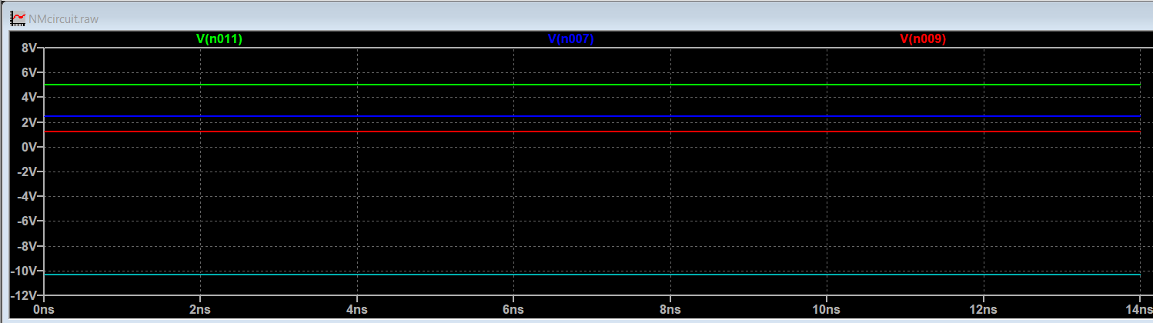

* + - 1. Green Probe (Vn011): Input Voltage = 5V
      2. Blue Probe(Vn007): Potentiometer Voltage = 2.49
      3. Red Probe(Vn009): Multiplier Output pin 7 = 1.257V
      4. Turquoise Probe (Vn021): Op-amp output = -10.298726V
  1. Scenario 2: Inputs 10101010 with weight at 50%
     1. Summary Tables:

|  |  |  |  |
| --- | --- | --- | --- |
| **Input** | **Weight** | **Potentiometer Output (V)** | **Multiplier Output Wi (V)** |
| Input1 = 1 (5V) | 0.5V | 5V*0.5V = 2.5V | (2.5V * 5V) / 10V = 1.25V |
| Input2 = 0 (0V) | 0.5V | 5V*0.5V = 2.5V | (2.5V * 0V) / 10V = 0V |
| Input3 = 1 (5V) | 0.5V | 5V*0.5V = 2.5V | (2.5V * 5V) / 10V = 1.25V |
| Input4 = 0 (0V) | 0.5V | 5V*0.5V = 2.5V | (2.5V * 0V) / 10V = 0V |
| Input5 = 1 (5V) | 0.5V | 5V*0.5V = 2.5V | (2.5V * 5V) / 10V = 1.25V |
| Input6 = 0 (0V) | 0.5V | 5V*0.5V = 2.5V | (2.5V * 0V) / 10V = 0V |
| Input7 = 1 (5V) | 0.5V | 5V*0.5V = 2.5V | (2.5V * 5V) / 10V = 1.25V |
| Input8 = 0 (0V) | 0.5V | 5V*0.5V = 2.5V | (2.5V * 0V) / 10V = 0V |

|  |  |
| --- | --- |
| **Total Input Sum** | 5V |
| **Bias Potentiometer Voltage** | 2.5V |
| **Op-Amp Output (Vout)** | -7.5V |