Matrix Reasoning Task
User Manual
- Overview
Do you like solving visual puzzles? Do you like those visual puzzles to become progressively more difficult? If so, then you have arrived at the right cognitive measure! This is a matrix reasoning task, which is thought to measure fluid intelligence. Fluid intelligence is thought of as the ability to reason and think abstractly in a manner that does not depend on prior learning (cf. crystallized intelligence). The reason why matrix reasoning tasks are good measures of fluid intelligence are not entirely clear; however, it could be because successful performance requires cognitive segmentation – i.e., using selective attention to break down a complex item into simpler parts (e.g., Duncan et al., 2017). There are several proprietary matrix-reasoning tasks, including the Raven’s (Advanced) Progressive Matrices (Raven et al., 1998) and the Cattell Culture Fair Intelligence Test (Cattell, 1963). The present matrix-reasoning task is nonproprietary and has been developed using the Sandia Generated Matrix Tool (Matzen et al., 2010)

- Task Details

This task consists of 42 different puzzles (matrices). Each matrix has a piece missing in the lower-right corner. Participants must determine which of the presented options best completes the general pattern of the matrix. The matrices are designed to become progressively more difficult – i.e., the first items are easier than the final items. Although matrix reasoning tasks generally do not have strict time limits, this task has a maximum duration of 60 minutes. Figure 1 provides a sample matrix and possible response. Participants make their responses by clicking on which shape best completes the pattern. Once an answer is selected, it is considered final – i.e., you cannot go back and change your response later.

Figure 1: Sample matrix (top) and response options (bottom)

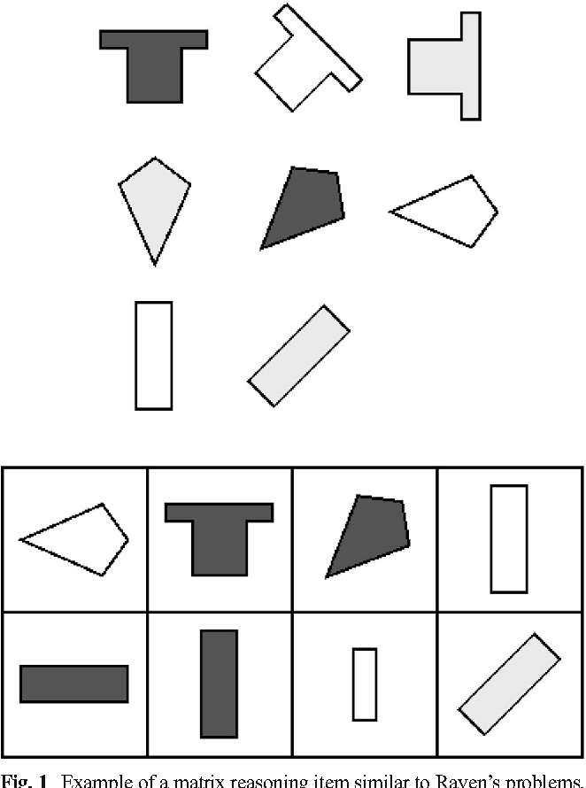

- Approximate Duration

There are 42 matrices in this assessment. Although the initial matrices might be solvable in just a few seconds, the later matrices are meant to be quite difficult. As such, it is likely that you will need at least 45 minutes to complete the task. However, as you complete the task, take note of the time, as the task will automatically end after 60 minutes.

- Important Variables

The important variable here is proportion (or number) correct, out of the total set of 42. One could also examine the relative speed with which an individual is able to successfully solve matrices; however, this would represent a nonstandard operationalization of performance.

- Validity and Reliability

There has been significant work on the validity and reliability of matrix reasoning tasks (e.g., Raven et al., 1998). These specific matrices have been normed against the Raven’s Standard Progressive Matrices (Matzen et al., 2010), and the correlation of the tests was robust (r =.63 / r = .93 for attenuation-corrected scores; Figure 2). The Cronbach’s alpha (measuring reliability) for the Sandia matrices was .76. For reference, the Raven’s Standard Progressive Matrices had a Cronbach’s alpha of .73. As such, the Sandia matrix reasoning assessment has good reliability and convergent validity.

Figure 2: Scatterplot of Sandia matrix problems and Raven’s Standard Progressive Matrices (taken from Matzen et al., 2010).

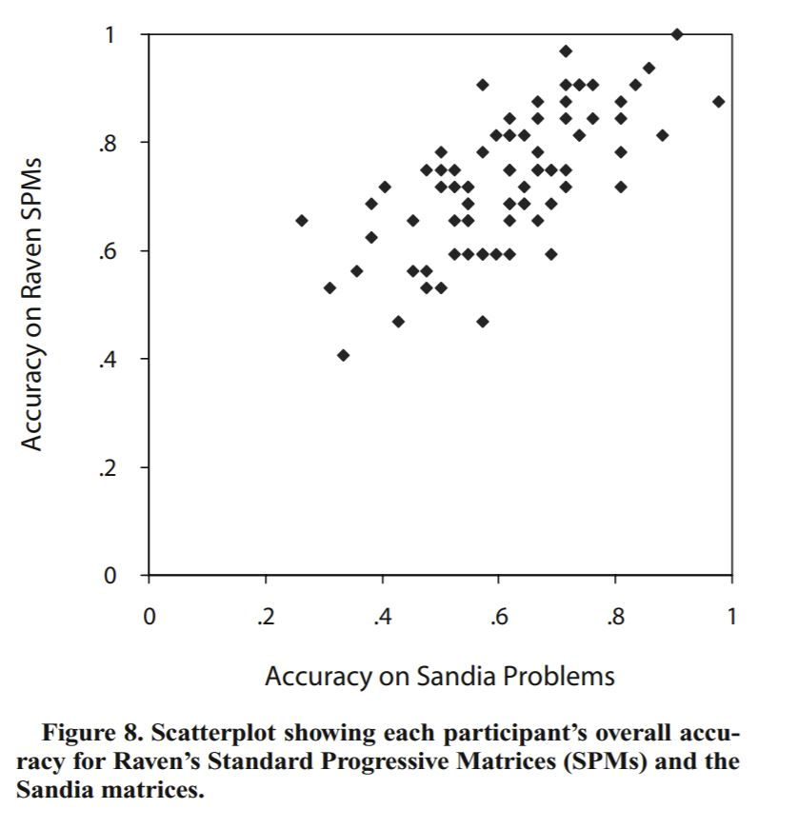

- References

Cattell, R. B. (1963). Theory of fluid and crystallized intelligence: A critical experiment. Journal of Educational Psychology, 54(1), 1–22. https://doi.org/10.1037/h0046743

Duncan, J. Chylinski, D. Mitchell, D.J., & Bhandari, A. (2017). Fluid intelligence and cognitive segmentation. Proceedings of the National Academy of Sciences, 114(20), 5295-5299. https://doi.org/10.1073/pnas.1621147114

Matzen, L.E., Benz, Z.O., Dixon, K.R., Posey, J., Kroger, J.K., & Speed, A.E. (2010). Recreating Raven’s: Software for systematically generating large numbers of Raven-like matrix problems with normed properties. Behavior Research Methods, 42, 525–541. https://doi.org/10.3758/BRM.42.2.525

Raven, J., Raven, J. C., Court, J. H. (1998). Manual for Raven's progressive matrices and vocabulary scales, Section 1: General overview. Oxford, UK: Oxford Psychologists Press: San Antonio, TX: The Psychological Corporation.

