**Overview**

My research focuses on fundamental questions in the domain of learning and memory on the one hand, and in the domain of pattern understanding on the other. The way in which I integrate these two areas of research is through the study of auditory perceptual expertise – specifically, how it develops and is how it is maintained by the environment.

While I have developed several approaches to understanding auditory perceptual expertise, using both behavioral and neuroscientific methodologies, a central theme that has emerged from my research is that there are often entrenched assumptions that can be profitably tested and modified, depending on research findings. Reexamining these entrenched assumptions can lead to new insights in understanding how humans perceive, learn, and remember information more broadly.

**Absolute Pitch as a Model System**

One of the most salient (and puzzling) phenomena within the realm of auditory expertise – which represents a significant focus of my research program – is that of absolute pitch (AP). AP, also known as “perfect pitch,” is defined as the ability to accurately categorize any musical note without hesitation. AP is an excellent model system for understanding the foundations of perceptual expertise for at least three reasons. First, AP is thought to develop during a critical period, after which successful acquisition should not be possible. Second, AP is thought to be highly stable and relatively insensitive to variability in the listening environment. Third, AP is treated as a clearly-defined, dichotomous ability, suggesting that there are no gradations of AP (i.e., one either clearly possesses the ability or they do not).

My research has reexamined these assumptions and shown that they are unlikely to be true, at least in their strongest forms. Below, I briefly summarize how my work has challenged these tenets and furthered our understanding of perceptual and cognitive processing more generally.

**1. AP can be acquired in adulthood**

My research has demonstrated that AP acquisition in adulthood is possible, at least for some individuals with exceptional auditory memory abilities. In a study published in *Cognition*, my co-authors and I demonstrated that AP could be trained, to an extent, in an adult population, and moreover individual differences in learning were predicted by auditory working memory (see Fig.1).

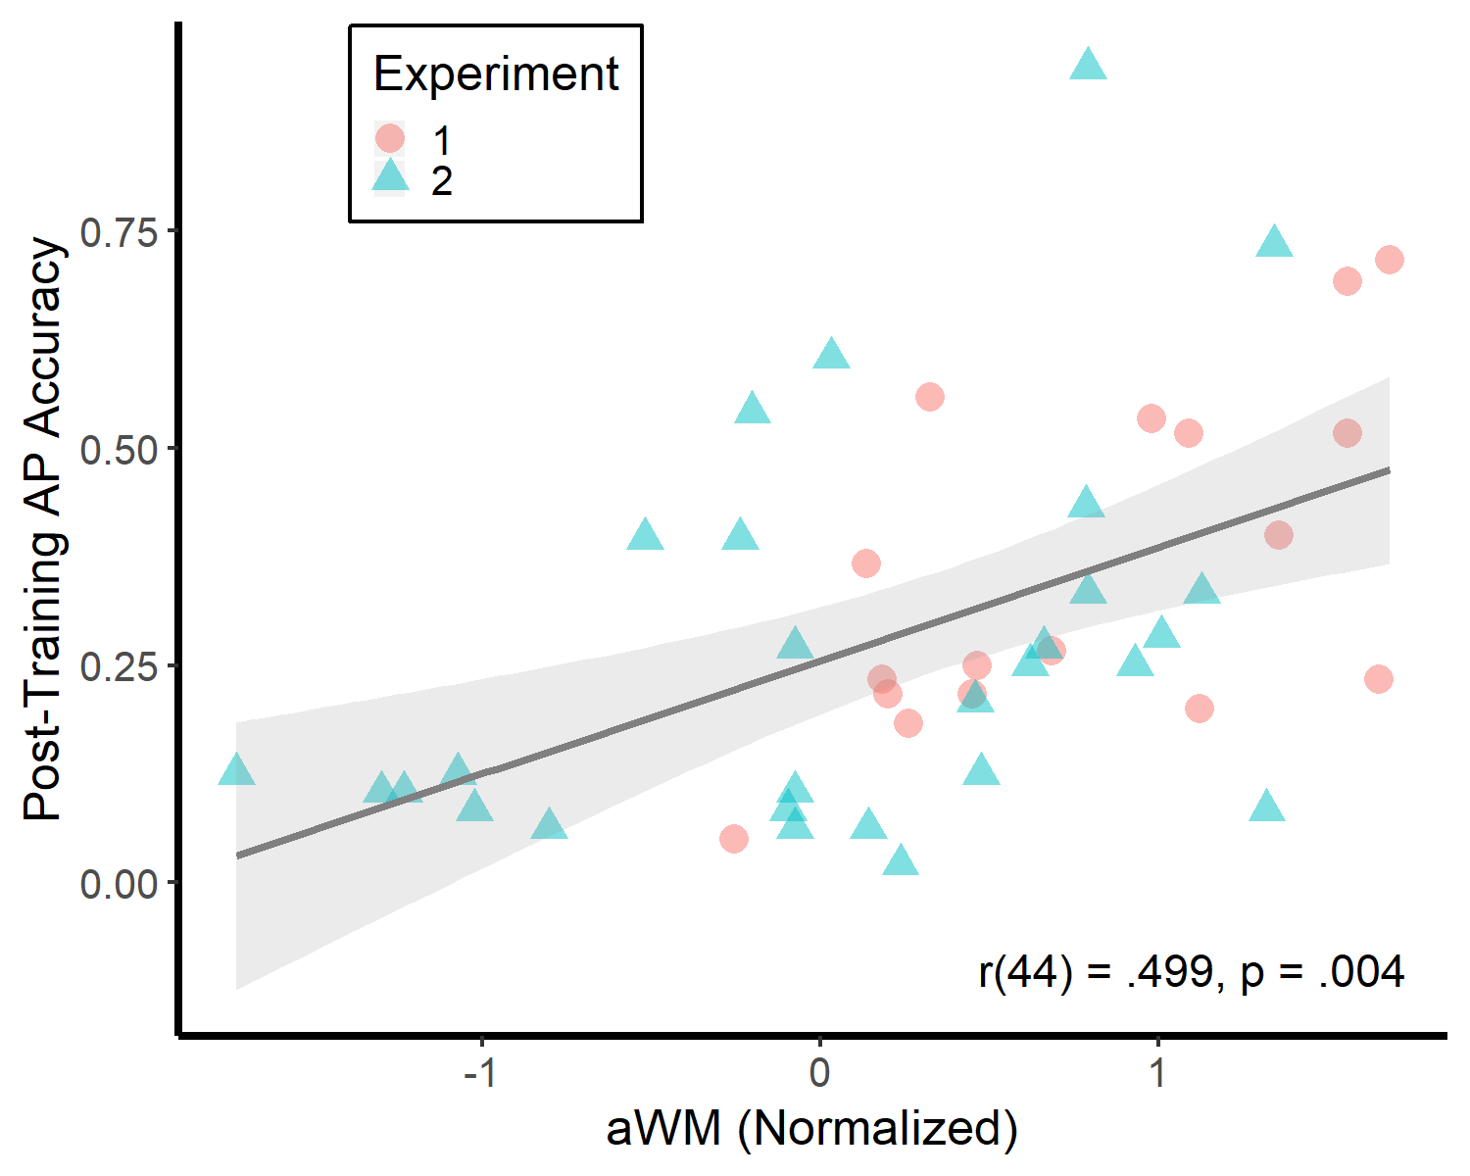

**Fig.1**: Data adapted from Van Hedger et al. (2015) demonstrates that auditory working memory – using a pitch reproduction task in Experiment 1 and an auditory n-back task in Experiment 2 – significantly relates to individual differences in absolute pitch learning.

We have extended this work in a paper that is currently under review and available as a preprint on *bioRxiv*. Using a long-term (eight-week) training paradigm, we demonstrate that some high-working-memory individuals are able to perform with sufficient speed and accuracy so as to be statistically indistinguishable from “genuine” AP possessors. Interestingly, however, the successful learners in this work could be differentiated from the other participants even *before* training had commenced, even if they were not performing with sufficient speed and accuracy to be considered AP possessors (see Fig.2). This pattern of results thus suggests that AP may be learnable by only some post-critical period adults. Identifying more of these individuals may help advance our understanding of environmental and genetic components to absolute pitch acquisition. Taken together, these findings help situate AP in a larger body of research on how cognitive abilities such as working memory relate to perceptual category learning.

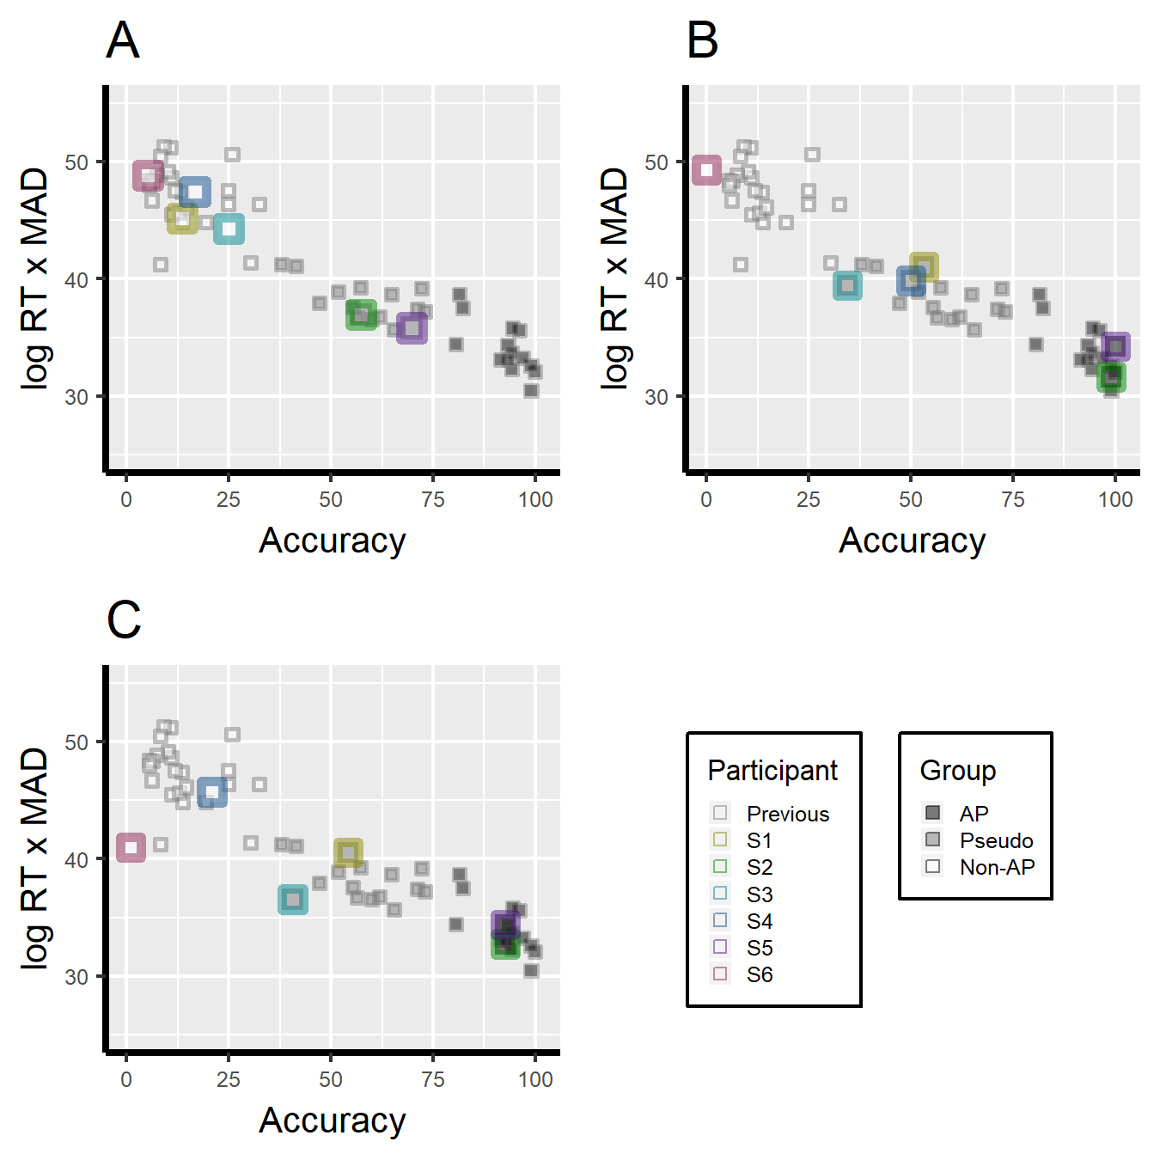

**Fig.2:** Depiction of six participants who completed an eight-week AP training program. Accuracy (percent of notes correctly identified) is represented on the x-axis, while a composite measure that incorporates response time and the mean absolute deviation from the correct note is represented on the y-axis. Prior to training (A), Participants S2 and S5 displayed note classification performance that could be considered “pseudo AP” (below typical thresholds for AP but clearly above chance). Immediately after the eight-week training program (B), Participants S2 and S5 were virtually perfect in classifying notes across several octaves and instrumental timbres and were statistically indistinguishable from a group of “genuine” AP possessors. This level of performance persisted four months post-training (C).

**2. AP categories flexibly accommodate the listening environment**

Once established, AP categories are thought to represent fixed frequency-to-note mappings (e.g., where 440 Hz is unequivocally labeled as an in-tune “A”). Yet, my research has demonstrated that AP categories are not fixed; rather, this illusion of fixedness arises from the strict tuning standards of our listening environment. In a study published in *Psychological Science*, AP possessors judged whether notes were “in-tune” or “out-of-tune” before and after listening to a symphony. Unknown to the participants, the symphony was slowly de-tuned until it was “flat” relative to canonical tuning. After listening to this flattened symphony, participants’ intonation ratings adapted to this new intonation, as they judged isolated flat notes as significantly more “in-tune” (see Fig.3). This pattern of results suggests that associating specific frequencies with note names is a flexible process that can accommodate recent listening experiences.

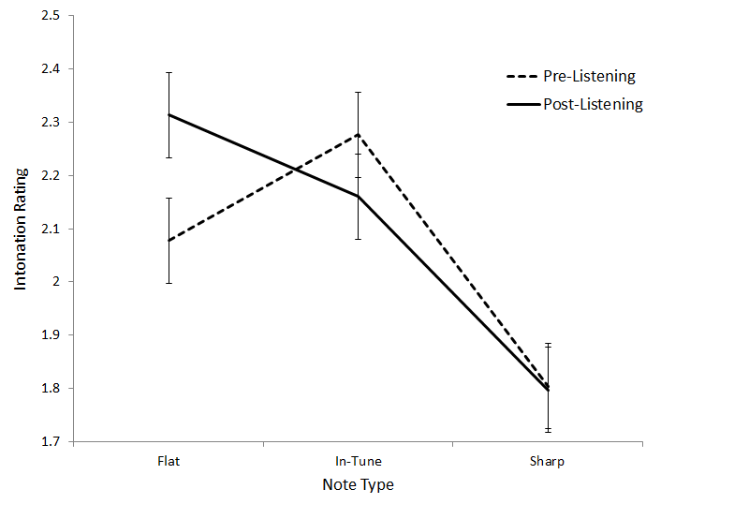

**Fig.3:** When AP participants were asked to judge the intonation of isolated notes (solid line), they rated in-tune notes higher than flat and sharp notes – a pattern that is expected among AP possessors and one that supports the idea of fixed frequency-to-note mappings. Yet, after listening to a slightly flattened symphony (dashed line), participants rated flat notes as significantly more in tune.

My co-authors and I have since extended these findings in a series of studies published in the *Journal of Experimental Psychology: Human Perception and Performance*. In this work, we found consistent evidence that hearing flat melodies shifts subsequent intonation judgments in the sharp direction, and hearing sharp melodies shifts subsequent intonation judgments in the flat direction. This tuning context effect, in maximally contrastive cases (e.g., hearing a flat melody followed by a sharp note) can make an AP possessor over ten times more likely to mislabel a note (e.g., to mislabel a B as a C), which should not be possible if absolute pitch representations are fixed (see Fig.4). Taken together, this research has supported conceptualizing AP as a skill that can flexibly accommodate variable listening environments. It also situates AP in a larger body of research on how preceding context can influence perception.

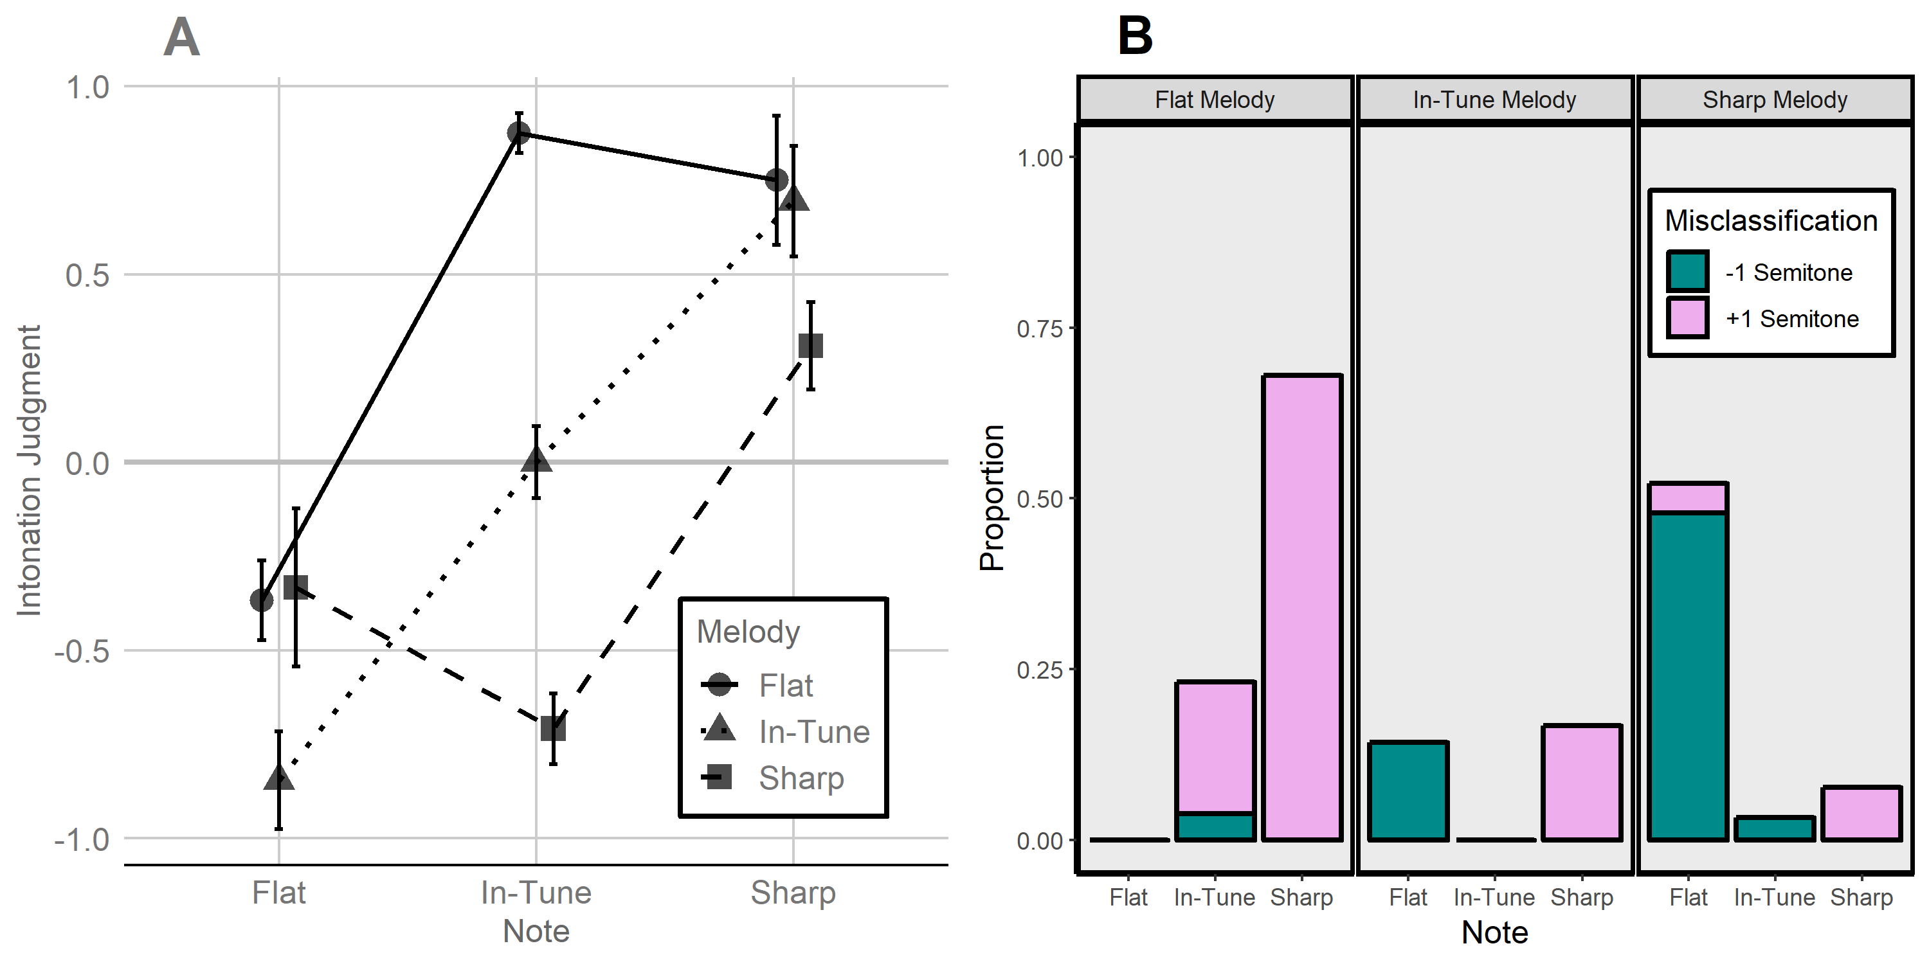

**Fig.4**: Intonation judgments and note (mis)classifications are strongly influenced by the listening environment. For intonation judgments (A), where 0 corresponds to an 'in-tune' rating, negative values correspond to a flat rating, and positive values correspond to a sharp rating, when a short context melody is in tune (dotted line), participants label a following isolated note according to its absolute intonation (i.e., a flat note is heard as flat, and in-tune note is heard as in tune, and a sharp note is heard as sharp). If the preceding melody was flat (solid line), intonation judgments are pushed in the sharp direction. If the preceding melody was sharp (dashed line), intonation judgments are pushed in the flat direction. In maximally contrastive situations (when a flat melody is followed by a sharp note or a sharp melody is followed by a flat note), this context effect is sufficiently strong to make listeners mislabel the note (B).

**3. AP is a continuously distributed ability**

Despite nearly a century of research, the distributional nature of AP is still actively debated. At the heart of this debate is the question of whether AP should be conceptualized as a dichotomous ability, with clearly defined “AP” and “non-AP” populations, or whether AP should be conceptualized as a more continuously distributed ability in the population.

My research in this area has supported the view that AP exists along a continuum. In one study, published in *Acta Psychologica*, self-identified AP possessors completed a typical AP assessment (labeling isolated piano and guitar notes) and performed essentially at ceiling (i.e., 100% accuracy). Yet, these same individuals displayed a more normal distribution of performance when labeling notes that posed a perceptual challenge (e.g., sine waves), with performance on these challenging notes relating to musical expertise, auditory working memory, and tonal language background. This work suggests that AP may appear homogeneous because of how it is typically tested and operationalized, not because it is a uniform ability. Expanding our testing procedures thus may give researchers a clearer sense of how AP ability is distributed in the population.

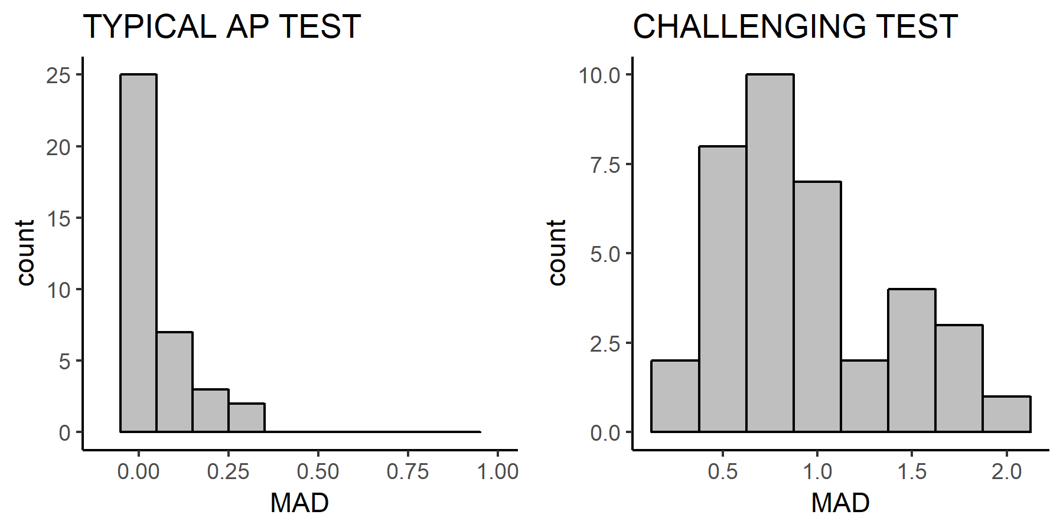

Fig.5: When self-identified AP possessors were tested on a typical AP test (left), consisting of piano and guitar notes in a comfortable and restricted octave range, mean absolute deviation (MAD) from the correct note was essentially zero. When tested on more challenging notes, such as sine tones, performance became more normally distributed. This suggests that there may be important variability in AP ability that is insensitive to typical AP assessments, which may be too simple.

In a second study, currently under review, 192 individuals who were not specifically recruited for their AP abilities completed an online AP assessment. In this sample, we found clear evidence that AP is *not* an “all-or-nothing” ability. Roughly one-third of the individuals who completed the AP assessment performed statistically above chance, but below typical thresholds used to denote “genuine” AP ability. The second and perhaps more important claim from this study is that these intermediate AP performers can be conceptualized as part of the same continuum as near-perfect (“genuine”) AP possessors. Not only did the intermediate AP performers report a similar age of beginning musical instruction and similar proportions of tonal language experience, but their performance profiles were also strikingly similar to the highest, “genuine” AP group (e.g., displaying worse performance on black key notes).

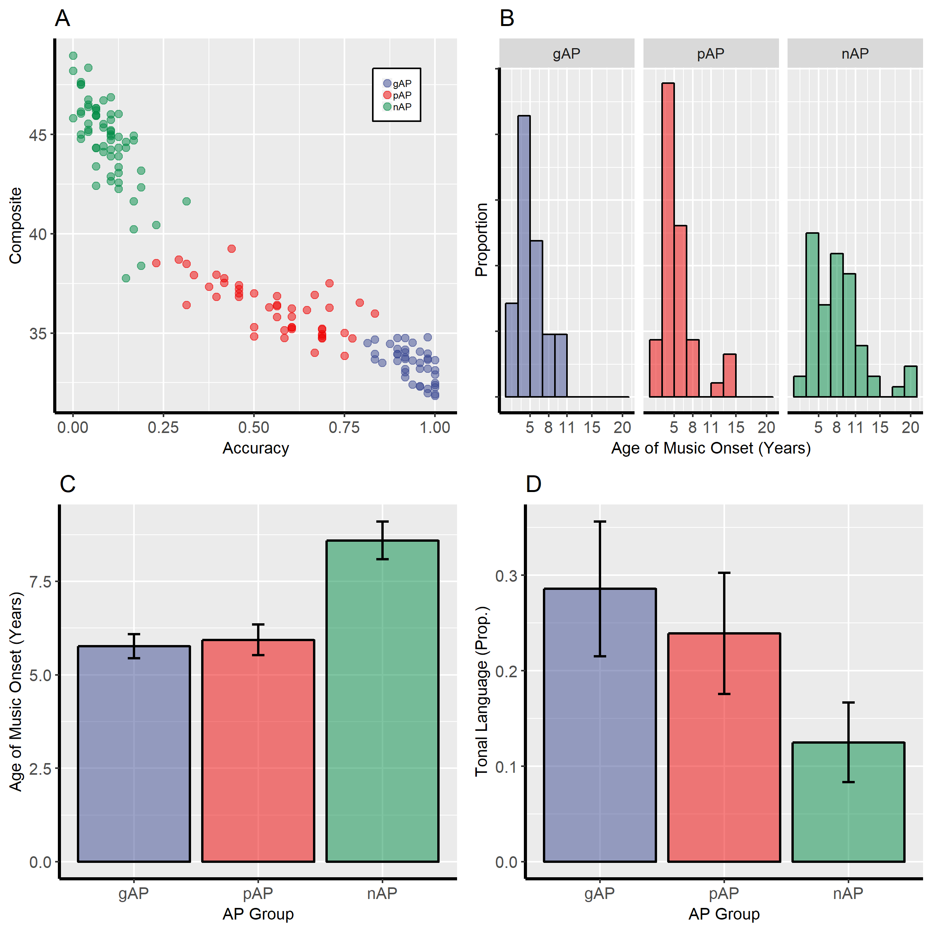

**Fig.6**: Scatterplot of AP performance across all participants demonstrates that performance is clearly continuous rather than dichotomous (A). Mean accuracy is represented on the x-axis and a composite score incorporating mean absolute deviation (MAD) and log response time (logRT) is represented on the y-axis (A). Histograms of the age at which individuals began musical instruction (B) and averaged ages for each participant group (C) show that the individuals performing at chance (nAP group) reported a significantly later age of music onset compared to both the highest, “genuine” (gAP) and intermediate, “pseudo” (pAP) groups. Mean proportions of reported tonal language experience (D) followed a similar pattern.

The viewpoint that AP is a continuously distributed ability starkly deviates from prior theoretic treatments of intermediate AP abilities. Specifically, intermediate AP has been dismissed as “pseudo AP” and has been *assumed* to reflect a different phenomenon than genuine AP, likely because such a position is mandated by a dichotomous treatment of AP. By challenging this position, my research suggests that virtually every prior study of AP has been too restrictive (e.g., by excluding individuals who do not perform above an arbitrary, high-performance threshold). Expanding the operationalization of AP to include these intermediate performers will undoubtedly lead to new insights into AP and auditory learning and memory more broadly.