**C Sc 335 Analysis and Design Artifacts for Final Project**

*Each team member completes this form SOLO, renames it with their last name, places it into the Eclipse project, then pushes the project to Github*

**1. Team Name:**  __MiddletonVanHoesen_____

**3. Team Members**: __Steffan Van Hoesen__ __Anthony Middleton___

___________________________

**4. Candidate Objects or Class Hierarchies**

List the most important objects, or an inheritance hierarchy name, and the single responsibility of each.

|  |  |
| --- | --- |
| **Candidate Object** | **Single Responsibility in 1 or 2 sentences** |
| Jukebox | Allows for setting the Student, playing the song, adding songs to the queue, implements a listener for when a song end. |
| MusicPlayer | Play the song stored in filename in a new thread after listener waits for the song to end. |
| Song | Keeps track of title, artist, file name, duration time, and how many times the song has been played. |
| Student | Keeps track of the students id, password, and songs that student chose today. |
| CardReader | Keeps track of students info and provide validation to JukeBox. |
| SongCollection | Keeps track of the list of songs. |
| Playlist | Stores songs that user chose and provide song info to JukeBox. |
| MainGUI | Coordinates activities, this is the player, has controllers, does layout |
| SongPlayer | |  | | --- | | Allows for the audio file to be played through the output device. | |
|  |  |

**5. Sequence Diagram 1:** Your team UML Sequence Diagram should show the most important scenario you can think of. Your sequence diagram should show most of your objects from above and how they communicate with each other.

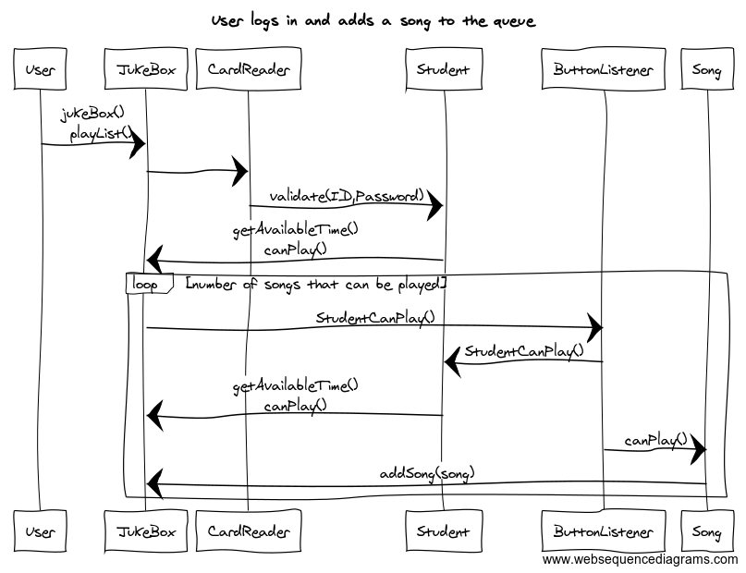

**6. Sequence Diagram 2:** Your team UML Sequence Diagram should show the seconf most important scenario you can think of. Your sequence diagram should show most of your objects from above and how they communicate with each other.

