**C Sc 335 Analysis and Design Artifacts for Final Project**

*Each team member completes this form SOLO, renames it with their last name, places it into the Eclipse project, then pushes the project to Github*

**1. Team Name:**  MiddletonVanHoesen

**3. Team Members**: _ Anthony Middleton Steffan Van Hoesen

**4. Candidate Objects or Class Hierarchies**

List the most important objects, or an inheritance hierarchy name, and the single responsibility of each.

|  |  |
| --- | --- |
| **Candidate Object** | **Single Responsibility in 1 or 2 sentences** |
| Jukebox | The student center. The place where the students come to play music |
| students | The user that play a song |
| card reader | The user will swipe a magnetic ID card to play a song |
| song collection | The list of song that can be played |
| song | the selected song to be play for the student |
| day | A song can be selected more than three times a day. |
|  |  |
|  |  |
|  |  |
|  |  |

**5. Sequence Diagram 1:**  Your team UML Sequence Diagram should show the most important scenario you can think of. Your sequence diagram should show most of your objects from above and how they communicate with each other.

*This Sequence Diagram must be created with the sequence diagram editor* [https://www.websequencediagrams.com/#](https://www.websequencediagrams.com/)

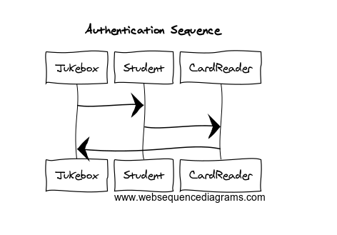

**6. Sequence Diagram 2:**  Your team UML Sequence Diagram should show the second most important scenario you can think of. Your sequence diagram should show most of your objects from above and how they communicate with each other.

*This Sequence Diagram must be created with the sequence diagram editor* [https://www.websequencediagrams.com/#](https://www.websequencediagrams.com/)

