Variable setup and documentation checklist:
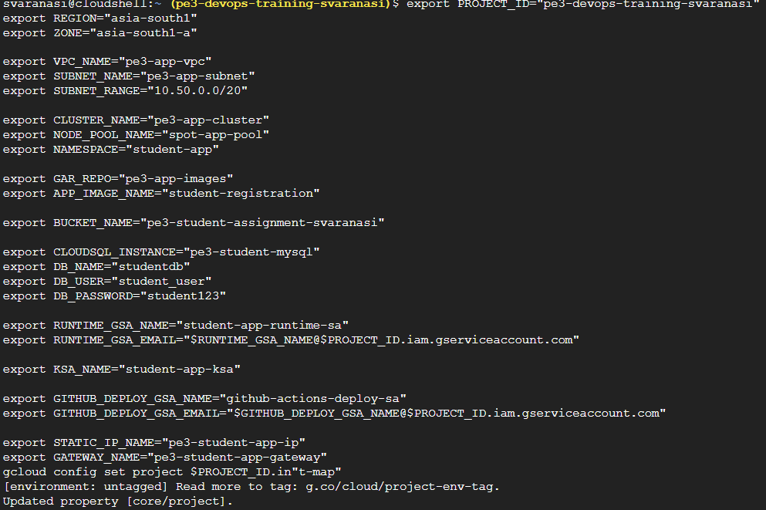
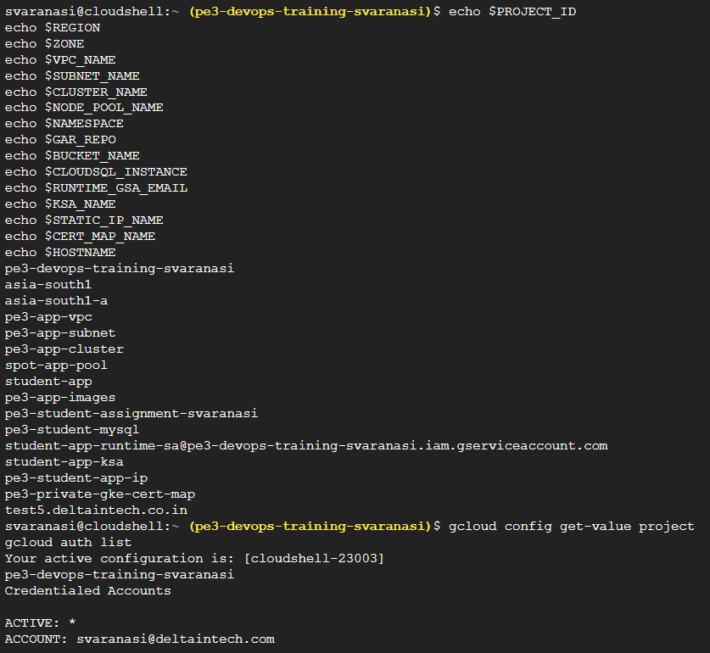

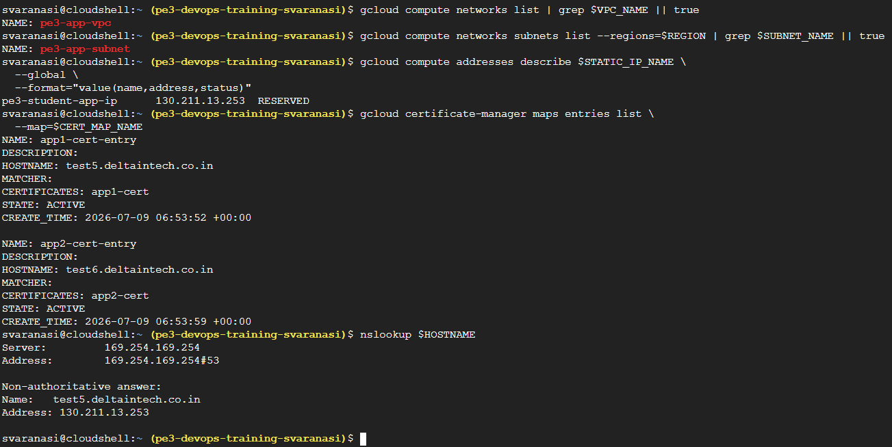
Existing reusable resources were verified before starting the new deployment:
- pe3-app-vpc
- pe3-app-subnet
- pe3-student-app-ip is reserved with IP 130.211.13.253
- pe3-private-gke-cert-map has active certificate entries
- test5.deltaintech.co.in resolves to 130.211.13.253
Artifact Registry repository:
Repository name: pe3-app-images
Location: asia-south1
Format: Docker
Purpose: Store student-registration application images
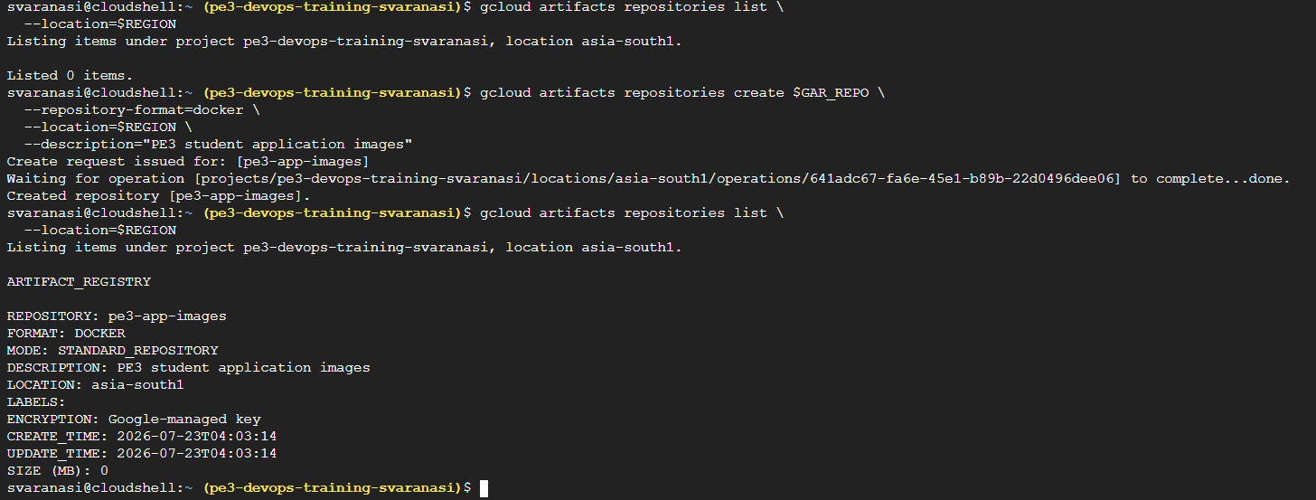
Configure Docker Setup:
gcloud auth configure-docker asia-south1-docker.pkg.dev
Artifact Registry
Created Artifact Registry Docker repository named pe3-app-images in asia-south1.
This repository will store the student-registration container image.
Docker authentication was configured for asia-south1-docker.pkg.dev so Cloud Shell and later GitHub Actions can push images to Artifact Registry.
Create GKE Cluster and Spot Node Pool:
GKE cluster: pe3-app-cluster
Temporary default node pool: 1 node
Spot node pool: spot-app-pool
Namespace: student-app
Gateway API: enabled
Workload Identity: enabled
VPC: pe3-app-vpc
Subnet: pe3-app-subnet

GKE Standard zonal cluster in asia-south1-a, VPC-native networking, Gateway API enabled, Workload Identity Federation enabled, and a separate Spot node pool with one Spot VM.
gcloud container clusters create $CLUSTER_NAME \
--zone=$ZONE \
--num-nodes=1 \
--machine-type=e2-small \
--disk-size=20 \
--disk-type=pd-balanced \
--release-channel=regular \
--enable-ip-alias \
--network=$VPC_NAME \
--subnetwork=$SUBNET_NAME \
--workload-pool=$PROJECT_ID.svc.id.goog \
--gateway-api=standard

VPC-native networking
Workload Identity enabled
Gateway API enabled
Temporary default node pool
Connect kubectl:
gcloud container clusters get-credentials $CLUSTER_NAME \
--zone=$ZONE \
--project=$PROJECT_ID

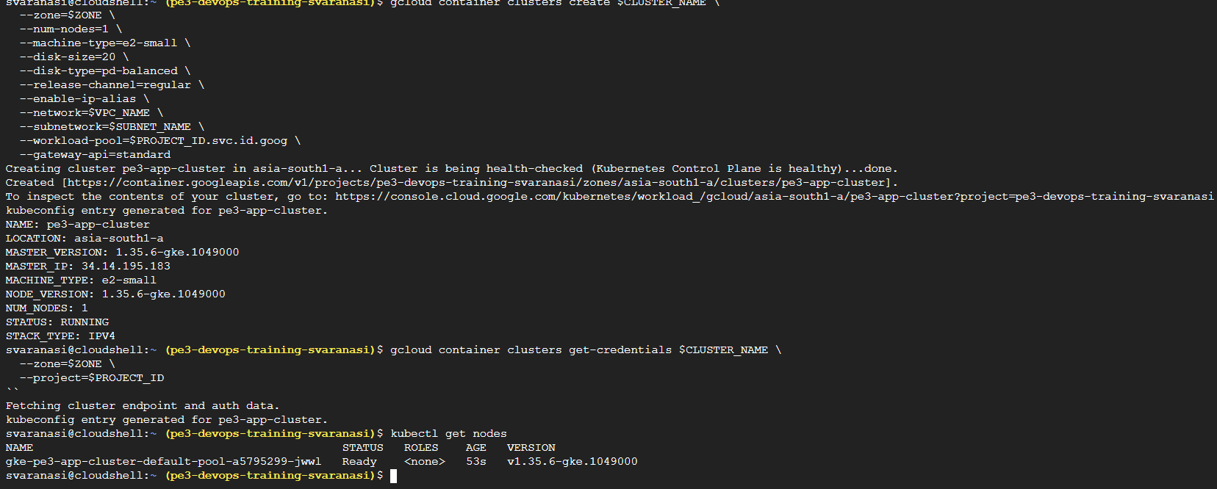
Verify Workload Identity
Verify Gateway API classes
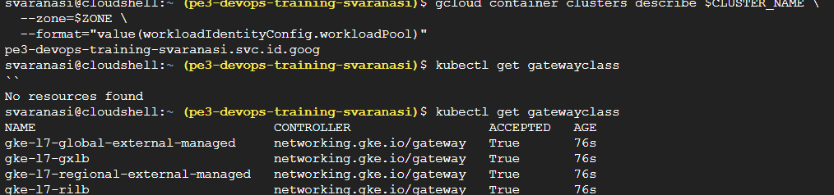

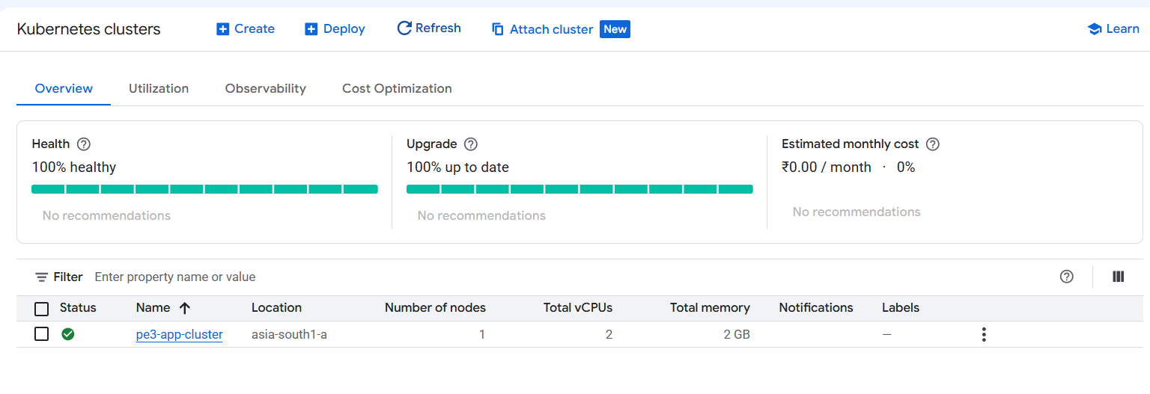
Create the Spot Node pool:
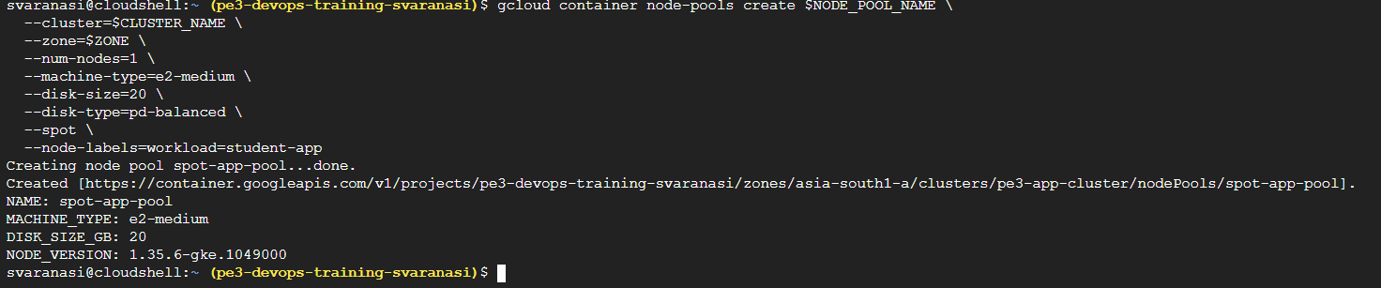

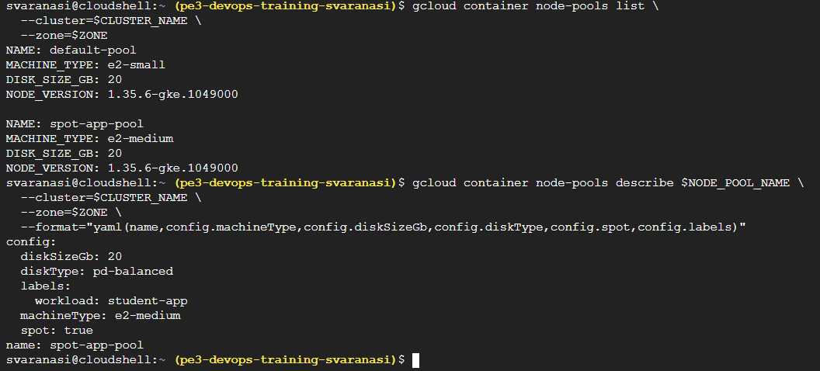

Create the name-space:
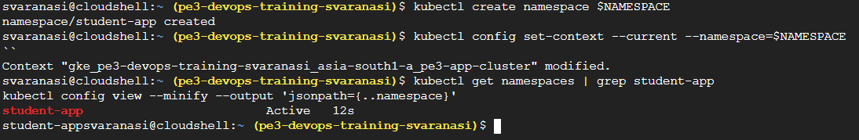

GKE Cluster and Spot Node Pool:
Created GKE Standard cluster pe3-app-cluster in asia-south1-a using custom VPC pe3-app-vpc and subnet pe3-app-subnet.
Workload Identity Federation for GKE is enabled.
Gateway API is enabled and gke-l7-global-external-managed GatewayClass is available.
Created Spot node pool spot-app-pool with one e2-medium Spot node, 20 GB balanced disk, and node label workload=student-app.
Created namespace student-app and set it as the current namespace.

Cloud Storage and Cloud SQL Setup:

Cloud Storage bucket: pe3-student-assignment-svaranasi
Cloud SQL instance: pe3-student-mysql
Database: studentdb
DB user: student_user
DB password: student123
Cloud SQL connection name: PROJECT_ID:REGION:INSTANCE_NAME

Create a storage bucket and enable public access prevention:
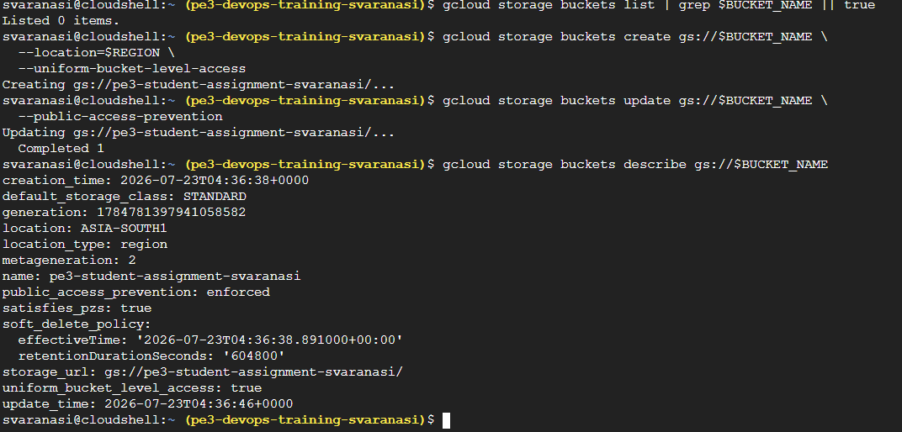

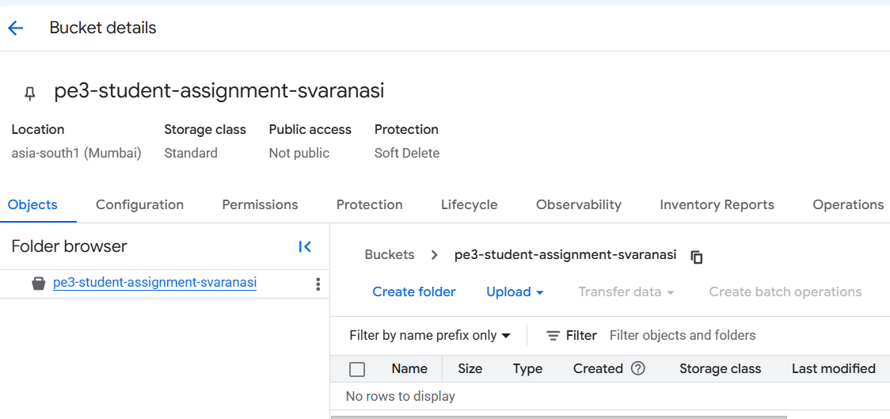
Verify the bucket by adding the test file:
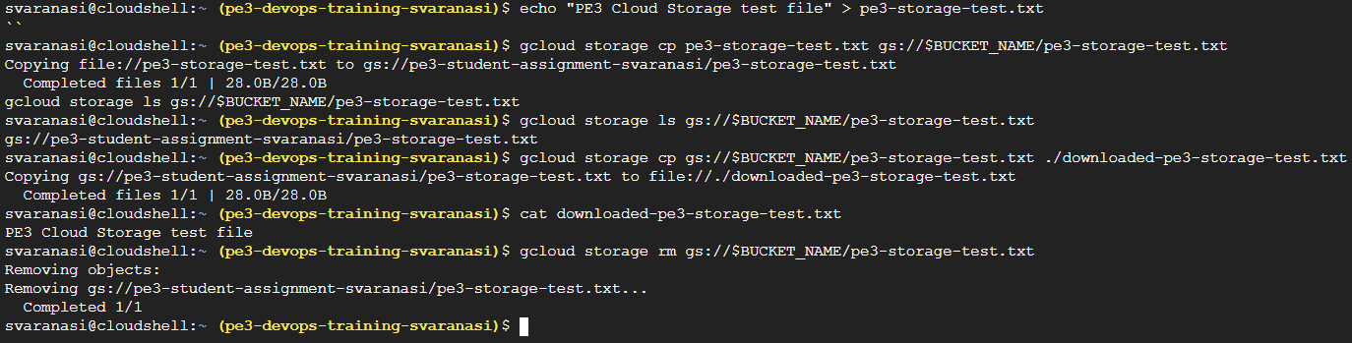

Now, we create a CLOUD SQL:
Cloud SQL instance pe3-student-mysql was created in asia-south1 using MySQL 8.0 and a low-cost development tier.

gcloud sql instances create $CLOUDSQL_INSTANCE \
--database-version=MYSQL_8_0 \
--tier=db-f1-micro \
--region=$REGION \
--storage-size=10GB \
--storage-type=SSD \
--availability-type=zonal

Then Record instance connection name:

export INSTANCE_CONNECTION_NAME=$(gcloud sql instances describe $CLOUDSQL_INSTANCE \
--format="value(connectionName)")

echo $INSTANCE_CONNECTION_NAME

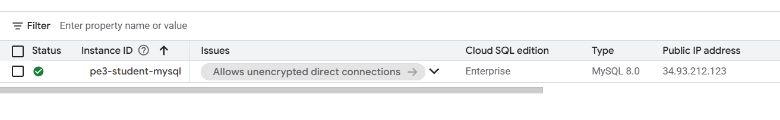
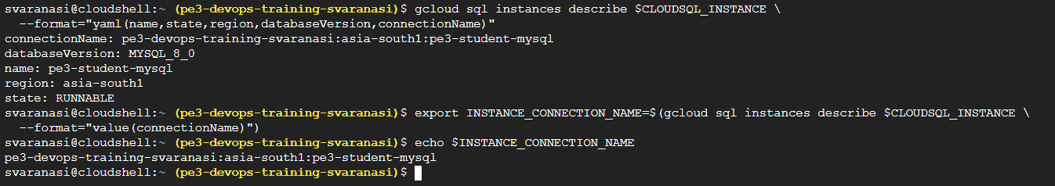

Create database

gcloud sql databases create $DB_NAME \
--instance=$CLOUDSQL_INSTANCE

From <https://www.microsoft365.com/hwav2/chat/conversation/ce634f28-317d-44df-b991-fdfc467771fc?version=19.2605.59121.0&capabilities=interopPromise%2CsuspendOnClose%2CautoStart&client-request-id=a786934b-f2b9-2f4c-9c16-d374a2c42eaf&fromCode=cmm6j3rjue2&appstate=suspended&SSRDesktopTest=2>

Create DB user
gcloud sql users create $DB_USER \
--instance=$CLOUDSQL_INSTANCE \
--password=$DB_PASSWORD

Verify database and user
gcloud sql databases list --instance=$CLOUDSQL_INSTANCE
gcloud sql users list --instance=$CLOUDSQL_INSTANCE

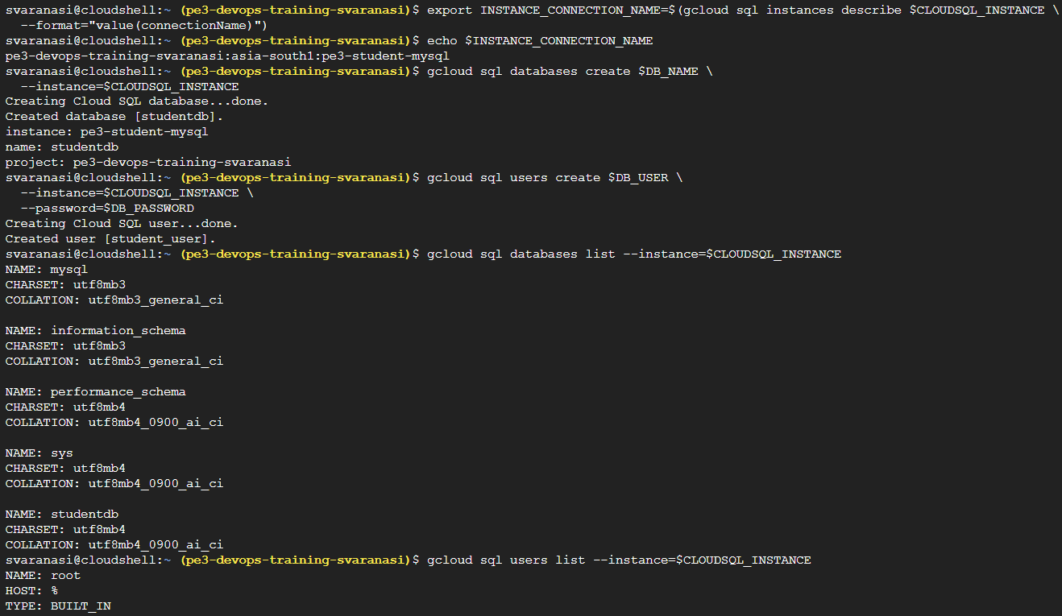

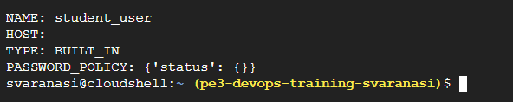

Configure Runtime Workload Identity:
This will allow
student-app Pod
↓
Kubernetes ServiceAccount: student-app-ksa
↓
Workload Identity
↓
Google Service Account: student-app-runtime-sa
↓
Access GCS bucket
↓
Allow Cloud SQL Auth Proxy to connect to Cloud SQL

Create runtime Google Service Account:
gcloud iam service-accounts create $RUNTIME_GSA_NAME \
--display-name="Student application runtime"

Grant bucket access to runtime GSA:
The app needs access to upload and read assignment files in the bucket.

gcloud storage buckets add-iam-policy-binding gs://$BUCKET_NAME \
--member="serviceAccount:$RUNTIME_GSA_EMAIL" \
--role="roles/storage.objectUser"

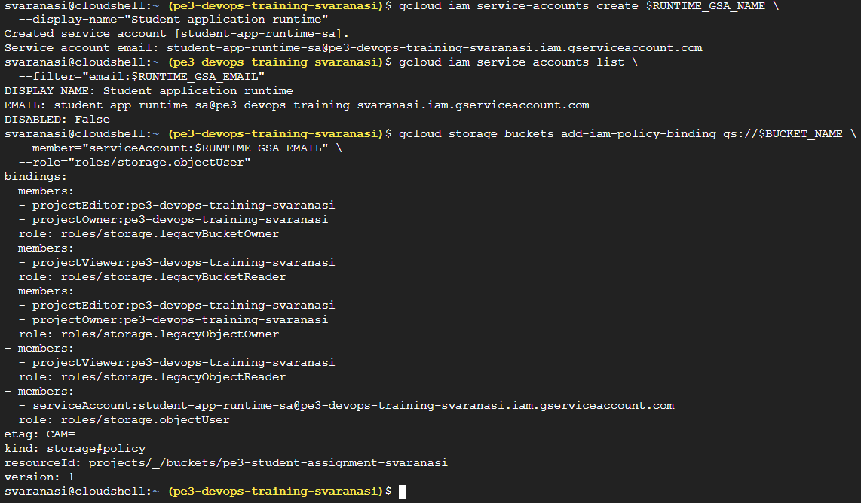

Cloud SQL Client role check:

gcloud projects get-iam-policy $PROJECT_ID \
--flatten="bindings[].members" \
--filter="bindings.role=roles/cloudsql.client AND bindings.members:$RUNTIME_GSA_EMAIL" \
--format="table(bindings.role, bindings.members)"

This should be added by admin and done
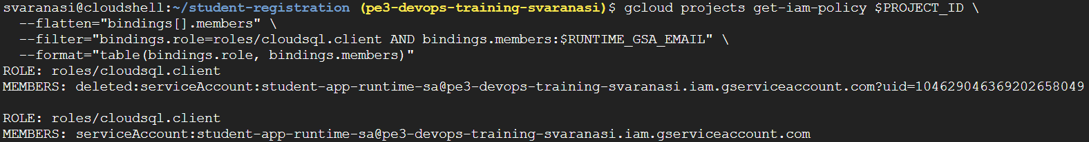

Create Kubernetes ServiceAccount:
kubectl create serviceaccount $KSA_NAME \
-n $NAMESPACE

kubectl get serviceaccount -n $NAMESPACE

Add Workload Identity binding:
gcloud iam service-accounts add-iam-policy-binding $RUNTIME_GSA_EMAIL \
--role="roles/iam.workloadIdentityUser" \
--member="serviceAccount:$PROJECT_ID.svc.id.goog[$NAMESPACE/$KSA_NAME]"

Annotate Kubernetes ServiceAccount:
kubectl annotate serviceaccount $KSA_NAME \
-n $NAMESPACE \
iam.gke.io/gcp-service-account=$RUNTIME_GSA_EMAIL \
--overwrite
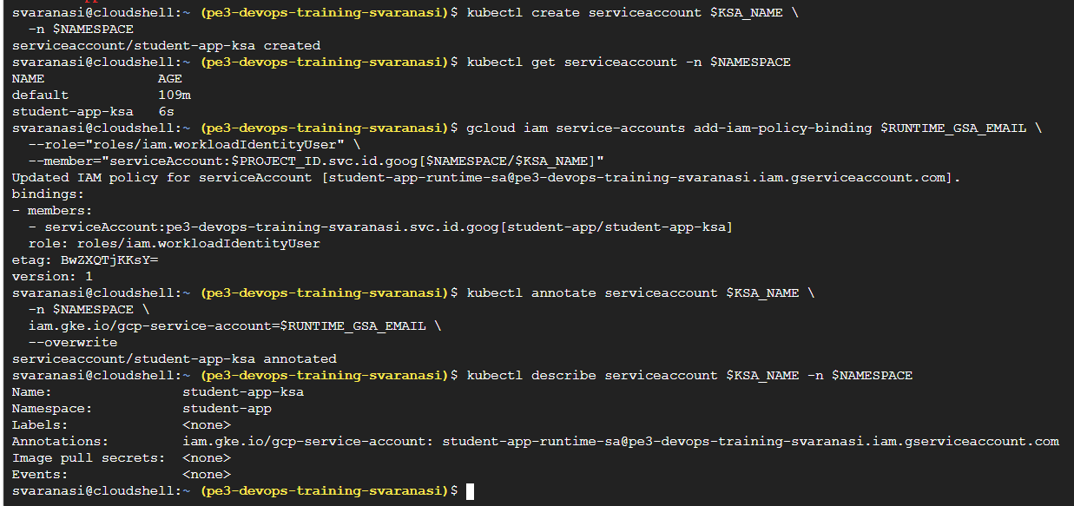

Create App Structure and Files:

student-registration/
├── Dockerfile
├── package.json
├── server.js
├── .dockerignore
├── public/
│ └── index.html
├── k8s/
│ ├── namespace.yaml
│ ├── service-account.yaml
│ ├── app-deployment.yaml
│ ├── app-service.yaml
│ ├── gateway.yaml
│ └── route.yaml
└── .github/
└── workflows/

cd ~

rm -rf student-registration

mkdir -p student-registration/public
mkdir -p student-registration/k8s
mkdir -p student-registration/.github/workflows

cd student-registration

Create package.json
Create frontend file
Create backend server.js
This version is designed for Cloud SQL Auth Proxy sidecar.

App connects to 127.0.0.1:3306
Cloud SQL Auth Proxy sidecar connects to Cloud SQL

Create Dockerfile

Create Kubernetes Manifests
namespace.yaml
service-account.yaml
app-service.yaml
This is ClusterIP, because Gateway/HTTPRoute will expose the app.

app-deployment.yaml
This contains:

Application container
Cloud SQL Auth Proxy sidecar
serviceAccountName: student-app-ksa
nodeSelector: workload=student-app
DB_HOST=127.0.0.1
DB_PORT=3306

gateway.yaml

GatewayClass: gke-l7-global-external-managed
Static IP: pe3-student-app-ip
Certificate map: pe3-private-gke-cert-map
Hostname: test5.deltaintech.co.in

GKE Gateway supports Certificate Manager via the networking.gke.io/certmap annotation, and the Gateway should not also use TLS certificateRefs when a certificate map is referenced.

route.yaml

NOW:
Create DB secret
We will not create a YAML file for the secret with password.

kubectl create secret generic student-app-secret \
-n ${NAMESPACE} \
--from-literal=DB_USER="${DB_USER}" \
--from-literal=DB_PASSWORD="${DB_PASSWORD}" \
--from-literal=DB_NAME="${DB_NAME}" \
--from-literal=BUCKET_NAME="${BUCKET_NAME}" \
--dry-run=client -o yaml | kubectl apply -f -

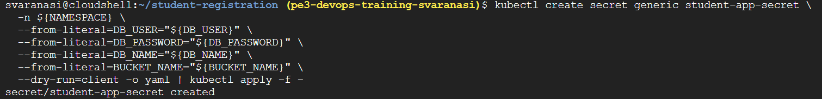

Build and Push Image:

Build Docker image:
docker build -t $IMAGE_URI .

Push image to Artifact Registry:
docker push $IMAGE_URI

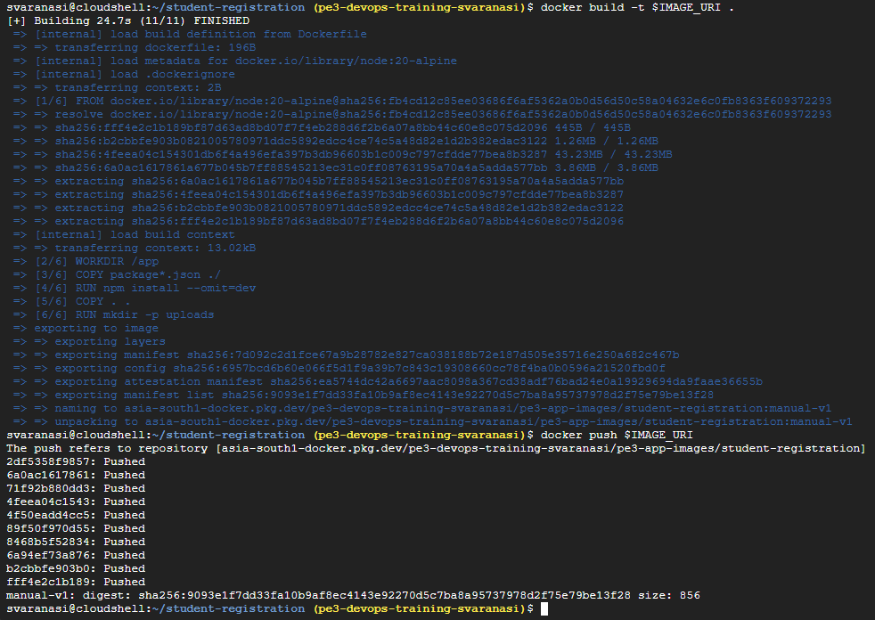

Check in Artifact Registry:
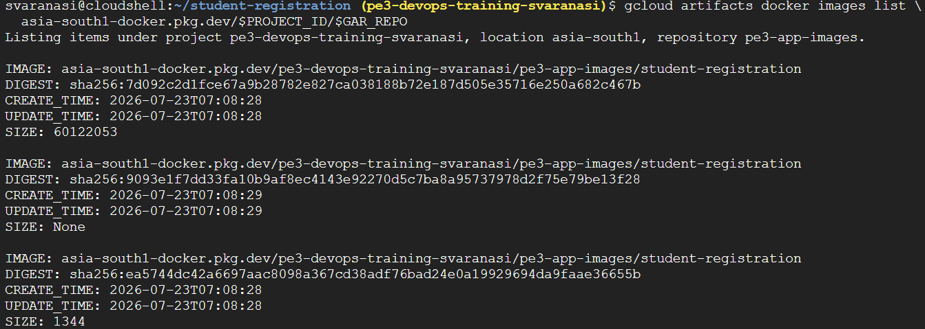

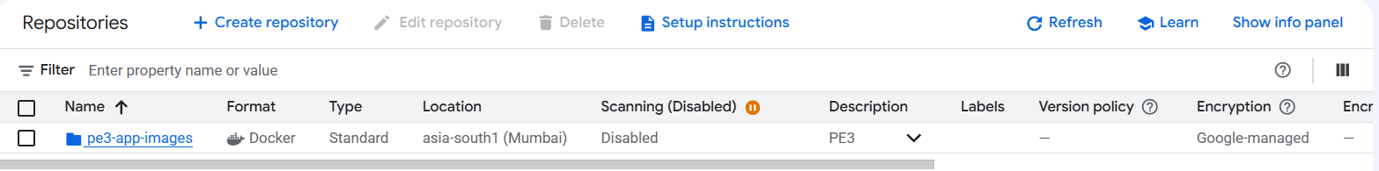

Build and Push Image
Built the Student Assignment Portal Docker image and pushed it to Artifact Registry repository pe3-app-images in asia-south1.
Image:
asia-south1-docker.pkg.dev/pe3-devops-training-svaranasi/pe3-app-images/student-registration:manual-v1
Push completed successfully with digest:
sha256:9093e1f7dd33fa10b9af8ec4143e92270d5c7ba8a95737978d2f75e79be13f28

Grant Artifact Registry Reader to GKE Node Service Account:
Find node pool service account

Deploy App with Cloud SQL Auth Proxy Sidecar:

kubectl apply -f k8s/app-deployment.yaml
kubectl apply -f k8s/app-service.yaml

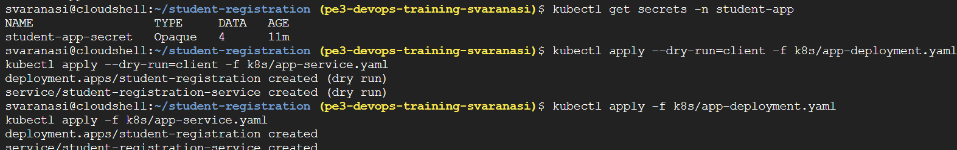

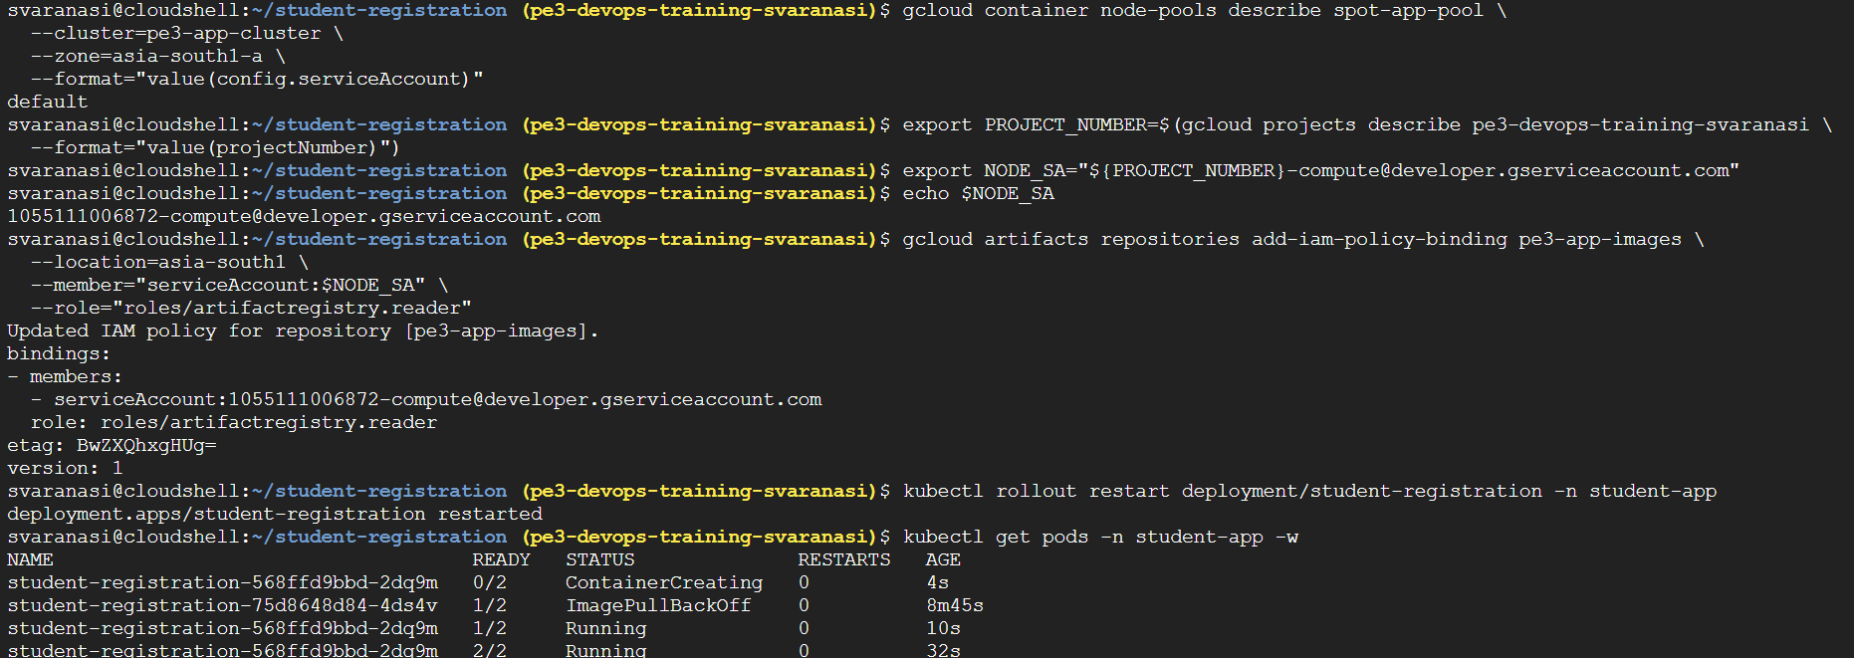

Gateway + HTTPRoute + HTTPS:

Apply Gateway and HTTPRoute:

kubectl apply -f k8s/gateway.yaml
kubectl apply -f k8s/route.yaml

Check Gateway and HTTPRoute:
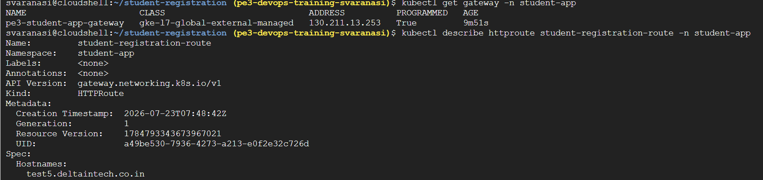

Browser Submit Test and Validate Cloud SQL + GCS


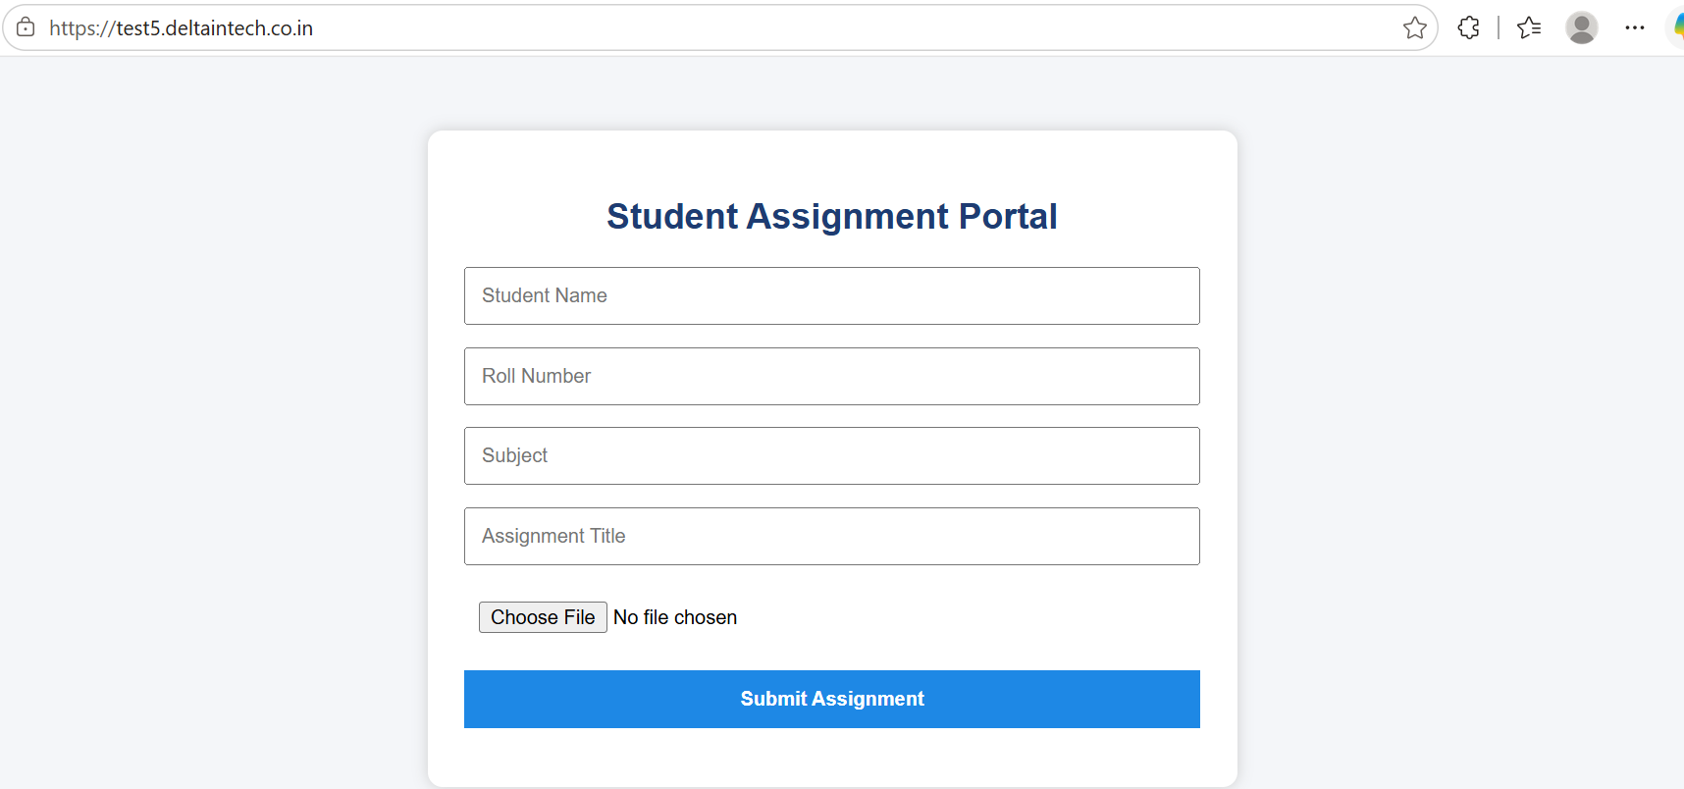
Fill and Submit
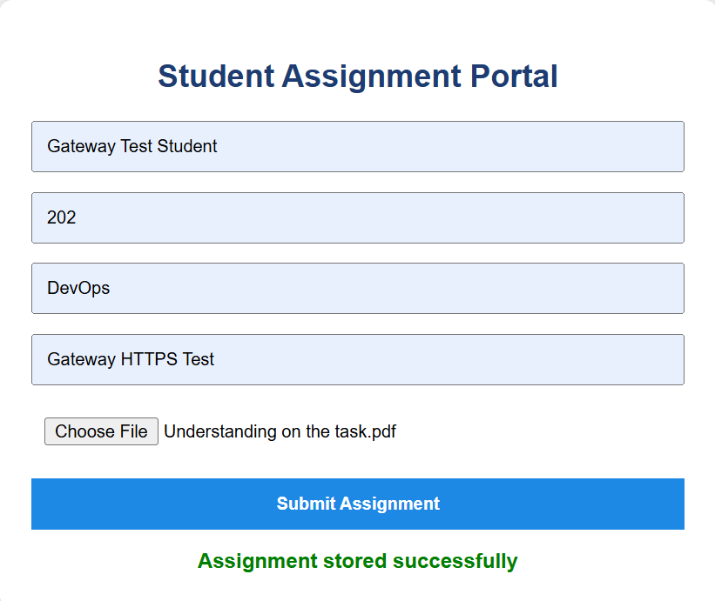

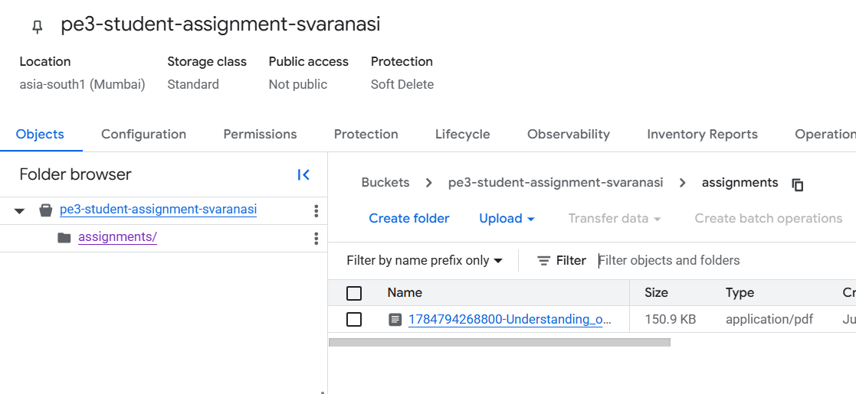

GitHub Actions Keyless CI/CD:

GitHub Actions
↓
GitHub OIDC token
↓
Google Workload Identity Pool
↓
GitHub OIDC Provider
↓
github-actions-deploy-sa
↓
Build image
↓
Push to Artifact Registry
↓
Deploy to GKE

Create GitHub Deploy Service Account:
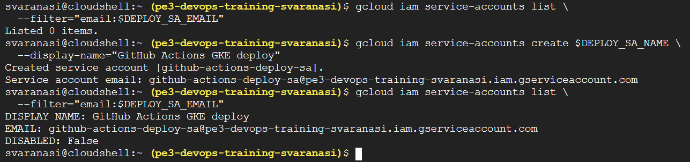

Give Artifact Registry Push Access:
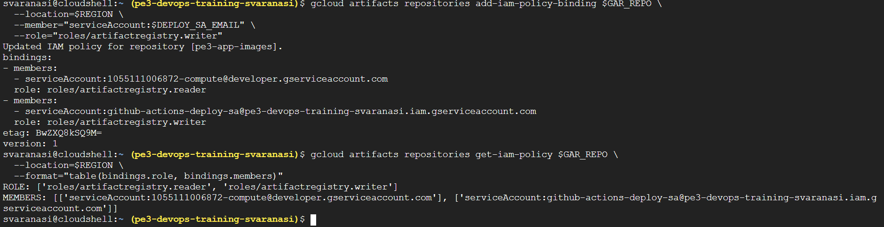

GKE Deploy Permission Check:

gcloud projects get-iam-policy $PROJECT_ID \
--flatten="bindings[].members" \
--filter="bindings.role=roles/container.developer AND bindings.members:$DEPLOY_SA_EMAIL" \
--format="table(bindings.role, bindings.members)"
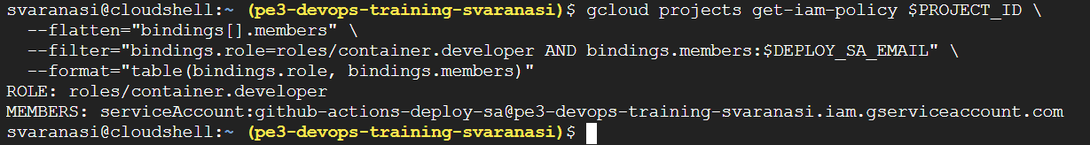
Create GitHub Workload Identity Pool:

gcloud iam workload-identity-pools list \
--location=global

gcloud iam workload-identity-pools create $POOL_ID \
--location=global \
--display-name="GitHub Actions pool"

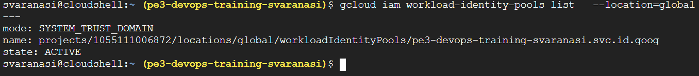

Create GitHub OIDC Provider:

export PROJECT_ID="pe3-devops-training-svaranasi"
export PROJECT_NUMBER="1055111006872"

export GITHUB_REPO="svaranasi06/student-registration"

export POOL_ID="github-actions-pool"
export PROVIDER_ID="github-provider"

gcloud iam workload-identity-pools providers create-oidc $PROVIDER_ID \
--location=global \
--workload-identity-pool=$POOL_ID \
--display-name="GitHub provider" \
--issuer-uri="https://token.actions.githubusercontent.com" \
--attribute-mapping="google.subject=assertion.sub,attribute.repository=assertion.repository,attribute.repository_owner=assertion.repository_owner,attribute.ref=assertion.ref" \
--attribute-condition="assertion.repository=='svaranasi06/student-registration'"

gcloud iam workload-identity-pools providers describe $PROVIDER_ID \
--location=global \
--workload-identity-pool=$POOL_ID

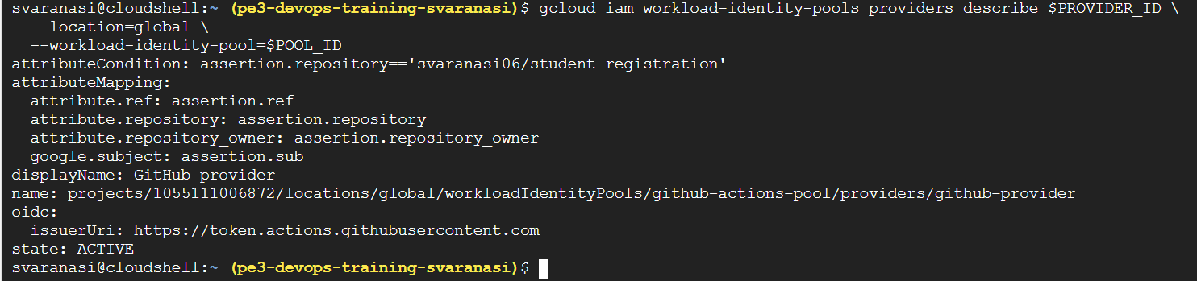

Bind GitHub repo to deploy service account:

gcloud iam service-accounts add-iam-policy-binding $DEPLOY_SA_EMAIL \
--role="roles/iam.workloadIdentityUser" \
--member="principalSet://iam.googleapis.com/projects/$PROJECT_NUMBER/locations/global/workloadIdentityPools/$POOL_ID/attribute.repository/$GITHUB_REPO"

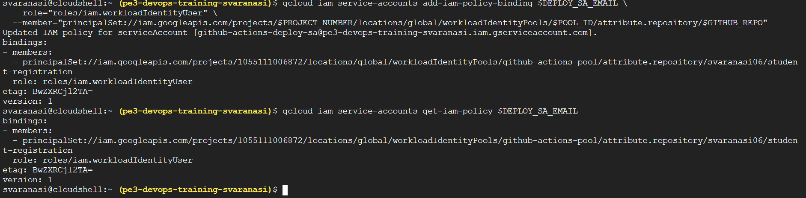

Get WIF Provider Name:

export WIF_PROVIDER=$(gcloud iam workload-identity-pools providers describe $PROVIDER_ID \
--location=global \
--workload-identity-pool=$POOL_ID \
--format="value(name)")

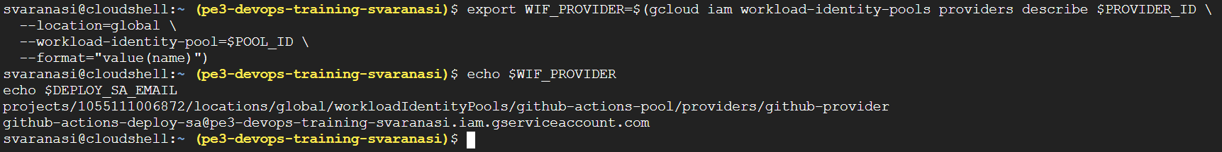

Create workflow directory:

mkdir -p .github/workflows
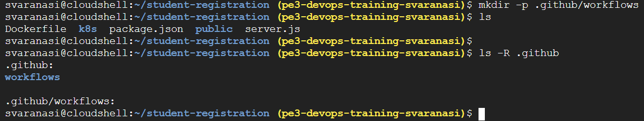

Create deploy-gke.yaml

Important GitHub repository variables:

GCP_PROJECT_ID=pe3-devops-training-svaranasi
GCP_PROJECT_NUMBER=1055111006872
GKE_CLUSTER=pe3-app-cluster
GKE_LOCATION=asia-south1-a
GAR_LOCATION=asia-south1
GAR_REPOSITORY=pe3-app-images
K8S_NAMESPACE=student-app
WIF_PROVIDER=projects/1055111006872/locations/global/workloadIdentityPools/github-actions-pool/providers/github-provider
DEPLOY_SERVICE_ACCOUNT=github-actions-deploy-sa@pe3-devops-training-svaranasi.iam.gserviceaccount.com

Verify no Google key file is used
grep -R "credentials_json\|service_account_key\|GOOGLE_APPLICATION_CREDENTIALS\|json key" .github/workflows || true

Create .gitignore

Then:
Check GitHub authentication

gh auth status

If it says not logged in, run:
gh auth login

Choose:
GitHub.com
HTTPS
Login with browser

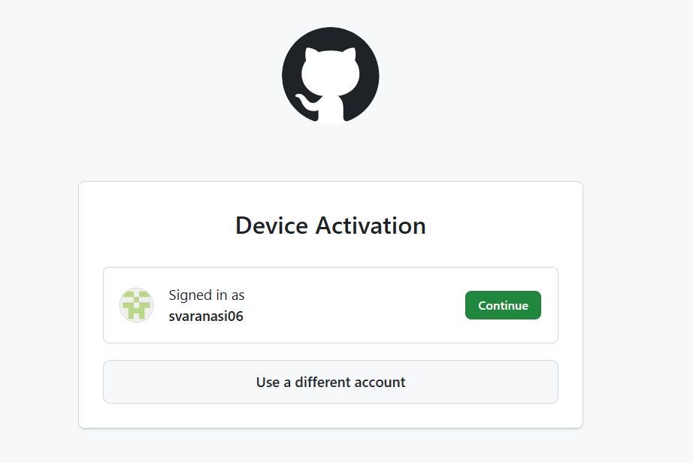
Continue

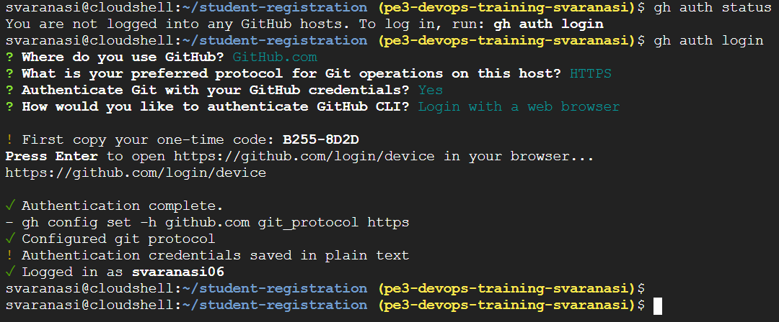

Now…

export PROJECT_ID="pe3-devops-training-svaranasi"
export PROJECT_NUMBER="1055111006872"
export REGION="asia-south1"
export ZONE="asia-south1-a"
export CLUSTER_NAME="pe3-app-cluster"
export NAMESPACE="student-app"
export GAR_REPO="pe3-app-images"

export WIF_PROVIDER="projects/1055111006872/locations/global/workloadIdentityPools/github-actions-pool/providers/github-provider"
export DEPLOY_SERVICE_ACCOUNT="github-actions-deploy-sa@pe3-devops-training-svaranasi.iam.gserviceaccount.com"

export GITHUB_REPO="svaranasi06/student-registration"

Set the variables:

gh variable set GCP_PROJECT_ID --repo $GITHUB_REPO --body "$PROJECT_ID"
gh variable set GCP_PROJECT_NUMBER --repo $GITHUB_REPO --body "$PROJECT_NUMBER"
gh variable set GKE_CLUSTER --repo $GITHUB_REPO --body "$CLUSTER_NAME"
gh variable set GKE_LOCATION --repo $GITHUB_REPO --body "$ZONE"
gh variable set GAR_LOCATION --repo $GITHUB_REPO --body "$REGION"
gh variable set GAR_REPOSITORY --repo $GITHUB_REPO --body "$GAR_REPO"
gh variable set K8S_NAMESPACE --repo $GITHUB_REPO --body "$NAMESPACE"
gh variable set WIF_PROVIDER --repo $GITHUB_REPO --body "$WIF_PROVIDER"
gh variable set DEPLOY_SERVICE_ACCOUNT --repo $GITHUB_REPO --body "$DEPLOY_SERVICE_ACCOUNT"

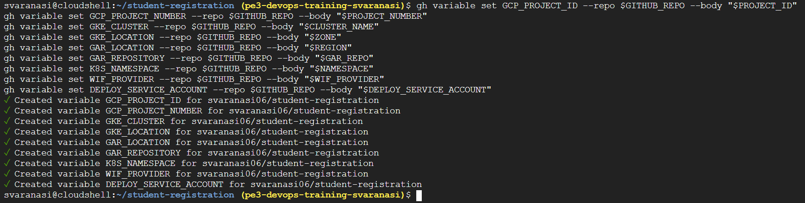

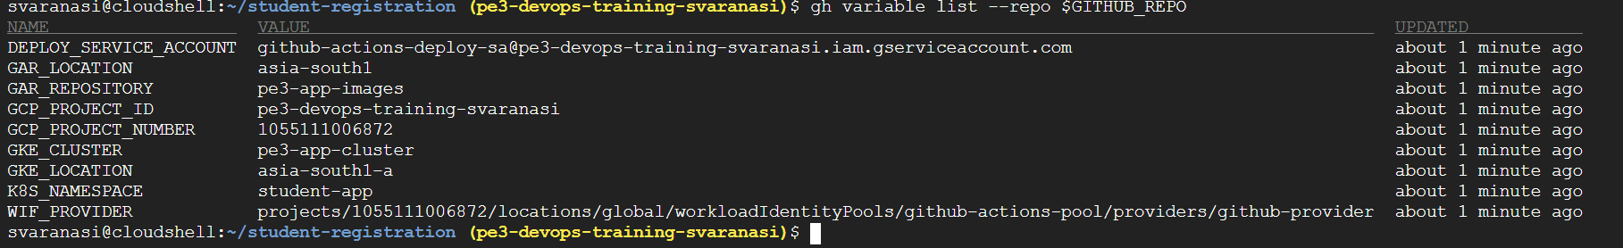

Push Code to GitHub:
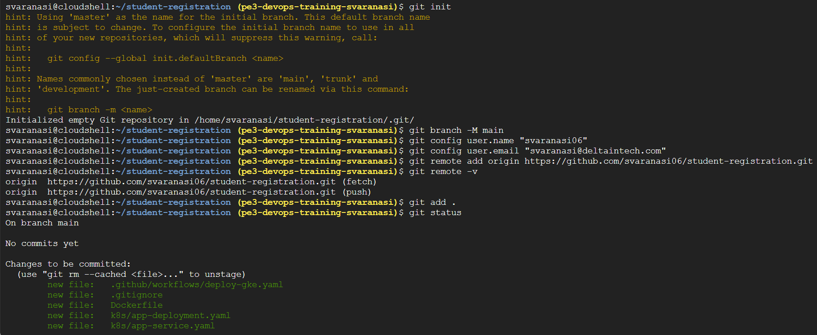

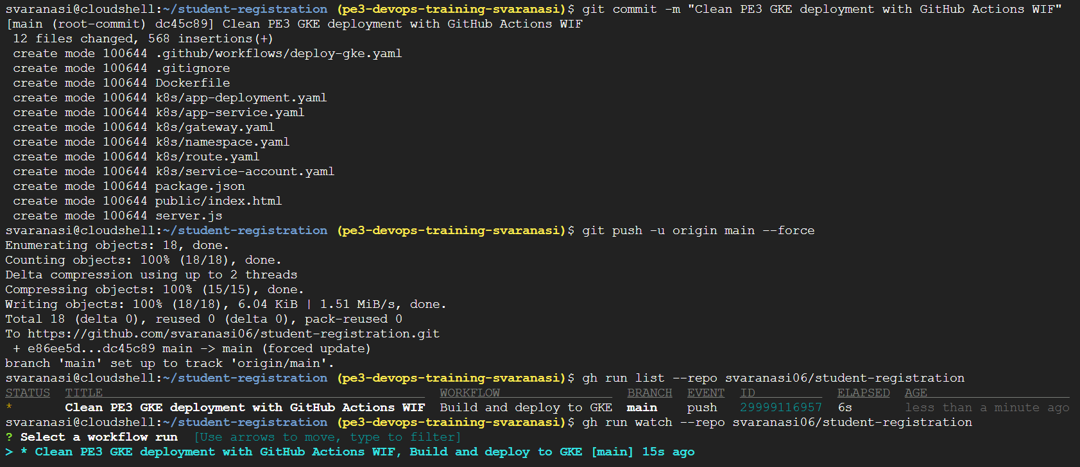
Enter
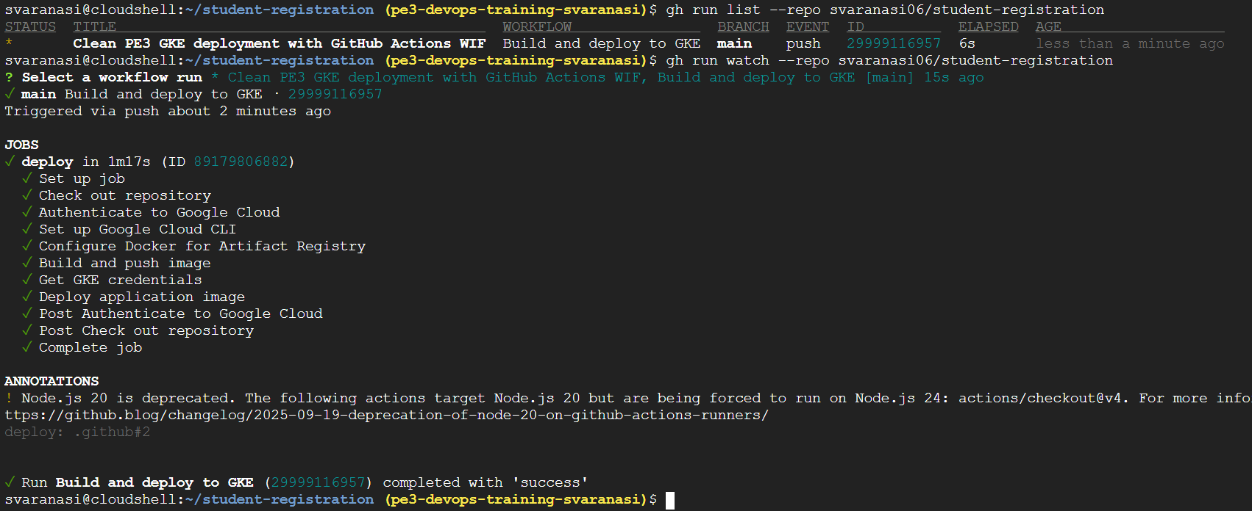

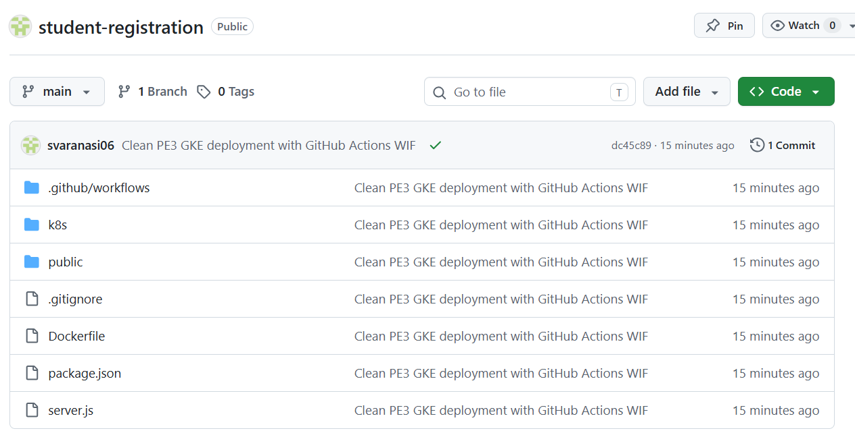
Verify GKE Deployment Updated:
New pods:

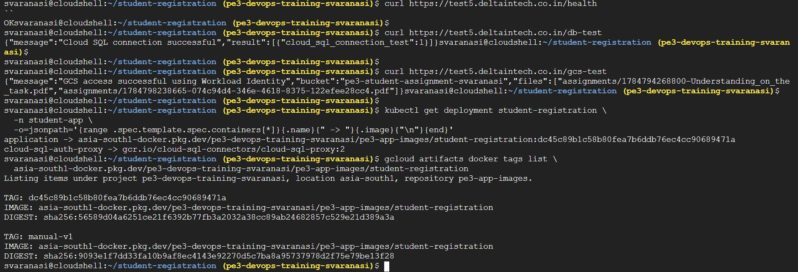

GitHub Actions keyless CI/CD was completed successfully.

Workflow run ID: 29999116957
Workflow: Build and deploy to GKE
Status: Success

The workflow authenticated to Google Cloud using GitHub OIDC Workload Identity Federation, built the Docker image, pushed it to Artifact Registry, obtained GKE credentials, updated the Kubernetes deployment image, and completed the rollout successfully.

Browser Submit Test:

https://test5.deltaintech.co.in

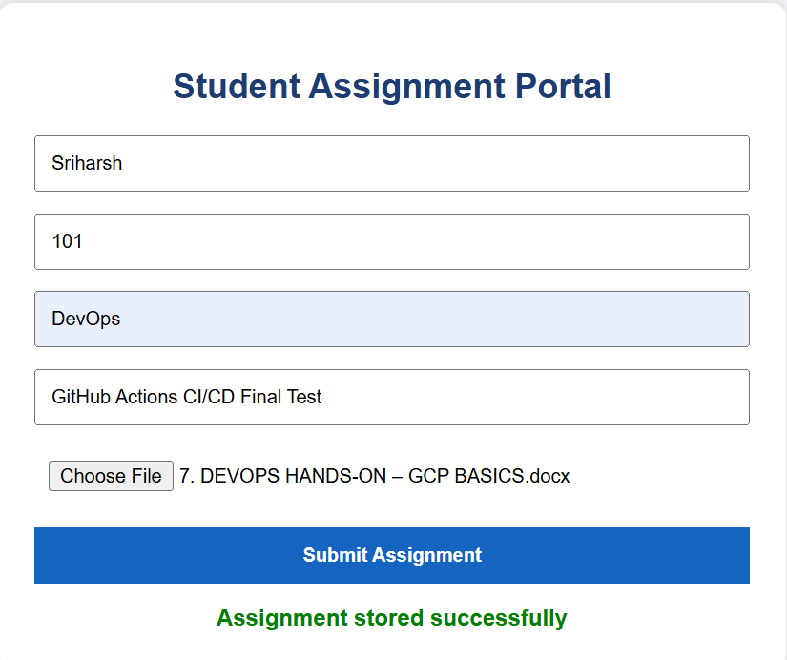

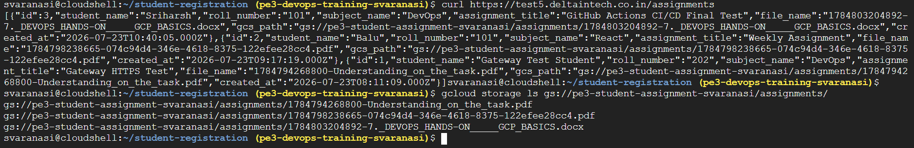

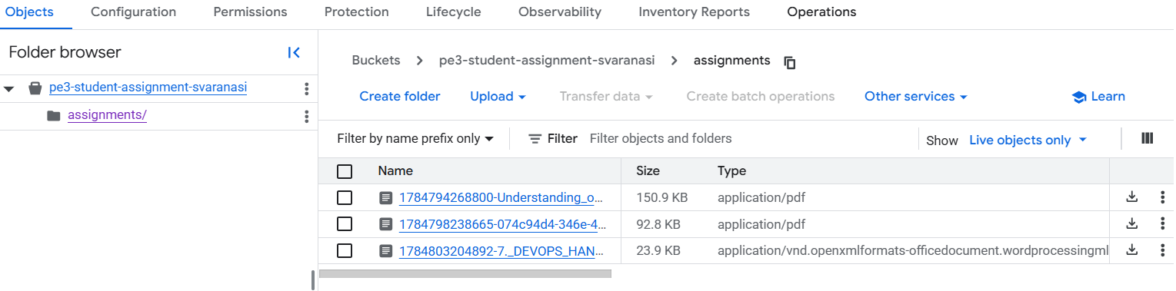

--------------
Check data in Cloud Studio:
Create Temporary User

export CLOUDSQL_INSTANCE="pe3-student-mysql"
export TEMP_DB_USER="studio_user"
export TEMP_DB_PASSWORD="Studio123"

Create user:

gcloud sql users create $TEMP_DB_USER \
--host=% \
--instance=$CLOUDSQL_INSTANCE \
--password=$TEMP_DB_PASSWORD

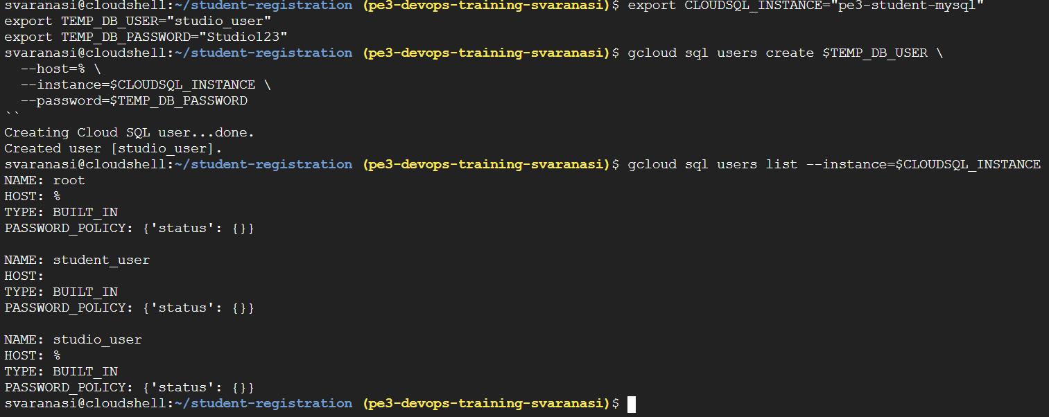

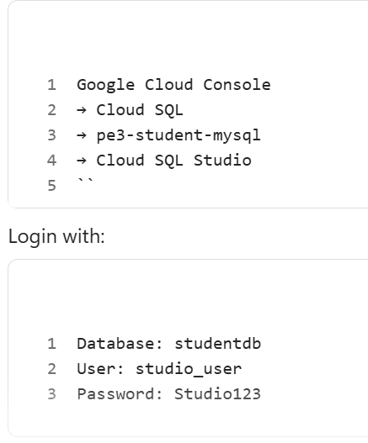

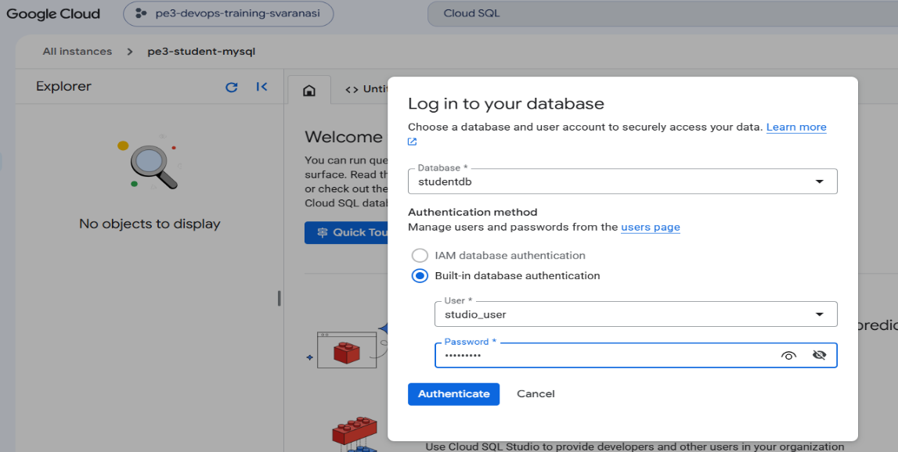

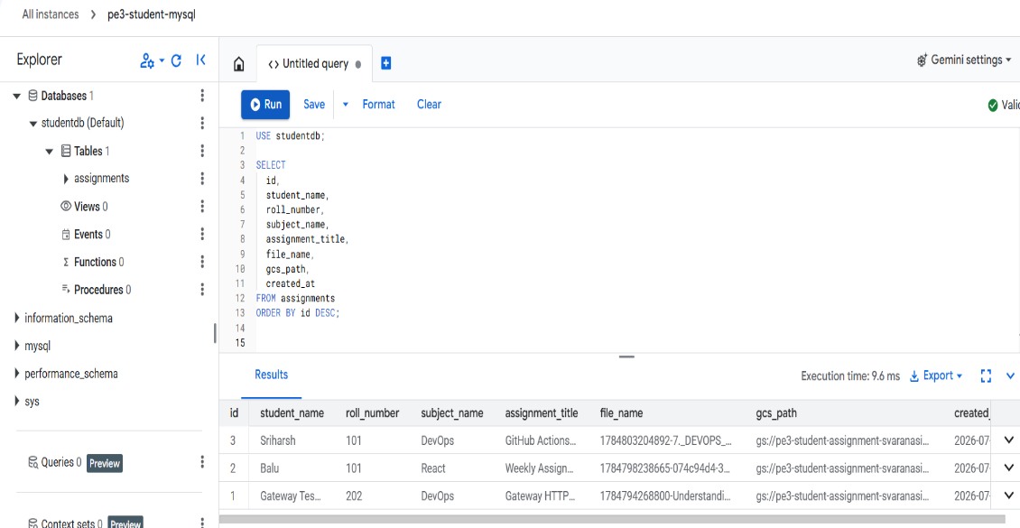
Later verification delete temporary user:

gcloud sql users delete $TEMP_DB_USER \
--host=% \
--instance=$CLOUDSQL_INSTANCE \
--quiet

A temporary Cloud SQL user named studio_user was created only to validate application records in Cloud SQL Studio. After confirming the assignment records, the temporary user was deleted.

