New Target Architecture:

Browser
↓
GKE LoadBalancer
↓
student-assignment-app Pod
↓
Cloud SQL MySQL Private IP
↓
Google Cloud Storage bucket
No MySQL StatefulSet.
No PVC.
No mysql-service.
No Cloud SQL Auth Proxy sidecar.

Prepare Variables and Verify Clean Environment and Verify:
Set Project Variables

export PROJECT_ID="pe3-devops-training-svaranasi"
export REGION="asia-south1"
export ZONE="asia-south1-a"

export CLUSTER_NAME="assignment-cloudsql-cluster"
export NAMESPACE="assignment-app"

export BUCKET_NAME="student-assignment-portal-svaranasi"

export CLOUDSQL_INSTANCE="assignment-cloudsql-mysql"
export DB_NAME="student_portal_db"
export DB_USER="student_user"
export DB_PASSWORD="student123"

export NETWORK_NAME="default"

echo $PROJECT_ID
echo $REGION
echo $ZONE
echo $CLUSTER_NAME
echo $NAMESPACE
echo $BUCKET_NAME
echo $CLOUDSQL_INSTANCE
echo $DB_NAME
echo $DB_USER
echo $NETWORK_NAME

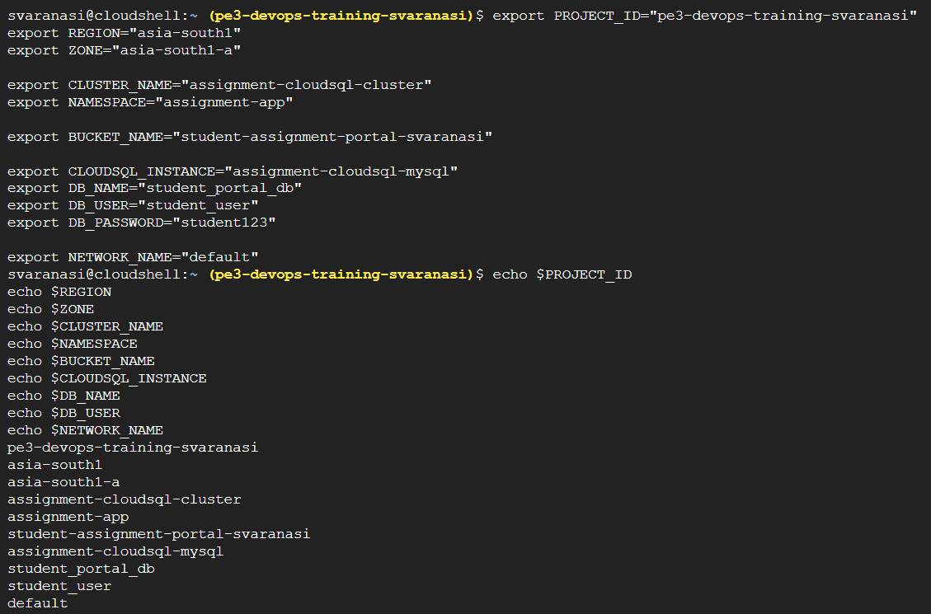

Set Correct GCP Project
Check Active Google Account
Enable Required APIs

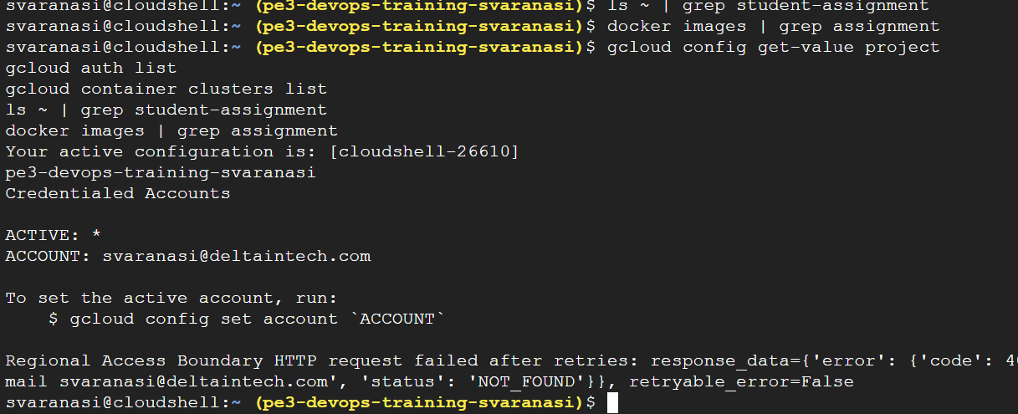

Create VPC-Native GKE Cluster for Cloud SQL Private IP:

Create VPC-Native GKE Cluster:
Cluster name: assignment-cloudsql-cluster
Zone: asia-south1-a
Network: default
Subnetwork: default
Nodes: 1
Machine type: e2-standard-2
VPC-native: enabled

gcloud container clusters create $CLUSTER_NAME \
--zone=$ZONE \
--num-nodes=1 \
--machine-type=e2-standard-2 \
--disk-size=30 \
--release-channel=regular \
--enable-ip-alias \
--network=$NETWORK_NAME \
--subnetwork=$NETWORK_NAME

After cluster creation completes, run to connect the cluster:

gcloud container clusters get-credentials $CLUSTER_NAME \
--zone=$ZONE \
--project=$PROJECT_ID

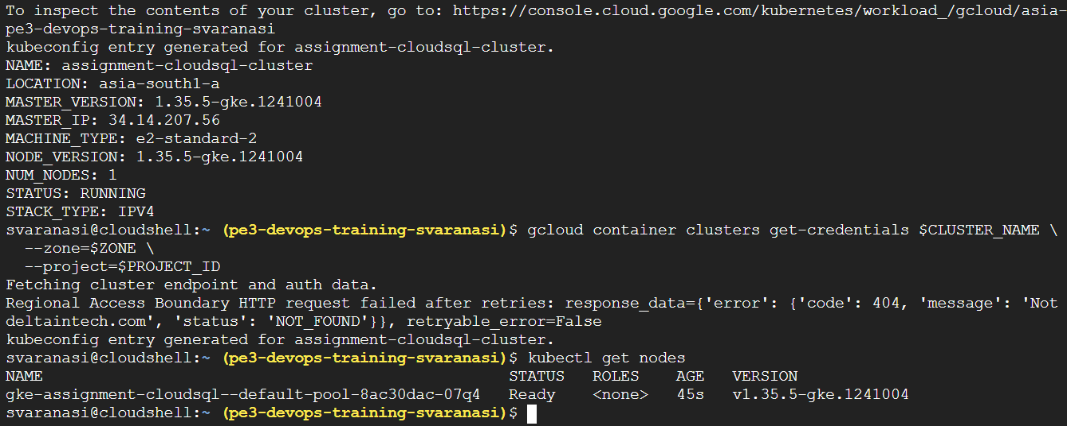

Cluster: assignment-cloudsql-cluster
Location: asia-south1-a
Node count: 1
Status: RUNNING
kubectl node status: Ready

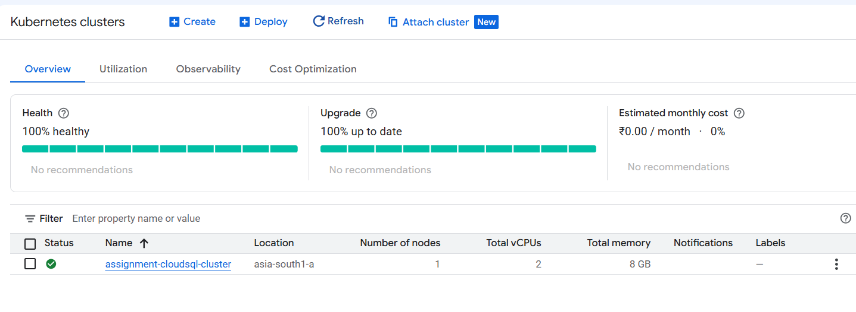

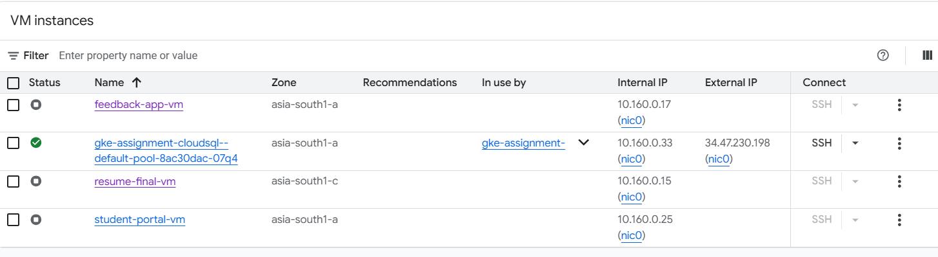

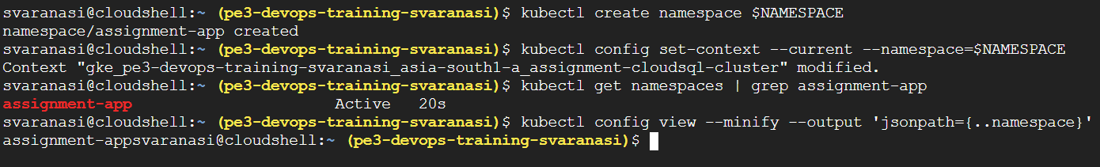

Configure Private Service Access for Cloud SQL Private IP:

Why this phase is needed
Because we are using Cloud SQL Direct Private IP, Cloud SQL needs a private IP range inside the VPC network. GKE and Cloud SQL must communicate through the same VPC/private network path for private IP connectivity. Google’s Cloud SQL for GKE guidance says private IP connectivity requires the GKE cluster to be VPC-native and connected through the same VPC network path as the Cloud SQL instance.

Simply:
GKE cluster is in default VPC
Cloud SQL also needs private IP in default VPC
Private Service Access connects Google-managed Cloud SQL network to your VPC

Enable Private Service Networking API:
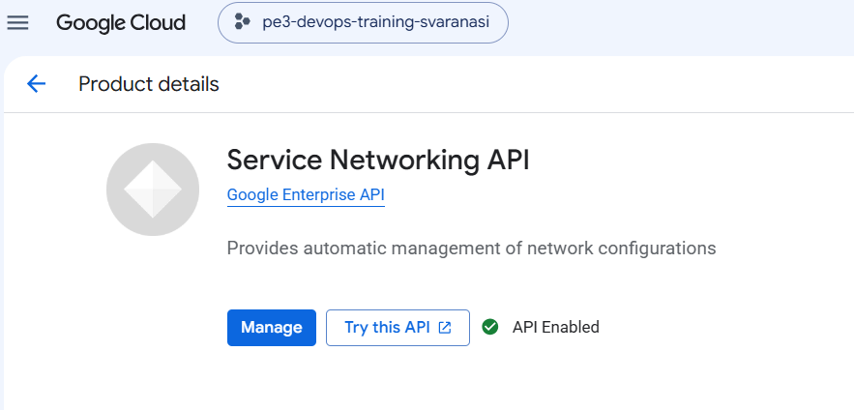
Check Existing Private Service Access Ranges
If no ranges Create one
Create Private IP Range for Google Services
gcloud compute addresses create google-managed-services-default \
--global \
--purpose=VPC_PEERING \
--prefix-length=16 \
--network=$NETWORK_NAME

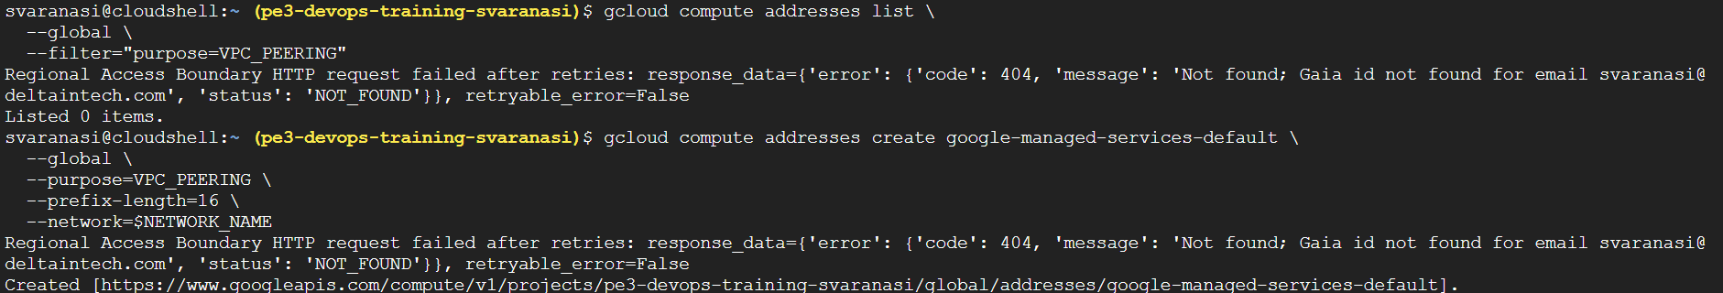

Verify the Reserved Range
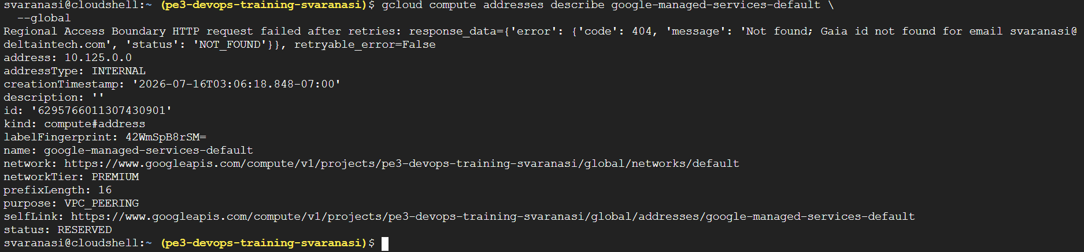

Create Private Service Access Connection

gcloud services vpc-peerings connect \
--service=servicenetworking.googleapis.com \
--ranges=google-managed-services-default \
--network=$NETWORK_NAME \
--project=$PROJECT_ID
This creates the private connection between your VPC and Google-managed services like Cloud SQL.

Now, verify the connection:

gcloud services vpc-peerings list \
--network=$NETWORK_NAME \
--project=$PROJECT_ID

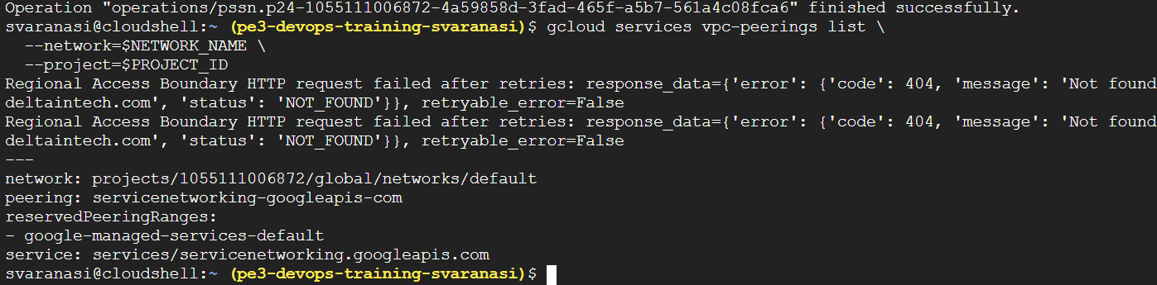

Status:
Private allocated range: google-managed-services-default
Reserved range: 10.125.0.0/16
VPC peering: servicenetworking-googleapis-com
Network: default
Service: servicenetworking.googleapis.com
This means:
Private Service Access is now ready. This is the key networking requirement for creating a Cloud SQL instance with private IP so your VPC-native GKE cluster can reach Cloud SQL privately. Google’s GKE and Cloud SQL documentation notes that private IP connectivity requires the GKE cluster and Cloud SQL instance to be connected through the same VPC/private network path.

Create Cloud SQL MySQL Instance with Private IP:

gcloud sql instances create $CLOUDSQL_INSTANCE \
--database-version=MYSQL_8_0 \
--tier=db-f1-micro \
--region=$REGION \
--network=$NETWORK_NAME \
--no-assign-ip \
--storage-size=10GB \
--storage-type=SSD \
--availability-type=zonal

We have created:
Cloud SQL instance name: assignment-cloudsql-mysql
Database engine: MySQL 8.0
Region: asia-south1
Machine type: db-f1-micro
Public IP: disabled
Private IP: enabled
Network: default
Storage: 10 GB SSD
Availability: zonal

--no-assign-ip because of this tag, no public IP is assigned

Wait for Instance Creation
gcloud sql instances list
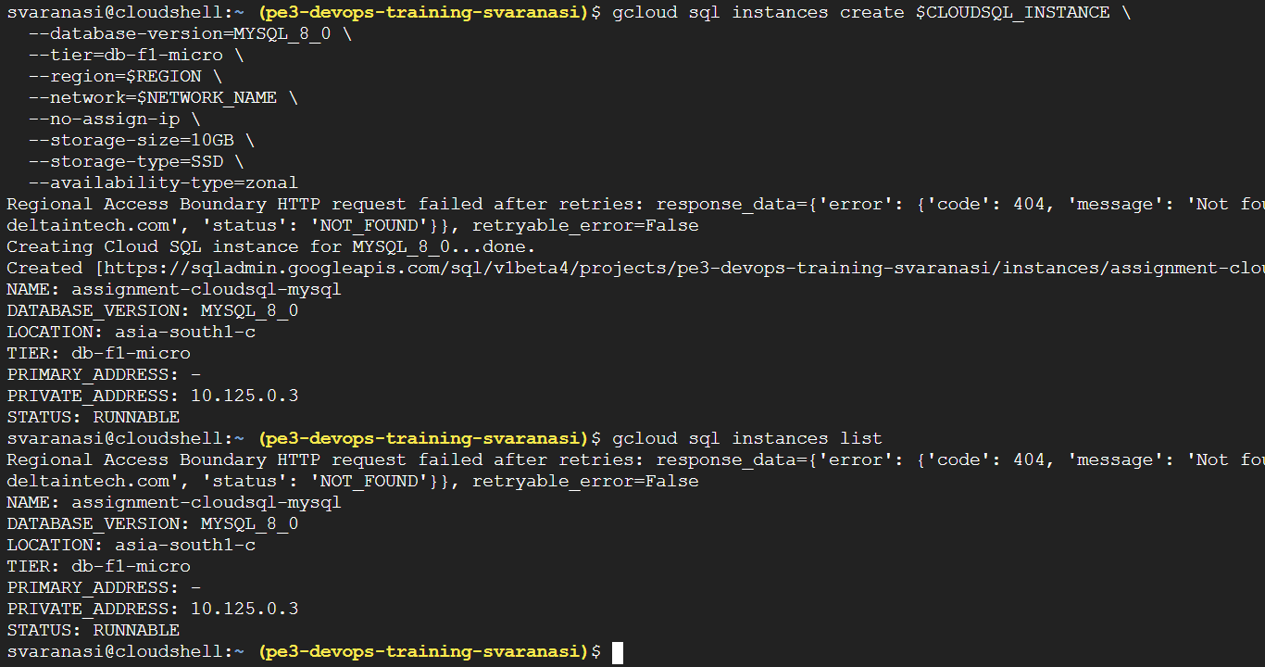

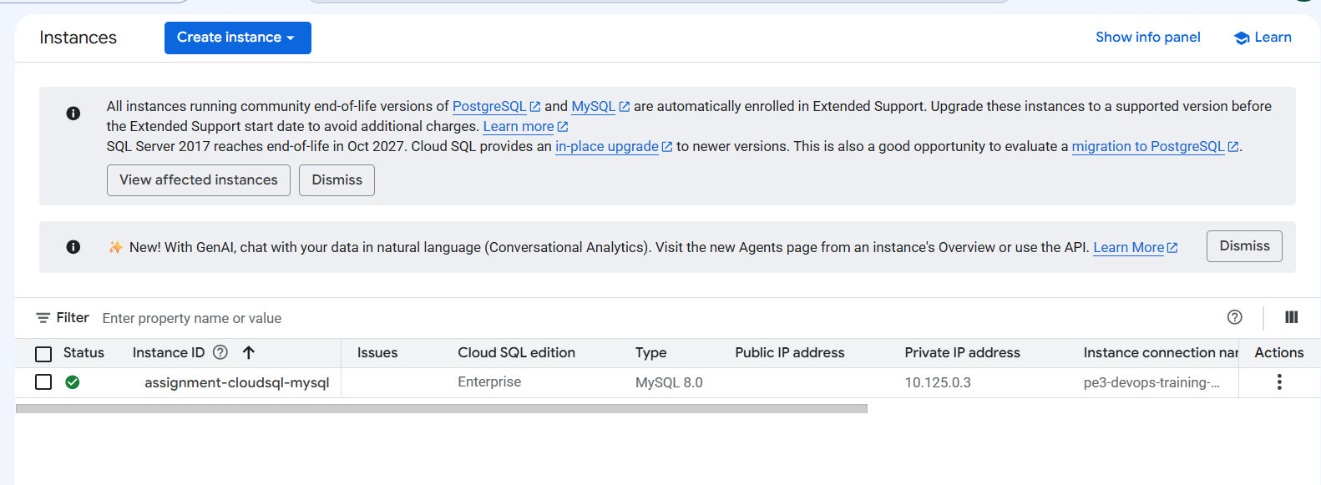

Get Cloud SQL Private IP and save it:

gcloud sql instances describe $CLOUDSQL_INSTANCE \
--format="value(ipAddresses.ipAddress)"

export CLOUDSQL_PRIVATE_IP=$(gcloud sql instances describe $CLOUDSQL_INSTANCE --format="value(ipAddresses.ipAddress)")

echo $CLOUDSQL_PRIVATE_IP
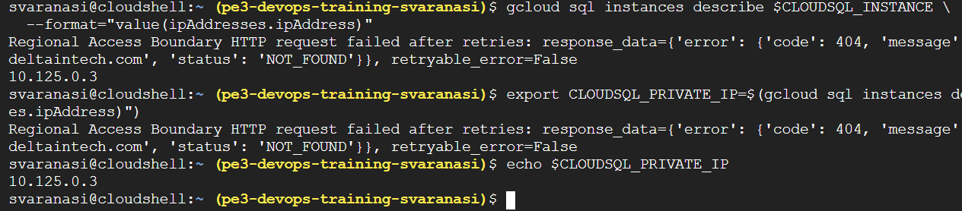

Create Cloud SQL Database, User, and Table:
Create database
Create database user
Connect to Cloud SQL using Cloud Shell
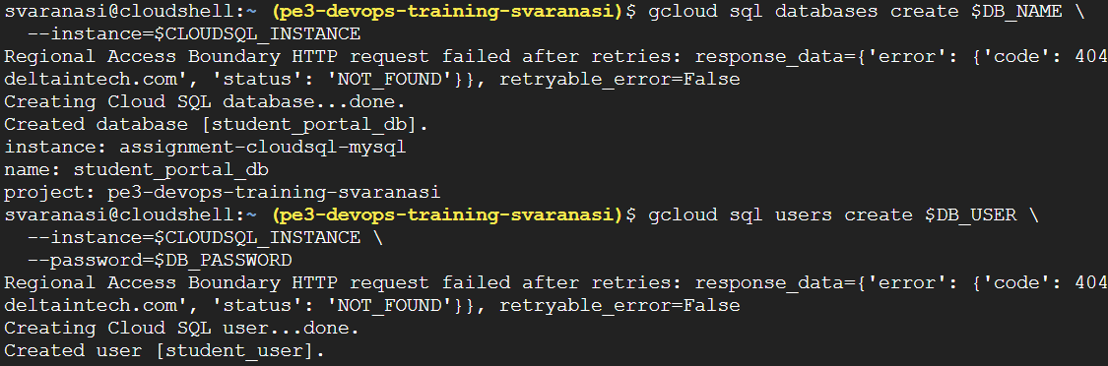

Create GCS Secret and Prepare App Files for Cloud SQL Direct Private IP:
Verify GCS Bucket Exists:

Check Service Account Key File:
svaranasi@cloudshell:~ (pe3-devops-training-svaranasi)$ ls -l ~/gcs-key.json
-rw-r--r-- 1 svaranasi 1001 2415 Jul 14 11:38 /home/svaranasi/gcs-key.json

Create GCS Secret in Kubernetes:

kubectl create secret generic gcs-key-secret \
--from-file=gcs-key.json=$HOME/gcs-key.json \
-n $NAMESPACE

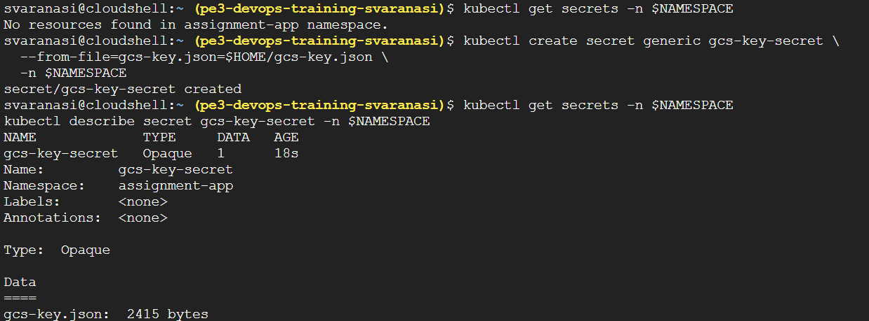

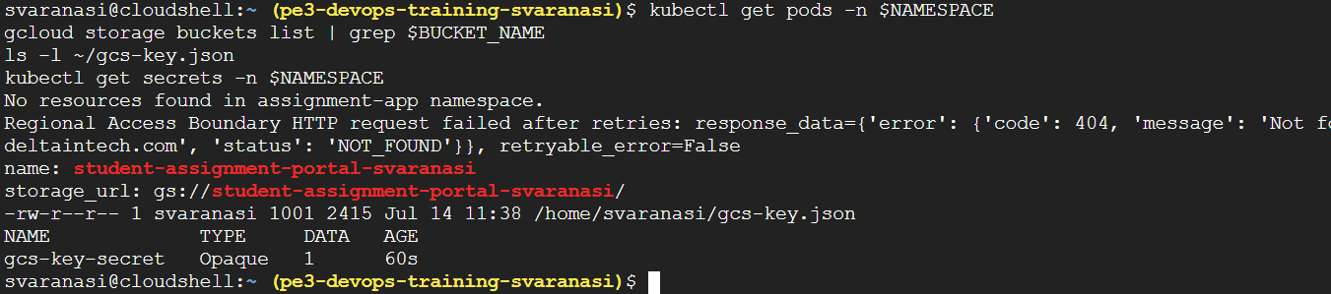

Important values:

Cloud SQL Private IP: 10.125.0.3
Database: student_portal_db
User: student_user
GCS Bucket: student-assignment-portal-svaranasi
Kubernetes Secret: gcs-key-secret

Create App Files for Cloud SQL Direct Private IP:

Our app will have:
1. Serve frontend HTML
2. Accept assignment upload
3. Upload file to GCS
4. Store metadata in Cloud SQL MySQL

Main change from previous setup is:

Old DB_HOST: mysql-service
New DB_HOST: 10.125.0.3

Because we are using Cloud SQL Direct Private IP, the app connects directly to the Cloud SQL private IP from inside GKE. Private IP connectivity requires the GKE cluster and Cloud SQL instance to communicate through the same VPC/private network path, which we already configured using Private Service Access.

Create Project Folder:

cd ~

rm -rf student-assignment-cloudsql

mkdir -p student-assignment-cloudsql/public

mkdir -p student-assignment-cloudsql/k8s

cd student-assignment-cloudsql

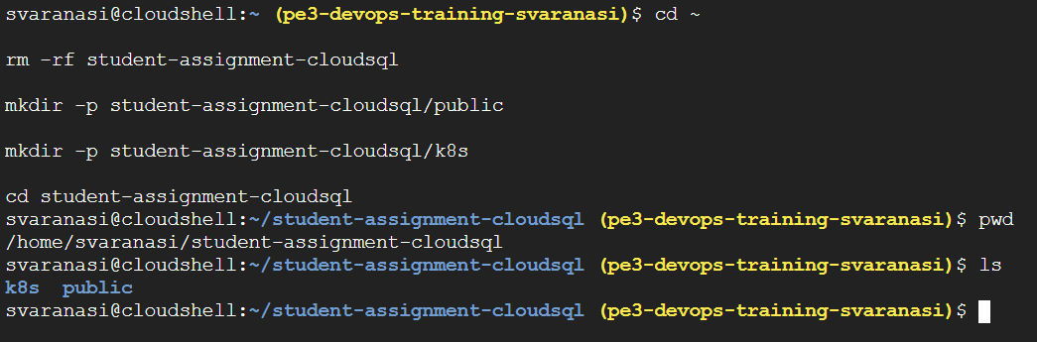

Create package.json
Create Frontend File
Create Backend File server.js

Why this server.js is better:
This version does not hardcode DB values.
Instead, Kubernetes will provide:

DB_HOST=10.125.0.3
DB_USER=student_user
DB_PASSWORD=student123
DB_NAME=student_portal_db
BUCKET_NAME=student-assignment-portal-svaranasi

Create Dockerfile
Create .dockerignore

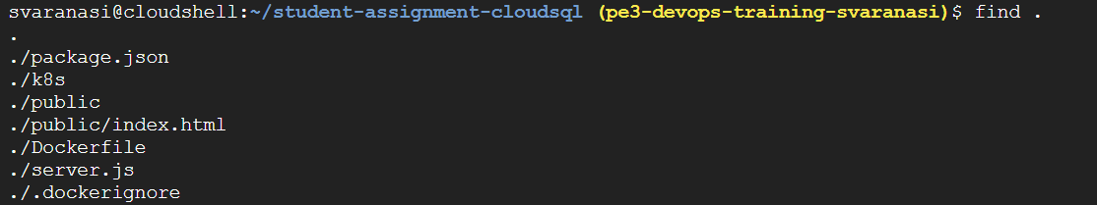

Build and Push New Docker Image for Cloud SQL Version:

Go to project folder: cd ~/student-assignment-cloudsql
Build Docker Image:
docker build -t student-assignment-cloudsql:v1 .
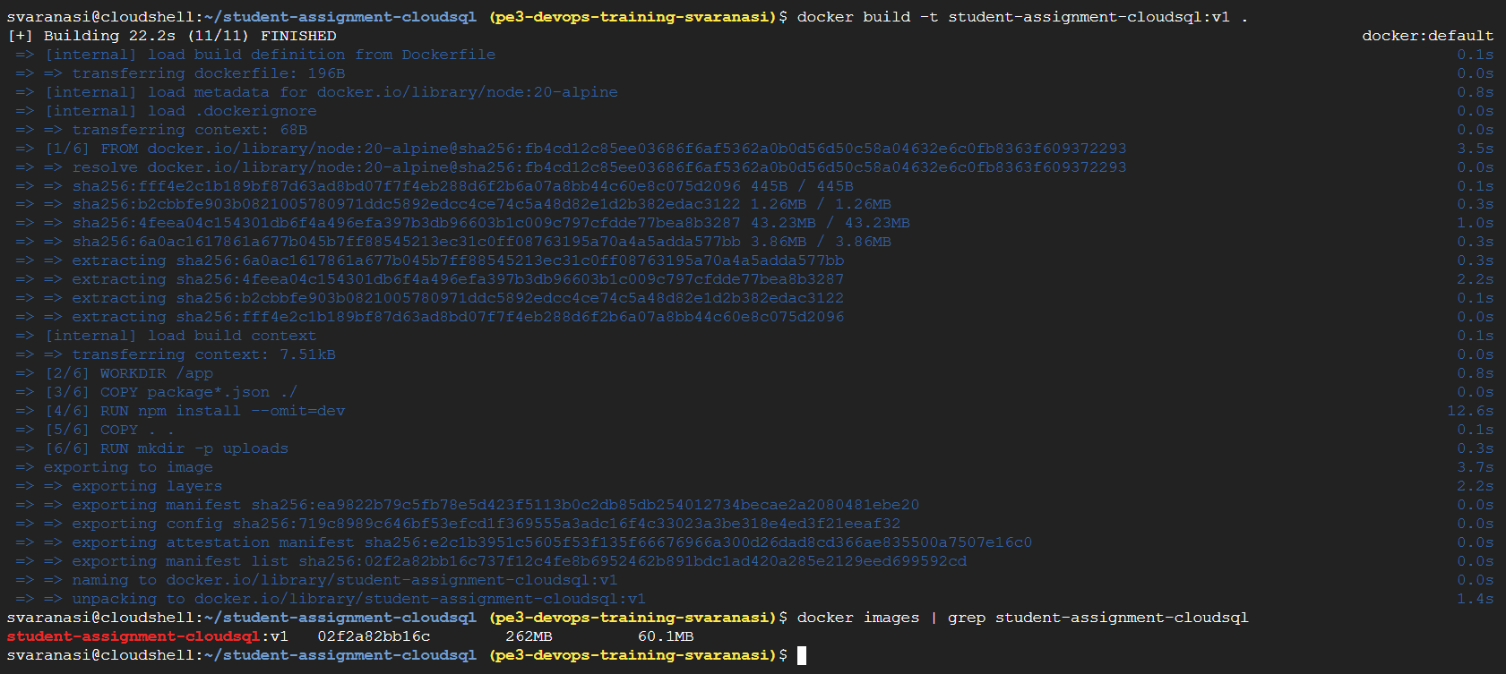

Tag image: export IMAGE_URI="svaranasi06/assignment-app:cloudsql-v1"
Now tag the image: docker tag student-assignment-cloudsql:v1 $IMAGE_URI
Push Image to Docker Hub: docker push $IMAGE_URI

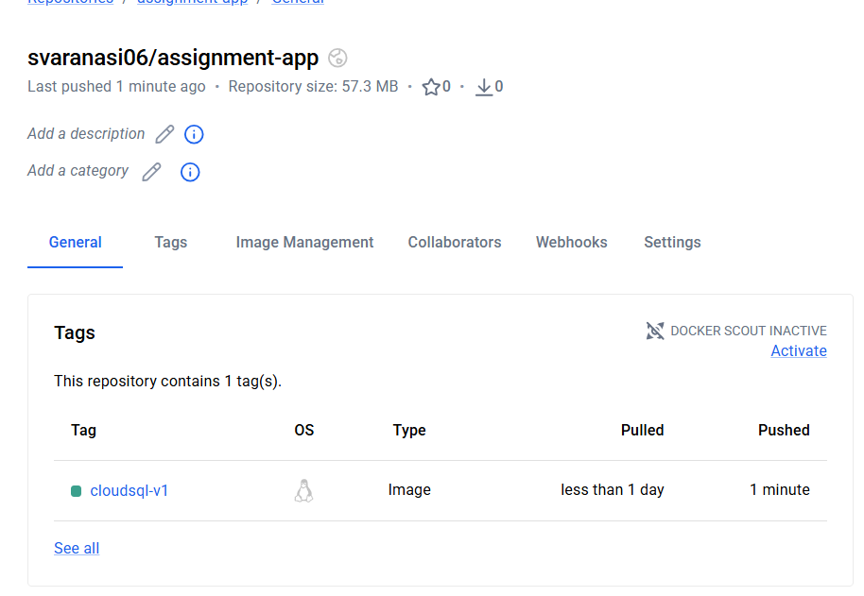
Create Kubernetes Secrets and Deployment YAML for Cloud SQL Direct Private IP:
Go to project folder: cd ~/student-assignment-cloudsql
Set variables:

export PROJECT_ID="pe3-devops-training-svaranasi"
export REGION="asia-south1"
export ZONE="asia-south1-a"
export CLUSTER_NAME="assignment-cloudsql-cluster"
export NAMESPACE="assignment-app"

export BUCKET_NAME="student-assignment-portal-svaranasi"

export CLOUDSQL_PRIVATE_IP="10.125.0.3"

export DB_NAME="student_portal_db"
export DB_USER="student_user"
export DB_PASSWORD="student123"

export IMAGE_URI="svaranasi06/assignment-app:cloudsql-v1"

Create Cloud SQL DB Secret

kubectl create secret generic cloudsql-db-secret \
--from-literal=DB_HOST="$CLOUDSQL_PRIVATE_IP" \
--from-literal=DB_NAME="$DB_NAME" \
--from-literal=DB_USER="$DB_USER" \
--from-literal=DB_PASSWORD="$DB_PASSWORD" \
-n $NAMESPACE

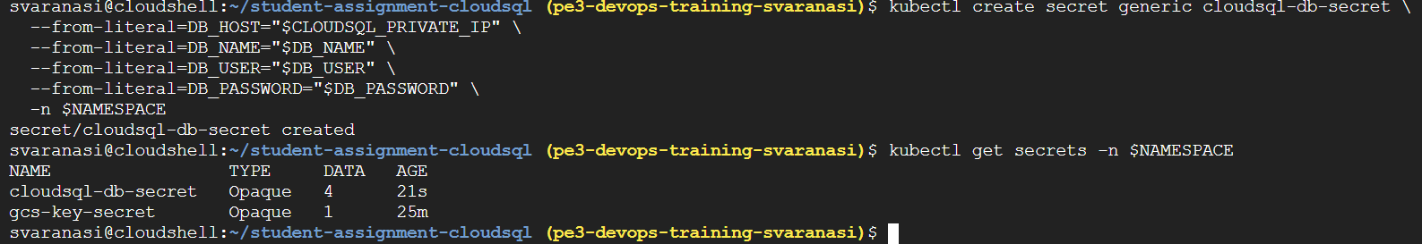

Now,
Create app-deployment.yaml
Create app-service.yaml

Deploy the App and Test Cloud SQL Direct Private IP Connection:
Apply App Deployment:
kubectl apply -f k8s/app-deployment.yaml -n $NAMESPACE

Apply LoadBalancer Service:
kubectl apply -f k8s/app-service.yaml -n $NAMESPACE

Check status of the pod
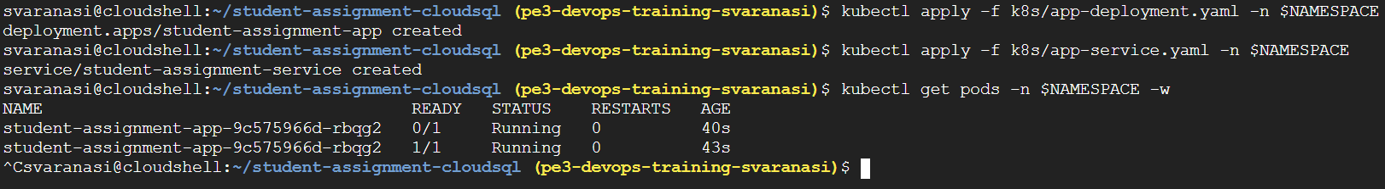

Check App Logs:
kubectl logs deployment/student-assignment-app -n $NAMESPACE

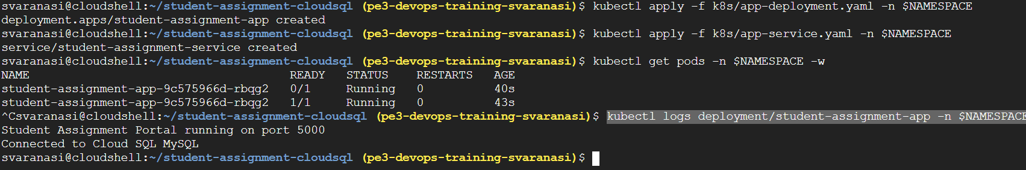

Check Service External IP:
kubectl get svc -n $NAMESPACE

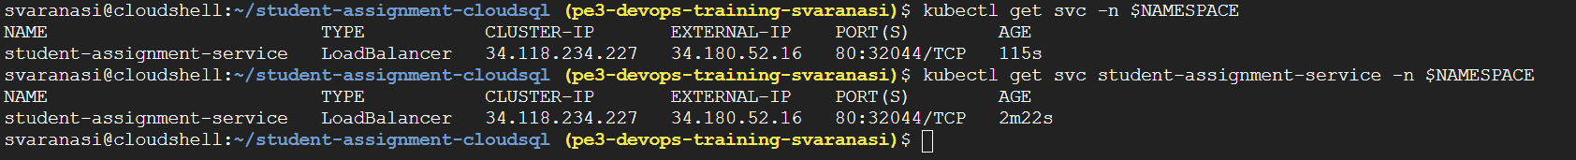

Check the health and test db:

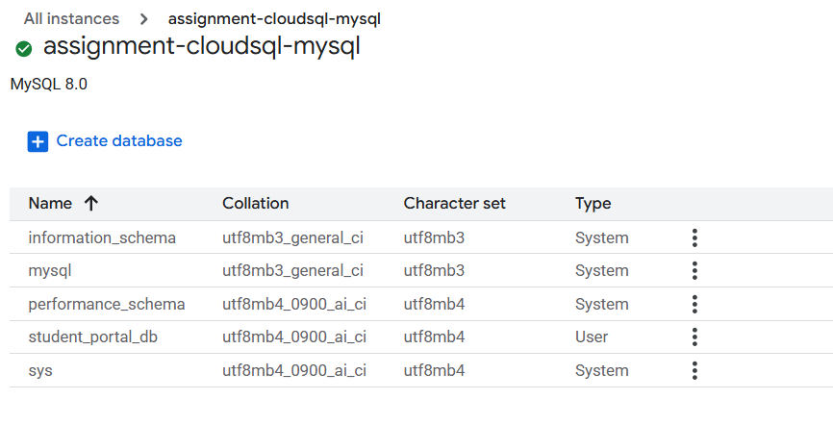

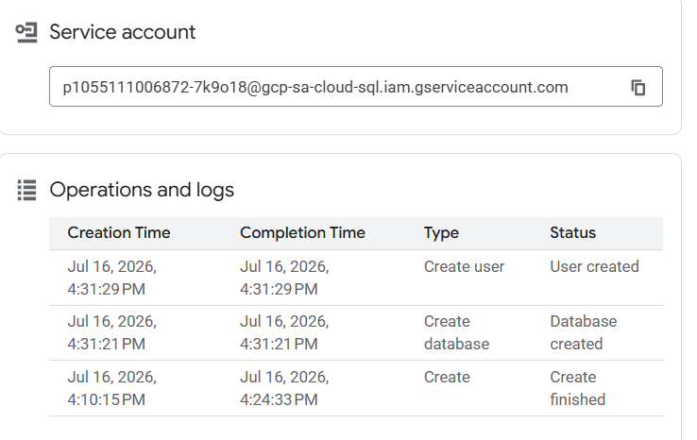
NOW OPEN THE URL IN BROWSER:
Student Assignment Portal - Cloud SQL
Get external IP command: kubectl get svc student-assignment-service -n $NAMESPACE

http://34.180.52.16
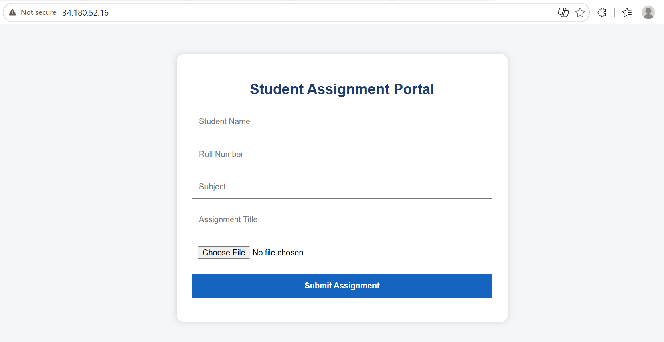
Fill the form and submit
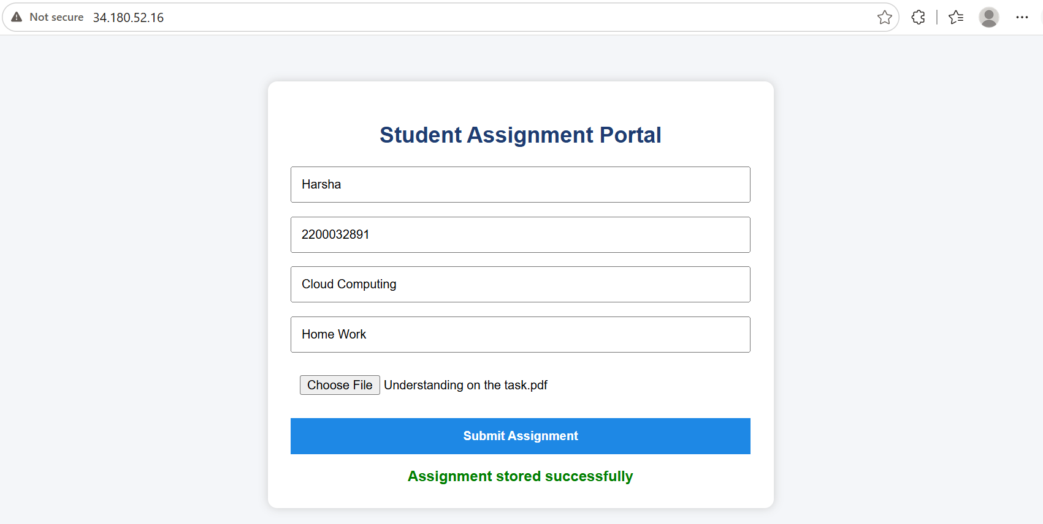

Verify Record in Cloud Storage Bucket and Cloud SQL:
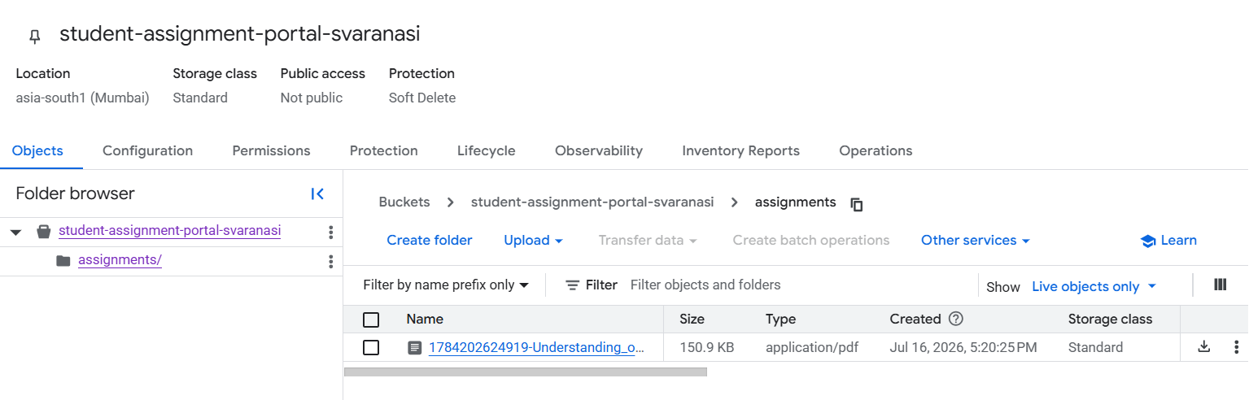

curl http://34.180.52.16/health
curl http://34.180.52.16/db-test
curl http://34.180.52.16/assignments

Browser / curl
↓
GKE LoadBalancer
↓
student-assignment-app Pod
↓
Cloud SQL MySQL using Private IP
↓
GCS bucket for file storage

How to check the MySQL data:
- Use your app API endpoint, easiest
curl http://34.180.52.16/assignments

- Use Cloud SQL Studio in Google Cloud Console
Cloud SQL Studio from the Google Cloud Console to run SQL queries directly in the browser. Cloud SQL Studio lets authorized users interact with Cloud SQL databases and run SQL queries from the console, including DDL, DML, and SELECT queries.

Steps:
- Open Google Cloud Console.
- Go to SQL.
- Click your instance
- Open Cloud SQL Studio.

gcloud sql users create studio_user \
--instance=$CLOUDSQL_INSTANCE \
--host=% \
--password=Studio123

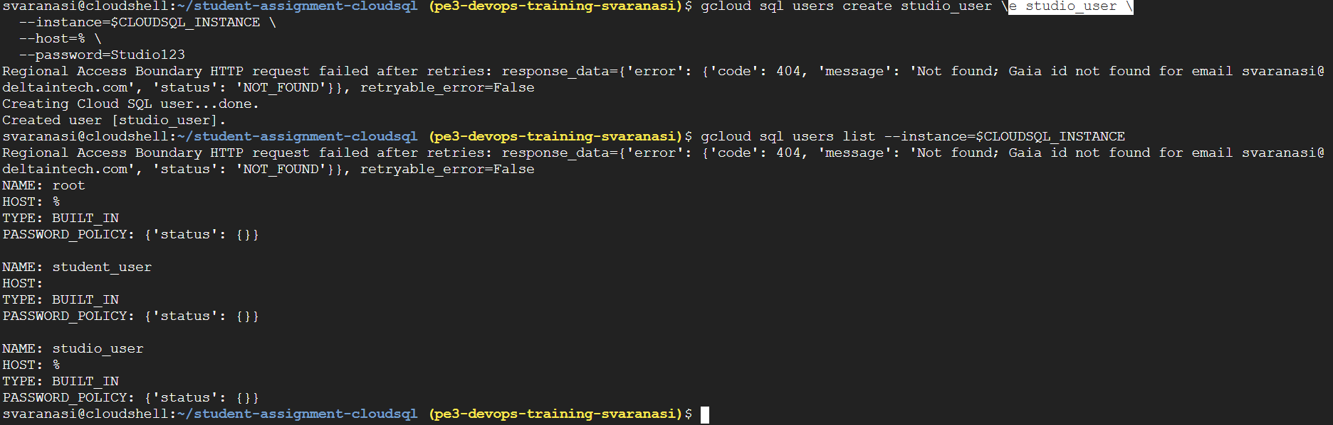
Authenticate
User: studio_user
Password: Studio123

